Northbourne Flats Place Implementation Guidelines

Purpose
The purpose of these Northbourne Flats Place Implementation Guidelines (the Guidelines) are to assist Developers to ensure the development that occurs on this prominent site creates a vibrant precinct, and enhances the liveability for its future residents and residents of the area surrounding the site.

These Guidelines reflect the ongoing work undertaken so far for the City and Gateway Urban Renewal Strategy project. The Territory intends to review the Territory Plan in respect to the City and Gateway Draft Urban Design Framework, and there is likely to be changes to the Territory Plan and Northbourne Avenue Precinct Code. Developers will be required to comply with changes to the Territory Plan.

These Guidelines reflect some of the matters under consideration by the Territory. These Guidelines provide a framework for the Developer to anticipate possible changes to the Territory Plan arising from the City and Gateway Draft Urban Design Framework.

The Guidelines are intended to provide an insight into possible changes to the Territory Plan contemplated under the City and Gateway Draft Urban Design Framework providing advance notice of the Territory’s current views in respect of how this area should develop.

Please note that the Guidelines are not intended to provide a definitive or final representation of future changes to the Territory Plan and land owners should not assume that plans consistent with the Guidelines will automatically be approved under the current or future versions of the Territory Plan.

Background
Northbourne Avenue is the most significant approach route to the Central National Area and one of the most important streets in Canberra. The avenue is important in the daily life of Canberra as a movement corridor and link between established inner north community and centres around it. The City and Gateway Urban Renewal Strategy will set the context to transform Northbourne Avenue into a fitting entrance for a national capital. It will transform from a traffic thoroughfare into a grand public transport, walking and cycling boulevard lined with trees and high quality development. The proposed Strategy considers the Gateway in four broad character areas as shown in Figure 1:

- Bushland
- Informal Park Boulevard
- Formal Landscape Avenue
- Urban Avenue.

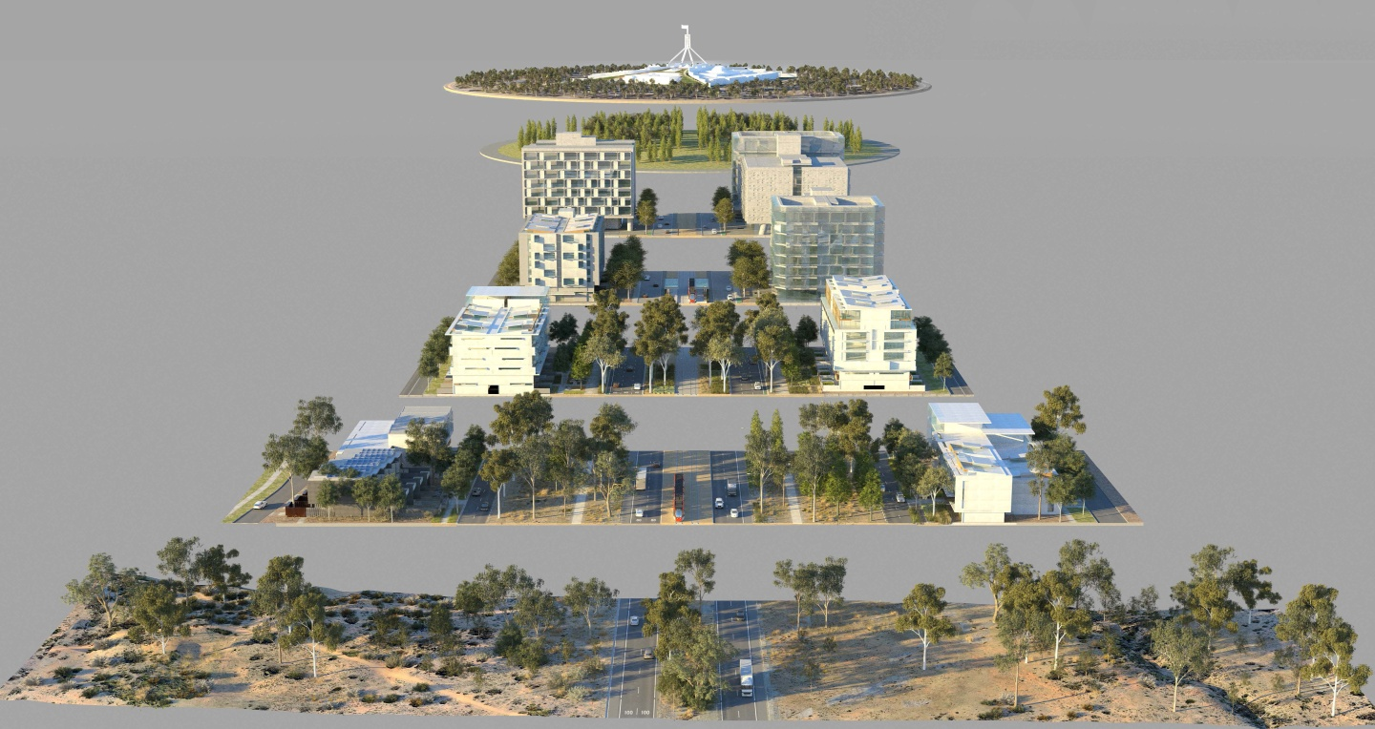
Figure 1 - The Gateway transition to the city centre from the North, becoming more urban and formal
On the outskirts of Canberra, it should appear more like bushland. Nearer to the city, well-designed buildings at ‘urban villages’ centres on light rail stops, will define the streetscape along with trees and landscaping.

The site is located within the ‘formal landscape avenue’ of the study area between Antill Street and Barry Drive. Formally planted trees and native landscaping will help to define the streetscape. High quality buildings should be redeveloped to address the light rail network.

The design for the Northbourne Flats is to demonstrate achievement of, and innovation in the following Place Implementation Principles:
- Respect and interpretation of the Weave Design
- High quality public and private realm
- Sustainable community concept
- High quality design

Community Engagement
The Developer is to undertake community engagement consistent with requirements of the Planning and Development Act 2007, in particular any guidelines issued under Section 138AE.

The Developer is to present concept plans for the redevelopment of the site to the National Capital Design Review Panel. At this meeting the Developer should be prepared to discuss incorporation of community feedback.

The Developer must also consult with the City Renewal Authority and receive endorsement from the City Renewal Authority on its Development Plan submission and any subsequent Development Plan submissions or variations to the Development Plan that are not minor.

The Developer must:
- Attend an introductory meeting with the City Renewal Authority to be briefed on the Northbourne Flats Place Implementation Guidelines at the Territory’s place of business at a time to be agreed between the parties but not later than 60 Business days form the date of the Project Delivery Deed. Attend a second meeting with the City Renewal Authority and the Developers appointed architect to present concept designs at the Territory’s pace of business at a time to be agreed between the parties but no later than 6 months from the date of the Project Delivery Deed.
- Participate in at least three independent design reviews conducted and chaired by the ACT Government Architect as part of the National Capital Design Review Panel. The initial meeting with the Panel should be at the commencement of the planning for the redevelopment so that the Panel can assist in shaping the design principles underpinning the future development proposal.
- Submit the draft Development Plan to the City Renewal Authority for review and
discussion, and
- Attend any further meetings reasonably required by the Territory to discuss the Developers designs in relation to the Land, the Northbourne Flats Place Implementation Guidelines and the Development Plan.
- Demonstrate how the proposal meets the criteria established under the Design Quality Principles (Attachment A), the Place Implementation Principles (Attachment B) and the Measures of Success (Attachment C). For each criteria establish clear reporting protocols for each phase of the development including; design, development approval, construction and post occupancy phases. Submit these to the City Renewal Authority for approval.

Principles
Attachment A details the Design Quality Principles, Attachment B details the Place Implementation Principles, and Attachment C details the appropriate Measures of Success that the Developer must consider in preparing its Development Plan submission.

Disclaimer
The City Renewal Authority makes no warranty as to the accuracy or completeness of this material and advises that it is subject to change. Any alterations or additional information will be issued as supplementary information.

Potential Buyers should make their own enquiries regarding the Land, its value, its suitability for development and all planning approvals and should not rely on any material included in the Sales Documentation.

Potential Buyers should review all of the Sales Documentation and seek any necessary legal, financial and planning advice prior to sale.

Attachment A
Design Quality Principles
Principle 1: Context and Neighbourhood Character
Good design responds and contributes to its context. Namely, the relationships and interactions of natural and built forms with consideration of the social, economic, health and environmental conditions they create.
Well-designed buildings respond to and enhance the qualities and identity of the area, including adjacent sites, streetscapes and neighbourhood. Consideration of local context is important for all sites, including sites in established areas, those undergoing change or identified for change.
Principle 2: Built Form and Scale
Good design achieves a scale, bulk and height appropriate to the existing or desired future character of the street and surrounding buildings, inclusive of considerations of building alignments, proportions, building type, articulation and the manipulation of building elements.
The built form defines the public domain, contributes to the character of streetscapes and parks, including their views and vistas, and provides internal amenity and outlook.
Principle 3: Density
Good design achieves a high level of amenity for residents’ through density appropriate to the site and its context.
Appropriate densities are consistent with the area’s existing or projected population. Densities can be sustained by existing or proposed infrastructure, public transport, access to jobs, services, community facilities and the environment.
Principle 4: Sustainability
Good sustainable design combines positive environmental, social and economic outcomes. Good sustainable design includes use of natural cross ventilation and passive solar design to reduce reliance on technology and operation costs. Other elements include recycling and reuse of materials and waste, use of sustainable materials, and deep soil zones for groundwater recharge and vegetation.
Principle 5: Landscape
Good landscape design recognises that built and natural systems operate as an integrated system. Landscape design strongly influences the amenity and contextual fit of a development sited within the streetscape and surrounding neighbourhood.
Good landscape design enhances the development’s environmental performance by retaining positive natural features which contribute to the local context, co-ordinating water and soil management, solar access, micro-climate, tree canopy, habitat values, and preserving green networks. Good landscape design optimises usability, privacy and opportunities for social interaction, equitable access, respect for neighbours’ amenity, provides for practical establishment and long term management.
Principle 6: Amenity
Good design positively influences internal and external amenity for residents and neighbours. Achieving good amenity contributes to positive living environments and resident well-being.
Good amenity combines appropriate room dimensions and shapes, access to sunlight, natural ventilation, outlook, visual and acoustic privacy, storage, indoor and outdoor space, efficient layouts and service areas, and ease of access for all age groups and degrees of mobility.
Principle 7: Safety
Good design optimises safety and security, within the development and the public domain. It provides for quality public and private spaces that are clearly defined and fit for the intended purpose. Opportunities to maximise passive surveillance of public and communal areas promote safety.
A positive relationship between public and private spaces is achieved through clearly defined secure access points and well-lit and visible areas that are easily maintained and appropriate to the location and purpose.
Principle 8: Housing Diversity and Social Interaction
Good design achieves a mix of dwelling sizes, providing housing choice for different demographics, living needs and household budgets.
Well-designed housing responds to social context by providing housing and facilities to suit the existing and future social mix. Good design involves practical and flexible features, including different types of communal spaces for a broad range of people, providing opportunities for social interaction amongst residents.
Principle 9: Aesthetics
Good design achieves a built form that has good proportions and a balanced composition of elements, reflecting the internal layout and structure. Good design uses a variety of materials, colours and textures. The visual appearance of well-designed housing responds to the existing or future local context, particularly desirable elements and repetitions of the streetscape.

Attachment B
Place Implementation Guidelines

- Weave Design
Aim: On 23 March 2011, Community Services Directorate (CSD) announced that a national design competition would be launched to bring forward design ideas for the redevelopment of the public housing flats in Braddon and Turner. The Design competition was formally launched in May 2011 and the winning design, ‘Weave’, was announced in November 2011.
The judging panel was unanimous in its decision on the winning entry.

The jury considered that the ‘Weave Design’ masterfully handled the core challenges of formality, scale and repetition. Formality was provided to Northbourne Avenue whilst maintaining a lower scale to the surrounding streets. Some of the existing buildings were retained and intelligently extended. A dynamic frontage to Northbourne Avenue was presented with the use of sculptured landforms and north facing community gardens. Sustainability measures such as solar access, cross ventilation and outdoor living spaces were also embedded in the design thus ensuring responsible civic contribution to Canberra.

The jury considered the entire composition as one of interesting and classic forms, well oriented apartments and community facilities set in attractive and usable open spaces. The design was considered to offer a ‘delightful’ scale and sense of accessibility and from an occupants perspective it was considered that the development would present a beautiful and liveable environment integrating a mix of accommodation and built elements from high to low rise buildings.

The design proposal was also judged to demonstrate a level of design quality and detail and considered a model of design innovation that could provide a paradigm for other development on Northbourne Avenue.

The Weave Design provides a composition of interesting and classic forms, with well oriented apartments set in attractive and usable open spaces. The design offers a ‘delightful’ scale and sense of accessibility and from an occupant’s perspective presents a beautiful and liveable environment integrating a mix of accommodation and built elements from high to low rise buildings.

A series of tall slender tower forms are proposed that are subtly angled away from being simply perpendicular to the Avenue. The slight diagonal geometry creates a symbolic stitching across the Avenue in a manner that allows for views between the opposing forms.

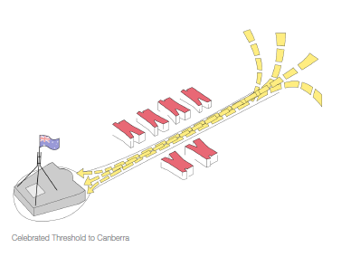

The diagonal shifts in geometry create desire lines that better suit longer views. The entire composition is an urban weave of alignments and view lines. There is a rhythm of forms on either side of the Avenue with repetition of major and minor elements.

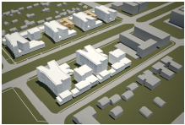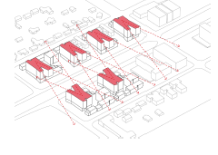

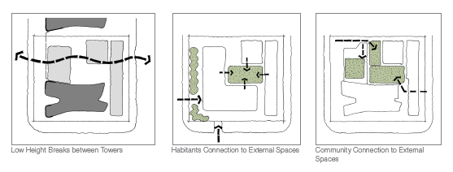

Design Criteria
- Provide an urban weave of alignments and view lines that interrelate with each site on either side of Northbourne Avenue.
- Create a symbolic stitching of the sites across Northbourne Avenue.
- Provide a series of tall tower forms that are subtly angled away from being simply perpendicular to Northbourne Avenue.
- Provide visual permeability through the site by the siting of low rise buildings
- Provide building envelopes that are arranged to cluster around a central communal outdoor spaces.
- Provide physical and visual connections between private residences and external space.
- Promote pedestrian access to the light rail stop.

- High quality public and private realm
Aim: A high quality public and private realm will provide amenity for residents of the site, improve the public domain and encourage and support a more people friendly environment.
Design Criteria:
- Integrate the development (particularly the Braddon site) with Haig Park.
- Provide appropriate shade trees and landscaping, wide paths, street furniture and lighting in the public and private realm to encourage greater intensity and a mix of uses. Public realm spaces must meet relevant TCCS standards.
- Provide active ground floors along public spaces and pathways.
- Create elements of either pocket park(s), market gardens, communal spaces front gardens, nooks or spaces that are accessible to all.
- Pedestrian focussed lighting to ensure pathways are safe and inviting after dark.
- Ensure passive surveillance from adjacent buildings.

- Sustainable community
Aim: Adopt a design led approach to guide sustainable innovation, improve liveability and contribute to a zero emission city.
Design Criteria:
- Meet or exceed a minimum 7 star NaTHERS rating each building.
- Design of built form and landscaping minimises the heat island effect and supports low carbon living.
- Provide permeable surfaces to reduce stormwater runoff and retain moisture in the landscape.
- Sufficient separate secure bike parking spaces provided in the basement or secure car parking to promote active travel.
- Dedicated visitor bike parking provided externally.
- Ensure vehicle access is safe and does not impact the safety and movement of local area traffic and pedestrian movements.
- Provide initiatives that reduce the need for vehicle parking below the required provision rates.
- Provide planting zones/gardens including either vertical, roof top and/or community gardens to encourage the enjoyment of nature

- High quality design
Aim: Whilst the quality of the design of the built form can be subjective, it is generally recognised that high quality mixed use development contributes to better places, a connected community and culturally active spaces.
Design Criteria:
- Articulation of built form, a mass of longer buildings is to be avoided.
- Building entries are to be accessible and aligned with the ground plain of the adjoining street or public realm.
- Developments should enhance the interface and connectivity between buildings, open spaces, landscaped areas and the public realm.
- The layout of the built form should provide a framework that allows for high quality internal spaces that meets or exceeds the minimum 70% natural light penetration and air circulation into living areas in accordance with rule 6.2 Solar-Access Apartments of the ACT multi-unit Housing Development Code.
- Design of the lower storeys, particularly ground floors, is important. Materials selection and architectural detailing should produce facades with a level of interest and variation that can be appreciated at pedestrian speed.

Attachment C
Measures of Success

- Measuring Success
Aim: The importance of measuring design outcomes via success measures assists the developer demonstrate positive benefit to community and stakeholders, whilst focussing on delivering viable and diverse communities. The criteria relevant to this project includes;
Success Criteria
- People and activity – maximising pedestrian footfall, ensuring equitable access and mobility and providing public amenity via the power of ‘free’;
- Diversity and vitality of place – the provision of artistic, cultural and leisure activities; events; market exchange; retail offer; and the focus on pedestrian comfort and safety;
- Community and business sentiment – ensuring urban design outcomes exceed community satisfaction and experience; builds business confidence; and is considered a place of great attractiveness;
- Viable opportunity – Creating places that ensure economic success; promote a night economy; add tourism potential; underpin investment and renewal attractiveness; and stimulate development approvals;
- Resilient and sustainable communities – Seeking opportunities through adaptable re-use; fostering demographic diversity; with housing choice; and building climate smart.
- Detailed Success Factors and Indicators
Success  Factors | Success Indicators | Comment
People and Activity | - Footfall | This indicator refers to the number of pedestrians walking and strolling in an area regardless of their reasons for doing so. Footfall is often a measure of an areas attractiveness and its ability to satisfy customer and visitor needs. A higher footfall generally indicates an areas ability to attract community participation.
 | - Access and Mobility | This indicator refers to the mode(s) of transport used by visitors and local residents to reach destination centres. Understanding the various modes helps plan for alternatives and/or supporting infrastructure to ensure an equitable balance of mode share types for the community.
 | - Power of Free | This indicator refers to the number of ‘free’ activities within a community. The higher number of activities that can be undertaken free of charge results in a welcoming and diverse community. Examples include, comfortable public tables and chairs, buskers and entertainers, games, street art, markets, movies, and community gardens.
Diversity and vitality of place | - Arts, Culture and Leisure | This indicator captures the variety of arts, culture and leisure activities offered within a precinct. It may include public art, performance art, theatre and cinema attendances. The indicator captures activities beyond standard retail offer, and typically indicates activities preferred by certain segments of the community, including families and pensioners.
 | - Events and Markets | This indicator monitors the number of events and markets within a community. Both are major motivating factors attracting people to participate in vibrant communities making significant contributions to the local economy, sense of pride, inclusiveness, and pride of place. Examples may include multi-cultural events, Christmas, night-lights, comedy, music, creative performances, food markets, artisan markets, and car boot sales. A calendar of events and markets throughout the year can attract a whole spectrum of the population including locals, business tourists, cultural tourists, young people, ethnic groups, families and children.
 | - Retail Offer | This indicator monitors the range and variety of retail goods and services in a community. To remain competitive, retail centres need to match demand with visitor needs and expectations. This indicator is linked to footfall, and visitor satisfaction.
 | - Pedestrian Comfort and Safety | This indicator monitors pedestrian comfort and safety within public spaces and places ensuring there are sufficient places to sit, socialise and converse in comfort. Related to the ‘power of free’ pedestrians value places that provide shade, shelter and safety as part of their place offering.
Community and Business Sentiment | - Community Satisfaction and Experience | This indicator refers to the levels of satisfaction and associated place experience within a community. A high level of community satisfaction (particularly with regard to retail provision) may not directly relate to the quality of place experience. In order to encourage people to linger longer, spend more and return they need to have an overall positive experience. Overall cleanliness, signage, public toilet arrangements, good lighting after dark, and ease of movement around the public realm amongst other factors have both a direct and subliminal impact on how a visitor feels about a place.
 | - Business Confidence | Business confidence is as much about perceptions and fear of future developments in the economy as actual turnover and profit. This indicator monitors the changes to retail traders in a community suggesting that the turnover rate (failure) of businesses in an area points to other deficiencies such as such retail mix, footfall and user experience.
 | - Attractiveness | The enduring beauty of a place is a subjective indicator of a success. This indicator attempts to establish how much people actually like the centre as a place to spend time.
Viable Opportunity | - Economic Success | A town centre may be very successful at attracting visitors and local residents. However, ultimately, if it is to survive financially, it needs to translate footfall into actual consumer spending. Having established the number of people visiting a town centre using the “footfall” indicator, this indicator closes the loop by establishing consumer spending in the same locations where “footfall” was measured.
 | - Night Economy | This indicator refers to the depth and quality of business offerings outside the traditional 9am-5pm daytime trade. A diverse offering across the evening (5pm-9pm) trade and late night (9pm-1am) is an indicator of economic health recognising that the community is culturally diverse and mature across different socio-economic spectrums.
 | - Investment and Development Approvals | Urban renewal is as much about providing the community housing and economic choice as it is about stimulating investment confidence and renewal activity. This indicator focusses on the investment opportunities available to the development sector (including interstate investment players).
Resilient and Sustainable Communities | - Climate Smart | This indicator measures the number of developments achieving recognised and adopted sustainability targets within the renewal area.
 | - Housing Choice | This indicator relates to the housing choices available to the community including private, intentional (co-housing) and affordable (subsidised) housing. Mature communities are those that provide these in various styles, types and locations usually integrated within well-crafted developments delivered by public and private entities.
 | - Adaptable Re-use | This indicator promotes the adaptive re-use of existing built form and landscapes within development opportunities as acknowledgment that creative re-use provides unique opportunity to create a sense of place.
 | - Demographic Diversity | This indicator promotes the creation of diverse communities with wide ranging demographic profiles. The provision of facilities and services catering for the widest possible demographic spectrum is encouraged.

