**Project Plan**

# 2022-23 ACE JobTrainer grants program

## **Applicant organisation:** _________________________________________________________

## **Project title:** _______________________________________________________

*Before you begin: Visit the* [*Skills Canberra’s ACE JobTrainer grants website*](https://www.act.gov.au/skills/grants/adult-and-community-education-ace-jobtrainer-grants-program) *to find several resources to assist you to complete this project plan.*

# Project outline

|  |  |  |  |  |
| --- | --- | --- | --- | --- |
| **Key project activity** | **Duration** *(days/ weeks)* | **Commencement date** *(indicative month/year)* | **Completion date** *(indicative month/year)* | **Lead party for activity** [1] |
|  |  |  |  |  |
|  |  |  |  |  |
|  |  |  |  |  |
|  |  |  |  |  |
|  |  |  |  |  |
|  |  |  |  |  |
|  |  |  |  |  |
|  |  |  |  |  |

*Notes: Add more rows as needed*

# Foundation skills training

## Non-accredited

|  |  |  |  |  |  |  |  |
| --- | --- | --- | --- | --- | --- | --- | --- |
| ***Please list any non-accredited foundation skills (FSK) modules[2] you plan to offer project participants*** | | | | | | | |
| **A** | **B** | **C** | **D** | **E** | **F** | **G** | **H** |
| **ACSF level[3]** | **Module code** | **Module title** | **Number of hours[4]** | **Core (C) or elective (E)[5]** | **Number of participants in class** | **Number of times will be delivered[6]** | **Total participants**  **H = F x G** |
| *Example:*  *1* | *NFSKLRG004.1* | *Prepare to engage in learning* | 5 | C | 8 | 2 | 16 |
|  |  |  |  |  |  |  |  |
|  |  |  |  |  |  |  |  |
|  |  |  |  |  |  |  |  |
|  |  |  |  |  |  |  |  |
|  |  |  |  |  |  |  |  |
|  |  |  |  |  |  |  |  |

*Notes: Add more rows as needed*

## Accredited

|  |  |  |  |  |  |  |  |
| --- | --- | --- | --- | --- | --- | --- | --- |
| ***Please list any accredited FSK units of competency (UoC)[7] you plan to offer project participants*** | | | | | | | |
| **A** | **B** | **C** | **D** | **E** | **F** | **G** | **H** |
| **ACSF level[8]** | **Unit code** | **Unit title** | **Number of hours[9]** | **Core (C) or elective (E)[10]** | **No. of participants in class** | **No. of times will be delivered[11]** | **Total participants**  **H = F x G** |
| *Example:*  *2* | *FSKLRG008* | *Use simple strategies for work-related learning* | *15* | *C* | *15* | *3* | *45* |
|  |  |  |  |  |  |  |  |
|  |  |  |  |  |  |  |  |
|  |  |  |  |  |  |  |  |
|  |  |  |  |  |  |  |  |
|  |  |  |  |  |  |  |  |
|  |  |  |  |  |  |  |  |

*Notes: Add more rows as needed*

# Training support resources[12]

|  |  |  |
| --- | --- | --- |
| ***Please list the staffing and other resources your project will provide to support learning and assessment activities.*** | | |
| **ACSF level** | **Skill area** | **The following resources will be made available during learning and assessment:** |
| *Example:  Pre-level 1* | *Learning* | * *The teacher/trainer with expertise, knowledge and skills in the contextualisation and assessment of informal vocational and workplace learning will lead the learning and assessment activities.* * *A mentor will be available to work alongside learners during learning and assessment activities to provide significant support, prompting, advice, modelling, and feedback.* * *The mentor will also act as a coordinator for the project, assisting participants to connect with services providing counselling, childcare, transport, disability support, financial support, or food, as required.* * *Peer support volunteers will provide learning models.* * *Participants will be provided with a frequently used word list for learning in the workplace.* * *Participants will also be encouraged and facilitated to bring along their own familiar support resources if they wish.* |
|  |  |  |
|  |  |  |
|  |  |  |
|  |  |  |
|  |  |  |
|  |  |  |
|  |  |  |
|  |  |  |
|  |  |  |

*Notes: Add more rows as needed*

# Budget

|  |  |  |  |  |
| --- | --- | --- | --- | --- |
| ***Please outline the proposed project budget allocation against the project activities*** | | | | |
| **Item description** | **Vendor/supplier[13]** | **Cost** (GST exclusive) | **Your contribution** (optional) | **ACE JobTrainer grant funding** |
|  |  | $ | $ | $ |
|  |  | $ | $ | $ |
|  |  | $ | $ | $ |
|  |  | $ | $ | $ |
|  |  | $ | $ | $ |
|  |  | $ | $ | $ |
|  |  | $ | $ | $ |
|  |  | $ | $ | $ |
|  |  | $ | $ | $ |
| **Total cost** (GST inclusive) | | **$** | **$** | **$** |

*Notes: Add more rows as needed*

# COMMUNICATIONS PLAN

|  |  |  |
| --- | --- | --- |
| ***Please outline your plan for promoting your project.*** | | |
| ***Target audience/s:*** | ***Key messages:***  *What are the key messages you plan to communicate?* | ***Communication methods:***  *How are you going to tell them?* |
| *Example:*   * *prospective participants* * *JobActive providers* * *community services peak bodies* * *employers* * *volunteer organisations* | *Example:*   * *This program will provide you with an opportunity to build confidence and skills to effectively communicate in a work environment.* | *Example:*   * *Flyer, website* * *Social media* * *Radio* * *Newsletters* * *Media Release* * *Project launch* * *Information sessions* |
|  |  |  |
|  |  |  |

*Notes: Add more rows as needed*

# RISK MANAGEMENT PLAN

|  |  |  |  |  |  |  |  |  |
| --- | --- | --- | --- | --- | --- | --- | --- | --- |
| ***Please complete the following plan for identifying and mitigating any risks that may impact the delivery of your project.*** | | | | | | | | |
| **Description of risk:** What can happen? How can it happen? | **Impact on project:**  *What is the outcome if it happens?* | **Likelihood** | **Consequence** | **Inherent Risk Rating** (before controls) | **Risk Treatment/Prevention Measure**  **Description of Controls**  *What are you going to do to prevent or reduce the risk?*  ***Risk Control Rating: (G)ood, (A)deequte, (M)arginal*** | **Likelihood** | **Consequence** | **Residual Risk Rating** (after controls) |
| *Example: Budget shortfalls – not scoping out all project’s costs* | Project is unable to achieve the cohort numbers, or all the outcomes outlined in the project plan. | *3* | *4* | *High* | *Develop budgets to fully plan for known likelihoods and factor in relevant contingencies* ***(G)*** | *2* | *2* | *Low* |
| *Example: Staff turnover* | Project could be delayed, and key milestones missed. | *3* | *3* | *Medium* | Project plans/ timeline to be updated at each project meeting. Project to follow record management procedures. Project manager to hand over to staff if leaving. **(G)_** | *2* | *2* | *Medium* |
| **Required:** Impacts on project timeframes/milestone delivery |  |  |  |  |  |  |  |  |
| **Required:** Work health and safety implications |  |  |  |  |  |  |  |  |
| **Required:** Budget impacts |  |  |  |  |  |  |  |  |
| **Required:** COVID-19 impacts (consider public health directions that may impact the project e.g., time, impacts on the cohort, delivery changes, staffing). |  |  |  |  |  |  |  |  |
|  |  |  |  |  |  |  |  |  |
| *(Notes: Add more rows as needed)* |  |  |  |  |  |  |  |  |

## Risk Matrix Key **Risk Control Ratings**

## **Good –** Documented policy and procedures

* **Adequate** **–** Established and proven practice
* **Marginal –** Untested practice or subject of unsubstantiated assessment

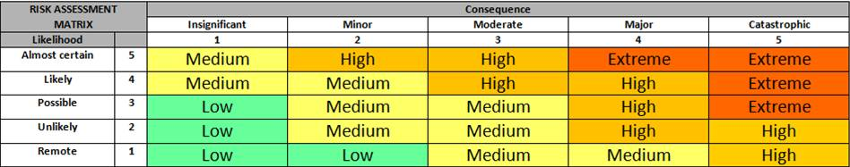

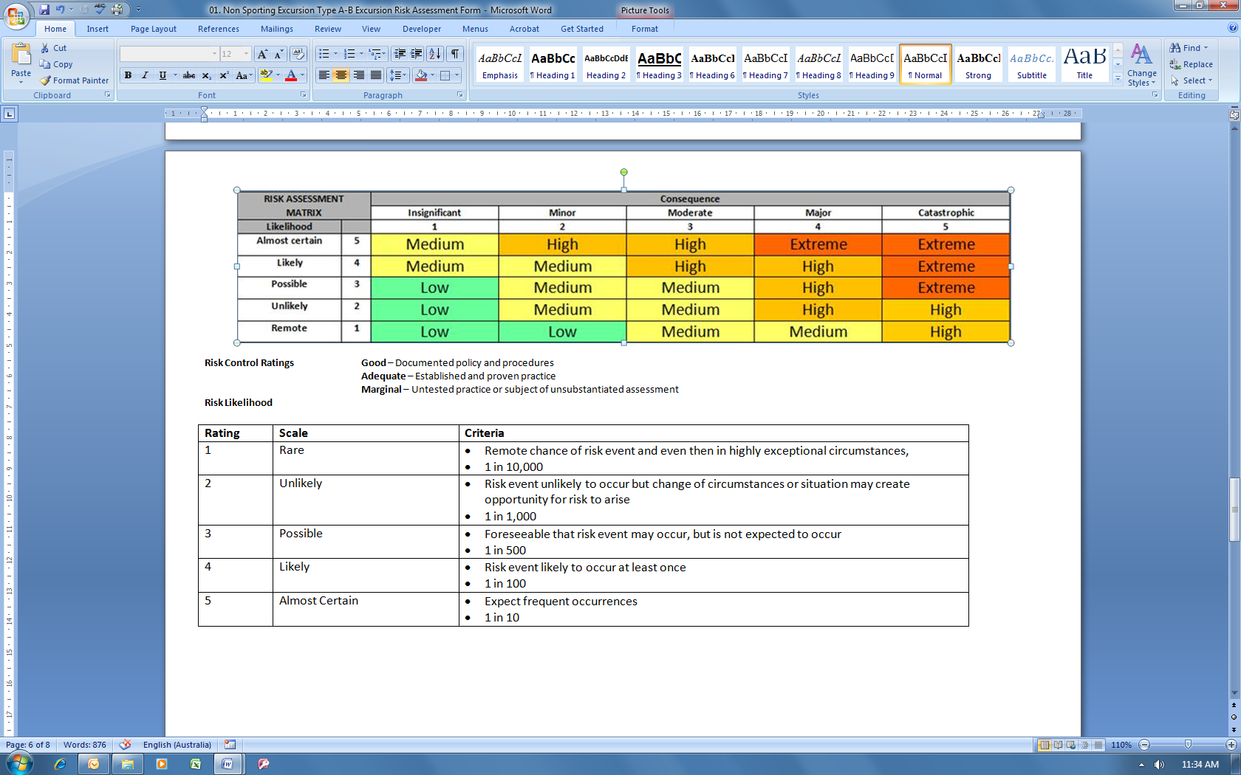

1. For example, *applicant organisation, identified subcontractor or other external party (please specify).*
2. See List of approved non-accredited FSK modules on Skills Canberra’s ACE JobTrainer grants website. This list contains the ACSF level, code, title and nominal hours for each module approved for delivery under the 2022-23 ACT ACE JobTrainer grants program.
3. ACSF means Australian Core Skills Framework. 
4. Use the nominal hours information sheet and the List of approved non-accredited FSK modules on Skills Canberra’s ACE JobTrainer grants website as a guide.
5. ‘Core’ means you expect all participants to enrol in the module. ‘Elective’ means participants can choose between this and another module, depending on their needs, interests, or goals. It is optional to offer Elective modules.
6. You may choose to repeat the subject to cater for more than one cohort. This is optional.
7. See List of approved accredited FSK UoC on [Skills Canberra’s ACE JobTrainer grants website](https://www.act.gov.au/skills/grants/adult-and-community-education-ace-jobtrainer-grants-program). This list contains the ACSF level, code, title and nominal hours for each UoC approved for delivery under the 2022-23 ACT ACE JobTrainer grants program.
8. ACSF means Australian Core Skills Framework.
9. Use nominal hours in [Victorian Purchasing Guide for FSK Foundation Skills Training Package Release 2.0](https://www.education.vic.gov.au/Documents/training/providers/rto/FSK-foundationskills-current.pdf) as a guide.
10. In this context ‘Core’ means you expect all participants to enrol in the UoC. ‘Elective’ means you offer participants a choice between this and another UoC. It is optional to offer Elective UoCs.
11. You may choose to repeat the subject to cater for more than one cohort. This is optional.
12. Applies to both accredited and non-accredited FSK training.
13. If not your organisation, quotes must be supplied. Attach quotes to application form.