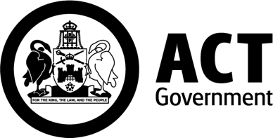

Grow Your ACCO Workforce with Supported Traineeships | 

The ACT ACCO Workforce Traineeship Grants Program 2026 offers eligible organisations up to $250,000 to create new paid traineeships for Aboriginal and Torres Strait Islander people. Expressions of Interest close 5.00pm, 01 September 2026

What can the grant support?
Funding can contribute to trainee wages and on-costs; recruitment and onboarding; workplace supervision and mentoring; cultural, wellbeing and practical support; project coordination and staff release; and participation costs such as transport, childcare, clothing, equipment and digital access.
For further information on eligibility and what can be funded please refer to the ACT ACCO Traineeship Grants Program 2026 Guidelines.

How does it work?
Create a new role that meets a real workforce need. Your organisation can employ the trainee directly or host them through a Group Training Organisation (GTO).

The role must combine paid work with a formal traineeship that leads to a nationally recognised qualification. The program can support one or more trainees. It cannot be used to subsidise an existing position or train an existing employee in their current role.

The grant provides a one-off payment to help fund the traineeship. It does not fund ongoing employment costs after the traineeship ends.

Who can apply?
Aboriginal Community-Controlled Organisations (ACCOS) and Aboriginal and Torres Strait Islander-owned Registered Training Organisations operating in the ACT may apply.

What is involved?
Stage 1 is a short Expression of Interest, open from 30 July. It asks about your workforce need, likely role and qualification, employment arrangement, trainee support and indicative funding request.
You do not need a detailed project plan, final partnership agreements, a fully itemised budget or quotes at this stage. Selected organisations will be invited to submit a full application.

Find out More
Group information session: 6 August 2026
Register here

One-on-one sessions: 10 and 11 August 2026
Contact the Skills Canberra Grants and Projects Team to book a session, ask questions or discuss an idea.
6205 4006
skills.projects@act.gov.au
https://www.act.gov.au/skills/grants

This is a pilot grants program with total funding of $500,000. The pilot will test how targeted grant funding can support ACCOs to create new traineeship opportunities, strengthen workforce capability and build pathways for Aboriginal and Torres Strait Islander people into ongoing employment, career progression or further training. Learnings from the pilot will help inform future initiatives.

This a joint initiative between the Australian Government and the ACT Government, under the National Skills Agreement ACT Closing the Gap Bilateral Implementation Plan.

