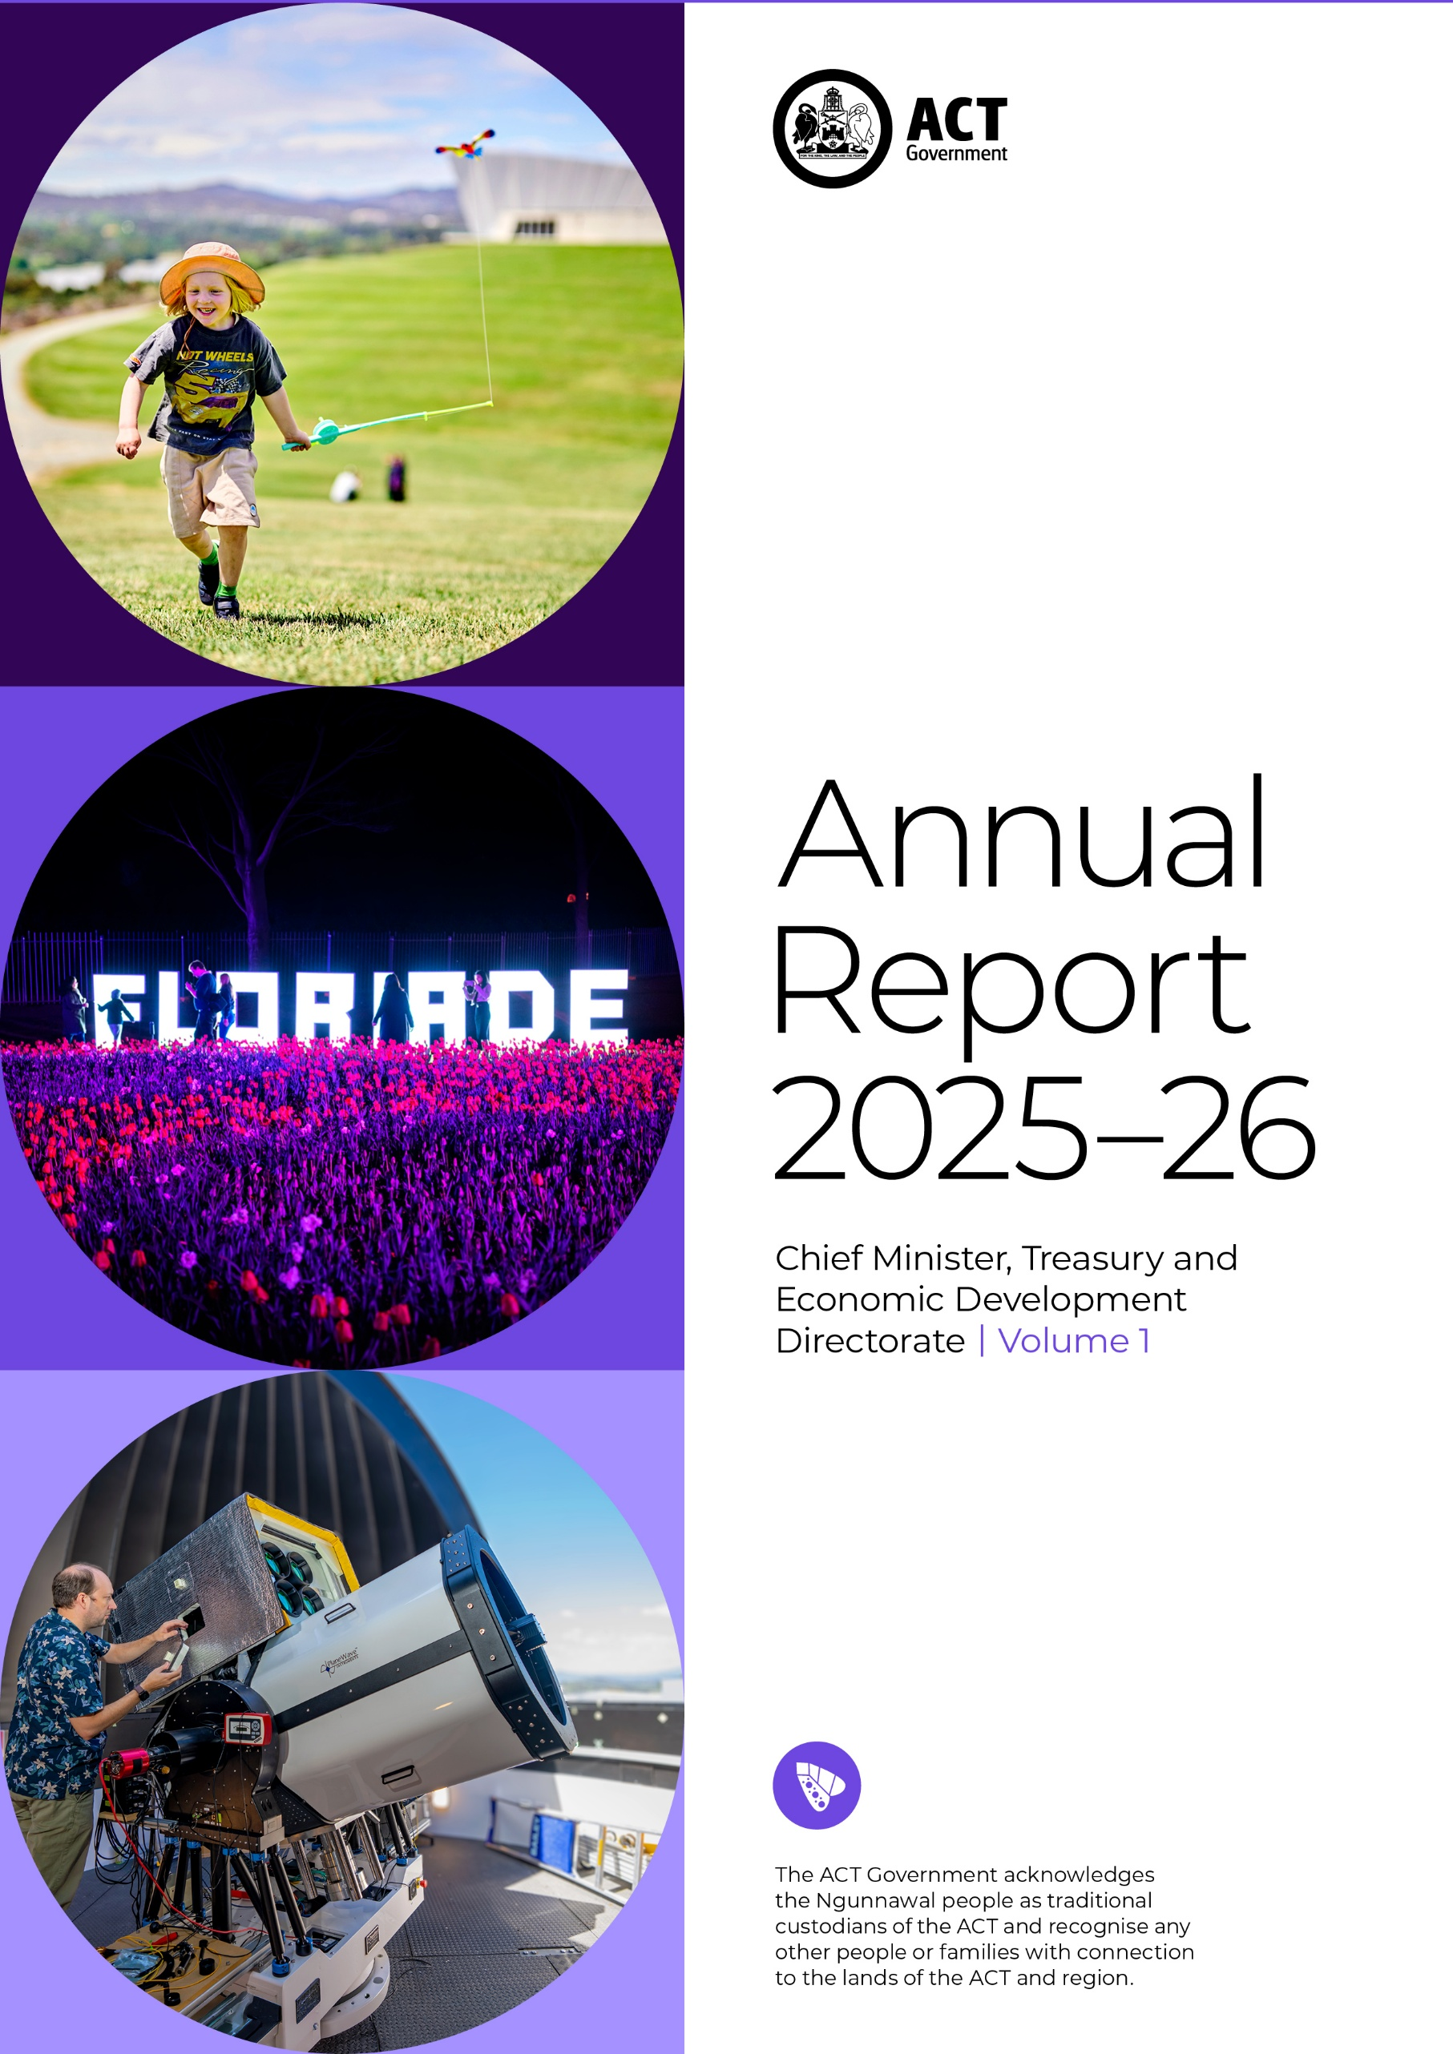

The Chief Minister, Treasury and Economic Development Directorate acknowledges the Ngunnawal people as traditional custodians of the ACT and recognise any other people or families with connection to the lands of the ACT and region.
We respect the Aboriginal and Torres Strait Islander people, particularly our Aboriginal and Torres Strait Islander staff, and their continuing culture and contribution they make to the Canberra region and the life of our city.
Contact for this report
General enquiries should be directed to:
CMTEDD Corporate
Governance, Reporting, Information and Facilities
CMTEDDCorporate@act.gov.au
Freedom of Information
Requests should be directed to: CMTEDDFOI@act.gov.au OR
via CMTEDD’s Freedom of Information website: www.cmtedd.act.gov.au/functions/foi
Accessibility
The ACT Government is committed to making its information, services, events and venues as accessible as possible. If you have difficulty reading a standard printed document and would like to understand the alternative formats available for documents or publications, please call 13 22 81.
If English is not your first language and if you require a translator or interpreter, you can contact us through the Translating and Interpreter Service (TIS) or call 13 14 50.
If you have difficulty hearing or using your voice, contact us through the National Relay Service (NRS): TTY users call 13 36 77 and then ask for 13 22 81 or visit www.accesshub.gov.au to make an internet relay or captioned relay call.
Speak and Listen users phone 1300 555 727 and then ask for 13 22 81. Internet relay users connect to the NRS and then ask for 13 22 81.
For more information on these services visit: www.accesshub.gov.au
ISBN: 978-0-642-61138-3

© Australian Capital Territory
This work, Chief Minister, Treasury and Economic Development Directorate Annual Report 2025-26, is licensed under a Creative Commons Attribution 4.0 licence. You are free to re-use the work under that licence, on the condition that you credit the Australian Capital Territory Government as author, indicate if changes were made and comply with the other licence terms.
The licence does not apply to the ACT Coat of Arms, the Chief Minister, Treasury and Economic Development Directorate logo and branding, images, artwork, photographs and any material protected by trademark.
Photo credits:
- Kite flying at the Arboretum by Rohan Thomson / Pew Pew Studio.
- Floriade NightFest 2025 by VisitCanberra.
- ANU’s Quantum Optical Ground Station by Nic Vevers / ANU.
Information about the directorate and an electronic version of this annual report can be found at:
www.act.gov.au/open/chief-minister-treasury-and-economic-development-directorate-annual-reports

Summary of volumes
The 2025-26 CMTEDD Annual Report has two volumes.
Volume 1
Contains all transmittal certificates and organisational overview and performance reporting for CMTEDD and all public sector bodies required to have their annual report annexed to the CMTEDD Annual Report. Each entity’s reporting includes, where relevant:
Organisational overview | Internal audit | Aboriginal and Torres Strait Islander reporting | Work health and safety
Performance analysis | Fraud prevention | Multiculturalism Act 2023 reporting | Human resources management
Scrutiny | Freedom of information | Disability Inclusion Act 2024 reporting | Ecological sustainability reporting
Risk management | Community engagement and support | Period Product (Access) Act reporting | Reporting by exception and annual report requirements for specific reporting entities
Volume 1 includes Annexed Reports of the following entities:
ACT Executive | Default Insurance Fund | Lifetime Care and Support Fund | Office of the Nominal Defendant of the ACT
ACT Government Procurement Board | Director of Territory Records | Motor Accident Injuries Commission | Public Sector Workers Compensation Fund

Volumes 2.1 and 2.2
Volume 2.1 contains all financial management reporting sections for the entities below, including where relevant the following sections:
Chief Minister, Treasury and Economic Development Directorate | Territory Banking Account | Superannuation Provision Account
Financial management analysis (management discussion and analysis) | Capital works | Government contracting
Financial statements | Asset management | Statement of performance
Volume 2.2 contains all financial management reporting sections (where relevant, as per the above) for:
ACT Executive | Lifetime Care and Support Fund | Office of the Nominal Defendant of the ACT
Default Insurance Fund | Motor Accident Injuries Commission | Public Sector Workers Compensation Fund

Contents
Summary of volumes 3
Contents 5
Abbreviations and acronyms 8
Glossary 9
Foreword 10
Transmittal Certificate 13
Compliance statement 15
B1. Organisational Overview 18
Our purpose and role as a central agency 18
Vision, Mission and Values 19
Organisation Chart 20
Planning Framework 21
Clients and stakeholders 22
Internal Accountability 24
Performance Summary 28
Outlook 37
B2. Performance Analysis 44
Output 1.1: Government Policy and Reform 44
Output 1.2: Coordinated Communications and Community Engagement 48
Output 1.3: International Engagement 52
Output 2.1: Capability and Governance 54
Output 2.2: Injury Management and Industrial Relation Policy 58
Output 2.3: Public Sector Employment 62
Output 2.4: Public Sector Standards Commissioner 64
Output 3.1: Economic Development 66
Output 4.1: Economic Management 78
Output 4.2: Financial Management 80
Output 5.1: Revenue Management 83
Output 6.1: Procurement 86
EBT 1.1: Superannuation Provision Account 89
EBT 1.1: Territory Banking Account 90
B3. Scrutiny 92
B4. Risk Management 121
B5. Internal Audit 123
B6. Fraud Prevention 125
B7. Freedom of Information 127
B8. Community Engagement and Support 130
Community Engagement – Major community engagement activities 130
Community engagement – stakeholder and business engagement/consultation 131
Community support initiatives - grants and sponsorship 135
B9. Aboriginal and Torres Strait Islander Reporting 181
Progress in implementing both the National Agreement and the ACT Agreement 184
Priority reforms 190
ACT Aboriginal and Torres Strait Islander Agreement commitments 192
B10. Disability Inclusion Act 2024 Reporting 202
B11. Multiculturalism Act 2023 Reporting 206
B12. Period Products and Facilities (Access) Act 2003 Reporting 212
B13. Work Health and Safety 213
Health and safety structures and consultation arrangements 213
Achievements and outcomes 214
Wellbeing, early intervention and injury management 214
Incident reporting and notices under the WHS Act 215
B14. Human Resources Management 217
Workforce planning and employment strategies 217
Capability 218
Gender Action Plan and Gender Impact Assessment Reporting 220
Staffing profile 220
B15. Ecological Sustainability Reporting 225
Support to the Commissioner for Sustainability and Environment 225
Business area activities 225
Other reporting 230
Financial management reporting 230
Covert surveillance authorisations issued to ACT employers 230
Ministerial Staffing Expenditure Reporting 230
Request for Accessible Executive Records 230
Carers Recognition Act reporting 231
Annexed Reports 232
ACT Executive 233
Overview 233
ACT Government Procurement Board 237
Compliance statement 238
1. Organisational overview and performance 239
2. Performance analysis 243
3. Outlook 247
4. Financial management reporting 251
Default Insurance Fund 252
Compliance Statement 253
Organisational Overview and Performance 254
Financial Management Reporting 261
Director of Territory Records 262
Compliance Statement 263
Organisational Overview and Performance 264
Whole of Government Annual Reporting: Territory Records 279
Lifetime Care and Support Fund 308
Compliance statement 309
Organisational overview and performance 310
Overall Lifetime Care and Support scheme Outlook 321
Motor Accident Injuries Commission 322
Compliance statement 323
Organisational overview and performance 324
Outlook 339
Office of the Nominal Defendant of the ACT 341
Compliance Statement 342
Organisational Overview and Performance 343
Performance Analysis 344
Financial Management Reporting 350
Public Sector Workers Compensation Fund 352
Compliance statement 353
Organisational overview and performance 354
Outlook 357
Financial management reporting 358

Abbreviations and acronyms

ACE | Adult Community Education
ACTIA | Australian Capital Territory Insurance Authority
ACTPS | ACT Public Service
ACTRO | ACT Revenue Office
A/g | Acting
AFL | Australian Football League
AI | Artificial Intelligence
ANU | Australian National University
ASBA | Australian School Based Apprenticeships
AWE | Average Weekly Earnings
CALD | Culturally and Linguistically Diverse
CBRIN | Canberra Innovation Network
CCCLM | Council of Capital City Lord Mayors
CFC | Cultural Facilities Corporation
CHS | Canberra Health Services
CIF | Collapsed Insurer Fund
CIT | Canberra Institute of Technology
CMTEDD | Chief Minister, Treasury and Economic Development Directorate
CTB | Cultural Transformation Branch
DCBR | Digital Canberra
DHR | Digital Health Record
EDRMS | Electronic Digital Records Management System
EFG | Economic and Financial Group
EML | Employers Mutual Limited
EPIC | Exhibition Park in Canberra
ETWE | Ethical Treatment of Workers Evaluation
FOI | Freedom of Information
FTE | Full Time Equivalent
HCSD | Health Community Services Directorate
HR | Human Resources
HRIMS | Human Resources Information Management System
HSR | Health and Safety Representative
ICMS | Integrated Case Management System
ICON | Innovation Connect
IGA | Intergovernmental Agreement
JACS | Justice and Community Safety Directorate
KPI | Key Performance Indicators
LGBTIQA+ | Lesbian, gay, bisexual, transgender, intersex, queer and asexual
LTCS | Lifetime Care and Support
LTCSA | Lifetime Care and Support Authority
MAI | Motor Accident Injuries
MLA | Member of the Legislative Assembly
MOU | Memorandum of Understanding
NSA | National Skills Agreement
OATSIA | Office of Aboriginal and Torres Strait Islander Affairs
OLA | Office of the Legislative Assembly
OIRWS | Office of Industrial Relations and Workforce Strategy
PSSC | Public Sector Standards Commissioner
PSU | Professional Standards Unit
PTG | Public Trustee and Guardian
RMP | Records Management Programs
RTO | Registered Training Organisation
SERBIR | Senior Executive Responsible for Business Integrity Risk
SES | Senior Executive Service
SLA | Suburban Land Agency
SPA | Superannuation Provision Account
TAFE | Technical and Further Education
VET | Vocational Education and Training
WhoG | Whole of Government
WHS | Work Health and Safety
WHSC | Work Health and Safety Committee

Glossary

Aboriginal and Torres Strait Islander Procurement Policy – The policy supports cultural change within the Territory to reduce some of the barriers to government procurement encountered by Aboriginal and Torres Strait Islander enterprises.
Each Territory Entity is required to identify and act on opportunities for Aboriginal and Torres Strait Islander enterprises in its procurement activities. The policy encourages Territory officers to seek quotes from relevant Aboriginal and Torres Strait Islander Enterprises wherever possible, driving growth in economic participation for Aboriginal and Torres Strait Islander enterprises through an increase to the government’s spend with Aboriginal and Torres Strait Islander enterprises.
ACT Remuneration Tribunal – Under the Remuneration Tribunal Act 1995 the ACT Remuneration Tribunal must inquire into and determine the remuneration, allowances and other entitlements to be granted to particular public offices every year.
Canberra Region Joint Organisation – Consists of the following local councils: Bega, Eurobodalla, Hilltops, Goulburn Mulwaree, Queanbeyan-Palerang, Snowy Monaro, Upper Lachlan and Yass Valley and the ACT Government, with the aim of facilitating opportunities and partnerships to create sustainable vibrant communities.
CBR – The CBR Brand is a city brand developed as a logo and a new way of thinking and talking about Canberra. The brand is used by government when talking about the city as a place to live, work, play, invest, do business, study or visit, and is also available for private and community businesses to use.
HPE Content Manager – An electronic document and records management system used by ACT Government (previously known as TRIM).
Priority Investment Program – A funding program established to support collaboration between the ACT Government, industry, research and the tertiary sectors to attract investment and grow established and emerging priority sectors of Canberra’s economy.
Shared Services – Provides the ACT Government with core corporate services across the ACT Government’s directorates and agencies.
Skilled Capital – An ACT Government funded training initiative that provides access to high-quality training in areas of skills needs in the ACT and maximises employment outcomes.
Whole of government – Refers to matters, issues or arrangements affecting or applicable to the whole of the ACT Public Service.
ThruPlay – a Meta unit of measurement that is counted when a person watches a video for 15 seconds or to completion.

Foreword

I am pleased to present the 2025-26 Annual Report for the Chief Minister, Treasury and Economic Development Directorate (CMTEDD).
As the central agency, we continue to work collaboratively across government and with the community to deliver the government’s priorities and improve outcomes for Canberrans.
A major focus during the year was supporting the implementation of the machinery of government changes resulting in functions and teams transitioning from CMTEDD to newly established directorates. The ACT Heritage Library also transferred to CMTEDD, creating a more integrated approach to the management of government records and information, and the preservation of and access to our documentary heritage. I thank our people for their professionalism and commitment throughout this period of change. While these changes reshaped our directorate, they also reinforced the importance of working as One Service, creating opportunities to strengthen collaboration across organisational boundaries, align efforts around shared priorities and deliver better outcomes for the government and the Canberra community.
Russ Campbell
Acting Director-General CMTEDD & Head of Service
This year marked a significant milestone with the passing of the Public Sector (Closing the Gap) Legislation Amendment Act 2025, that came into effect on 1 July 2026. The ACT became the first jurisdiction in Australia to legislate its commitments under the National Agreement on Closing the Gap, embedding them into the way the ACT Public Service (ACTPS) designs policy, delivers services, supports our workforce and measures performance.
The Cultural Transformation Group in the Office of Industrial Relations and Workforce Strategy, played a key role in developing the framework to implement the legislation across the ACTPS. This included embedding cultural capability expectations in Senior Executive Performance Agreements, developing the BRAVE (Bias, Racism, Allyship, Validate and Empower) Program for rollout in 2026-27, and making Cultural Safety Care Plans available across the Service. The team also established a framework to recognise cultural load as a psychosocial hazard within the Work Health and Safety framework, as well as a Cultural Integrity Professional Learning Database and strengthened cultural awareness training.
While the legislation marks a significant milestone, the next stage of this work is embedding these commitments into the way we work every day. We are advancing this work in genuine partnership with the Aboriginal and Torres Strait Islander Elected Body and the CMTEDD Cultural Advisors through shared decision-making, co-design and mutual accountability. This reflects the intent of the National Agreement and our commitment to achieving better outcomes for Aboriginal and Torres Strait Islander peoples, including our staff and the communities we serve.
Alongside these reforms, we progressed a large number of government commitments and other activities during the reporting period to support Canberra’s economic prosperity, community participation and effective government. Key achievements included:
- Launching CBR2030: ACT’s Strategic Economic Development Framework, providing a long-term vision for a more inclusive, sustainable and prosperous Canberra.
- Working with the Commonwealth and NSW Governments to secure a joint $100 million investment to progress planning and upgrades for train travel between Canberra and Sydney.
- Strengthening community participation in government decision-making, with more than 6,500 Canberrans joining the YourSay Panel to help inform policy, programs and new initiatives.
- Supporting 103 Canberra businesses with export development and advice, contributing to 12 successful export outcomes and helping businesses access new markets and international opportunities.
- Facilitating 48 international engagement activities, including trade missions, inbound delegations and business events to strengthen Canberra’s global connections and promote opportunities for trade, investment and economic growth.
- Investing in economic development, arts and events to support local businesses, attract visitors and strengthen Canberra’s economy. The Major Event Fund alone generated more than $111 million in direct economic benefit to the community.
- Delivering procurement policy and legislative reform to modernise government purchasing and improved supplier engagement to support more efficient delivery of government priorities.
These achievements reflect the dedication, professionalism and expertise of our people. I thank all CMTEDD staff, our partners across government and the wider community for their contributions throughout the year.

Russ Campbell
Acting Director-General and Head of Service


Part A

Transmittal Certificate
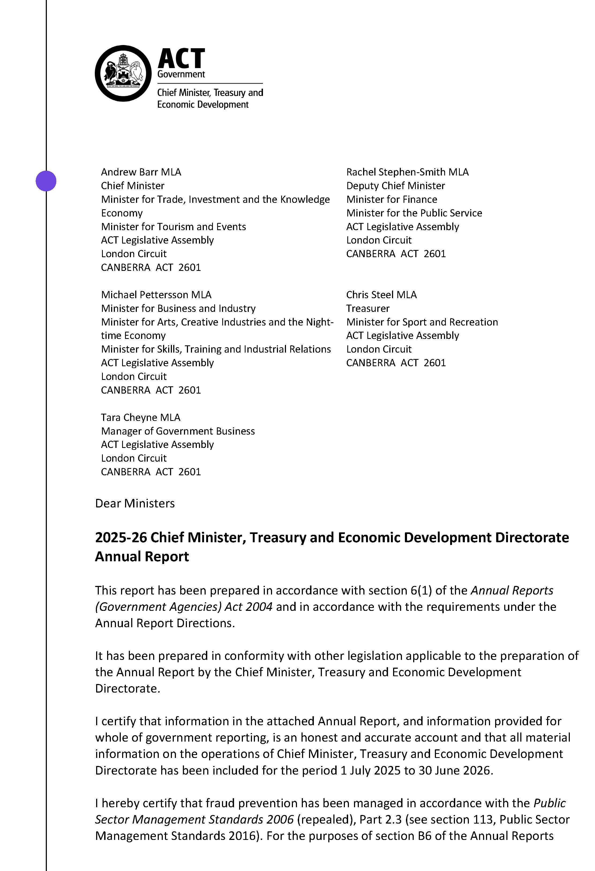
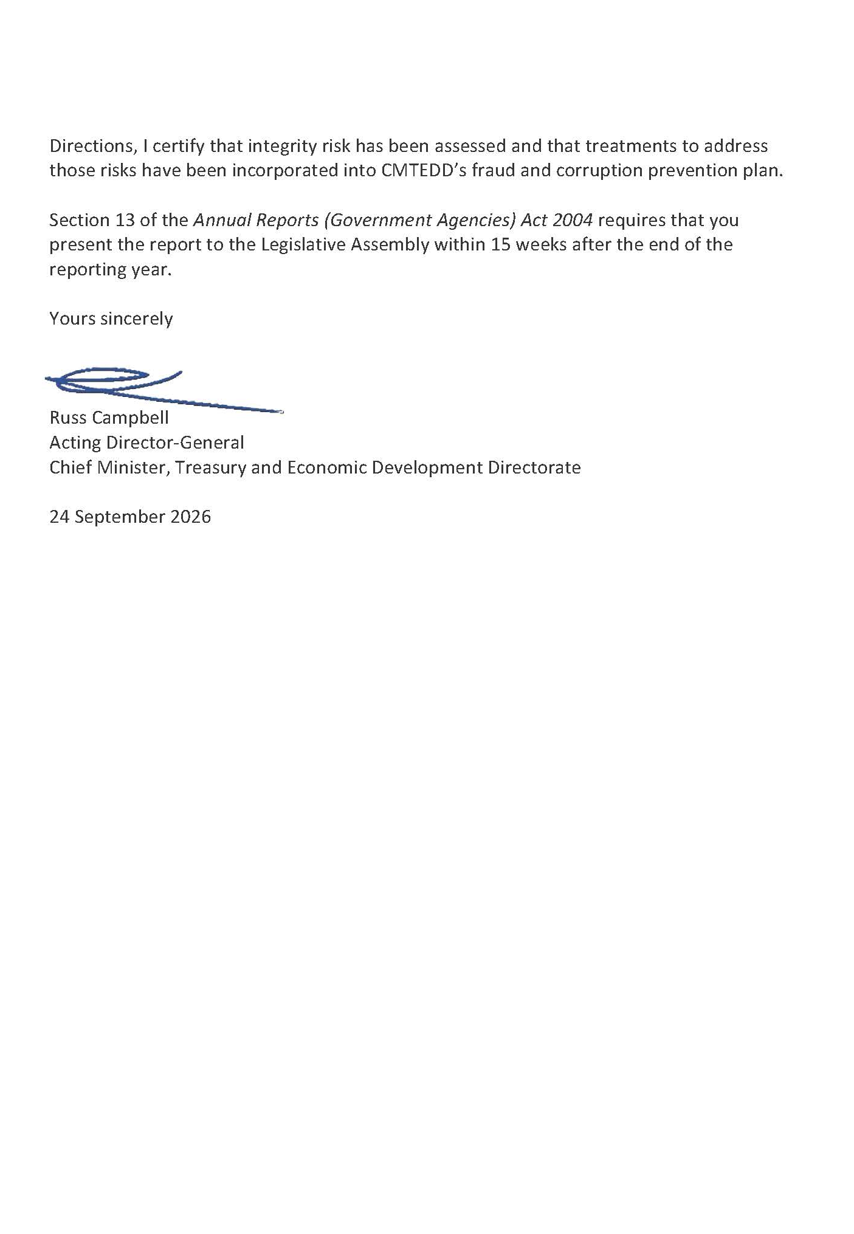

Compliance statement
The 2025-26 Chief Minister, Treasury and Economic Development (CMTEDD) Annual Report must comply with the Annual Reports (Government Agencies) Directions 2026 (the Directions) made under section 8 of the Annual Reports (Government Agencies) Act 2004. The Directions are found at the ACT Legislation Register Annual Reports (Government Agencies) Directions 2026.
The compliance statement indicates the subsections, under parts 1 to 5 of the Directions, that are applicable to CMTEDD and the location of information that satisfies these requirements.

Part 1 Directions overview
The requirements under Part 1 of the Directions relate to the purpose, timing and distribution, and records keeping of annual reports. The 2025-26 CMTEDD Annual Report complies with all subsections of Part 1 under the Directions.
To meet Section 15 Feedback, Part 1 of the Directions, contact details for CMTEDD are provided within the 2025-26 CMTEDD Annual Report to provide readers with the opportunity to provide feedback.

Part 2 Annual report requirements
The requirements within Part 2 of the Directions are mandatory for all reporting entities, and the 2025-26 CMTEDD Annual Report complies with all subsections. The information that satisfies the requirements of Part 2 is found in the 2025-26 CMTEDD Annual Report as follows:
- Transmittal certificate, see the previous page.
- Organisational overview and performance, inclusive of all subsections, see the Organisational Overview and Performance section of this report.
- Financial management reporting, inclusive of all subsections, see volume 2.1 of this report.

Part 3 Reporting by exception
CMTEDD has no information to report by exception under Part 3 of the Directions for the 2025-26 reporting year.

Part 4 Annual report requirements for specific reporting entities
The following subsections of Part 4 of the 2025-26 Directions are applicable to CMTEDD and reported in the Other Reporting section of this report.
• Covert surveillance authorisations issued to ACT employers.

Part 5 Whole of government annual reporting
All subsections of Part 5 of the Directions apply to CMTEDD. Consistent with the Directions, the information satisfying these requirements is reported in one place for all reporting entities as follows:
- Bushfire risk management, see the annual report of the Justice and Community Safety Directorate (JACS).
- Human rights, see the JACS annual report.
- Legal services directions, see the JACS annual report.
- Public sector standards and workforce profile, see the annual State of the Service Report.
- Territory records, see the CMTEDD Annual Report, annexed report of the Director of Territory Records.
ACTPS directorate annual reports are found at the following website: www.act.gov.au/open/chief-minister-treasury-and-economic-development-directorate-annual-reports

Part B

B1. Organisational Overview

Our purpose and role as a central agency
The Chief Minister, Treasury and Economic Development Directorate (CMTEDD) leads the ACT Public Service (ACTPS).
We work collaboratively within government and with the community to deliver government priorities and drive initiatives aimed at making Canberra a better place to live. CMTEDD also leads the strategic direction of the ACTPS to ensure it is well positioned to shape and respond to change, and to continue to deliver against government priorities, now and in the future.
As a central agency, we:
- Support the Chief Minister, the directorate’s ministers and the Cabinet by providing informed, holistic and innovative advice.
- Provide support and direction across the ACTPS on Cabinet and Assembly business, policy and strategy.
- Lead the ongoing development of the ACTPS, including advising on the structure of the ACTPS, ACT public sector employment legislation and conditions, employment, industrial relations, senior executive leadership development and human resource management.
- Drive growth in our knowledge-based economy and our reputation as a global destination in collaboration with business, tertiary education institutions as well as community and industry partners.
- Provide strategic financial and economic advice to the ACT Government to improve the Territory's financial position and economic management.
- Administer the ACT tax laws and manage the assessment and collection of ACT taxes.
- Support public sector health and productivity by providing effective injury prevention and management services and infrastructure.
- Support government through the provision of financial, human resources, insurance, infrastructure and procurement advisory services.
- Keep the Canberra community well informed in times of a Territory emergency through the whole of government Public Information Coordination Centre.
- Provide meaningful opportunities for Canberrans to inform government decision making, including the development of government policies, programs and services.

Vision, Mission and Values
We promote and demonstrate the ACTPS employee values of respect, integrity, collaboration and innovation.
As the central agency, we are committed to:
- Communicating openly and honestly, explaining context and reporting back on outcomes.
- Engaging early with an open mind.
- Demonstrating and earning trust.
- Acting collectively, both as a directorate and as one service.

Respect
We take pride in our work.
We value and acknowledge the contribution of others.
We relate to colleagues and clients in a fair, decent, caring and professional manner.

Integrity
We do what we say we’ll do and respond appropriately when the unexpected occurs.
We take responsibility and are accountable for our decisions and actions.
We engage genuinely with the community, managing the resources entrusted to us honestly and responsibly.

Collaboration
We work openly and share appropriate information to reach shared goals.
We actively seek out other views when solving problems, and value and act on feedback on how we can do things better.

Innovation
We look for ways to continuously improve our services and skills.
We are open to change and new ideas from all sources.

Organisation Chart
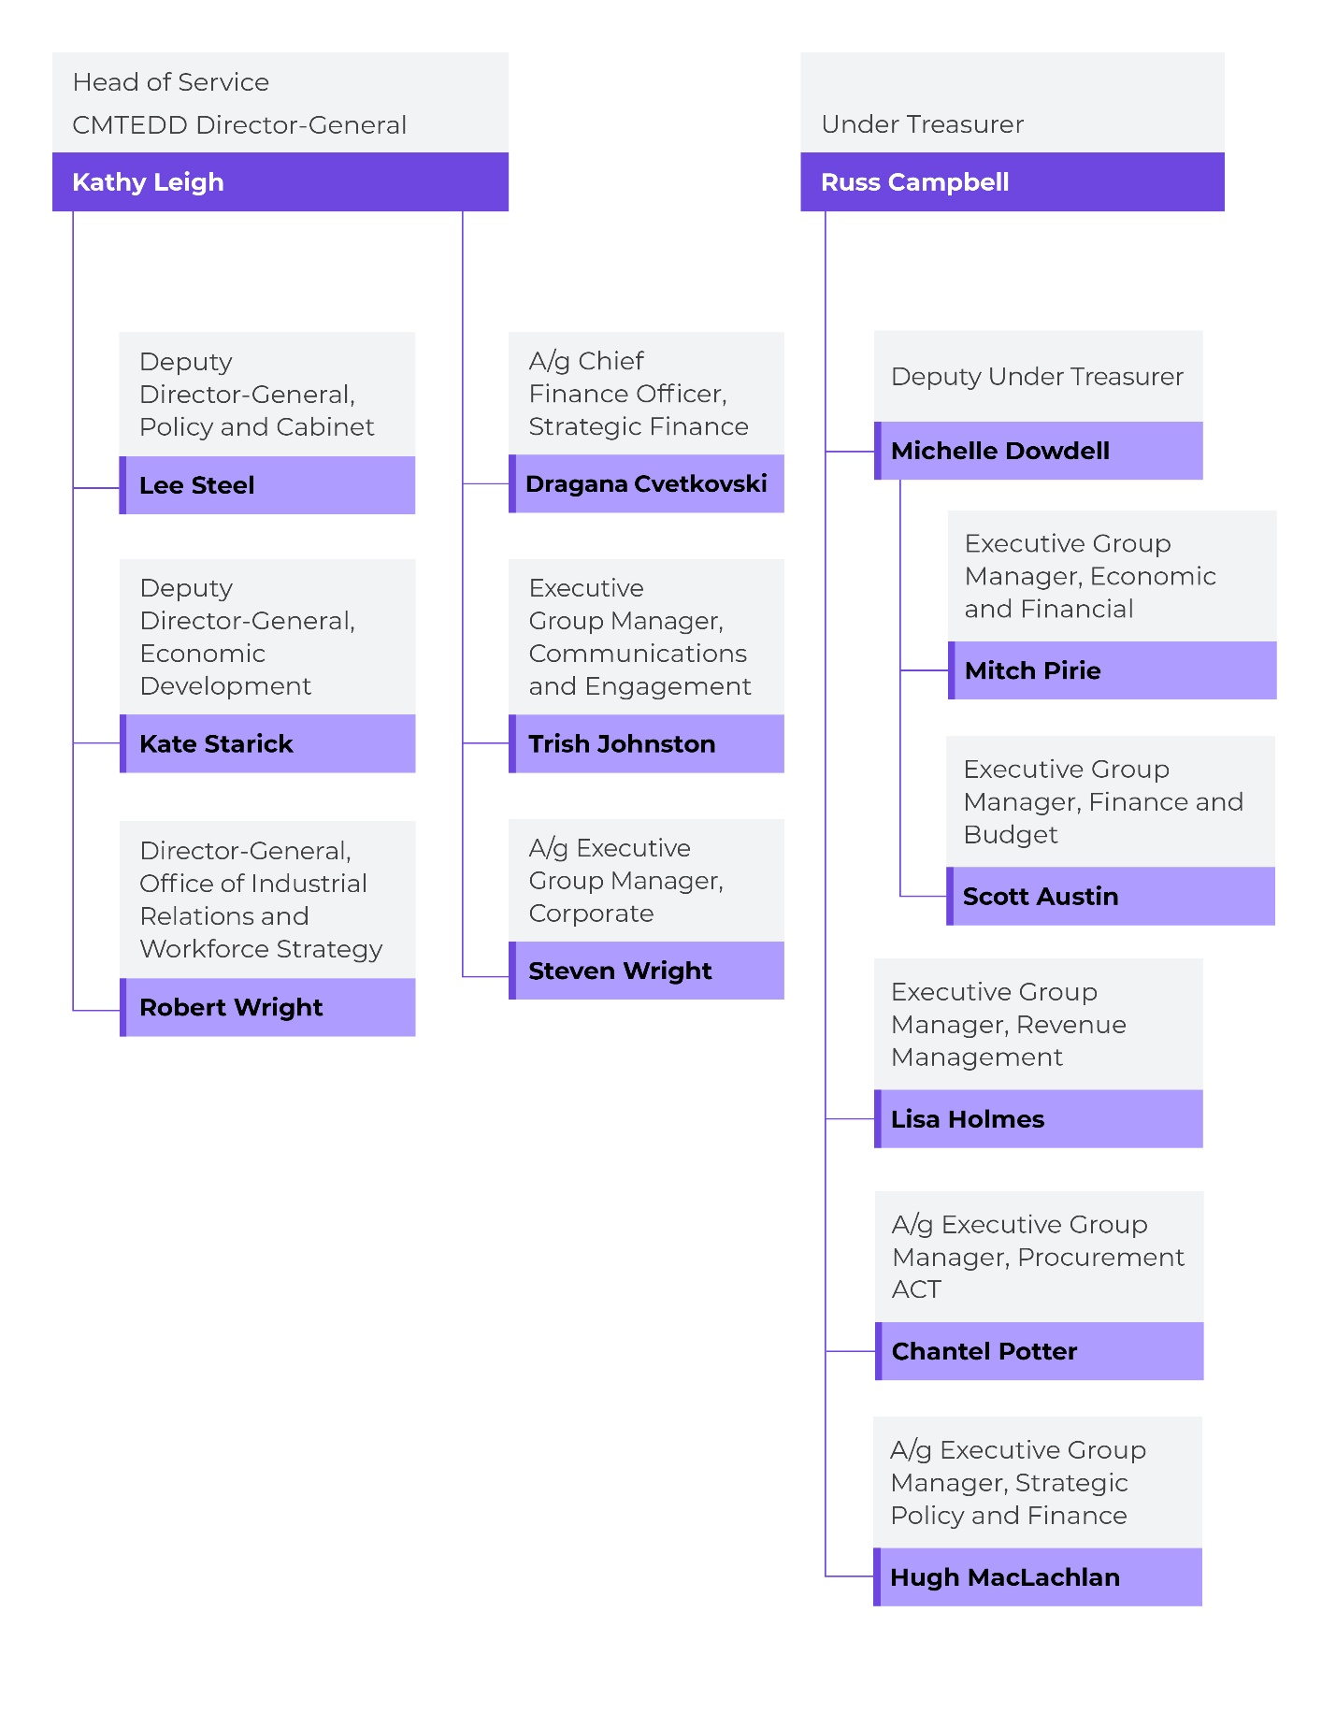

Planning Framework
CMTEDD works collaboratively both within government and with the community to deliver government priorities and undertake actions and improvements to benefit the community.
During the reporting year, the Directorate’s work was aligned with the ACT Government’s priorities and commitments in the:
- The Government Priorities of the 11th Legislative Assembly
- Supply and Confidence Agreements
- Requirements of the Public Sector (Closing the Gap) Legislation Amendment Act 2025
- 2025-26 Budget Statements
- ACT Wellbeing Framework
- CBR2030: ACT’s Strategic Economic Development Framework
Our strategic objectives guide our long-term direction and priorities:
- Provision of high-quality policy advice and support to the ACT Government, including coordinated and integrated policy development and service delivery across government agencies.
- Delivery of an agile, responsive and innovative public service to deliver government priorities.
- Supporting ACT Government in the delivery of responses to urgent and complex emerging priorities.
- Promotion of economic growth, inclusive innovation, responsible investment in Canberra, and social inclusion.
- Providing high-quality advice and support to the ACT Government in the economic and fiscal management of the Territory, working closely with relevant government agencies.
- Delivering improved ‘One Government, One Voice’ communications and community engagement.
Shorter term direction and priorities are published in the annual CMTEDD Budget Statement Priorities, Output and Accountability Indicator sections.
To achieve our outcomes, we will continue to invest in a highly valued, skilled and safe workforce that builds trust and confidence with all our stakeholders by being informed, connected, adaptive and innovative in everything we do.

Clients and stakeholders
We provide strategic policy advice and high-level support to our ministers. The following table lists our ministers on 30 June 2026 and their portfolios.
Table 1: CMTEDD ministers and portfolios as at 30 June 2026
Minister | Portfolio
Andrew Barr MLA | Chief Minister  Minister for Economic Development  Minister for Tourism and Trade
Yvette Berry MLA | Deputy Chief Minister  Minister for Sport and Recreation
Chris Steel MLA | Treasurer
Rachel Stephen-Smith MLA | Minister for Finance  Minister for the Public Service
Michael Pettersson MLA | Minister for Business, Arts and Creative Industries  Minister for Skills, Training and Industrial Relations

We support and assist many other key stakeholders and clients including:
- Cabinet and the ACT Government
- ACT Legislative Assembly
- ACT community
- ACT Aboriginal and Torres Strait Islander Elected Body
- Community councils and groups
- Industry and business institutions
- Key arts organisations, professional and community sporting clubs and representative groups
- Higher and vocational education institutions
- Consumers and licensees
- Media
- ACT Government directorates, agencies and authorities

Changes to structure and functions
There were several changes made to the structure of the directorate at the commencement of and during the reporting year.

ACTPS 2025 changes came into effect 1 July 2025
In December 2024, the government announced that in 2025 it would undertake machinery of government changes to more closely align public service administration and resourcing with government priorities. These changes were designed to provide clear responsibility and accountability, reduce silos, increase information sharing and foster policy capability to better support ministers.
Following an extensive information gathering and analysis process by the Chair of the ACTPS 2025 Taskforce, the following changes were announced relating to CMTEDD, commencing from 1 July 2025:
- Access Canberra became part of the City and Environment Directorate.
- Digital, Data and Technology Solutions became part of the Digital Canberra Directorate.
- The Office of LGBTIQA+ became part of the Health and Community Services Directorate.
- The Better Regulation Taskforce became part of the City and Environment Directorate.
- The ACT Heritage Library joined CMTEDD from the former Transport Canberra and City Services Directorate.

Administrative Arrangements changes from 1 January 2026
Under Administrative Arrangements 2025 No.2 (NI2025-686), the Suburban Land Agency became a portfolio agency of the City and Environment Directorate.
In addition, the functions of Affordable and community housing policy and Housing strategy and policy were moved to the City and Environment Directorate.

Internal restructuring of the Treasury
The Treasury stream of the directorate previously operated under two Deputy Under Treasurers, responsible for Budget, Procurement and Infrastructure Finance, and for Economics, Insurance and Revenue.
With the appointment of a new Deputy Under Treasurer in November 2025, the Treasury stream was restructured. The Finance and Budget, and Economic and Finance areas report to the Deputy Under Treasurer, while Procurement ACT, Revenue Management and Strategic Policy and Finance areas report directly to the Under Treasurer.

Internal Accountability

Senior executives and their responsibilities
Our directorate consists of two streams:
- The Chief Minister stream, led by the Director-General.
- The Treasury stream, led by the Under Treasurer.
The names of the primary business areas within each stream and their responsible senior executives are below. Where business areas have an associated output, we explain their functions and responsibilities by output in the Performance Analysis section (B2 of this report).

Chief Minister Stream

Head of Service and Director-General - Kathy Leigh
The Director-General of CMTEDD is also the head of the ACTPS. The Director-General provides high-level strategic advice to the Chief Minister and is Secretary to the Cabinet. As Head of Service, the Director-General provides whole of government (WhoG) leadership and strategic direction to the ACTPS and chairs the Strategic Board.
Table 2: Chief Minister stream executives at 30 June 2026, by budget output
Responsible senior executive | Business area name | Relevant budget output/s
Lee Steel  Deputy Director-General | Policy and Cabinet | Output 1.1: Government Policy and Reform
Trish Johnston  Executive Group Manager | Communications and Engagement | Output 1.2: Coordinated Communications and Community Engagement
Brendan Smyth  Commissioner for International Engagement | Office of International Engagement | Output 1.3: International Engagement
Kate Starick  Deputy Director-General | Economic Development | Output 3.1: Economic Development
Robert Wright  Deputy Director-General | Office of Industrial Relations and Workforce Strategy | Output 7.1: Capability and Governance  Output 7.2: Injury Management and Industrial Relation Policy  Output 7.3: Public Sector Employment  Output 7.4: Public Sector Standards Commissioner
Note: The Commissioner for International Engagement is appointed under a separate Instrument of Appointment and is included in this table as the responsible office-holder for Output 1.3: International Engagement
In addition to the business areas listed above, the Chief Minister stream includes the following whole of directorate coordination and business support functions.

Corporate – A/g Executive Group Manager – Steven Wright
Corporate leads strategic initiatives across business governance, workforce capability and digital transformation, supporting the effective operation of the directorate and achievement of organisational priorities. The Executive Group Manager drives integrity through their role as CMTEDD Senior Executive Responsible for Business Integrity Risk (SERBIR) and is also the directorate’s Public Interest Disclosure Officer, and Chair of the Directorate Consultative Committee, and the Work Health and Safety Tier 1 Committee.

Strategic Finance – A/g Chief Finance Officer – Dragana Cvetkovski
Strategic Finance delivers strategic financial leadership and advice across the directorate, supporting sound financial management and outcomes. The Chief Finance Officer oversees the Directorate's financial management framework, including budget development, performance monitoring, financial controls and statutory reporting obligations. This framework comprises policies, systems, tools and guidance that support all CMTEDD staff to meet their financial responsibilities, including obligations under the Financial Management Act 1996.

Treasury Stream

Under Treasurer – Russ Campbell
The Under Treasurer leads the Treasury stream of CMTEDD and is responsible for the provision of strategic financial and economic policy advice to the government. The Under Treasurer plays a leading role in promoting accountability and transparency in the delivery of services to the community.
The Under Treasurer also oversees a range of WhoG functions including procurement, general insurance and risk management, and infrastructure finance and reform policy and advice.
In 2025-26, Treasury comprised four sub-streams:
- Finance and Budget Group, and Economic and Financial Group, led by Deputy Under Treasurer, Michelle Dowdell
- Revenue Management, led by Executive Group Manager, Lisa Holmes
- Procurement ACT, led by A/g Executive Group Manager, Chantel Potter
- Strategic Policy and Finance, led by A/g Executive Group Manager, Hugh MacLachlan
The Strategic Policy and Finance stream includes the ACT Insurance Authority (ACTIA). ACTIA is led by a General Manager and provides insurance protection and risk management advice for the ACT Government. ACTIA has its own annual report, available on the Open Government Annual Reports page on www.act.gov.au.

Tables 3 lists key Treasury business areas and the responsible senior executive by budget output.
Table 3: Treasury stream executives at 30 June 2026, by budget output
Responsible senior executive | Business area name | Relevant budget output/s
Michelle Dowdell – Deputy Under Treasurer
Mitch Pirie  Executive Group Manager | Economic and Financial | Output 4.1:  Economic Management
Scott Austin  Executive Group Manager | Finance and Budget | Output 4.2:  Financial Management (partial)
Hugh MacLachlan  A/g Executive Group Manager | Strategic Policy and Finance | Output 4.2:  Financial Management (partial)
Lisa Holmes  Executive Group Manager | Revenue Management | Output 5.1:  Revenue Management
Chantel Potter  A/g Executive Group Manager | Procurement ACT | Output 6.1:  Procurement

Remuneration
Full-time holders of public office (which includes executives of the directorate) are listed in Schedule 1 of the Remuneration Tribunal Act 1995 and the Tribunal must make determinations every twelve months in relation to remuneration, allowances and other entitlements.
The annual determinations for full-time holders of public office usually take effect from 1 July each year and currently include remuneration, salary packaging, relocation entitlements, vehicles, travel, employer provided benefits of Fringe Benefits Tax and superannuation.
The current Tribunal determination can be viewed at the Remuneration Tribunal website www.remunerationtribunal.act.gov.au/determination

Committees
Several boards and committees oversee our strategic direction, priorities and governance.
Table 4: Key committees
Name of committee | Role of committee and membership
Audit and Risk Committee | The Audit and Risk Committee assists the Director-General and the Under Treasurer in fulfilling their oversight and governance responsibilities. The Committee’s functions are governed by an Audit and Risk Committee Charter.  Committee membership includes an independent chair, deputy and member, and an executive from another ACT Government directorate. Observers from CMTEDD and a representative from the ACT Auditor-General's Office also regularly attend meetings. The Internal Audit section of this report contains further details on this committee.
CMTEDD Executive Management Group | The Executive Management Group (EMG) oversees governance within CMTEDD.  EMG’s membership consists of the Director-General CMTEDD, the Under Treasurer, the Executive Group Manager Corporate and the Chief Finance Officer.
Executive Operations Group | The Executive Operations Group (EOG) provides operational oversight and coordination across CMTEDD to support the delivery of government commitments, organisational strategies, and WhoG priorities. The EOG advises the Executive Management Group through a whole-of-organisation lens, ensuring alignment, performance, and responsiveness across the Directorate.  The Executive Operations Group (EOG) consists of all Deputy Directors-General, the Deputy Under Treasuer, the Executive Group Managers of Corporate, Communications and Engagement and the Office of the Head of Service, and the Chief Finance Officer.
CMTEDD Work Health and Safety Committees | The CMTEDD Work Health and Safety Committees (WHSC) provide consultative forums for work health and safety (WHS) matters across the directorate. They comprise three-tiered committees (directorate level WHSC, directorate WHS Network, and local level WHS) and are established in accordance with the ACT Work Health and Safety Act 2011 (the WHS Act) and the Public Sector Management Act 1994.  Information is cascaded from the Tier 1 (directorate level) committee. Matters can also be raised at Tier 2 or 3 level and reported and managed through the higher tiers.  The role of the committees is to:  Facilitate communication and consultation between management and workers on matters relating to workers’ health and safety at work.  Assist in the development of health and safety protocols, rules and procedures.  Review information related to WHS performance to assist CMTEDD to achieve Continuous improvement in the management of WHS.  Consider relevant programs that enhance employee health and wellbeing.  Provide a mechanism for escalation and resolution of unresolved WHS issues.
Directorate Consultative Committee | The ACTPS enterprise agreements provide for the establishment of a Directorate Consultative Committee (DCC).  The key objectives are to:  Monitor the operation and implementation of the agreements.  Consider any proposed new or significant changes to directorate policy Statements and guidelines that relate to the provisions of the agreements.  Exchange information about workplace issues affecting employees.  Consult on any existing directorate performance management schemes, and on the development of any new performance management schemes.  The DCC consists of employee, union and management representatives, with Corporate providing secretariat support.

Performance Summary

Leading key government priorities
In 2025-26, we worked to progress key government priorities:

Closing the Gap
- Delivery of the Government response to the Public Sector (Closing the Gap) Legislation Amendment Bill 2025.
- Preparing for the commencement of the Public Sector (Closing the Gap) Legislation Amendment Act 2025, which embeds a Closing the Gap principle into the Public Sector Management Act 1994 and introduces strengthened accountability requirements for all administrative units, including Senior Executive Staff performance requirements and mandatory annual reporting through the State of the Service Report and directorate Annual Reports.
Further details can be found in section B9.
- Monitored and supported progress against CMTEDD’s commitments under Phase 3 of the ACT Aboriginal and Torres Strait Islander Agreement and Priority Reforms of the National Agreement on Closing the Gap, including through engagement with the Aboriginal and Torres Strait Islander Elected Body through the CMTEDD Internal Steering Committee, and managed transition of these functions to the Cultural Transformation Group in CMTEDD.
- Supported the Minister for Aboriginal and Torres Strait Islander Affairs in their role as Chair of the Select Policy Subcommittee of Cabinet on Closing the Gap.

Wellbeing of Canberrans
- Established a cross-directorate working group to oversee the next phase of embedding the ACT Wellbeing Framework within the ACTPS, including changes to support a greater focus on wellbeing outcomes in directorate planning and performance reporting.
- Published new data for the ACT Wellbeing Framework dashboard, including results of the 2024 University of Canberra Living Well in the ACT Region survey which measures the personal wellbeing of Canberrans.
- Commissioned a second research project with the Australian National University (ANU) as part of the ACT Government participation in the Life Course Data Initiative (LCDI), that will examine the impact on wellbeing of changes in the labour market, particularly the decline in lower-skilled jobs.
- Contributed to budget decision-making through analysis of the policy and wellbeing impacts of proposals brought forward through the 2026-27 Budget process. The 2026-27 Wellbeing Budget Statement provides an overview of investment in the Budget against the six Wellbeing Budget Priority Areas.
- Continued to support the development of policy capability and skills in the ACTPS with resources hubs, guidance material and training, including resources to support staff to identify wellbeing impacts and develop business cases for the 2026-27 Budget.

Oversight mechanisms
- Progressed amendments to the Inquiries Act 1991 to address confidentiality and report handling requirements; strengthen safeguards around disclosure and enhance procedural fairness by extending response times for adverse comments.
- Continued regular engagement with the ACT Ombudsman to ensure the ACT Reportable Conduct Scheme is operating effectively to monitor and support designated entities to prevent and respond to allegations of reportable conduct.
- Provided central and streamlined WhoG reporting on implementation of the ACT Government's response to recommendations of the Royal Commission into Violence, Abuse, Neglect and Exploitation of People with Disability (Disability Royal Commission) and managed transition of this function to the Health and Community Services Directorate.
- Developed operational processes and procedures to support implementation of new Executive Document Release provisions in the Territory Records (Executive Records) Amendment Act 2026.

Intergovernmental and interstate matters
- Supported the Chief Minister and Head of Service to ensure the needs and interests of the ACT were represented in intergovernmental forums, including National Cabinet and the Council for the Australian Federation, on issues of national significance including health and disability reforms, fuel security and firearms reform.
- Successfully supported the negotiations for the National Health Reform Agreement (2026-2031 addendum) and the National Agreement on Foundational Supports (2026-2031) through National Cabinet, including securing additional small-state funding for the ACT.
- Delivered the Sydney to Canberra Rail Strategic Pathway Report, the primary evidence base for the $100 million joint funding announcement for Sydney to Canberra rail in the Federal Budget.
- Supported the Chief Minister from January 2026 in his role as Chair of the Council of Capital City Lord Mayors (CCCLM).
- Supported the government to negotiate major intergovernmental funding agreements, including the Addendum to the National Health Reform Agreement.
- Worked closely with the Commonwealth and states and territories on National Competition Policy reforms.

Supporting workforce capability
In 2025-26, we worked to improve working conditions, workforce productivity and wellbeing for Canberrans. Key initiatives included:
- Supporting the ACT Integrity Commission to perform its statutory functions by developing and delivering legal policy solutions to strengthen the ACT integrity framework, including:
- Securing further temporary declarations to grant telecommunications interception powers to the Commission under the Telecommunications (Interception and Access) Act 1979 (Cth).
- Work to develop a witness assistance reimbursement regulation.
- A government submission to the Commission’s inquiry into arrangements for lobbying and influence in government in the ACT.
- Work to progress implementation of the recommendations of the review of the Integrity Commission Act 2018 and Public Interest Disclosure Act 2012, undertaken by Mr Ian Govey AM.
- Delivery of the ministerial response to the ACT Integrity Commission’s report on Operation Luna (Part Two).
- Leading the delivery of sector wide leadership and talent strategies and learning and capability development programs.
- Support for over 1,400 employees to remain in or return to work following work related illness or injury, through effective early intervention programs, tailored case management support and person focused work rehabilitation services.
- Industrial relations optimisation reforms, including the Workplace Legislation Amendment Act 2025 and introducing a provisional liability crisis payment for families of workers who die in the course of their work within the ACT's private sector workers compensation scheme.
- Delivery of the government response to the ACT Auditor-General’s Performance Audit Report: Diversity, equity and inclusion in the ACTPS.
- Design and delivery of the ACTPS Pilot Mentoring Program for leaders from CALD backgrounds, to strengthen the capability and capacity of the ACTPS through supporting the career goals of people from CALD backgrounds and encouraging increased Senior Executive Service (SES) representation over time. Increased leadership diversity will enhance ACTPS advice to government, decision making and service-delivery by strengthening diverse lived experience and perspectives that reflect the ACT community’s needs and expectations in this critical leadership cohort.
- Delivery of the 2025 ACTPS Employee Survey and results report analysing workforce trends and patterns to inform strategic decision-making.
- Commencement of bargaining negotiations for the next round of ACTPS Enterprise Agreements with the issuing of Notices of Employee Representational Rights (NERRs), issued from July 2025, and meetings with stakeholder groups held from August 2025.
- Delivery and enhancement of WhoG recruitment and payroll systems, services and advice.
- Support of the public sector employment framework through the introduction of new and updated WhoG policies and guidelines.
- Delivery of the Secure Employment Framework and Secure Workforce Conversion programs for the ACT public sector.
- Support for the Remuneration Tribunal in its Spring Review and Autumn Reviews.

Keeping the community informed
In 2025-26, we continued our commitment to a One Government, One Voice approach, ensuring that through effective and well-targeted information campaigns and engagement activities, Canberrans know how to access ACT Government services and have the information they need to actively participate in decision making.
We also continued to implement the WhoG approach to delivering priority campaigns, with a focus on using evidence and insights to improve quality and impact. These included campaigns to raise awareness of the change in legislation to the Affirmative Consent laws in the ACT, the government's plan to enable the building of 30,000 new homes, and the delivery of key infrastructure projects in the city precinct.
We continued to focus on updating and informing the Canberra community across the ACT Government social media and Our Canberra channels:
- Increased page views on the Our Canberra website by 10.4 per cent to a total of 975,076.
- Delivered an approach, which resulted in more than 28 million impressions on the ACT Government Facebook and LinkedIn and We Are CBR Instagram and grew followers across the channels by 13.3 per cent.
- Continued to consolidate websites and social media channels across ACT Government to make it easier for Canberrans to access information digitally.
During the year we engaged with a wide range of Canberrans to seek their input and diverse views on policies, programs, projects and services through the online engagement platform YourSay Conversations and the YourSay Panel research platform.

Leading the ACT Government’s international engagement activities
In 2025-26, we continued to help Canberra businesses achieve their export goals, engaged with international stakeholders both domestically and overseas, and organised internationally focused events and export training workshops.
Export training workshops focused on building core export skills and knowledge – including “what is your value proposition”, “are you export ready” and “what Government export support is available?” Dedicated export support programs such as ACT TradeStart, the International Business Engagement Program and the ACT Chief Minister’s Export Day assisted the full spectrum of export businesses, from aspirational to highly experienced. We delivered the ACT Government’s fifth ACT Export Day where attendees learned about available government support, key export trends, and stories of export success.
In 2025-26, several additional companies accompanied the ACT Commissioner for International Engagement on a trade mission to Fiji. The university sector also joined the trade mission to India, as well as Fiji.
The variety of engagement events we delivered helped to progress the ACT Governments internationally focused objectives as detailed in Canberra’s International Engagement Strategy.
During this financial year, we delivered trade missions to Thailand, Singapore, India and Fiji, which focused on promoting key areas of strength and actioning key international engagement objectives, including:
- Tourism
- Aviation connectivity
- Investment
- Education
- Sustainability
- Health technology
- Food and beverage products
Throughout the year we also hosted international delegations from around the globe and further developed our close relationships with Canberra’s diplomatic community, as well as our Sister Cities, Nara, Beijing and Wellington.

Supporting Canberra’s economic development
In 2025-26, we launched CBR2030: ACT’s Strategic Economic Development Framework which focuses on accelerating knowledge based economic growth, the transition to a net zero economy, and productivity and lifestyle enhancing infrastructure for Canberrans.
The Framework builds on a decade of transformation to ensure that Canberra remains inclusive, sustainable and full of opportunity as it continues to grow.
We also delivered across a range of economic development activities to support Canberra as a great place to live, work, study, visit and do business in.

Business, innovation and skills
- Established the ACT Venture Capital Fund, Activate Capital to support high-growth potential companies in the Territory. The Fund was registered as an Early Stage Venture Capital Limited Partnership (ESVCLP) and launched in November 2025.
- Launched the Canberra Screen and Games Fund, administered by Screen Canberra, allocating $1.1 million to support 11 screen and games projects.
- Supported 350 local businesses across Canberra with free access to the Canberra Business Advice and Support Service (CBASS).
- Delivered the ACT Aboriginal and Torres Strait Islander Business Support Program, Badji supporting 96 business engagements with culturally appropriate support to progress new procurement, employment and growth opportunities across the ACT.
- Expanded activity through the Canberra Cyber Hub to develop local ecosystems, promote ACT capabilities, and attract and retain skilled talent in advanced technology sectors, including space and quantum and supported Canberra SMEs through Team Canberra trade show events.
- Facilitated 15 investment leads via the Investor Concierge Service, with interest across cyber, AI, advanced technology, defence and space sectors.
- Developed and delivered priorities under the National Skills Agreement 2024-2028, including collaboration with the Canberra Institute of Technology (CIT) to establish the Cyber Security TAFE Centre of Excellence and develop projects under the National TAFE Network (NTN).
- Launched completion grants under the National Skills Agreement to pilot innovative projects that help more Vocational Education and Training (VET) learners successfully complete their training and transition into employment or further study.
- Nominated 1,600 skilled migrants through the ACT Nominated Migration Program, targeting occupations in demand across the Territory.
- Funded six initiatives under the Adult Community Education Grants Program, supporting lifelong learning and community engagement.
- Agreed the Clean Energy Capital Federal Funding Agreement, unlocking federal funding to enhance training infrastructure, including facilities, equipment and learning environments, to enable the ACT’s training system to train the workforce needed for the clean energy economy.
- Agreed the Turbocharging of the VET Workforce Federal Funding Agreement to support recruitment, retention and professional development initiatives that will strengthen the ACT’s VET workforce and improve training outcomes.

Supporting the arts and culture in Canberra
- Delivered increased investment totalling approximately $1.5 million in arts project funding through the Arts Activities and Aboriginal and Torres Strait Islander Cultural Arts programs, supporting 117 activities that directly support artists and arts projects.
- Commissioned the public artwork honouring community volunteer Stasia Dabrowski OAM. The bronze artwork design and fabrication were completed by artist Louise Skačej in June 2026.
- Delivered the $2 million upgrade to Tuggeranong Arts Centre theatre including improved back of house facilities, new lighting and sound systems and new theatre seating. The works improved facility accessibility and functionality expanding opportunities for arts activity and enhancing audience experience.
- Implemented City of Design project funding, investing across major and smaller initiatives to support high quality, design-led activity and strengthen Canberra’s profile as a global City of Design through targeted, impact-driven projects.
- Commenced construction works associated with the $12.9 million upgrade project at the heritage-listed Gorman Arts Centre.

ACT Government major events
- Achieved a record economic impact of $56.7m and total expenditure impact of $71.5m for Floriade and Floriade NightFest 2025, driven by a record attendance of 519,413.
- Delivered major events including the British and Irish Lions Tour match and Socceroos v New Zealand at GIO Stadium Canberra, as well as the NBL Blitz and Australian Masters Games to help drive the visitor economy.
- Released the Floriade 5-Year Plan 2025-2029.
- Attracted record attendance of more than 18,000 visitors at Kitefest 2025 at the National Arboretum Canberra and introduced low-sensory workshops to enhance accessibility and inclusion.
- Also at the National Arboretum, a new six-week event, Winter in the Woods, was developed for launch in June 2026 to drive local and interstate visitation, expand site activation and strengthen commercial partnerships.

Strategic infrastructure and venues
- Delivered on Milestone One under the Federation Funding Agreement with the Australian Government which included the Project Plan, Completion of Project Scoping (Functional Design Brief Report) and Delivery Model Analysis for the new National Convention and Entertainment Centre project.
- Progressed the Technical Due Diligence to inform the preferred site of a new stadium.
- Progressed commercial negotiations with Telstra, visitor experience concept designs and engagement planning with the local Aboriginal and Torres Strait Islander community as part of the Telstra Tower project.
- Commenced Stage 1 of the Stromlo Forest Park Tracks and Trails Master Plan, engaging environmental and heritage consultants and initiating detailed design.
- Hosted numerous national and international events including the return of Spilt Milk, the 60th anniversary of the National Folk Festival and a strongly attended Summernats.

Sport and recreation development
- Established a Para Uplift Unit at the ACT Academy of Sport (ACTAS), in partnership with Paralympics Australia and the AIS, to increase Australia’s representation and medal success.
- Provided over $4 million in grant funding to 43 organisations through the 2026 Sport and Recreation Investment Scheme.
- Stromlo Forest Park hosted events, supporting participation from junior and beginner levels through to masters competitions and national championship events with 17 achieving major event attendance thresholds.

Visitor economy
- Launched Phase 2 of the T2030 ACT Tourism Strategy, targeting $1 billion growth in the visitor economy by 2030 through coordinated effort across government and industry.
- Delivered 25 partnership marketing campaigns to promote Canberra domestically and internationally, including campaigns with airlines and international distribution partners.
- Continued the domestic “There’s more than they’re telling us” campaign, driving overnight visitation through paid, social, and partnership activities. A new brand extension campaign was also delivered, achieving 4 million impressions and 55,000 clicks.
- Supported tourism-driving events through the Major Event Fund that generated $111 million in direct economic benefit for the ACT.
- Partnered with Canberra’s tertiary institutions on a program of activity at the Australian International Education Conference, which saw over 1,500 education delegates from across Australia and key international markets visit Canberra.
- Hosted over 400 new international tertiary students at the National Gallery of Australia for the Chief Minister’s Student Welcome in March 2026.

Providing strategic financial and economic advice and services to the ACT Government
- Delivered the 2025-26 Budget Review, the 2026-27 Budget and the Consolidated Financial Statements.
- Managed $8.2 billion in investment assets and approximately $15.4 billion of bonds and other debt securities on issue in the Australian capital markets.
- Led development of the ACT Government’s submission to the Productivity Commission Inquiry into the 2018 GST Distribution Reforms.
- Supported the delivery of treatment, care and support services through the Lifetime Care and Support (LTCS) Scheme.
- Administered the ACT tax laws, managed the assessment and collection of ACT taxes and administered concessions, exemptions and grants consistent with the government’s policies.
- Commenced implementation of agreed actions flowing from the ACT Ombudsman’s inquiry into historical land tax debt.
- Introduced and implemented the Payroll Tax Amendment Act 2025, facilitating a mid-year tax rate increase for large employers with Australia-wide wages exceeding $150 million through a split-period tax calculation method.
- Implemented the new payroll tax-free threshold for commencement on 1 July 2026.
- Implemented changes to the ACT Revenue Office digital environment:
- Launched the redeveloped ACT Revenue Office website, one of the largest externally facing service improvements delivered during the year.
- Developed the new Digital Objections Service, a substantial citizen-facing digital service to replace manual processes with a fully integrated workflow across Objections, Operations and the Valuation Office.
- Delivered two of four planned enhancement releases for the Rental Bonds Portal, reducing operational pain points, improving client experience and addressing structural issues affecting business operations.
- Implemented a new graph database capability as part of ongoing business intelligence improvements.
- Supported (Procurement ACT) 73 managed-tier procurements with an estimated aggregate value of $1.84 billion.
- Resolved more than 4,500 procurement support enquiries.
- Published 277 tenders on Tenders ACT, the Territory's electronic tendering platform, which supports open, transparent and accountable procurement by improving supplier access to government opportunities and helping Territory entities meet their procurement reporting obligations.
- Supported more than 160 procurement activities with formal and informal probity advice through the Probity and Supplier Complaints Service.
- Strengthened ethical procurement practices by supporting a coordinated WhoG response to emerging supplier conduct issues, ensuring procurement decisions reflected the Charter of Procurement Values and maintaining public confidence in government procurement.
- Strengthened procurement governance through the Government Procurement Board and administration of the annual assurance process under the Goods and Services Procurement Accreditation Program.
- Developed new guidance materials, templates and implementation resources to support the changes made by the Government Procurement Amendment Act 2026, commencing on 1 July 2026, which strengthen and simplify processes for Territory entities engaging local businesses and certified Aboriginal and Torres Strait Islander enterprises.

Outlook
Looking forward to 2026-27, the Directorate will be undertaking the following activities:

Leading key government priorities
- Supporting negotiations on upcoming intergovernmental agreements, including the National Mental Health and Suicide Prevention Agreement and the Preschool Reform Agreement.
- Establishing shared key initiatives under the new focus areas of the ACT and NSW Memorandum of Understanding (MoU) for Regional Collaboration.
- Continuing to support the Chief Minister and Head of Service to ensure the needs and interests of the ACT are represented in intergovernmental forums, including National Cabinet and the Council for the Australian Federation.
- Progressing review and legislative amendment to the ACT Ombudsman Act 1989, specifically related to the ACT Reportable Conduct Scheme.
- Providing funding for the University of Canberra to undertake the 2027 Living Well in the ACT Region survey.
- Continuing the Life Course Data Initiative partnership with the Australian Bureau of Statistics, including generating research findings.
- Continuing partnerships with research organisations (University of Canberra, The Australian National University and the CSIRO) to build the wellbeing evidence base.
- Implementing a new Performance and Accountability Framework to strengthen the focus on wellbeing outcomes in the ACTPS.
- Piloting a cross-directorate partnership agreement to formalise and support collaboration on a shared wellbeing outcome in the ACTPS.
- Continuing to support budget decision-making through policy and wellbeing considerations in the Budget process, and analysis and advice on the wellbeing impacts of business cases.
- Increasing our focus on online discoverability of and access to the archival resources of the ACT Government and community.

Supporting workforce capability
- Delivering the next phase of work arising from reviews of the Integrity Commission Act 2018 and Public Interest Disclosure Act 2012, undertaken by Mr Ian Govey AM, including a proposed bill to improve witness support and strengthen the effectiveness and efficiency of the ACT Integrity Commission.
- Optimising ACT workers’ compensation, work health and safety and industrial relations legislative and regulatory frameworks.
- Supporting the Secure Local Jobs Code (SLJC) Registrar in administering the SLJC, including certification and verifying compliance, carrying out ethical treatment of workers assessments and a review of the Code.
- Continuing support for the public sector employment framework through a program of updated and new WhoG policies and guidelines and public sector management standards.
- Continuing negotiating ACT Public Service enterprise agreements in conjunction with ACT Government Bargaining Leads, in consultation with unions and other relevant stakeholder groups.
- Delivering senior leadership development initiatives that meet the emerging needs of ACTPS Executives and support their collective stewardship of the service.
- Enhancing graduate recruitment and employment systems and practices.
- Designing and delivering workers’ compensation, health safety and wellbeing services and programs that improve workforce health and resilience.
- Delivering the recommendations agreed to in the Government Response to the ACT Auditor-General’s Performance Audit Report: Diversity, equity and inclusion in the ACTPS. This includes the development of an ACTPS Inclusion and Belonging Strategy to support and continue building the capacity, capability and agility of the ACTPS through innovative workforce transformation strategies.
- Championing best-practice leadership to build a more inclusive, culturally safe and engaged workforce that is responsive to requirements of: The National Agreement on Closing the Gap (Priority Reform Three – Transforming Government Organisations); the ACT Aboriginal and Torres Strait Islander Agreement 2019-2028; ACT Disability Strategy 2024-33; ACT Women’s Plan 2016-26; Multiculturalism Act 2023; ACT Capital of Equality Strategy 2024-29; and the ACT Disability Inclusion Act 2024.
- Developing and leading innovative workforce transformation strategies, policies and programs, including for workforce inclusion, secure employment, mobility and insourcing.
- Embedding the Secure Employment Framework across the ACT Public Sector to build capability and expertise, and further solidify the role of the ACT Government in modelling good employment practices.
- Developing progressive employment policy and promoting its consistent and compliant application.
- Providing efficient and effective support services to the ACT Public Sector including payroll and recruitment functions.

Keeping the community informed
- Growing the number of subscribers to the Our Canberra e-newsletter and social media channels to deliver up-to-date, readable and accessible news to even more Canberrans in a timely and effective manner.
- Implementing the ACT Government’s engagement framework to achieve a consistent, robust and collaborative approach to community engagement. The work will better coordinate ACT Government community engagement activities across each region. It will also include the implementation of an engagement targets model that will guide directorates on how to reach the right members of the community for their issue.
- Continuing to support the promotion of ACT Government news and information through earned channels, including traditional media.
- Developing priority integrated campaigns that help inform the Canberra community and drive change.
- Delivering a content care framework to allow directorates to maintain standards of content across ACT Government websites including usability, accessibility and consistency.

Leading the ACT Government’s international engagement activities
Looking to 2026-27, we will continue to maintain our high-level of engagement with businesses and international stakeholders. With an aim of exceeding our performance targets for business support and event delivery, we will work to better convert these into export outcomes throughout the year to meet set targets.
To help do this, the ACT Government will continue the ACT TradeStart Program and continue building on business opportunities with the Singapore-based Southeast Asia Business Development Manager.
As we raise Canberra’s global profile each year, our forward calendar of trade missions and events, as well as hosting foreign inbound delegations, continues to grow. Our activities will include:
- Providing export advice and development opportunities through the ACT TradeStart Program, International Business Engagement Program and ACT Chief Minister’s Export Awards.
- Executing our rolling forward trade mission plan to priority markets.
- Welcoming inbound delegations from around the globe, facilitating connections and export opportunities along the way.
- Delivering our full schedule of events, training workshops, briefings.
- Converting these activities into export outcomes for Canberra businesses.
- Creating economic, cultural and social opportunities for all Canberrans in line with Canberra’s International Engagement Strategy.

Supporting Canberra’s economic development

Business, innovation and skills
- Delivering an expanded Canberra Business Advice and Support Service to include alternative business models and social enterprises within its remit.
- Continuing funding Screen Canberra to support television, film and digital gaming projects through the 2027 round of the Screen and Digital Games Fund, to develop the local creative industry and attract screen and gaming productions to the ACT.
- Continuing to deliver the Badji program, supporting the ACT’s Aboriginal and Torres Strait Islander businesses.
- Continuing to support the local innovation ecosystem, including through the ACTivate Capital venture capital fund.
- Progressing a governance review of the Canberra Institute of Technology.
- Continuing administration of the current Free TAFE program and work with the Commonwealth Government on the extension of Free TAFE in the ACT.
- Continuing support of the ACT’s growing high-value industries, including cyber security, quantum technologies, space, and advanced technology sectors through continued funding for the Canberra Cyber Hub.
- Administering government-subsidised vocational education and training (VET) through the Australian Apprenticeships (User Choice) and Skilled Capital programs.
- Managing the State and Territory nominated stream of the Australian Migration Program.
- Reviewing and updating the ACT Skills Action Plan to strengthen the ACT’s skills system and ensure it supports current and future workforce needs.

Supporting the arts and culture in Canberra
- Developing an updated arts, culture and creative policy for the ACT, which will support the sector to meet current and future challenges and opportunities. The policy will include an updated action plan which will guide the future work of artsACT and its partners.
- Continuing to support arts organisations in the ACT, which in 2026-27 will include a 25 per cent increase in funding from 1 January 2027. This funding will be allocated through a new funding cycle of the Arts Organisation Investment Program to support a network of leading arts organisations and arts centres, with a focus on stability, sector development and long-term impact including increased funding.

ACT Government major events
- Delivering the Australian Masters Rowing Championships, NBL Ignite Cup, and Sydney Kings games along with Wallaroos vs Scotland
- Continuing the implementation of the Enlighten 5-Year Plan 2024-2028 and the Floriade 5-Year Plan 2025-2029
- Continuing the strategic partnership with Cricket Australia and Cricket NSW for national and international matches
- Redeveloping the Events ACT’s portfolio of websites, delivering modern, user-focused sites that improve event discovery and accessibility compliance

Strategic infrastructure and venues
- Finalising commercial negotiations with Telstra and finalising visitor experience design work as part of the Telstra Tower project, informed by continuing engagement with Traditional Custodians
- Progressing Milestone 2 and 3 of the new National Convention and Entertainment Centre project, which includes engaging a consultant for the Project Management Contract Administration (PMCA) and reference design procurement and Reference Design Development
- Progressing planning for a Functional Design Brief, Concept Design Report and Cost estimates for Canberra Stadium
- Delivering targeted upgrades and maintenance and improved signage across both the National Arboretum Canberra and Stromlo Forest Park under the annual Asset Renewal Program
- Developing a Living Collection Strategy for the National Arboretum Canberra, informed by targeted stakeholder and public consultation. The strategy will establish shared objectives and key actions for the management of forests, gardens and bonsai over the next 10 years
- Delivering infrastructure upgrades at Exhibition Park in Canberra including arena lighting and roof repairs to the Coorong and Budawang Pavilions
- Commencing $15 million of improvements to GIO Stadium Canberra with the priority in 2026-27 being replacement of the West Grandstand lift and other improvements to the East and West grandstands.

Sport and recreation development
- Developing a new ACT Aquatic Strategy to guide the planning, management and future investment in territory wide aquatic facilities over the next decade.
- Delivering an independent territory wide report on sporting infrastructure.
- Undertaking a Feasibility Study and concept design for upgrades to sporting pavilions at primary AFL venues, including Amaroo District Playing Fields and Kambah District Playing Fields.

Visitor economy
- Continuing implantation of Phase 2 of the T2030 ACT Tourism Strategy through marketing activity, major event support, industry and travel trade engagement, and efforts to expand domestic and international aviation capacity.
- Continuing to promote Canberra as a study destination in partnership with our tertiary institutions.
- Continuing a suite of investment attraction activities including Investor Concierge services and support for trade missions.

Providing strategic financial and economic advice and services to the ACT Government
- Supporting the government in delivering the 2026-27 Budget Review, the 2027-28 Budget and the Territory’s 2025-26 Consolidated Financial Statements.
- Coordinating the government’s budget processes and report on financial outcomes.
- Providing regular updates to the Expenditure Review Committee of Cabinet on the Territory’s finances, including agency expenditure, to allow the Government to manage the public finances appropriately and maintain a strong balance sheet.
- Review the Financial Management Act 1996 to ensure it remains fit for purpose and supports contemporary standards of public sector financial management, accountability, transparency and Legislative Assembly scrutiny.
- Working with directorates to ensure sound financial management and high-quality policy advice to Cabinet.
- Progressing the 2026 review of the Motor Accident Injuries Act 2019.
- Strengthening engagement with the Commonwealth Grants Commission to support a fair GST distribution outcome for the Territory.
- Providing advice on the 2028-33 ICRC Water and Sewerage Pricing Review, including implications for Icon Water's capital investment and financing strategy.
- Implementing National Competition Policy reforms and investigate pathways for future reforms under the NCP Funding Agreement.
- Continuing to implement matters arising from reports of the ACT Ombudsman, the Standing Committee on Public Accounts and Administration, and the ACT Auditor-General, including penalty tax and interest circulars, and developing a debt management policy.
- Implementing the New Unit Title Duty Exemption.
- Completing the Rental Bonds Improvements Project, delivering two further releases to support real estate agents, tenants, lessors and staff.
- Delivering infrastructure upgrades to the Rates and Land Tax system to sustain the platform in the short-term.
- Continuing the refresh of ACT Revenue Office website content.
- Supporting Territory entities to deliver services and outcomes for the ACT community through procurement services provided under the Tiered Service Support model.
- Managing WhoG procurement arrangements to deliver value for money, sustainability and strategic procurement outcomes for Territory entities.
- Enhancing WhoG procurement capability across the ACTPS through updated training, guidance, digital resources, targeted engagement and administration of the Goods and Services Procurement Accreditation Program.
- Supporting the Government Procurement Board in the discharge of its functions through high-quality secretariat and governance services.

B2. Performance Analysis

Output 1.1: Government Policy and Reform
Through this output the directorate provides advice and support to the Chief Minister, the Head of Service and the Director-General on complex policy matters. We perform a central agency coordination role in strategic planning and social, economic and regional policy, including high-priority reforms and effective delivery of government policies and priorities.
The Directorate delivers this output by:
- Providing ongoing advice to the Chief Minister and the ACT Government in relation to whole of government policy development and priorities, and the implementation of key government decisions.
- Supporting the Chief Minister as Chair of Cabinet and the Head of Service as Secretary of Cabinet.
- Supporting the Head of Service as Chair of the Strategic Board and providing advice on whole of service government issues.
- Leading, coordinating and monitoring policy and project initiatives to promote across government outcomes and delivery.
- Supporting the development and improvement of policy capabilities, including design and evaluation, across government.
- Through the Deputy Director-Generals’ Group, led by the Deputy Director-General Policy and Cabinet, continuing to support information sharing and whole of government coordination on priority issues.
- Leading development of ACT positions on national policy issues and the ACT Government’s participation in National Cabinet, the Council for the Australian Federation and their sub-fora.
- Leading the government’s engagement with regional stakeholders on mutually beneficial activities including the NSW Government and the NSW Cross-Border Commissioner, the Canberra Region Joint Organisation and local councils in the Canberra Region.
- Continuing to embed the ACT Wellbeing Framework, including working with the Australian Bureau of Statistics and the Australian National University to develop the pilot implementation of the Life Course Data Initiative as a tool to expand the Wellbeing evidence base.
- Providing advice and support to Cabinet and the Manager of Government Business in the Legislative Assembly.
- Through the Territory Records Office, driving the ACTPS’ growing capability and maturity in digital recordkeeping.
- Preserving the ACT Government’s archival records and providing services and initiatives that make them available to the public.

Performance – Accountability Indicators
During 2025-26 we met 4 out of 6 accountability indicators against this output.
The accountability indicators not met were:
- 1.1b - Regional partnerships and participation. One of the unmet targets for this accountability indicator was to hold an ACT-NSW Senior Officials Forum in the 2025-26 year. In place of an ACT-NSW Senior Officials Forum, ACT and NSW senior officials have been meeting fortnightly to discuss priorities under the ACT-NSW MoU, as well as attending project specific committee meetings and workshops to progress the agreed key initiatives. This includes ongoing collaboration through the ACT-NSW Potable Urban Water Issues Steering Committee, Parkwood Steering Committee, Regional Futures Framework Steering Committee and Sydney-Canberra Rail Improvement Steering Committee, in addition to an issue-specific Cross Border Police Roundtable in November 2025. The ACT is collaborating with the NSW Cross-Border Commissioner to plan for meaningful cross-border fora when they are required.
- 1.1f - The ACT Heritage Library (ACTHL) underwent a planned relocation to enable sustainability improvements to its accommodation at 255 Canberra Avenue. The collection remained onsite. In addition to the necessary closures to allow staff to leave and return to the site, the impact of the relocation has been greater than anticipated, due to unexpected, limited access to the building. This resulted in a lack of ready access to the collection, and the inability to host public programs which attract researchers to the library. Public access facilities were established at Civic Library to provide a temporary space for researchers to access original materials. These arrangements allowed for some ongoing access to the ACTHL collection, including through exhibitions, displays and public events.

Highlights
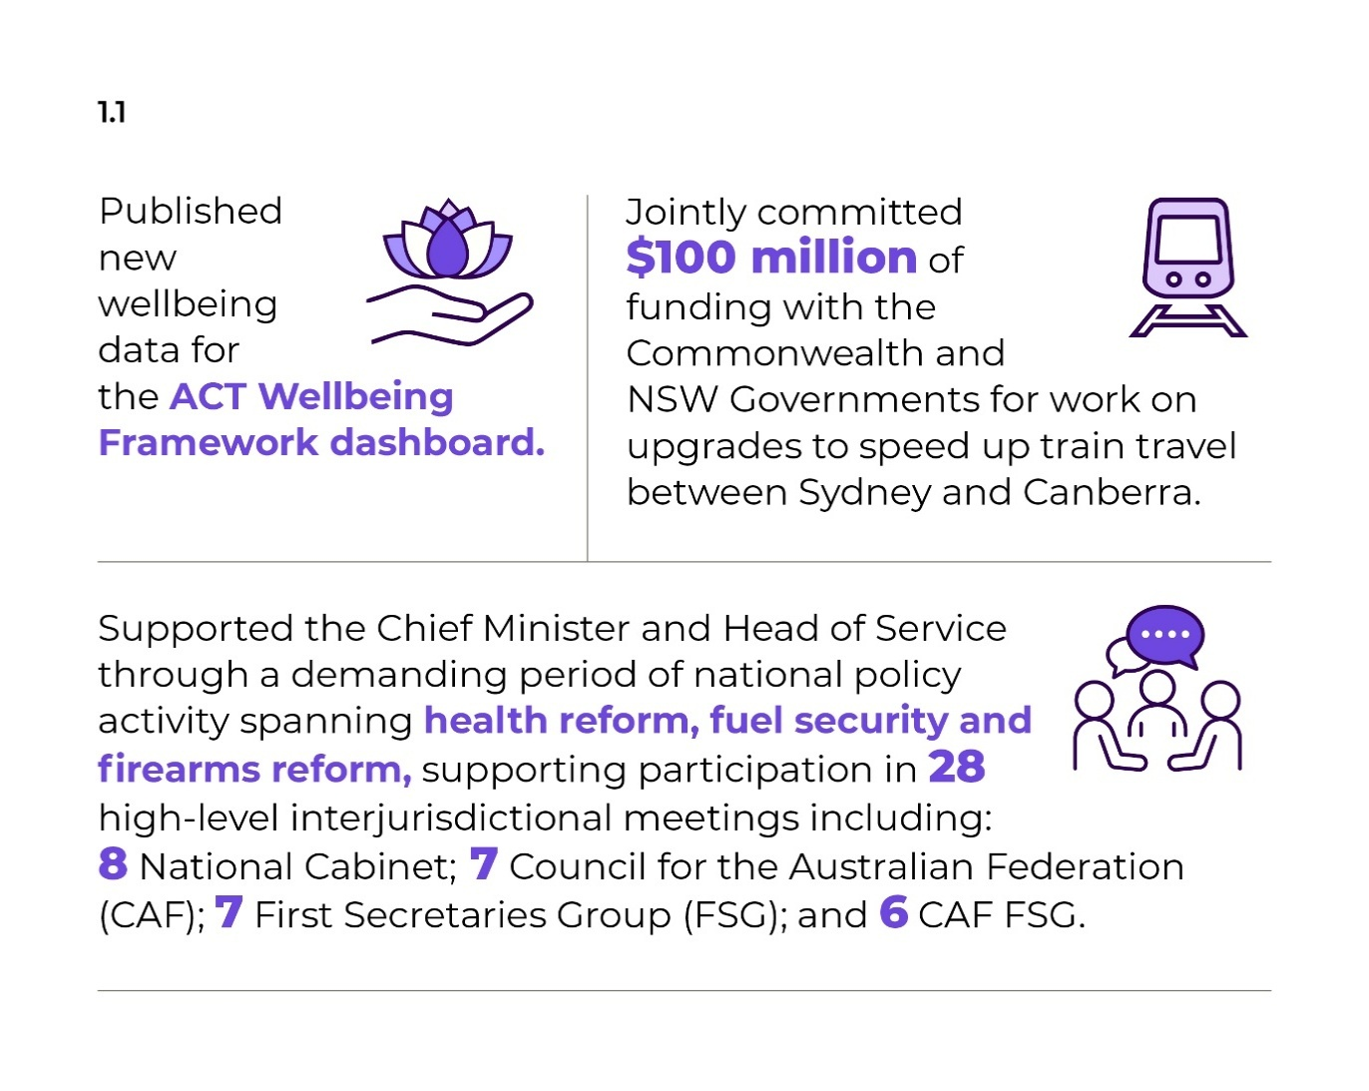
During 2025-26, we also:
- Delivered an ACTPS-wide policy development information hub to strengthen ACTPS policy capability.
- Progressed the ACT’s pilot implementation of the Life Course Data Initiative in partnership with the Australian Bureau of Statistics, the Australian National University and ACT directorates.
- Provided strategic direction to the Sydney-Canberra Rail Improvement Steering Committee, resulting in a commitment to $100 million of joint funding for planning and delivery of improvement options for Sydney to Canberra rail.
- Coordinated delivery of some State Government-like services to the Jervis Bay Territory on behalf of the Commonwealth Government.
- Supported the ACT’s participation on the Council of Capital City Lord Mayors (CCCLM), including support for the Chief Minister in his role as 2026 chair.
- Engaged with the NSW Government and local councils on issues that impact the Canberra Region.
- Supported the government’s response to multiple Section 213A requests by providing timely and accurate documentation to the Legislative Assembly.
- Finalised our project to digitise at-risk materials on magnetic media in the ACTHL and Territory Records Office collections, including by establishing our software emulation suite, which allows us to assess and preserve records housed using obsolete software and hardware.
- Released the first Government Commitment progress report for the 11th ACT Legislative Assembly to highlight progress made on government priorities.

Future direction
In 2026-27, we will:
- Continue partnerships with research organisations (University of Canberra, the Australian National University and the CSIRO) to build the wellbeing evidence base.
- Continue to work through cross-border mechanisms on priority initiatives with NSW, including Sydney-Canberra Rail improvements and considering regional water supply.
- Negotiate new key initiatives with the NSW Government under the ACT and NSW MoU for Regional Collaboration.
- Coordinate service delivery to the Jervis Bay Territory on behalf of the Commonwealth Government.
- Continue to support the ACT’s participation on the CCCLM, including the Chief Minister’s role as chair until the end of 2026.
- Continue to support:
- the Chief Minister as Chair of Cabinet
- the Manager of Government Business in the ACT Legislative Assembly
- the Head of Service as Secretary of Cabinet
- Increase the quantity and range of archival material in ACT Government collections that is accessible through our online systems.

Contact
For further information, please contact
Lee Steel
Deputy Director-General, Policy and Cabinet
Lee.Steel@act.gov.au

Output 1.2: Coordinated Communications and Community Engagement
Through the Coordinated Communications and Community Engagement output the Directorate delivers communications and engagement support and protocol services to the ACT Government and community.
The directorate delivers this output by:
- Informing Canberrans about programs, policies and services through the ACT Government’s key channels, including Our Canberra (print, e-newsletter and website) and ACT Government social media channels and the ACT Government website.
- Delivering priority communications and engagement activities for the Chief Minister and the Directorate’s Ministers.
- Coordinating the delivery of priority public information campaigns across government.
- Supporting enhanced whole of government engagement practices, including through greater coordination of engagements and the exploration of engagement targets.
- Providing research and insights services to inform government decision-making and managing the YourSay Panel and digital engagement platform YourSay Conversations.
- Preparing an annual whole of government communications and engagement plan to outline the government’s priority public information campaigns and engagements.
- Offering digital support and services across government.
- Delivering high-quality creative services for priority projects.
- Providing honours and awards, ceremonial and protocol services to the Chief Minister.
- Delivering coordinated communications to the Canberra community in times of Territory emergency.

Performance – Accountability Indicators
During 2025-26, we met 3 out of 4 accountability indicators against this output.
The accountability indicator not met was:
- 1.2d - Annual number of YourSay Panel surveys conducted – we completed 14 research projects against a target of 20. This includes surveys conducted through the YourSay Panel, qualitative research and support for a limited number of off-panel stakeholder surveys. The variance reflects a reduced demand for research activities in 2025-26, due to fewer campaigns across the ACT Government, impacting the overall target of 20.

Highlights
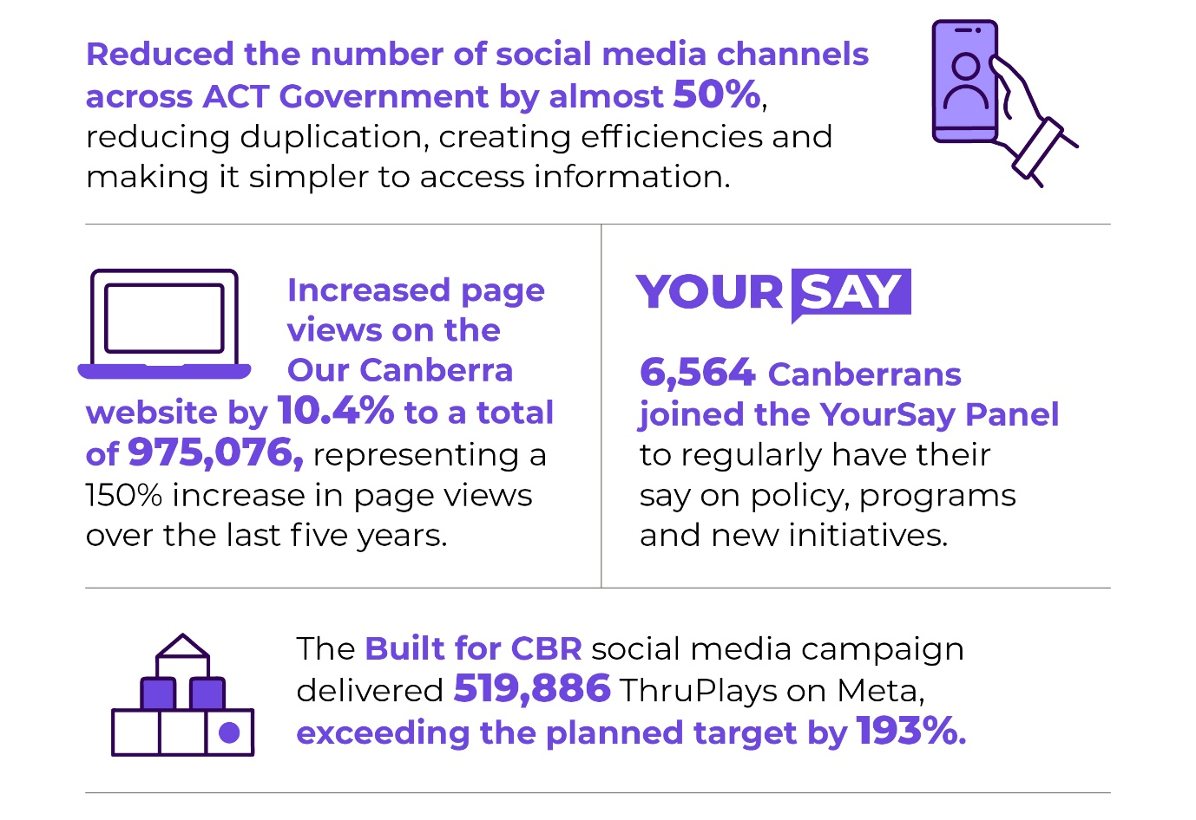
During 2025-26, we also:
- Used valuable research and insights from the community and stakeholders to deliver ACT Government priority information programs, including:
- the 2025-26 ACT Budget
- Infrastructure “Bulit for CBR”
- Housing “Homes for CBR”
- Health Literacy “Know where to go for your health care”
- Affirmative Consent “Great sex starts with consent”
- Be Emergency Ready
- Continued to develop the Open Government section on act.gov.au to support consolidation of access and transparency related content.
- Improved the user experience for members of the public wishing to lodge a Freedom of Information (FOI) request by developing a single online FOI request form for use across ACT Government.
- Continued to focus on updating and informing the Canberra community across the ACT Government social media and Our Canberra channels.
- Facilitated 23 engagements via YourSay Conversations. The top visited projects were:
- Punjabi and Hindi Language Education
- Canberra Aquatic Centre Design Consultation
- Missing Middle Housing Reforms
- Welfare of Dogs in the ACT
- Options to Restore Lake Tuggeranong.
- Recognised outstanding achievements of local Canberrans by delivering the 2025-26 awards program, including 2026 ACT Australian of the Year Awards, 2026 Chief Minister’s Canberra Gold Awards, and 2026 Canberra Citizen of the Year Award.
- Supported the delivery of the Order of Australia honours in the ACT, including the Public Service Medal.
In 2025-26, we continued to grow the ACT Government’s primary social media accounts, delivering accurate and timely information to more Canberrans.
Table 5: Social media followers and impressions
Social media platform | Followers  (% change from 2025-26) | Average monthly impressions  (% change from 2025-26)
Facebook | 81,306 (+13.2%) | 1,881,608 (+ 75%)
LinkedIn | 45,036 (+11.3%) | 103,167 (+ 0.5%)
Instagram | 40,927 (+16%) | 350,586 (+ 9.8%)

Future direction
In 2026-27, we will:
- Lead the prioritisation of the ACT Government’s communication activities by delivering the annual WhoG Communications and Engagement Plan.
- Partner with ACT Government directorates to deliver priority integrated communications approaches identified in the Plan, including campaigns to communicate the most important messages to the Canberra community.
- Increase followers, engagement and the reach of priority ACT Government social media channels.
- Deliver the Our Canberra Print newsletter and Easy Read edition, grow the Our Canberra e-newsletter subscriber list and engagement, and increase page views on the Our Canberra website.
- Embed the operations of the website consolidation project to maintain a simple, unified and customer-focused digital experience for the Canberra community.
- Implement a refreshed ACT Government engagement framework that outlines robust and inclusive minimum standards of engagement to deliver a consistent experience for Canberrans.
- Promote the two main engagement platforms that ACT Government uses to connect with the community to gather their views on policies, programs and initiatives that may impact them.
- Promote priority ACT Government initiatives through external channels, including traditional media.
- Coordinate a series of priority honours and awards processes as well as providing protocol advice and support to the Chief Minister and Head of Service.
- Progress the Territory Coat of Arms/Insignia project, including community consultation.

Contact
For further information, please contact
Trish Johnston
Executive Group Manager, Communications and Engagement
Public Information Coordinator
Trish.Johnston@act.gov.au

Output 1.3: International Engagement
The directorate, through the International Engagement output, supports the economic growth and diversification of the Canberra economy, and enhances Canberra’s global reputation as an innovative, creative, artistic, liveable and welcoming city.
The directorate delivers this output by:
- Oversight and the development and delivery of a targeted program of international engagement activities, including trade missions, inbound delegations, export-promotion programs, and other activities that enhance Canberra’s economic welfare, international connectedness and reputation economically, culturally and socially.
- Working with the Australian Government, including Austrade and its TradeStart program, and key stakeholders, to make education and other export programs readily available to prospective and ongoing exporters.
- Building relationships with the Canberra diplomatic community for the purpose of connections supportive of exporting and enhancing Canberra’s international reputation.
- Providing strategic leadership, oversight and coordination of inbound investment and collaboration opportunities originating from target-market countries.
- Continuing to build Canberra’s government-to-government relationships, including formal sister-city agreements, to raise awareness of opportunities across Canberra’s economic key areas of strength, and ensure alignment with our objectives to expand and diversify Canberra’s economy and its reputation.

Performance – Accountability Indicators
During 2025-26, we met 3 out of 3 accountability indicators against this output, exceeding all its key performance indicators for 2025-26 financial year, including achieving a new record of twelve export outcomes for businesses.

Highlights
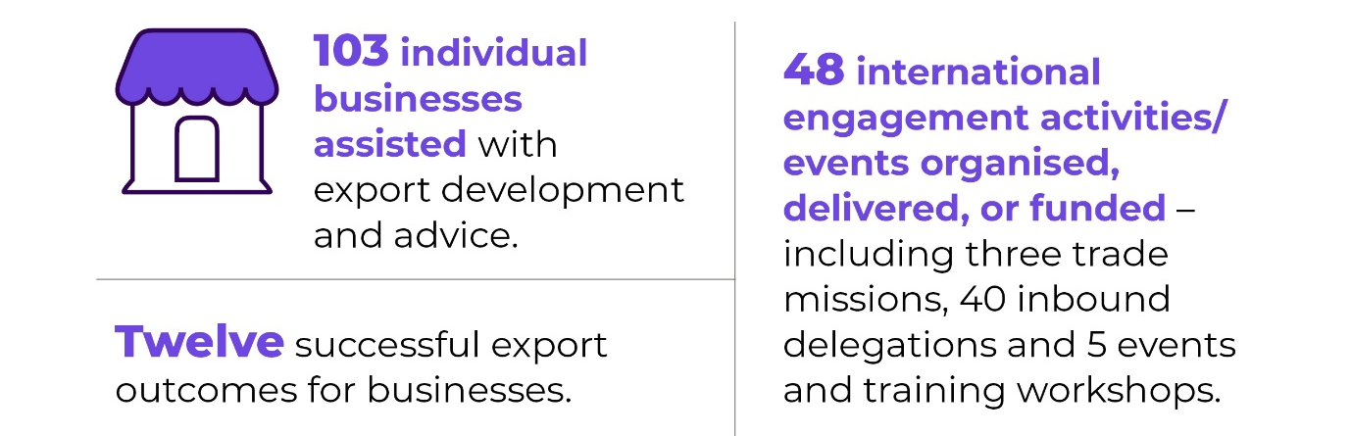
During 2025-26, we also:
- Assisted businesses export into the Fiji market.
- Delivered the 2025 ACT Export Awards.
- Commenced delivery of the Council of Pacific Capital Cities MoU.

Future direction
In 2026-27, we will:
- Continue delivering trade missions that support export development and export flows; attract inbound investment, visitors and tertiary students to the Territory; increase cultural and social connections; and enhance the international reputation of Canberra in general.
- Provide ACT TradeStart Advisor services to a growing number of Canberra businesses that are ready to export or are already exporting and looking to expand.
- Provide ongoing export support to businesses through our Southeast Asia Business Development Manager based in Singapore.
- Continue to deliver the International Business Exchange Program and deliver the ACT Chief Minister’s Export Awards.
- Foster Sister-City relationships with Nara, Wellington and Beijing.
- Continue activity under the new Canberra-Wellington-Suva MoU.
- Deliver the sixth annual ACT Export Day.
- Deliver the sixth Canberra Pacific Forum.

Contact
For further information, please contact
Jonathan Kobus
A/g Commissioner for International Engagement
Jonathan.Kobus@act.gov.au

Output 2.1: Capability and Governance
Through this output, the directorate provides capability and oversight for ensuring a professional, skilled and accountable public service that is responsive to the ACT Government and the community now and into the future including managing whole of government capacity building programs.
The directorate delivers this output by:
- Building an ACTPS workforce culture that supports the Government’s vision of a progressive, sustainable and inclusive Canberra for all Canberrans; with a particular focus on supporting and enabling Aboriginal and Torres Strait Islander staff and the cultural maturity of the ACTPS and attracting and retaining people with disability.
- Driving and delivering whole of government workforce capability development, including through leadership and graduate strategies, and delivery of whole of government learning services.
- Delivering a whole of service survey every second year so that workforce trends and patterns inform strategic decision-making.
- Maintaining and monitoring whole of government ethics and accountability frameworks.
- Supporting the Head of Service, the ACT Remuneration Tribunal, and the Strategic Board and its sub-committees.
- Managing the implementation of the Secure Employment Framework across the ACT Public Sector to build the capability and expertise of the Public Sector and further solidify the role of the ACT Government in modelling good employment practices.
- Supporting public sector efficiency through whole of government workforce capability building, assessment or guidance.

Performance – Accountability Indicators
During 2025-26, we met 4 out of 4 accountability indicators against this output.

Highlights
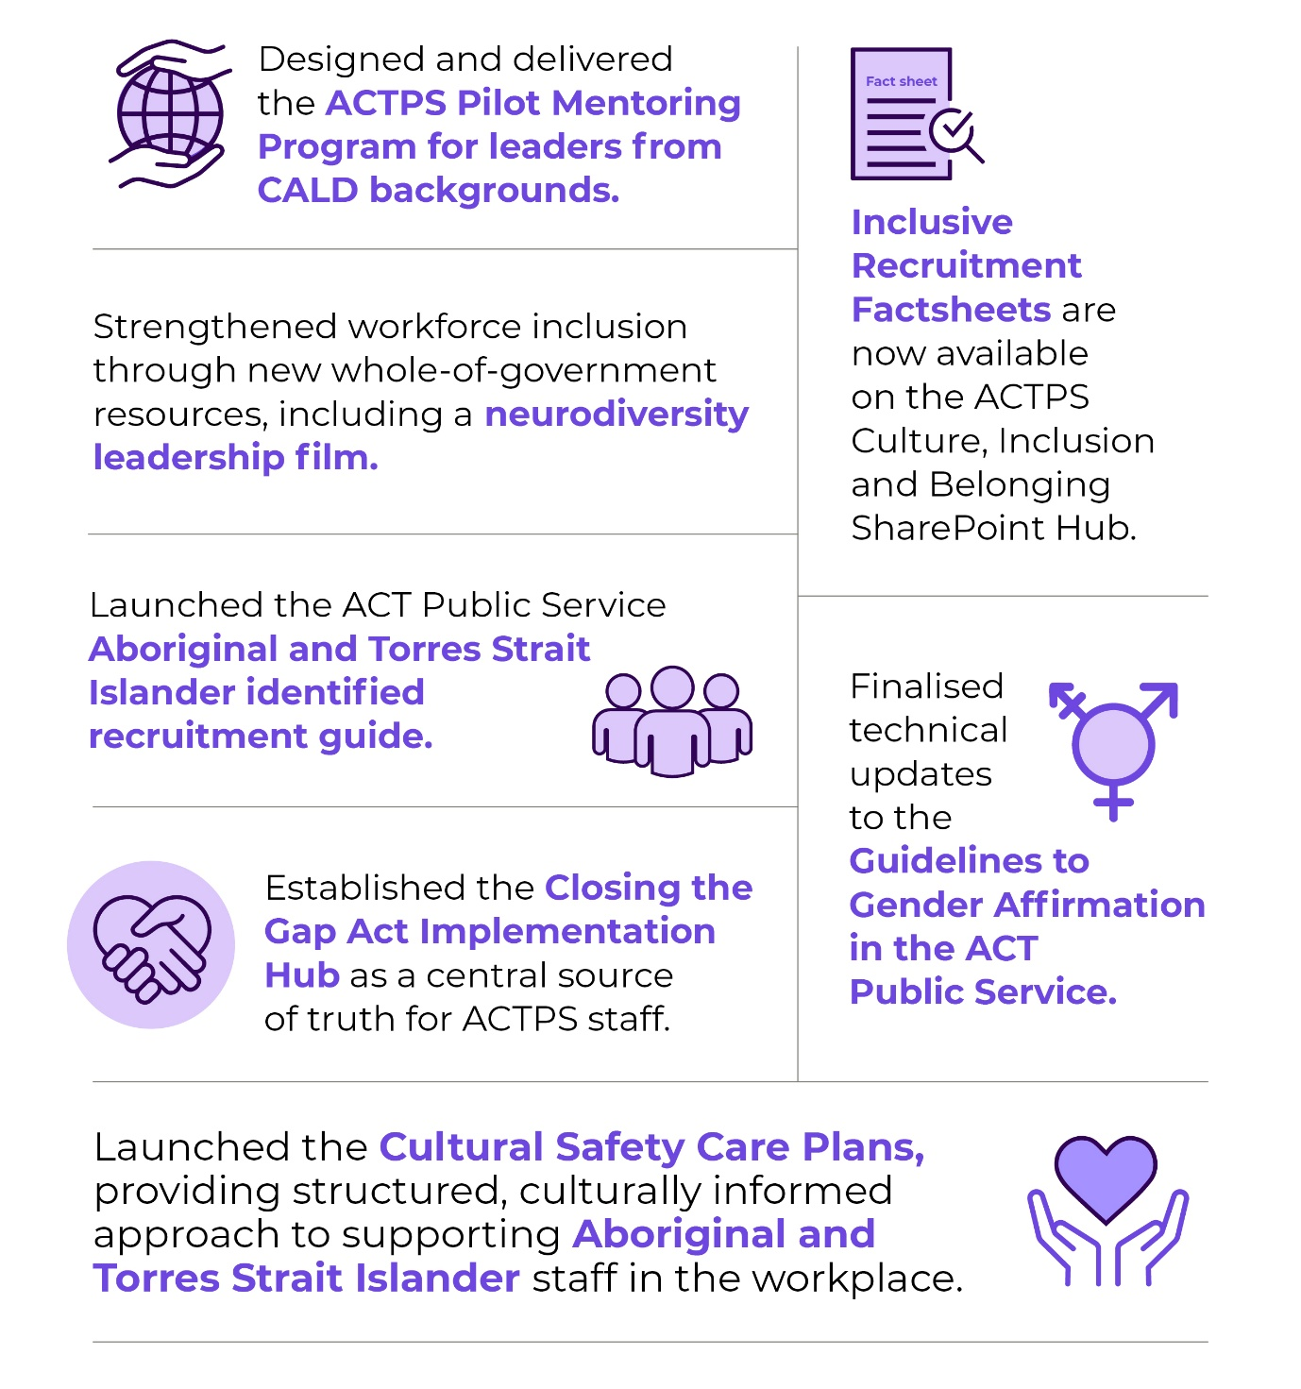

To address future workforce needs and strengthen capability in the ACTPS during 2025-26, we also:
- Delivered the new Senior Executive Service (SES) Induction Program, tailored to newly promoted SES, reinforcing expectations of the SES role, and embedding a focus on Closing the Gap reform priorities.
- Delivered a strengthened SES Speaker Series, designed as a cohesive leadership program aligned to executive capability expectations and key priorities. These sessions foster cross-directorate engagement, enabling shared leadership insight, and promoting a one-service culture.
- Enabled more than 37,000 learning interactions through the WhoG learning and development library in the Learning Management System.
- Delivered 97 policies, guidelines, fact sheets, information sheets and templates to the public service on public sector management issues including Closing the Gap Act implementation, guidance on SES obligations, and Secure Workforce conversion.

Future direction
In 2026-27, we will:
- Progress a strengthened WhoG approach to learning and development through the:
- Analysis of system-wide duplication, governance gaps and opportunities to improve consistency and learner experience.
- Introduction of a new Learning Strategy, prioritising investment in critical capability areas including leadership, cultural capability, digital and data skills and core public sector capability. This will support reform priorities, workforce mobility and long-term workforce sustainability aligned to broader ACT Government outcomes.
- Continue the development of a WhoG inclusion and belonging strategy that is part of a broader approach to create a holistic strategy for inclusive employment for all ACTPS staff, and finalise the draft ACTPS Inclusion and Belonging Strategy. This approach will improve accessibility, clarity and impact of the inclusion agenda in the ACTPS.
- Continue investigations into diversity data in the ACTPS to improve data capture capability by introducing new fields, refreshing existing fields, and better aligning data fields with the ACTPS Employee Survey. These changes will facilitate better visibility of workforce composition, trend analysis, and support evidence-based and strategic decision-making.
- Reforming diversity data on a broader scale means that we can:
- Provide more identification options which better reflect the diversity and lived experiences of our workforce.
- Reduce barriers and increase employee autonomy around self-identification and management of personal information.
- Support employees to feel safe to affirm their authentic identity on their HR21 profile.
- Ensure terminology is contemporary and reflects best practice.
- Develop a whole of government Transformation Strategy that will set the overarching direction for system reform and will establish the ACT Government’s commitments and obligations to transform the way systems, policies, services and decision-making operate in alignment with the National Agreement on Closing the Gap.
- Develop the Cultural Integrity Framework and Systemic Racism Guidelines. These Frameworks/Guidelines may form part of a broader WhoG Transformation Strategy, ensuring alignment with and reinforcement of the ACTPS’s overarching reform agenda.

Contact
For further information, please contact
Robert Wright
Deputy Director-General, Office of Industrial Relations and Workforce Strategy
Robert.Wright@act.gov.au

Output 2.2: Injury Management and Industrial Relation Policy
Through this output, the directorate provides health and work sustainability solutions, focusing on risks arising from work and the relationship between employers and workers.
The directorate delivers this output by:
- Managing ACT workers’ compensation, work health and safety and industrial relations regulatory and policy frameworks.
- Supporting the Secure Local Jobs Code Registrar and their functions under the ACT Government’s secure local jobs code requirements.
- Administering the Secure Local Jobs Code and Ethical Treatment of Workers Evaluation to verify that suppliers and contractors to the ACT Government meet the highest safety and ethical standards.
- Supporting the Public Sector Workers Compensation Commissioner in the management of the Public Sector Workers Compensation Fund.
- Developing and reviewing whole of government health, safety and rehabilitation policies and providing work health and safety services to support the policy framework.
- Supporting workplaces to implement approaches to deliver good work for health and productivity.
- Coordinating the Territory’s consultative bodies for industrial relations regulation, workers’ compensation and work health and safety.
- Administering the Loose Fill Asbestos Disease Support Scheme, on behalf of the Chief Minister, to provide financial assistance to people with an asbestos disease caused by living in a loose fill asbestos insulation (Mr Fluffy) contaminated home.

Performance – Accountability Indicators
During 2025-26, we exceeded 6 out of 6 accountability indicators against this output.

Highlights
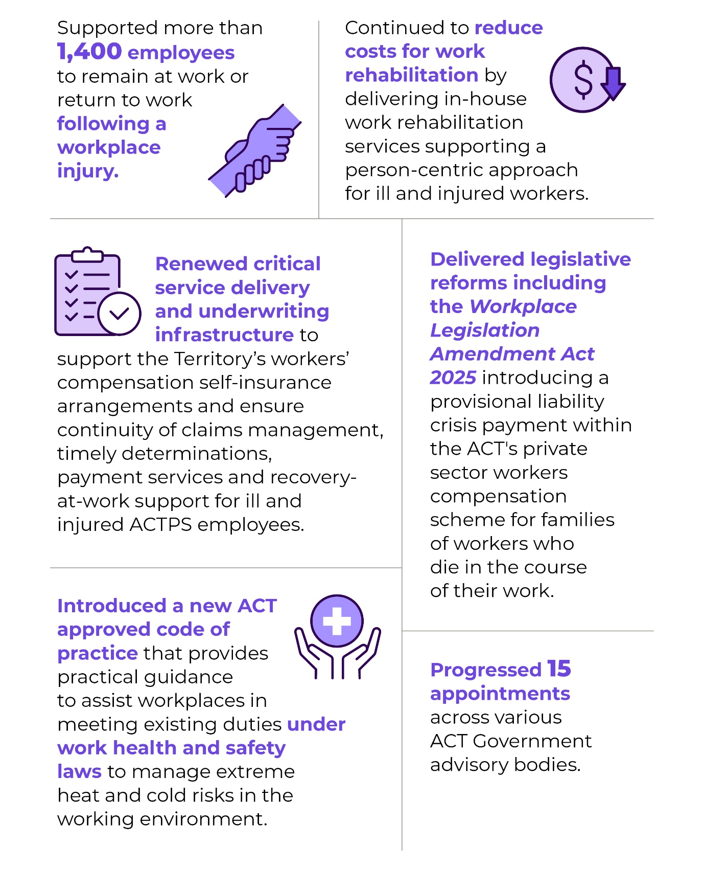
In 2025-26, we continued to support ACTPS workplaces to implement contemporary prevention, health promotion, early intervention and work rehabilitation arrangements, to reduce the impact of illness and injury in our workplaces.
Using the momentum since becoming a self-insured licensee for workers compensation under the Safety Rehabilitation and Compensation Act 1988, we have continued to:
- Focus on ensuring that our leaders, our managers and our workers have the skills and resources to identify, understand and address risks to work health and safety.
- Review, update and develop polices and guidance materials to deliver on our commitment to safe workplaces where staff can participate fully and be productive.
- Ensure that our WHS systems achieve legislative compliance, are effective and accessible for all staff through the delivery of the WhoG WHS Audit and Assurance program.
Managing the psychosocial risks associated with work remains a key focus for the Territory. In May 2026, the ACTPS introduced Before Blue, a free early intervention mental health coaching service developed by Beyond Blue, offering confidential one-on-one support and practical tools for employee wellbeing.
In 2025-26, we:
- Implemented the Determined Indemnity Pathway to address market failure and ensure appropriate Workers Compensation coverage for a high-risk workforce in the ACT horse racing industry.
- Strengthened worker protections through legislative and policy arrangements and improving safety in ACT workplaces.
- Updated an additional seven work health and safety codes of practice in the ACT to align with nationally agreed model codes of practice published by Safe Work Australia, to help workplaces better identify and manage psychosocial hazards, such as stress, bullying, and poor working conditions and include clearer guidance on how to manage risks at work.
- Delivered the annual actuarial scheme performance review of the ACT Private Sector workers’ compensation scheme and published suggested reasonable premium rates by industry for the forthcoming 2026-27 policy year.
- Issued 1,197 secure local jobs code certificates to businesses after an approved auditor review to verify they are complying with workplace obligations and requirements of the Code.
- Conducted assessments under the Government Procurement (Ethical Treatment of Workers Evaluation) Direction 2023 (No 2) in 159 tenders.

Future direction
In 2026-27, we will continue to support ACTPS workplaces through the delivery of safe systems of work, to understand the psychosocial risks associated with work and implement evidence-based initiatives to ensure staff remain safe and healthy at work.
We will also:
- Improve workers’ compensation services, particularly through person centred approaches, for ACTPS workers who become injured or ill because of their work.
- Enhance in-house Work Rehabilitation Services by expanding the team to increase capability and capacity, enabling allied health professionals to deliver targeted, person-centred rehabilitation support.
- Deliver an ongoing legislative reform program to optimise ACT workers’ compensation, work health and safety and industrial relations regulatory frameworks.
- Engage with unions, employer representatives and jurisdictions through national forum participation and local consultative fora on regulatory policy matters under the industrial relations portfolio.
- Support the functions of the Secure Local Jobs Code Registrar by managing the Secure Local Jobs Code certification scheme, assisting Territory entities and tenderers to meet their legislative obligations under the Code and undertaking education and awareness raising activities on the implementation of the Code.
- Assess entities against the Government Procurement (Ethical Treatment of Workers Evaluation) Direction 2023 (No 2) requirements as part of the procurement process.
- Cooperate with the Work Health and Safety Commissioner to ensure data analytic and regulatory policy services are efficient.

Contact
For further information, please contact
Robert Wright
Deputy Director-General, Office of Industrial Relations and Workforce Strategy
Robert.Wright@act.gov.au

Output 2.3: Public Sector Employment
Through this output the Directorate provides an employment and policy framework to support a professional, skilled and accountable public service that is responsive to the ACT Government and the community, as well as delivering transactional human resource services to directorates and agencies.
The Directorate delivers this output by:
- Developing and reviewing whole of government employment policies, regulations and standards and providing industrial relations services to support better employment practices.
- Leading, supporting and coordinating enterprise bargaining, enterprise agreement implementation and application across the service.
- Providing payroll, personnel and recruitment services.
- Delivering salary packaging services for employees across the ACT Government.
- Administering the Annual Report Directions, including management of the review, consultation and promulgation phases.
- Providing secretariat support to the ACT Remuneration Tribunal in reviewing remuneration, allowances and other entitlements for Members of the Legislative Assembly, full-time Statutory Office Holders, Executives, the Judiciary and Part-time Public Office Holders.
- Supporting implementation of the ACT Public Sector Secure Employment Framework to build the capability and expertise of the Public Sector and exemplify good employer practice.

Performance – Accountability Indicators
During 2025-26, we met 2 out of 2 accountability indicators against this output.
- 2.3a - The implementation of Enterprise agreements accountability indicator covers negotiation of ACTPS Enterprise Agreements. During 2025-26, this work involved commencement of negotiations to establish new ACTPS agreements beyond the nominal expiry date of 31 March 2026. The Notice of Employee Representation Rights was issued in July 2025, signifying the formal commencement of bargaining for the new agreements. This complex work will continue into the 2026-27 year.
- 2.3b - The HR Service desk accountability indicator tracks the resolution of service requests within standard service timeframes (five working days). The estimated 2025-26 target of 95 per cent was achieved during the reporting period.

Highlights

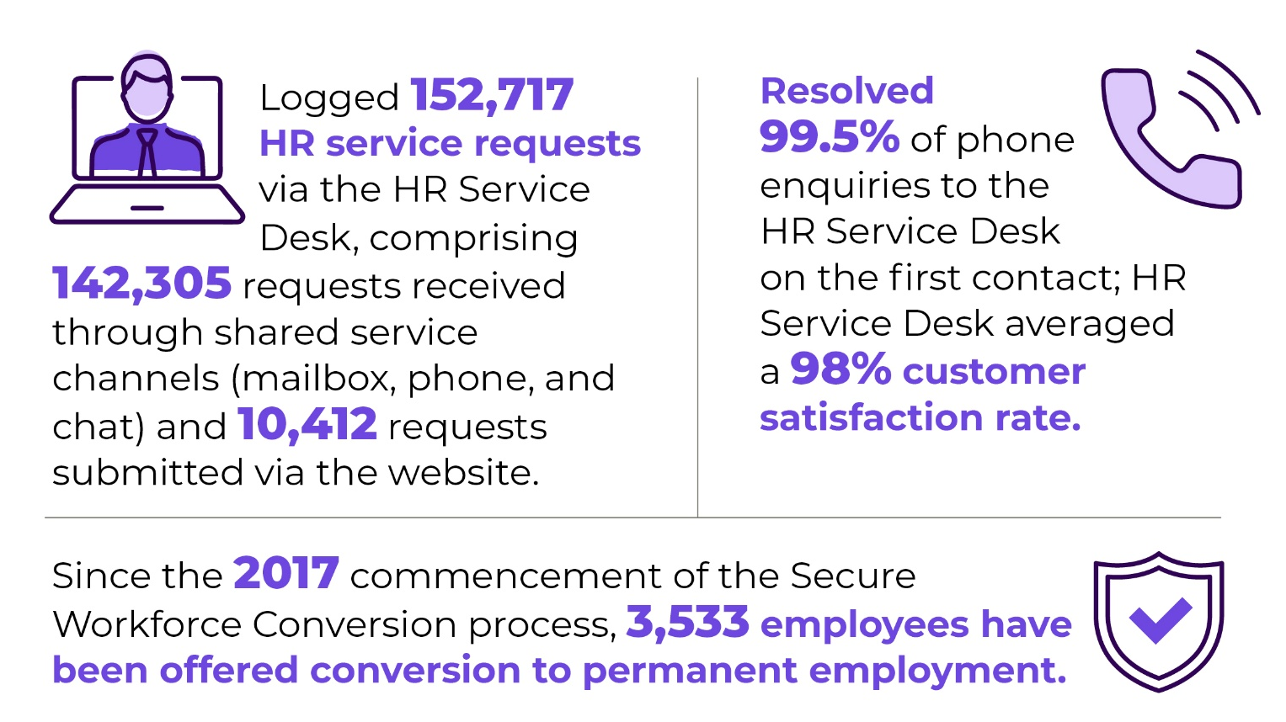Future Direction
In 2026-27, we will:
- Continue negotiations for the next round of ACT Public Service Enterprise Agreements.
- Support the operation of the Secure Employment Framework, including the insourcing framework, secure workforce conversions and the same job same pay commitment.
- Provide secretariat support and strategic advice to the ACT Remuneration Tribunal in delivery of functions associated with the annual Spring and Autumn sittings.
- Review Annual Report Directions for currency and incorporation of emerging reporting requirements.

Contact
For further information, please contact
Robert Wright
Deputy Director-General, Office of Industrial Relations and Workforce Strategy
Robert.Wright@act.gov.au

Output 2.4: Public Sector Standards Commissioner
Through this output the directorate provides support to the Public Sector Standards Commissioner undertaking complaints management and misconduct investigation functions for the ACT Public Sector.
The directorate will deliver this output by allocating resources to the Professional Standards Unit to provide services and undertake functions on behalf of the Commissioner, such as:
- Assessing and appropriately managing referrals for misconduct investigations
- Managing complaints and enquiries made to the Commissioner
- Enquiring into the operations of the Service
- Undertaking misconduct, public interest disclosure and other investigations referred to the Commissioner
- Promoting and providing advice about the public sector values, the public sector principles and conduct required under the Public Sector Management Act 1994

Performance – Accountability Indicators
All 2025-26, accountability indicators against this output were exceeded.
- 2.4a - Number of referrals (investigations and admission statements) managed by the Public Sector Standards Commissioner and the Professional Standards Unit. We achieved 125 against the target of 85.
- 2.4b - Number of complaints and enquiries managed by the Public Sector Standards Commissioner (PSSC) and the Professional Standards Unit (PSU). We achieved 173 against the target of 25.
For a more comprehensive account of the activities undertaken by the PSSC and the PSU during the reporting period, please refer to the 2025-26 State of the Service Report. A summary of the key results against the relevant accountability indicators is provided below.
During 2025-26, 125 misconduct processes were referred to the PSSC from across the ACTPS, with 119 referred from directorates and six by public sector entities. This represents an increase on an annual basis from the previous year, during which 110 misconduct matters were referred. Of the 125 misconduct processes referred this financial year, 119 were allocated to the PSU for investigation, admission statement, management or assessment. Six matters were referred by the PSSC to external investigation services, with oversight maintained by the PSU.
Several factors need to be considered when reviewing misconduct investigation case numbers. For example, case numbers are recorded at the time of receipt of the allegation noting the alleged offending or behaviour may have occurred in previous years, or an incident may have more than one person of interest. Each person of interest is identified as a separate case.
The increase in referral numbers in 2025-26 should be considered in context with actual misconduct findings. 118 misconduct matters were closed during 2025-26 of which:
- 17 matters had outcomes of:
- Resignation: 13
- Discontinued by PSSC: 3
- Withdrawn by directorate: 1
- Of the remaining 101 matters, 57 per cent resulted in a finding of misconduct, compared to 35 per cent of matters in 2024-25
The PSU completed 98 investigation reports for misconduct delegates in 2025-26.

Sanctions imposed
At the end of each financial year, the PSSC requests statistical information from directorates regarding sanction outcomes. Of the 28 outcomes reported to the PSSC in 2025-26, the sanctions imposed (noting multiple sanctions can be imposed by a delegate relating to a single misconduct finding) were:
- Letter of reprimand: 20 matters
- Financial penalty: 9 matters
- Transfer to another position at level or lower: 4 matters
- Termination of employment: 7 matters
- No sanction imposed by the delegate: 1 matter

Complaints and enquiries
In addition to the referrals for investigation, 173 complaints and enquiries were made directly to the PSSC or the PSU. These complaints and enquiries range from general advice to more complex matters which result in a referral for investigation. Capturing this data more accurately reflects the breadth of work undertaken by the PSSC and the PSU. The high number of complaints and enquiries provided directly to the PSSC and PSU may, in part, be due to the increase in engagement and outreach the PSSC and PSU have undertaken to lift standards across the ACTPS this financial year.

Contact
For further information, please contact
Christina Thompson
Executive Branch Manager
Christina.Thompson@act.gov.au

Output 3.1: Economic Development
Through the Economic Development output, the directorate:
- Delivers on the government’s economic development priorities through programs, policies and initiatives to make Canberra an even better place to live, work, visit, study, invest in and do business.
- Strengthens collaboration with universities, training providers, research organisations, commercialisation entities, businesses and other government agencies to enhance Canberra’s innovation ecosystem and attract responsible investment.
- Attracts visitors to the ACT through innovative tourism marketing and industry development programs, while also delivering, supporting and promoting events that showcase and connect Canberrans, attracts visitors and enriches Canberra’s reputation as a global destination.
- Enhances the wellbeing of Canberrans through participation in organised sport and recreation through the delivery of programs, sporting infrastructure development and supporting player pathways.
- Plans for and designs strategic economic development driving infrastructure such as the new Canberra Convention and Entertainment Centre.
- Contributes to the liveability of Canberra by supporting arts and creative practice that is reflective of our community.
- Supports the skills and workforce agenda for the ACT by facilitating skilled and business migration pathways.
- Manages and maintains key venues including GIO Stadium Canberra, Exhibition Park in Canberra, Corroboree Group Oval Manuka, National Arboretum Canberra and Stromlo Forest Park as premier tourism and recreational attractions.

Performance – Accountability Indicators
During 2025-26, we met 15 out of 22 accountability indicators against this output.
The accountability indicators not met were:
- 3.1h – Canberra and Region Visitors Centre overall visitor satisfaction with customer service. Overall visitor satisfaction with aspects of the Canberra and Region Visitors Centre remained very high at 91.1 per cent but fell short of a 96 per cent target. Key metrics that negatively impacted the overall satisfaction result included ‘ease of finding the centre’ and ‘parking’, related to construction work occurring on Commonwealth Avenue, and changed traffic management and access arrangements for the Regatta Point precinct.
- 3.1m – Satisfaction with the management of grants administered by artsACT. The result reflects the range of experiences reported by applicants who responded to the survey. Of the 52 survey participants who responded to this question, 50 per cent were successful applicants, and the remainder were not successful. Applicants who received funding reported a high-level of satisfaction with the administration of their grants, including notification of outcomes, funding agreements and payment processes. Unsuccessful applicants reported a lower satisfaction rating.
- 3.1p – Number of attendees at programs delivered by artsACT funded organisations. The result reflects attendance across programs delivered by artsACT-funded organisations, including ticketed and non-ticketed events and activities. The result is influenced by attendance at biennial festivals, which affects attendance figures every two years.
- 3.1q (i, ii, iii) – Participation rate of 15-64 year olds in VET. The overall participation rate was less than the target rate. This impacted the participation rates, calculated as a proportion of the overall population, for the relevant student cohorts.
- 3.1r – VET graduate outcomes after training – employed after training or in further study. The percentage of government funded graduates employed after training or in further study in the ACT is the second highest nationally but fell short of the target of 92 per cent. The result of 87 per cent of VET graduates employed after training or in further study in the ACT is higher than the national average of 84.4 per cent.
- 3.1s (i, ii) – Skilled Migration Attraction and Facilitation. The variation is due to the difference between the number of skilled visa nominations requested by the ACT Government (target) and the skilled visa nominations processed, based on allocation from the Australian Government Department of Home Affairs (Result). For average processing time for applications, the variance is attributed to reduced time taken to process applications.
- 3.1t (ii) – Number of Major Events at Manuka Oval. The AFL draw differed slightly in 2025-26 and due to phasing, one less AFL match was conducted during the financial year however, the minimum contracted number of matches occurred during the 2025 calendar year and will occur during 2026.

Highlights
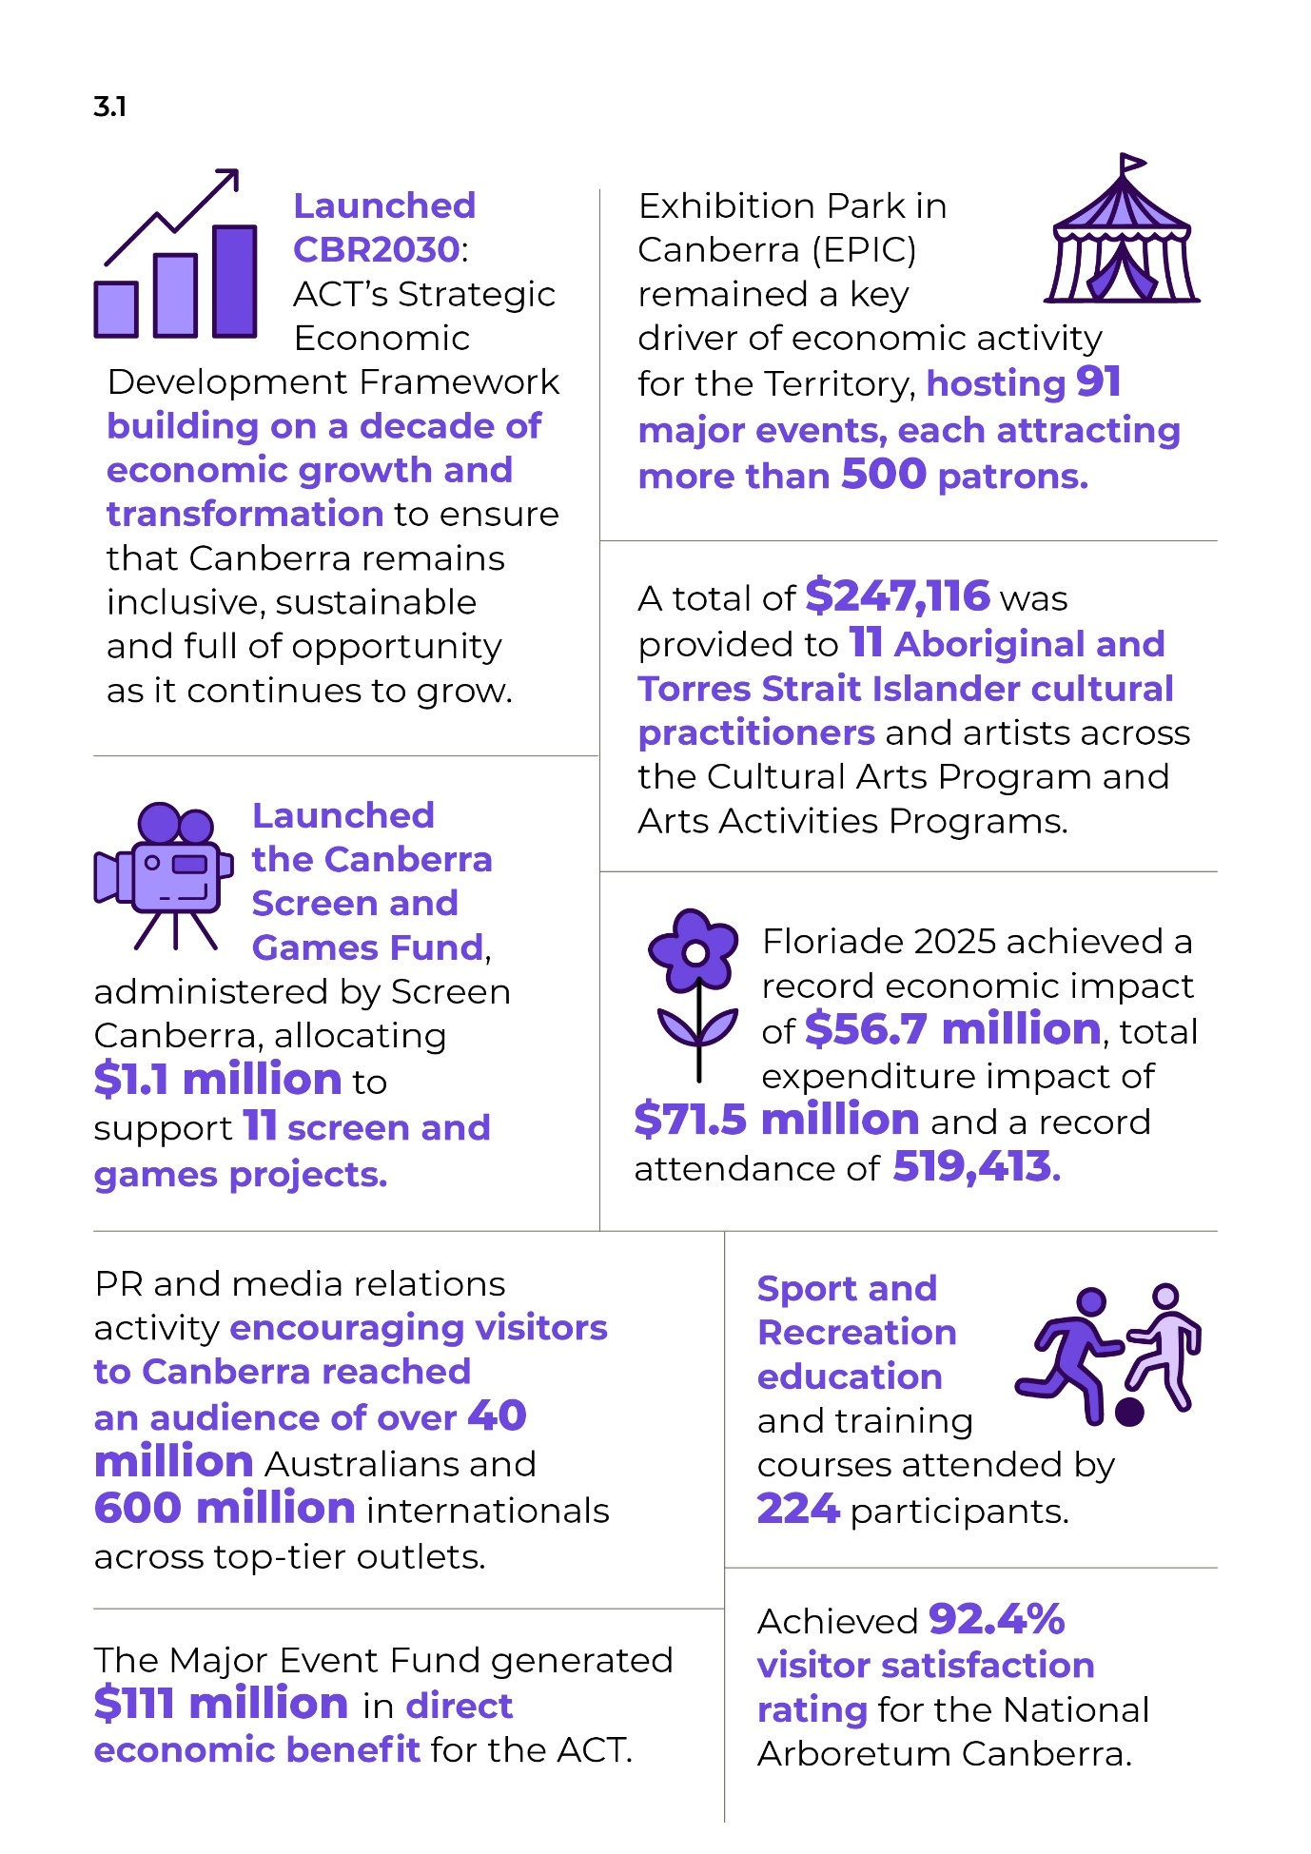

artsACT
During 2025-26 we delivered a total of $12.3 million through the ACT Arts Fund to support artists, arts groups, and arts organisations. Key funding allocations included:
- $81,500 provided for six initiatives under the Aboriginal and Torres Strait Islander Cultural Arts Program.
- A further $165,616 was provided to five Aboriginal and Torres Strait Islander cultural practitioners and artists through the Arts Activities Program.
- Over $9.3 million allocated to 28 organisations through the Arts Organisation Investment Program.
- $696,029 granted to the ANU School of Music and School of Art and Design to deliver community outreach programs.
- Two rounds of project funding ranging from $5,000 to $50,000, totalling $1,074,555 across 33 recipients.
- Throughout the year, a small grants program providing up to $5,000 per project, with $342,419 distributed to 79 recipients supporting a diverse range of arts activities.
- $300,000 provided to Craft + Design Canberra to deliver the 2026 Craft + Design Canberra Festival as a high-quality, collaborative program, expanding inclusion across the sector and contributing to Canberra’s UNESCO City of Design bid.
- $514,148 provided to 15 initiatives under the City of Design Project fund, supporting design excellence and strengthening Canberra’s City of Design profile.
- We continued staged delivery of a $12.9 million major refurbishment of Gorman Arts Centre to enhance functionality, accessibility, safety, energy efficiency and site heritage values.

Venues Canberra
During 2025-26, we:
- Hosted 28 events at GIO Stadium Canberra, including two NRL finals fixtures featuring the Canberra Raiders.
- Hosted major international sporting fixtures, including the ACT Brumbies against the touring British and Irish Lions and the Socceroos versus New Zealand, alongside regular season Super Rugby, NRL and NRLW matches.
- Hosted national cricket at Corroboree Group Oval Manuka including Big Bash League. The successful partnership with the GWS Giants also delivered four AFL and AFLW matches at the venue.
- Hosted international cricket at Manuka Oval including the popular Indian team competing in Men’s and Women’s T20 and the PM’s XI matches.
- Exhibition Park in Canberra (EPIC) continued to host a diverse range of events, including major festivals such as the National Folk Festival, Summernats and the return of Spilt Milk, with 27-time Grammy Award winning artist Kendrick Lamar headlining the event. EPIC remained a key driver of economic activity for the Territory, hosting 91 major events, each attracting more than 500 patrons.

Business, Communications and Engagement
During 2025-26, we:
- Supported 350 local businesses across Canberra with free access to the Canberra Business Advice and Support Service (CBASS) with advice, including business structures, understanding compliance requirements, marketing strategies, and increasing customer numbers.
- Delivered Badji, the ACT Aboriginal and Torres Strait Islander Business Support Program, supporting 96 business engagements with culturally appropriate support, including assistance with workshops, grant applications, marketing, and trade fair participation.
- Funded the CBR Innovation Network to continue working with partners to strengthen the innovation ecosystem, supporting entrepreneurs and start-ups to grow and scale, and generating high value jobs across the ACT economy.
- Enabled local SMEs and institutions in defence, space, cyber, quantum, and advanced technology sectors to showcase at major national industry events via the Team Canberra initiative, including:
- 14 co-exhibitors at the International Aeronautical Congress (IAC) 2025
- 15 co-exhibitors at the Indo Pacific International Maritime Exhibition (Indo Pacific) 2025
- 12 co-exhibitors at the Military Communications and Information Systems (MilCIS) 2025.
- Expanded the scope of activity of the Canberra Cyber Hub to develop local ecosystems, promote ACT capabilities, and attract and retain skilled talent in advanced technology sectors, including space and quantum.
- Launched the Canberra Screen and Games Fund, administered by Screen Canberra, allocating $1.1 million to support 11 screen and games projects. The Fund’s debut was met with overwhelming interest from the digital games, TV and film production communities, reflecting Canberra’s growing reputation as a hub for world-class digital games and visual storytelling.
- Strengthened business communications through enhancements to the ACT Business Hub website and complemented by the CBR Business Update e-newsletter which is distributed to more than 8,000 Canberra business owners and stakeholders on a fortnightly basis.
- Provided $447,500 early-stage commercialisation grant funding to 15 start-ups through the Innovation Connect Grant Program, in partnership with the Canberra Innovation Network (CBRIN).
- Provided $90,000 in grant funding to three social enterprises through the ACT Social Enterprise Grant Program, in partnership with The Mill House Ventures.

Sport and Recreation
During 2025-26, we:
- Established a Para Uplift Unit at the ACT Academy of Sport (ACTAS), in partnership with Paralympics Australia and the AIS, to increase Australia’s representation and medal success.
- Completed preliminary planning and design works for the expansion of the Belconnen Basketball Stadium and secured $37.544 million in construction funding through the 2026-27 ACT Budget.
- Delivered 23 education and training courses, attended by 224 participants, complemented by 676 online course completions through the Play by the Rules partnership. Topics included gender equity, inclusive coaching, and child protection/safeguarding.
- Provided over $4 million in grant funding to 43 organisations through the 2026 Sport and Recreation Investment Scheme.
- Provided $50,000 in grant funding to nine organisations through the Women’s Coaching and Officiating Support Program to provide accredited training for female officials and coaches at any level.
- Supported community infrastructure projects through the Sport and Recreation Investment Scheme, including:
- Removal and replacement of the stadium roof at the ACT Netball Centre
- Upgrades to changerooms at Belconnen Basketball Stadium
- Court conversion to synthetic grass at Majura Tennis Club
- Upgrades to the existing clubhouse at Molonglo Reach for Water Ski ACT

Events ACT
During 2025-26, we:
- Delivered 11 major and community events with a combined attendance of 853,382.
- Funded 27 event organisers through the ACT Event Fund 2025 generating an estimated economic impact of $34.6 million.
- Achieved a record economic impact of $56.7 million and total expenditure impact of $71.5 million for Floriade 2025 and a record attendance of 519,413.
- Achieved record attendance for Lights! Canberra! Action! and the Canberra Balloon Spectacular.
- Released the Floriade 5-Year Plan 2025-2029.

Tourism and Investment
During 2025-26, we:
- Reached an audience of over 40 million Australians and 600 million internationals through PR and media relations activity across top-tier outlets.
- Generated 769,546 engagements and 19.7 million video views through social media activity on Facebook, Instagram, LinkedIn and YouTube.
- Delivered over 49 million ad impressions, nearly 18 million video completions and over 156,000 sessions to visitcanberra.com.au (up 51 per cent) through domestic paid media activity.
- Welcomed 196,505 visitors across 364 days at the Canberra and Region Visitors Centre.
- Saw the Canberra and Region Visitors Centre win the Visitor Information Services category at the Canberra Region Tourism Awards, progressing to the Australian Tourism Awards.
- Collaborated with regional partners such as Destination Southern NSW – highlighted by engagement to develop the Great Southern Trails mountain bike network.
- Facilitated record attendance by Canberra tourism businesses at the Australian Tourism Exchange (ATE) – with a total of 11 local businesses participating.
- Hosted 78 agents across 17 familiarisation tours from key markets including India, the USA, Singapore, Hong Kong, New Zealand and domestic (Inbound Tour Operators).
- Engaged with more than 2,200 travel trade across all key international markets to educate them on selling Canberra as a destination to their clients.
- Worked with the Office of International Engagement to support the ACT Trade Mission to India in February 2026.
- Delivered cooperative student recruitment marketing campaigns with Canberra’s tertiary institutions through the Study Canberra Cooperative Marketing grants.
- Engaged with over 400 education agents and high school counsellors across seven key international markets to educate them on selling Canberra as a study destination.
- Hosted the National Investment Forum for state/territory investment executive and Austrade senior executive to drive collaboration on national investment matters.
- Presented an ACT Spotlight to Austrade global networks, providing Austrade investment practitioners with the latest insights and opportunities in the ACT.

National Arboreum Canberra and Stromlo Forest Park
During 2025-26, we:
- Commenced on Stage one of the Stromlo Forest Park Tracks and Trails Master Plan, including engaging environmental and heritage consultants and initiating detailed design for new tracks and trails.
- Achieved 92.4 per cent visitor satisfaction rating for the National Arboretum Canberra.
- Hosted a range of events at Stromlo Forest Park, with 17 achieving major event attendance thresholds across local and interstate audiences.
- Welcomed 63,281 school students to the National Arboretum Canberra, with participation in facilitated education programs increasing by 12.7 per cent.

Skills Canberra
During 2025-26, we:
- In 2025, 86.9 per cent of government-funded qualification completers in the ACT were employed or in further study after training. This was above the national result of 84.2 per cent.
- Developed and delivered priorities under the National Skills Agreement 2024-2028, including collaboration with the CIT to establish the National Cyber Centre of Excellence and develop projects under the National TAFE Network (NTN).
- Launched completion grants under the National Skills Agreement to pilot innovative projects that help more VET learners successfully complete their training and transition into employment or further study.
- Administered government-subsidised vocational education and training through the Australian Apprenticeship (User Choice) and Skilled Capital programs.
- Funded six initiatives at $941,344 through the Adult Community Education Grants Program, supporting lifelong learning and community engagement.
- Agreed the Clean Energy Capital Federal Funding Agreement, unlocking federal funding to enhance training infrastructure, including facilities, equipment and learning environments, ensuring the ACT’s training system can meet the workforce demands of the clean energy economy.
- Agreed the Turbocharging the VET Workforce Federal Funding Agreement to support recruitment, retention and professional development initiatives that will strengthen the ACT’s VET workforce and improve training outcomes.
- Nominated 1,600 skilled migrants through the ACT Nominated Migration Program, targeting occupations in demand across the Territory.

Policy, Strategy and Projects
During 2025-26, we:
- Launched CBR2030: ACT’s Strategic Economic Development Framework, building on a decade of transformation to ensure that Canberra remains inclusive, sustainable and full of opportunity as it continues to grow.
- Established the ACT Venture Capital Fund, ACTivate Capital to support high-growth potential companies in the Territory. The Fund was registered as an Early Stage Venture Capital Limited Partnership (ESVCLP) and launched in November 2025.
- We progressed commercial negotiations with Telstra, visitor experience concept designs and engagement planning with the local Aboriginal and Torres Strait Islander community as part of the Telstra Tower Revitalisation project.

Strategic Infrastructure Coordination
During 2025-26, we:
- Delivered on Milestone One under the Federation Funding Agreement with the Australian Government which included the Project Plan, Completion of Project Scoping (Functional Design Brief Report) and Delivery Model Analysis for the new National Convention and Entertainment Centre project.
- Progressed the Technical Due Diligence to inform the preferred site of a new stadium.

Future direction
In 2026-27, we will:

Business, Communications and Engagement
- Deliver an expanded Canberra Business Advice and Support Service to include alternative business models and social enterprises within its remit.
- Continue industry event sponsorship and activities to help keep businesses informed.
- Continue funding Screen Canberra to support television, film and digital gaming projects through the 2027 round of the Screen and Digital Games Fund, to develop the local creative industry and attract screen and gaming productions to the ACT.
- Continue to deliver the Badji program, supporting the ACT’s Aboriginal and Torres Strait Islander businesses to start up and access new opportunities.
- Continue working with the CBRIN to support and attract new entrepreneurs to start up and scale up.
- Partner with the Canberra Cyber Hub to support local small and medium enterprises (SMEs) and institutions in space, cyber, quantum, defence industry and advanced technology sectors to showcase at major national industry events via the Team Canberra initiative through participation at key industry events.
- Continue support of the ACT’s growing high-value industries, including cyber security, quantum technologies, space, and advanced technology sectors through continued funding for the Canberra Cyber Hub.

Sport and Recreation
- Deliver a local Our Connection to Country project, in partnership with the Australian Sports Commission, to build culturally safe, inclusive high-performance sport environments.
- Develop a new ACT Aquatic Strategy to guide the planning, management and future investment in territory wide aquatic facilities over the next decade.
- Deliver an independent territory wide report on sporting infrastructure.
- Complete a State Sporting Organisation Categorisation process to determine funding eligibility across Sport and Recreation Investment Scheme funding programs for the next three years.
- Deliver the 2027 Sport and Recreation Investment Scheme.
- Continue the delivery of capital works projects including:
- Construction of the Gungahlin Tennis Facility.
- Feasibility Study and concept design for upgrades to sporting pavilions at primary AFL venues, including Amaroo District Playing Fields and Kambah District Playing Fields.
- Delivery of the expansion of the Taylor District Playing Fields.

Events ACT
- Continue to deliver 12 major and community events that provide social and economic benefits to the ACT.
- Continue to deliver funding and industry development programs that support a diverse and vibrant event calendar for the ACT.
- Continue the implementation of the Enlighten 5-Year Plan 2024-2028 and the Floriade 5-Year Plan 2025-2029.
- Oversee the delivery of the Australian Masters Rowing Championships 2027 and NBL Ignite Cup 2027.

artsACT
- Deliver an updated arts, culture and creative policy for the ACT, which will support the sector to meet current and future challenges and opportunities. The policy will include an updated action plan.
- Continue to deliver support to arts organisations in the ACT, which in 2026-27 will include a 25 per cent increase in funding from 1 January 2027. This increased funding will be administered by artsACT through the Arts Organisation Investment Program.
- Continue to deliver support to the sector through grant funding, by delivering the next rounds of Arts Activities and the Aboriginal and Torres Strait Islander Cultural Arts Fund.
- Complete Stage 2 and commence Stage 3 construction of the $12.9 million upgrade project at the heritage-listed Gorman Arts Centre.
- Install the public artwork celebrating community volunteer Stasia Dabrowski OAM by artist Louise Skačej.

Tourism and Investment
- Continue to work collaboratively with tourism businesses, partners and other industry stakeholders to support growth of the ACT’s visitor economy.
- Continue to market the Canberra region to domestic and international target audiences through marketing campaigns, social media content, public relations activity, content partnerships, distribution development activities and travel trade engagement.
- Continue to support a diverse range of tourism-driving events through an expanded Major Event Fund.
- Continue investment attraction activities, including Investor Concierge services, Foreign Investment Review Board support, trade missions, and collaboration with Austrade and national forums.
- Continue to partner with Canberra’s tertiary institutions to attract international students and support positive student experiences and connections.

National Arboretum Canberra and Stromlo Forest Park
- Continue to progress the staged implementation of the Stromlo Forest Park Tracks and Trails Master Plan. This will include design development, delivery of selected built elements, and improved signage for interpretation and wayfinding.
- Upgrade and maintain key assets across both the National Arboretum Canberra and Stromlo Forest Park through the delivery of the 2026-27 Asset Renewal Program of projects.

Venues Canberra
- Continue to host significant events at GIO Stadium Canberra, Corroboree Group Oval Manuka and Exhibition Park in Canberra that provide social connection and deliver economic benefits for the Territory. In addition to the regular calendar of events, the Wallaroos will compete against Scotland in October 2026.
- Maintain and enhance the above venues by delivering infrastructure upgrades including arena lighting and roof repairs to the Coorong and Budawang pavilions at Exhibition Park in Canberra, and commence improvements at GIO Stadium Canberra by undertaking capital works to the East and West Grandstands. Further works will include lighting upgrades to an effective LED solution for the field of play to ensure flexibility and reliability and improvements to the concourse.

Skills Canberra
- Continue to lead the implementation of ACT commitments under the National Skills Agreement through effective governance, stakeholder engagement and partnership with the Australian Government, industry, training providers and community organisations.
- Continue administration of the current Free TAFE program and work with the Commonwealth Government on the extension of Free TAFE in the ACT.
- Administer government-subsidised VET through the Australian Apprenticeships (User Choice) and Skilled Capital programs, working collaboratively with industry partners, Australian Apprenticeship Support Network providers (ACAPs), Registered Training Organisations and employers to ensure training delivery is responsive to workforce needs and supports strong learner and employment outcomes.
- Manage the State and Territory nominated stream of the Australian Migration Program, working with the Australian Government, industry and employers to ensure migration settings and nomination priorities align with the ACT’s workforce needs and help address critical skills shortages.
- Review and update the ACT Skills Action Plan to strengthen the ACT’s skills system and ensure it supports current and future workforce needs.

Policy Strategy and Projects
- Progress a governance review of the CIT.
- Finalise commercial negotiations with Telstra and finalise visitor experience design work as part of the Telstra Tower project, informed by continuing engagement with Traditional Custodians.
- Finalise amendments to the Building and Construction Industry Training Levy Act 1999.
- Continue to support a more harmonised tertiary education sector and maintain strong intergovernmental relationships.
- Continue to support the local innovation ecosystem, including through the ACTivate Capital venture capital fund.

Strategic Infrastructure Coordination
- Progress Milestone 2 and 3 of the new National Convention and Entertainment Centre project which includes engaging a consultant for the Project Management Contract Administration (PMCA) and reference design procurement and Reference Design Development.
- Progress planning for a Functional Design Brief, Concept Design Report and Cost estimates for Canberra Stadium.

Contact
For further information, please contact
Kate Starick
Deputy Director-General, Economic Development
Kate.starick@act.gov.au

Output 4.1: Economic Management
The Economic Management output incorporates the provision of advice to the government on:
- Economic and revenue analysis, and economic policy.
- Management of Federal Financial Relations.
- The development of major infrastructure projects, including unsolicited proposals and financing options.
- Insurance policy and regulation/administration of the Motor Accident Injuries and Lifetime Care and Support schemes.
The directorate delivers this output by:
- Monitoring and providing advice on the state of the ACT economy.
- Preparing economic forecasts and revenue forecasts for own source revenue.
- Undertaking analysis and modelling to provide demographic projections.
- Publishing tax expenditure statements.
- Facilitating the development and review of taxation reform.
- Providing advice on a wide range of policy matters considered by government in terms of economic and regulatory impacts, competition reform, cost of living and industry sectoral matters, including economic regulation of water and energy markets.
- Coordinating the function and responsibilities provided under the Intergovernmental Agreement on Federal Financial Relations.
- Coordinating and/or contributing to:
- Heads of Treasuries, Board of Treasurers and Council on Federal Financial Relations processes.
- ACT Government involvement with the Commonwealth Grants Commission.
- Providing advice on the performance of selected government entities, including emerging issues and associated corporate governance arrangements.
- Providing advice and regulating the Motor Accident Injuries (MAI) Scheme.
- Administering the Lifetime Care and Support (LTCS) Scheme.
- Continuing to undertake economic analysis and advice to support the emissions reduction initiatives, provide oversight of the Sustainable Household Scheme, and guidance into the Zero Emissions Government Loan Fund.
- Advising on the development of infrastructure projects within the Capital Framework.
- Providing financial and commercial advice on the development and procurement of Public Private Partnership (PPP) and other major, complex infrastructure projects, and managing life-of-project transactions for PPP projects.
- Maintaining and providing training on the policy frameworks that support the development and delivery of infrastructure projects, including the Capital Framework, Guidelines for Unsolicited Proposals and Guidelines for PPPs.

Performance – Accountability Indicators
During 2025-26, we met 6 out of 6 accountability indicators against this output.
Two accountability targets were exceeded during the reporting period:
- 4.1b - Briefings on the ACT economy. This was exceeded due to the additional Monthly Consumer Price Index briefings.
- 4.1c - Coordinate government participation in intergovernmental Treasury fora. This was exceeded due to the increased intergovernmental activity associated with health and disability reform negotiations and international developments affecting the Australian economy.

Highlights
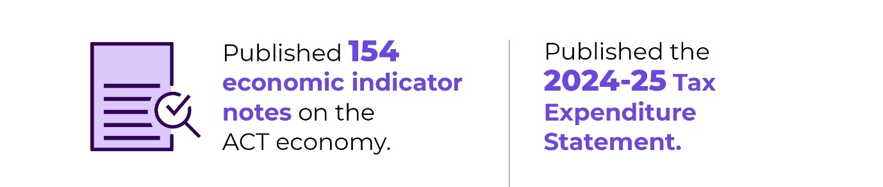
During 2025-26, we also:
- Supported the government’s engagement with the Productivity Commission inquiry into the 2018 GST distribution reforms, building on methodological improvements to resident population estimates that increased the Territory’s GST share.
- Published the 2024-25 Tax Expenditure Statement.
- Supported the negotiation of major intergovernmental funding agreements, including the Addendum to the National Health Reform Agreement.
- Finalised a second tranche of National Competition Policy reforms across health, transport, planning and labour mobility in collaboration with the Commonwealth, states and territories.
- Supported the delivery of treatment, care and support services to people catastrophically injured in motor accidents through the LTCS Scheme.

Future direction
In 2026-27, we will:
- Continue to monitor and advise on the ACT economy.
- Work across the ACTPS and with the Commonwealth, states and territories on key intergovernmental agreements.
- Engage with the Commonwealth Grants Commission on GST distribution matters.
- Implement National Competition Policy reforms and investigate pathways for future reforms under the NCP Funding Agreement.
- Progress the 2026 review of the Motor Accident Injuries Act 2019.
- Work with the MAI Commission to implement the net profit mechanism for the MAI Scheme.
- Support the government to progress the ACT tax reform program.
- Maintain strategic financial oversight of selected government business entities, including Icon Water, the Suburban Land Agency and the City Renewal Authority.
- Monitor and analyse the impacts of ACT taxes and provide evidence-based advice to improve the efficiency, equity and sustainability of the Territory's tax system.

Contact
For further information, please contact
Michelle Dowdell
Deputy Under Treasurer
Michelle.Dowdell@act.gov.au

Output 4.2: Financial Management
Through the Financial Management output the directorate provides analysis, monitoring and reporting on the financial performance of agencies, the Territory’s budget, and major projects, management of financial investment assets and borrowing and superannuation liabilities and assists the ACT Government to achieve its policy objectives.
The directorate delivers this output by:
- Managing the preparation and presentation of the ACT Government’s annual budget, budget review and annual financial statements.
- Providing quarterly whole of government consolidated financial reports.
- Reporting to external agencies including the Australian Bureau of Statistics, and the Commonwealth Grants Commission.
- Providing advice to the ACT Government on financial and budget policy issues.
- Reviewing government programs and functions.
- Managing the Territory’s borrowings, financial investments, cash and liquidity needs and the defined benefit employer superannuation liabilities through the Territory Banking Account and the Superannuation Provision Account.
- Preparing annual and monthly financial statements across government in accordance with legislative requirements.
- Providing accounts payable, accounts receivable, banking, debt management and salary packaging support functions.
- Preparing and lodging Fringe Benefits Tax and Goods and Services Tax returns, and Business Activity Statements, in accordance with Australian Tax Office obligations.
- Managing core whole of government applications that underpin financial activity, including interaction with government banking platforms.

Performance – Accountability Indicators
In 2025-26, we met or exceeded, 11 out of 11 accountability indicators against this output. We exceeded our target for:
- 4.2k - Finance service requests made via the Service Desk are resolved within Service Standards timeframes. We achieved a result of 99 per cent against a target of 95 per cent. The higher achievement rate is a result of improved capability on the Service Desk, which has enabled better customer outcomes.

Highlights
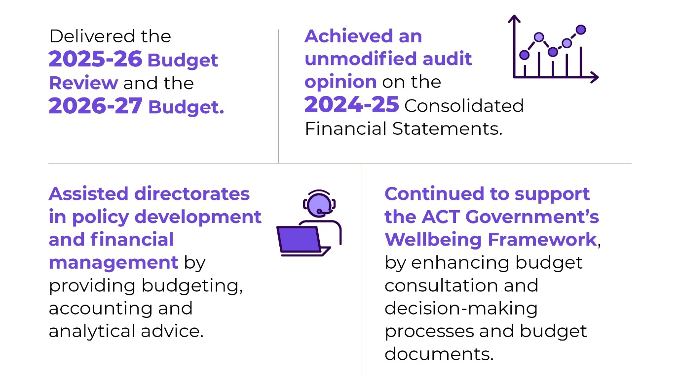
During 2025-26, we also:
- Provided regular updates to the Expenditure Review Committee of Cabinet on the Territory’s finances, allowing the government to manage public finances appropriately and maintain a strong balance sheet.
- Provided advice to the Expenditure Review Committee of Cabinet on new spending proposals to enable the government to prioritise available resources.
- Prepared the Annual Financial Statements for the Territory, which were provided to the Auditor-General in the required timeframe.
- Prepared the Quarterly Consolidated Financial Statements, which were presented to the Legislative Assembly in the required timeframe.
- Prepared the budget appropriation bills – the Appropriation Act 2025-26 and Appropriation (Office of the Legislative Assembly) Act 2025-26.

Future direction
In 2026-27, we will:
- Support the government in delivering the 2026-27 Budget Review, the 2027-28 Budget and the Territory’s Consolidated Financial Statements.
- Coordinate the government’s budget processes and report on financial outcomes.
- Prepare the budget appropriation bills.
- Provide regular updates to the Expenditure Review Committee of Cabinet on the Territory’s finances to allow the government to manage the public finances appropriately and maintain a strong balance sheet.
- Review the Financial Management Act 1996 to ensure it remains fit for purpose and supports contemporary standards of public sector financial management, accountability, transparency and Legislative Assembly scrutiny.
- Continue to support the effective use of the ACT Government’s Wellbeing Framework in decision making.
- Work with directorates to ensure sound financial management and high-quality policy advice to Cabinet.
- Support the implementation of the WhoG Enterprise Resource Planning (ERP) system.
- Continuously assess internal controls to ensure that they are robust in preventing fraud.
- Ensure that arrangements are in place to maintain the WhoG Banking Agreement for directorates and Territory Authorities to utilise products and services beyond 30 September 2027.

Contact
For further information, please contact
Michelle Dowdell
Deputy Under Treasurer
Michelle.Dowdell@act.gov.au

Output 5.1: Revenue Management
Through the Revenue Management output, the directorate provides for the administration of the ACT Government’s taxation revenue.
Revenue Management (ACT Revenue Office) delivers this output by:
- Collecting taxation revenue in accordance with legislation.
- Providing high-quality and timely advice to assist taxpayers in meeting their obligations.
- Processing objections to taxation assessments and decisions, in accordance with timeframes published on the ACT Revenue Office website.
- Ensuring the integrity, consistency and effectiveness of the ACT’s taxation system through prioritised compliance programs and regular reviews of legislation.
- Processing concessions in accordance with legislation.
- Administering Rental Bonds.

Performance – Accountability Indicators
In 2025-26, we met 1 out of 5 accountability indicators against this output. The accountability indicators not met were:
- 5.1a Debt management – level of overdue rates as a percentage of total rates revenue. Rates debt levels have remained above the accountability indicator since the COVID pandemic when debt recovery activities were suspended. The result for 2025-26 is comparable with the performance for 2024-25. Debt recovery strategies continue, which consider sensitivities in the context of cost-of-living pressures and other factors to progressively reduce debt.
- 5.1b Debt management – level of overdue debt as a percentage of tax revenue (not including rates). Other debt levels (excluding rates) continue to be influenced by the ongoing effects of legacy debts from the COVID-19 pandemic period when there was a reduction in debt recovery action. While debt levels have remained above the accountability indicator in the post COVID period, there has been an improvement from the 2024-25 result. Recovery efforts continue to focus on reducing debt levels around payroll tax, duties and land tax.
- 5.1c Internal reviews of objections completed within 6 months.
- 5.1d Internal reviews of objections completed within 12 months.
5.1c and 5.1d targets were not met due to high objection and appeal numbers for the last three years which has a flow through impact on the ACT Revenue Office's ability to meet objection completion timeframes. In addition, the Revenue Office is responding to complex tax arrangements and appeals that require more time and resourcing. The number of reviews of objections completed substantially increased in the second half of 2025-26.

Highlights
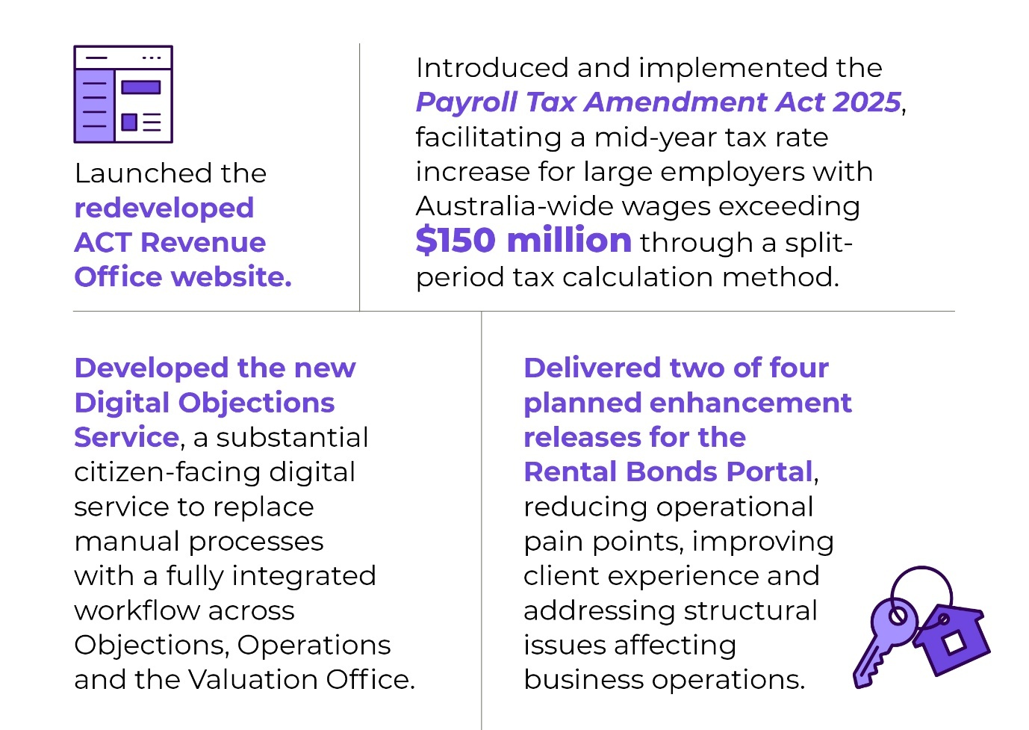
During 2025-26, we also:
- Administered the ACT tax laws, managed the assessment and collection of ACT taxes and administered concessions, exemptions and grants consistent with the government’s policies.
- Commenced implementation of agreed actions flowing from the ACT Ombudsman’s inquiry into historical land tax debt.
- Provided advice to government and commenced actioning matters arising from:
- the Standing Committee on Public Accounts and Administration inquiry into the Home Buyer Concession Scheme Administration.
- the ACT Audit Office performance audit of the Management of the Home Buyer Concession Scheme.
- Implemented the new payroll tax-free threshold for commencement on 1 July 2026.
- Commenced planning and design for the future IT needs of the ACT Revenue Office. This included completing Technology Market Testing.
- Implemented a new graph database capability as part of ongoing business intelligence improvements.

Future direction
In 2026-27, we will:
- Continue to implement matters arising from reports of the ACT Ombudsman, the Standing Committee on Public Accounts and Administration, and the ACT Auditor-General. This includes updating penalty tax and interest circulars; and developing a debt management policy.
- Implement the New Unit Title Duty Exemption.
- Participate in the review and reform of the Lease Variation Charge.
- Complete the Rental Bonds Improvements Project, delivering two further releases to support real estate agents, tenants, lessors and staff.
- Deliver infrastructure upgrades to the Rates and Land Tax system to sustain the platform in the short-term.
- Continue the refresh of ACT Revenue Office website content.

Contact
For further information, please contact
Lisa Holmes
Executive Group Manager, Revenue Management Group
Lisa.Holmes@act.gov.au

Output 6.1: Procurement
Through the Procurement output, the directorate has oversight of the ACT Government procurement framework. We assist ACT Government and suppliers through advice, support and services.
The Directorate delivers this output by:
- Managing and developing the legislation and policy that underpin the ACT Government’s procurement framework ensuring it is aligned to the needs of the Territory.
- Uplifting procurement capability across the service by offering a range of training and knowledge sharing opportunities, including by coordinating a procurement community of practice and procurement e-Newsletters.
- Administering the whole of government procurement systems, including ACT Government online tendering and contracts register platforms, to comply with legislative obligations.
- Representing the ACT Government in cross-jurisdictional engagement on procurement policy matters, including in relation to international trade agreements.
- Working in collaboration with the ACT Government’s Better Regulation Taskforce to reduce barriers faced by small to medium enterprise in accessing ACT Government procurement opportunities.
- Providing procurement advisory services to Territory entities to support the pursuit of value for money in strategic goods and services procurement.
- Supporting Territory Entities in undertaking low risk goods and services procurements by providing guidance and templates.
- Supporting active consideration of ethical, environmental, economic and social factors to ensure procurement processes reflect the values of the ACT Government and community.
- Developing and maintaining templates and standardised procurement guidance, documentation and processes to support all procurement.
- Applying contemporary category procurement knowledge and contract management skills to establish and manage cost effective whole of government arrangements for categories such as travel, electricity, stationery and fleet.

Performance – Accountability Indicators
We met 2 of our 4 accountability indicators against this output. The indicators not met were:
- Indicator 6.1b – Public satisfaction with tender systems was not achieved. User satisfaction with the Tenders ACT tendering system was 80.73 per cent against a target of 85 per cent. Survey feedback identified search functionality and ease of use as key areas for improvement. Enhancements to search functionality have since been implemented and further improvements will continue to be explored.
- Indicator 6.1c – Territory entity staff satisfaction with procurement training achieved a result of 83.64 per cent against a target of 85 per cent for eLearning delivery. For in-person training delivered by the Probity and Supplier Complaints Service, 96 per cent of respondents rated the training as good or excellent and 100 per cent indicated they could apply the knowledge gained in their role and would recommend the training to others. Further refinements to online training are scheduled for 2026-27 as part of the training and capability forward work program.

Highlights
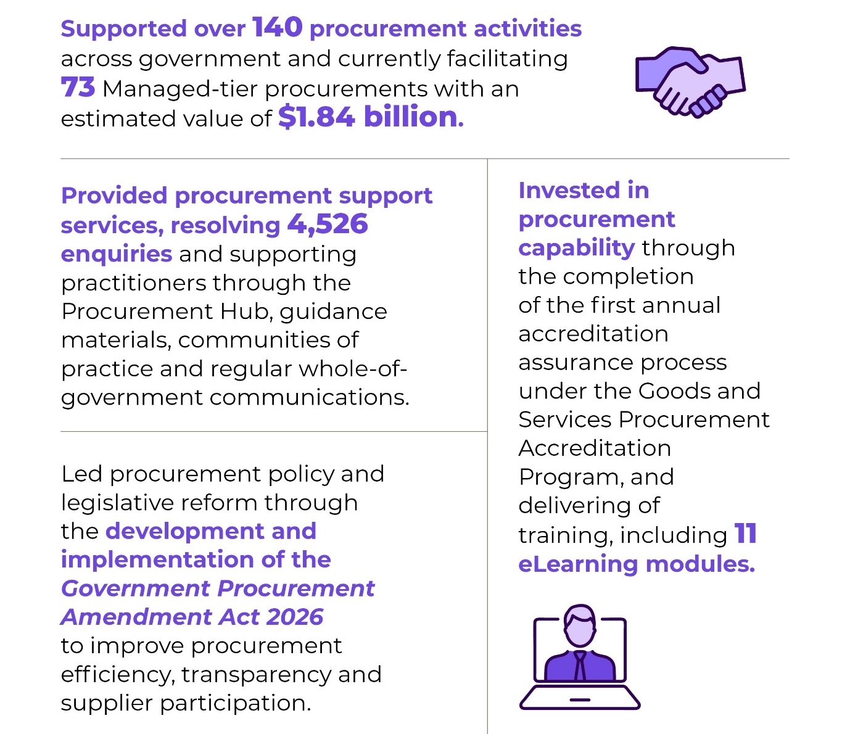

Future direction
In 2026-27, we will:
- Enhance procurement capability across government through updated training, guidance, resources and targeted engagement.
- Strengthen procurement policy, guidance and digital resources to support consistent, efficient and defensible procurement practices across government.
- Administer the Goods and Services Procurement Accreditation Program and maintain Level 4 (Advanced/Lead Buyer) accreditation across all goods and services categories.
- Continue delivery of the Tiered Service Support model, providing procurement services aligned to the capability, capacity and risk profile of Territory entities.
- Continue to provide trusted probity advisory and supplier complaints services to support ethical, transparent and accountable procurement outcomes across government.
- Support the Government Procurement Board through high-quality secretariat and governance services.
- Consolidate the implementation of procurement reforms that improved transparency, streamline processes and created greater opportunities for local businesses and Aboriginal and Torres Strait Islander enterprises.
- Manage WhoG procurement arrangements to deliver value for money, sustainability and other strategic procurement outcomes.

Contact
For further information, please contact
Chantel Potter
A/g Executive Group Manager, Procurement ACT
Chantel.Potter@act.gov.au

EBT 1.1: Superannuation Provision Account
This output involves the management of the Territory’s defined benefit employer superannuation liabilities and financial investment assets.
The directorate delivers this output by:
- Managing the Investment Plan and reporting on the financial investment assets set aside to fund the Territory’s defined benefit employer superannuation liability.
- Completing the annual superannuation liability valuation review of the Territory’s Commonwealth Superannuation Scheme and Public Sector Superannuation Scheme defined benefit employer superannuation liability.
- Managing the defined benefit superannuation liability funding plan and emerging cost payments to the Commonwealth Government in respect of the Territory’s employer share of employee retirement benefits.
- Completing the annual Member Information Statements for the Members of the Legislative Assembly Defined Benefit Superannuation Scheme, with calculation and settlement of benefit determinations as required.
- Budgeting and financial reporting on the operations of the Superannuation Provision Account.

Performance – Accountability Indicators
We met all the 2025-26 accountability indicators against this output.

Highlights
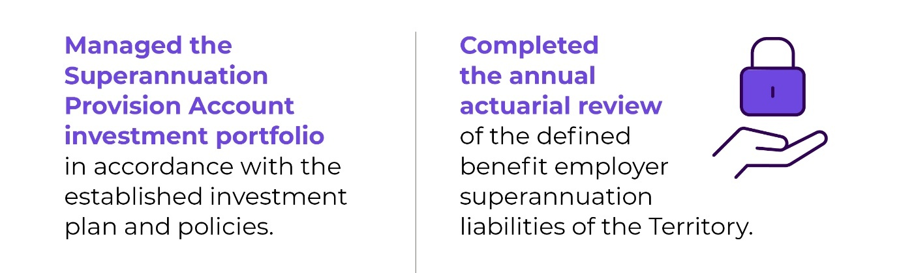

Future direction
In 2026-27, we will:
- Complete the triennial actuarial review of the defined benefit employer superannuation liabilities using salary and membership data as at 30 June 2026.
- Monitor the funding plan to extinguish the unfunded defined benefit superannuation liability.
- Manage the Investment Plan and the financial investment assets of the Superannuation Provision Account.

Contact
For further information, please contact
Patrick McAuliffe
Executive Branch Manager, Investments & Borrowings
Patrick.McAuliffe@act.gov.au

EBT 1.1: Territory Banking Account
This output involves the management of the government’s investment and borrowing activities and the Territory Banking Account as the central account of the Government.
The directorate delivers this output by:
- Managing the Territory Banking Account centralised investment platform for Territory financial investment assets.
- Managing the Government’s Responsible Investment policy framework.
- Managing the borrowing liabilities of the Territory Banking Account.
- Raising new Territory borrowings as required.
- Managing the cash flow and liquidity requirements of the Territory Banking Account.
- Budgeting and financial reporting on the operations of the Territory Banking Account.

Performance – Accountability Indicators
We met all the 2025-26 accountability indicators against this output.

Highlights
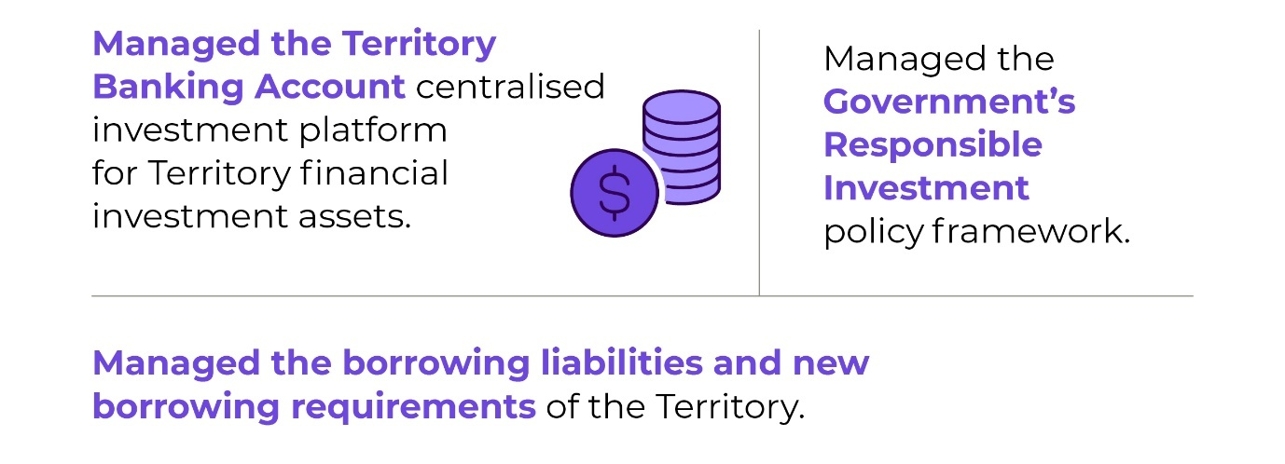

Future direction
In 2026-27, we will:
- Manage the Territory borrowing program.
- Manage cash and liquidity.
- Manage the centralised investment platform for Territory financial investment assets.
- Manage the Government’s Responsible Investment policy framework.

Contact
For further information, please contact
Patrick McAuliffe
Executive Branch Manager, Investments & Borrowings
Patrick.McAuliffe@act.gov.au

B3. Scrutiny
Several bodies have responsibility for scrutiny for CMTEDD’s activities, including Committees of the ACT Legislative Assembly, the ACT Auditor-General, the ACT Ombudsman and the ACT Integrity Commission.
The tables below describe progress on implementing recommendations by those bodies where the government has agreed to them. This includes both recommendations the government agreed to in 2025-26, and recommendations from previous years where the directorate undertook further work during 2025-26 to progress them to completion.
In accordance with the Annual Report Directions, we have not included recommendations below where the government’s initial response indicated that implementation of the recommendation was already complete.
The ACT Integrity Commission is not listed as it did not release a report in the period.
Table 6 – Responses to Auditor-General reports
Report title | Recommendation number and summary | Status and action in reporting year
Auditor-General Report No. 8 of 2017 Selected ACT Government Agencies' Management of Public Art | Recommendation 1: Agreed  artsACT should lead the development of an ACT Public Art Strategic Plan that covers all ACT Government public art. The plan should incorporate: a desired management model, mechanisms for the involved agencies to work cooperatively, and awareness raising of the contribution of ACT public art to the public realm. If the Australian Government and private sector entities who manage public art in the ACT agree, this plan should be jointly developed. | Complete  The development of an ACT Public Art Strategic Plan has been superseded by the ACT Government Public Art Guidelines (updated in 2021 and currently in review, with an updated version to be published in late 2026) that together guides the future direction of the ACT public art collection.  The action plan under Canberra: Australia’s Arts Capital - Arts, Culture and Creative Policy 2022-2026 outlines activities, both ongoing initiatives and targeted projects, against ten focus areas to deliver on the policy objectives. Progress against the action plan is reported annually and includes actions related to the conservation, commissioning, management and promotion of public art in the ACT.  An existing informal network linking the ACT Government with Australian Government agencies and private sector organisations effectively serves as a public art forum. artsACT works with the National Capital Authority and the National Gallery of Australia on areas of common interest related to public art including artwork conservation and management. artsACT is also in regular contact with private organisations that commission public art in the ACT providing advice and support to assist compliance with the ACT Government Public Art Guidelines where relevant.
Auditor-General Report No.2 of 2022 Fraud Prevention  Government response tabled 2 August 2022 | Recommendation 2: Conflict of Interest Registers – Agreed in principle  CMTEDD should provide guidance to ACT Government agencies on requirements for the documentation and recording of conflict of interest declarations. The guidance should address:  whether conflict of interest declarations are expected to be recorded in a centralised register in the agency; and  if they are, the circumstances in which the information in the register is to be used and for what purpose. | In progress  Draft guidance addressing conflict of interest declaration requirements and record-keeping arrangements has been prepared and is due to be finalised by 31 December 2026.
Auditor-General Report No.11 of 2024 – Governing Boards of Selected Act Government Entities  Government response tabled 18 March 2025 | Recommendation 3: Strengthening guidance to ACT Government boards – Agreed  The Chief Minister, Treasury and Economic Development Directorate should review the Governance Principles: Appointments, Boards and Committees in the ACT (2021) document, and as part of this review: a) strengthen guidance on the ACT public sector context in which governance boards operate, including further explanation on the applicable legislation and the roles and relationships between boards, statutory authorities, directorate and Ministers; and b) strengthen guidance on the management of conflicts of interest for governing boards, including with respect to material interests. | In progress  Consultation on the updated Governance Principles was finalised by 30 June 2026. Feedback is being consolidated and the updated Governance Principles are due to be promulgated before 31 December 2026.
Auditor-General Report No. 1 of 2026 Diversity, equity and inclusion in the ACT Public Service  Government response tabled May 2026 | Recommendation 1: Agreed  Whole-of-government diversity, equity and inclusion strategy.  The Chief Minister, Treasury and Economic Development Directorate (CMTEDD), is progressing the development of an overarching ACTPS Inclusion and Belonging Strategy, ensure that the Strategy specifically recognises and reflects:  a) key contemporary concepts, such as belonging and intersectionality; and  b) the broad range of the different diversity groups represented in the ACTPS and their specific needs. | In progress  The Public Sector Policy and Integrity Group (PSPI) within CMTEDD is reviewing and reforming strategies and systems with a focus on supporting inclusive outcomes, removal of inclusion barriers and enabling the Government’s transformative agenda.
Auditor-General Report No. 1 of 2026 Diversity, equity and inclusion in the ACT Public Service  Government response tabled May 2026 | Recommendation 2: Agreed  Provision of Information.  CMTEDD should:  a) enhance the information provided through the ACTPS Culture, Inclusion and Belonging Hub by providing an accessible and identifiable roadmap of relevant legislation, frameworks, strategies and plans for diversity, equity and inclusion relevant to the ACTPS; and  b) provide ACTPS policy and associated guidance about making workplace adjustments for people with disability through an alternative forum to the Rehabilitation Management System. | In progress  In line with the proposed response to Recommendation 1, PSPI will develop an overarching Inclusion and Belonging Strategy which will improve accessibility and clarity of information and provide an identifiable roadmap of relevant legislation, frameworks, strategies and plans for diversity, equity and inclusion relevant to the ACTPS.
Auditor-General Report No. 1 of 2026 Diversity, equity and inclusion in the ACT Public Service  Government response tabled May 2026 | Recommendation 3: Agreed  Collection of diversity, equity and inclusion employment data.  CMTEDD should:  a) collect employment data for people who identify as neurodivergent; and  b) develop systems and processes for ACTPS employees to directly update key personal information. | In progress  PSPI will continue to work to evolve the HR21 personal information options so that ACTPS employees have informed and accessible options to share key personal information. The first priority will be to find a solution to collect employment data for neurodivergent people.
Auditor-General Report No. 1 of 2026 Diversity, equity and inclusion in the ACT Public Service  Government response tabled May 2026 | Recommendation 5: Agreed  Performance and accountability arrangements for cross-agency frameworks, strategies and plans.  When developing future frameworks, strategies and plans for diversity, equity and inclusion initiatives, ACT Government agencies should clearly identify:  a) strategic objectives and outcomes.  b) actions with timeframes for implementation.  c) performance measures with targets. | In progress  The ACT Government agrees with this recommendation and recognises that the intent is consistent with existing ACT Performance and Accountability Framework, the planning and performance reporting framework for ACT directorates and agencies. Responsibility for the implementation of this recommendation will be shared by all ACTPS government directorates and agencies that develop and publish diversity, equity and inclusion-related frameworks, strategies and plans.
Auditor-General Report No. 1 of 2026 Diversity, equity and inclusion in the ACT Public Service  Government response tabled May 2026 | Recommendation 7: Agreed  State of the Service Reporting.  CMTEDD should improve annual State of the Service reporting by:  a) including multi-year tracking and trend analysis of diversity, equity and inclusion data.  b) incorporating analysis of diversity, equity and inclusion data from the ACTPS Employee Survey.  c) including analysis of relevant and appropriate data from the Employee Assistance Program. | In progress  The annual State of the Service Report contains multi-year trend analysis on a variety of diversity, equity and inclusion topics, such as workforce representation and gender pay gap. Public Sector Policy and Integrity Group (PSPI) will incorporate further multi-year tracking and trend analysis information of diversity, equity and inclusion data into future State of the Service Reports to support greater insight for readers. PSPI will include data analysis from biennial ACTPS Employee Surveys in relevant years.
Auditor-General Report No. 1 of 2026 Diversity, equity and inclusion in the ACT Public Service  Government response tabled May 2026 | Recommendation 8: Agreed  Assessing diversity, equity and inclusion maturity CMTEDD should:  a) undertake regular review of ACTPS maturity in diversity, equity and inclusion practices through self-assessment process against a relevant maturity model.  b) consider using multiple better practice tools or approaches, such as the Australian Human Resource Institute’s (AHRI) Diversity and Inclusion maturity model and Global Diversity, Equity and Inclusion Benchmarks (GDEIB). | In progress  PSPI will incorporate a process of cross-service review and reflection into the development of the ACTPS Inclusion and Belonging Strategy, utilising better practice tools and approaches such as AHRI’s Diversity and Inclusion maturity model and Global Diversity, Equity and Inclusion Benchmarks (GDEIB).

Table 7 – Responses to Ombudsman reports
Report title | Recommendation number and summary | Status and action in reporting year
ACT Ombudsman - What's Fair? Collecting Historical Debts - An investigation into the ACT Revenue Office and its collection of historic land tax debt | Recommendation 1: Improve processes when raising historical debts  ACT Revenue Office (ACTRO) should:  Engage with individuals upfront to ensure the most complete and accurate information is available to staff before issuing an assessment.  Ensure staff record detailed reasons for their determinations that show due consideration of the factors relevant to reducing penalty tax and interest.  Review and update the Revenue Circulars with a focus on defining key factors relevant to penalty tax and interest.  Provide further training and practical internal procedures to support staff to engage more fairly with individuals prior to issuing an assessment. | In progress  Before issuing any compliance assessment, an investigation is conducted which includes a Request for Information process.  Land tax compliance has been better integrated with property transfer settlement processes to reduce potential investigations of prior property owners.  Notices of assessment include reasons considered in the determination.  Penalty tax and interest circulars are under review.  Education modules for ACTRO staff are being updated.
ACT Ombudsman - What's Fair? Collecting Historical Debts - An investigation into the ACT Revenue Office and its collection of historic land tax debt | Recommendation 2: Review and update processes for historical debt collection  ACTRO should review its processes and seek to ensure greater administrative fairness when recovering historical debts, including:  Reasonable timeframes for payments to be made.  The appropriateness of accruing interest during objection reviews and payment plans.  When it is appropriate to waive interest charges and penalty tax.  Fairer calculations for end dates on interest charges. | In progress  Due dates for payment are now at least two months from date of Notice of Assessment from land tax compliance investigations.  As stated in the ACT Government submission to the Standing Committee on Public Accounts and Administration - Report No. 5 - Inquiry into Home Buyer Concession Scheme Administration (the Inquiry), “This ability of the Revenue Office to undertake debt recovery action even while matters are under internal review is similar in all jurisdictions. This provision is essential to protecting the tax base.”  Also further to the Inquiry, an objections interest freeze applies, from 1 May 2026 to 30 April 2028, on unpaid amounts subject to an objection in certain circumstances. The interest freeze acknowledges that currently some objections may take longer than the standard timeframe to finalise.  Penalty tax and interest circulars are under review.  Calculations for interest charges are set by legislation.
ACT Ombudsman - What's Fair? Collecting Historical Debts - An investigation into the ACT Revenue Office and its collection of historic land tax debt | Recommendation 3: Increase communication and transparency about the process of recovering historical debt.  Promote effective and timely communication and greater transparency around decision-making and review processes, including:  Introducing key performance indicators for responding to enquiries about assessments or objections.  Creating accessible website information about ongoing and future compliance programs, outlining key phases, timelines and links to relevant information.  Including a link to historical interest rates and attach an individual’s Land Tax Calculator Schedule Report within the assessment notices.  Where a debt is raised retrospectively due to ACTRO’s error, that is directly acknowledged and an apology is provided to the individual at the start of any engagements, or as soon as possible after the error becomes evident. | In progress  Actions are subject to development.  ACTRO’s website is undergoing a substantial redevelopment, including functionality, accessibility and content.  A land tax calculator report has been developed and is available on request to taxpayers.  ACTRO administration errors are being acknowledged.
ACT Ombudsman - What's Fair? Collecting Historical Debts - An investigation into the ACT Revenue Office and its collection of historic land tax debt | Recommendation 4: Improve timeliness for objection decisions  Prioritise new approaches to reduce the average 6 to 12-month timeframe for responding to objections. | In progress  ACTRO’s commitment is that 85 per cent of objections be finalised within 6 months and 100 per cent within 12 months of receipt of the objection or the provision of information in support of the objection. In order to achieve these Commitments ACTRO has instituted procedural improvements, increased staffing in the team, has developed and implemented an enhanced Work Management System supporting the objection process, and on 15 July 2026 went live with an Unimproved Value (UV) Portal that will further support the objection process including the lodgment of objections by a property owner.
Table 8 – Responses to Legislative Assembly Inquiry reports
Report title | Recommendation number and summary | Status and action in reporting year
Standing Committee on Public Accounts and Administration - Report No. 5 - Inquiry into Home Buyer Concession Scheme Administration  Government response tabled 5 May 2026 | Recommendation 2: Agreed  The Committee recommends that the ACTRO ensure that the information presented on their website in relation to the HBC Scheme is as clear and accessible as possible. | Complete  In conjunction with a redevelopment of the ACTRO website, HBC Scheme material has been updated consistent with Web Content Accessibility Guidelines (WCAG) 2.1 AA standards and Australian Government Guidelines. Taxpayers can now select a preferred language to read the website.
Standing Committee on Public Accounts and Administration - Report No. 5 - Inquiry into Home Buyer Concession Scheme Administration  Government response tabled 5 May 2026 | Recommendation 4: Agreed in part  The Committee recommends that the ACT Government ensure all notices of assessment and reminder letters clearly explain the conditional nature of the concession and how to self-report issues. This should include common accidental non-compliance scenarios and how to resolve them without penalty. | In progress  ACTRO is currently examining its correspondence with taxpayers.  Actions are being progressed with related measures from another investigation and audit report.
Standing Committee on Public Accounts and Administration - Report No. 5 - Inquiry into Home Buyer Concession Scheme Administration  Government response tabled 5 May 2026 | Recommendation 6: Agreed in principle  The Committee recommends that the ACTRO use available daily and weekly data, such as Rental Bonds and Land Titles Office transfers to flag non-compliance early. | Complete  ACTRO already uses all available data in an efficient manner.  Land tax compliance has been better integrated with property transfer settlement processes to reduce potential investigations of prior property owners.
Standing Committee on Public Accounts and Administration - Report No. 5 - Inquiry into Home Buyer Concession Scheme Administration  Government response tabled 5 May 2026 | Recommendation 7: Agreed  The Committee recommends that the ACT Government assessment and debt notices implement plain-English, trauma-informed templates that clearly explain decisions, set out rights of review and available support. | In progress  ACTRO is currently examining its correspondence with taxpayers.  Actions are being progressed with related measures from another investigation and audit report.
Standing Committee on Public Accounts and Administration - Report No. 5 - Inquiry into Home Buyer Concession Scheme Administration  Government response tabled 5 May 2026 | Recommendation 10: Agreed in part  The Committee recommends that in implementing a formal compassionate review process, the Government include consideration of domestic violence, mental health, financial instability, or language barriers as mitigating factors. | In progress  ACTRO is considering its engagement with vulnerable community members.
Standing Committee on Public Accounts and Administration - Report No. 5 - Inquiry into Home Buyer Concession Scheme Administration  Government response tabled 5 May 2026 | Recommendation 13: Agree in principle  The Committee recommends that the ACT Government provide tailored repayment plans for duty reassessments resulting from non-compliance, especially where large sums are involved. | In progress  ACTRO is developing a formal debt management policy.
Standing Committee on Economics, Industry and Recreation - Report No 2 - Inquiry into insurance costs in the ACT  Government response circulated 14 January 2026 | Recommendation 1: Agreed in principle  The Committee recommends that the ACT Government determine whether introducing caps on personal injury claims is likely to reduce premiums and if so, develop legislation to introduce such caps. | In progress  Noting the complexity of areas proposed for reform by the Committee, Work Safety Group has commenced preliminary work within existing resources to progress the recommendations. This work is focused on the ACT’s private sector workers compensation scheme. To the extent that any recommendations extend beyond workers compensation insurance, responsibility for that would be led by the Justice and Community Safety Directorate (JACS).
Standing Committee on Economics, Industry and Recreation - Report No 2 - Inquiry into insurance costs in the ACT  Government response circulated 14 January 2026 | Recommendation 3: Agreed in principle  The Committee recommends the ACT Government determine whether a statutory cap on legal fees is likely to reduce insurance premiums in the ACT. If yes, the Committee recommends the ACT Government develop legislation to introduce such a cap. | In progress  Noting the complexity of areas proposed for reform by the Committee, Work Safety Group has commenced preliminary work within existing resources to progress the recommendations. This work is focused on the ACT’s private sector workers compensation scheme. To the extent that any recommendations extend beyond workers compensation insurance, responsibility for that would be led by JACS.
Standing Committee on Economics, Industry and Recreation - Report No 2 - Inquiry into insurance costs in the ACT  Government response circulated 14 January 2026 | Recommendation 7: Agreed in principle  The Committee recommends that the ACT Government consider amending the Civil Law (Wrongs) Act 2002 to allow proportional liability to be applied to both personal injury claims and claims made under the Workers Compensation Act 1951. | In progress  Noting the complexity of areas proposed for reform by the Committee, Work Safety Group has commenced preliminary work within existing resources to progress the recommendations. This work is focused on the ACT’s private sector workers compensation scheme. To the extent that any recommendations extend beyond workers compensation insurance, responsibility for that would be led by JACS.
Standing Committee on Economics, Industry and Recreation - Report No 2 - Inquiry into insurance costs in the ACT  Government response circulated 14 January 2026 | Recommendation 8: Agreed in principle  The Committee recommends that the ACT Government consult with relevant stakeholders to develop legislative reform that addresses contributory negligence in insurance claims. | In progress  Noting the complexity of areas proposed for reform by the Committee, Work Safety Group has commenced preliminary work within existing resources to progress the recommendations. This work is focused on the ACT’s private sector workers compensation scheme. To the extent that any recommendations extend beyond workers compensation insurance, responsibility for that would be led by JACS.
Standing Committee on Economics, Industry and Recreation - Report No 2 - Inquiry into insurance costs in the ACT  Government response circulated 14 January 2026 | Recommendation 11: Agreed in principle  The Committee recommends that the ACT Government give consideration to aligning the ACT workers’ compensation scheme in relation to journey claims with those in other jurisdictions. This should include a requirement that there must be a real and substantial connection between employment and the accident in which the injury arose, and that the incident is not otherwise covered by the Motor Accident Insurance Scheme. | In progress  Potential reforms requiring legislative change including adjustments to journey claim arrangements remain under active review.
Standing Committee on Economics, Industry and Recreation - Report No 2 - Inquiry into insurance costs in the ACT  Government response circulated 14 January 2026 | Recommendation 12: Agreed in principle  The Committee recommends that the ACT Government consider subsidising the workers’ compensation premiums for insurance policies that cover apprentices. | In progress  This work is progressing through the ongoing monitoring of industry trends through the annual independent Scheme Review, which is published by CMTEDD each year.
Standing Committee on Economics, Industry and Recreation - Report No 2 - Inquiry into insurance costs in the ACT  Government response circulated 14 January 2026 | Recommendation 13: Agreed in principle  The Committee recommends that the ACT Government consider introducing alternative dispute resolution mechanisms to help resolve workers’ compensation claims. | In progress  Work has progressed to consider alternate dispute resolutions ahead of consultation with key stakeholders in 2026-27.
Standing Committee on Economics, Industry and Recreation - Report No 2 - Inquiry into insurance costs in the ACT  Government response circulated 14 January 2026 | Recommendation 15: Agreed in principle  The Committee recommends that the ACT Government examine models to facilitate insurance pooling for like organisations. | In progress  Preliminary work to progress the Committee’s recommendations has commenced within existing Work Safety Group resources. This work is focused on the ACT private sector workers compensation scheme.
Standing Committee on Economics, Industry and Recreation - Report No 2 - Inquiry into insurance costs in the ACT  Government response circulated 14 January 2026 | Recommendation 16: Agreed in principle  The Committee recommends that the ACT Government examine policy options that enable insurance pooling for organisations using its facilities. | In progress  The ACT Insurance Authority (ACTIA) can assist organisations to explore commercially available insurance pooling arrangements, where they are using government facilities  ACTIA continues to work with ACT Government directorates and agencies to strengthen risk-informed decision making when determining insurance requirements for organisations using government facilities. This includes ensuring requirements are proportionate to the activity and associated risks, and are sufficient but not excessive, helping to minimise unnecessary insurance costs while appropriately managing risk to the Territory.
Standing Committee on Social Policy – Report 1 - Inquiry into Annual and Financial Reports 2023-24  Government response tabled September 2025 | Recommendation 16: Agreed in principle  The Committee recommends that the ACT Government publish all directorate workforce gender equity strategies and action plans on its website. | In progress  Under the ACTPS Gender Equity Strategy 2024-2029, agencies and public sector bodies that are required to have an action plan must report progress against the plan in their annual report. Given the number of plans, and that annual reports are available on agency websites, the Government considers that this remains the most appropriate mechanism for monitoring gender equity progress and performance.
Standing Committee on Social Policy – Report 1 - Inquiry into Annual and Financial Reports 2023-24  Government response tabled September 2025 | Recommendation 46: Agreed in principle  The Committee recommends that the ACT Government provide an end of financial year update to the Assembly on the University of Canberra’s financial position as at 30 June 2025, as provided for in section 35(2)(d) and Schedule 1 of the University of Canberra Act 1988. | Complete  The University of Canberra’s Annual Report includes the University’s financial position and is tabled in the Legislative Assembly each year by the Minister for Economic Development. The 2024 and 2025 Annual Reports were tabled on 26 June 2025 and 5 May 2026, respectively.  Information has not been requested outside of standard annual reporting requirements. However, the Treasurer may request information in future.
Standing Committee on Public Accounts and Administration – Report 2 - Inquiry into Annual and Financial Reports 2023-24  Government response tabled 4 September 2025 | Recommendation 9: Agreed  The Committee recommends that the ACT Government strengthen debt management strategies by reporting to the Legislative Assembly on the reasons for and factors driving the high level of residential and commercial rates debt. | Complete  The reasons were provided to the Assembly in the Government Response to this recommendation.
Standing Committee on Public Accounts and Administration – Report 2 - Inquiry into Annual and Financial Reports 2023-24  Government response tabled 4 September 2025 | Recommendation 12: Agreed  The Committee recommends that the ACT Government provides clarity about which Minister is responsible for the social and economic development of the commercial hubs across Canberra. | Complete  The social and economic development of the commercial hubs across Canberra rely on the work under many ministerial portfolios and is therefore a shared responsibility of multiple ministers.
Standing Committee on Economics, Industry and Recreation – Report 1 - Inquiry into Annual and Financial Reports 2023-24  Government response tabled 4 September 2025 | Recommendation 9: Agreed  The Committee recommends that the ACT Government inform the arts sector as soon as possible when they will receive the additional 25% plus CPI arts organisation funding and 50% plus CPI grant funding and how this will be distributed. | Complete  As part of the 2026 ACT Budget, the government announced a 25 per cent increase in funding to arts organisations, indexed at 2.5 per cent in the forward years. Arts organisations have been informed, and the increased funding will be administered by artsACT from 1 January 2027 through the Arts Organisation Investment Program.
Standing Committee on Economics, Industry and Recreation – Report 1 - Inquiry into Annual and Financial Reports 2023-24  Government response tabled 4 September 2025 | Recommendation 19: Agreed in principle  The Committee recommends that the ACT Government review and publish the criteria to be utilised in investment decisions by the ACT’s venture capital fund. | Complete.  The Venture Capital Fund’s (Fund) investment criteria are established through the Fund's governing documents, including the Limited Partnership Deed and Fund Licence and the Territory’s Investment Plan and Responsible Investment Policy. These documents set out the Fund's objectives, eligibility requirements, permitted investment parameters and governance arrangements.  Fund Licence: www.tenders.act.gov.au/contract/view?id=217467  Investment Plan: www.act.gov.au/__data/assets/pdf_file/0006/2971698/Venture-Capital-Fund-Investment-Plan.pdf  Responsible Investment Policy: www.act.gov.au/__data/assets/pdf_file/0010/2971702/Venture-Capital-Fund-Responsible-Investment-Policy.pdf
Standing Committee on Economy and Gender Economic Equality Report 11 - Inquiry into micro, small and medium business in the ACT region  Government response released 27 December 2024 | Recommendation 2: Agreed in principle  The Committee recommends that where laws are harmonised with other jurisdictions, the implementation timeframes should also be consistent. | Complete  The ACT Government continues to work towards harmonising regulation where possible and supports nationally consistent approaches where appropriate. As part of business-as-usual policy development, implementation arrangements continue to be considered on a reform-by-reform basis, recognising that jurisdictions are required to progress reforms in accordance with their own policy and legislative processes.  For example, the ACT participates in national reform initiatives such as the revitalised National Competition Policy, which is intended to promote nationally consistent and complementary competition laws and regulatory frameworks, reduce unnecessary regulatory barriers, and support the efficient operation of national markets. Where reforms are progressed collaboratively across jurisdictions, the ACT will continue to support a nationally consistent approach to implementation timeframes where appropriate and practicable, while recognising that implementation remains a matter for each jurisdiction.
Standing Committee on Economy and Gender Economic Equality Report 11 - Inquiry into micro, small and medium business in the ACT region  Government response released 27 December 2024 | Recommendation 3: Agreed  The Committee recommends that the ACT Government investigate how to better apprise micro, small and medium businesses of regulatory and legislative changes that might affect them. | Complete  ACT Government continues to maintain and improve act.gov.au/business as an accessible portal for ACT businesses bringing together a range of ACT and Australian Government information. User testing is carried out to inform improvements to the website.  Advertising campaigns were carried out to promote the Canberra Business Advice and Support Service and also to encourage subscription to the CBR Business Update e-newsletter, with 1,209 subscribers gained. The newsletter includes information on regulatory and legislative changes in the ACT and nationally.
Standing Committee on Economy and Gender Economic Equality Report 11 - Inquiry into micro, small and medium business in the ACT region  Government Response released 27 December 2024 | Recommendation 9: Agreed  The Committee recommends that the ACT Government market the ACT to potential workers, trainees, and apprentices. | Complete  ACT Government continues to market the ACT’s lifestyle through tourism and events marketing and by maintaining canberra.com.au as a central portal to live work and study in Canberra.  ACT Government proactively markets the destination to students through international engagements and partnering with educational institutions.
Standing Committee on Economy and Gender Economic Equality Report 11 - Inquiry into micro, small and medium business in the ACT region  Government response released 27 December 2024 | Recommendation 10: Agreed  The Committee recommends that the ACT Government re-examine the criteria it uses to identify critical occupations, decide on occupations caps (in relation to migration/skilled visa nominations), and calculate points on the matrix. | In progress  In late 2024 occupation caps were removed. A review of Skilled Migration Policy settings, including the calculation of matrix points commenced in 2025-26.
Standing Committee on Economy and Gender Economic Equality Report 11 - Inquiry into micro, small and medium business in the ACT region  Government response released 27 December 2024 | Recommendation 12: Agreed in part  The Committee recommends that the Government target the promotion of building and associated trades training and apprenticeships, and increase training places and subsidies in the ACT to help with shortages in these areas. | Complete  Training places are demand-driven, with no cap on the number of available places.  On 1 July 2025, the ACT Government increased the User Choice subsidies from 72 per cent of the ACT efficient price to 90 per cent of the ACT efficient price for six qualifications essential to supporting the ACT’s building and construction sector:  Certificate III in Carpentry  Certificate III in Plumbing  Certificate III in Bricklaying and Blocklaying  Certificate III in Wall and Floor Tiling  Certificate III in Roof Plumbing  Certificate III in Air Conditioning and Refrigeration.  These higher subsidies follow the same increase on 1 July 2024 of the subsidy for the Certificate III in Electrotechnology Electrician.
Standing Committee on Justice and Community Safety - Report No. 31 - Inquiry into the Integrity Commission’s confidential report into Operation Kite  Government response tabled 3 December 2024 | Recommendation 2: Agreed  The Committee recommends that the ACT Government put in place measures to ensure that ACT Public Service recruitment processes and ACT Government Board appointments are able to adequately identify and determine suitability of any candidates who have previously received an adverse finding by Integrity Commission reports, including confidential reports. | Complete  Pre-appointment declarations of adverse findings by the Integrity Commission are required to the extent such declarations are authorised by law.
Report No. 24 of the Standing Committee on Public Accounts (Tenth Assembly) Inquiry into Auditor-General’s Performance Audit Reports July – December 2023  Government response tabled 4 February 2025 | Recommendation 2 – Agreed  The Committee recommends that the ACT Government review the effect of the Government Procurement Amendment Act 2024 in July 2026 to ensure that the measures introduced by the Act have resolved the issues raised in the Auditor-General’s performance audit report. The terms of reference of this review should include:  the clarity of statutory roles and responsibilities;  the effectiveness and efficiency of the Government Procurement Board’s review and advice functions; and  the role and responsibilities of the Chair of the Government Procurement Board. | In progress  A high-level post-implementation review of the efficacy of the amendments to the ACT Government Procurement Framework that took effect on 1 July 2024 was undertaken through various consultation channels in 2025, following the 12-month anniversary of the commencement of key legislative changes. This review highlighted areas for potential further refinement, with further legislative amendments anticipated to commence on 1 July 2026.  A post-implementation review remains under consideration, with updates to guidance material, training, and templates anticipated to align with the further legislative amendments being advanced.  The Government Procurement Board’s Terms of Reference and Strategic Direction have been finalised and are now available on the Procurement ACT website.  A review is planned to be undertaken in Q1 2026-27 to assess the roles and responsibilities and effectiveness of the Government Procurement Board.
Select Committee on Estimates – Appropriation Bill 2024-25 and Appropriation (Office of the Legislative Assembly) Bill 2024-25  Government response tabled 27 August 2024 | Recommendation 6: Agreed in principle  The Committee recommends that the ACT Government consider whether the Screen Investment Fund should be opened to the Interactive Games (video games) industry and whether the 10 per cent Screen Attraction fund should be opened to the video games industry. | Complete  The 2025-26 Budget committed $1.25 million to establish the Screen and Games Fund, comprising $150,000 to administer the fund and $1.1m for deployment as grants.
Select Committee on Estimates – Appropriation Bill 2024-25 and Appropriation (Office of the Legislative Assembly) Bill 2024-25  Government response tabled 27 August 2024 | Recommendation 13: Agreed in principle  The Committee recommends that the ACT Government amend legislation to allow for privacy for sexual assault complainants. | Complete  The Workplace Legislation Amendment Bill 2025 (No 2) was tabled in the ACT Legislative Assembly on 2 September 2025 and incorporated amendments to the Evidence (Miscellaneous Provisions) Amendment Bill 2024 in relation to extending legal protections to complainants of sexual assault/harassment workplace issues involving WHS legal proceedings.  These amendments were passed by the ACT Legislative Assembly on 25 September 2025 under the Workplace Legislation Amendment Bill 2025 (No 1).
Select Committee on Estimates – Appropriation Bill 2024-25 and Appropriation (Office of the Legislative Assembly) Bill 2024-25  Government response tabled 27 August 2024 | Recommendation 17: Agreed in principle  The Committee recommends that, as part of any future review of the Financial Management Act 1996, consideration be given to how the Financial Management Act 1996 interacts with the Integrity Commission Act 2018 and the Public Sector Management Act 1994, as well as employment and human rights laws and obligations in the event a public service employee or office holder has an adverse finding against them by the Integrity Commissioner. | In progress  A review of the Financial Management Act 1996 will be undertaken during the current term of the Legislative Assembly.
Select Committee on Estimates 2019-2020 – Inquiry into the Appropriation Bill 2019-2020 and the Appropriation (Office of the Legislative Assembly) Bill 2019-2020 – Government response tabled 13 August 2019 | Recommendation 55: Agreed  The Committee recommends that the ACT Government ensure that Budget funding decisions are explicitly considered in the context of the zero emissions by 2045 target and associated interim targets, and the cost of carbon emissions (or ‘the social cost of carbon’) are factored into Treasury and directorate cost benefit analyses. | In progress  Work continues on valuing emissions reductions to inform government decision making, including infrastructure. This includes engaging with other jurisdictions to understand approaches to valuing emissions in the context of infrastructure decision-making and delivery.
Select Committee on Estimates Inquiry into Appropriation Bill 2023-2024 and Appropriation (Office of the Legislative Assembly) Bill 2023-2024  Government response tabled 29 August 2023 | Recommendation 29: Agreed in principle  The Committee recommends that the contract name is included as a field on the notifiable invoices register, to improve transparency of use of public funds. | Complete  The Procurement Unique Identifier follows the procurement throughout the lifecycle of the procurement and where used, is listed on the ACT Government Contracts Register and is included in the descriptions for Notifiable Invoices where available, this allows users to link contracts with invoices.  From June 2025, monthly notifiable invoice reporting issued by Shared Services Finance and published on the Open Data Portal by Procurement ACT will include a contract number column for Territory Entities to capture Territory entities’ unique identifying numbers. Communications have been distributed to key stakeholders notifying them of the change.
Select Committee on Estimates - Inquiry into Appropriation Bill 2023-2024 and Appropriation (Office of the Legislative Assembly) Bill 2023-2024  Government response tabled 29 August 2023 | Recommendation 31: Agreed in part  The Committee recommends that the ACT Government have a proactive monitoring and auditing process for ensuring that contracts managed by other Territory entities are provided and uploaded to the contract register. | Complete  The requirement to notify contracts within 21 days of their execution remains. A reporting process has been introduced which will require Territory entities to report non-compliance in their Annual Reports.  Since 1 July 2024, under the Tiered Services Support model, Procurement ACT has monitored the notification of contracts to the contracts register as received. Procurement ACT provides guidance through relevant factsheets including through the ACT Government Contract Management Guide. Procurement ACT is progressing a process of enabling Territory entity procurement teams to directly contribute to the contracts register related to their contracts to allow for entity specific service and monitoring.
Select Committee on Estimates - Inquiry into Appropriation Bill 2023-2024 and Appropriation (Office of the Legislative Assembly) Bill 2023-2024  Government response tabled 29 August 2023 | Recommendation 32: Agreed in principle  The Committee recommends that the ACT Government publish and track all active supplier panels across ACT Directorates to the Procurement ACT website, including how many suppliers are on each panel, the data of refreshment or renewal of the panels, the purpose of the panel and the directorate it originates from. | Complete  While work against this commitment continues to progress (subject to the supplier’s ability to make the necessary changes to configure the refresh/renewal dates of panels), a full listing of Territory panels is now available on the contracts register.
Standing Committee on Education and Community Inclusion - Report 7 - Inquiry into Access to Services and Information in AUSLAN  Government response tabled 7 June 2023 | Recommendation 4: Agreed in principle  That the ACT Government and public agencies translate highly trafficked webpages into Auslan and create provision for Deaf people to forward queries, feedback and submissions in Auslan. | In progress  CMTEDD Communications and Engagement is working with the Health and Community Services Directorate's Auslan interpreter to develop translated priority content for websites. Information is available on the Accessibility page and the Contact Us page of the act.gov.au website which directs users to the National Relay Service which allows Deaf users to contact the ACT Government in Auslan.
Standing Committee on Economy and Gender and Economic Equality - Report 7 - Inquiry into Annual and Financial Reports 2021-22  Government response tabled 26 July 2023 | Recommendation 7: Existing Government Policy  The Committee recommends that the ACT Government:  increase funding to artsACT to deliver public art commissions by female artists that recognise significant women; and  establish an ongoing program to increase the number of public statues of women and by women. | Complete  The Celebrating Significant Women Program was established in 2021 to increase the number of public statues of women and by women. The ACT Government increased funding to artsACT in 2021-22 and 2023-24 to deliver public art commissions by female artists that recognise significant women. A statue to honour the late Senator Susan Ryan AO FAICD was commissioned and installed in the Parliamentary Zone. A bronze artwork representing community volunteer, Stasia Dabrowski OAM, is complete and will be installed in Garema Place in 2026-27.
Standing Committee on Environment and Transport and City Services Report No. 9 – Inquiry into Territory Coat of Arms  Government response released 24 December 2019 | Recommendation 2: Agreed  Dependent on the legal standing of the City of Canberra Coat of Arms, the Committee recommends that the ACT Government either adopt a Coat of Arms for the Territory or update the City of Canberra Coat of Arms. | In progress  Work has commenced to design and adopt a Territory Coat of Arms/insignia.
Standing Committee on Environment and Transport and City Services Report No. 9 – Inquiry into Territory Coat of Arms  Government response released 24 December 2019 | Recommendation 3: Agreed  The Committee recommends that the ACT Government engage in community consultation to determine the final design for any new Coat of Arms for the ACT. | In progress  The community was invited to contribute to the project through the YourSay Panel. The community will have further opportunities to contribute to the design process for a Territory Coat of Arms/Insignia. The community will be given the opportunity to vote on their preferred design.
Standing Committee on Environment and Transport and City Services Report No. 9 – Inquiry into Territory Coat of Arms  Government response released 24 December 2019 | Recommendation 4: Agreed in principle  The Committee recommends that in consultation with the community the ACT Government redesign the ACT Flag. | In progress  The redesign of the ACT Flag will be considered following the process to adopt a Territory Coat of Arms/Insignia.
Standing Committee on Environment and Transport and City Services Report No. 9 – Inquiry into Territory Coat of Arms  Government response released 24 December 2019 | Recommendation 5: Agreed  The Committee recommends the ACT Government develop a guideline on the appropriate use of the ACT’s Official Symbols and make this publicly available. | In progress  Following the development of a Territory Coat of Arms/Insignia and a new ACT Flag, a set of guidelines and consistent artwork for all the ACT’s symbols will be developed and made publicly available.
Standing Committee on Public Accounts - Report 15 - Inquiry into Auditor-General’s Report No. 8 of 2021: Canberra Light Rail Stage 2A: Economic Analysis  Government response tabled 28 June 2023 | Recommendation 8: Agreed in-principle  The Committee recommends that the ACT Government publish a benefits realisation plan for Light Rail stage 2A as soon as possible. | This item has been transferred to Infrastructure Canberra for future reporting.
Standing Committee on Public Accounts - Report 17 - Inquiry into Grants Management  Government response tabled 25 August 2023 | Recommendation 1: Agreed in principle  The Committee recommends that the ACT Government establish a community sector consultation mechanism to ensure the range and availability of funding for grants programs is meeting community needs in the ACT. | In progress  The annual Budget consultation process remains the primary mechanism for the community to identify areas of priority funding need. This consultation process also involves roundtables with community organisations, including ACT Council on Social Services. Outcomes from this process are used to inform proposals for additional funding (including for grants programs) brought forward for consideration in the Budget process. Grants programs are also funded through existing agency funding. Treasury is continuing to work with relevant agencies to improve reporting on program funding. This will facilitate analysis of how community needs are being met. Treasury also regularly engages with the community sector on funding issues.
Standing Committee on Public Accounts - Report 17 - Inquiry into Grants Management  Government response tabled 25 August 2023 | Recommendation 3: Agreed in principle  The Committee recommends that the ACT Government include the option for allocating costs to include volunteer management in ACT Government grant programs. | In progress  Treasury is expected to consider this recommendation as part of updating the Grants Administration Framework, with higher priority for this work in 2026 and 2027.
Standing Committee on Public Accounts - Report 17 - Inquiry into Grants Management  Government response tabled 25 August 2023 | Recommendation 4: Agreed  The Committee recommends that the ACT Government include flexible grant management approaches relating to the way in which grant outcomes can be delivered by the community organisation. | In progress  Treasury is expected to consider this recommendation as part of updating the Grants Administration Framework, with higher priority for this work in 2026 and 2027.
Standing Committee on Public Accounts - Report 17 - Inquiry into Grants Management  Government response tabled 25 August 2023 | Recommendation 5: Agreed in principle  The Committee recommends that the ACT Government improve consistency across the ACT Government in the design, management of and acquittal of grants, including standardised insurance requirements, a standardised application form, and standardised acquittal processes for small dollar grants. | In progress  Treasury is expected to consider this recommendation as part of updating the Grants Administration Framework, with higher priority for this work in 2026 and 2027.
Standing Committee on Public Accounts - Report 17 - Inquiry into Grants Management  Government response tabled 25 August 2023 | Recommendation 6: Agreed in principle  The Committee recommends that the ACT Government examine an initial Expression of Interest process before requiring more detailed grant applications so projects out of scope are identified early, before extensive time is committed to developing them. | In progress  Treasury is expected to consider this recommendation as part of updating the Grants Administration Framework, with higher priority for this work in 2026 and 2027.
Standing Committee on Public Accounts - Report 17 - Inquiry into Grants Management  Government response tabled 25 August 2023 | Recommendation 7: Agreed in principle  To ensure transparency in the grant decision making process, the Committee recommends that the ACT Government:  ensure that selection criteria, outcomes and reporting requirements are co-designed in partnership with the community sector; and  provide open communication and feedback to all grant applicants. | In progress  Treasury is expected to consider this recommendation as part of updating the Grants Administration Framework, with higher priority for this work in 2026 and 2027.
Standing Committee on Public Accounts - Report 17 - Inquiry into Grants Management  Government response tabled 25 August 2023 | Recommendation 9: Agreed  The Committee recommends that the ACT Government make the following information publicly available prior to organisations applying for a grant:  grant process flowcharts for each funding opportunity;  grant decision making process;  decision maker;  selection criteria;  outcomes (including links to wellbeing indicators);  reporting requirements;  an explicit statement on how administrative overheads, staffing costs and Project Management for activities for the Grant shall be covered during the grant process; and  draft deed applicable to grant. | In progress  Treasury is expected to consider this recommendation as part of updating the Grants Administration Framework, with higher priority for this work in 2026 and 2027.
Standing Committee on Public Accounts - Report 17 - Inquiry into Grants Management  Government response tabled 25 August 2023 | Recommendation 10: Agreed  The Committee recommends that the ACT Government update applicants’ information resources and documents on the ACT Government Grants website. | In progress  Treasury is expected to consider this recommendation as part of updating the Grants Administration Framework, with higher priority for this work in 2026 and 2027.
Standing Committee on Public Accounts - Report 17 - Inquiry into Grants Management  Government response tabled 25 August 2023 | Recommendation 12: Agreed  The Committee recommends that the ACT Government establish a specific process for feedback on the quantum of money allocated to grant categories within budget consultation. | In progress  Treasury is continuing to work with relevant agencies to improve reporting on program funding, including for grants programs. This will provide greater transparency on grants funding.
Standing Committee on Public Accounts - Report 17 - Inquiry into Grants Management  Government response tabled 25 August 2023 | Recommendation 13: Agreed in principle  The Committee recommends that the ACT Government review the administrative requirements and complexity of the application and reporting process of grants to ensure the application process is proportionate to the funding amount and outcomes. It is recommended a two-tier approach be adopted with lower levels of accountability for very small grants (<$10,000) versus multi-year-larger grants with more robust procedures. | In progress  Treasury is expected to consider this recommendation as part of updating the Grants Administration Framework, with higher priority for this work in 2026 and 2027.
Standing Committee on Public Accounts - Report 17 - Inquiry into Grants Management  Government response tabled 25 August 2023 | Recommendation 15: Agreed in part  The Committee recommends that The Administration of Government Grants in the ACT: A Framework and Best Practice Policy be amended as follows:  In Section 1.5 Governance – officials must provide reasons as to why an applicant is successful/unsuccessful; and  In Sections 3.1 Planning Design and 3.2 Selection and Decision Making – these sections be updated to include: o consulting and co-designing grants with the community sector; and o having community sector and/or community member with lived experience representation on grants selection committees/panels. | In progress  Treasury is expected to consider this recommendation as part of updating the Grants Administration Framework, with higher priority for this work in 2026 and 2027.
Standing Committee on Public Accounts - Report 17 - Inquiry into Grants Management  Government response tabled 25 August 2023 | Recommendation 17: Agreed  The Committee recommends that the ACT Government conduct a review of language and accessibility in all ACT Government grant program materials. | In progress  Treasury is expected to consider this recommendation as part of updating the Grants Administration Framework, with higher priority for this work in 2026 and 2027.
Standing Committee on the Integrity Commission and Statutory Office Holders - Report 1 - Inquiry into Annual and Financial Reports 2023-24  Government response released on 5 August 2025 | Recommendation 4: Existing government Policy  The Committee recommends that the ACT Government proceed with implementation of the outstanding Govey Review recommendations and provide advice on which recommendations it intends to action. | In progress  The government has committed to resolve the Govey Review recommendations during the 11th Legislative Assembly.
Standing Committee on the Integrity Commission and Statutory Office Holders - Report 1 - Inquiry into Annual and Financial Reports 2023-24  Government response released on 5 August 2025 | Recommendation 5: Existing Government Policy  The Committee recommends that the ACT Government move legislative amendments to the Integrity Commission Act 2018 to expedite the timeframes for consideration of draft reports. | In progress  The government has committed to resolve the Govey Review recommendations during the 11th Legislative Assembly.

B4. Risk Management
CMTEDD upholds a robust risk management approach to enable quality service delivery and continuous improvement. CMTEDD’s approach to risk management is based on the Australian Risk Management Standard AS ISO 31000:2018 and is consistent with the ACT Government Risk Management Policy.

Risk framework and plan
CMTEDD maintains a Risk Management Framework and Policy, and a Risk Management Plan. These documents are reviewed every two years to ensure they remain current and aligned with the operating environment.
Risk management training is delivered as part of an ongoing program to strengthen risk capability and maturity across the directorate.

Strategic and operational risk environment
The directorate manages risk at the strategic and operational level through a structured approach:
- Strategic Risk Register - sets out the key organisational strategic risks that could significantly impact the achievement of strategic objectives and performance.
- Business-area risk registers - identify risks that may impact respective areas, to support the achievement of their objectives and improve their performance.
- Operational risk assessments - are completed for new initiatives, programs, projects, events, procurements, and to address risk associated with specific focus areas, including work health and safety, hazards, security, digital and fraud related risks.

Risk oversight
Oversight of risk, including ensuring the effective implementation and continuous improvement of risk management, is monitored through the Executive Management Group; Audit and Risk Committee; and SERBIR. Regular reporting includes business areas’ risk profile, major risks, and new and emerging risks. These risks are actively identified and discussed to ensure that appropriate and effective management strategies are developed, implemented and monitored.

Resilience
We continue to strengthen the directorate’s resilience capability to support the continuity of critical services and minimise the impact of business disruptions.
CMTEDD’s Business Continuity and Disaster Recovery Framework is being expanded into a broader Resilience Management Framework and Policy. This will support a coordinated approach to:
- emergency management
- crisis management
- business continuity
- IT disaster recovery/critical infrastructure recovery
- bushfire management and preparedness
- climate change/adaptation

Business continuity arrangements
CMTEDD has refreshed its approach to Business Continuity Planning by introducing a simplified suite of documents and working with business areas to develop and test team-level continuity plans. This work has improved preparedness and clarified roles and responsibilities during disruptions.
Insights from testing and reviews continue to inform and strengthen business continuity arrangements. An 18-month resilience testing program is also being implemented across all business areas to support regular validation, ongoing preparedness, capability development and continuous improvement.

Contact
For further information, please contact
Steven Wright
A/g Executive Group Manager, Corporate
Steven.Wright@act.gov.au

B5. Internal Audit
Internal Audit and the Audit and Risk Committee (Committee) are key components to CMTEDD’s governance arrangements. They support the Director-General and Under Treasurer in fulfilling their responsibilities under the Financial Management Act 1996.
The operations and expectations of the Committee are set out in their respective Charters. Internal Audit is responsible for the development and implementation of the CMTEDD Internal Audit Plan, audit recommendation tracking and providing secretariat support for the Committee.
Internal Audit tabled eight audit reports at Committee meetings during 2025-26:
- Budget Management
- Expense Management
- Information and Records Management (Health Records)
- Accounts Receivable (including Debtor Management)
- Affordable Housing Project Fund
- Contract Management
- Grant Funding Evaluation (Assessment and Decision)
- External Quality Assurance of Internal Audit
A further three audit reports included on the 2025-26 Internal Audit Plan will be tabled at the first Committee meeting for 2026-27.
The Committee met four times during the year. Strategic risks were reviewed at each of the ordinary meetings, with the Strategic Risk Register and business area risk registers presented to the Committee on a rotational basis. New or emerging risks are reported to the Committee as identified, and major risks are monitored on an ongoing basis until they are managed to an acceptable level.
The Committee consists of two Independent members (Chair and Deputy Chair) and a Senior Executive from a directorate outside of the CMTEDD Portfolio.
The following changes were made to the Committee during 2025-26:
- Committee meetings were reduced in number but increased in length in response to the machinery of government changes to CMTEDD.
- The Advisor role has been removed from the Committee structure.
- A Senior Executive from another ACT Government directorate was appointed in March 2026.
- The Independent Member resigned from the Committee in April 2026.
The Chair, Deputy Chair and Members stand up the Financial Sub-Committee to review the directorate’s financial statements.
The Chair provides advice to the Director-General and Under Treasurer on audit outcomes, significant risks and implementation of mitigation strategies through quarterly outcomes meetings.
The Independent Committee members are engaged under service delivery contracts and remunerated based on an agreed rate for each meeting.
Table 9 – Internal Audit Committee Membership and Attendance 2025-26
Name | Position | Duration | Meetings Attended
Darren Schaeffer | Independent Chair | 1 July 2025 – 30 June 2026 | 4
Diana Hamono | Independent Deputy Chair | 1 July 2025 – 30 June 2026 | 4
Sam Volker | Independent Member | 1 July 2025 – 14 April 2026 | 3
Catherine King | Senior Executive Officer from another ACT Government directorate | 16 March 2026 – 30 June 2026 | 1

Contact
For further information, please contact
Steven Wright
A/g Executive Group Manager, Corporate
Steven.Wright@act.gov.au

B6. Fraud Prevention
The directorate is committed to creating, supporting and maintaining a culture embedded with integrity and good governance practices to support positive working relations, robust decision-making and community confidence. Implementing an effective framework for preventing fraud and corruption demonstrates that CMTEDD is serious about professional and ethical practice. Accordingly, we have adopted a proactive risk based approach to ensure we have appropriate controls in place to support our operating environment

Fraud and Corruption Plan
The CMTEDD Fraud and Corruption Prevention Policy and Plan assists the directorate with the identification and management of fraud and corruption risks and applies to all employees and contractors engaged within CMTEDD.
CMTEDD’s Audit and Risk Committee, Executive Management Group and SERBIR have oversight of the implementation of the Plan through regular updates, along with visibility of trends of fraud related matters.
The CMTEDD SERBIR has a monthly meeting with People and Capability, Employee Relations and Injury Management, and Governance, Security and Audit teams in relation to fraud and integrity which covers updates on fraud policy, awareness and information, governance oversight, and case management.

Training
- 87 per cent of staff have completed the Fraud and Ethical Behaviour e-Learning course.
- 95 per cent of staff have completed the Conflict of Interest e-Learning course.
- The eLearning program Reporting Corruption to the ACT Integrity Commission is a required learning for SOGA, SOGB and SES. At year end there was an 85 per cent completion rate.

Communications from the CMTEDD SERBIR to staff
- Making Decisions with Integrity – an all-staff email advising that an important part of integrity is robust decision-making.
- Fraud and Integrity Risk during Change – a message to Senior Executive with respect to Administrative and machinery of government changes being disruptive and the potential increase in fraud and integrity risk.
- Integrity Themes – a message to Senior Executive with respect to Integrity Themes arising through the Integrity Commission.
- End of Year Celebrations – reminding that we have responsibility to ensure our actions and behaviours reflect community expectations and our own high standards.
- Advice on upcoming Risk Management Training session availability.
- Advice on declaring and managing Conflicts of Interest.

Incidents of fraud reported in 2025-26
From 1 July 2025 to 30 June 2026, the SERBIR was made aware of three allegations of fraud and corruption in relation to CMTEDD staff. One matter related to corruption and two matters related to fraud.
The main themes identified in the 2025-26 matters were allegations of alterations to attendance records and non-compliance with processes. Appropriate actions and reviews of controls have occurred in relation to the identified themes.
Two of the three matters have been closed as at 30 June 2026, with appropriate actions taken. One of the three matters remain ongoing as at 30 June 2026. In relation to the ongoing internal cases reported in the previous annual report, the two matters were closed with appropriate actions taken.

Contact
For further information, please contact
Steven Wright
A/g Executive Group Manager, Corporate
Steven.Wright@act.gov.au

B7. Freedom of Information
Section 96 of the Freedom of Information Act 2016 (the FOI Act) sets out the FOI reporting requirements for agencies and ministers. We manage FOI applications on behalf of several public sector bodies aligned to CMTEDD and the reporting requirements for these entities are included in this section.

Making an access application
To apply for access to information under the FOI Act please visit the ACT Access Government information webpage, email CMTEDDFOI@act.gov.au or post to The FOI Information Officer, CMTEDD, GPO Box 158, CANBERRA ACT 2601.
We publish details of FOI requests we receive, including the access application, decision and any released documents, on the CMTEDD Disclosure Log https://www.cmtedd.act.gov.au/functions/foi. We do not publish access applications for personal information.

Availability of open access information
Open access information is publicly available government-held information that can be freely used, reused and redistributed (noting any copyright and attribution requirements). Open access information includes agencies’ functional information, policies, budgetary papers, information about government grants and other categories of government-held information listed under Section 23 of the FOI Act.
Table 10: Availability of open access information (Section 24 of the FOI Act)
 | Number
Number of decisions to publish open access information | 812¹
Number of decisions not to publish open access information | 482²
Number of decisions not to publish a description of open access information withheld | 0
Notes:
1. Includes 411 Cabinet decisions
2. Includes 252 decisions not to publish under section 28(6)(a) and (b) of the FOI Act.

Table 11: FOI applications received and decisions made
 | Number
Number of access applications received | 370¹
Number of applications where access to all information requested was given | 12
Number of applications where access to only some of the information requested was given (partial release) | 72
Number of applications where access to the information was refused | 19
Number of applications where CMTEDD did not hold information | 31
Number of applications transferred, withdrawn, completed outside of the FOI Act or still pending a decision on 30 June 2026 | 194²
Notes:
1. Includes 42 access applications to be carried over into 2026-27 for decision.
2. Includes 123 applications transferred outside of CMTEDD, six where information was released outside the FOI Act, 54 where the application was withdrawn and eight not dealt with under sections 31(4) or 34(6)(b).

FOI processing timeframe
Section 40 (1) of the FOI Act states that an access application must be decided no later than 30 working days after receipt. Under section 40 (2) of the Act, if a relevant third party is consulted the period under subsection (1) is extended by 15 working days. The statutory timeframe is also met if an extension of time is negotiated/granted as provided for in sections 41 and 42 of the Act.
Table 12: Processing timeframes
 | Number
Total applications decided within the statutory timeframe | 383¹
Applications not decided within the statutory timeframe | 1
Number of days exceeding statutory timeframe | 1
Note:
1. Includes 56 access applications carried over from 2024-25.

Amendment to personal information
There were no requests made to amend personal information in the reporting period.

Applications for Ombudsman review
Table 13: Applications for Ombudsman review under section 74 of the FOI Act
Applications for Ombudsman review under section 74 of the FOI Act | Number
Affirmed | 2¹
Varied | 3²
Set aside and substituted | 1³
Withdrawn | 1
Other | 1⁴
Review not completed by end 2025-26 | 15⁵
Total number | 23
Notes:
1. Includes one review carried over from 2024-25.
2. All varied considerations were on 2024-25 decisions.
3. 2024-25 decision.
4. Review was set aside on a 2024-25 decision.
5. Includes six reviews remaining from 2024-25, nine from 2025-26.

Applications for ACT Civil and Administrative Tribunal (ACAT) review
There were no applications for ACAT review under section 84 of the FOI Act.

Charges collected from access applications
In 2025-26, we did not collect any charges to process access applications.

Contact
For further information, please contact
Steven Wright
A/g Executive Group Manager, Corporate
Steven.Wright@act.gov.au

B8. Community Engagement and Support
Our policies, programs and services are enriched by input from stakeholders and the ACT community. CMTEDD is committed to creating opportunities for the community and stakeholders to have their say on what is important to them and to help shape the way we live.
In 2025-26, we initiated a range of community and stakeholder engagement activities to respond to the needs of the community and of business and industry. A selection of engagement projects is detailed in the following section.

Community Engagement – Major community engagement activities

ACT 2026-27 Budget Consultation
Budget consultation is a key element of the Government’s budget planning framework through which it seeks views from community members, businesses and local organisations on how government service provision can become even more efficient, innovative and deliver more for the Territory.
The 2026-27 Budget consultation process included a survey conducted through the YourSay Panel which sought feedback on the prioritisation of government expenditure, with a particular focus on wellbeing considerations. The survey was open from 27 October 2025 to 4 November 2025 and 1,801 responses were received.
ACT Government officials also held a series of round table meetings with key community and industry groups from 9 February 2026 to 4 March 2026 to gain insights into the priorities of these organisations.
Members of the public, business and community organisations were also able to provide written submissions regarding their views on longer-term expenditure and revenue priorities, and how the Government can best support the wellbeing of the Canberra community. The written submission process remains open on an ongoing basis, with any input received after publication of the 2026-27 Budget being used to inform future budgets.
Written contributions received as part of the 2026-27 Budget consultation process have been published, except where submissions were provided in confidence. All non-confidential submissions are available through the Budget consultation website. 119 submissions were received prior to the finalisation of the 2026-27 Budget.
A community Budget roundtable session was also held with the Aboriginal and Torres Strait Islander Elected Body.

The submissions and survey responses covered a diverse range of topics, including:
- Support for community services and groups (including support for disability, youth, women, domestic violence services and Aboriginal and Torres Strait Islander Services)
- Social inclusion
- Education and skills, including early childhood support
- Environment and climate
- Transport and the amenities of our city (including active travel)
- Infrastructure proposals
- Business resilience and activity, including tourism, events and creative industries
- Proposals for regulatory and planning amendments
- Health services (including mental health)
- Housing access and support
- Seniors
- Wellbeing
The responses were summarised in the “What we heard” report, released in August 2026 on the ACT Government YourSay page.

Community engagement – stakeholder and business engagement/consultation

ACT Aquatic Strategy
In April 2026 we provided an opportunity for the community to provide feedback on the draft Terms of Reference for the new ACT Aquatic Strategy, which will guide the planning, management and future investment in Territory-wide aquatic facilities over the next decade. Over 70 stakeholder organisations were invited to provide feedback on the draft Terms of Reference, with 12 responses received - one response co-signed by 31 stakeholder organisations. These responses called for a more inclusive and comprehensive strategy that better reflects the full range of users and facilities – this input will help shape the upcoming procurement to engage a consultant to lead the development of the new ACT Aquatic Strategy.

ACT Export Day 2026
In May 2026 we hosted the ACT Export Day as a forum, with two workshops that ran simultaneously, to provide guidance on content to Canberra businesses in their exporting journey. The event was attended by 120 participants, and the feedback from the two surveys conducted (pre and post-event) was positive, including direction on subjects that Canberra businesses would like covered at future Export Day events.

ACT Foundation Skills Training Review
Stage One of this process was held between March and August 2026, to inform a review of ACT foundation skills training and identify opportunities to strengthen system effectiveness, learner outcomes and workforce capability. The review was delivered by Nous Group under the National Skills Agreement (NSA) Foundation Skills Bilateral Action Plan. Approximately 40–50 stakeholder organisations and representatives from government, the community sector, adult community education providers and registered training organisations, including the CIT, participated in targeted stakeholder interviews and consultations and Reference Group meetings as well as data analysis.
Initial themes and emerging findings have been identified through consultation and analysis. These findings will be tested with stakeholders during Stage Two of the review before recommendations are finalised. Findings will be used to inform further initiatives under the NSA to strengthen the ACT Adult Community Education (ACE) Grants Program; foundation skills training workforce capability; and a ‘no wrong door’ approach to foundation skills training in the ACT. A final report and recommendations are expected to be complete in 2026.

Business and Economic Development Industry Consultative Forum (BEDICF)
Three forums were held between September 2025 and June 2026 as a mechanism for government and industry representatives to discuss emerging economic, business and regulatory issues affective the ACT economy. The Forum supports ongoing collaboration between government and industry through information sharing, consultation activities and referral of issues to relevant agencies, helping to strengthen engagement across sectors and improve understanding of emerging business conditions. Fourteen organisations participated in the forums. Their input and feedback assists in the development of various government initiatives such as the next ACT Climate Change Strategy, housing and planning reforms and the future of the ACT Clubs Industry.

Creative Spaces Mapping (arts assets needs analysis)
Between October and December 2025, we undertook targeted consultation meetings, and an online survey to understand utilisation, demand and key issues in relation to community arts facilities. Over 25 consultation meetings with arts sector stakeholders were held and 204 online survey responses received. We heard from stakeholders how creative spaces and arts facilities across Canberra are used, including the accessibility of spaces and the demand. The consultation will inform the arts assets needs analysis, which will support Government decision making related to the strategic management of community arts facilities.

Events Sector Development Conference
In March 2026 the Enlightened: Events Sector Conference was held to support the event sector by providing a professional learning opportunity for event organisers. This year the focus was on Accessibility in Events, what it looks like and why it is important. The conference is an opportunity for event organisers to network and build relationships in the events community. Four keynote speakers provided expert advice on creating successful and accessible events, panel discussions, including those with lived experience, provided powerful learnings, and a mini trade show was also delivered during the break with relevant event sector attendees.
This event was attended by approximately 70 people, who provided an overall satisfaction rating of 4.7 out of 5—the quality of the presentations and information delivered was highly valued, along with the chance to connect with industry peers. This feedback is instrumental in informing future conferences, ensuring they continue to reflect the needs and preferences of the event sector community.

Industry Fuel Roundtable
In March 2026 a virtual roundtable was convened to hear from industry about concerns and impacts being experienced because of the fuel security issue. Thirteen organisations participated, with feedback received describing the various impact being felt across industries including rising transportation costs, product costs and increasing uncertainty for businesses to operate.

International business exchange program
In March and June 2026, we ran three training events to provide guidance to Canberra businesses in their exporting journey. These events were held both online and in person, with attendance from between 5 and 15 people at each event. Feedback from the events was positive and will provide directions on future International Business Exchange programming for 2026-27.

Portable Long Service Leave – Employee Engagement Survey
In March 2026 we undertook a public survey to inform the effective implementation of the expansion of the Portable Long Service Leave Scheme to the accommodation and food services industry (from 1 July 2026). The survey engaged workers to better understand workforce characteristics, employment patterns and identify where additional supports may be required. We promoted the survey through stakeholders including advisory bodies, unions and employee representative groups, with 310 responses.
Survey participants provided insight into employment characteristics within the accommodation and food services industry, including varied work patterns and tenure. Engagement with stakeholders recognised the value of the Portable Long Service Leave scheme, while noting ongoing cost pressures across the sector and highlighting the importance of a staged implementation approach and adjusted timelines to support business transition.
The ACT Government eased the transition to the expanded Portable Long Service Leave schemes by delaying commencement to 1 January 2027 and providing targeted relief, including a phased discounted levy for food services employers, in recognition of cost pressures faced by businesses.
The ACT Government is focused on improving working conditions for all Canberrans, including workers in transient industries where many miss out on long service leave despite years of work. The Government will continue to work closely with businesses to support the smooth implementation of the expanded portable long service leave scheme.

Tourism Industry Roundtable
In May 2026 we held a Tourism Industry Roundtable to bring together government and tourism operators to share insights on current market and business conditions, discuss common priorities and areas for collaboration. Approximately 20 local tourism operators attended the facilitated roundtable discussion, where we heard that businesses continue to face pressure from higher fuel prices and broader cost-of-living pressures, although consumers are still travelling if they have compelling reasons to do so. Roundtable input will be used to map out steps for potential industry innovation and collaboration to drive tourism demand.

VisitCanberra Industry Update
In December 2025, we delivered a presentation to approximately 250 tourism industry stakeholders, providing an overview of the newly launched Phase 2 update of the T2030 ACT Tourism Strategy, including foundational research insights, priority focus areas and forward programs. This presentation facilitated greater industry awareness of strategic priorities to grow the ACT’s visitor economy over the next five years.

Update to the Canberra Arts Policy (for the period 2027-2031)
Between April and June 2026, targeted consultation meetings, roundtables and an online survey were undertaken to bring together the arts and creative sector to discuss current and future opportunities. In the six consultation meetings, four roundtables, one Minister’s Creative Council meeting and 94 online survey responses, we received feedback on the current policy and suggestions on how to strengthen the sector. These findings will support the development of the next Canberra arts policy.

Community support initiatives - grants and sponsorship
During 2025-26 CMTEDD provided grants, assistance and sponsorship to the following individuals and organisations. All amounts are rounded to the nearest whole number and are GST exclusive unless otherwise indicated.

Aboriginal and Torres Strait Islander Cultural Arts Program
The purpose of the Aboriginal and Torres Strait Islander Cultural Arts Program is to enhance outcomes that reflect Canberra’s unique culture and identity by funding self-determined programs that support and enhance arts and cultural outcomes for Aboriginal and Torres Strait Islander artists and build cultural leadership.
Table 14: Aboriginal and Torres Strait Islander Cultural Arts Program recipients
Recipient | Project purpose/Summary | Artform | Amount ($)
Yingari Ngali Design | To support ‘Jewellery Off Country’, a series of community-based jewellery making workshops using materials from Country | Visual Arts | $6,500
Project Dust | To create a new dance and music work | Dance | $15,000
Corella & Crow | To support ‘Threads of Leadership: First Nations Fashion ACT – Runway’, Canberra’s inaugural First Nations fashion showcase during NAIDOC Week 2027 | Visual Arts | $15,000
Brenda Croft | To develop a workshop series for Us Mob Writers ACT as part of the exhibition 'Nurrunurru Bala, Nurrunurru Wuwaa (Always Was, Always Will Be)/Edge of the Colony' at CMAG in 2027 | Literature | $15,000
Megan Daley | To support ‘From Country to Cloth – First Nations Batik’ for Country to Couture in 2027 | Visual Arts | $15,000
William Walker Respecting Country | To support production of ‘The Rocky River’, digital art and animation project to be presented at Q Gallery ACT | Visual Arts | $15,000

Arts Activities Funding Up to $5,000
Arts Activities Funding of up to $5,000 is offered all year round and supports Canberra artists, groups and organisations to undertake one-off self-identified arts activities across a range of artforms. Applicants can receive funding in this category once each calendar year. If funding has been provided twice in the 2025-26 financial year the project purpose/summary includes the calendar year funding was approved.
Table 15: Arts Activities Funding up to $5,000 recipients
Recipient | Project purpose/Summary | Artform | Amount ($)
Oppolyon Studios | To promote the new digital game, ‘Ascending Inferno’ at BitSummit & Osaka World Expo in Japan | Digital games | $5,000
Dylan Van Den Berg | Professional development and promotional opportunities through participation in the Australian Theatre Festival in New York | Theatre | $5,000
Thomas Fell | To support the recording and releasing of a debut album of original jazz compositions by the Tom Fell Quartet | Music | $4,815
Madeleine Hepner | To develop a new solo exhibition, 'Paradox of Control' at Platform Manuka | Visual Arts | $4,240
Lyn Parker | To support artist fees for the ANU Choral Society’s Répétiteur and Music Director and develop the technical skills of the choir members | Music | $4,965
Shan Crosby | To support attending the CYA Writers & Illustrators Conference for Professional Development. | Literature | $1,215
Christopher Samuel Carroll | To support touring The Cadaver Palaver, at the Edinburgh Fringe Festival 2025 | Theatre | $5,000
Kylie Walsh | To support artist residency at Watershed Studios, Galway, Ireland, to develop new work | Visual Arts | $2,950
Matthew Crowe | To support a short story writing mentorship with author Melanie Cheng | Literature | $1,349
Litia Roko | To support travel costs for Hatched: National Graduate Show 2025 and the development of new work | Visual Arts | $2,065
Emeirely Nucifora-Ryan | To support travel and tuition costs for a neon glass residency at Pilchuck Glass School in Washington, USA | Visual Arts | $5,000
Tamara Henderson | To develop new art works for ‘Spider with the Glass Legs’ solo exhibition at PALAS in Sydney | Visual Arts | $5,000
Annette Blair | To support freight of artworks to Australia following a glass residency at Tacoma Museum of Glass in Washington, USA | Visual Arts | $5,000
Rosalind Lemoh | To develop new works for a solo exhibition at Canberra Contemporary Lakeside Gallery | Visual Arts | $5,000
Music Theatre Projects | To support artist fees and mentorship on the musical production ‘Newsies Jnr’ | Theatre | $5,000
Miya Zawa | To support Miya Zawa tour, promoting their upcoming single | Music | $5,000
Sammy Hawker | To support a 6-week residency and creating work for exhibition in 2026 at Messums Org UK | Visual Arts | $5,000
Nick Delatovic | To support Bashville, a studio album for the band Fancy Nick Delatovic and the Empty Lake Singers | Music | $4,662
Taryn Lee | To support attendance at Colourful Minds Market in October in Sydney NSW | Visual Arts | $679
Peter Papathanasiou | To support the adaptation of ‘Little One’ for screen | Literature | $5,000
Jane Ingall | To support the performance of ‘HomeGround’ a dance-theatre production at Gorman Arts Centre in 2025 | Dance | $4,834
Cassandra Dove | To support costs for 'Behind the View', a new visual arts exhibition at Belconnen Arts Centre | Visual Arts | $4,471
Eleri Harris | To support travel to attend events and promotion of your debut picture book tour | Literature | $3,292
Max O'Sullivan | To support the production of two singles to enable commercial radio play | Music | $3,368
Blame the Shadows | To support concept art and 3D assets for an immersive VR work | Digital Games | $4,900
Lachlan Houen | To support the production of ‘The Almighty Sometimes’ at The Q (Queanbeyan Performing Arts Centre) in 2025 | Theatre | $5,000
Georgia Bennett | For 'Belladonna’ new EP tour and promotional costs | Music | $5,000
Kreiworks Entertainment Pty Ltd | To support travel and attendance at the Frankfurt Bookfair in Germany | Screen | $5,000
Karen Viggers | To support costs to create ‘Secrets From the Green Room’, a new podcast series featuring six international authors at Ubud Writers & Readers Festival 2025 | Literature | $2,225
Mirramu Dance Company | To support ‘ECDysis’, a new dance theatre presentation celebrating 60 years of Australian Dance Theatre and 25 years of Mirramu Dance Company | Dance | $5,000
Cathy Franzi | To support travel to attend and present at the Australian Ceramics Triennale in Fremantle | Visual Arts | $995
Leah Blankendaal | To support travel and living costs to attend the recording of 'Music for a Sleeping City' as part of the Australian Music Centre's Momentum Plus Program | Music | $1,805
Hangama Obaidullah | To support ‘Yalda Night Creative Celebration,’ showcasing emerging and established performers to present their work | Theatre | $5,000
Victoria Whyte | To develop skills in grand piano regulation and piano technology by attending the Grand Regulation Workshop at Yamaha Australia HQ | Music | $3,963
Deborah Kingsland | To support Stage 1 production of ‘Tin Toys’, a new documentary based on the life of Czech-Australian artist John Cervenka | Screen | $5,000
Ylaria Rogers | To support the seventh stage dramatological development of new verbatim play, ‘You Are Not Alone’ | Theatre | $4,910
Isidora Pekic | To support the editing and musical composition of a short documentary film, Canberra Stories: Turning of Seasons | Screen | $3,500
Yu-Ching Kim Yang | To support the promotion and distribution of debut album ‘Turn on the Lights' | Music | $5,000
Mimir Soboslay Moore | To support freight and installation costs for ‘Delicious FREAK’, an exhibition of emerging LGBteA+ Canberra Artists at Sawtooth ARI in Tasmania | Visual Arts | $4,763
Katie Hayne | To support the interstate solo painting exhibition 'Blue Poles is Not a Park' in Melbourne | Visual Arts | $2,277
Sally Golding | To support travel and installation costs for immersive audiovisual installation ‘Assembly Now’ at the Sound/Image Festival, United Kingdom | Visual Arts | $5,000
Hangama Obaidullah | To support ‘Yalda Night Creative Celebration,’ showcasing emerging and established performers to present their work | Theatre | $5,000
Jennifer Adams | To support Nature and Mental Health a visual art exhibition at the Belconnen Arts Centre | Visual Arts | $5,000
Xenia Hanusiak | To support the final manuscript and editing of the novel, Floating. | Literature | $5,000
Laura Johnson | To support the professional filming of, That’s…Brave, a solo comedy hour in the Canberra Playhouse | Theatre | $5,000
Musonga Mbogo | To support the development of a new series of paintings for exhibition at Canberra Art Gallery | Visual Arts | $3,079
Paul Bissett | To support a research trip to the Isle of Wright to research and rewrite, Above the Angelic: Isle of Wight | Screen | $4,542
Rachel Reid | To support Music & Mayhem: REBELLION, Creative Development Intensive, enabling a focused period of collaborative experimentation and development toward a new performance work | Dance | $4,821
Dylan Hayley Rosenthal | To support the production of the new short film, ‘Vices and Other Weapons’ | Screen | $5,000
Ruby Martyn | To support production costs for ‘20, love’, a new short film | Screen | $3,292
Jelin Palm | To support travel and accommodation costs to present a new comedy show, ‘Wedding Ring & suffeRING’, at the Adelaide Fringe Festival | Theatre | $5,000
Mia Rashid | To support travel and attendance at a dance workshop intensive with Kalakeli Movement Arts in Goa, India | Dance | $5,000
Selma Kaasinen | To support translation of the Finnish novel ‘Araukaria’ into English to expand its accessibility and publishing potential | Literature | $5,000
Jasmine Guffond | To support ‘The Right to be Lazy’, an exhibition at Civic Arts Bureau, Canberra in April 2026 | Visual Arts | $4,992
Jim Sharrock | To support travel and accommodation costs for clowning skills development through research and study tour to Europe | Theatre | $4,955
Billie Rooney | To undertake a Stewardship for Verse Novelists with Karen Comer to further develop ‘Collision Course’, a new young adult novel in verse | Literature | $4,000
Sammy Hawker | To support casting a series of bronze works for upcoming solo exhibition, 'The Pressure of Darkness’ | Visual Arts | $5,000
David Cina | To develop marketing, promotion, and branding skills through the I Heart Songwriting Level Up Mentoring Program | Music | $3,564
Masoud Varjavandi | To support production and post-production artist fees for ‘OI (Organic Intelligence)’, a new short film | Screen | $5,000
Kaitlyn Boye | To support travel, present and promote the international premiere of new feature film, ‘Break a Leg’ at Panic Fest, USA | Screen | $5,000
Julie McKay | To support developing the treatment for ‘The Vanishing Lake’, a new feature film | Screen | $5,000
Julie Monro-Allison | To support an artist residency at Space Department, Nara, Japan | Visual Arts | $2,763
Leanne Thompson | To support festival costs for ‘Ray of Light’ at The Polo | Music | $5,000
Georgina Jenkins | To support pitching a new TV series ‘With My Little Eye’ at Screen Forever | Screen | $5,000
John Ma | To support Splatterfest 2026, a mini festival using Early Music practice across abilities and genres | Music | $5,000
Bonnie Neate & Suzy Piani | To support production costs for new contemporary dance production, ‘The Edge’ | Dance | $5,000
Benji Moss | To support a music tour with the Australian Mandolin Ensemble in Europe, 2026 | Music | $5,000
Gabrielle Hall-Lomax | To support artist fees to develop photographs for a new photobook, ‘Bless the Well’ | Visuals Art | $4,993
Jemima Parker | To support phase two of the contemporary fiction Young Adult manuscript, ‘Scorched’ | Literature | $1,759
Liz Lea | To support the development and promotion of ‘Diamond’, a new dance production | Dance | $5,000
Madeline Cardone | To support workshop attendance at Pilchuck Glass School (USA) to learn kiln-formed glass and plasma techniques | Visuals Art | $5,000
Karen Viggers | To support a 10-day writing and research retreat at Wilsons Promontory National Park for a new novel | Literature | $4,414
Declan Shrubb | To record songs for ‘Tramdemic: The Musical’, Act 2 | Music | $4,900
Caitlin Baker | To support artist fees and production costs for ‘The Good Boy Game’, a new play | Theatre | $5,000
Lina Foti | To support attendance and industry engagement at the Annecy International Animation Film Festival in June 2026 | Screen | $5,000
Cathy Franzi | To support attendance at the International Academy of Ceramics Congress as a New Artist Member and to exhibit in three significant exhibitions in Jingdezhen China | Visual Arts | $3,830
Simone Rodrigues | For creation and production of a professional music video for Shadows of the Undertow’s debut studio album | Music | $4,972
Mikhael O'Brien | To support the marketing and release of ‘Planticulture’ a new digital game | Digital Games | $4,300
Ryleigh Hilton | To support Australian tour of Sonic Reducer with Teen Jesus and the Jean Teasers in May 2026. | Music | $5,000

Arts Activities Funding $5,000 to $50,000
Arts Activities Funding $5,000 to $50,000 Arts Activities Funding between $5,000 and $50,000 is offered twice a year and supports Canberra artists, groups and organisations to undertake one-off self-identified arts activities across a range of activities and artforms.
Table 16: Arts Activities Funding $5,000 to $50,000 recipients
Recipient | Project purpose/Summary | Artform | Amount ($)
Arts Activities $5,000 to $50,000 2025 Round 2
Emma Batchelor | To support ‘Bloomwaves’: an experimental new literary work created in queer community | Literature | $44,750
Jordan Best | To support the NSW tour of ‘Bombshells’, with Echo Theatre and Arts on Tour, featuring ACT based artists | Theatre | $28,577
Canberra Burlesque Academy Incorporated | To support accessibility-focused dance and performance mentorship programs for BIPOC, LBGTQI+, disabled persons and allies | Dance | $25,000
Christopher Samuel Carroll | To stage the premiere production of a new theatre work, ‘Commitment to the Cause’, at Canberra Theatre Centre | Theatre | $45,086
Craig Cormick and Darren Rix | To develop a new non-fiction book looking at First Nations’ perspectives of John Batman and Australia’s first treaty | Literature | $20,000
Brenda L Croft | For the creation of new work for a solo exhibition at Goulburn Regional Art Gallery and scanning of photographic archives | Visual Arts | $50,000
Callie Doyle-Scott | To develop ‘Soup for the Moon’, a new fantasy novel focused on food and food history through a queer lens | Literature | $32,384
Gang Gang Cafe | To develop and promote ‘Sundowner 2026’, a one-day urban music and arts festival | Music | $50,000
Tamara Henderson | To create a new glass sculpture for an immersive installation at Canberra Contemporary | Visual Arts | $30,000
King Howe | To support the King Howe regional Australian tour, featuring Canberran supporting musicians | Music | $35,918
MangoMilk Productions | To edit a new documentary film about Slovenian/Italian cultural relationships | Screen | $19,460
Music Theatre Projects Ltd | To support artists fees for a residency at The Street to develop and present readings of the new musical, ‘Hornig and the Gadget’ | Theatre | $20,000
Musica Viva Australia | To support mentorship for emerging ACT musicians to support skill development, musicianship, collaboration and leadership | Music | $21,000
Ujjwal Rai | To develop ‘Maha Maya’, a feature screenplay with a local writer and recognised industry professionals | Screen | $25,000
Vivienne Rogis | To support the redevelopment and performance of ‘The Whole Cake’, a dance theatre work | Dance | $16,219
SD Games PTY LTD | To support further development of ‘Rocketcard Defence’, a new tower defence digital game | Digital Games | $50,000
Arts Activities $5,000 to $50,000 2026 Round 1
Jack Biilmann | To promote a new music album across Australia and the USA | Music | $19,960
Jo-Anne Brechin | For script development of a new feature film, ‘ZOM-BAE’ | Screen | $49,142
Sotirios Dounoukos | For the writing and development of the new play, ‘WILL’ | Theatre | $24,782
Dreampunk | To port ‘Super Sphere FX’ to the Nintendo Switch, and localising to 4 languages | Digital Games | $16,934
Paul Girrawah House | To create limited edition bronze gulaman (coolamons) and balang-wirra (head-rests) at Strathnairn Arts Foundry with master sculptor/caster Alex Kosmas | Visual Arts | $50,000
Selma Kaasinen | To develop a new historical mystery novel, ‘Two Edges of the World’ | Literature | $25,160
Zora Jane Kerr | To develop a vertical slice of ‘I Am This Castle’, a new digital game about transgender coming-of-age | Digital Games | $48,917
Liz Lea | To present a new one woman show, ‘Diamond’, at The Q Theatre | Dance | $34,393
Christopher Marcatili | To develop a vertical slice of new digital game ‘Gutterjacket’ | Digital Games | $49,240
Stella Eve Joan Martin | To market and promote the debut album ‘Always’ | Music | $45,805
Jennifer Kemarre Martiniello OAM | To develop ‘Between the Light’, a major large-scale glass and poetry installation for La Trobe Art Institute | Visual Arts | $45,978
Musonga Mbogo | To produce 'Neo Expression', a video series exploring the practices of artists and creatives in Australia and the United Kingdom | Screen | $14,121
Eli Narev | For the creative development of a new theatrical work, ‘Schrader on the Fold-Out Bed’ | Theatre | $9,772
Lisa Sammut | To create and present a new solo exhibition at Canberra Contemporary, ACT | Visual Arts | $32,319
Dylan Van Den Berg | To support writing and development of a new First Nations play, ‘Dancing Back’ | Theatre | $14,638
Vorfreude Pictures | To support post-production for new feature film ‘Endling’ | Screen | $50,000
Woodlands & Wetlands Trust | To support art activations with threatened species photography | Visual Arts | $30,000

Arts Community Outreach
Arts Community Outreach Funding enables the Canberra community to access and participate in a range of arts programs, as well as capacity building initiatives for organisations and individual artists.
Table 17: Arts Community Outreach recipients
Recipient | Project purpose/Summary | Term of grant (if applicable) | Amount ($)
Australian National University School of Music | To deliver a range of music community access programs through the School of Music | 3 years | $573,029
Australian National University School of Art and Design | To deliver a range of visual arts community access programs through the School of Art and Design | 3 years | $123,000

Arts Organisation Investment Program
Funding under the Arts Organisation Investment Program commenced on 1 January 2023, under the following three streams:
- Arts Centre Investment Funding
- Arts Organisation Investment Funding
- Emerging Arts Organisation Investment Funding

Arts Centre Investment Funding
This funding stream provides multi-year funding for ACT arts organisations that manage an ACT Government arts centre/s, aligned with a five-year licence to occupy the centre/s.
Table 18: Arts Centre Investment Funding recipients
Recipient | Project purpose/Summary | Term of grant (if applicable) | Amount ($)
Arts Capital | To assist with annual program operating costs in managing the Ainslie and Gorman House Arts Centres, and for 2025-26 includes Budget Initiative funding of $128,000 | 5 years | $884,450
Belconnen Arts Centre | To assist with annual program operating costs and to manage the Belconnen Arts Centre | 5 years | $945,563
Canberra Potters Society | To assist with annual program operating costs for ceramics and to manage the Watson Arts Centre | 5 years | $210,125
Canberra Glassworks | To assist with annual program operating costs for glass art and to manage the Canberra Glassworks | 5 years | $893,031
PhotoAccess | To assist with annual program operating costs for photo media and to manage the Manuka Arts Centre | 5 years | $294,175
The Stagemaster | To assist with annual program operating costs in theatre and to manage The Street Theatre | 5 years | $998,094
Strathnairn Arts Association | To assist with annual program and operating costs for visual arts and to manage Strathnairn Arts Centre | 5 years | $210,125
Tuggeranong Community Arts Association | To assist with annual program operating costs for community arts programs and to manage the Tuggeranong Arts Centre | 5 years | $903,538

Arts Organisation Investment Funding
This funding stream provides multi-year funding for leading ACT arts organisations.
Table 19: Arts Organisation Investment Funding recipients
Recipient | Project purpose/Summary | Term of grant (if applicable) | Amount ($)
ACT Writers Centre (MARION) | Professional development programs for Canberra writers at all levels, and promoting their work | 2+2 years | $194,366
Australian Dance Council - Ausdance ACT | Support to independent professional dancers and deliver accessible dance programs across all genres | 4 years | $157,594
Australian Dance Party | Professional dance company creating new contemporary dance works for local artists | 4 years | $105,063
Canberra Contemporary Art Space | Opportunities for emerging and established artists to create and present contemporary visual arts and engage in audience programs | 4 years | $315,188
Canberra International Music Festival | Present an annual festival of classical and contemporary/fine art music | 4 years | $96,658
Canberra Symphony Orchestra | Program of classical music concerts and performances including community access programs | 4 years | $646,134
Canberra Youth Theatre | Creative opportunities for young people through theatre workshops, productions and creative pathways | 4 years | $315,188
Craft ACT: Craft and Design Centre | Contemporary craft and design programs and exhibitions for local artists | 4 years | $430,756
Girls Rock! Canberra (Noisy Futures) | Participation opportunities in contemporary music for young people of marginalised gender identities | 2+2 years | $73,544
M16 | Program of exhibitions for local visual artists | 4 years | $73,544
Music for Canberra | Support to independent professional dancers and deliver accessible dance programs across all genres | 2 years | $210,125
Megalo Access Arts | Access to print media equipment and professional development programs and exhibitions | 4 years | $388,731
Music ACT | Professional development programs and services for contemporary musicians and bands | 4 years | $131,328
Rebus Theatre | Inclusive and accessible theatre making and presentation opportunities for people of all abilities | 4 years | $105,063
QL2 Dance (Quantum Leap Australia) | Support to independent professional dancers and deliver high quality, accessible dance programs across all genres | 4 years | $378,225
Warehouse Circus | Development programs and services for circus/physical theatre emerging artists | 4 years | $157,594
You Are Here Canberra | Professional development and presentation opportunities for local contemporary artists and producers | 2+2 years | $84,050

Emerging Arts Organisation Investment Funding
This funding stream provides two plus two years funding of up to $100,000 per year for organisations that have not received artsACT multi-year funding previously.
Table 20: Emerging Arts Organisation Funding recipients
Recipient | Project purpose/Summary | Term of grant (if applicable) | Amount ($)
Contour 556 (Canberra Art Biennial) | Biennial contemporary visual arts festival in public spaces | 2+2 years | $52,531
Luminescence Chamber Singers | Vocal/choral development programs and performances | 2+2 years | $42,025
Australian Talented Youth Project (The Stellar Company) | Develop and present inclusive dance activities for people of all ages, abilities and backgrounds | 2+2 years | $42,025

Arts Special Initiatives
Special Initiatives Funding provides support to strategic arts initiatives and projects.
Table 21: Arts Special Initiatives recipients
Recipient | Project purpose/Summary | Term of grant (if applicable) | Amount ($)
Arts Law Centre of Australia | To assist with costs of providing legal advice to artists and arts organisations. |  | $25,000
Australian Dance Party | To enable the delivery of IMPULSE, a live, multidisciplinary performance event that activates public spaces in Woden and Gungahlin through dance and creative response. |  | $20,000
Kulture Break | To assist with costs of delivering community arts programs that build the confidence and wellbeing of at-risk young people and to enhance the sustainability of the organisation into the future. |  | $65,000
Tuggeranong Community Arts Association | To enable the delivery of Weaving Stories: Gathering Invisible Lines, a series of First Nations-led workshops in Tharwa. |  | $20,000
The Stellar Company | To enable the delivery of BOLD Moves ON, a series of dance and exercise classes designed for older Canberrans from migrant backgrounds living in the Gungahlin, Philip and Woden regions. |  | $19,960

ACT Adult Community Education (ACE) Grants Program
The ACT ACE Grants Program provides funding for not-for-profit community sector organisations’ delivery of quality foundation skills training in accessible and inclusive community settings, to support Canberrans experiencing barriers to learning, training and work.
Table 22: ACE Grants Program recipients
Recipient | Project purpose/Summary | Term of grant (if applicable) | Amount ($)
Stepping Stone Social Enterprise | Women Skilled to Succeed will provide training and employment opportunities to 20 vulnerable migrant and refugee women in the ACT, to help them gain foundational skills in hospitality, tourism, and horticulture. The women will build the confidence, experience and the qualifications needed to enter the wider job market or pursue further education. |  | $199,950
Worldview | Solid Start is an Aboriginal and Torres Strait Islander-led foundation skills and employment readiness program supporting young Aboriginal and Torres Strait Islander men in the ACT experiencing disadvantage, to build the confidence, skills and direction that leads them into meaningful employment, training or further study. |  | $200,000
Capital Region Community Services Limited | Bridge to Brighter Futures is an education and employment program supporting young people aged 17–24 in Canberra. The program builds participants’ skills and confidence in a safe environment. They then put these skills into practice through flexible placements, opening pathways to further education, training, and meaningful employment. |  | $173,086
Master Builders ACT | The Career in Construction Program helps unemployed and underemployed adults build the skills, confidence, and industry connections needed for a successful career in the building and construction sector. Participants develop essential foundation skills and complete mandatory work health and safety training. |  | $198,036
Uniting Care Kippax with Umbrella Collective | Launch into Learning for Migrants and Refugees helps migrants and refugees prepare for VET pathways. Through practical workshops covering workplace culture, Australian history, English language, digital literacy, and study skills, participants build confidence, study readiness, and community connections in an inclusive environment. |  | $189,000
Deaf Connect | Sign into Tech is a digital skills program designed for deaf and hard of hearing adults living in the ACT, delivered entirely in Auslan by deaf trainers. The project removes barriers to learning and employment by providing a safe, accessible environment where participants can build essential technology skills to support independent living and workplace readiness. |  | $41,272

Business, Communications and Engagement Funding, sponsorship and Grant recipients
The Business, Communication and Engagement Funding supports the development of our innovation ecosystems and small businesses in priority sectors.
Table 23: Business, Communications and Engagement Funding, sponsorship and grant recipients
Recipient | Project purpose/Summary | Term of grant (if applicable) | Amount ($)
Screen Canberra Limited | Screen Canberra Base Funding Agreement 2025-2029 | 18 September 2025 - 30 June 2029 | $2,403,000
Screen Canberra Limited | Canberra Screen and Games Fund | 18 December 2025 - 30 June 2026 | $1,100,000
The Mill House Ventures Limited | Funding for the delivery of the ACT Social Enterprise Grant Program in 2025-26. | 5 December 2025 - 30 June 2027 | $300,000
CBR Innovation Network Limited | Funding to undertake services and programs to accelerate innovation and entrepreneurship in the ACT and in-kind support through the provision of level 4 and 5 of 1, Moore Street under a peppercorn lease arrangement. | 24 July 2025 - 31 August 2027 | $3,192,000
CBR Innovation Network Limited | Funding for the delivery of the Innovation Connect grant program, targeting early-stage commercialisation and prototyping activity in the ACT. | 24 July 2025 - 30 June 2027 | $1,142,000
Canberra Cyber Hub Limited | Funding to support the delivery of initiatives that connect SMEs with customers and investors, showcase local capability, and accelerate talent pipelines across four key pillars: Cyber Business, Big Challenges, Skilled Workforce, and Business Cyber Safety. In 2025-26, the funding expanded the Cyber Hub’s remit to include the broader advanced technology sector and delivery of Team Canberra. | 2025-26 | $1,630,000
Pearcey Foundation Limited | 2026 Sponsorship of ACT Chief Minister's Pearcey Award | 3 June 2026 - 30 June 2027 | $8,000
Canberra Women in Business | 2026 Sponsorship of Canberra Women in Business | 17 April 2026 - 17 April 2027 | $30,000
Space Industry Association of Australia | Territory Sponsorship of the 2026 Southern Space Conference including curation of a panel discussion focused on building an inclusive space workforce in support of the ACT Women's Action Plan 2016-26 and ACT Space Update 2023. | 21 May 2026 - 31 August 2026 | $10,780

Major Event Fund
The Major Event Fund supports major event opportunities that can drive substantial economic impact for Canberra through tourism visitation and spend. It also enables marketing and promotion of the Canberra region and delivery of high-quality event experiences that support the Canberra brand and engage the Canberra community.
Table 24: Major Event Fund recipients
Recipient | Project purpose/Summary | Term of grant (if applicable) | Amount ($)
Kicks Entertainment Events Pty Ltd | Spilt Milk Canberra 2025 | 2025-26 | $250,000
Summernats Pty Ltd | Summernats 2026 | 2023-24 to 2026-27 | $500,000
amplifyCBR Pty Ltd | Skyfire 2026 | 2025-26 | $120,000
National Portrait Gallery | Super Kaylene Whiskey exhibition | 2025-26 | $60,000
The Trustee for the Sole Motive Unit Trust | Canberra Times Marathon Festival | 2025-26 to 2027-28 | $150,000
National Gallery of Australia | 5th National Indigenous Art Triennial: After The Rain exhibition | 2025-26 | $150,000
National Museum of Australia | Hallyu! The Korean Wave exhibition | 2025-26 | $120,000

ACT Event Fund
The ACT Event Fund is a key driver of positive economic, social and community outcomes for the Canberra region through the events sector, supporting successful applicants to deliver high-quality events. Funding for 2025–26 was allocated via a competitive Main Round and an Out-of-Round process.
The ACT Event Fund 2026 funding was distributed in 2025–26 to support events scheduled for the 2026 calendar year.
Table 25: ACT Event Fund recipients
Recipient | Project purpose/Summary | Term of grant (if applicable) | Amount ($)
ACT Scale Modellers' Society Incorporated | ScaleACT26 |  | $6,550
Africa2Australia Incorporated | Africa Festival in the Park |  | $10,000
Australian Multicultural Women’s Crafting Enterprise Pty Ltd | Crafting Connections: Multicultural Craft & Cuisine Festival |  | $7,500
Australian Short Film Festivals – Canberra | 2026 Canberra Short Film Festival |  | $10,000
AusTriathlon - ACT Triathlon | Canberra Kids Triathlon |  | $10,000
Canberra Art Biennial Limited | Canberra Art Biennial |  | $20,000
Canberra Comedy Company Pty Ltd | Canberra Comedy Festival |  | $25,000
Canberra Racing Club | Canberra Festival of Speed |  | $30,000
Canberra Skateboarding Association | Belco Bowl Jam |  | $30,000
Capital Plein Air Pty Ltd | Capital Plein Air - Outdoor Painting Festival |  | $10,481
Elizabeth Lea | BOLD- A Festival of Dance |  | $10,000
Fun Canberra | Canberra Moon Festival |  | $10,000
Lakespeare & Co | Shakespeare by the Lakes VII |  | $12,000
Lyneham Community Association | Light Up Lyneham |  | $9,950
Ms Anne McGrath | Majura Valley Sunflower Maze |  | $15,000
National Folk Festival Ltd | The National Folk Festival |  | $30,000
National Sheep Dog Trial Assoc | National Sheep Dog Trial Championships |  | $18,000
Nick Boutzos Presents Pty Ltd | ICN Australian Titles 2026 |  | $8,000
Orienteering ACT (OACT) | 2026 Oceania Orienteering Championships and Australian Schools Orienteering Championships |  | $7,500
Race Hub Australia Pty Ltd | Race Hub Australia |  | $8,000
Red Shed Inc | Golden Oar |  | $20,000
Rocky Trail Entertainment Pty Ltd | Shimano 100 - 2026 National Marathon Championships |  | $5,000
Royal National Capital Agricultural Society | Royal Canberra Show |  | $30,000
Sole Motive Pty Ltd | The Canberra Times Fun Run |  | $20,000
Spectaplar Enterprises Pty Ltd | Canberra Beer & Cider Festival |  | $22,500
Tennis ACT Ltd | Workday Canberra International 2026 and the GLTA Canberra Clay Court Classic |  | $20,000
The Dionysus Movement Pty Ltd | Techno Picnic |  | $9,982
Tuggeranong Community Council Inc | SouthFest2026 |  | $10,000
Viva Italia in Canberra | Viva Italia in Canberra |  | $5,000

Floriade Community Grants
The Floriade Community Grant Program is available to community groups participating in the Floriade Community Planting initiative. This funding supports the delivery of community-led events held during Floriade at various locations across Canberra. The program aims to foster positive economic, social, and community outcomes throughout the Canberra region.
Table 26: Floriade Community Grants recipients
Recipient | Project purpose/Summary | Term of grant (if applicable) | Amount ($)
Narrabundah College P&C | Floriade 2025 | 2025-26 | $1,500
Meridian | Floriade 2025 | 2025-26 | $2,500
Yarralumla Residents Association | Floriade 2025 | 2025-26 | $2,500
Vietnam Veterans Support Centre Belconnen | Floriade 2025 | 2025-26 | $2,350
Curtin Residents Association | Floriade 2025 | 2025-26 | $1,025
Communities at Work Taylor | Floriade 2025 | 2025-26 | $2,500
Community Home Australia | Floriade 2025 | 2025-26 | $2,500
Communities at Work – Apple Tree House | Floriade 2025 | 2025-26 | $2,000
Focus ACT | Floriade 2025 | 2025-26 | $2,396
ACT Wild Org: Federation Square | Floriade 2025 | 2025-26 | $1,500
Evelyn Scott School | Floriade 2025 | 2025-26 | $2,500
YMCA Holt (YMCA of Canberra) | Floriade 2025 | 2025-26 | $1,729

Study Canberra Cooperative Marketing Grants
The Study Canberra Cooperative Marketing Grants Program offers Canberra’s major tertiary institutions the opportunity to apply for co-funding from the Territory for eligible marketing campaign activity. Program objectives include increased investment in high-quality marketing campaigns which incorporate Canberra as a study destination, supporting Canberra’s tertiary education providers to increase enquiries and applications from prospective interstate and/or international students, and delivering positive and measurable economic outcomes for the ACT education sector.
Table 27: Study Canberra Cooperative Marketing Grants recipients
Recipient | Project purpose/Summary | Term of grant (if applicable) | Amount ($)
Canberra Institute of Technology (CIT) | To increase awareness of Canberra as a study destination, elevate the value of vocational education and promote the CIT’s Hospitality and Culinary training programs for 2027 to prospective international students in South Korea. | 2025-26 | $38,500
University of New South Wales | To promote the University of New South Wales (UNSW) Canberra City campus and UNSW’s new Bachelor of Cyber Security program to school leavers and prospective students in the greater Canberra region (excluding ACT). | 2025-26 | $44,000
University of Canberra | To support an international marketing campaign targeting prospective students in China and to elevate the profile of Canberra as a study destination. | 2025-26 | $55,000
Australian Catholic University | To increase awareness of Canberra as a study destination and to promote the Australian Catholic University’s Social Work programs at the undergraduate and postgraduate level to prospective international students and international student agents in Vietnam and Bhutan. | 2025-26 | $22,743

Club Enhancement Program
The Club Enhancement Program funding provides ACT sport and active recreation clubs, district associations and State Sporting Organisations to further develop the services and programs they provide within the Canberra community. Funding can be used to purchase non-consumable equipment, increase the skills of coaches, officials, volunteers and management committees, or support improvements to club capability, capacity, and accessibility.
Table 28: Club Enhancement Program recipients
Recipient | Project purpose/Summary | Term of grant (if applicable) | Amount ($)
ACT and Southern NSW Rugby Union | Women's rugby strategic redevelopment | 1 year | $15,000
ACT Badminton | Risk management framework | 1 year | $7,600
ACT Kyudo | Equipment upgrade | 1 year | $1,100
ACT Swimming | Event starting equipment | 1 year | $4,500
ANU Football Club | Purchase of defibrillator | 1 year | $2,250
Belconnen Bowling Club | Governance training and support program | 1 year | $4,900
Belconnen Croquet Club | Establishing a new competition playing location | 1 year | $8,000
Canberra Cycling Club | Race equipment capability uplift initiative – New trailer | 1 year | $20,000
Canberra Juventus Football Club | Establishment of new junior program | 1 year | $10,500
Canberra Royals Rugby Union Football Club | Non fixed scoreboard | 1 year | $500
Capital Athletics | Safety Enhancement for athletics facilities and event operations | 1 year | $11,000
Capital Football | Tribunal improvement project | 1 year | $12,600
Croatia Deakin Soccer Club | Equipment upgrade | 1 year | $7,000
Gungahlin Eagles Rugby Union Club | Non fixed scoreboard | 1 year | $14,500
Norths Rugby | Equipment upgrade | 1 year | $9,670
Orienteering ACT | Purchase of control flags | 1 year | $1,600
Rebels Netball Club | Coach Accreditation and Development Program | 1 year | $8,000
Rowing ACT | Purchase of umpire boat | 1 year | $20,000
Squash ACT | Safety eyewear for junior players | 1 year | $2,500
Triathlon ACT | Purchase of event radios | 1 year | $3,600
Tuggeranong Vikings Bowls Club | Governance training and support program | 1 year | $4,900

Community Sport Facilities Program
The Community Sport Facilities Programs supports not-for-profit sport, recreation and community organisations to develop fit for purpose, sustainable and accessible places and spaces for sport and active recreation. Funding can be used for the development of new, or the upgrade of current facilities which maintain or increase physical activity, through rational development of sustainable, good quality, well-designed and well-utilised facilities.
Table 29: Community Sport Facilities Program recipients
Recipient | Project purpose/Summary | Term of grant (if applicable) | Amount ($)
ACT Disc Golf Club | Athllon Park Disc Golf Course development | 1 year | $30,000
Belconnen Tennis Club | Solar panel and battery installation | 1 year | $29,000
Belconnen United Sharks Rugby League Football Club | Construction of new LED lighting | 1 year | $374,000
Canberra Dragon Boats Association | Grevillea Park pontoon and accessibility path | 1 year | $217,000
Canberra Royals Rugby Union Football Club | Canteen container at Rivett Oval | 1 year | $37,600
Capital Petanque | Establishment of proposed clubhouse design | 1 year | $6,000
Eastlake Football Club | Kingston Oval upgrades | 2 years | $615,806
Majura Tennis Club | Installation of shade structures and seats | 1 year | $15,000
Murrumbidgee Country Club | Irrigation redevelopment | 1 year | $1,000,000
Netball ACT | Solar battery installation | 1 year | $38,000
Rowing ACT | Planning for Yarramundi Reach regatta course finish tower | 1 year | $25,000
Tuggeranong BMX Club | Construction of new LED lighting | 1 year | $180,000

City of Design Initiative Funding
City of Design Initiative funding supports the delivery of the 2026 Craft + Design Canberra Festival as a high-quality, collaborative program that delivers exceptional impact, strengthens Canberra’s reputation as a designed city, and contributes to a future UNESCO City of Design bid.
Table 30: City of Design Initiative Funding recipients
Recipient | Project purpose/Summary | Term of grant (if applicable) | Amount ($)
Craft ACT: Craft and Design Centre Inc | To assist with costs of delivering the 2026 Craft + Design Canberra Festival, with a focus on expanding inclusion of designers, arts and cultural organisations and creative businesses alongside artists and craft practitioners and to contribute to Canberra’s bid to be recognised as a UNESCO City of Design. |  | $300,000

City of Design Major Projects
City of Design Major Projects funding of $5,000 to $50,000 supports the development and delivery of ambitious, high-quality design initiatives that contribute to Canberra’s position as a global City of Design, including projects delivered as part of the 2026 Craft + Design Canberra Festival or independently.
Table 31: City of Design Major Projects recipients
Recipient | Project purpose/Summary | Term of grant (if applicable) | Amount ($)
Australian Dance Party | Support the delivery of ‘Clothing the Loop’ is a sustainable fashion parade, with workshops, panel discussions and live performances. |  | $49,998
Eggpicnic | Deliver ‘Stories in the Dark’ an animated public installation in Civic Square that shifts with daylight, revealing Canberra’s ignored or erased species. |  | $49,694
Tuggeranong Community Arts Association | Develop ‘Weaving Waters’, a collaborative protest artwork creating a temporary Murray Cod sculpture by Tuggeranong Arts Centre’s lakeside. |  | $50,000
Travis Bullock | Deliver ‘The Canberra Kinetic Sculpture Expo’, a one-day public event showcasing human-powered, amphibious art sculptures at the National Carillon. |  | $46,500
Such and Such | Deliver ‘Clubb Chess’, a three day interactive exhibition celebrating contemporary Canberra artists and designers through the lens of chess games. |  | $49,993
Canberra Game Developers Association Incorporated | Deliver ‘Digital Dissent’ is a showcase of microgames made by local designers, mentored by local industry experts, and co-curated by the NFSA. |  | $50,000
Matthew Curtis | Support the delivery of 'Revitrification’, reforming glass waste into bespoke architectural panels and sculptural components to display at the Australian National Botanic Gardens. |  | $39,245
Liz Lea | Deliver ‘Alter,’ an Austral/Asian collaboration. Presented by dancers living with and without disability. |  | $48,040
Christopher Samuel Carroll | Deliver ‘WALTER BURLEY GRIFFIN WANTS HIS CITY BACK’ is an original, anarchic musical theatre about the design of Canberra. |  | $49,260
Canberra Youth Theatre | Deliver ‘Nightwalks with Teenagers’, created with local youth, who plan, design and lead public walks through Canberra at night. |  | $25,000
Canberra Contemporary | Support the activation of Tal Fitzpatrick’s solo exhibition ‘Quietly Seething: Fate, Fury and Transmutation’ at Canberra Contemporary. |  | $24,090
M16 Artspace | Support ‘Bespoke Utopia’, an exhibition presenting 10-20 visual artists showcasing works that celebrating the idea of slow design and resist design practices for mass-scale production. |  | $7,400
Harriet Schwarzrock | Support the delivery of 'Delightly’, featuring constellations of interactive luminous glass objects exhibited at the Canberra Glassworks. |  | $16,000

City of Design Smaller Projects
City of Design Smaller Projects funding of up to $5,000 supports smaller-scale initiatives that contribute to the 2026 Craft + Design Canberra Festival program or strengthen Canberra’s City of Design profile through focused, high-quality design activities.
Table 32: City of Design Smaller Projects recipients
Recipient | Project purpose/Summary | Term of grant (if applicable) | Amount ($)
Phoebe Porter | Support the delivery of the “Raw and Refined” exhibition in the Departures Lounge at Canberra Airport for the 2026 Craft + Design Canberra Festival. |  | $4,928
Gautam Jhanjee | Support the delivery of Axis: a temporary, site-specific installation at the Shine Dome, Australian Academy of Science. |  | $4,000

Community Council Annual Deed of Grant
The annual Community Council Annual Deed of Grant is provided to each of the seven ACT community councils to enable them to communicate the views, expectations and concerns of community members to the ACT Government.
Table 33: Community Council Annual Deed of Grant recipients
Recipient | Project purpose/Summary | Term of grant (if applicable) | Amount ($)
Gungahlin Community Council Inc. | Annual grant to assist local community council | Annual | $13,000
Inner South Canberra Community Council Inc. | Annual grant to assist local community council | Annual | $13,000
North Canberra Community Council Inc. | Annual grant to assist local community council | Annual | $13,000
Tuggeranong Community Council Inc. | Annual grant to assist local community council | Annual | $13,000
Weston Creek Community Council Inc. | Annual grant to assist local community council | Annual | $13,000
Woden Valley Community Council Inc. | Annual grant to assist local community council | Annual | $13,000
Belconnen Community Council Inc. | Annual grant to assist local community council | Annual | $13,000

Community Support Fund
The Community Support Fund is designed to meet emerging community needs, fund initiatives that do not meet any existing ACT Government grants program eligibility requirements and make donations to charitable organisations on behalf of the ACT Government.
Table 34: Community Support Fund recipients
Recipient | Project purpose/Summary | Term of grant (if applicable) | Amount ($)
Salvation Army | Donation to Red Shield Appeal |  | $15,000
Messagestick Foundation | Sponsorship of NAIDOC Week for Youth By Youth event |  | $10,000
Lakespeare | Donation to Shakespeare by the Lakes VII (February 2026) |  | $5,000
ACT Council of Social Services | Sponsorship of Anti-Poverty Week 2025 |  | $15,000
Future Ukraine | Donation to support the energy needs of Ukrainians without light or heat in the winter |  | $10,000
MusicACT | Donation to support live music in the CBD |  | $20,000
Watson Community Association | Donation to Watson Community Day |  | $4,500
ACT Retirement Village Residents Association (RVRA) | Donation to the ACT RVRA Forum 2026 |  | $3,000
Weston Molonglo Football Club | Donation to support the Club canteen following a break-in |  | $3,000
Water Wombats | Donation to Poolside Counselling Program |  | $20,000
Roundabout Canberra | Donation to winter appeal to support baby and children’s items for families |  | $20,000
St Vincent de Paul | Donation to CEO Sleepout - Women Building Change team |  | $10,000
SEE Change | Donation to expand operations and increased safety of operations for community bike libraries |  | $17,000
Tuggeranong Arts Centre | Sponsorship of Battle of the Bands event |  | $12,000
Lions Club Tuggeranong | Donation to purchase equipment for Operation Formal Wear event |  | $5,000
Medtilda's | Sponsorship for Women’s Medical Football Team Training clinic in the ACT |  | $5,000
The Smith Family | Donation to winter appeal |  | $15,000
St Vincent de Paul | Donation to winter appeal |  | $15,000
Anglicare | Donation to winter appeal |  | $15,000
Al-Haadi Welfare Association of Australia | Donation for equipment upgrades to support the hosting of community events. |  | $3,500

Industry Partnership Program
The Industry Partnership funding supports innovative, collaborative and co-investment projects with State Sporting Organisations who demonstrate high levels of capacity and capability to deliver identified projects which are assessed as scalable and sustainable.
Table 35: Industry Partnership Program recipients
Recipient | Project purpose/Summary | Term of grant (if applicable) | Amount ($)
Basketball ACT | Basketball ACT Governance and Operating Model Project | 3 years | $125,000
Cricket ACT | Operation Heart Beat | 3 years | $125,000
ACT Netball Association | Building a diverse and inclusive community at Netball ACT | 3 years | $125,000
Capital Football | Capital Football financial operating model review | 3 years | $125,000
Tennis ACT | Game on! For Kids and Teens | 3 years | $125,000
ACT & Southern NSW Rugby Union Limited | Get into Rugby and Try Tag Program | 3 years | $77,000
AFL NSW/ACT | Women and Girls - ACT Accelerator | 3 years | $85,000
Auscycling | ACT Club Development Program | 3 years | $85,000
Capital Athletics | Access For All | 3 years | $85,000
Hockey ACT | Volunteer Workforce Development | 3 years | $85,000
Rowing ACT | Digital Optimisation of the Regattas | 3 years | $41,625
Canberra Region Rugby League | The Coach Developer Program | 3 years | $85,000
Volleyball ACT | Grass Sports Project | 3 years | $85,000

Sponsorship
The directorate entered into the following agreement to deliver economic and community benefits.
Table 36: Sponsorship
Recipient | Project purpose/Summary | Term of grant (if applicable) | Amount ($)
Royal National Capital Agricultural Society | Funding to support the 100th Anniversary Royal Canberra Show | 1 year | $250,000 (GST inclusive)

State Organisation Support Program
The State Organisation Support Program supports strategic partnerships with ACT State Sport and State Active Recreation organisations who demonstrate the potential to enhance the diversity of organised sport and active recreation opportunities available to the Canberra community. Funding can be used for improving organisational capacity and capability as determined by the organisation’s prior submission to the State Sport Organisation Categorisation Matrix.
Table 37: State Organisation Support Program recipients
Recipient | Project purpose/Summary | Term of grant (if applicable) | Amount ($)
ACT Baseball | Expansion of grand slam T-ball and coach development program | 1 year | $35,000
Triathlon ACT | Workforce and Participation Development | 1 year | $35,000
Bowls ACT | Participation Through Workforce Capability & Inclusive Pathways | 1 year | $35,000
Orienteering ACT | Remote Area First Aid Training | 1 year | $17,600
Table Tennis ACT | Participation and Workforce Development in ACT Table Tennis | 1 year | $35,000
Water Polo ACT | Workforce Development Initiatives and Portable Equipment upgrade | 1 year | $35,000

University of Canberra Wellbeing Survey
The ACT Government is funding the 2026 wave of the University of Canberra’s “Living well in the ACT Region” survey. Conducted since 2019 (including through the period of the COVID-19 pandemic), the survey provides valuable insights into the wellbeing of our residents and supports measurement under the ACT Wellbeing Framework.
Table 38: University of Canberra Wellbeing Survey recipients
Recipient | Project purpose/Summary | Term of grant (if applicable) | Amount ($)
University of Canberra | Grant to support conduct of the 2026 ‘Living well in the ACT Region’ wellbeing survey. | 2025-26 | $184,913

Women’s Coaching and Officiating Program
The Women’s Coaching and Officiating program provides funding to ACT sport and active recreation clubs, associations and state sporting organisations to deliver accredited training for female officials and coaches at any level.
Table 39: Women’s Coaching and Officiating Program recipients
Recipient | Project purpose/Summary | Term of grant (if applicable) | Amount ($)
Canberra City Gymnastics Club | Coaching development program | 1 year | $5,700
Females In Training | Advanced coach training | 1 year | $2,419
Hockey ACT | Coaching, umpiring and officiating development program | 1 year | $9,600
Majura Football Club | Coaching accreditation program | 1 year | $6,500
Pickleball ACT | Coach development program | 1 year | $4,800
Rowing ACT | Coach and mentor development program | 1 year | $10,000
South Canberra Football Club | Coaching and referee development program | 1 year | $3,150
Tennis ACT | Officiating development program | 1 year | $6,950
Triathlon ACT | Coaching development program | 1 year | $9,800

Workplace Health and Safety Conditions Liaison and Education Grant
Commencing in December 2023, the Workplace Health and Safety Conditions Liaison and Education Grant provides multi-year funding to support work health and safety and workplace rights education, training, advisory services and specialist workplace support for employers and workers in the ACT.
Table 40: Workplace Heath and Safety Conditions Liaison and Education Grant recipients
Recipient | Project purpose/Summary | Term of grant (if applicable) | Amount ($)
Trades and Labour Council of the ACT Inc. (Unions ACT) | The purpose of this grant initiative is to improve information, awareness, and education of workplace rights, with a focus on vulnerable workers such as young workers, culturally and Linguistically Diverse (CALD) workers and high-risk industry sectors. | 5 years, to 30 June 2028 | $2,154,961

B9. Aboriginal and Torres Strait Islander Reporting

Cultural Transformation Group
The Cultural Transformation Group in CMTEDD is an Aboriginal-led, whole of government reform group driving system wide change across the ACTPS.
The Cultural Transformation Group works to address and dismantle institutional racism, strengthen cultural safety, build workforce capability, and embed accountable, culturally informed practices to improve outcomes for Aboriginal and Torres Strait Islander peoples.

The ‘Closing the Gap principle’ Implementation Plan
- In December 2025, the Public Sector (Closing the Gap) Legislation Amendment Act 2025 (The Closing the Gap Act) was passed by the Legislative Assembly with the commencement date of 1 July 2026.
- The Closing the Gap Act embeds a Closing the Gap principle into the Public Sector Management Act 1994 (PSM Act) and introduces strengthened accountability requirements for all administrative units, including Senior Executive Staff (SES) performance requirements and mandatory annual reporting through the State of the Service Report and directorate Annual Reports.
- The new legislation requires a consistent and significant uplift in cultural capability across the ACTPS. This includes deepening understanding of cultural safety, systemic racism and culturally safe leadership, as well as the ability to apply these concepts in decision making and everyday practice to transform the way the ACTPS operates.
- The Cultural Transformation Group has engaged with Directors-General, Deputy Directors-General, Human Resource leads, Cultural Advisers, teams delivering Aboriginal and Torres Strait Islander specific programs and services (including the Office of Aboriginal and Torres Strait Islander Affairs), Yarning Brew, the ACT Aboriginal and Torres Strait Islander Elected Body (The Elected Body) and Aboriginal and Torres Strait Islander staff more broadly to co-design the implementation plan to assist the ACTPS to meet the requirements of the Closing the Gap Act.

Phased approach
Pre-July 2026, we:
- Established the Closing the Gap Act Implementation Hub (the Hub) as the central source of truth for ACTPS staff. The Hub provides up-to-date information and resources to support implementation.
- Delivered three Directors-General and Deputy Directors-General cohort workshops to support the implementation of the Closing the Gap Act.
- Updated SES Performance Agreements to include standardised cultural capability wording and associated guidance.
- Established ongoing yarning circles to strengthen connection, cultural safety and wellbeing for Aboriginal and Torres Strait Islander staff.
- Launched Cultural Safety Care Plans, which are now available to all staff through the Hub. These plans support Aboriginal and Torres Strait Islander staff by providing a clear, structured approach to recognising and responding to their cultural needs. These plans help guide tailored strategies that reduce cultural load and foster a workplace that is respectful, culturally safe, and genuinely supportive.
- Partnered with Dr Karen Demmery (Burbirra) to deliver a coordinated six-month program of support. This includes cultural supervision and connection sessions (both individual and group) for Aboriginal and Torres Strait Islander staff, as well as capability coaching and strategic advisory support for teams, executives and other staff to uplift cultural safety, workforce capability and inclusive service delivery across the ACTPS.
- Co-designed a stakeholder engagement proposal with the ACT Aboriginal and Torres Strait Islander Elected Body. We are implementing this as the preferred ACTPS model for engagement across the Cultural Transformation Group’s workplan, ensuring alignment with Priority Reform 1 and Priority Reform 3 under the National Agreement on Closing the Gap.
- Launched WhoG Cultural Awareness e-learning.
- Engaged Dr Craig Leon from Conscious Solutions to facilitate the All-SES Closing the Gap workshops, held from 23–25 June 2026.
- Launched the BRAVE (Bias, Racism, Allyship, Validate, Empower) cultural capability uplift program for SES. The program will commence in late July 2026.
- Commenced a cultural safety analysis informed by the 2025 ACTPS Employee survey findings and additional insights from yarning and healing circles.

Strategic Board workshop on Closing the Gap
In December 2025 at Boomanulla Oval, a quiet but significant shift began to take shape. Directors-General, Deputy Directors-General, Chairs of the Elected Body, Cultural Advisors, staff from CMTEDD Cultural Transformation Group, and the Office of Aboriginal and Torres Strait Islander Affairs gathered to take meaningful first steps toward Closing the Gap.
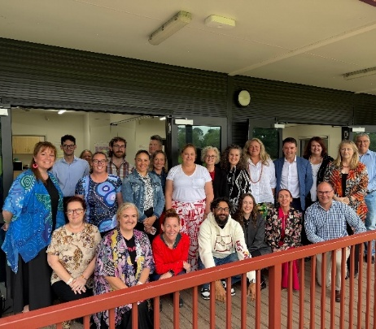
Guided by Aboriginal and Torres Strait Islander leaders, participants engaged in yarning circles, reflective exercises, and candid conversations that encouraged openness and accountability. Stories of lived experience, resilience, challenge, and progress which created a space where truth-telling became not just encouraged, but essential.
Participants confronted difficult truths, acknowledged systemic barriers, including racism and bias, that outcomes for Aboriginal and Torres Strait Islander communities remain uneven, and recognised the importance of partnership with community, investing in leadership, amplifying community voices, and fostering genuine partnerships. This work is helping to build a future where equity is not an aspiration, but a reality.

All-SES Closing the Gap Workshops (23-25 June 2026)

The SES Leadership training brought leaders together with a shared purpose: to build a consistent understanding of their responsibilities and collectively shape how the Closing the Gap Principle would be embedded in practice. Designed in partnership with subject matter experts and informed by Aboriginal and Torres Strait Islander perspectives, the workshops created space for open dialogue, reflection and truth-telling.
Participants examined how the systems they lead—people, structures and processes—produce outcomes and identified where change was needed to deliver more equitable results.
Leaders aligned around common language, expectations and accountability, and co-developed practical commitments embedded in their Executive Performance Agreement.

Progress in implementing both the National Agreement and the ACT Agreement
During 2025-26 CMTEDD continued to apply the principles of the National Agreement on Closing the Gap across our policy, workforce, procurement and governance functions. Our focus was on lifting cultural capability and ensuring decisions are informed by Aboriginal and Torres Strait Islander perspectives.
We introduced improvements to workforce practices and service delivery under Priority Reform Three 3 – Transforming Government Organisations. This includes embedding culturally safe recruitment and employment approaches and strengthening structured employment pathways such as the Employment Pathways Program. Also expanding access to career development initiatives including coaching and targeted professional development, and opportunity to access Cultural Advisers for mentoring and cultural workforce support. These activities support implementation of the ACT Aboriginal and Torres Strait Islander Agreement 2019-2028.
A key priority was building leadership capability and accountability. Senior executives participated in targeted workshops to prepare for the implementation of the Public Sector (Closing the Gap) Legislation Amendment Act 2025, which came into effect 1 July 2026. This work strengthened understanding of the Closing the Gap principles and complemented Cultural Awareness Training as part of the CMTEDD Cultural Learning Strategy. Cultural Awareness Training continued to be delivered by National Indigenous Training Employment Solutions (NITES), complemented by the new CMTEDD Cultural Awareness eLearning module, which became required learning for staff in July 2025 and was refreshed in June 2026 for broader use across the ACTPS.
Implementation of the CMTEDD Reconciliation and Cultural Integrity Plan 2024–2027 remained a priority under both the ACT Aboriginal and Torres Strait Islander Agreement and the National Agreement Priority Reforms. Progress was supported by the CMTEDD Reconciliation Working Group, who met quarterly to provide oversight, monitor delivery, and guide implementation. The Working Group held an in-person meeting during National Reconciliation Week 2026, with attendance by the Director-General, Under Treasurer, and members of the directorate’s Aboriginal and Torres Strait Islander Staff Network. The Working Group supported business areas to overcome any obstacles to delivery, and highlighted areas of good practice to support our learning.

National Reconciliation Week – walk on Country
CMTEDD staff participated in a walk on Country at the Jerrabomberra Wetlands during Reconciliation week - helping strengthen Aboriginal and Torres Strait Islander cultural integrity by building awareness, fostering culturally safe environments, and encouraging respectful engagement.

CMTEDD staff learn about Aboriginal and Torres Strait Islander cultures celebrating National Reconciliation Week 2026.
Staff also took part in the ACTPS Walk for Reconciliation, from 220 London Circuit to Reconciliation Place. Walking together is a powerful demonstration of unity, healing and commitment towards reconciliation; by walking side by side staff were able to reflect on our progress while acknowledging the challenges we still face.

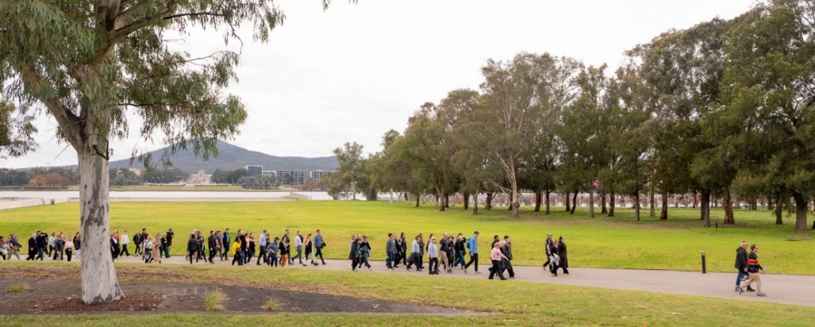
ACT Public Service Walk for Reconciliation 2026
CMTEDD has maintained Cultural Adviser roles since 2020. The two current Cultural Advisers were appointed in December 2025 for a two-year term. Cultural Advisers provide strategic guidance to enhance cultural capability, lead the Aboriginal and Torres Strait Islander Staff Network, and deliver mentoring and advice to business units.
CMTEDD strengthened employment pathways for Aboriginal and Torres Strait Islander peoples through continued delivery of the Employment Pathways Program (EPP), which is an 18-month initiative combining paid work experience with formal training under the Australian School Based Apprenticeship (ASBA) scheme. In 2025-26, five participants were engaged in the EPP, with one participant completing in December 2025 and four expected to complete in December 2026. CMTEDD will improve students’ access to these opportunities through annual intakes from 2026 and expand across additional directorates to increase the volume and variety of employment opportunities available.
We continued to support career development through the Professional Development Fund, which enabled Aboriginal and Torres Strait Islander staff to access tailored learning and development opportunities beyond Studies Assistance. During 2025-26, this included application and interview skills training, and access to one-on-one coaching, strengthening pathways for those seeking progression.
We also introduced a new professional development initiative for Aboriginal and Torres Strait Islander Board, Committee and Council Members, providing targeted support in financial assistance to build governance, leadership and strategic capabilities.
At a whole of government level, the Cultural Transformation Group has implemented a range of initiatives to support the attraction, recruitment, retention and development of Aboriginal and Torres Strait Islander employees across the ACTPS in 2025-26.
Key initiatives included:
- The establishment of ongoing yarning circles as a proactive mechanism to support staff wellbeing, strengthen cultural connection, and foster culturally safe workplaces for Aboriginal and Torres Strait Islander employees.
- Support for 10 Aboriginal and Torres Strait Islander employees to participate in the Institute of Public Administration Australia (IPAA) Emerging Leaders Program.
- Sponsorship of 10 Aboriginal and Torres Strait Islander employees to attend the ANZSOG First Nations Public Administration Conference.
- Sponsorship for 10 Aboriginal and Torres Strait Islander employees to attend the Australian Institute of Aboriginal and Torres Strait Islander Studies Summit.
- Funding for four Aboriginal and Torres Strait Islander staff to participate in the Public Sector Employment Program, supporting structured employment and workforce development opportunities.

Economic Development Mapping Project
In 2025-26, we mapped Aboriginal and Torres Strait Islander initiatives and activities across Economic Development branches to establish a baseline, identify examples of strong practice and highlight opportunities for improved coordination and collaboration. This work supports organisational readiness for the implementation of amendments to the Public Sector Management Act 1994. A snapshot of those examples and opportunities is presented below.
Table 41: Economic Development Mapping Project
Business area opportunities | Key areas identified
Venues Canberra identified opportunities to strengthen Aboriginal and Torres Strait Islander engagement and participation across major venue operations, public-facing events, hirer partnerships, employment pathways, commercial partnerships, procurement and communications. | Acknowledgement of Country and Welcome to Country at major events  Engagement with hirers and event partners to improve integration of Aboriginal and Torres Strait Islander products and businesses into operations  Aboriginal and Torres Strait Islander staffing pathways through Australian School Based Apprenticeship (ASBA)-style programs  Reconciliation-focused internal discussions  Public-facing opportunities across GIO Stadium Canberra, Manuka Oval and EPIC to provide a visible platform for recognition, reconciliation and cultural presence  Corroboree Group naming rights partnership at Manuka Oval  Potential future opportunities in signage, uniforms, artwork and venue presentation  Procurement and supplier engagement opportunities
artsACT identified substantial Aboriginal and Torres Strait Islander engagement occurring across nearly all areas of operations. | ACT Aboriginal and Torres Strait Islander Cultural Arts Program  Aboriginal and Torres Strait Islander Arts Network  Aboriginal and Torres Strait Islander Arts Reference Group  Arts, Culture and Creative Policy 2022–2026 review  Canberra Pōneke Indigenous Artist Exchange  Indigenous Cultural and Intellectual Property (ICIP) work
Events ACT’s Indigenous culture, programming and experiences feature in Canberra’s major and community events. | Welcome to Country was performed at the majority of events.  Smoking Ceremonies were conducted at Floriade and Enlighten Festival.  Indigenous performers were included in programming across all events.  Indigenous culture also featured prominently at Floriade in 2025. This included storytelling, performances, and a dedicated market stall. A native garden showcased bush tucker and medicinal plants, highlighting sustainable traditional practices and sharing knowledge of the local Ngunnawal culture. Garden bed signage featured a translation of the bed name into Ngunnawal language.  Two of the Illuminations at the 2026 Enlighten Festival featured work by internationally renowned Aboriginal artists. The National Gallery of Australia presented Kukawarra kwatja, pmara nhanhanama marra inthurra, soft rain, strong Country by Yarrenyty Arltere Artists and Grace Kemarre Robinya, and the National Portrait Gallery aligned their Illumination with Kaylene Whiskey’s major solo exhibition, creating Queens of the Desert.

Skills Canberra
Skills Canberra continued to support the implementation of the National Agreement on Closing the Gap through targeted initiatives delivered under the National Skills Agreement.
To support shared decision-making Skills Canberra progressed planning to engage an Aboriginal or Torres Strait Islander provider to lead consultation and co-design activities. This work will inform the establishment of an Aboriginal and Torres Strait Islander-led shared-decision making mechanism to inform the development of an Activity Plan for the National Skills Agreement Closing the Gap Bilateral Implementation Plan for the remainder of the National Skills Agreement.
Through the National Skills Agreement Foundation Skills Bilateral Implementation Plan, Skills Canberra expanded access to adult and community education opportunities for Aboriginal and Torres Strait Islander learners. The 2025–27 ACT Adult and Community Education Grants Program prioritised delivery by, or in partnership with, Aboriginal and Torres Strait Islander organisations, including funding for Worldview Foundation to deliver the Solid Start program for young Aboriginal and Torres Strait Islander men in the ACT.
ACT’s National Skills Agreement Improved Completions Bilateral Implementation Plan identifies Aboriginal and Torres Strait Islander learners as a priority cohort for future targeted support initiatives aimed at improving vocational education and training completion outcomes. Program design and implementation work continued during 2025-26, with funded activities to commence in 2026–27.

Communications and Engagement
We have tailored information on the act.gov.au website into topics, accessible via a single page, including information on programs and services that support Aboriginal and Torres Strait Islander people in the ACT. Work is underway to consider other relevant communication channels that can also be tailored and/or targeted to Aboriginal and Torres Strait Islander peoples.
The International Association for Public Participation (IAP2), the nationally recognised body for Community Engagement, released national guidelines to support engagement (including co-design) with Aboriginal and Torres Strait Islander communities in March 2026. Now that these have been released, CMTEDD will consult with local community members to appropriately tailor them for local use.

Procurement
The ACT Aboriginal and Torres Strait Islander Procurement Policy supports the ACT Government's commitments under the National Agreement on Closing the Gap and the ACT Aboriginal and Torres Strait Islander Agreement by increasing opportunities for Aboriginal and Torres Strait Islander businesses to participate in government procurement.
Through promoting economic participation, supporting self-determination, and strengthening culturally safe procurement practices across government, the policy contributes to more equitable outcomes for Aboriginal and Torres Strait Islander peoples while fostering a procurement environment that values cultural knowledge, respect and inclusion.
Procurement ACT continued to progress work to update the Aboriginal and Torres Strait Islander Procurement Policy (Policy) and associated resources, with the updated policy anticipated to be released in the first quarter of 2026-27. Procurement ACT has also progressed implementation of an action plan to support implementation of the updated Policy. This includes continued activity to raise awareness of the Policy and of the benefits of engaging with Aboriginal and Torres Strait Islander entities, such as through supplier and buyer training and engagement and a refreshed eLearning module.
Procurement ACT also supports the application of the Aboriginal and Torres Strait Islander Procurement Policy through the administration of the Canberra Region Aboriginal and Torres Strait Islander ‘Enterprise List’ and reporting for Territory entities to measure their performance in accordance with the policy.
Procurement ACT represents the ACT Government at the Australasian Procurement and Construction Council’s Indigenous Procurement Policy roundtable.

Priority reforms
CMTEDD continues to work towards the outcomes and targets of the Priority Reforms in the National Agreement on Closing the Gap that align to our work. This includes through making progress on actions under the ACT Aboriginal and Torres Strait Islander Agreement and actions under our Cultural Integrity and Reconciliation Action Plan.
In April 2025, CMTEDD developed an Aboriginal and Torres Strait Islander Internal Steering Committee. This committee monitors progress against our ACT Agreement Actions and Closing the Gap Priority Reform Areas and Targets.
Table 42: Priority Reforms
Business area | Progress status
Priority reform 1: Formal partnerships and shared decision making
Policy and Cabinet | In 2025-26, we had regard to the Closing the Gap principles of partnership and shared decision-making by engaging with the Aboriginal and Torres Strait Islander Elected Body on work related to Priority Action 27 of the ACT Aboriginal and Torres Strait Islander Agreement 2019–2028 Phase 3.  Priority Action 27 commits the ACT Government to undertaking work required to implement proportional funding, working with the Elected Body on the scope and methodology for future Expenditure Reviews, and establishing the Proportional Funding Steering Committee.  During the reporting year, the Elected Body was engaged in planning activities and early discussions on the implementation of Priority Action 27, informing decision-making and policy development. Progress was also made towards establishing governance arrangements through the Proportional Funding Steering Committee, with the Elected Body invited to participate as members of the Committee. These activities contributed to implementation of the ACT Agreement and supported the ACT Government's commitments under the National Agreement on Closing the Gap.
Office of Industrial Relations and Workforce Strategy | The Cultural Transformation Group has engaged with Directors-General, Deputy Directors-General, Human Resource leads, Cultural Advisers, teams delivering Aboriginal and Torres Strait Islander specific programs and services (including the Office of Aboriginal and Torres Strait Islander Affairs), Yarning Brew, the ACT Aboriginal and Torres Strait Islander Elected Body (The Elected Body) and Aboriginal and Torres Strait Islander staff more broadly to co-design the implementation plan to assist the ACTPS to meet the requirements of the Closing the Gap Act.  We co-designed a stakeholder engagement proposal with the ACT Aboriginal and Torres Strait Islander Elected Body. We are implementing this as the preferred ACTPS model for engagement across the Cultural Transformation Group’s workplan, ensuring alignment with Priority Reform 1 and Priority Reform 3 under the National Agreement on Closing the Gap.
Corporate | Collaboration with the ACT Aboriginal and Torres Strait Islander Elected Body, the Office of Aboriginal and Torres Strait Islander Affairs, and community stakeholders has ensured that Aboriginal and Torres Strait Islander perspectives inform and shape key decisions and initiatives.  Engagement with Aboriginal and Torres Strait Islander stakeholders continued to inform CMTEDD’s policies and programs. A review of the Aboriginal and Torres Strait Islander Procurement Policy was vital and characterised by strong collaboration with the Aboriginal and Torres Strait Islander Elected Body and the Office of Aboriginal and Torres Strait Islander Affairs. Broader engagement included organisations such as Supply Nation and Aboriginal and Torres Strait Islander suppliers. Engagement with Aboriginal and Torres Strait Islander stakeholders also supported the development of guidance on Indigenous Cultural and Intellectual Property, aiming to ensure CMTEDD and the ACTPS undertake culturally appropriate procurement practices.
Economic Development | To support shared decision-making in the implementation of the National Skills Agreement Closing the Gap initiatives, Skills Canberra progressed planning to engage an Aboriginal or Torres Strait Islander provider to lead consultation and co-design activities. This work will inform the establishment of an Aboriginal and Torres Strait Islander-led shared-decision making mechanism to inform the development of an Activity Plan for the National Skills Agreement Closing the Gap Bilateral Implementation Plan for the remainder of the National Skills Agreement.
Priority reform 3: Transforming Government organisations
CMTEDD has undertaken significant activity in this priority reform. Details of these activities can be found in the information above, and referenced in the ACT Aboriginal and Torres Strait Islander Agreement Commitments, below.
Priority reform 4: Shared access to data and information at a regional level
Policy and Cabinet | CMTEDD has continued to support work under Priority Reform Four of the National Agreement to enable shared access to data and information for Aboriginal and Torres Strait Islander communities and organisations and to support the achievement of the first three Priority Reforms.  CMTEDD, in partnership with Digital Canberra, committed to a fundamentally new way of developing and implementing policies that enable Aboriginal and Torres Strait Islander people have access to, and the capability to use, locally-relevant data and information to set and monitor the implementation of efforts to close the gap, their priorities and drive their own development – as part of work under Priority Action 43 of the ACT Aboriginal and Torres Strait Islander Agreement 2019-2028 Phase 3.

ACT Aboriginal and Torres Strait Islander Agreement commitments
Table 43: ACT Aboriginal and Torres Strait Islander Agreement commitments
ACT Agreement Focus Area | Closing the Gap Priority Reform Area and Targets | ACT Agreement Action | Status Update
Cultural Integrity | Priority Reform Three: Transforming Government Organisations | Embed cultural capability and cultural safety into the fabric of the way the ACTPS works  (Phase III Action Plan – priority action 25) | Cultural capability  A whole of government uplift in cultural capability has been progressed through the implementation of the Public Sector (Closing the Gap) Legislation Amendment Act 2025 (the Act), commencing 1 July 2026. Cultural capability has been embedded into SES accountability through standardised wording in Executive Performance Agreements, with guidance issued service‑wide. Closing the Gap workshops for SES and Statutory Office Holders were held from 23-25 June 2026, strengthening understanding of legislative obligations, culturally safe leadership and performance responsibilities. A whole of government cultural awareness eLearning has been released.  Cultural safety  Cultural safety has been strengthened through practical, co-designed supports. Cultural Safety Care Plans have been developed with ACTPS Cultural Advisers and piloted in the Health and Community Services Directorate (HCSD), embedding structured engagement, culturally responsive practice and early inclusion of Aboriginal and Torres Strait Islander perspectives in decision-making. These Plans have been launched. Ongoing yarning circles have been embedded into everyday practice as a proactive mechanism to support wellbeing, connection and cultural safety for Aboriginal and Torres Strait Islander staff. This work is supported by the Act Implementation Support Hub, providing centralised guidance and tools.  Cultural remuneration  The ACT Government is exploring options to address cultural remuneration through the current employment framework and round of Enterprise Bargaining. This action aligns with Phase Three, embed cultural capability and cultural safety into the fabric of the way the ACTPS works (Priority Action 25), under which the Government has committed to developing remuneration guidance to recognise Aboriginal and Torres Strait Islander cultural expertise. Future action planning, including any potential reporting on cultural expertise payments, will be considered as part of Phase Four and will require privacy, confidentiality and costing considerations.  Systemic racism  Systemic racism is being addressed through both legislative and capability-based reforms. The Act strengthens accountability through SES performance requirements and mandatory reporting. In parallel, the BRAVE Program (Bias, Racism, Allyship, Validate, Empower) has been launched and will commence in August 2026 to build SES capability to identify and address racism in practice.  Employment framework  Consideration of further attraction, recruitment and retention initiatives will occur post-July 2026 alongside the whole of government Closing the Gap Transformation Strategy, noting that the Identified Recruitment Guidelines have already been implemented across the ACTPS.
Economic Participation | Priority Reform Two: Building the Community Controlled Sector | Proportional funding fundamentals  (Phase II Action Plan – priority action 27) | In progress  In April 2026, CMTEDD officials met with representatives of the Aboriginal and Torres Strait Islander Elected Body to facilitate a workshop on implementing this priority action. The workshop provided an opportunity for early engagement, collaborative planning and information sharing to support transparency and shared progression of future work.  A key deliverable under this action is establishing the Proportional Funding Fundamentals Steering Committee which has now been established, with representation from the Aboriginal and Torres Strait Islander Elected Body and relevant Directorates, to progress work on proportional funding and the related ACT Aboriginal and Torres Strait Islander Expenditure Review.  The Committee will guide the development of a consistent, transparent, and accountable ACT Government approach to proportional funding, including establishing a shared understanding of its meaning and measurement.
Economic Participation | Socio-economic Target 8 | Reform Procurement to Remove Barriers and Shift Power  (Phase II Action Plan – priority action 28) | In progress  From 1 July 2026, on commencement of the Government Procurement Amendment Act 2026, Territory entities will be able to procure goods and services directly from a suitable certified Aboriginal or Torres Strait Islander entity for procurements under $500,000 (GST Inclusive). Territory entities are still required to establish value for money, however this new approach removes the requirement to seek an exemption where a certified Aboriginal and Torres Strait Island supplier has been identified.  Review of the Aboriginal and Torres Strait Island Procurement Policy is continuing to ensure cultural alignment
Inclusive Community  Health and Wellbeing | Priority Reform Four: Shared Access to Data and Information at a Regional Level | Indigenous Data sovereignty and data management and the supporting arrangements  (Phase III Action Plan – priority action 43) | In progress  CMTEDD, in partnership with Digital Canberra (DCBR) are working to embed across government, principles of Indigenous Data Sovereignty and Indigenous Data Governance.  In January and June 2026, CMTEDD and DCBR met with the Elected Body to jointly discuss approaches to progress this Priority Action and how to stage work.  Within government, the Data Reform Group, chaired by the Director-General of DCBR, is providing WhoG data and policy stewardship and support for implementation of this action.  Since the establishment of the Third Action Plan and within 2025-26, CMTEDD and DCBR have:  Designed the Data Reform Group’s (DRG) 2026 work program that focuses efforts on the WhoG Indigenous Data Sovereignty project;  Co-designed and implemented (through the Data Management Group - DMG) a WhoG data audit of datasets to support the identification of data relevant to the ACT Aboriginal and Torres Strait Islander Community;  Hosted directorate workshops to support completing the data audit exercise and developed and shared reference materials to support directorates.
Economic Participation | Focus Area: Economic Participation | Strengthening Aboriginal and Torres Strait Islander Vocational Pathways  (Phase II Action Plan – priority action 54) | Ongoing  Skills Canberra is progressing Action 54 through implementation of the National Skills Agreement (NSA). This includes:  developing a targeted grants program to strengthen workforce capability in the ACCO sector;  establishment of a procurement process to support consultation and shared decision-making to inform the development of an Activity Plan for NSA Closing the Gap priorities;  prioritising investment in foundation skills and learner completion initiatives for Aboriginal and Torres Strait Islander learners; and  research to inform future approaches to Aboriginal and Torres Strait Islander student loadings and learner success.  CMTEDD strengthened employment pathways for Aboriginal and Torres Strait Islander peoples through continued delivery of the Employment Pathways Program (EPP), which is an 18 month initiative combining paid work experience with formal training under the Australian School-Based Apprenticeship (ASBA) scheme. In 2025–26, five participants were engaged in the EPP, with one participant completing in December 2025 and four expected to complete in December 2026. CMTEDD will improve students’ access to these opportunities through annual intakes from 2026 and expand across additional directorates to increase the volume and variety of employment opportunities available.
Cultural Integrity | Priority Reform Three: Transforming Government Organisations | ACTPS to develop general guidelines on identifying systemic racism in systems and processes, including expert input on barriers and governance to progress. | Ongoing  The Cultural Transformation Group has begun consultation on guidance with the aim of finalising and launching the resource in 2026. This process will see a consultation period that ensures alignment with evidence-based approaches to eliminating systemic racism in the ACTPS and supports principles under the Public Sector (Closing the Gap) Legislation Amendment Act 2025 (Closing the Gap Act).  The Systemic Racism Guidelines may form part of a broader whole of government Transformation Strategy, ensuring alignment with and reinforcement of the ACTPS’s overarching reform agenda.  It should be noted that increases in reporting instances of cultural safety concerns or racism indicate greater confidence and safety in raising issues to be addressed across the system, and we expect to see instances increase before they decrease.
Cultural Integrity | Priority Reform Three: Transforming Government Organisations | Develop and implement an ACT Public Service Cultural Integrity Framework to support each Directorate to create their own Cultural Integrity Action Plan and Professional Learning Plan relevant to their own contexts. | Ongoing  The Cultural Transformation Group has begun consultation on the guidance, with the aim of finalising and launching the resource in 2026. This process will see a consultation period that ensures alignment with existing Cultural Integrity resources and work underway across the ACTPS and the Closing the Gap Act.  The ACTPS Cultural Integrity Framework may form part of a broader whole of government Transformation Strategy, ensuring alignment with and reinforcement of the ACTPS’s overarching reform agenda.
Cultural Integrity | Priority Reform Three: Transforming Government Organisations | Develop a Cultural Integrity ‘best practice’ guide including case studies that align with the ACT Public Service Cultural Integrity Framework to support all Directorates to develop their own Cultural Integrity Action Plans. | Ongoing  A whole of government strategy informing the development of Reconciliation and Cultural Integrity Plans/strategies has been developed to support embedding strategies to align with Closing the Gap principles. This strategy has been released and can be found on the ACTPS Culture, Inclusion and Belonging Hub.  The Cultural Transformation Group has developed a project plan and consultation approach to support the development of the Cultural Integrity Framework and associated guidance. Consultation has commenced to ensure alignment with existing Cultural Integrity resources, work underway across the ACTPS, and the Closing the Gap Act. The final guide will include practical case studies to support Directorates to develop and implement their own Cultural Integrity Action Plans, with publication planned for 2026.  The ACT Public Service Cultural Integrity Framework may form part of a broader WhoG Transformation Strategy, ensuring alignment with and reinforcement of the ACTPS’s overarching reform agenda.
Inclusive Community | Priority Reform Four: Shared Access to Data and Information at a Regional Level | Develop an implementation-ready roadmap that will support an improved understanding of Aboriginal and Torres Strait Islander demographic information at different statistical geography levels. The roadmap should support the improved use of Aboriginal and Torres Strait Islander demographic information for service and policy design, and for wellbeing initiatives. The roadmap could consider data sharing or commissioning of survey collection activities. | Ongoing  As part of Phase 3 Priority Action 43 activity, directorates are completing a WhoG data audit of datasets to help identify data relevant to the ACT Aboriginal and Torres Strait Islander Community, including which datasets can contribute relevant demographic information.  The outcomes of the audit will inform what updates may be required to existing Aboriginal and Torres Strait Islander demographic information, such as the Health and Demographic Profile for the ACT and Surrounds, published in 2023 by the former ACT Health Directorate.
Lifelong Learning | Socio-Economic Outcome 6, Target 6  Socio-Economic Outcome 7, Target 7  Socio-Economic Outcome 8, Target 8 | Review subsidy loadings for Aboriginal and Torres Strait Islander traineeships and apprenticeships. | Complete  A review of the User Choice Funding Model focused on training subsidies was recently completed. A separate review of User Choice loadings will be conducted under the National Skills Agreement Completions Research Grants initiative.
Lifelong Learning | Socio-Economic Outcome 6, Target 6  Socio-Economic Outcome 7, Target 7  Socio-Economic Outcome 8, Target 8 | Develop, implement, and promote quality pathways to tertiary qualifications for Aboriginal and Torres Strait Islander students in the ACT. | Ongoing  The Aboriginal and Torres Strait Islander winners of ACT Training Awards will represent the ACT and compete at the Australian Training Awards in November 2026 in Sydney. The 2026 ACT Training Awards attracted eight Aboriginal and Torres Strait Islander nominations.  Skills Canberra Field Officers continue to engage with Aboriginal and Torres Strait Islander Australian Apprentices and their employers, including the group training organisation Indigenous Allied Health Australia (IAHA). In 2025-26, the team has engaged with 30 Aboriginal and Torres Strait Islander Australian Apprentices, including Australian School-based Apprentices.
Lifelong Learning | Socio-Economic Outcome 6, Target 6  Socio-Economic Outcome 7, Target 7  Socio-Economic Outcome 8, Target 8. | Increase community awareness of post school pathways and lifelong learning opportunities available to Aboriginal and Torres Strait Islander Canberrans. | Complete  In 2025-26, Skills Canberra strengthened its collaborative approach to promoting post-school pathways, vocational education and training (VET), and Australian Apprenticeships for Aboriginal and Torres Strait Islander Canberrans. The commencement of new Apprentice Connect Australia Providers (ACAPs) in the ACT created an opportunity to better coordinate outreach activity and make use of ACAPs’ Australian Government-funded role in promoting apprenticeship pathways through schools, career expos, industry events and stakeholder engagement. Skills Canberra’s Field Officer Program worked with ACAPs to support selected school career expos and larger industry-wide events, helping to provide consistent information about VET and Australian Apprenticeship pathways while avoiding duplication of effort. The Field Officer team also continued to provide direct support to Aboriginal and Torres Strait Islander Australian Apprentices and their employers, including through workplace engagement focused on apprentices’ and employers’ understanding of available supports, obligations and pathway options.
Lifelong Learning | Socio-Economic Outcome 6, Target 6  Socio-Economic Outcome 7, Target 7  Socio-Economic Outcome 8, Target 8 | Monitor the uptake and breadth of Australian School-based Apprenticeship opportunities for Aboriginal and Torres Strait Islander school students to inform future planning. | Completed and ongoing  Aboriginal and Torres Strait Islander students are well represented in the ACT ASBA population and the proportion has increased in recent years. In 2024-2026, Aboriginal and Torres Strait Islander students represented 12 to 13 per cent of all ASBAs in the ACT. This is a significantly higher proportion than (a) their representation in the general student population and (b) the proportion in 2023 i.e. 7 per cent.  The number of Aboriginal and Torres Strait Islander students who participated in ASBA opportunities remained stable in 2026 (at 47) compared to 48 in 2025.  The breadth of ASBA qualifications accessed by Aboriginal and Torres Strait Islander students decreased in the calendar year 2025 (from 19 in 2024 to 12 in 2025), while the number of available opportunities remained relatively constant between 2024 and 2025. That is, the number of unique ASBA qualifications available for Aboriginal and Torres Strait islander students to access in 2025 was 48 and in 2024 was 47.
Economic Participation | Socio-Economic Outcome 8, Target 8 | Business and Innovation branch to deliver the Aboriginal and Torres Strait Islander business support Program providing: Mentoring and Coaching advice; Concierge connections to business support providers; and access to Accelerator programs for businesses looking to grow. | Complete  Economic Development’s Business, Communications and Engagement branch, formerly Business and Innovation, continues to deliver the Aboriginal and Torres Strait Islander business support Program providing: Mentoring and Coaching advice; Concierge connections to business support providers; and access to Accelerator programs for businesses looking to grow. Future actions relating to business support packages will be covered under new commitments.

B10. Disability Inclusion Act 2024 Reporting
The Disability Inclusion Act 2024 provides reporting entities with a legislated framework to address barriers to, and promote the inclusion of, people with disability in the ACT.
In 2025-26, CMTEDD continued to build staff awareness of disability and accessibility through training, communication and celebrating important days, such as International Day of People with Disability. We shared ways staff can support disability inclusion in the workplace from staff with disability and allies. We also promoted workplace adjustments, accessible recruitment and ways managers can build disability confidence.
CMTEDD also maintained the Enable Network. This group provides peer support and gives a voice to staff with disability, carers, and allies. Network members discussed results from the 2025 ACTPS Staff Survey and considered areas for improving access and inclusion. The network informs disability initiatives for CMTEDD.
We provide learning and development opportunities promoting awareness and disability confidence through the CMTEDD Training Catalogue. The aim is to increase knowledge about workplace adjustments, disability confident conversations and facilitating positive employment, so every individual feels supported and has an equitable opportunity to develop a fulfilling career.
Procurement ACT continues to support employment and economic participation opportunities for people living with disability through the ACT Government procurement framework. The Government Procurement (Charter of Procurement Values) Direction 2020 promotes diversity, equality and inclusion as a core procurement value, encouraging Territory entities to consider broader social outcomes when undertaking procurement activities. From 1 July 2026, legislative amendments provide greater flexibility for Territory entities to engage Canberra Region small and medium enterprises. These actions are likely to benefit local social enterprises, Australian Disability Enterprises and disability-led organisations.
This year we established the ACT Academy of Sport Para Uplift Unit through a co-funded partnership with Paralympics Australia, the Australian Institute of Sport and the Australian Sports Commission. The unit forms part of the national Para Uplift initiative, which aims to identify and develop future Paralympic athletes by expanding classification opportunities, improving access to fit-for-purpose training environments, and enhancing specialised coaching and performance support. The initiative leverages Australia's network of state and territory institutes and academies of sport to deliver localised multi-sport pathway programs in the lead-up to the Brisbane 2032 Paralympic Games.
CMTEDD has been undertaking preliminary work in the development of a Disability Inclusion Plan (DIP), involving a desktop review of existing plans, considering relevant themes connected to CMTEDD’s services and functions, and undertaking training in the creation of a DIP.
The table below outlines CMTEDD’s key pieces of work against actions from the ACT Disability Strategy First Action Plan 2024-26.

ACT Disability Strategy First Action Plan 2024-26 – implementation
Table 44: CMTEDD’s activities against actions from the ACT Disability Strategy First Action Plan 2024-26
Commitment | Status Update
1.3 Review of the YourSay platforms and research services to ensure more people with disability can take part in consultation and engagement. | A procurement process for both engagement platforms, the YourSay Panel and YourSay Conversations, will be undertaken within the next 12 months and will consider accessibility best practice to ensure inclusive engagement.  CMTEDD continues to collaborate across ACT Government, including with the Health and Community Services Directorate (HCSD), to identify opportunities for participation in activities on issues of interest for people with disability, including appropriate qualitative research projects.  Easy English assistance is provided for projects where people with disability are identified as a target audience.  Further enhancements to guidance provided on the platform and additional accessibility tools are being explored and implemented where appropriate.
4.1 Strengthen ACT Government accessible communications and information provision by:  Modernising digital and other communications across ACT Government, including through improved accessibility for assistive devices, simpler language, consistent and clear design, and better searchability.  Promoting Easy English editions of all issues of Our Canberra in print and online and provide printed copies at ACT libraries.  Progress actions under the government response to Auslan Inquiry.  Improve accessibility of ACT Government events and communications by including accessibility information in all event listings and trialing several methods for communicating information in accessible ways (e.g. audio description of designs, video tours, tactile maps). | Our Canberra Easy Read is now a business-as-usual activity and continues to be distributed in line with all Our Canberra print editions. It continues to be promoted and remains available in ACT Libraries.  CMTEDD is working with HCSD and their Auslan interpreter to implement Auslan versions of priority content on act.gov.au  Community of practice in content design for government websites is part of business-as-usual to maintain the standard of website accessibility and readability.  We adhere to the internationally recognised benchmark Web Content Accessibility Guidelines (WCAG 2.0) across all communication including, but not limited to, text and image contrast ratios, audio descriptions on prerecorded video, synchronised captions on live media and consideration to readable and functional pages. We apply Plain English at a 7.0 grade reading level with consideration to Easy English principles when appropriate.  Events ACT developed its Disability Inclusion Plan in 2025.  The plan has been converted into Plain English and Easy  Read formats for publication on events websites, ensuring accessibility for all audiences.  Throughout 2025-26, a range of initiatives have been delivered to progressively embed accessibility and inclusion across Events ACT activities, with a strong focus on building capability, improving event design, and enhancing the visitor experience.  Sector Capability & Leadership  Delivered the Enlightened: Accessibility in Events Conference (March 2026) with approximately 90 attendees, promoting a “progress over perfection” mindset and sharing expert insights. Conference recordings have been published online to extend reach and continue sector education.  Progressed procurement of an Accessible Events Toolkit, with input from the Office of Disability and negotiations underway with a preferred supplier.  Enhanced Accessibility at Major Events  Introduced new initiatives, including audio-described tours for people who are blind or have low vision.  Delivered a comprehensive suite of accessibility measures, including:  Accessible transport, parking, and amenities (including Changing Places)  Mobility hire and temporary accessible infrastructure  Clearly mapped accessible routes and shuttle services  Strengthened accessible communications, including:  - Plain language and Easy Read Accessibility Guide  - Screen-reader-friendly site map and digital wayfinding (Bindimaps)  The National Arboretum Canberra strengthened accessible communications and inclusive program delivery through targeted initiatives:  Accessible Event Design (KiteFest 2025):  Introduced dedicated low sensory kite-making workshops, featuring low lighting, reduced noise and higher staff support ratios.  Developed Social Stories using simple English and visual supports, and distributed these online, in advance, to ticket holders and onsite, to support confident participation for people with diverse needs.  Inclusive Education Partnerships (2026):  Partnered with the Vision and Hearing Team, Inclusive Education (ACT Government) to deliver an accessible excursion program for regional students.  Delivered activities including kite making, orienteering and nature play with adapted resources, including large print and braille maps.  Enabled participation for students with vision and hearing impairments (with subsidised access).
6.1 We will lead by example to make the ACT Public Service a more inclusive workplace by:  Developing an ACTPS Diversity and Inclusion Strategy in consultation with ACTPS staff with disability and subject matter experts from across the ACTPS including Offices for Disability, Women, Aboriginal and Torres Strait Islanders, LGBTIQ+, Multicultural Affairs, and Seniors and Veterans.  Including reasonable adjustment questions in the ACTPS staff survey.  Setting an initial target of 9 per cent of ACTPS employees, including executive staff, being people with disability.  Including employment targets for people with disability in ACTPS executive staff performance agreements. | Work on the Inclusion and Belonging Strategy has commenced in consultation with Human Resources leaders and subject matter experts from across the ACTPS including Offices for Disability, Women, Aboriginal and Torres Strait Islander Affairs, LGBTIQA+ Affairs, Multicultural Affairs, and Seniors and Veterans. Mindful of consultation fatigue, the Cultural Transformation Group will incorporate insights from the in-depth listening exercise undertaken with people with disability in 2025.  The 2025 ACTPS Employee Survey included questions on reasonable adjustments.  OIRWS continues to implement the commitment of 9 per cent of ACT public servants identifying as having a disability including executives. In 2025, the ACTPS Employee survey indicated that 5 per cent of respondents identify as people with disability and 9 per cent of respondents identify as Neurodivergent. While data from HR/payroll records indicates that workforce representation of people with disability is lower than the target; however, national research has demonstrated that people with disability are more likely to identify via anonymous mechanisms, indicating that survey results may be the more reliable indicator.  The requirement to include employment targets for people with disability in ACTPS executive staff performance agreements has been communicated to Directors-General.

B11. Multiculturalism Act 2023 Reporting
The Multiculturalism Act 2023 commits the ACT Government to a whole of government approach to reporting. This includes reporting on the Charter for Multiculturalism to ensure the ACT continues to grow as an inclusive jurisdiction which values and promotes cultural and linguistic diversity.
The table outlines CMTEDD’s key pieces of work that will make a positive difference to the lives of the ACT multicultural community.

Multiculturalism Action Status and Summary
Table 45: CMTEDD’s actions to comply with section 15 of the Multiculturalism Act 2023
Requirements under the Multiculturalism Act 2023 | 2025-26 Actions Summary
Promotes multiculturalism | The data dashboard for the ACT Wellbeing Framework includes a measure about how confident people feel that there is community acceptance of people from different cultures. In 2025-26, the update of the dashboard published updated data for this measure.  CMTEDD supported the 2026 National Multicultural Festival across WhoG channels, including social media and Our Canberra print, e-newsletter and website. We also worked with HCSD to promote multiculturalism across social media and Our Canberra channels.  The opening of Fitzroy Pavilion at Exhibition Park in Canberra (EPIC) has provided multicultural and community groups with an event space that meets their needs. Increased engagement with multicultural groups has driven greater awareness and hire of facilities, with six multicultural events held during 2025-26.  CMTEDD delivered a six-month pilot mentorship program for leaders from Culturally and Linguistically Diverse (CALD) backgrounds who wish to advance their career into the ACTPS SES.  We also funded people from CALD backgrounds to participate in the Public Sector Management Program delivered by Queensland University of Technology.  Inclusive Recruitment Factsheets continue to be available on the ACTPS Culture, Inclusion and Belonging SharePoint Hub.  Procurement ACT promotes diversity, equality and inclusion through implementation of the Government Procurement (Charter of Procurement Values) Direction 2020. The Charter encourages participation by a diverse supplier market and supports inclusive procurement practices across government.
Takes into account the charter for multiculturalism in exercising functions | The Minister’s Creative Council is an advisory body for the arts in Canberra, assisting the Government to develop arts policies that promote and advance the arts across government and community. The Council is a diverse group of creative people, with a membership that includes CALD people.  All CMTEDD boards and committee are encouraged to use the Diversity Register when advertising positions.  Procurement ACT supports Territory entities to apply the Diversity, Equality and Inclusion procurement value when undertaking procurements.
Develops, applies, and reviews policies, programs and services in a way that promotes multiculturalism | CMTEDD continues to monitor website accessibility, content readability and implementation of translation functionality.  Procurement ACT continues to actively support Territory entities to promote diversity and multiculturalism through adherence to the Government Procurement (Charter of Procurement Values) Direction 2020 (Direction) which requires Territory entities to consider the Charter of Procurement Values, including Equality and Inclusion value, in procurement activities. By emphasising diversity and inclusion and the economic participation of the Aboriginal and Torres Strait Islander business in the management of procurement activities, the Direction has encouraged a broader range of suppliers, including those from diverse cultural backgrounds, to participate in procurement opportunities and achieving innovative and inclusive procurement outcomes.  In the 2025-26 financial year, a total of 482 ACT Government procurements incorporated the Diversity, Equality, and Inclusion value. This figure is based on ServiceNow contract notification data for contracts above the $25,000 notifiable contract threshold and reflects information submitted by Territory entities.  The ACTPS continues to encourage Aboriginal and Torres Strait Islander people, people with disability, people with CALD backgrounds, veterans, younger and older workers, and people with diverse genders, sexes and sexualities to apply for all CMTEDD job vacancies.  The Inclusive Recruitment resources are succinct and practical ‘Inclusive Recruitment Factsheets’ titled Inclusive recruitment Guiding Principles; Pro-Diversity Statements; Key Capabilities; and Onboarding. These resources were rigorously user-tested and continued to be available to all ACTPS staff via the Cultural Transformation Group’s Culture, Inclusion and Belonging SharePoint Site (intranet) during the reporting period. Additional guidance is being finalised which provides practical examples to illustrate what inclusive recruitment looks like in practice.
Works with the council, other administrative units, and Territory agencies to promote multiculturalism | CMTEDD worked with HCSD to promote multiculturalism across ACT Government social media and Our Canberra channels.  CMTEDD worked with HCSD and the Office for Multicultural Affairs to promote nominations in our award programs, including the Chief Minister’s Canberra Gold Awards, Canberra Citizen of the Year and the ACT Australian of the Year Awards, encouraging community members to nominate outstanding individuals for recognition.
Provides effective and equitable access to information, programs, and services to the ACT Community | CMTEDD continues to deliver the Our Canberra Easy Read newsletter, supporting those with low English literacy to access important ACT Government news and information. The newsletter is distributed to community partners, libraries, peak bodies and organisations each month.  We adhere to the internationally recognised benchmark Web Content Accessibility Guidelines (WCAG 2.0) across all communication including, but not limited to, text and image contrast ratios, audio descriptions on prerecorded video, synchronised captions on live media and consideration to readable and functional pages. We apply Plain English at a 7.0 grade reading level with consideration to Easy English principles when appropriate.  We have a translation tool available in the YourSay Conversations online engagement platform to support non-English speaking members of the community.  The ACT Revenue Office implemented an automated translation service on its website in June 2026.  The ACT Social Enterprise Grant Program provides matched funding grants to support new social enterprises to establish and help existing social enterprises to grow and scale. This program is delivered by The Mill House Ventures on behalf of the ACT Government.  In the 2025-26 round of the ACT Social Enterprise Grant Program three participants identified as supporting multiculturalism:  Artfullness Pty Limited  Australian Multicultural Women's Crafting Enterprise Pty Ltd  EDG Support Services Pty Limited

Staff engagement
The CMTEDD Diversity and Inclusion Strategy 2024-26 sets out how we promote a diverse and inclusive workplace. We value different ideas, backgrounds and experiences and facilitate access to opportunities and support. This helps our people feel like they belong, can do their best and reach their goals. In our 2025 staff survey, results for CALD CMTEDD staff showed positive responses, consistent with earlier surveys.
The CMTEDD Gender Action Plan 2024-28 aims to reduce the pay gap for women from CALD diverse backgrounds. To address this, we take part in the ACTPS Mentoring Program for Leaders from CALD Backgrounds. This program helps develop skills, support goals and build networks for aspiring executives.
CMTEDD also supported Multicultural ACT’s Work Experience and Support Program. This program helps people from different backgrounds start or grow their careers. We supported four jobseekers in 2025-26.
We changed how we share diversity and inclusion news. Our new approach is more conversational and easier to access, providing access to valuable resources and the calendar of diversity and inclusion events and awareness.
In March 2026, we promoted Harmony Week to celebrate our diverse workforce and shared ways to be inclusive at work every day.

Public Sector Management Program (PSMP)
We are committed to ensuring an inclusive workforce where diverse perspectives are actively sought, all voices are heard, and everyone has the opportunity for growth and success. In 2025, 11 Public Sector Management Program (PSMP) placements were funded through combined OIRWS budget (eight positions), and scholarships offered by Queensland University of Technology (QUT) (three positions). In 2026, 14 PSMP placements were funded through combined OIRWS budget (seven positions) and scholarships offered by QUT (seven positions).
Placements were open to employees from CALD backgrounds, Aboriginal and Torres Strait Islander employees, employees with disability, and neurodivergent employees.
Participants will complete a range of study units both online and in person and be awarded a Graduate Certificate in Business (Public Sector Management) on successful completion.

ACTPS Pilot Mentoring Program for Leaders from CALD Backgrounds
During the reporting period, the Cultural Transformation Group launched a new pilot mentorship program for people from CALD backgrounds who wish to advance their career into the SES. The aim of the pilot program was to strengthen the capability and capacity of the ACTPS. This will be achieved through supporting the career goals of people from CALD backgrounds and ultimately encouraging increased SES representation. Increased leadership diversity will enhance ACTPS advice to government, decision making and service-delivery by strengthening diverse lived experience and perspectives that reflect the progressive ACT community’s needs and expectations.
The pilot ran for 6 months from June to December 2025 with 13 pairs of mentees and mentors (26 participants). The pilot was an immensely successful program, and demonstrates the effectiveness of a low cost, high impact alternative professional development initiative for the ACTPS. With strong alignment between program design and participant needs, the program supported the leadership development of staff from CALD backgrounds, strengthened cross directorate connections, and provided meaningful two-way learning between mentees and senior executives.

B12. Period Products and Facilities (Access) Act 2003 Reporting
The Period Products and Facilities (Access) Act 2023 provides reporting entities with a legislated framework to address the reduction and prevention of period poverty in the ACT.
The table outlines CMTEDD’s work that support the intentions of the Act.
Table 46: CMTEDD’s actions to comply with the Period Products and Facilities (Access) Act
Part II: Access to period products | Part III: Workplace access to facilities | Part IV: Information and Guidelines
Period product dispensers are currently available at 220 London Circuit (ground floor bathrooms) and GIO Stadium Canberra. | Workplaces have appropriate toilets, sanitary waste, handwashing facilities in a way that respects the dignity of the person. | The ACTPS Employment Portal includes detailed information about Menstruation and Menopause Leave and flexible working arrangements for ACTPS staff.
CMTEDD notes that professionally serviced sanitary disposal facilities are provided in all female amenities, both for the public and staff, operated by CMTEDD (office sites, and major venues).

B13. Work Health and Safety
Work health and safety (WHS) is managed in accordance with the statutory provisions of the Work Health and Safety Act 2011 (the WHS Act), the directorate’s Work Health and Safety Management System—PeopleSafety, and relevant whole of government policies.
CMTEDD promotes a culture where health, safety and wellbeing are a part of everyday business. In support of this we implemented a range of continuous improvements to our WHS management arrangements, some of which are detailed below.

Health and safety structures and consultation arrangements
Table 47: Work Health and Safety Committee Structure
Consultative Committee Structure
Tier 1 | Directorate-wide WHS Committee
Tier 2 | CMTEDD WHS Network
Tier 3 | Local WHS Committees

The CMTEDD WHS Committees supported effective consultation and engagement on WHS arrangements to support workers and clients in the workplace. Our committees monitored the effectiveness of our WHS Management System, oversaw ongoing review and improvement of WHS management arrangements, and promoted the achievement of improved health and safety outcomes.
The Terms of Reference (TOR) for our Tier 1 WHS Committee and Tier 2 WHS Network were reviewed and revised TOR issued in April 2026. The revisions aimed to streamline and simplify the TOR, and to reflect the current CMTEDD organisational structure.
The tiered CMTEDD WHS Committees and Network, comprising Executives, Senior Managers, Health and Safety Representatives (HSRs), officers in safety and compliance roles and union representatives, met quarterly throughout the reporting period.
The directorate had an engaged network of 27 HSRs and four deputy HSRs, as well as 12 WHS Coordinators and other safety and compliance roles, who contribute to developing and supporting WHS performance and outcomes.

Achievements and outcomes
CMTEDD revised and updated our CMTEDD WHS Management Policy, in consultation with our workers. The revised policy continues to mandate PeopleSafety as CMTEDD's WHS management system and provide evident alignment with ACTPS WHS requirements and the AS/NZS ISO 45001:2018 – Occupational Health and Safety Management Systems Requirements with guidance for use.
CMTEDD undertook an external management review of our WHS Management System—PeopleSafety, providing external assurance of the continuing suitability, adequacy and effectiveness of our WHS management arrangements. The review confirmed PeopleSafety as fit-for-purpose and aligned with legislative and ISO requirements. Improvements were identified to enhance usability, ensure proportionate application, strengthen assurance, and support consistent implementation, which will be addressed in 2026-27.
Our 2025 WHS Assurance Program identified strong WHS leadership awareness and active HSR engagement, with opportunities for improvement in WHS governance and reporting, including management of corrective actions; risk management; and WHS training.
We launched the CMTEDD WHS Strategy 2026-28, and supporting Action Plan, outlining the vision, priorities, and areas of strategic focus to support the ongoing improvement and maturity of WHS management across CMTEDD.
CMTEDD achievements in WHS were recognised as part of our Staff Awards Ceremony held on 12 May 2026, where the Director-General and Under Treasurer acknowledged exceptional efforts and contributions to improve health, safety and wellbeing.

Wellbeing, early intervention and injury management
CMTEDD continued to promote initiatives to support early intervention and injury management to support workers who become ill or injured. This includes case management support, early intervention physiotherapy, workstation assessments for home and office-based work, and facilitated discussions.
We have a range of programs to support workers return or remain in the workplace including:
- Complex Reasonable Adjustments Service to help people who are at risk of an injury or illness, or who have a medical condition, to stay healthy and well at work by engaging a Workplace Rehabilitation Provider to help identify and implement reasonable adjustments for employees.
- Early intervention physiotherapy is available to employees who have recently experienced a musculoskeletal injury while at work.
- Facilitated Discussion Service to support workers manage interpersonal conflict, communication problems, or personality differences, with the aim of restoring a professional working relationship.
- Professional counselling and support for employees through our Employee Assistance Program.
- Before Blue early intervention mental health coaching program run by Beyond Blue, to support employees in managing everyday challenges, including stress and burnout, work pressures, relationship issues, and health concerns.
Our Mental Health Champions Staff Network supported the development and implementation of key initiatives under the CMTEDD Mental Health and Wellbeing Action Plan 2024-27, including:
- a new tiered mental health training offering to build the capability of CMTEDD staff and managers, with a focus on caring for self and others.
- a draft framework to assist employees affected by addiction to seek help and access appropriate workplace support.
We promoted a range of initiatives and wellbeing resources to support staff and team wellbeing and healthy work-life balance including:
- STEPtember
- Training and development opportunities
- Services available from our Employee Assistance Program Provider
- Health and wellbeing reimbursement
- Delivery of the CMTEDD Workplace influenza vaccination program, which vaccinated a total of 885 workers via a combination of onsite vaccination clinics (529) and vouchers to attend an offsite location (356).

Incident reporting and notices under the WHS Act
During 2025-26, 228 incidents were reported across CMTEDD. Seventeen incidents were reported to WorkSafe ACT in accordance with Part 3 Section 38 of the WHS Act.
CMTEDD was not issued any improvement, prohibition, or non-disturbance notices (under Part 10 of the Act), and had no findings by the regulator of a failure to comply with a safety duty or an enforceable undertaking.

ACTPS Work Health Safety and Wellbeing Strategy Target
In 2025-26, CMTEDD had four claims resulting in one or more weeks off work. Under the ACTPS Work Health and Safety and Wellbeing Strategy target of a 10 per cent reduction over five years (to 2028-29) or a 2 per cent reduction year on year from the result achieved in 2023-24, CMTEDD was set the target incidence rate of 1.93 claims/1,000 workers resulting in one or more weeks off work.
CMTEDD's result of 2.71 claims per 1,000 workers did not achieve the target for a reduction in claims resulting in one or more weeks off work in this reporting period. This is reflective of the reduction in size of the directorate due to machinery of government changes, and the low number of claims resulting in one or more weeks off work. CMTEDD's number of claims resulting in one or more weeks off work has remained relatively consistent over the past three financial years, with four claims in 2024-25 and three claims in 2023-24.
During 2025-26, CMTEDD has continued to focus on creating a mentally healthy workplace through a range of initiatives including the CMTEDD Mental Health and Wellbeing Action Plan 2024-27 and continued focus on the psychosocial health component of CMTEDD’s WHS Management System—PeopleSafety providing a range of resources to assist areas to provide a safe workplace for all.
Table 48: CMTEDD’s 2025-26 performance against the ACTPS WHS/Workers Compensation Target
2025-26 | WHS/workers compensation target | Achieved Result
CMTEDD | 1.93 | 2.71¹
1. The work health and safety indicator measures the number of ACT public servant workers’ compensation claims resulting in absence from the workplace of one week or more, expressed as a rate per 1,000 full-time employees.

Contact
For further information, please contact
Steven Wright
A/g Executive Group Manager, Corporate
Steven.Wright@act.gov.au

B14. Human Resources Management
In 2025-26, CMTEDD delivered human resources management initiatives to ensure a professional, skilled and accountable public service that is responsive to the ACT Government and the community now and into the future.

Culture, attraction and retention
Key actions to progress a positive culture, attract and retain staff included:
- Celebrating excellence at the 2026 CMTEDD Staff Awards. Seventeen individuals and teams received awards in seven areas. These awards show we value reconciliation, respect, collaboration, innovation, integrity, leadership, and safety and wellbeing.
- Supporting and promoting staff-led groups that celebrate diversity and wellbeing. These groups include:
- the Pride Network for LGBTQIA+ staff and allies
- the Enable Network for people with disability, carers, and allies
- the Aboriginal and Torres Strait Islander Staff Network for Aboriginal and Torres Strait Islander staff
- the Mental Health Champions Network to promote and support a culture of wellbeing and psychosocial safety.
- Surveying staff about their experience of work in the 2025 ACTPS survey. 80 per cent of staff said they were satisfied with their job.
- A series of workshops were run with staff to further explore survey themes identified as key drivers of engagement and from these directorate-wide actions. The actions focus on communication about goals, support for health and wellbeing, and improving equity and inclusivity by building a stronger feedback culture.

Workforce planning and employment strategies
In 2025-26, we continued our strong engagement with entry level programs. These programs support our talent pipelines, provide an entry point into the workforce for people starting their careers and help us engage staff with diverse experiences. CMTEDD has continued its support of the ACT Government Graduate Program. The CMTEDD Employment Pathways Program for Aboriginal and Torres Strait Islander students has been very successful, and we will expand this program to other directorates in late 2026, enhancing the volume and variety of opportunities.
Table 49: CMTEDD participants in targeted employment programs
Program name | Participants
ACTPS Graduate Program | 7
CMTEDD Employment Pathways Program | 5

Capability
The focus of our capability-building in 2025-26 was to:
- Uplift cultural capability across the directorate through the launch of a new Cultural Awareness eLearning module, which supports foundational cultural learning under the CMTEDD Cultural Learning Strategy.
- Design and deliver a tiered Mental Health Tiered Training Offering to support the CMTEDD Mental Health and Wellbeing Action Plan 2024–27. The aim is to build the capability of staff and managers, with a focus on caring for self and others.
- Enhance and improve leadership program content and relevance by incorporating new priority topics identified through emerging capability needs, staff survey feedback and organisational priorities.
- Continuously expand and update the CMTEDD training catalogue through new eLearning and instructor-led training opportunities, and review and update existing CMTEDD eLearning courses, ensuring alignment with legislative and policy requirements.

Learning and development programs and activities
CMTEDD staff continued to access a range of directorate-specific and whole of government learning and development opportunities to strengthen capability across priority areas. These included induction, cultural awareness, diversity and inclusion, mental health and wellbeing, human rights, domestic family and sexual violence, cyber security, procurement, risk management, governance, security, compliance and legislative capability.
Table 50: CMTEDD 2025-26 course completions
 | e-learning |  | Instructor Led
 | Courses | Completions | Courses | Completions
CMTEDD | 27 | 7,527 | 16 | 771
WhoG | 84 | 3,702 | 16 | 213
Total | 111 | 11,229 | 32 | 984
New training initiatives were offered to support the new Mental Health Tiered Training Offering, including workshops on creating psychologically safe workplaces, and mental health awareness. Various Employee Assistance Program awareness sessions were also offered, complemented by regular promotion of mental health and wellbeing resources, including the new Before Blue early intervention program. Disability Confident Managers training was also refreshed promoting awareness and disability confidence, aiming to increase knowledge about workplace adjustments, disability confident conversations and facilitating positive employment.
A new CMTEDD Cultural Awareness eLearning course was developed and launched during NAIDOC Week 2025. The course aims to build awareness and understanding about Aboriginal and Torres Strait Islander cultures, history, knowledge, and rights, and was assigned as required learning for all CMTEDD staff.
61 CMTEDD SES and 2 CMTEDD Statutory Office Holders attended Closing the Gap workshops, coordinated by Cultural Transformation Group. These workshops were delivered to support ACTPS SES and Statutory Office Holders to understand their responsibilities and obligations under the Closing the Gap Act.
CMTEDD introduced a suite of ACTPS Toolkit learning opportunities to strengthen staff understanding of our systems, processes and governance arrangements. This included legislation development training delivered by the Parliamentary Counsel’s Office, Hare-Clark voting system training by ACT Elections, and Legislative Assembly public sector seminars. Business areas also continued to deliver tailored training to meet specific operational requirements.
The Required Learning Framework continued to be embedded, ensuring staff continue to have the knowledge, awareness, skills and behaviours to work effectively and safely. The Framework is regularly reviewed to ensure that strategic risk factors, completion rates, learner time commitments, and learner feedback are appropriately balanced. In 2025-26, the overall completion rate for the Framework was 86 per cent.
CMTEDD offered a range of leadership development programs. There were 127 participants across two multiple-module CMTEDD leadership programs, aimed at building capability of both new and current supervisors, as well as experienced team leaders. In addition, 26 senior staff accessed one-to-one leadership coaching, and 64 participants joined the 2026 CMTEDD mentoring program.
The CMTEDD training catalogue also included other training sessions relevant for leaders, including People and Performance masterclasses for senior officers and an induction for new supervisors. Senior leaders and executive staff also participated in whole of government co-ordinated leadership programs and initiatives.
CMTEDD continued providing studies assistance to support staff seeking external learning and development opportunities. Thirty-one employees were supported undertaking formal courses of study and a total of $45,590 was provided in financial assistance towards course costs.
CMTEDD introduced a new professional development initiative for Aboriginal and Torres Strait Islander Board, Committee and Council Members, providing targeted support in financial assistance to build governance, leadership and strategic capabilities.

Gender Action Plan and Gender Impact Assessment Reporting
The CMTEDD Gender Action Plan 2024-28 aims to improve workforce gender demographics and ensure our workplaces are consistently safe and respectful. It focuses on access to opportunities and support for wellbeing, ensuring these are equitable for people of all genders.
In 2025-26, we progressed key actions:
- Providing access to resources to increase capability in understanding and preventing workplace gender discrimination and violence.
- Implementing a campaign about inclusive language and pronouns.
- Promoting access to leave and flexible options to support work and home life.
- Monitoring gender balance on leadership programs and ensuring equal access to additional development opportunities for Aboriginal and Torres Strait Islander employees under the CMTEDD Professional Development Fund.
CMTEDD also supports gender equality by:
- Providing mandatory training for staff about respectful behaviour in the workplace.
- Taking part in the ACTPS Women’s Mentoring Program.
- Providing access to different types of leave to support family and personal needs.
- Maintaining accreditation as a Breastfeeding Friendly Workplace with the Australian breastfeeding Association.
- Celebrating International Women’s Day.

Staffing profile
The staff numbers in the tables below represent CMTEDD employees who received a payment on the last payday of 2025-26. The figures exclude board members, staff on leave without pay and ACT Insurance Authority.
Recruitment and separation rates are defined as commencing or departing the ACTPS respectively for permanent employees, and members of the SES with long-term contracts.
Diversity data which may identify individuals has been removed from some tables.

Table 51: FTE (full-time equivalent) and headcount by business area
Business Unit | FTE | Headcount
Employment Programs | 8.2 | 11
Office of the Deputy Under Treasurer | 120.6 | 123
Communications and Engagement | 44.3 | 46
Corporate | 76.6 | 79
Economic Development | 276.4 | 306
Revenue, Procurement and Strategic Policy | 340.5 | 349
Office of Industrial Relations and Workforce Strategy | 356.2 | 365
Policy and Cabinet | 103.1 | 107
Strategic Finance | 28.7 | 29
Offices of the Head of Service, Under Treasurer, Professional Standards Unit and International Engagement | 41.5 | 43
Total | 1,396.0 | 1,458
Table 52: FTE and headcount by gender
 | Female | Male | Non-Binary | Total
FTE by Gender | 905.0 | 488.0 | 3.0 | 1,396.0
Headcount by Gender | 950 | 505 | 3 | 1,458
% of Workforce | 65.2% | 34.6% | 0.2% | 100.0%
Table 53: Headcount by classification group and gender
Classification Group | Female | Male | Non-Binary | Total
Administrative Officers | 510 | 212 | 3 | 725
Senior Executive Service | 33 | 32 | 0 | 65
General Service Officers & Equivalent | 1 | 11 | 0 | 12
Health Professional Officers | 5 | 1 | 0 | 6
Information Technology Officers | 3 | 1 | 0 | 4
Legal Officers | 2 | 0 | 0 | 2
Professional Officers | 5 | 7 | 0 | 12
Senior Officers | 388 | 232 | 0 | 620
Statutory Office Holders | 0 | 2 | 0 | 2
Technical Officers | 1 | 5 | 0 | 6
Trainees and Apprentices | 2 | 2 | 0 | 4
Total | 950 | 505 | 3 | 1,458
Table 54: Headcount by employment category and gender
Employment Category | Female | Male | Non-Binary
Casual | 13 | 8 | 0
Permanent Full-time | 756 | 419 | 3
Permanent Part-time | 112 | 19 | 0
Temporary Full-time | 66 | 56 | 0
Temporary Part-time | 3 | 3 | 0
Total | 950 | 505 | 3

Table 55: Headcount by diversity group
 | Headcount | % of Total Staff
Aboriginal and/or Torres Strait Islander | 35 | 2.4%
Culturally & Linguistically Diverse | 438 | 30.0%
People with a disability | 82 | 5.6%
Table 56: Headcount by age group and gender
Age Group | Female | Male | Non-binary | Total
Under 25 | 38 | 12 | 1 | 51
25-34 | 231 | 126 | 2 | 359
35-44 | 341 | 153 | 0 | 494
45-54 | 214 | 126 | 0 | 340
55 and over | 126 | 88 | 0 | 214
Total | 950 | 505 | 3 | 1,458
Table 57: Average length of service by gender
Gender | Female | Male | Non-binary | Total
Average years of service | 8.3 | 8.5 | 4.4 | 8.4
Table 58: Permanent recruitment and separation rates
Recruitment rate (%) | Separation rate (%)
8.2% | 7.6%
Table 59: Gender pay gap
Classification Group | Female Avg Salary | Male Avg Salary | Pay Gap
Administrative Officers | $101,803 | $100,518 | -1.3%
Senior Executive Service | $271,272 | $252,746 | -7.3%
General Service Officers & Equivalent | $82,572 | $89,500 | 7.7%
Health Professional Officers | $123,743 | $106,402 | -16.3%
Information Technology Officers | $106,916 | $109,818 | 2.6%
Legal Officers | $169,816 | 0 | 0.0%
Professional Officers | $108,313 | $102,564 | -5.6%
Senior Officers | $153,824 | $155,073 | 0.8%
Statutory Office Holders | 0 | $253,450 | 0.0%
Technical Officers | $110,414 | $117,260 | 5.8%
Trainees and Apprentices | $66,453 | $66,453 | 0.0%
Total | $129,484 | $135,774 | 4.6%

Contact
For further information, please contact
Steven Wright
A/g Executive Group Manager, Corporate
Steven.Wright@act.gov.au

B15. Ecological Sustainability Reporting

Support to the Commissioner for Sustainability and Environment
In 2025-26, we continued to take action to implement agreed recommendations from the below reports. Further information in relation to actions against reports of the Commissioner for Sustainability and Environment can be found in the Commissioner’s Annual Report.
- State of the Environment Report 2023
- Scope 3 Greenhouse Gas Emissions in the ACT 2021

Business area activities

Improving energy efficiency
In 2025-26, we undertook lighting upgrades within and around the National Arboretum Canberra Visitor Centre precinct to improve energy efficiency and reduce reliance on ageing electrical infrastructure.
We continued implementation of ecologically sustainable work practices at Venues Canberra’s major sporting and entertainment venues. This includes the ongoing installation of LED lighting at EPIC, GIO Stadium Canberra and Manuka Oval as older-style lights require replacement.
In 2025-26, we supported the first stage of a multi-phase procurement of the ACT Social Housing Virtual Power Plant, a transformational initiative to install rooftop solar and battery systems on up to 7,500 social housing properties to reduce energy costs, improve network resilience and support an equitable energy transition.

Improving water efficiency
CMTEDD continued sourcing non-potable water from rainwater collection and bores to support the Living Collection at the National Arboretum Canberra and the running track facilities at Stromlo Forest Park (SFP).
Upgrades to water metering systems were completed at the National Arboretum Canberra and SFP, ensuring compliance with new EPA regulations on non-urban and non-potable water metering (as outlined in the Non-Urban Water Metering Policy), and improving system efficiency.
We also undertook the annual irrigation audit of the Events Terrace and Amphitheatre lawns at the National Arboretum Canberra, identifying and repairing potential leaks, and replacing irrigation hardware that was not operating at optimal water efficiency.

Improving waste, reuse and recycling
We coordinated the direct delivery of 1,500m³ of mulch generated through the ACT Government street tree management programs to the National Arboretum Canberra for use in living collection management, with a further 2,000m³ committed for installation across forests and gardens by the end of 2026.
At our events, we enforced the use of paper-based food packaging only at all events, and to support the continued a phase out of plastic drink containers, we also enforced the sale of canned soft drinks only at all events.
At the Territory’s major venues of GIO Stadium Canberra, Manuka Oval and Exhibition Park in Canberra (EPIC) we continued the single-use plastic reduction strategy. Soft drink and water bottles, straws, sauce and condiment packets, plastic sleeves, plastic cutlery, stirrers and sandwich containers have been eliminated.
We also continued recycling across all major sporting and entertainment venues. The Container Deposit Scheme has been implemented at GIO Stadium Canberra and Manuka Oval. All Venues Canberra venues are annually accredited under the ACTSmart Business Recycling program. Waste sorting to refine recyclable waste items and organics for composting was also introduced for major events at EPIC.
Across the board we worked to reduce our waste by adhering to a culture of accessibility and sustainability and adopting eco-friendly practices wherever possible, including adopting a digital first policy where appropriate and leveraging online platforms to disseminate messages and engage with stakeholders.

Promoting sustainable transport
For our events, we installed Active Travel hubs at event entries and widely promoted to encourage active travel to and from events. We also invested in additional way-finding signage in and around Lake Burley Griffin to encourage active travel to Floriade.
We increased the number of free public shuttles for Floriade and Enlighten Festival, as well as providing free public transport (express services) between Belconnen, Tuggeranong and Woden bus interchanges.
At our major venues we prioritised the utilisation of public transport options for our spectators to all events. For GIO Stadium Canberra and Manuka Oval, this typically is a promotion of bus services, and carpooling. At EPIC, the light rail service is promoted.
Both GIO Stadium Canberra and Manuka Oval utilise an integrated ticketing system to promote the use of public transport, and this is communicated in various ways by Venues Canberra and hirers.
Procurement ACT supported planning for future procurements to expand the ACT's electric bus fleet and contribute to delivering the transition to a zero-emissions public transport network.

Sustainability in procurement
Events ACT continued measures to ensure environmentally responsible practices among our food and beverage procurement as part of our commitment to sustainability through the following activities:
- Sustainable Practices Assessment: Vendors are required to demonstrate their sustainability efforts, particularly in their packaging and product choices.
- Packaging Approval Process: Vendors must submit details of all packaging intended for public use at least one month prior to the event and provide samples if requested.
- Compliance Enforcement: Auditing vendors onsite to ensure vendors are not using non-compliant packaging.
Procurement ACT continued to leverage WhoG procurement arrangements to drive environmental outcomes across government. These arrangements supported the transition to zero-emission vehicles, with more than 280 zero-emission vehicles operating across the ACT Government, informed lower-emissions travel decisions through sustainability ratings, and encouraged sustainable purchasing practices through stationery supply arrangements.
We also continue to promote the ACT Government's expectations for ethical, sustainable and value-for-money procurement through the Government Procurement (Charter of Procurement Values) Direction 2020.

Supporting sustainable infrastructure
With support from the Infrastructure Canberra’s Electrification of Government Gas Assets Program, we commenced the phase-out of gas infrastructure as part of the Gorman Arts Centre Centenary Upgrade.

Supporting innovation and investment in ecologically sustainable development
In 2025-26, we continued support through the Priority Investment Program for the WhalePOD project by the Canberra based ANU start-up company Thaum. The $741,900 project commenced in 2023-24 and continues through until early 2027. WhalePOD is a multispectral optical radar and AI system designed to detect and monitor marine mammals in the context of noisy industrial activities. These activities are subject to regulatory obligations under the Environment Protection and Biodiversity Conservation Act 1999. Thaum has established an advanced manufacturing facility for WhalePOD to deploy in Australian and international marine environments and are collaborating with scientists at Data61 at the CSIRO, the ANU Research School of Physics, and a range of ACT SMEs. The technology will benefit researchers and industrial activities like offshore wind and commercial marine operations.
We also continued supporting businesses involved in ecological sustainable development through the programs delivered by the Canberra Innovation Network.
Table 60: Sustainable Development performance
Indicator as at 30 June | Unit | Current FY | Previous FY | % change
Stationary energy usage
Electricity use | Kilowatt hours | 5,615,895 | 5,164,114 | 8.7%
Fossil fuel gas use (non-transport) | Megajoules | 1,426,928 | 1,454,789 | -1.9%
Diesel use (non-transport, e.g. generators) | Kilolitres | 3.59 | 0.56 | 540.4%
Liquid Petroleum Gas | Kilolitres | n/a | n/a
Fleet vehicles
Zero Emissions Vehicles (ZEV) | Number | 10 | 8 | 25%
Plug-in Hybrid Electric Vehicles (PHEV) | Number | 1 | 0 | 100%
Hybrid Electric Vehicles (HEV) | Number | 0 | 0 | 0
Internal Combustion Engine (ICE) vehicles | Number | 23 | 23 | 0
Water usage
Water use | Kilolitres | 172,871 | 175,524 | -1.5%
Resource efficiency and waste
Waste to landfill | Litres | 1,036,363 | 1,502,080 | -31%
Co-mingled material recycled | Litres | 271,697 | 302,805 | -10.3%
Paper & cardboard recycled (incl. secure paper) | Litres | 502,616 | 432,955 | 16.1%
Organic material recycled | Litres | 206,294 | 226,399 | -8.9%
Waste to landfill (Events ACT Actsmart Public Events) | Litres | 275,067 | 309,043 | -11.0%
Material recycled (incl. comingle recycling, paper and cardboard recycling, and organic recycling) (Events ACT Actsmart Public Events) | Litres | 376,672 | 571,731 | -34.1%
Greenhouse gas emissions
Emissions from fossil fuel gas use (non-transport) | Tonnes CO2-e | 265 | 270 | -1.9%
Emissions from diesel use | Tonnes CO2-e | 43.9 | 48.6 | -9.6%
Emissions from petrol and E10 use | Tonnes CO2-e | 6.8 | 7.5 | -9.8%
Emissions from Compressed Natural Gas (transport) where applicable | Tonnes CO2-e | n/a | n/a | n/a
Emissions from refrigerants | Tonnes CO2-e | n/a | n/a | n/a
Total emissions | Tonnes CO2-e | 315.7 | 326.1 | -3.2%
Notes
Data for this reporting period was extracted on 3 September 2026. At the time of data extraction, CMTEDD data in the Enterprise Sustainability Platform had 98.91 per cent actual data, and 0.12 per cent estimated data.
Due to Machinery of Government changes where previous Directorates were significantly changed, for the purposes of reporting, these changes have been backdated to 1 July 2024 to enable a useful year-on-year comparison for impacted Directorates, including CMTEDD. As a result, the data for 2024-25 in the table above is different from that reported in the 2024-25 CMTEDD Annual Report.
Emissions reported include Scope 1 and Scope 2 emissions only. Scope 1 are direct emissions from sources owned and operated by the government, including emissions from transport fuel, fossil fuel gas, and refrigerants. Scope 2 emissions from mains electricity is considered zero in the ACT due to the ACT’s 100 per cent renewable electricity supply.
Emission factors used to calculate natural gas and fleet fuel are based on the latest National Greenhouse Accounts factors.
Refrigerant data across ACT Government is progressively being updated as new assets are identified and documented, current data is therefore limited, and accuracy will be improved in future reporting years.
The significant increase in non-transport diesel use reported does not reflect an increase in usage, but improved reporting. The majority of this usage relates to the lighting towers at GIO Stadium.
Fleet vehicle numbers include mowers, excavators, tractors and all-terrain vehicles to support activities at the Arboretum, Stromlo and Venues Canberra.
Volumes of waste reported fluctuates year by year, including at ACT Government events.

Other reporting

Financial management reporting
All Financial Management reporting is included in Volume 2 of CMTEDD’s Annual Report, including:
- Financial Management Analysis (Management Discussion and Analysis)
- Financial Statements
- Capital Works
- Asset Management
- Government Contracting
- Statement of Performance

Covert surveillance authorisations issued to ACT employers
The Workplace Privacy Act 2011 (Workplace Privacy Act) requires employers to apply to the Magistrates Court for authority to conduct any workplace covert surveillance.
In the financial year ending 30 June 2026, the Magistrates Court issued nil covert surveillance authorities under the Workplace Privacy Act.

Ministerial Staffing Expenditure Reporting
This information can be found in the Annexed report of the ACT Executive.

Request for Accessible Executive Records
The Territory Records (Executive Records) Amendment Act 2026 (the Amendment Act) amended Part 3A of the Territory Records Act 2002 from 9 March 2026. The Act provides for a 30-working day release period for access to be provided to a requested accessible executive record, or part of the record. The release period may be extended by up to 30 working days by the Principal Officer if the request involves large amounts of information or if responding to the request is complex.
There were no extensions of time to a release period from the commencement of the Amendment Act to the end of the reporting period.
Release Decisions made in accordance with the requirement of Part 3A of the Territory Records Act 2002 are published on ACT Memory: https://act.accesstomemory.org/ACT17

Carers Recognition Act reporting
In line with the Carers Recognition Act 2021, the directorate ensures it consults, considers and supports employees who are carers and to foster understanding of the care relationship principles, including when considering changes to policies, supports and services. FlexiSpaces are available across the ACT to provide alternative office-based workspaces, and access to flexible working arrangements to better meet the needs of CMTEDD employees who are carers or have other responsibilities, to manage their commitments alongside their work role. CMTEDD maintains four staff networks for CMTEDD to consult with particular cohorts of employees enabling input on policies, strategies and other workplace matters that may affect them:
- Enable Network - For people with disability, carers, and allies
- Pride Network - For LGBTIQA+ (Lesbian, Gay, Bisexual, Transgender, Intersex, Queer and Asexual, Aromantic, Agender) People and Allies Network
- Aboriginal and Torres Strait Islander Staff Network - For Aboriginal and/or Torres Strait Islander staff only and
- Mental Health Champions Network - For those passionate about mental health and wellbeing
CMTEDD is also an accredited Breastfeeding Friendly Workplace. Employees can access flexible working arrangements, paid lactation breaks and suitable facilities to support them to continue breastfeeding upon returning to the workplace. CMTEDD employees are engaged under Enterprise Agreements that provide a wide range of leave entitlements to support work/life balance and caring responsibilities. CMTEDD also promotes learning opportunities to improve cultural safety and respect for all employees.

Annexed annual reports
Public sector bodies required to have their annual report annexed to CMTEDD’s report are listed below. Their reports are included in alphabetical order in the following annex.
- ACT Executive
- ACT Government Procurement Board
- Default Insurance Fund
- Director of Territory Records
- Lifetime Care and Support Fund
- Motor Accident Injuries Commission
- Office of the Nominal Defendant of the ACT
- Public Sector Workers Compensation Fund

Annexed Reports

ACT Executive
The ACT Executive consists of the Chief Minister and other Ministers and their staff. The ACT Executive has powers under the Australian Capital Territory (Self Government) Act 1988 to govern the Territory and execute and maintain enactments and laws.

Overview
Table 1: Barr Ministry (as at 30 June 2026)
Minister | Portfolios
Andrew Barr | Chief Minister  Minister for Economic Development  Minister for Tourism and Trade
Yvette Berry | Deputy Chief Minister  Minister for Education and Early Childhood  Minister for Homes and New Suburbs  Minister for Sport and Recreation
Chris Steel | Treasurer  Minister for Planning and Sustainable Development  Minister for Heritage  Minister for Transport
Rachel Stephen-Smith | Minister for Health  Minister for Mental Health  Minister for Finance  Minister for the Public Service
Tara Cheyne | Manager of Government Business  Attorney-General  Minister for Human Rights  Minister for City and Government Services  Minister for Night-Time Economy
Suzanne Orr | Minister for Aboriginal Torres Strait Islander Affairs  Minister for Climate Change, Environment, Energy and Water  Minister for Disability, Carers and Community Services  Minister for Seniors and Veterans
Michael Pettersson | Minister for Business, Arts and Creative Industries  Minister for Children, Youth and Families  Minister for Multicultural Affairs  Minister for Skills, Training and Industrial Relations
Marisa Paterson | Minister for Police, Fire and Emergency Services  Minister for Women  Minister for the Prevention of Family, Domestic and Sexual Violence  Minister for Corrections  Minister for Gaming Reform

Staff
Staff are employed under the Legislative Assembly (Members Staff) Act 1989 (LAMS).
Table 2: Staff employed (as at 30 June 2026)
Classification | Staff FTE | Staff Headcount | Female FTE | Male FTE | Female Headcount | Male Headcount
Executive Chief of Staff | 1 | 1 | 0 | 1 | 0 | 1
Principal Adviser | 3 | 3 | 1 | 2 | 1 | 2
Senior Adviser L2 | 8 | 8 | 3 | 5 | 3 | 5
Senior Adviser L1 | 17.8 | 18 | 11.8 | 6 | 12 | 6
Adviser L2 | 21 | 21 | 9 | 12 | 9 | 12
Adviser L1 | 8.06 | 9 | 5.06 | 3 | 6 | 3
Total | 58.86 | 60 | 29.86 | 29 | 31 | 29
Table 3: Gender Breakdown at 30 June 2026
LAMS – ACT Executive | Female | Male
FTE by Gender | 29.86 | 29
Percentage (%) of Workforce | 51 | 49
Headcount by Gender | 31 | 29
Percentage (%) of Workforce | 52 | 48
Table 4: Employee Expenses by Executive Members at 30 June 2026 ¹
Executive Member | Staff Expenses ($’000)
Barr | 1,908
Berry | 1,543
Cheyne | 1,443
Orr | 1,320
Paterson | 1,150
Petterson | 1,219
Shared Resources | 3,337
Steel | 1,534
Stephen-Smith | 1,508
Gentleman | 16
Total | 14,978
1. Employee expenses comprise all costs incurred in relation to employing staff including wages and salaries, fringe benefits tax, leave entitlements, annual leave loading, termination payments, termination allowance entitlements for Members’ staff, resettlement allowance, entitlements for Members of the Legislative Assembly workers’ compensation insurance premiums, non-monetary benefits, and other employee benefits and oncost expenses. The payment for the Gentleman office was a late termination payment from July 2025.

Other reporting
During the reporting period the Chief Minister, Treasury and Economic Development Directorate (CMTEDD) was responsible for the administration of the ACT Executive budget appropriation. The ACT Executive financial results, including asset management, and the Management Discussion and Analysis are reported in Volume 2.2 of the 2025-26 CMTEDD Annual Report.
In the reporting period, CMTEDD provided the ACT Executive with financial management and associated reporting services. CMTEDD also provided payroll services through Shared Services.
The Office of the Legislative Assembly (OLA) controlled accommodation and building security. OLA also provided oversight of workplace health and safety and associated risk management, facilities management, and workplace environmental management. Reporting on these issues is contained in the 2025-26 Office of the Legislative Assembly Annual Report. OLA managed emergency management and shared management of business continuity arrangements with CMTEDD.
CMTEDD provided the ACT Executive with corporate, administrative, and financial support, including protocol matters, awards, functions, and events.
The ACT Government Solicitor’s Office provided the ACT Executive’s legal services and reviewed any issues to ensure compliance with the Model Litigant Guidelines.

Freedom of Information
During the reporting period the ACT Executive did not receive any Freedom of Information access requests. There were no applications for Ombudsman review and no requests to amend personal information.

Availability of open access information
During 2025-26 the ACT Executive published 43 open access information documents on ministerial diaries, FOI, and ministerial staff travel and hospitality expenses. Ministers’ open access information is published at https://www.act.gov.au/open-access/ministers-information.

Contact
Further information, please contact
Steven Wright
A/g Executive Group Manager, Corporate
Steven.Wright@act.gov.au

ACT Government Procurement Board

Transmittal Certificate
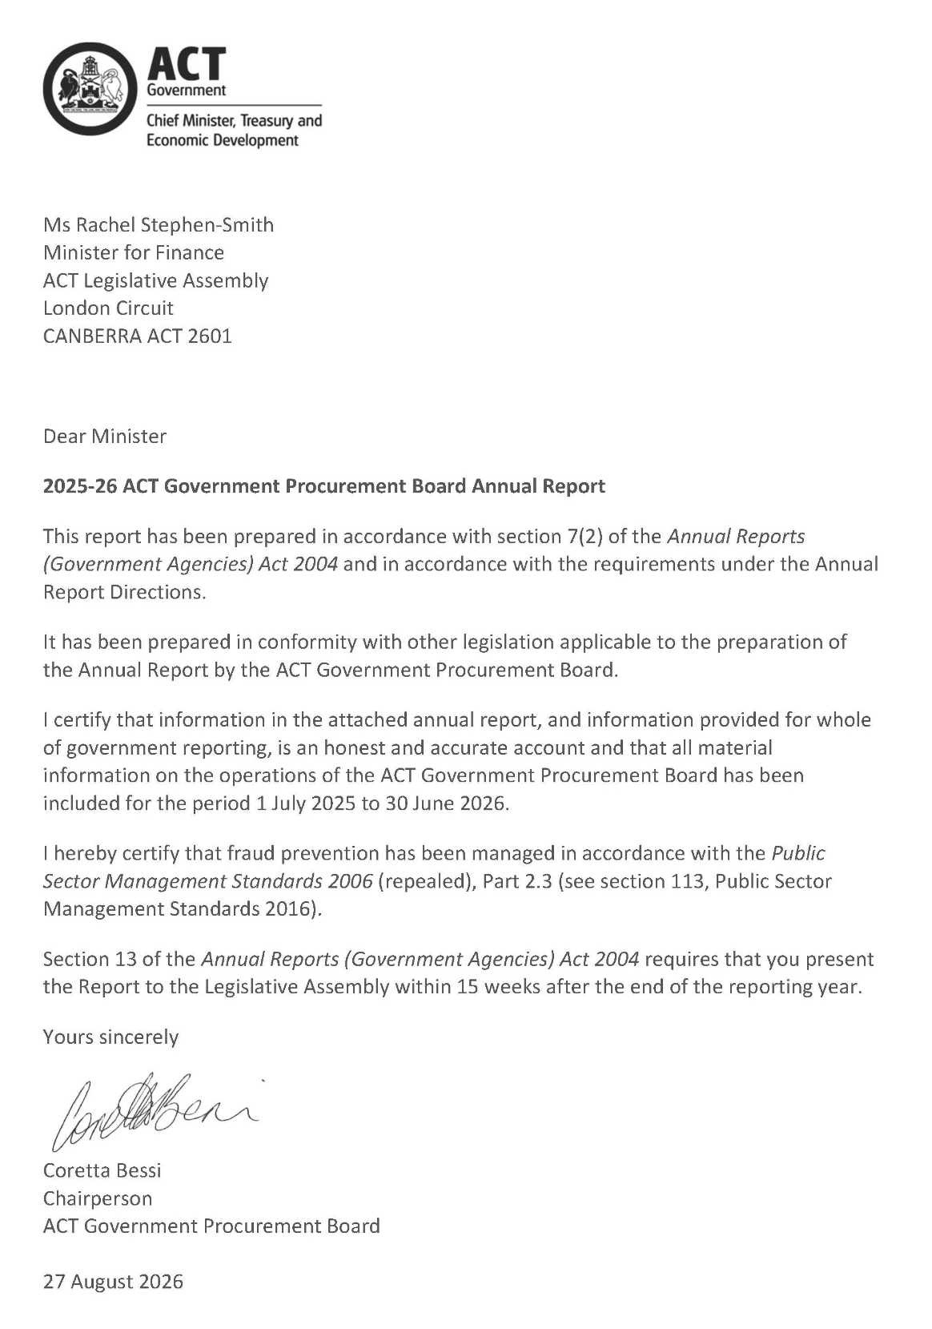

Compliance statement
The 2025-26 ACT Government Procurement Board Annual Report must comply with the Annual Reports (Government Agencies) Directions 2026 (the Directions) made under section 8 of the Annual Reports (Government Agencies) Act 2004. The Directions are found at the ACT Legislation Register.
The compliance statement indicates the subsections, under Parts 1 to 5 of the Directions, that are applicable to the ACT Government Procurement Board and the location of information that satisfies these requirements.

Part 1 Directions overview
The requirements under Part 1 of the Directions relate to the purpose, timing and distribution, and records keeping of annual reports. The 2025-26 ACT Government Procurement Board Annual Report complies with all subsections of Part 1 under the Directions.
To meet Section 15 Feedback, Part 1 of the Directions, contact details for the ACT Government Procurement Board are provided within the 2025-26 ACT Government Procurement Board Annual Report to provide readers with the opportunity to provide feedback.

Part 2 Reporting entity annual report requirements
The requirements within Part 2 of the Directions are mandatory for all reporting entities and the ACT Government Procurement Board Annual Report complies with all subsections. The information that satisfies the requirements of Part 2 is found in the ACT Government Procurement Board Annual Report as follows:
- Transmittal Certificate, see the previous page.
- Organisational Overview and Performance Analysis, see the Organisational Overview and Performance section below.
- Financial Management Reporting: The Board has no information to report under this section.

Part 3 Reporting by exception
The ACT Government Procurement Board has no information to report by exception under Part 3 of the Directions for the 2025-26 reporting year.

Part 4 Directorate and public sector body specific annual report requirements
Part 4 of the Directions is not applicable to the ACT Government Procurement Board.

Part 5 Whole of government annual reporting
All subsections of Part 5 of the Directions apply to the ACT Government Procurement Board. Consistent with the Directions, the information satisfying these requirements is reported in one place for all reporting entities as follows:
- Bushfire Risk Management, see the annual report of the Justice and Community Safety Directorate.
- Human Rights, see the annual report of the Justice and Community Safety Directorate.
- Legal Services Directions, see the annual report of the Justice and Community Safety Directorate.
- Public Sector Standards and Workforce Profile, see the annual State of the Service Report.
- Territory Records, see the annexed report within this 2025-26 CMTEDD Annual Report.
ACT Public Service directorate annual reports are found at the following web address:

1. Organisational overview and performance

1.1 Organisational overview
The ACT Government Procurement Board (Board) is established by the Government Procurement Act 2001 (Act). The functions of the Board under the Act are:
- review and make recommendations regarding specified procurements;
- review and endorse procurement practices;
- to recommend that the Minister give a direction about government procurement practices to Territory entities;
- provide advice to the Minister on any issue relevant to the procurement activities of Territory entities or the operation of the Act; and
- exercise any other function given to the Board under the Act or any other Territory law.

1.2 Internal accountability
In 2025-26, section 32 of the Act stipulated the Board comprises 9 part-time members:
- Chairperson, who is a non-public employee member;
- Deputy Chairperson, who is a public employee member;
- three public employee members; and
- four non-public employee members.
The position of Chairperson, like all Board memberships, is part-time. The Chairperson reports directly to the Minister for Finance, the responsible Minister under the Act, in relation to their role on the Board.

1.3 Board movements and appointments
Table 1: Membership and attendance of the ACT Government Procurement Board 2025-26
Name | Role | Meeting Attended | Notes
Ms Coretta Bessi | Chairperson  Non-public employee member. | 34/37
Ms Sally Druhan | Deputy Chairperson  Public employee member.  Chief Performance Officer, Digital Canberra. | 30/37
Dr Dave Gilbert | Public employee member.  Senior Director, Project  Delivery, Infrastructure and Health Support Services  Canberra Health Services. | 36/37
Mr Ashley Cahif | Public employee member.  Deputy Director-General, Infrastructure Canberra. | 26/37
Dr Anuj Saraogi | Public employee member.  Executive Branch Manager, Customer Data and Technology Group, Digital Canberra. | 34/37
Ms Sommer Roles | Non-public employee member. | 34/37
Mr Alan Galbraith | Non-public employee member. | 34/36 | Commenced membership on 4 July 2025.
Mr Anthony Srejic | Non-public employee member. | 25/36 | Commenced membership on 4 July 2025.  Mr Srejic took a leave of absence during the year.
Ms Hannah Bodilly | Non-public employee member. | 22/27 | Commenced membership on  12 September 2025.
Mr Mathew Baldwin | Non-public employee member. | 12/12 | Ceased Board membership as of 9 September 2025.

1.4 Conflicts of Interest
The Board has instituted arrangements to identify and address conflicts of interest (including as they relate to private interests) in recognition that members may be faced with potential conflicts of interest due to their other responsibilities.
The Board has instituted the following arrangements:
- members are made aware that conflicts of interest include perceived, potential and actual conflicts-of-interest;
- new members are provided with a probity briefing as to their conflict-of interest obligations within the induction process;
- Members are required to undertake Probity in Procurement training upon joining the Board and then at the commencement of each financial year.
- members must comply with the Board’s Terms of Reference and Code of Conduct both of which specify obligations in relation to the identification and management of conflicts of interest;
- members are required to make themselves aware of, and ensure that they comply with, all other relevant obligations that may apply to them by virtue of their membership of the Board, including as applicable, under legislation and instruments such as the Act, Financial Management Act 1996, Public Sector Management Act 1996, Public Sector Management Standards 2016 and ACT Public Sector Code of Conduct, ACT Government policies or procedures (as applicable), and the Strategic Direction of the Board from time to time;
- members are required to identify and document any standing conflicts of interest and private interests on joining the Board and at the beginning of each financial year;
- at the commencement of all meetings, members are requested to state any declarations of interest that may arise due to the business to be considered at the meeting;
- members with a potential, perceived or actual personal conflict of interest in a matter are not involved in the discussion or decisions relating to that matter.
There were 3 declarations of a potential conflict of interest recorded during the 2025-26 financial year, of which 1 disclosure was made by public employee members and 2 were made by non-public employee members.

1.5 Conflicts of Duties
The Board has instituted arrangements to identify and address conflicts of duties in recognition that members may be faced with potential conflicts of duties due to their roles within the Territory entities in which they are employed. A conflict of duties occurs when a reasonable person could conclude that a public official or entity has public duties that are incompatible. This includes situations where fulfilling one’s public duty may compromise or favour another.
The Board has instituted the following arrangements:
- members are made aware that conflicts of duties include perceived, potential and actual conflicts;
- new members are provided with a probity briefing as to their conflict-of interest obligations within the induction process;
- members must comply with the Board’s Terms of Reference and Code of Conduct both of which specify obligations in relation to the identification and management of conflicts of duties;
- members are required to make themselves aware of, and ensure that they comply with, all other relevant obligations that may apply to them by virtue of their membership of the Board, including as applicable, under legislation and instruments such as the Act, Financial Management Act 1996, Public Sector Management Act 1996, Public Sector Management Standards 2016 and ACT Public Sector Code of Conduct, ACT Government policies or procedures (as applicable), and the Strategic Direction of the Board from time to time;
- members are required to identify and document any standing conflicts of duties on joining the Board and at the beginning of each financial year;
- at the commencement of all meetings, members are requested to state any declarations of duties that may arise due to the business to be considered at the meeting;
- for declarations of a potential or perceived conflict of duties for public employees on matters affecting their employing directorate, Board consensus is reached as to whether the member who declared the interest partakes in the discussion. Where there is not unanimous agreement of the Board and a vote is taken, the Chairperson determines whether that member is recused from voting.
The minutes of the meeting reflect the identification of any potential conflict(s) and any action taken by the Board in respect of any conflict(s).
There were 64 declarations of a potential or actual conflict of duties recorded during the 2025-26 financial year, of which 61 disclosures were made by public employee members and 3 were made by non-public employee members. All 61 disclosures made by public employee members were when a procurement proposal related to the Territory entity in which they were employed even though they may not have a direct involvement with the procurement proposal. Of the 61 disclosures, 9 were considered actual conflicts of duties, where the member was involved in the procurement or the procuring business area fell under their responsibility.

1.6 Remuneration
Public employee members of the Board do not receive any remuneration for their participation on the Board.
The remuneration for non-public employee members of the Board is determined from time to time by the ACT Remuneration Tribunal. Currently, non-public employee members are paid $30,435 per annum, with the Chairperson being paid $45,870.
The current determination can be viewed at: Determination 13 of 2025 Part-time Statutory Office Holders

2. Performance analysis

2.1 Overview
In 2025-26, the Board delivered its role in accordance with its purpose and function as described in the Act and Government Procurement Regulation 2007 (Regulation), as well as its Terms of Reference and Strategic Direction (both issued as Ministerial Directions under section 31 of the Act).

2.2 Highlights

2.2.1 Goods and Services Accreditation Program
As set out in the Terms of Reference, the Board is the governance body under the Accreditation program – Goods and Services (Accreditation Program). Since its implementation in 2024, the Board has overseen the accreditation of 33 Territory entities, which includes all directorates, a number of business units within directorates and independent entities.
As part of the initial accreditation process, the Board provided recommendations to Territory entities, outlining how it can best meet the accreditation focus areas of:
- strategy;
- supplier and market management;
- people and governance;
- risk assessment;
- process and systems;
- performance and contract management; and
- continuous improvement.
In August 2025, the Board commenced an annual assurance review of each accredited Territory entity and completed 26 reviews in the 2025-26 financial year. Territory entities provided updated information for the Board to review which included:
- the status of actions taken by Territory entities in addressing the initial recommendations, including the level of progress against each recommendation and any barriers to implementing a recommendation.
- the Territory entity’s efforts to increase its level of maturity in procurement where the Territory entity was close to achieving the next level up of accreditation.
- the structure and resourcing in each Territory entity relating to procurement support.
- the extent to which a Territory entity’s forecast of procurements in its APA is an accurate reflection of the future procurements, and if not, factors that have acted as a barrier to the Territory entity having an accurate forecast of its procurements.
- any proposed change in accreditation level, including accreditation impact, and reasons and options for remediation.
All Territory entities demonstrated sufficient ongoing focus on improving procurement practices and capability to maintain their existing level of accreditation.

2.2.2 Meetings
The Board typically meets weekly to view presentations, consider procurement proposals, review responses to Board recommendations and conduct assessments of accreditation levels, in accordance with the Accreditation Program. Out of Session reviews may be undertaken on less complex items referred for review. Out of Session reviews provide for timely review of lower risk items, updates on matters previously discussed by the Board or time sensitive matters.
The Board is required to meet at least once per financial year to discuss how the Board proposes to improve the processes and management of procurements undertaken and consider strategic, whole of government matters, Board operations and policies.
Table 2: Board meetings in comparison to previous years
 | 2021-22 | 2022-23 | 2023-24 | 2024-25 | 2025-26
Total Board meetings | 44 | 33 | 46 | 39 | 37
Strategic planning meetings | 1 | 1 | 2 | 3 | 4
Regular weekly meetings | 44 | 33 | 46 | 36 | 33
Out of session reviews | Not known | Not known | Not known | 22 | 49

2.2.3 Deliberations
Throughout the financial year, the Board considered and made recommendations on procurement proposals, responses to Board recommendations and determined accreditation levels under the Accreditation Program. A summary of the Board’s deliberations is in the table below.
Table 3: Summary of deliberations
 | 2021-22 | 2022-23 | 2023-24 | 2024-25 | 2025-26
Strategic presentations and updates | 13 | 14 | 4 | 2 | 19
Procurement proposals | 90 | 165 | 91 | 106 | 97
Estimated value of procurement proposals ($M) | 2,566 | 2,354 | 1,907 | 4,040 | 2,569
Recommendation responses | N/A | N/A | N/A | 56 | 32
Determination of accreditation levels under the Accreditation Program | N/A | N/A | 14 | 19 | 0
Assurance of accreditation levels under the Accreditation Program | N/A | N/A | N/A | N/A | 26
Notes:
1. The Accreditation Program was established in 2023-2024, with all eligible Territory entities being initially assessed across the 2023-24 and 2024-25 years.
2. No new applications for accreditation were submitted in 2025-26.

In 2025-26 the Board considered 116 matters including review of 97 procurement proposals.
This compares to 108 matters including 106 procurement proposals in the 2024-25 period. An increased number of strategic presentations reflects the Boards proactive engagement to have earlier strategic dialogue with Territory entities beyond specific procurement proposals. An increased number of procurement proposals were reviewed out of session which reflects the Boards commitment to support Territory entities achieve their required timelines while ensuring procurement practices are consistent with the Procurement Framework.
The estimated value of procurement proposals reviewed by the Board in 2025-26 was less than the 2024-25 year. Values of items considered each financial year can vary significantly due to timing of large infrastructure or multi year panel contracts. Variations formed a significant portion of the Board’s considerations. The legislation in place across the year required that variations to substantially change the scope or nature of an existing procurement contract not expressly provided for in that contract, irrespective of the value of the contract, needed to be reviewed by the Board. This resulted in many low value and low risk procurements coming to the Board for review. Changes to the legislation that came into effect on 1 July 2026 will ensure that the Board can better focus on supporting Territory Entities to better manage higher risk variations over the coming year.
Table 4: Summary of procurement proposals considered by the Board in 2025-26¹
 | Number | Percentage of total  (%) | Estimated value  ($M) | Percentage of total value (%)
Open Tender | 32 | 28 | 1,489 | 58
Limited tender (single or multiple supplier) | 17 | 14 | 942 | 37
Variations | 48 | 41 | 138 | 5
Presentations, updates or other | 19 | 16 | 0 | 0
Total | 116 |  | 2,569
1. Data on procurement methodology was provided by procuring entities.

2.2.4 General observations, patterns and trends
A high volume of procurements were considered out of session, either because they were low value and low risk, or because they were brought to the Board in urgent circumstances.
The Board noted that system-wide procurement capability continues to mature across territory entities with some agencies demonstrating high levels of capability and practices and others still developing their organisational capacity.

2.2.5 Patterns and trends about accreditation levels and recommendations
A broad range of recommendations were provided to Territory entities by the Board, with a higher number of recommendations provided to entities of lower accreditation levels. Key recommendations provided concerned:
- risk mitigation;
- contract negotiation;
- evaluation criteria; and
- procurement documentation.

2.2.6 Specific or systematic procurement risks
Systematic procurement risks identified by the Board include the use of variations and limited tenders (single or multiple supplier), particularly high-value procurements undertaken without market testing, workforce capability gaps, limitations in systems visibility, and limited marketplace competition in the ACT. The Board also observed that engagement with the Board through procurement processes improved outcomes for the Territory. The Board notes that improving oversight of expiring contracts, better planning of future activity and building workforce capability will strengthen procurement outcomes for the Territory.
The Board has and will continue to address these risks through a number of means, including through its recommendations in relation to reviewed procurements, review of responses to Board recommendations, assurance activities under the Accreditation Program, and strategic engagement with Territory entities and Procurement ACT.

3. Outlook

3.1 Strategic procurement discussions with Territory entities
The Board has reinforced with Territory entities that presentations to the Board on the entity's procurement strategy, including its anticipated procurement activity enables the Board to provide input early. These discussions provide an opportunity for the Board to gain further strategic insight to assist its considerations of procurements.

3.2 Scrutiny
The Board has nothing to report against this section.

3.3 Risk Management
The Board currently works closely with Procurement ACT to identify, monitor and address risks at an operational level. Board operations are addressed in Procurement ACT’s business continuity plan.

3.4 Internal Audit
No internal audits have been completed and reported to the Audit Committee during the financial year.
Given its size, the Board does not have an internal audit committee. Where required, the Board will refer relevant matters to the CMTEDD Audit and Risk Committee.
Please refer to the CMTEDD Annual Report for relevant arrangements.

3.5 Fraud Prevention
No reports of or allegations of fraud or corruption have been received and investigated during the financial year by the Board.
The Board does not have specific fraud control and prevention policies and practices however complies with relevant aspects of the CMTEDD Fraud and Corruption Prevention Policy and Plan. In addition, Board members have access to relevant ACTPS training, are required to sign an annual code of conduct declaration and provide declarations of private interests and conflicts routinely.

3.6 Freedom of information
Freedom of Information (FOI) requests for the Board may be lodged via the same process used to lodge an FOI request with CMTEDD.
The Board submits the following data as required:
- number of decisions to publish Open Access information – nil;
- number of decisions not to publish Open Access information – nil; and
- number of decisions not to publish a description of Open Access information withheld – nil.
FOI applications received and decision type - Section 96 (3)(a) (iv), (vii), (viii) and (ix):
- number of access applications received – nil;
- number of applications where access to all information requested was given - nil;
- Number of applications where access to only some of the information requested was given (partial release) – nil; and
- number of applications where access to the information was refused – nil.
FOI processing timeframe - Section 96 (3)(v) and (vi); Section 96 (3)(d):
- total applications decided within the time to decide under section 40 – nil;
- applications not decided within the time to decide under section 40 – nil; and
- number of days taken to decide over the time to decide in section 40 for each application - nil.
Amendment to personal information - Section 96 (a)(x) and Section 96 (3)(e):
- number of requests made to amend personal information, and the decisions made (e.g., amended, refused, notation added to record, other) - nil.
Reviews - Section 96 (3)(b); Section 96 (3)(c):
- number of applications made to Ombudsman under section 74 and the results of the application (e.g., affirmed, varied, set aside, and substituted, withdrawn, other) – nil; and
- number of applications made to ACT Civil and Administration Tribunal under section 84 and the results of the application (e.g., affirmed, varied, set aside, and substituted, withdrawn, other) - nil.
Fees - Section 96 (3)(f):
- total charges and application fees collected from access applications - nil.

3.7 Community Engagement and Support
No community engagement activities were undertaken by the Board during the financial year.

3.8 Aboriginal and Torres Strait Islander reporting
The Board does not have specific reporting obligations under the ACT Agreement and National Agreement.
However, the Board supports the above Agreements by ensuring the consideration by Territory entities of the Government Procurement (Charter of Procurement Values) 2020 to procurements reviewed by the Board. The Procurement Values include the Aboriginal and Torres Strait Islander Economic Participation value.
Consistent with the ACT Indigenous protocol, Board recruitments conducted in this financial year were advertised through Supply Nation and the Diversity register with a view to making these opportunities more visible to potential Aboriginal and Torres Strait Islander applicants. Board meetings also commence with an Acknowledgement of Country.

3.9 Disability Inclusion Act 2024 Reporting
The Board supports the development and implementation of disability inclusion strategies by:
- ensuring the consideration by Territory entities of the Government Procurement (Charter of Procurement Values) 2020 to procurements reviewed by the Board. The Procurement Values include the Diversity on Equality and Inclusion value; and
- advertising Board recruitments through the Diversity register with a view to making these opportunities more visible to diverse applicants.
The Board is not required to develop and implement a disability inclusion plan.

3.10 Multiculturalism Act 2023 Reporting
The Board does not appear to have specific reporting obligations under the above Act.
However, the Board supports the multiculturalism by:
- ensuring the consideration by Territory entities of the Government Procurement (Charter of Procurement Values) 2020 to procurements reviewed by the Board. The Procurement Values include the Diversity on Equality and Inclusion value; and
- advertising Board recruitments through the Diversity register with a view to making these opportunities more visible to diverse applicants.

3.11 Period Products and Facilities (Access) Act Reporting
The Board operates primarily online and not from specific premises.
Where the Board meets in-person, the Board ensures that such meetings are conducted at premises that allow the Board to provide the access to Board members, Secretariat members and other invited guests that comply with the above Act, section 20 in particular.

3.12 Work health and safety
The Board submits the following information as required:
- the nature and brief description of any improvement, prohibition, or non disturbance notice issued under Part 10 - nil;
- any finding by the regulator of a failure to comply with an improvement, prohibition or non-disturbance notice issued under Part 10 - nil;
- the nature and brief description of any enforceable undertaking under Part 11 - nil;
- any finding by the regulator of a failure to comply with an enforceable undertaking under Part 11 - nil;
- any findings by the regulator of a failure to comply with a safety duty under Part 2 Division 2.2, 2.3 or 2.4 - nil;
- any instances of a failure to address any finding of failing to comply with a safety duty under Part 2 Division 2.2, 2.3 or 2.4 - nil; and
- what is being done/was done to address the failures – not applicable;
- worker consultation arrangements – Board members are consulted as relevant to their appointment;
- the number of elected Health and Safety Representatives - nil;
- the number of resources dedicated to WHS functions - nil, though the Secretariat is part of CMTEDD and draws on CMTEDD WHS support as required;
- the number of WHS audits and their type - nil;
- the top three risks (and what they are doing about them) – as the Board generally meets online, the top three risks identified as ergonomic risks, psychosocial hazards and eye strain and fatigue. Members are assisted to understand the risks, and the tools and support available to reduce/manage the risks;
- statistics about serious injury or illness and dangerous incidents that required notification to the regulator in accordance with part 3 section 38 of the Work Health and Safety Act 2011 – nil; and
- details of injury prevention programs initiated or implemented during the year to improve its return-to-work performance - nil.

3.13 Human resources management
The composition of the Board over the 2025-26 financial year 44% of Board members were women.
The Board actively monitors membership terms for all members and plans recruitment processes in anticipation of the expiry of member terms.
The Board advertises its recruitment processes widely to both attract expertise across a range of domains and actively seek diversity in its membership, including advertising on Women on Boards, Supply Nation, and promoting the vacancy through a range of methods and organisations to raise awareness of people from diversity types.
The Board also maintains a skills matrix and details of the diversity status of members.
In the 2025-26 financial year, five members were appointed to the Board. Three new non-public employee members were appointed, one non-public employee member was reappointed, and one public employee member was extended in their appointment.

3.14 Ecological sustainability reporting
The Board does not have specific reporting obligations under the Commissioner for Sustainability and the Environment Act 1993, Climate Change or Greenhouse Gas Reduction Act 2010 and the Environment Protection Act 1997.
The Board supports ecologically sustainable development principles through ensuring the consideration by Territory entities of the Government Procurement (Charter of Procurement Values) 2020 to procurements reviewed by the Board. The Procurement Values include the Environmentally Responsible procurement value.
As the Board is not a Directorate, it is not required to report annually on its resource usage.
The Board submits the following information as required:
- requests for staff to assist in the preparation of the State of the Environment Report - nil;
- assistance provided in response to such a request – not applicable;
- investigations carried out by the Commissioner of any activities carried out by the reporting entity - nil;
- recommendations made by the Commissioner following an investigation of the reporting entity's activities – not applicable; and
- any actions taken in response to those recommendation – not applicable.

4. Financial management reporting

4.1 Government contracting
The Board has nothing to report against this section.

Contact
For further information, please contact
Coretta Bessi
Chairperson, Government Procurement Board
Coretta.Bessi@act.gov.au
Secretariat, Government Procurement Board
(02) 6207 9000
GovernmentProcurementBoard@act.gov.au

Default Insurance Fund

Transmittal Certificate
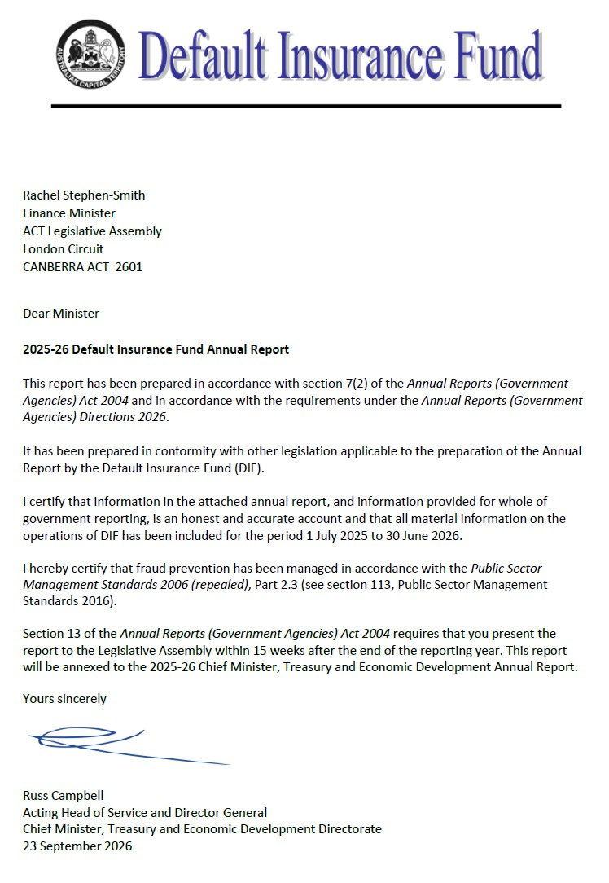

Compliance Statement
The 2025-26 Default Insurance Fund (the Fund) Annual Report must comply with the Annual Reports (Government Agencies) Directions 2025-26 (the Directions) made under section 8 of the Annual Reports (Government Agencies) Act 2004. The Directions are found at the ACT Legislation Register: www.legislation.act.gov.au.
The compliance statement indicates the subsections, under Parts 1 to 5 of the Directions, that are applicable to the Fund and the location of information that satisfies these requirements.

Part 1 Directions Overview
The requirements under Part 1 of the Directions relate to the purpose, timing and distribution, and records keeping of annual reports. The 2025-26 Default Insurance Fund Annual Report complies with all subsections of Part 1 under the Directions.
In accordance with section 15 (Feedback) of Part 1 of the Directions, contact details for the Fund are provided in this Annual Report to enable readers to provide feedback.

Part 2 Reporting Entity Annual Report Requirements
The requirements within Part 2 of the Directions are mandatory for all reporting entities and the 2025-26 Default Insurance Fund Annual Report complies with all subsections. The information that satisfies the requirements of Part 2 is found in the 2025-26 Default Insurance Fund Annual Report as follows:
- A. Transmittal Certificate, see the previous page.
- A. Organisational Overview and Performance Analysis, see the Organisational Overview and Performance section below.
The following subsections, contained within the 2025-26 ACT Insurance Authority Annual Report, apply to the Fund:
- Risk Management
- Internal Audit
- Fraud Prevention
- Freedom of Information
- Community Engagement and Support
- Aboriginal and Torres Strait Islander Reporting
- Disability Inclusion Act 2023 Reporting
- Multiculturalism Act 2023 Reporting
- Period Products and Facilities (Access) Act Reporting
- Work Health and Safety
- Ecological Sustainability Reporting
- Carer and carer support: Reporting under the Carers Recognition Regulation 2021
- C. Financial Management Reporting: All financial management reporting is included in the CMTEDD Annual Report.

Part 3 Reporting by Exception
The Fund has no information to report by exception under Part 3 of the Directions for the 2025-26 reporting year.

Part 4 Directorate and Public Sector Body Specific Annual Report Requirements
Part 4 of the Directions is not applicable to the Fund.

Part 5 Whole-of-Government Annual Reporting
All subsections of Part 5 of the Directions apply to the Fund. Consistent with the Directions, the information satisfying these requirements is reported in one place for all reporting entities as follows:
- Bushfire Risk Management, see the Annual Report of the Justice and Community Safety Directorate.
- Human Rights, see the Annual Report of the Justice and Community Safety Directorate.
- Legal Services Directions, see the Annual Report of the Justice and Community Safety Directorate.
- Public Sector Standards and Workforce Profile, see the Annual State of the Service Report.
- Territory Records, see the annexed report within this 2025-26 CMTEDD Annual Report.
ACT Public Service Directorate Annual Reports are found at the following web address: https://www.act.gov.au/open/annual-reports.

Organisational Overview and Performance

Organisational Overview
The Workers Compensation Act 1951 (the Workers Compensation Act) was established to provide compensation to workers employed in the private sector for injuries arising out of or in the course of their employment.
The Fund was established under the Workers Compensation Act on 1 July 2006. It provides a safety net to meet the cost of workers’ compensation claims made by workers in circumstances where:
- An employer does not have a workers’ compensation insurance policy and cannot meet the claim costs payable under the Workers Compensation Act;
- An employer’s insurance company is wound up under the Corporations Act 2001 (Cth) or cannot provide the indemnity required to be provided under a compulsory workers’ compensation policy;
- A worker is suffering from an imminently fatal asbestos-related disease as a result of exposure to asbestos fibres whilst employed as a worker in the Australian Capital Territory; or
- An employer is an approved prescribed employer under Division 8.2.2A of the Act.
The Fund’s assets are held in trust under the Financial Management Act 1996 in two separate accounts:
- The Uninsured Employer Fund (UEF); and
- The Collapsed Insurer Fund (CIF).
The General Manager for the ACT Insurance Authority (the Authority) is the appointed Fund Manager.
The Fund meets the cost of workers’ compensation settlements and any common law judgments including the payment of weekly compensation, medical expenses and rehabilitation costs. The Fund is required to satisfy the cost of claims and other relevant expenses, which are not guaranteed by the ACT Government. Part 8.2 of the Workers Compensation Act allows the Fund Manager to impose contributions and supplementary contributions on approved insurers and self-insurers to meet the cost of claims.
The Fund’s administrative operations are subject to the same governance controls in relation to risk management, fraud prevention and records management as the Authority. The reporting on these operations is included in the relevant sections of the Authority’s Annual Report.
The Authority also has oversight for workplace health and safety and associated risk management, accommodation, facilities management and workplace environmental management for the Fund. Reporting for these issues is contained in the Authority’s Annual Report.

Internal Accountability
The Default Insurance Fund Advisory Committee (the Committee) was established under Schedule 3 of the Workers Compensation Act. Its role is to monitor the operations of the Fund and, when requested by the Minister or the Fund Manager, provide advice on matters relating to its operation.
The Committee consists of the Executive Group Manager, Workplace Safety Group (Chair), the Fund Manager, and three members appointed by the Minister.
Table 1: Membership and Attendance of the Fund Advisory Committee 2025-26
Name | Role | Meetings attended
Michael Young | Chair | 4 of 4
Belinda Farrelly | Member | 4 of 4
Augustus Modelo | Member | 3 of 4
Rosalind Read | Member | 2 of 4
Damian Black | Fund Manager | 1 of 1
Notes:
- At each meeting, a report on the status of the Fund was provided and a schedule detailing the status of open claims was considered.

Performance Analysis
The Fund engaged Taylor Fry Consulting Actuaries to estimate the provision for claims payable (liability) and related claims expenses for the 2025-26 reporting period. Actuarial assumptions are based on past claims experience, risk exposure and projections of economic variables.

Uninsured Employer Fund (UEF)
This component of the Fund currently administers claims that have arisen when a worker has been injured, and the employer did not hold an ACT workers’ compensation policy or is an approved prescribed employer. Where the employer does not or cannot meet the cost of claims, the UEF responds on behalf of the employer, as the default insurer.

Claims
When a claim is received, the Fund undertakes a search to determine whether an insurer can be identified for the injured worker. In some cases, an insurer is identified, and the claim is then forwarded to the appropriate insurer.
When satisfied that an insurance policy is not in place, the Fund acts as the default insurer for the injured worker. The Fund arranges and facilitates appropriate rehabilitation and medical treatment for injured workers with the aim of returning an injured worker to their pre-injury condition where possible. Claims are managed pursuant to the Workers Compensation Act, and the Fund meets the cost of all legislated entitlements for injured workers, including medical expenses, rehabilitation costs, weekly compensation, and lump sum settlements.
Table 2: Uninsured Employer Fund Claims
 | Number
Total claims opened during the reporting period | 14
Total claims closed during the reporting period | 9
Total claims re-opened during the reporting period | 1
Current open claims | 89

Revenue
Section 168A of the Workers Compensation Act requires the Fund Manager to undertake a review of the UEF each year to determine the appropriate levy on approved insurers and self-insurers.
In determining an appropriate levy for 2025-26, the Fund Manager took into consideration a range of issues including a sensitivity analysis of the volatility of the UEF, the potential for an increase in claims costs, and claim numbers in the current and future insurance years.
The Fund Manager imposed contributions from insurers and self-insurers equal to 1.8 per cent of the gross written premiums resulting in $5.827 million in levy revenue.

Expenses
The expenses for UEF during the year were $3.536 million, which includes $2.921 million in claims expense and $0.615 million in supplies and services. The claims expense consisted of $3.016 million in settlements, compensation payments and other claims costs, offset by a decrease in the provision for claims payable of $0.095 million, as a result of the 2025-26 actuarial valuation.

Balance Sheet
As at 30 June 2026, the UEF held total assets of $58.089 million consisting of $55.286 million in cash and cash equivalents and receivables of $2.803 million. The receivables include current receivables of $1.392 million and non-current receivables of $1.411 million. The UEF’s liabilities total $36.994 million, which includes $0.555 million in payables, along with $5.582 million in current provisions for claims payable and $30.857 million in non-current provisions for claims payable.

Collapsed Insurer Fund (CIF)
This component of the Fund currently administers claims that have arisen from a previously approved workers’ compensation insurer that has been wound up or is in liquidation. Currently the Fund administers claims for two collapsed insurers, National Employers’ Mutual Association Ltd in 1990 (NEM) and HIH Insurance in 2001 (HIH).

Claims
When satisfied that an insurer is unable to pay, the Fund acts as the default insurer for the injured worker. The Fund arranges and facilitates appropriate rehabilitation and medical treatment for injured workers with the aim of returning an injured worker to their pre-injury condition where possible. Claims are managed pursuant to the Workers Compensation Act, and the Fund meets the cost of all legislated entitlements for injured workers including medical expenses, rehabilitation costs, weekly compensation, and lump sum settlements.
As at 30 June 2026, there were two open claims against NEM and two open claims against HIH. The Fund Manager represented the Fund on the Committee of Inspection for the HIH liquidation.
Table 3: Collapsed Insurer Fund Claims
 | Number
Total claims opened during the reporting period | -
Total claims re-opened during the reporting period | -
Total claims closed during the reporting period | 2
Current open claims | 4

Revenue
The CIF is not levying insurers or self-insurers for the CIF Fund at present. The Fund can appropriately and responsibly manage the impact of any future insurance collapses within the workers’ compensation industry through the retention of its current reserve and the imposition of a tailored levy on employers in the event of a collapse. The CIF collected $0.412 million in interest from its investments during the reporting period.

Expenses
The total expenses incurred by the CIF during the year were $0.051 million, consisting of $0.025 million in supplies and services and $0.026 million in claims expense. The claims expense consisted of $0.033 million in compensation and a decrease of $0.007 million in the provision for claims payable as a result of the 2025-26 actuarial valuation.

Balance Sheet
As at 30 June 2026, the CIF had cash and cash equivalents totalling $9.601 million with an estimated outstanding claims provision of $2.392 million. The CIF Fund’s total equity as at 30 June 2026 was $7.195 million.

Scrutiny
There were no inquiries or reviews from the ACT Audit Office, the ACT Ombudsman, ACT Integrity Commission or any Legislative Assembly Committees in 2025-26. The only scrutiny from the Audit Office during the reporting year was for the audit of the 2024-25 Financial Statements.

Freedom of Information
The Freedom of Information Act 2016 (FOI Act) gives individuals the legal right to:
- Access government information unless access to the information would, on balance, be contrary to the public interest
- Ask for personal information to be changed if it is incomplete, out-of-date, incorrect or misleading; and
- Appeal a decision about access to a document, or a decision in relation to a request to amend or annotate a personal record.
In accordance with section 96 of the FOI Act, the Fund is required to report on the operation of the FOI Act in relation to the Fund for the reporting year. CMTEDD manages FOI applications on behalf of the Fund and reporting requirements are detailed in Volume 1 of the CMTEDD 2025-26 Annual Report.
Further information relating to FOI, including how to make an FOI application, what details you need to make an application, and contact details for the CMTEDD Information Officer, can be found on CMTEDD’s website https://www.cmtedd.act.gov.au/functions/foi. There are also details of requests received by the directorate listed on the FOI Disclosure Log for CMTEDD.

Community Engagement and Support
The Fund has nothing to report against this section. The Fund does not undertake any community engagement or support in performing its functions.

Aboriginal and Torres Strait Islander Reporting
The Fund is committed to progressing actions towards the National Closing the Gap Agreement (the National Agreement) and working towards goals of the ACT Aboriginal and Torres Strait Islander Agreement 2019-28 (the ACT Agreement). Refer to the CMTEDD Annual Report for more detailed information on CMTEDD’s priority actions, programs, engagements and activities during the reporting period. The Fund does not undertake any Aboriginal and Torres Strait Islander programs, projects and/or initiatives other than those delivered by CMTEDD.
For further information on progress on implementing both the National Agreement and the ACT Agreement, refer to section B.9 of the ACT Insurance Authority Annual Report 2025-26.

Disability Inclusion Act 2023 Reporting
The Fund is committed to progressing actions towards the Disability Inclusion Act 2023. Refer to the CMTEDD Annual Report for more detailed information on CMTEDD’s priority actions, programs, engagements and activities during the reporting period. The Fund does not undertake any disability inclusion programs, projects and/or initiatives other than those delivered by CMTEDD.

Multiculturalism Act 2023 Reporting
The Fund is committed to progressing actions towards the Multiculturalism Act 2023. Refer to the CMTEDD Annual Report for more detailed information on CMTEDD’s priority actions, programs, engagements and activities during the reporting period. The Fund does not undertake any multicultural programs, projects and/or initiatives other than those delivered by CMTEDD.

Period Products and Facilities (Access) Act Reporting
Workplaces have appropriate toilets, sanitary waste disposal services and handwashing facilities in a way that respects the dignity of the individual. The ACTPS Employment Portal includes detailed information about Menstruation and Menopause Leave and flexible working arrangements for ACTPS staff.

Ecological Sustainability Reporting
Information on the Fund’s operational consumption data captured at a directorate level can be found in the Ecological Sustainability Reporting section of the CMTEDD Annual Report 2025-26.

Carer and Carer Support: Reporting under the Carers Recognition Regulation 2021
The Fund recognises the important contribution that carers make to the Canberra community and is committed to supporting employees who have caring responsibilities in accordance with the principles of the Carers Recognition Act 2021.
During 2025-26, the Fund promoted and upheld the care relationship principles through its people and culture practices, including:
- providing flexible working arrangements to help employees balance work and caring responsibilities, including flexible hours, hybrid working arrangements and access to leave provisions;
- supporting employees to access personal leave, carer's leave and other workplace flexibility measures where required;
- ensuring managers are aware of their responsibilities to support employees with caring responsibilities and to consider individual circumstances when making workplace decisions; and
- promoting a workplace culture that values diversity, inclusion and employee wellbeing, including recognising that carers may have needs distinct from those of the person they care for.
During 2025-26, the Fund did not administer any programs or services specifically targeted to people in care relationships and did not fund other organisations to provide targeted carer support services. Accordingly, the Fund’s activities under the Carers Recognition Act 2021 were focused on supporting employees with caring responsibilities and promoting awareness of the care relationship principles within the workplace.

Financial Management Reporting

Government Contracting
The Fund engages consultants to perform specialised actuarial and legal services. The procurement selection and management processes for all contractors, including consultants, complied with the Government Procurement Act 2001 and the Government Procurement Regulation 2007.
The ACT Government Contracts Register, records contracts with suppliers of goods, services, and works with a value of $25,000 or more, and is available online.
A full search for Default Insurance Fund contracts notified with an execution date from 1 July 2025 to 30 June 2026 can be made at https://www.tenders.act.gov.au/contract/search.

Further information
Damian Black
General Manager, ACT Insurance Authority
ACTInsuranceAuthority@act.gov.au

Director of Territory Records

Transmittal Certificate
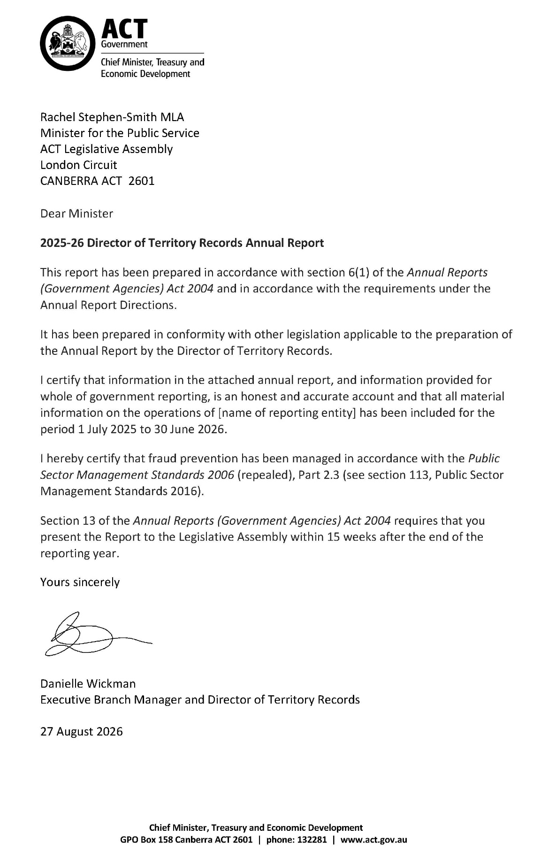

Compliance Statement
The 2025-26 Director of Territory Records Annual Report must comply with the Annual Reports (Government Agencies) Directions 2026 (No 1) (the Directions) made under section 8 of the Annual Reports (Government Agencies) Act 2004. The Directions are found at the ACT Legislation Register: www.legislation.act.gov.au.
The Compliance Statement indicates the subsections, under Parts 1 to 5 of the Directions, that are applicable to Director of Territory Records and the location of information that satisfies these requirements:

Part 1 Directions overview
The requirements under Part 1 of the Directions relate to the purpose, timing and distribution, and records keeping of annual reports. The 2025-26 Director of Territory Records Annual Report complies with all subsections of Part 1 under the Directions.
To meet Section 15 Feedback, Part 1 of the Directions, contact details for Director of Territory Records are provided within the 2025-26 Director of Territory Records Annual Report to provide readers with the opportunity to provide feedback.

Part 2 Reporting entity annual report requirements
The requirements within Part 2 of the Directions are mandatory for all reporting entities and the Director of Territory Records Annual Report complies with all subsections. The information that satisfies the requirements of Part 2 is found in the 2025-26 Director of Territory Records Annual Report as follows:
- Transmittal Certificate, see the previous page.
- Organisational Overview and Performance, inclusive of all subsections, see Organisational Overview and Performance section below. For all other subsections refer to the CMTEDD Annual Report for more detailed information on CMTEDD’S priority actions, programs, engagements and activities during the reporting period.
- Financial Management Reporting, see Volume 2 of the CMTEDD Annual Report.

Part 3 Reporting by exception
Director of Territory Records has nil information to report by exception under Part 3 of the Directions for the 2025-26 reporting year.

Part 4 Directorate and public sector body specific annual report requirements
Part 4 of the Directions is not applicable to the Director of Territory Records.

Part 5 Whole of government annual reporting
All subsections of Part 5 of the Directions apply to the Director of Territory Records. Consistent with the Directions, the information satisfying these requirements is reported in the one place for all ACT Public Service directorates, as follows:
- Bushfire Risk Management, see the annual report of the Justice and Community Safety Directorate.
- Human Rights, see the annual report of the Justice and Community Safety Directorate.
- Legal Services Directions, see the annual report of the Justice and Community Safety Directorate.
- Public Sector Standards and Workforce Profile, see the annual State of the Service Report.
- Territory Records, see this report.
ACT Public Service Directorate annual reports are found at the following web address: https://www.act.gov.au/open/annual-reports.

Organisational Overview and Performance

Organisational overview
The Director of Territory Records, supported by the Territory Records Office, leads the ACT Public Service (ACTPS) on records management policy, strategy and practice. The Territory Records Act 2002 provides for the Director to develop recordkeeping standards and tools, give assistance, advice and training to agencies on records management, and assist members of the public to access ACT Government archives.
The main purposes of the Territory Records Act are to:
- Encourage open and accountable government by ensuring that Territory records are made, managed and, if appropriate, preserved in accessible form.
- Support the management and operation of Territory agencies.
- Preserve Territory records for the benefit of present and future generations.
- Ensure that public access to records is consistent with the principles of the Freedom of Information Act 2016.
The Office is also responsible for the ACT Government’s hard copy records storage facility at Mitchell, along with courier and mail services, and the management of whole of government contracts for secondary storage of records with commercial providers.
The machinery of government changes introduced on 1 July 2025 saw the addition of the ACT Heritage Library (ACTHL) to the Branch. The ACTHL is the ACT’s equivalent to a state library, with a responsibility to collect the documentary heritage of the Canberra community. While the functions of the two entities remain distinct and separate, in 2025-26 we took opportunities to explore areas of cooperation and alignment, while acknowledging that the remit of the ACT Heritage Library is separate from the role of the Director of Territory Records.

Internal accountability
The Territory Records Act establishes the statutory position of the Director of Territory Records. Led by the Director of Territory Records, the Territory Records Office is an administrative unit within the ACT Heritage Library and Territory Records Office Branch of the Policy and Cabinet Division in CMTEDD. In 2025-26, the Office was made up of 36.87 full time equivalent (FTE) staff, including the Director. An additional 5 FTE staff made up the ACT Heritage Library.
Ms Danielle Wickman is the current Director of Territory Records. The Director is a senior executive appointed under both the Public Sector Management Act 1994 and the Territory Records Act. Ms Wickman was reappointed to the statutory role under the Territory Records Act for five years commencing 24 May 2023. The Director’s remuneration is as determined for all ACT Senior Executives under the Remuneration Tribunal’s Determination 1 of 2026 – Head of Service, Directors-General and Executives.
The Director’s responsibilities include leading the work of the Territory Records Office and providing advice to the Minister for the Public Service, CMTEDD Executives and ACT Government agencies on archives, records and information governance matters. Additionally, the Director exercises powers and functions under the Territory Records Act, including approving standards for government recordkeeping, authorising the disposal of Territory records, and making determinations regarding the restriction of records from public access. The Director’s responsibilities also extend to overseeing the storage and preservation of hard copy ACT Government archives.
The Office is structured around two streams of work:
- Information Governance and Capability, focussed on supporting ACT Government agencies to meet their responsibilities under the Territory Records Act, and on communicating our work to a broad range of stakeholders.
- ArchivesACT, responsible for the safe storage and management of hard copy ACT Government records in our custody, as well as those stored with commercial providers on behalf of agencies. Our ArchivesACT stream also provides avenues for the community to engage with the ACT Government’s archival collection and delivers the ACT Government mail service.

Territory Records Advisory Council
The Territory Records Act establishes the Territory Records Advisory Council (the Council) to advise the Director, particularly in relation to the development of standards and guidelines, access to and disposal of records, and on the protection of records about Aboriginal and Torres Strait Islander heritage.
Members of the Council are appointed on a part-time basis by the Minister. Appointments must be made from the range of categories set out in section 44 of the Territory Records Act. The Director of Territory Records is also a member of the Council. Members, apart from the Director, are appointed for a term of three years and may be reappointed.
Members who are not public servants are paid a sitting fee in accordance with the ACT Remuneration Tribunal’s Determination 13 of 2025 – Part Time Public Office Holders (Amended). The activities of the Council are funded from within the Territory Records Office’s budget. Financial oversight, including risk management, audit and fraud control arrangements, are managed within CMTEDD’s control systems.
The ACT Public Service code of conduct applies to Territory Records Advisory Council members. The Council has also established Terms of Reference that derive from its responsibilities under the Act, and members are required to sign a conflict-of-interest declaration as part of the appointment process. The Council has not established any sub committees.
The Territory Records Advisory Council met in person and online four times during 2025-26 as follows:
- Meeting 1 of 2025-26, 7 August 2025
- Meeting 2 of 2025-26, 4 December 2025
- Meeting 3 of 2025-26, 26 February 2026
- Meeting 4 of 2025-26, 27 May 2026

Membership
Membership of the Council and attendance during the 2025-26 financial year is detailed in the following table.
Table 1: Membership and attendance of the Territory Records Advisory Council 2025-26
Name | Role | Meetings attended
Mr David Fricker | Chair, Member representing public administration, governance, public accountability | 4 out of 4 meetings
Mr Adrian Cunningham | Deputy Chair, Member representing records management and archives | 4 out of 4 meetings
Dr Wayne Applebee | Member representing Aboriginal and Torres Strait Islander heritage | 0 out of 4 meetings
Ms Julia Burns | Member representing ACT Government agencies | 3 out of 4 meetings
Ms Arden Jones | Member representing history and heritage | 3 out of 4 meetings
Dr Terhi Nurmikko-Fuller | Member representing history and heritage | 4 out of 4 meetings
Ms Diana Hamono | Member representing public administration, governance, public accountability | 4 out of 4 meetings
Ms Wicka Simet | Member representing records management and archives | 1 out of 4 meetings
Ms Danielle Wickman | Director of Territory Records | 4 out of 4 meetings

Advice and reporting
The Territory Records Office (TRO) reports to Council on public access, relations with government agencies, and progress against the TRO business plan. The Director informs and seeks the advice of the Council on significant initiatives of the TRO, with a particular focus on the Council’s areas of responsibility under the Act. In 2025-26 the Council discussed a range of the Office’s activities, including:
- the public and government stakeholder engagement plan
- impacts from machinery of government changes
- digital preservation and archiving initiatives
- strategies to streamline the disposal of government records overdue for destruction, and
- agency arrangements for protecting records about Aboriginal and Torres Strait Islander heritage.
A key part of the Council’s role is to advise the Director on issues relating to public access to ACT Government archives. The Council’s meeting agenda includes a standing item on decisions to restrict public access to archives under section 28 of the Territory Records Act. In 2025-26, nine declarations were updated to ensure their ongoing application.
The Territory Records Act assigns the Council a specific role in advising the Director on the disposal of ACT Government records. Records retention and disposal are governed by disposal schedules issued under section 19 of the Act, with all draft schedules referred to the Council for advice prior to the Director’s approval. In 2025-26, Council considered three revised schedules:
- Advocacy Services – records relating to advocacy, oversight and engagement to represent and uphold the rights and interests of children, young people and adults in the ACT community who are marginalised.
- Human Rights Protection and Promotion – records relating to the protection and promotion of human rights in the ACT.
- Victim Support and Redress - records relating to providing support and services to victims of crime.
This level of activity is consistent with previous years and reflects the breadth of established schedules already in place. In considering draft schedules, members consistently focus on ensuring that government decisions are properly documented and remain accessible for scrutiny by review bodies, integrity agencies and the broader community.
This year the Council continued its practice of inviting a guest to each meeting. Guests alternate between senior TRO staff and representatives from the wider ACT Government. During 2025-26 senior staff from the Justice and Community Safety Directorate and the Office of the Auditor-General met with Council to discuss the review of the Freedom of information Act, and records-related findings in performance audits. The importance of effective records management was a key point of discussion on both topics and provided Council members with useful insights into practical issues underpinning ACT Government agencies’ records management practices.

Performance assessment
The Council follows a practice of conducting an annual self-assessment of its performance, and of its satisfaction with the support provided to it by the Territory Records Office. The survey is intended to allow the Office to better understand and respond to members’ perceptions of the operation of the Council and its secretariat. The results this year are consistent with previous years and are strongly positive. Members feel aligned with the mission and purpose of the Council and found the opportunity to discuss complex ideas and engage with the ACT Government records management community to be highly valuable.
Members discussed potential procedural improvements that would support increased capacity and opportunities to participate in discussions. Following that discussion, the Office is improving the induction materials that will be made available to incoming Council members. These will include a plain English guide to legislation and a dictionary of acronyms. The new induction materials will be available to incoming members prior to the November 2026 meeting.

Performance Analysis
The purpose of the Territory Records Office is to inspire trust in government through transparent and accessible records that tell the story of Canberra and its community. TRO measures its performance against four key objectives that shape its strategic direction and enable it to achieve its mission. These objectives are:
- Promote the value and effectiveness of the Territory Records Office
- Support strong records management capability within the ACT Government
- Enhance community access and awareness of government records
- Preserve the ACT Governments’ physical archive collection

2025-26 Performance Highlights
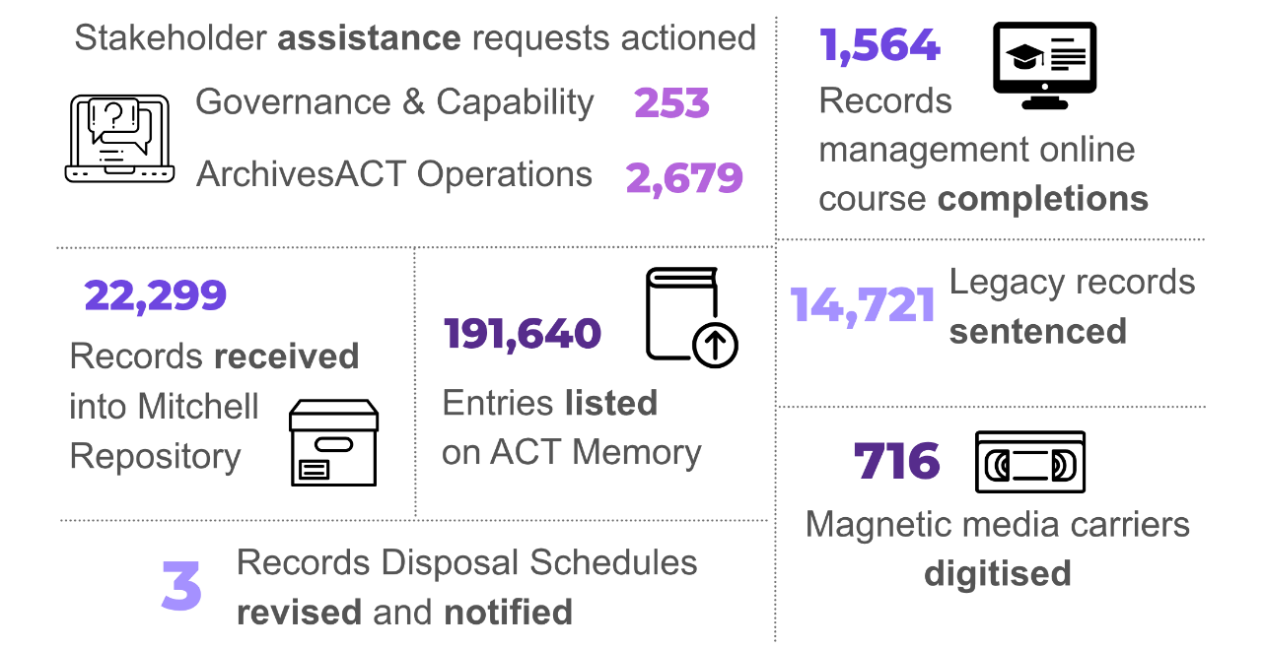

2025-26 Outcomes

Promote the value and effectiveness of the Territory Records Office
The Territory Records Office engagement strategy was finalised in the last quarter of the year. The strategy outlines both internal and external contexts, challenges and opportunities. It positions the Office as both as resource that assists agency operations and accountability and as a key cultural institution that facilitates access to the work of government and tells the story of Canberra. Priorities set out by the engagement strategy are building relationships with internal stakeholders, taking a targeted approach to outreach and promotion and focusing on discoverability to foster meaningful collaboration. Options for implementation are outlined alongside the strategy, and these initiatives are now being worked into business planning and work programs for 2026-27.
This year the Territory Records Office has seen an increase in visitors to the Mitchell repository, reflecting a growing awareness of our organisation and our work. In February we hosted Professor Hirooki Hosaka, visiting Australia from Gakushūin University in Tokyo, Japan. Professor Hosaka teaches archival science and was eager to understand more about the TRO’s relationships with government agencies with regards to digital records.
In March, we hosted colleagues from Policy and Cabinet, who were able to explore collection material relating a number of current priority projects for the Division. In May, the Head of Service toured the facility, delved into collection items and met with staff to talk about their work. That same month we welcomed a visit from incoming Deputy Director-General, Policy and Cabinet, Lee Steel, who toured the repository to provide her with a picture of the breadth of our activities and the context for our priority projects.

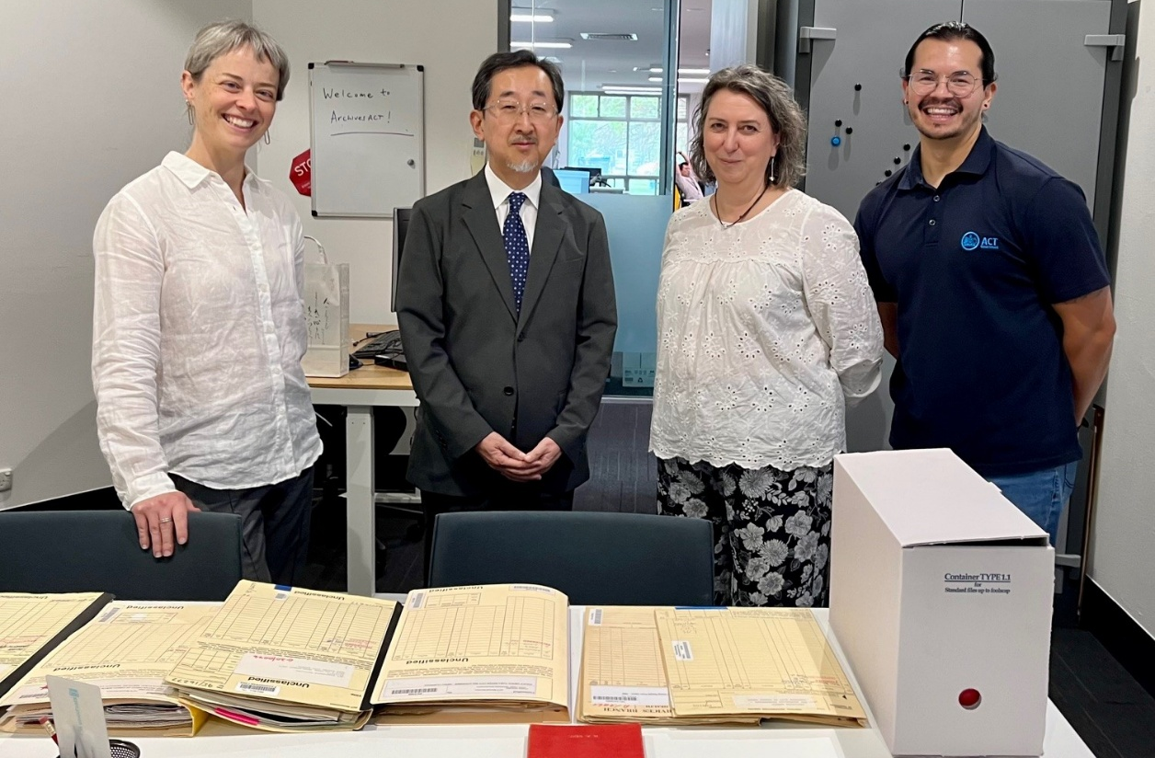
Professor Hosaka and Territory Records Office staff at ArchivesACT Reading Room

Support strong records management capability within the ACT Government

Records management e-learning
In 2020, the ACT Government Information and Records Management Strategy was developed to establish a baseline understanding of the ACT Government’s information and records management maturity and provide a foundation for continuous improvement. Our final action in implementing the strategy was to develop and launch a new e-learning module in January 2026 titled Introduction to ACT Government Recordkeeping. The module is aimed at all ACTPS staff and is designed to provide a clear, accessible overview of why good recordkeeping matters, the responsibilities of government employees, and the everyday practices that support transparency, accountability, and trusted service delivery.
More than 1,500 staff had completed the module as at 30 June 2026.

Community of Practice
The Records and Information Managers Community of Practice (RIMCoP) continues to provide ACTPS staff with opportunities to collaborate and improve capability through shared experience, problem solving and training exercises. The community met in September 2025 and March 2026. The September meeting focused on understanding the value of government records and how they impact government business and the community. The theme of the March meeting centred on managing records in times of change, with staff sharing their experiences of the recent machinery of government changes and strategies deployed to support transition.

Maturity assessment and targets
In 2025 we paused our annual Recordkeeping Capability Maturity Assessment to allow directorates to focus on records management adjustments arising from the machinery of government changes. The Office instead used this period to review of the assessment tool, its associated processes, and their effectiveness in improving records management maturity across the ACTPS.
Our survey of agency records management staff indicated that they value the annual maturity assessment, which provides them with a framework for their own business planning and for communicating information governance strengths and opportunities within their organisations. Constructive feedback arising from the consultation included improving quantitative measures to support easier analysis and more transparent reporting; aligning assessment questions with information already held or collected by TRO; simplifying the tool to enhance readability and navigation; and incorporating additional feedback mechanisms based on assessment outcomes. These findings are informing refinements to the Maturity Assessment process for implementation in 2026-27.
While the maturity assessment was on hold, directorates were asked to report on three specific targets for the 2025 calendar year:
- Assessment of records management capacity against the Public Record Office of Victoria Staff Resourcing Model.
- Development of records preservation and disposal procedures.
- Timely authorisation of physical records destruction.
The majority of directorates made progress with the targets, indicating the Resourcing Model was a useful tool to identify best practice staffing profiles, and supported change management activity following machinery of government amendments. Timely authorisation of disposal of physical records has been challenging for agencies this year, and the TRO continues to identify ways to support records managers to undertake this work. Our consultations with records managers indicate that they find the annual maturity targets valuable, helping to set priorities for ongoing improvement.

Records advice
Our library of advice for records management and other staff across government continues to be updated and extended to in response to emerging issues and changes in existing practices. This year the Office published two new references:
- guidance on disaster recovery planning for physical records, and
- disposal of medical certificates.

Records Management Program template review
Section 16 of the Territory Records Act requires agencies to have a Records Management Program (RMP) that sets out their policies, procedures and resources for meeting their recordkeeping responsibilities. In 2025-26, we reviewed and redrafted our RMP templates to reflect the current business environment and changes in practice and expectations. These include a greater focus on openness and transparency, technological impacts and links with other areas of government such as Security and ICT. The modernised templates will assist agencies to consider how these issues should be embedded in their records management practices.

Streamlining disposal processes
A key aspect of our business is maintaining the framework that enables agencies to responsibly and transparently dispose of records that no longer hold significant value for government or the community. Well-designed disposal arrangements are essential to ensure the preservation of records with enduring archival value, while also supporting the efficient operation of government. Removing information clutter enables easier and faster access for agency staff and researchers to records that are of business and community value. Last year the Office identified categories of records where authorisation of disposal can be simplified. This year, with support from agencies, we applied these new processes to allow for the disposal of a backlog of some 20,000 hard-copy records. The Office will continue this work on with a view to expanding the categories of records that can be assessed for disposal in this way.
This body of work and the systematic review and disposal of older records in the Office’s custody is supported by our Records Review team. The team’s primary focus is on assessing records to determine their significance through a process known in archival practice as sentencing. Good sentencing ensures that each records’ value is clearly understood and managed in a transparent and accountable manner. Since the team began its work in 2022, more than 62,000 previously unassessed records have been individually inspected and reviewed. Around 15 per cent have been identified as having archival value, while the remainder are suitable for disposal either now or in the future.

Enhance community awareness and access

Access to archives
ArchivesACT continued to improve access to ACT Government records during 2025–26 through its reference services, digitisation activities, online access initiatives and public engagement programs. These activities support researchers, government agencies and the wider community to discover and access records documenting the history and administration of the Australian Capital Territory.  ArchivesACT saw an increase of 4 per cent in research assistance requests in 2024-25. Of these requests, 24 per cent resulted in a visit to the reading room located in Mitchell. | 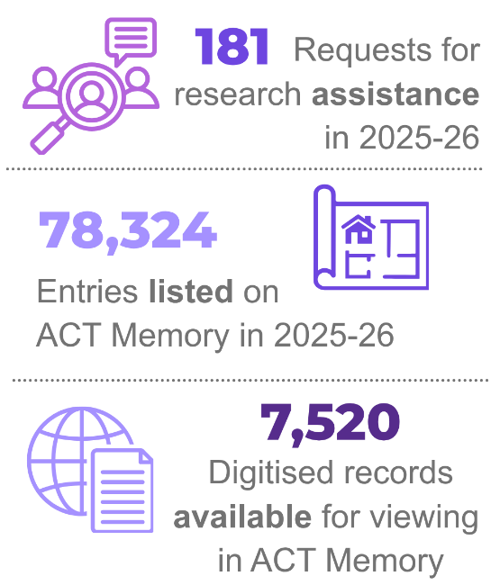
The reading room continues to see a steady stream of researcher visits, demonstrating the ongoing community interest in the ACT Government record collection and the impact of interacting with the physical record.
ACT Memory is the ACT Government’s public online catalogue of open access records. The total number of records listed in the ACT Memory catalogue has now reached 191,640, improving the discoverability and accessibility of records held by ArchivesACT. This work has included describing new series of records within ACT Memory. This involves identifying significant groupings of archives, digitising component records and enhancing series-level information within the database. By bringing related records together within a clearly defined series structure, researchers will be able to better understand the context of records and navigate collections more effectively.
Public engagement with online collections has remained strong, as reflected in page view statistics and an average of 139 digital record downloads each month. These figures highlight the growing importance of online access to the Territory's archival collections.
Our newly established digitisation team has enabled records that were previously only available in hardcopy to be made accessible online through ACT Memory. A focus of this work has been on identifying records that have historically received multiple access requests and digitising them to improve future access for researchers. During 2025–26, this included the digitisation and upload of our popular tenancy registers, as well as the continued publication of Executive Documents through ACT Memory. Work is continuing to identify additional records and collections suitable for digitisation and online access.

Events and engagement
The 2025 Chief Minister’s Governance Lecture was delivered by athlete and academic Dr Catherine Ordway on 1 December at The ACT Government offices on 220 London Circuit. Aunty Serena Williams provided an inspiring Welcome to Country. The topic, Let’s Play! Sport, Identity and Inclusion, highlighted the history of inclusive sport in the ACT, drawing on records of the ACT’s hosting of the Masters Games in 2003, and marking Canberra’s host role again in 2025. Dr Ordway shared her experiences championing women’s sport, and integrity within the industry. In a robust lecture Dr Ordway advocated for transparency in sports funding, increased funding for women’s sport, and finding the courage to speak up about racism, injustice and gender-based violence.
The lecture was followed by a panel discussion chaired by the event’s MC Emma Bickley (ABC Radio Canberra), with panel members Natalee George (Coach, ACT First Nations Netball Team), Geoff Dudley (Vice-President, Pink Tennis) and Dr Ordway. Panel members explored the barriers that limit participation across diverse communities, at all levels of sport, and provided practical recommendations and everyday actions to promote inclusion.
Dr Ordway and Ms Bickley drew upon a diverse array of Territory records to inform the event. These included records relating to the planning of the Masters Games in Canberra; records on sports and recreation development grants for community associations; and earlier records examining the need for recreational facilities in the ACT, reflecting a burgeoning understanding of the benefits of physical activity.
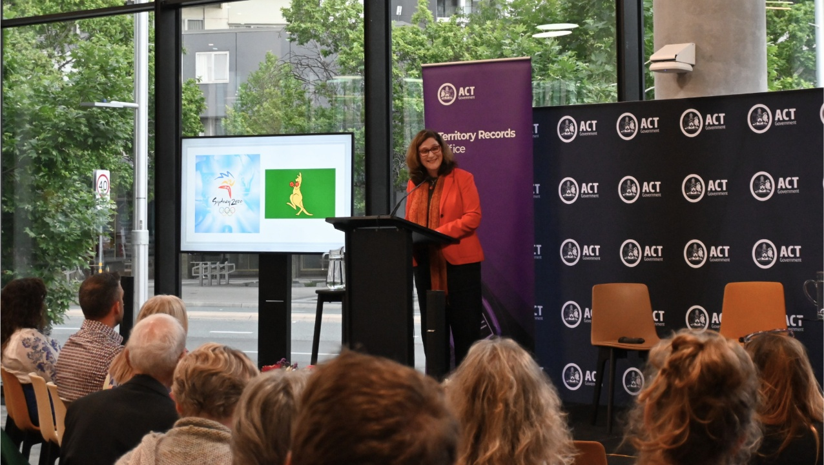
Dr Catherine Ordway presenting her lecture at 220 London Circuit
The Territory Records Office participated in the 2026 Canberra and Region Heritage Festival with a panel event, Skateboarding and the Modernist Movement, held at Smiths Alternative. The event considered how Canberra’s mid-century modernist design helped create an unexpected playground for skateboarders, and acknowledged the heritage listing of the iconic Canberra skating venue, the Erindale Brick Banks. Drawing on rare photographs and records from ArchivesACT, the discussion traced how skaters reimagined and activated the city’s fluid concrete landscapes and expansive civic spaces to shape a distinctive local skate culture.
Bringing together perspectives from heritage, conservation, photography, and the skateboarding community, the panel highlighted the enduring influence of Canberra’s modernist aesthetic and the role of youth culture in interpreting the city’s-built environment. The panel comprised David Pang, Brenden “Woody” Wood, Nathan Pharoah, and Jessica Whelen Begley, with artist Sancho Murphy as MC.
During the Festival our ACT Heritage Library colleagues presented six events. These talks and tours, showcasing Canberra modernist residential architecture, provided an opportunity to highlight ACT Government archives, alongside the rich collection of architectural heritage in the Library’s collection. Heritage Library staff were also key contributors to the TRO’s Skateboarding event.
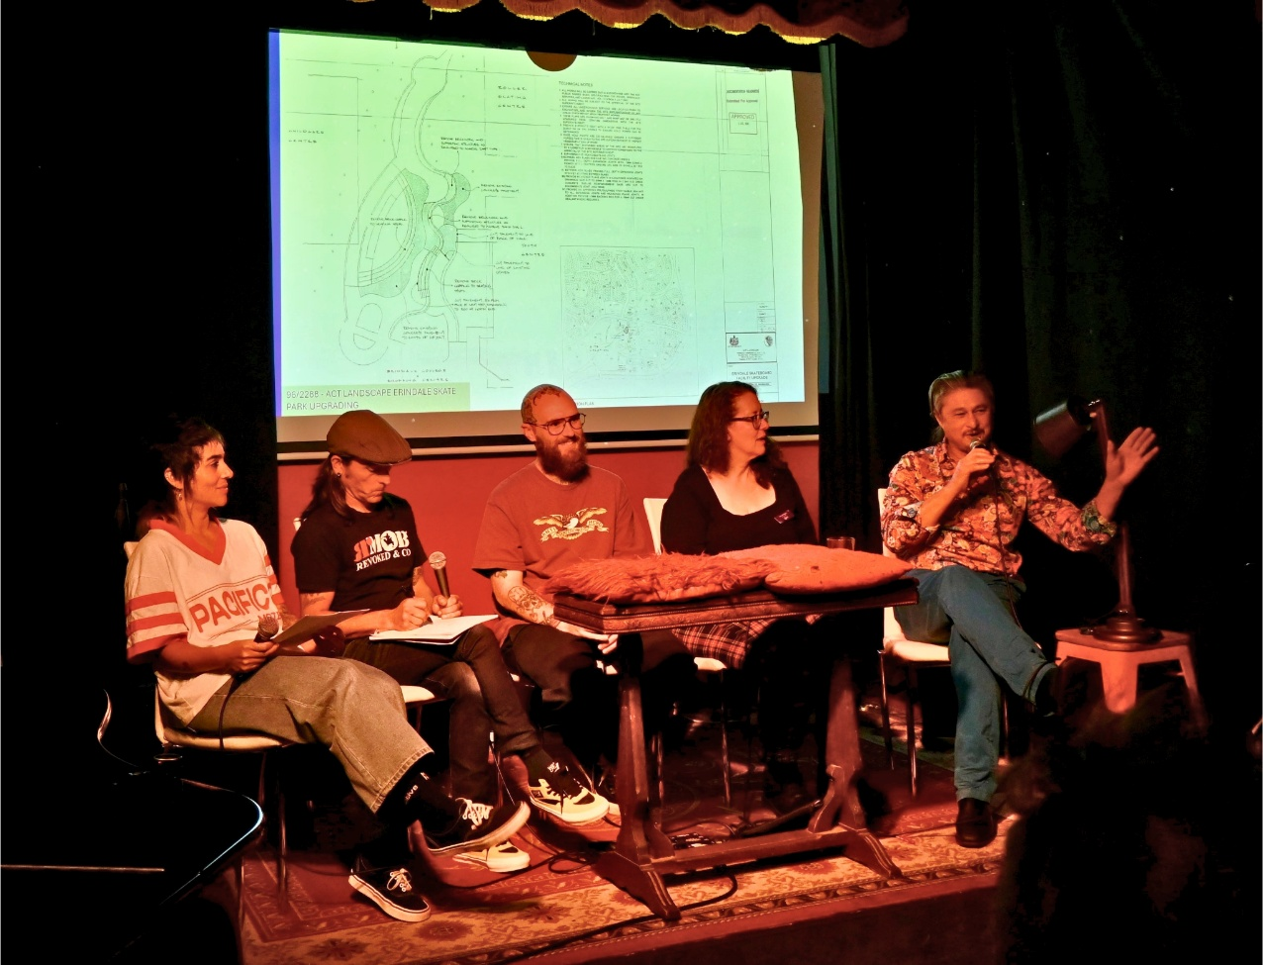
MC and panel members discussing Erindale Brick banks
The Find of the Month continues to be an important way of highlighting ACT Government records and sharing Canberra's history with the community. During 2025–26, featured topics included Daylight Saving, 50 Years of Dickson College, the Canberra Tivoli Gardens and the Canberra Hog Farm. The May edition complemented the 2026 Canberra and Region Heritage Festival through its connection to the panel discussion event Skateboarding & the Modernist Movement, demonstrating the ongoing relevance of archival records in exploring and celebrating the Territory's history.

Government Mail Room
The Territory Records Office continues to oversee mail services across the ACT Government. Following the successful transition to an in-house model in August 2024, the 2025–26 period has focused on consolidating and further refining operations to ensure they remain efficient, sustainable and responsive to evolving workplace practices.
The ACT Government mailroom service has continued to expand and adapt with increased demand for related services such as the distribution of ICT equipment. The service now supports delivery to 315 locations for ICT equipment, reflecting a significant broadening of its operational reach. The on-demand delivery model has been maintained and strengthened, enabling greater flexibility in servicing directorates while reducing unnecessary trips to under-used locations.
These refinements have supported improved service delivery while reducing environmental impact and operational costs. The mailroom continues to play a key role in enabling government operations, demonstrating measurable improvements in efficiency, sustainability and responsiveness to business needs.

Preserve the ACT Governments’ physical archive collection

Establishment of the Records Processing Centre
In late 2026 we commenced a project to reduce the ACT Government’s reliance on commercial physical records storage providers. The project has been made possible through the availability of a large industrial building, formerly occupied by the ACT’s hospital sterilisation service, next to our existing archives repository. The building does not have archival standard environmental controls but is comparable with the standards available with our existing commercial providers. The site will be fitted out as a records processing centre, with space for agency and TRO staff to work with records without incurring the fees associated with commercial arrangements. Approximately 12,000 boxes (around 4 shelf kilometres) of records were delivered to ACT Government premises in the lead-up to 30 June 2026.
In the past some of the records sent to commercial storage were not described in our systems and therefore can be difficult to access. This lack of visibility has also contributed to likely over-retention of low value records, as sentencing and review processes have not been completed. The records amalgamation project will allow the TRO and agencies to work through this material to better understand its value, arrange disposal of time expired records, and provide public access to the most valuable of the Territory’s archives.

Health records uplift
This year we also completed the transfer of more than 14,000 boxes of paper records from ACT Health’s Hume warehouse. A key focus of the project was ensuring the accurate migration and integration of health records information with our existing record management dataset. This required a comprehensive review of the existing Health dataset, detailed analysis of record structures, and the alignment of data fields to ensure consistency, accuracy and continuity across systems. To support the transition, every box of physical records was audited prior to transfer to verify location information and ensure records could be accurately tracked and managed. Quality assurance processes were applied throughout the project to maintain data integrity and minimise risks associated with the migration and repository uplift. The project has provided records management efficiencies for both the TRO and ACT Health.

Digitisation of physical records
During 2025–26, ArchivesACT established a dedicated digitisation team and invested in new scanning equipment and supporting software. These foundations have increased our digitisation capability and provide a platform for future growth. The digitisation program supports a number of outcomes, including reducing reliance on physical storage for eligible records, preserving records of long-term value and improving access to information.
This new team builds on our pilot project, working with CMTEDD last year to establish a digitise-on-demand service for agencies. Our additional investment in staff and equipment increases our capacity to digitise more fragile archives for use in response to public access requests. This year we were also able, in association with our colleagues in Digital Canberra, to finalise tools that will complete the upload of human resources files and their metadata into our digital records systems.

Magnetic media project
This year saw the winding down of the Magnetic Media Digitisation Project. As part of the 2023–24 Budget, the TRO received $200,000 to support the digitisation of Territory Archives held on magnetic media, including audio and video cassettes, reel-to-reel tapes and floppy disks. This investment has supported ongoing improvements in access to government archives, reinforcing the ACT Government’s commitment to open and transparent access to government information, and responds to the Legislative Assembly Select Committee on Estimates 2022–23 Report recommending increased funding for ArchivesACT to proactively digitise records for access by the community.
As of 30 June 2026, over 700 magnetic media carriers have been digitised from the ACT Government record collection, resulting in the digitisation of some 14,000 records. These are progressively being listed on ACT Memory, providing a means to access these records that was not previously available. Some of the types of material that are now accessible to the public include environmental survey data, geospatial data, tourism material including Floriade and Olympic campaigns, oral histories, arts grant demo tapes, and pre-self-government assembly meetings.
The project was also expanded to include the digitisation of 728 magnetic media carriers within the ACT Heritage Library collection. Material now digitally preserved includes interviews from ArtSound radio featuring local artists and Aboriginal elders, and oral histories including those from Tharwa School and the Majura Women’s Group. This work has been an important example of the value of bringing the Territory Records Office and the ACT Heritage Library together administratively, allowing both teams to share information and resources to achieve better outcomes for our collections and communities.

Digital archives, disk imaging and emulation work
Recovery of born digital files stored on magnetic media carriers has presented several challenges to providing access. The nature of some born digital files, such as geospatial data or other proprietary formats, requires bespoke environments to view the information. Our magnetic media digitisation work led us to invest in a disk-imaging and software emulation lab supported by the Australian Emulation-as-a-Service Infrastructure (AusEaaSI) program based at Swinburne University of Technology. This relationship was also supported by the closer links between the TRO and ACTHL, drawing on spare capacity available through the Library’s existing subscription to AusEaaSI, as well as hardware the Library had already acquired. Our expanded emulation lab now allows us to assess material on floppy discs and other obsolete carriers to understand their value and their preservation requirements.
In 2025-26 the Office partnered with CMTEDD CIO Branch to focus on a whole of government digital preservation discovery project. The project was initiated to understand how digital records of enduring value are currently managed and preserved, and what capability is needed to ensure their long-term management so that digital content remains accessible, usable and reliable over time. The project responded to a clear risk that valuable digital records, including those required to be preserved under the Territory Records Act, may be lost as systems evolve, migrate, or are decommissioned. The project delivered an executive blueprint reporting the findings of our investigations as well as offering recommendations and next steps. The report found that that, while the ACT Government has solid recordkeeping foundations, it lacks a sustainable digital archive and preservation capability. The TRO has already explored and identified options for immediate action, including our emulation lab, to support access to and management of records of enduring value on obsolete media including DVDs or CDs.

Outlook 2026-27
This year has seen some significant changes in our operations that cement our role as a key memory institution for the ACT Government, expanding the range of the archival materials we protect and the services we have available to preserve them and make them available to the community. Turning our new records processing centre from a major project into business-as-usual operations will be a key area of focus. So too will be the ongoing expansion of our digitisation services, and the implementation of our stakeholder engagement plan, both of which aim to increase the value our stakeholders receive from our work and the archives we protect.
The closer relationship between the Territory Records Office and the ACT Heritage Library has already provided opportunities to share collection preservation and promotion activities, and we will seek to repeat and expand those in the coming year. Our commitment to sharing the ACT’s documentary heritage with Canberrans, wherever they are, is captured in the accountability indicator we have set for ourselves in 2026-27. In the coming year we will focus on increasing the amount of information about both the ACTHL and TRO collections that is available and discoverable online.
For the Territory Records Office, the archives we care for today are the day-to-day recordkeeping of the ACT Government’s past decisions and actions. There continues to be work to do to ensure that today’s records are captured and managed well, to support trust in government now and be captured as tomorrow’s archives, telling Canberrans our shared stories.
In 2026-27, we will:
- Conduct a small-scale pilot to validate and surface issues in operationalising a digital archive and preservation practices, to help inform a detailed design of a future archiving and preservation capability.
- Launch a modernised suite of templates to better support agencies in the development of their Records Management Programs and overall information and governance framework.
- Further streamline disposal opportunities by reducing red tape to destroy physical records that have exceeded their retention requirements.
- Commence work on reviewing our Standard for Records and Information Governance and its supporting guidelines.
- Uphold the ACT Government’s Closing the Gap principle by improving the cultural capability of our staff and the cultural safety of our public spaces and assisting ACT Government agencies to understand their obligations for the management of records of Aboriginal and Torres Strait Islander heritage.

Whole of Government Annual Reporting: Territory Records
The Annual Reports (Government Agencies) Directions 2026 require the Director of Territory Records to provide a consolidated report on the records management activities for the 2025-26 financial year of all agencies that are subject to both the Territory Records Act 2002 and the ACT Government Annual Report Directions.
Reporting entities must provide a statement that:
- provides the date at which the most recent Records Management Program was approved by the reporting entity’s Principal Officer and submitted to the Director of Territory Records
- provides details of how the public can inspect the Records Management Program as required by section 21(1) of the Territory Records Act
- outlines the arrangements for preserving records containing information that may allow people to establish links with their Aboriginal or Torres Strait Islander heritage
- outlines the areas on which the reporting entity intends to focus in the coming reporting period to improve its records management capabilities and makes comment on progress committed to in the previous reporting period

Records Management Programs
The Territory Records Act requires agencies to have a Records Management Program (RMP) which provides a framework to ensure records and information management requirements are met. Agencies can elect to adopt the records management program of a relevant directorate if they are satisfied that the program meets their recordkeeping needs.
Table 2: Agency Records Management Programs (RMP) and how the public can access them.
Agency |  | RMP Status | Status Date | Access (website link, access instructions)
ACT Building and Construction Industry Training Fund Authority | Adopted |  |  | Please see entry for Chief Minister, Treasury and Economic Development Directorate for details.
ACT Human Rights Commission | Adopted |  |  | Please see entry for Justice and Community Safety Directorate for details.
ACT Insurance Authority | Adopted |  |  | Please see entry for Chief Minister, Treasury and Economic Development Directorate for details.
ACT Teacher Quality Institute | Approved |  | February 2023 | The public can inspect the RMP via the website:  www.tqi.act.edu.au/__data/assets/pdf_file/0013/2211115/Records-Management-Program-2023.pdf
Canberra Health Services (Corporate Records) | In development |  | June 2026
Canberra Health Services (Clinical Records) | Approved |  | June 2025 | The public can inspect the RMP via the website: www.canberrahealthservices.act.gov.au
Canberra Institute of Technology (CIT) | Approved |  | October 2024 | The public can inspect the RMP via the website:  https://cit.edu.au/policies/records-management-policy
Chief Minister, Treasury and Economic Development | Approved |  | December 2022 | The public can inspect the RMP via the website:  www.act.gov.au/open-access
City and Environment Directorate (CED) | Approved |  | January 2026 | The public can inspect the RMP via the website:  www.cityservices.act.gov.au
City Renewal Authority | Adopted |  |  | Please see entry for Chief Minister, Treasury and Economic Development Directorate for details.
Commissioner for Sustainability and the Environment | Adopted |  |  | Please see entry for City and Environment Directorate for details.
Cultural Facilities Corporation (CFC) | Approved |  | February 2026 | The public can inspect the RMP via: www.act.gov.au/open-access  or the CFC website located at www.culturalfacilities.act.gov.au  or by applying to:  Cultural Facilities Corporation  GPO Box 782  Canberra City ACT 2601
Digital Canberra | In Development |  | June 2026
Director of Public Prosecutions | Approved |  | December 2018 | The public can inspect the RMP by contacting the office on:  Phone: 6207 5399  Email: dpp@act.gov.au.
Education Directorate | Under review |  | June 2026 | The public can inspect the RMP via the website:  www.education.act.gov.au/publications_and_policies/corporate-policies/school-administration-and-management/records-management/records-management-policy
Gambling and Racing Commission | Adopted |  |  | Please see entry for City and Environment Directorate for details.
Health and Community Services Directorate | Under review |  | June 2026 | The public can inspect the RMP via the website:  www.act.gov.au/__data/assets/pdf_file/0004/2423704/Records-Management-Program.pdf
Independent Competition and Regulatory Commission (ICRC) | Approved |  | October 2025 | The public can inspect the records management program by downloading it from our website at www.icrc.act.gov.au.
Infrastructure Canberra (iCBR) | Under review |  | June 2026 | The public can inspect the RMP via the website:  http://www.act.gov.au/infrastructurecanberra/about/publication
Justice and Community Safety | Approved |  | August 2025 | The public can inspect the RMP via the website: www.act.gov.au/__data/assets/pdf_file/0009
Legal Aid Commission (ACT) | Approved |  | August 2023 | The public can inspect the RMP via the website:  https://legalaidact.org.au/node/236
Long Service Leave Authority (ACT Leave) | Adopted |  |  | Please see entry for Chief Minister, Treasury and Economic Development Directorate for details.
Office of the Inspector of Custodial Services | Adopted |  |  | Please see entry for Justice and Community Safety Directorate for details.
Office of the Work Health and Safety Commissioner (Worksafe) | Approved |  | January 2021 | The public can inspect the RMP via the website:  www.worksafe.act.gov.au/contact-us
Public Trustee and Guardian | Adopted |  |  | Please see entry for Justice and Community Safety Directorate for details.
Suburban Land Agency | Approved |  | May 2026 | The public will be able to inspect the RMP via the website shortly: www.suburbanland.act.gov.au/about-us/resources

Preservation of records supporting Aboriginal and Torres Strait Islander heritage connections
The ACT Government acknowledges the Ngunnawal people as traditional custodians of the land we live and work on, and recognises other people and families with connection to the lands of the ACT and region. We acknowledge and respect their continuing culture and the contribution they make to the life of this city and this region. The Territory Records Office and the ACT records management community recognise the responsibility we have in supporting the preservation of records containing information that may allow people to establish links with their Aboriginal or Torres Strait Islander heritage.
One of the Director of Territory Records’ functions is to develop measures for the preservation of records about Aboriginal and Torres Strait Islander heritage. The Director has issued Records Disposal Schedule NI2011-162 which requires agencies to retain records that may assist Aboriginal and Torres Strait Islander people to connect with their heritage. Agencies have a responsibility to identify and protect these records, and the measures they have in place are outlined below. The Office is currently working with agencies and the Territory Records Advisory Council to update whole of government mechanisms for identifying and appropriately managing these records.

ACT Building and Construction Industry Training Fund Authority
The Authority does not retain any specific data in relation to a person’s identity as Aboriginal or Torres Strait Islander. There is specific funding support provided under Inclusion Funding for Aboriginal and Torres Strait Islander students undertaking training in construction. This is funded at up to 90% of the cost of training, a higher rate than standard funding for training rebates – details at: https://trainingfund.com.au/inclusion-funding. Any details retained in regard to this funding category does not relate to establishing links with Aboriginal and Torres Strait Islander heritage.

ACT Human Rights Commission
The ACT Human Rights Commission (the Commission) stores information in a centralised, single database – Resolve Enterprise. This record management system allows for the appropriate collection of qualitative and quantitative data.
Aboriginal and Torres Strait Islander record management is considered in collaboration with the Commission’s Cultural Advisor, and consideration of the Commission’s Cultural Safety Charter (Ngattai yerddung).
While no specific data sharing arrangements are in place, information regarding Community engagement with the Commission’s functions is in the public domain through the publication of annual reports. This reporting is done with consideration for sensitivities with direct data sharing, given the nature of the functions of the Commission (eg complaints, victim support etc), however high-level information is available on the Commission’s website.
The Commission will continue to work collaboratively with Aboriginal and Torres Strait Islander peoples in 2026-27 to address Closing the Gap and the Aboriginal and Torres Strait Islander Agreement priorities, with data underpinning that process.

ACT Insurance Authority
The Authority operates under CMTEDD’s Records and Information Governance Program, which includes arrangements to identify and preserve records that may help individuals establish links to their Aboriginal and Torres Strait Islander heritage.
As relevant records are identified, the Records Manager captures heritage-related links through disposal action metadata in the Directorate’s recordkeeping systems, in accordance with the Territory Records (Records Disposal Schedule – For Preserving Records Containing Information that May Allow People to Establish Links with Their Aboriginal and Torres Strait Islander Heritage) Approval 2011 (No. 1).
The Authority operates under and utilises CMTEDD’s Records and Information Governance Program.
The Authority has sought to align its activities with broader ACT Government initiatives that support reconciliation, cultural awareness, Closing the Gap outcomes and commitments under the ACT Aboriginal and Torres Strait Islander Agreement, including:
- actively encouraging and supporting staff to participate in cultural capability development opportunities, including cultural awareness training delivered by National Indigenous Training and Employment Solutions (NITES), as well as other face-to-face and online learning programs. Consideration of closing the gap priorities is incorporated into staff professional development discussions to promote greater awareness and understanding across the organisation.
- when a statutory claim is submitted by a person that identifies as Aboriginal or Torres Strait Islander, metadata is added to the record to ensure its use meets cultural expectations and the records are searchable for future generations. Identifying this information can contribute to improving community outcomes and indigenous data governance.
- supporting Aboriginal and Torres Strait Islander economic participation, by engaging an Aboriginal and Torres Strait Islander-owned company to print its 2024–25 Annual Report.

ACT Teacher Quality Institute
Records management procedures have been created and are available to all staff in the ACT Teacher Quality Institute via the Teacher Quality Institute shared digital workspace.
Teacher Quality Institute’s policy and procedures include specific arrangements for preserving records containing information that may allow people to establish links with their Aboriginal or Torres Strait Islander heritage. Teachers or pre-service teachers may identify as an Aboriginal and/or Torres Strait person when they apply to be included on the teacher or pre-service teacher register. They may include previous names or subsequently change their name. Staff are advised that records relating to people who identify as an Aboriginal and/or Torres Strait Islander person must be preserved. All registered teachers and pre-service teachers can access the information related to them on the registers and can apply to TQI to change information on the register.

Canberra Health Services
Canberra Health Services (CHS) preserves health records in accordance with its Clinical Records Management Policy and Procedure, Records Management Program (RMP), CHS Digitisation Plan and relevant Territory Records requirements. These arrangements support the long-term preservation and accessibility of records that may assist individuals to establish links with their Aboriginal and Torres Strait Islander heritage.
The implementation of the Digital Health Record (DHR) and the ongoing digitisation program have strengthened record preservation by reducing reliance on paper records, improving accessibility and supporting the long-term protection of information. Paper-based health records continue to be managed through the Clinical Patient Folder (CPF) information system, ensuring records remain accessible throughout their retention period.
CHS is committed to providing culturally safe and responsive services for Aboriginal and Torres Strait Islander peoples. Through initiatives such as the Aboriginal and Torres Strait Islander Liaison Service, CHS supports Aboriginal and Torres Strait Islander patients and families to access health information, navigate health services and maintain connections to community and culture.
These arrangements align with the ACT Aboriginal and Torres Strait Islander Agreement and broader Closing the Gap priorities by supporting equitable access to information, strengthening trust in health services and contributing to improved outcomes for Aboriginal and Torres Strait Islander peoples.
Aboriginal and Torres Strait Islander status is a mandatory data element captured for patients in the DHR and legacy health record systems. This information enables CHS to identify and locate relevant records when responding to access requests and enquiries. Clinical records are managed within secure systems with appropriate access controls to protect sensitive personal and cultural information.
The CHS Corporate Records Management Program identifies arrangements for preserving records containing information that may allow people to establish links with their Aboriginal and Torres Strait Islander heritage. These arrangements include authorising the use of the Records Disposal Schedule for preserving records containing information that may allow people to establish links with their Aboriginal and Torres Strait Islander heritage which allows for these records to be easily identified, retained and protected.

Canberra Institute of Technology (CIT)
Records containing information that may be of cultural significance, including information relating to Aboriginal and Torres Strait Islander heritage, are captured and preserved permanently for future reference.
CIT Records Management has established a specific titling convention and business classification to support the creation and maintenance of a current register. This enables accurate identification, management, and reporting of records relating to Aboriginal and Torres Strait Islander heritage.
Records may only be destroyed in accordance with an approved records disposal schedule or Canberra Institute of Technology’s accepted Normal Administrative Practice (NAP). Additional safeguards are in place to protect records, information, and data that may assist individuals in establishing links to their Aboriginal or Torres Strait Islander heritage, as well as records retained in perpetuity for cultural, historical, and community purposes.
In all cases, any proposed disposal is subject to review and approval in consultation with the Executive Branch Manager, Audit, Risk and Corporate Governance, and the Records Manager before disposal activities are completed.

Chief Minister, Treasury and Economic Development Directorate (CMTEDD)
CMTEDD is committed to keeping records and information that may help people trace and confirm their Aboriginal and/or Torres Strait Islander heritage. This commitment is part of CMTEDD's Records and Information Governance Program.
CMTEDD follows records management practices that ensure important records are kept and preserved, including records that may help people connect with their Aboriginal and Torres Strait Islander heritage. The organisation also has rules for safely and responsibly destroying records to make sure culturally significant information is not accidentally lost. This includes following Territory Records Disposal Schedule - For preserving records containing information that may allow people to establish links with their Aboriginal and Torres Strait Islander heritage.
CMTEDD also helps people access information through Freedom of Information requests, personal information requests, and archive requests.

City and Environment Directorate
The ACT Aboriginal and Torres Strait Islander Elected Body Thirteenth report to the ACT Government, Truth through Transparency, provides 56 recommendations for the ACT Government, including recommendation 35:
- Share Cultural Heritage Data Under Community Control:
- Complete the extraction, cleansing and return of heritage and cultural site data to Traditional Custodians and community chosen representatives.
- Establish long-term digital and cultural safeguards to support culturally appropriate access and use of information.
To assist the directorate to help achieve this outcome, a small proof of concept will be undertaken to confirm that CED can consistently identify and apply cultural content markers to records held in the Objective Electronic Document and Records Management System (EDRMS), and report on outcomes to inform future scaling within CED and across the ACT Public Service.

City Renewal Authority
City Renewal operates in accordance with the Territory Records Act. The requirement to establish specific arrangements for preserving records containing information that may assist individuals to establish links to their Aboriginal or Torres Strait Islander heritage is addressed within the CMTEDD Records and Information Governance Program. This requirement will be considered as part of the proposed adoption of the Program by City Renewal in 2026–27.

Commissioner for Sustainability and the Environment
The Office of the Commissioner for Sustainability and the Environment follows the CED policy and procedures to enable preservation of records which contain information that may allow people to establish links with their Aboriginal or Torres Strait Islander heritage.

Cultural Facilities Corporation (CFC)
The CFC’s policy and procedures include specific arrangements for preserving records containing information that may allow people to establish links with their Aboriginal or Torres Strait Islander heritage.
CFC staff members understand the sensitivities relating to records about Aboriginal and Torres Strait Islander peoples and the need for these records to be preserved for possible future access and reference. The Canberra Museum and Gallery owns a number of works of art by Aboriginal and Torres Strait Islander artists. Records of these works are kept both on hard copy Territory Records files and on an EDRMS database (Content Manager).
Records management procedures have been created and are available to all staff in the CFC via the internal shared drive, CFC Intranet and website.

Digital Canberra
Following the rollout of the DCBR Electronic Document Records Management System (EDRMS) and the completion of an audit of all DCBR records to identify information relevant to Aboriginal and Torres Strait Islander peoples and Country, Digital Canberra will utilise metadata options within its EDRMS to identify and appropriately manage records that may contain information enabling individuals to establish links with their Aboriginal and Torres Strait Islander heritage.
This approach will support consistent identification, classification and protection of culturally significant records. It will help to ensure appropriate protocols are followed when handling sensitive information, including enabling staff to engage with Elders, Traditional Owners, Native Title holders, and relevant community and organisations where records relate to places, people or matters of culture significance.
As the Digital Canberra Records Management Program matures, further processes and controls will be embedded to strengthen accessibility, preservation and culturally appropriate management of these records, consistent with Territory Records obligations and broader whole of government commitments.

Director of Public Prosecutions
The Office of the Director of Public Prosecutions maintains policies, procedures and recordkeeping practices that support the preservation of records containing information that may assist individuals to establish links with their Aboriginal or Torres Strait Islander heritage. Records are managed within the Office's electronic document and records management systems in accordance with applicable records management requirements.
During the reporting period, steps were taken to improve the collection and recording of demographic information relating to the Aboriginal and Torres Strait Islander status of defendants, victims and witnesses. It is anticipated that this enhanced data will not only preserve the Office's ability to support a better understanding of overrepresentation within the criminal justice system, but will also ensure that information of potential cultural, historical or personal significance is appropriately identified, retained and accessible for future use.

Education Directorate
The Education Directorate uses a metadata field (a tick box) within Content Manager to identify records that could contain information that allows people to establish links with their Aboriginal and Torres Strait Islander heritage. Identification of these records provides staff with the knowledge to check the appropriate information within the file to engage with Elders, Traditional Owners and Native Title holders, communities and organisations when planning work. This information is derived from enrolment forms and is also added to the Student Administration System (SAS).
Education Directorate’s Records and Information Management Program (RIMP) 13.6 covers the preservation of records establishing Aboriginal and Torres Strait Islander heritage. Education also submitted their Section 17 Declaration to Territory Records Advisory Council (TRAC) in March 2026 for their endorsement.
All Closing the Gap or Territories Stolen Generation Redress Scheme applications are handled by the Territory Records Office, which requests details from Education’s Information Access team if required. No assistance has been requested in the past 12 months.

Gambling and Racing Commission
ACT Gambling & Racing Commission follows the CED/Access Canberra policy and procedures to enable preservation of records which contain information that may allow people to establish links with their Aboriginal or Torres Strait Islander heritage.

Health and Community Services Directorate

Community Services Stream
The Community Services Stream was committed to preserving records that assist individuals in establishing their Aboriginal and Torres Strait Islander heritage, while ensuring these records are managed with care, sensitivity and confidentiality.
Key achievements during FY2025-26 include:
- Improved record identification and metadata capture - Significant progress was made to strengthen the identification, preservation and accessibility of relevant records. Metadata fields were introduced within CSD TRIM to identify records relating to adoption, foster care, child protection, children's court proceedings and tenancy management matters relevant to Aboriginal and Torres Strait Islander communities. In FY2026-27, the HCSD Records Management Unit (HCSDRMU) will continue working with business areas to improve identification and retrieval of these records, including extending metadata capture to other recordkeeping repositories and business systems.
- Digitisation of priority records - All physical records identified by ArchivesACT as potentially relevant to the Territory Stolen Generations Redress Scheme were digitised, improving discovery, preservation and searchability while reducing the risk of loss or deterioration.
- Responsive support for Redress Scheme enquiries - The Directorate also achieved a 100 per cent response rate to requests associated with the Territory Stolen Generations Redress Scheme. Records Management Unit staff provided active support through comprehensive record searches, demonstrating a strong commitment to responsive, client-focused service delivery.
As a consolidated Directorate, we reaffirm our commitment in FY2026-27 to work collaboratively with the Office for Aboriginal and Torres Strait Islander Affairs (OATSIA) and relevant business areas to ensure recordkeeping practices support and align with Reconciliation Action Plans, the National Agreement on Closing the Gap, and commitments under the ACT Aboriginal and Torres Strait Islander Agreement.

Health Stream
The Health Directorate policy and procedures include specific arrangements for preserving records containing information that may allow people to establish links with their Aboriginal or Torres Strait Islander heritage. The Directorate creates administrative records for targeted Health initiatives and programs for Aboriginal and Torres Strait Islander people.
Records are reviewed as part of the disposal process to ensure information pertaining to Aboriginal and Torres Straight Islanders is identified and preserved.

Independent Competition and Regulatory Commission (ICRC)
The Independent Competition and Regulatory Commission (the Commission) has established comprehensive records management procedures that are accessible to all staff. These procedures align with ACT Government requirements for document retention, disposal, and file registry management. They are outlined in the Commission’s Office and Induction Manual and embedded within key governance documents including the Business Continuity Plan, Risk Management Plan, Internet Policy, and Administrative Procedures.
The Commission does not currently hold records relating to Aboriginal or Torres Strait Islander heritage. However, the Commission acknowledges the importance of preserving such records and is committed to adapting its policies and procedures should this change in the future. In such a case, the Commission would implement specific arrangements to ensure the respectful and secure preservation of records that may assist individuals in establishing links with their heritage.

Infrastructure Canberra
During the reporting period, Infrastructure Canberra continued to strengthen its management and preservation of records and information that may contain Aboriginal and Torres Strait Islander cultural content. This work was supported through implementation of the Reconciliation Action Plan (RAP), ongoing Indigenous Data Governance initiatives, and records and information management frameworks.
Key activities included supporting the City and Environment Directorate's (CED) pilot implementation of a Cultural Content Marker within Objective to improve the identification and management of records containing Aboriginal and Torres Strait Islander content, development of guidance through the Cultural and Pathways Advisory team's Indigenous Data Governance work, and continued collaboration with Cultural Advisors, Aboriginal Community Controlled Organisations (ACCOs), and ACT Government partners. Infrastructure Canberra also continued to create and preserve culturally relevant records through heritage, cultural, advisory, and reporting activities, supporting the appropriate stewardship and preservation of information with ongoing cultural significance.
iCBR ensures records remain accessible and reliable through structured management in Objective, with controlled access and developing processes for culturally significant records. It supports Aboriginal and Torres Strait Islander peoples through secure, culturally appropriate access to records, aligned with strategic commitments and ongoing improvement.

Legal Aid Commission ACT
Legal Aid ACT’s approved Records Management Program and policies provide for the preservation and access of legal services records, including records for clients who choose to identify as Aboriginal or Torres Strait Islander, informed by our Reconciliation Action Plan commitments.

Long Service Leave Authority (ACT Leave)
Due to the nature of our work, ACT Leave does not hold any records containing information that may allow people to establish links with their Aboriginal or Torres Strait Islander heritage.

Justice and Community Safety Directorate
The Justice and Community Safety Directorate’s policy and procedures include specific arrangements for the preservation of records containing information that may allow people to establish links with their Aboriginal and Torres Strait Islander heritage. The Directorate is currently exploring options for developing further clear guidance and protocols on recordkeeping practices that may allow people to establish these links, including metadata requirements and access arrangements. This will build on the Directorate’s cultural capability development program, Mulanggari, which is being rolled out to all staff to form a shared foundation of cultural understanding and responsibility.

Office of the Inspector of Custodial Services
The Office of the Inspector of Custodial Services follows the JACS policy and procedures to enable preservation of records which contain information that may allow people to establish links with their Aboriginal or Torres Strait Islander heritage. The Office is also guided by our Collection and Release of Information Policy.

Office of the Work Health and Safety Commissioner (WorkSafe ACT)
WorkSafe ACT’s Records Management Policy provides the basis for how the agency and its staff adhere to the better practice and legislative requirements for managing records, information and data. The Records Management Policy and the Records Management Program are available to all WorkSafe ACT staff in Objective.
A Territory Records Disposal Schedule, NI2005-399, was approved for the disposal of agency records. Specific processes on preserving records containing information that may allow people to establish links with their Aboriginal and Torres Strait Islander heritage (NI2011-162) will be established as part of the Records Management Program.
WorkSafe ACT will continue to abide by any requirements for the preservation of records under NI2011-162 in line with our administrative unit’s processes.
Generally, instructions to staff and others on how to protect WorkSafe ACT’s records, information and data are contained in the relevant Standard Operating Procedures and WorkSafe ACT’s Records Management Framework.
WorkSafe ACT will comply with recordkeeping metadata standards endorsed by the Territory Records Office. The Whole-of-Government (WHoG) Recordkeeping Thesaurus is used to classify WorkSafe ACT’s records, information, and data according to the business functions and activities they represent. Requirements to capture metadata for WorkSafe ACT’s records will be documented in Standard Operating Procedures for business activities.
Metadata requirements for business systems that contain records will be identified in systems management plans and manuals, data dictionaries, and other systems’ documentation. This will include arrangements for the ongoing preservation and management of recordkeeping metadata.
Arrangements are in place to protect records, information, and data. This includes ensuring continued access to records, information, and data for as long as they are required to be kept in accordance with the Territory Records Act. This includes the identification of endorsed locations for records storage, both in hard copy and digital form.

Public Trustee and Guardian
Public Trustee and Guardian follows the JACS policy and procedures to enable preservation of records which contain information that may allow people to establish links with their Aboriginal or Torres Strait Islander heritage.

Suburban Land Agency
Suburban Land Agency (SLA) currently has limited capacity to identify records relevant to First Nation people.
SLA is in the very early stages of planning a data maturity uplift, including developing processes for identifying records containing Aboriginal and Torres Strait Islander materials.
SLA notes that the City and Environment Directorate is planning a proof of concept (POC) for applying cultural markers to records held in the Objective Electronic Document and Records Management System. SLA’s own processes will be informed by the outcome of this POC.

Records management capability
Records management capability refers to the agency’s ability to meet essential records and information management requirements. This section outlines the agency’s performance, including progress made on commitments from the previous reporting period and the key areas of focus for the coming year to further strengthen records and information management practices across the organisation. Agencies use tools such as the Recordkeeping Maturity Model to measure their capability against the Territory Records (Records and Information Governance) Standard 2022.

ACT Building and Construction Industry Training Fund Authority
During 2025-26, the Authority maintains storage of financial records in relation to the past years 2024 and prior at an external facility. Financial records that were more than seven years old still retained in hard copy are confidentially destroyed periodically. Our office still stores current records in hard copy, for some financial documents such as bank statements.
Our applications for training rebates are submitted and stored via a database using the software product Hubspot. The application data is accessed via an online form at our website.
The Authority continues to comply with all conditions of the following relevant ACT Government legislation:
- Public Sector Management Act 1994 (ACT)
- Territory Records Act 2002 (ACT)
- Freedom of Information Act 2016 (ACT)
- Archives Act 1983 (ACT)
In 2026-27 the fund will continue to review all policies and procedures including Records Management and continue to meet all ACT government requirements relevant to our records. The Authority’s Records Management policy was last reviewed in May 2026.

ACT Human Rights Commission
Throughout the reporting period, the Commission continued to use its Resolve Enterprise database, the major repository of records regarding clients, stakeholders and the community. Resolve Enterprise allows the Commission to create and manage detailed client records, as well as timely access to records for staff.
The Resolve Enterprise security plan covers vital issues such as our firewall, risk management and training of new users, ensures that our records are managed in compliance with the Territory Records Act and current best practice. Staff are trained regularly in the use of the database, as per the relevant client and record keeping requirements of each team’s respective functions.
The Resolve Enterprise database was upgraded during the reporting period to improve security, address system improvements, and improve the effectiveness of risk mitigation strategies. The Commission’s disposal schedules were updated during the reporting period and approved by TRO.
Within the reporting period work commenced to integrate disposal schedules in the Resolve Enterprise database to streamline lifecycle management, and ensure timely, consistent disposal of records in accordance with approved schedules.
Over 2026-27 the Commission will continue to work collaboratively with Aboriginal and Torres Strait Islander peoples to address Closing the Gap and the Aboriginal and Torres Strait Islander Agreement priorities, with data underpinning that process.

ACT Insurance Authority
Records management training continues to be actively promoted and delivered through a combination of face-to-face and digital formats consistent with business needs and flexible working arrangements. Authority staff received in house training from Digital Records Support following the upgrade of HPE Content Manager to a new version. This training was recorded and remains available to all Authority staff on a dedicated Teams/SharePoint site.
Records management training is provided to all new staff as part of the Authority’s induction process, as well as through e-learning available via CMTEDD training portal. Refresher training is available as required and additional training is provided whenever changes are made to the Records Management Program or associated procedures. The transfer of records for archiving is undertaken by appropriately trained staff when required.
The Authority is currently reviewing and updating the organisational structure used within its claims management system to ensure records are appropriately captured and managed. Once finalised, the revised structure will also be implemented in the new Risk Management system and incorporated into the development of the future Insurance Management system, ensuring consistency in recordkeeping and information management across all core business systems following the Machinery of Government (MoG) changes.

ACT Teacher Quality Institute
TQI has undergone significant changes in records management during the reporting period. TQI is still largely storing records on G drive and in SharePoint. Except for two staff, TQI officers are not competent to use Content Manager. TQI’s records were formally migrated to the whole of government Content Manger data base in April, 2025 with access available in July 2025. Formally, TQI’s Content Manger was managed by an external company. Through 2025, TQI staff undertook training to give them a basic concept of Content Manager. More training is required to enable staff to save records not saved in the customer management system to Content Manger. TQI also undertook to establish security of records protocols and is working towards establishing best practice in the management of records.
TQI’s focus for 2026-2027 is to establish disposal of records and record security protocols in Content Manager. TQI will also begin the transfer of records from G drive and SharePoint to Content Manager. Officers will undertake further training in the use of Content Manger during this period.

Canberra Health Services
CHS assessed its records management resourcing as part of the 2025 Territory Records Office maturity assessment. Health records management was assessed as operating at a proactive maturity level, supported by six specialised Health Information Services staff and established governance, policies and procedures.
Significant progress was made in managing inactive paper health records. Through a two-year project to centralise and reduce inactive clinical records, CHS worked with the Territory Records Office to develop a disposal plan that enabled the lawful destruction of over 600,000 patient records during 2025. This reduced inactive holdings by more than 50 per cent and improved the management of records storage, risk and compliance requirements.
CHS Corporate Records and Information Governance conducted a review of the corporate records management practices at CHS and created the CHS Corporate Records Maturity Plan. This plan focuses on short-term objectives which will bring the largest compliance and maturity outcomes for corporate records at CHS and sets the groundwork for the medium and long-term corporate records management objectives.
The key focus of the CHS Corporate Records Maturity Plan is the development of corporate records governance documents to provide a framework and guidance for staff to follow. To address this, CHS have developed a new Corporate Records Management Program and a new Corporate Records Management Policy.
CHS will continue to work to centralise health records storage and digitisation activities, including further consolidation of physical health records into a dedicated records repository and scanning facility at Mitchell. This will support more efficient records management, improved accessibility, stronger governance controls and continued reduction of inactive paper-based record holdings.
CHS Corporate Records and Information Governance will focus on the implementation of the CHS Corporate Records Maturity Plan. Key focus areas will include:
- the development of procedures, guides and standard operating procedures to assist staff with their records management responsibilities
- working with staff and business areas to meet their recordkeeping responsibilities and improve compliance
- determining and documenting corporate records roles, responsibilities and services between stakeholders.

Canberra Institute of Technology (CIT)
The information held by the Canberra Institute of Technology (CIT) is a significant and evolving corporate asset. Effective management of this information is essential to maintaining operational efficiency, supporting informed decision-making, and ensuring compliance with legislative and regulatory obligations.
CIT manages its records in accordance with the Territory Records Act (TRA) and the standards and guidelines issued by the Territory Records Office (TRO). These standards provide the framework for best-practice recordkeeping across the organisation. All managers and supervisors have a responsibility to ensure staff understand and comply with records management requirements and to actively promote a culture of accountable and effective recordkeeping.
Records at CIT are managed within a hybrid environment consisting of both physical and digital records. OpenText Content Manager 23.4 is CIT’s authorised Electronic Document and Records Management System (EDRMS) and serves as the primary system for corporate records management.
Electronic records are captured and maintained in a manner that preserves their structure, context and content. To ensure their ongoing evidentiary value, records must remain authentic and reliable and must not be altered or manipulated for the duration of their retention period.
While the term record has a specific legislative meaning, it can sometimes be difficult to distinguish records from other information and data. Although the TRA applies specifically to records, CIT applies sound recordkeeping principles across all information and data holdings, regardless of the business system in which they reside.
In addition to Territory records requirements, CIT must comply with recordkeeping obligations established by the Australian Skills Quality Authority (ASQA) and the Tertiary Education Quality and Standards Agency (TEQSA) as part of its registration and regulatory compliance framework.
To support the changing information management environment, CIT refreshed its Records Management Program and Records Management Policy in 2025. The updated framework strengthens governance, improves information capture, and supports the transition to increasingly digital business operations.
Key Achievements and Priorities for 2025–26:
- Successfully relocated the Records Management Unit from the Reid Campus to the Bruce Campus.
- Assume full custody and responsibility for all CIT Solutions records following the shutdown of CIT Solutions operations and the commencement of liquidation.
- Enhanced staff capability through improved records management training, increased awareness activities, and the development of additional online learning resources.
- Continued implementation of the Physical Records Digitisation Program to improve accessibility and reduce reliance on paper-based records.
- Improved the capture and integration of information from CIT business systems into Content Manager, strengthening recordkeeping compliance and information governance across the organisation.
These initiatives support CIT’s commitment to modern, compliant and efficient records management practices that meet both current operational needs and future regulatory requirements.
The agency direction for 2026-27 will be:
- Undertake a comprehensive CIT Records Management Audit to assess compliance, identify improvement opportunities, and strengthen information governance practices
- Appraise, capture, and register all CIT Solutions records within the CIT corporate recordkeeping system to ensure their ongoing management, preservation, and compliance with recordkeeping requirements.
- Deliver ongoing staff training and capability development in Content Manager, with a focus on advanced functionality, best-practice recordkeeping, and improved user adoption.
- Lead the Physical Storage Sentencing and Space Management Project to optimise storage utilisation, reduce costs, and ensure records are managed in accordance with approved retention requirements.
- Continue the CIT Physical Records Digitisation Project to improve accessibility, support digital transformation initiatives, and reduce reliance on physical records.
- Progress the integration of Content Manager with CIT’s core business systems to enhance information management, streamline business processes, and support effective records capture across the organisation.

Chief Minister, Treasury and Economic Development Directorate
CMTEDD maintains a dedicated records management team that provides governance, support and training across the directorate to strengthen recordkeeping practices and compliance obligations.
During the reporting period, the team delivered over 40 targeted training sessions, enhanced guidance materials and supported staff through helpdesk functions. The helpdesk serviced over 2,300 requests this financial year.
The team continued to enhance the directorate's EDRMS through the development of dedicated content structures. Business units across Treasury, the National Arboretum, and Stromlo Forest Park implemented these structures, improving the management and accessibility of records. Security and access permissions were also reviewed to ensure appropriate safeguards were in place to protect sensitive information.
CMTEDD records management team undertook significant work to progress the lawful destruction of records in partnership with the TRO and initiated and led collaborative cross directorate work to enhance digital destruction capabilities.
The team also supported machinery of Government changes and reported to the Territory Records Office on key targets to strengthen information governance and records management capability.
The CMTEDD Records Management team continues supporting staff and business areas to meet recordkeeping responsibilities and enhance compliance. Key initiatives include:
- Updating user guides for Content Manager
- Reviewing guidance on Territory Privacy Principles (TPPs)
- Delivering online and in-person Content Manager training
- Developing recorded training resources for greater accessibility
- Reviewing whole-of-agency mandatory Records eLearning module
Disposal - The Records Management team has developed an Accountable Destruction Policy for Content Manager, while working closely with Digital Canberra to test system capabilities and implement the technical functionality required to support compliant destruction.
Machinery of Government - Significant updates to privacy and records policies will be made to reflect machinery of government changes effective 1 July 2025 and 1 January 2026.
Information Asset Register (IAR) - The IAR was developed in 2023-24 and is under review to ensure it delivers value, eliminates duplication, and aligns with Territory Records Office expectations. This work strengthens records management and security, privacy compliance, and operational efficiency across CMTEDD.

City and Environment Directorate
The following focus areas have been identified to strengthen records and information governance across CED:
- Implementation of CED Objective EDRMS transition and uplift project, focusing on embedding records governance cadence, securing access to sensitive information and reducing ungoverned documentation.
- Targeted consolidation of the physical records inherited from three merging entities. This initiative will streamline legacy holdings, reduce duplication and improve operational efficiency. By rationalising storage and aligning retention practices, the directorate expects to realise measurable budget savings and enhance access to critical information assets.
- Strengthening the management of Aboriginal and Torres Strait Islander Records. To support culturally respectful and compliant records management, CED will prioritise the development of function-specific procedures with a particular focus on the management and preservation of Aboriginal and Torres Strait Islander records.
CED will continue to build upon the records and information governance priorities established in the Records and Information Management Program, recognising that the consolidation and uplift of records management practices is a multi-year undertaking.

City Renewal Authority
Progress made in 2025-26 towards improving records management capability within the agency includes:
- Following machinery of government changes, moving City Renewal from EPSDD to CMTEDD, City Renewal assumed responsibility for records management.
- Establishing internal records management and operational EDRMs capability (City Renewal has maintained Objective as its EDRMs and transacts selected records with CMTEDD via Content Manager).
- Consulting with CMTEDD about corporate service provision, including records management support and potential adoption of the CMTEDD Records and Information Governance Program (the Program).
The agency direction for 2026-27 will be:
- Finalise a Memorandum of Understanding (MoU) with CMTEDD for corporate support, including adoption of the Program and the provision of records management advice.
- Subject to the agreed MoU and adoption of the Program, review the agency-specific Records Disposal Schedule and consider improved local records management processes within Objective.

Commissioner for Sustainability and the Environment
The Office of the Commissioner for Sustainability and the Environment is guided by the CED Information Governance teams’ program of work for the reporting year.

Cultural Facilities Corporation (CFC)
The CFC Records Management Program, Policy and standard operating procedure (SOP) were reviewed and renewed in February 2026. These documents are available to all CFC staff via the internal shared drive, CFC Intranet and CFC website. An understanding of records management also forms part of the CFC induction processes for new starters.
During 2025-26, the CFC continued to improve its overall records management by prioritising the digitisation of records and migration of these records to Content Manager/TRIM platforms. Implementation of this plan leads to improved recordkeeping practices and greater accessibility to records.
The CFC also undertook significant Records Management and EDRMS training in 2025-26. Face to Face, eLearning and Webinar training sessions were provided for over 50 staff, and the training was made part of the CFC Core Learning for all Content Manager licence holders within the organisation. Chief Minister, Treasury and Economic Development Directorate assisted in providing training to CFC staff.
The Canberra Theatre Centre progressed with the migration of past show records to Content Manager/TRIM platforms. Finance continues to digitise new records and migrate older records into Content Manager/TRIM. The Collaboration and Engagement Team continued to digitise Finance, Human Resources, and Galleries, Museums and Heritage data and facilitate training to staff.
Digital records management is included in the CFC’s Business and Strategic Plans to ensure implementation across the CFC. The CFC’s Induction Training incorporates a General Awareness Record Keeping and Freedom of Information component.
The CFC continues to seek and receive practical advice and support from the Territory Records Office and ACT Record Services in their undertaking this work.
The focus for CFC during 2026-27 includes the following improvements:
- All business units in the CFC will continue to digitise records in accordance with the advice from the Territory Records Office and the Record Management and Disposal - CLASSIFICATIONS ACTGOV-WhoG-RDS-Data-Sheets.
- In addition, continued training and development as part of the CFC’s Induction processes will continue which incorporates a General Awareness Record Keeping and Freedom of Information component.
Records Management training will be offered to all new CFC staff to ensure understanding and compliance with the Territory Records Office and ACT Government requirements.

Digital Canberra
Progress made in 2025-26 towards improving records management capability within the agency includes:
- Digital Canberra was established in July 2025 following ACT Government Machinery of Government changes.
- Digital Canberra establishment was supported under CMTEDD Records Management Programs through Memoranda of Understanding (now expired), while incorporating digital records and records management procedures and systems from ACT Health.
- Development of the Digital Canberra Records Management Program is underway to establish the foundations for a consistent, Directorate-wide approach to records governance.
- An interim solution for an Electronic Document Records Management System (EDRMS) for Digital Canberra has been selected and planning for its Directorate-wide rollout has commenced.
The agency’s direction for 2026-27 will be:
- Transition Health and Community Services Directorate (HCSD) level 1 EDRMS support from Digital Canberra to HCSD in line with Machinery of Government changes.
- Finalise and implement the Digital Canberra Records Management Program, including associated governance frameworks, policies and procedures.
- Finish rollout of interim EDRMS to enable digital first recordkeeping practices across the Directorate
- Complete evaluation and selection of a long-term EDRMS solution for the Directorate.
- Establish baseline monitoring, reporting and assurance mechanisms aligned with the Territory Records (Records and Information Governance) Standard.
- Delivery of Records Management training and awareness to uplift capability across the Directorate
- Complete an audit of all DCBR records to identify information relevant to Aboriginal and Torres Strait Islander peoples and country as part of the DCBR Indigenous Data Sovereignty Audit

Director of Public Prosecutions
The Office of the Director of Public Prosecutions continues to enhance its records management framework and capabilities. Significant progress has been made in improving integration between the ACT Courts and Tribunal Integrated Case Management System (ICMS) and the Office's CASES system. Continued integration with the Australian Federal Police case management system, PROMIS, has facilitated the efficient and accurate exchange of information, supporting the effective administration of justice in the ACT and driving ongoing improvements in operational efficiency.
In the year ahead, we will continue to strengthen our records management practices and examine the records management frameworks adopted by other State and Territory prosecution offices. This will help us identify and implement best practice approaches within our own operating environment. A particular focus will be the increasing volume and complexity of digital evidence contained within briefs of evidence, and the implications this has for the storage, record management and accessibility of prosecution files.

Education Directorate
Progress made in 2025-26 towards improving records management capability within the agency includes:
- RMP reviewed and awaiting approval once the organisation re-structure (MOG) has been completed.
- Disposed 268 Finance Boxes and Recruitment files by time served.
- 1,500 files of long-term value have been digitised.
- Continued work with School Administration System (SAS) team to improve record-keeping functionality in SAS resulted in successful delivery of the Activities module which has reduced administrative burden for school-based staff.
- 36 training sessions held in the past 12 months on record-keeping obligations and how to use Content Manager.
The agency’s direction for 2026-27 will be:
- Working with the SAS team to improve record-keeping functionality within SAS. The digital consent project will significantly reduce the number of paper files created and will be a digital-only process for staff and parents. Future enhancements will have a record-keeping component to ensure less duplication for school-based staff.
- Focus on digitising long retention records to reduce cost of physical storage.
- On going disposal of Low-Risk Records, as per Territory Records Office policy.
- Registration of Telopea Park School, Heritage collection in conjunction with Territory Records Office, Canberra Museum and Gallery and ACT Heritage Library.
- Investigation of how to link Sharepoint with Content Manager for better and easier record-keeping for staff in schools and the Education Support Office.

Gambling and Racing Commission
ACT Gambling & Racing Commission is guided by the CED/Access Canberra Information Management teams’ program of work for the reporting year.

Health and Community Services Directorate
Progress made in 2025-26 towards improving records management capability within the agency includes:
- Delivered ongoing records management and records systems training across the Community Services stream, including targeted sessions for RMU staff and Community Services business areas. Training was tailored to specific operational requirements, strengthening staff capability, promoting consistent recordkeeping practices, and improving understanding of records management obligations and responsibilities.
- Continued the development, review and enhancement of CSD Content Manager Standard Operating Procedures (SOPs) to embed sound records management practices across business processes. Business areas were encouraged and supported to incorporate clear recordkeeping requirements, responsibilities and workflows within their local procedures, helping to strengthen accountability and consistency.
- Undertook targeted audits and compliance activities within the Community Services stream to identify and address legacy and non-compliant recordkeeping practices. Audit findings informed corrective actions, process improvements and staff guidance, resulting in stronger compliance, improved information governance and more effective records management practices across the Directorate.
- Key focus for the Health stream (managed through the DCBR Records Management via MOU) is the continuous review and update of digital creation and records management in Objective system and implementation of digital file disposal annual program of work.
- These initiatives contributed to improved recordkeeping culture, increased staff awareness of records management responsibilities, and improved compliance with legislative and policy requirements.
The agency direction for 2026-27 will be:
- Review records management operating arrangements, governance responsibilities and resourcing requirements arising from the Machinery of Government changes.
- Review and update the Directorate's Records Management Program (RMP) to reflect MOG changes and the consolidated operating environment. The revised RMP will strengthen governance, clarify responsibilities and ensure recordkeeping practices remain aligned with legislative, operational and business requirements.
- Develop and implement a risk-based audit and assurance program to monitor compliance with records management obligations and identify opportunities for continuous improvement. This will be complemented by a Directorate-wide records management capability and skills assessment to identify training needs and inform the development of targeted learning and professional development initiatives.
- Undertake a comprehensive census of physical records holdings across the Directorate to improve visibility, control, accountability and encourage digital transition. The census will support more effective management of physical records, inform storage and digitisation priorities, and ensure records are accurately identified, located and managed throughout their lifecycle.
These initiatives are aimed at strengthening information governance, enhance compliance, improve business efficiency, and support a consistent and sustainable records management culture across the consolidated Directorate.

Independent Competition and Regulatory Commission (ICRC)
Progress made in 2025-26 towards improving records management capability within the commission includes:
- reviewed and updated its records management program
- worked extensively with Territory Records in reviewing and disposal of archived records
- commenced a review and redesign of its website.
The focus for the coming year will be:
- The Commission will continue to review its website.
- Monitor performance of the updated records management program

Infrastructure Canberra
Progress made in 2025-26 towards improving records management capability within the agency includes:
- Onboarding Training - iCBR strengthened records management capability through enhanced onboarding and training, including mandatory Objective Nexus training and records management eLearning for all staff, ensuring consistent practices from commencement.
- Objective Connect Link Rollout - The successful transition to Objective Connect Link improved secure collaboration with external stakeholders, with all activity auditable and records retained within Objective as a single source of truth.
- Machinery of Government (MoG) - During the reporting period, iCBR supported Machinery of Government (MoG) changes through the identification, management, transfer and preservation of physical and digital records and information assets as well as supporting new staff members in iCBR record management practices.
- Objective Restructure Project - The Objective Restructure Project aligns the Objective system with the new organisational design, ensuring records reflect current accountability structures across groups and branches. This improves compliance with records management obligations while enhancing usability and navigation for staff. The new structure uses a level 5 folder type, ensuring records are saved only within controlled file structures. Significant progress has been made, including the review of 1,090 projects, with only 11 remaining non-compliant and actively being resolved. Work is ongoing to identify and archive completed Defect Liability Period (DLP) projects, with files being closed as required. A standard EGM/EBM folder structure has been developed and circulated for executive endorsement to support consistency and staff movements across this network. To date, approximately 820,000 objects have been successfully relocated into the new structure, including archiving and closure of files where appropriate.
The agency direction for 2026-27 will be:
- Objective Restructure Project - Will ensure that, once completed, all relocated records are stored within structured files, reinforcing compliance, improving governance, and ensuring consistent recordkeeping practices across the organisation.
- Advancing Records Management Maturity - iCBR will continue to increase its Records Management Maturity Assessment results by focusing on key improvement areas, subject to available staffing capacity. Priority activities include:
- Preserving and managing culturally significant records to ensure their ongoing accessibility and protection.
- Strengthening human and financial resourcing to support sustainable records and information management practices.
- Developing and implementing robust communication and awareness strategies to promote records management compliance and best practice.
- Reviewing, updating, and maintaining records disposal schedules to ensure alignment with legislative and operational requirements.
- Progressing the development and maintenance of the Information Asset Register to improve information governance and accountability.
- Supporting the archival transfer and preservation of records in accordance with compliance, regulatory, and archival requirements.
- Investigating opportunities to improve records management efficiency through integration between business systems, such as Aconex, and Objective, to support best practice recordkeeping and reduce duplication of effort.
This targeted approach will support continuous improvement in records management capability, governance, and compliance across iCBR.
- Machinery of Government (MoG) - iCBR will support the effective implementation of Machinery of Government (MoG) changes through the identification, management, transfer, and preservation of physical and digital records and information assets. This work will focus on ensuring compliance with legislative and policy requirements, maintaining business continuity, protecting information assets, and supporting accountability throughout organisational change processes. Activities will be progressed in line with resourcing availability and Government priorities.
- Review Physical Records Disposal Program – iCBR will continue its systematic review of physical records due for destruction to ensure records are retained and disposed of in accordance with approved records disposal schedules and legislative requirements. This work will include ongoing consultation with business areas to validate disposal decisions, identify records of continuing business value, reduce storage liabilities, and improve the management of physical information assets across the organisation.

Legal Aid Commission ACT
The Practice Management system records information at creation to support the appropriate preservation, archiving and destruction of records in accordance with applicable legislative and policy requirements. Records identified for archiving are audited before proceeding to storage, and destruction processes are subject to formal sentencing and approval.
Legal Aid ACT continued to provide staff with induction, operational training, operational manuals and how-to guides to support appropriate recordkeeping practices. Ongoing support was also provided to assist staff to maintain current files and records in relevant systems.
Legal Aid ACT has not completed a Recordkeeping Maturity Assessment in conjunction with the Territory Records Office during the reporting period.
The Commissions’ direction for 2026-27 will be:
- Continuous improvement of archiving practices.
- Continuous improvement of maintenance of current files and records in systems.
- Continuous improvement of information barriers and undertakings, including auditing of records management and archiving processes and ongoing training and support for staff as required.

Long Service Leave Authority (ACT Leave)
Over 2025-26, ACT Leave focussed on managing our records securely and in compliance with the Territory Records Act by:
- Engaging records and information management expertise through:
- The appointment of an ASO5 Records and Information Officer
- Regular engagement with the Territory Records Office (TRO) and CMTEDD Records Management
- Participating in professional networks such as the ACT Government Records and Information Management Community of Practice.
- Uplifting records and information governance by:
- Adopting CMTEDD’s Records Management Program on 12 October 2025
- Assigning and documenting records management roles for the Principal Officer and Senior Officer responsible for record keeping
- Documenting ACT Leave’s information landscape in an information asset register
- Identifying personal information holdings, and reviewing procedures for their collection and retention to ensure appropriate management
- Developing a suite of procedures and management plans for:
- Managing records in Microsoft Teams and SharePoint
- Managing digitised records
- Physical records disposal
- Disposal of low-value records under Normal Administrative Practice (NAP)
- Managing medical certificates for routine personal leave.
- Baselining records operations by:
- developing a new Records Disposal Schedule (RDS) to ensure disposal coverage of ACT Leave’s core business records
- indexing and sentencing onsite physical records
- reviewing physical record holdings in offsite storage and remediating legacy destruction issues
- participating in TRO’s low value, low risk disposal program.
- Increasing organisational awareness internal newsletters of records management by:
- promulgating records management procedures and guidelines
- engaging staff expertise during the development of the RDS
- updating on records matters at staff meetings and in
ACT Leave’s direction in 2026-27 will be on:
- Approval and implementation of ACT Leave’s RDS
- Progressing our records destruction program
- Implementing improved management of personal information records
- Assessing a possible transition to an ACT Government Electronic Document and Records Management System (EDRMS)
- Conducting a records management maturity assessment.

Justice and Community Safety Directorate
The Justice and Community Safety Directorate continued to strengthen its digital recordkeeping capabilities throughout 2025-26, with ongoing delivery of training on the approved Electronic Document Records Management System (EDRMS) being made regularly available via tailored group and one-on-one sessions.
The Directorate also moved requests for records management support from an email-based process to an online form. The form is tailored to effectively capture accurate information to reduce wait times and provide more efficient service delivery. The data collected from the forms helps to highlight recurring requests and issues to better inform proactive preventative or educational measures.
The Directorate has supported the digitisation of physical legacy records and assisted with updating records affected by internal restructures.
Records management staff have also worked closely with business areas on records-by-design initiatives, providing guidance on integrating records management considerations into business system design to ensure recordkeeping in built into a seamless process wherever possible.
The Directorate is committed to building and maturing its digital recordkeeping capabilities to ensure more effective information management. To support this effort, the Directorate will continue promoting better practice recordkeeping through a comprehensive communications and training campaign, assisting business areas in transitioning from legacy systems to endorsed recordkeeping platforms, and continuing to mature our records disposal program to ensure timely destruction of information in both physical and digital formats.

Office of the Inspector of Custodial Services
The Office of the Inspector of Custodial Services is guided by the Justice and Community Safety Directorate’s Information Management teams’ program of work for the reporting year.

Office of the Work Health and Safety Commissioner (WorkSafe ACT)
WorkSafe ACT has continued to implement items identified in the Records Management Framework, which acknowledges the seven principles to assist with open and accountable governance to ensure records are managed and preserved to meet business requirements and community expectations.
WorkSafe ACT made ‘Introduction to ACT Government Recordkeeping’, ‘General Awareness – Freedom of Information & Information Security’ and ‘General Awareness – Information Privacy’ as mandatory eLearning trainings for all staff. All new staff are required to complete these eLearning modules as part of their induction process.
There are various WorkSafe ACT specific Objective manuals available to support this learning. The Senior Governance Officer and Records manager is offering Objective system and Recordkeeping in-person training for new staff and refresher training for existing staff.
WorkSafe ACT primarily uses Objective as its electronic document and records management system (EDRMS). HPE Content Manager (TRIM) is also used on an ad-hoc basis. WorkSafe ACT has a dedicated Objective Administrator and a Senior Governance Officer and Records Manager role to assist in meeting its obligations under the Territory Records Act 2002.
A review of Objective and associated records is currently underway to ensure that all relevant metadata—including keywords and disposal schedules—has been accurately captured. Enhancements to workflows have been developed and implemented to improve consistency in information and data capture, and to support the timely retrieval of records when required.
During the reporting period, the WHS Commissioner authorised an independent audit of recordkeeping practices within WorkSafe ACT. The audit assessed the agency’s records management framework, including the use of the records management system Objective and the case management system Salesforce. The audit resulted in four recommendations addressing four medium-level risks, aimed at strengthening records management practices and governance arrangements.
The WorkSafe ACT Records Management Framework, which is reviewed on a five-year cycle, was last updated in January 2021. With the support of updated templates provided by the Territory Records Office—including those for the Records Management Program, Records and Information Governance Policy, and Information Asset Register—the framework will be comprehensively refreshed in the next reporting period.
WorkSafe ACT will adopt WhoG Objective training modules once they become available and will utilise the Human Resources Information Management System (HRIMS) training platform to monitor and track completion of relevant Objective online training (including Objective Nexus modules) to support oversight and compliance.
WorkSafe ACT remains committed to best practice in records management and will continue to strengthen its policies, procedures and systems through the ongoing implementation and refinement of its Records Management Framework.

Public Trustee and Guardian
Public Trustee and Guardian is guided by the Justice and Community Safety Directorate’s Information Management teams’ program of work for the reporting year.

Suburban Land Agency
Progress made in 2025-26 towards improving records management capability within the agency includes:
- SLA RMP endorsed (Open Access process is pending)
- Initial work on risk assessment around internal records management processes
- Initial work on links with relevant data and records management processed specified in the ACT Protective Security Framework
The agency direction for 2026-27 will be:
- Ongoing work on links with relevant data and records management processes specified in the ACT Protective Security Framework (PSF)
- Rationalisation of Objective privileges
- Further development of a risk management plan for records management processes
- Further work on communicating effective records management strategies; this also overlaps with PSF work.

Contact
For further information, please contact:
Danielle Wickman
Executive Branch Manager, Director of Territory Records
TRO@act.gov.au

Lifetime Care and Support Fund

Transmittal Certificate
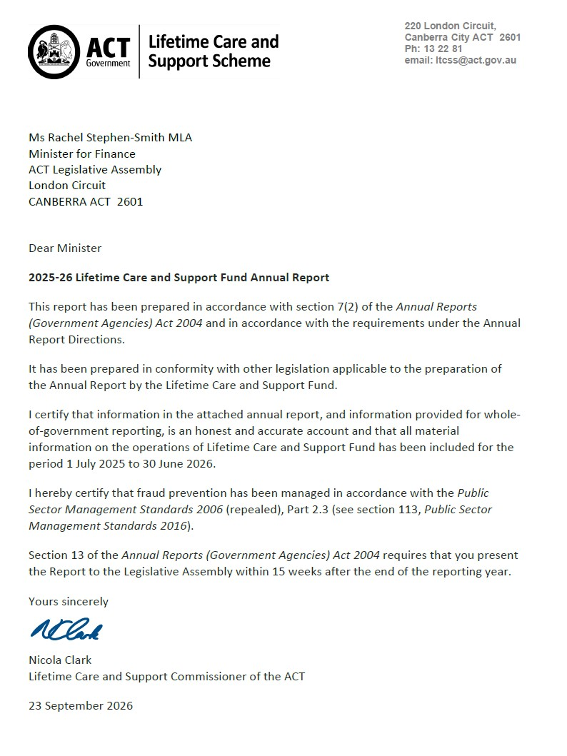

Compliance statement
The 2025-26 Lifetime Care and Support fund (LTCS fund) Annual Report must comply with the Annual Reports (Government Agencies) Directions 2026 (the Directions) made under section 8 of the Annual Reports (Government Agencies) Act 2004. The Directions are found at the ACT Legislation Register.
The compliance statement indicates the subsections, under Parts 1 to 5 of the Directions, that are applicable to the LTCS fund and the location of information that satisfies these requirements.

Part 1 Directions overview
The requirements under Part 1 of the Directions relate to the purpose, timing and distribution, and records keeping of annual reports. The 2025-26 LTCS fund Annual Report complies with all subsections of Part 1 under the Directions.
To meet Section 15 Feedback, Part 1 of the Directions, contact details for the LTCS fund are provided within the 2025-26 LTCS fund Annual Report to provide readers with the opportunity to provide feedback.

Part 2 Reporting entity annual report requirements
The requirements within Part 2 of the Directions are mandatory for all reporting entities and the LTCS fund Annual Report complies with all subsections. The information that satisfies the requirements of Part 2 is found in the LTCS fund Annual Report as follows:
- Transmittal Certificate, see the previous page.
- Organisational Overview and Performance Analysis, see the Organisational Overview and Performance section below. All other subsections are contained within the CMTEDD Annual Report.
- Financial Management Reporting: All financial management reporting is included in Volume 2 of the CMTEDD Annual Report.

Part 3 Reporting by exception
The LTCS fund has no information to report by exception under Part 3 of the Directions for the 2025-26 reporting year.

Part 4 Directorate and public sector body specific annual report requirements
Part 4 of the Directions is not applicable to the LTCS fund.

Part 5 Whole of government annual reporting
All subsections of Part 5 of the Directions apply to the LTCS fund. Consistent with the Directions, the information satisfying these requirements is reported in one place for all reporting entities as follows:
- Bushfire Risk Management, see the annual report of the Justice and Community Safety Directorate.
- Human Rights, see the annual report of the Justice and Community Safety Directorate.
- Legal Services Directions, see the annual report of the Justice and Community Safety Directorate.
- Public Sector Standards and Workforce Profile, see the annual State of the Service Report.
- Territory Records, see the annexed report within this 2025-26 CMTEDD Annual Report.
ACT Public Service directorate annual reports are found at the following web address: www.act.gov.au/open/chief-minister-treasury-and-economic-development-directorate-annual-reports

Organisational overview and performance

Organisational overview
The Lifetime Care and Support scheme (LTCS scheme) is established under the Lifetime Care and Support (Catastrophic Injuries) Act 2014 (LTCS Act) and provides reasonable and necessary ongoing treatment and care to people who have been catastrophically injured because of a motor accident or private sector workplace accident in the Australian Capital Territory (ACT). The types of injuries covered by the scheme are injuries that involve a spinal cord injury, traumatic brain injury, amputation, burns, permanent blindness, or any other injury mentioned in the LTCS guidelines (more information can be found at www.treasury.act.gov.au/ltcss).
The LTCS scheme has been in operation since 2014 and covers pedestrians, cyclists, and people travelling on, or in motor bikes and motor vehicles if there is at least one registrable motor vehicle involved in a motor accident, regardless of who is at fault for the accident. The scheme also applies to catastrophic private sector work injuries that occurred from 1 July 2016.
As the LTCS scheme is designed specifically for catastrophically injured people; participants will receive all their treatment and care needs under this scheme and not any other personal injury scheme under which they might have an application or claim (i.e. Motor Accident Injuries scheme or private sector workers’ compensation scheme). As a no-fault scheme, the LTCS scheme reduces stress on those injured and their families associated with litigating claims to meet ongoing treatment costs. It ensures early access to medical and rehabilitation care. Further, participants in the scheme do not have the additional financial concern of planning for their future needs through a lump sum payment. Scheme participants receive funding through the scheme for their reasonable and necessary ongoing treatment that they require.
Examples of treatment and care provided to participants in the scheme include:
- medical treatment
- rehabilitation
- attendant care services
- home and transport modification.
For motor accident injuries the LTCS scheme is funded by a levy on Motor Accident Injuries insurance policies. Private sector work injuries are funded through a separate levy collected from workers’ compensation insurers and self-insurers. The financial operations of the LTCS scheme are reflected in the LTCS fund which is a separate financial reporting entity.
The LTCS Act is administered by the Chief Minister, Treasury and Economic Development Directorate (CMTEDD). Under section 10 of the LTCS Act, the Minister must appoint a public servant as the LTCS Commissioner of the ACT.
The position of the Executive Branch Manager (EBM), Insurance Branch, Economic and Financial Group (EFG), CMTEDD was appointed by the Minister as the LTCS Commissioner in September 2025. The position of the Executive Group Manager of EFG was appointed by the Minister as the Acting LTCS Commissioner when the LTCS Commissioner is unavailable, also in September 2025. Acting arrangements were in place for most of the financial year with an acting Executive Branch Manager performing the functions of the LTCS Commissioner. The Executive Branch Manager position was finalised later in the financial year. The functions of the LTCS Commissioner are supported by the Insurance Branch of EFG within CMTEDD.
The NSW Government provides operational support for the ACT scheme. The NSW LTCS Authority (LTCSA) provides coordinated lifetime care and support services on behalf of the LTCS Commissioner to participants in the ACT scheme. This arrangement commenced on 1 September 2015 and gives effect to the Intergovernmental Agreement signed by the ACT Government with NSW in February 2015.

LTCS Commissioner Responsibilities
Under the provisions of the LTCS Act, some of the key responsibilities of the LTCS Commissioner are to:
- provide an indemnity and insurance scheme to respond to and pay assessed treatment and care needs for eligible participants.
- determine the LTCS levy amount separately for both the motor vehicle and work injuries streams.
- issue and monitor guidelines for the LTCS scheme.
- assess applications for eligibility for scheme participation.
- monitor the reasonable and necessary treatment and care needs of participants.

Highlights
The key priorities for the LTCS Commissioner during the 2025-26 financial year were to:
- issue guidelines and determinations when required under the LTCS Act.
- assess future funding requirements and levy setting.
- collect feedback from participants on their expectations and experience with the LTCS scheme.
- undertake investments in accordance with the fund’s investment strategy.
Against these priorities, the LTCS Commissioner:
- determined, having regard to independent actuarial advice, the LTCS levy for both motor vehicle and work injuries for 2026-27 (see Performance analysis, indicator (a) for further information on the levies).
- commissioned and received the 2026 LTCS participant feedback report on the administration and effectiveness of LTCS scheme services provided to participants. This included insights on how aspects of service delivery may be further enhanced - see the LTCS scheme Survey section of this report for further information on the survey and its findings (Performance analysis, indicator (b) also provides an explanation of the performance indicator).
- invested an additional $40 million of funds not required in the short-term in accordance with the approved LTCS fund investment strategy. In 2025-26 investments recorded a return of 7.6 per cent with market valuation gains on the investment portfolio contributing to the return. In comparison in 2024-25 investments made a return of 10.5 per cent.

Applications to the scheme
All participants start as ‘interim participants’ for up to two years. During this time, the scheme will pay for any reasonable and necessary treatment, rehabilitation and care related to the motor accident or work injury. After two years, an interim participant may be eligible to become a ‘lifetime participant.’ Children cannot apply for lifetime eligibility until they are at least five years old.
Decisions about whether an interim participant is accepted as a lifetime participant are made before the end of the interim participation period. Around six months prior to the end of the interim participation period, a participant’s eligibility to remain in the scheme is assessed to determine whether the person may have sufficiently recovered to the extent that they no longer meet the eligibility criteria after the two-year period. If it is assessed that the injured person is likely to meet the eligibility criteria beyond two years, the person is accepted into the scheme for life.
During 2025-26, the LTCS Commissioner accepted two motor accident injury applicants as interim participants in the scheme. The associated expenses for the two new interim participants are reflected in the LTCS fund’s financial statements for 2025-26. As of 30 June 2026, the scheme had been advised of one potential future applicant, who will be assessed for participation in 2026-27 for an accident that occurred prior to 30 June 2026.
Since the LTCS scheme commenced in July 2014 up until the end of June 2026, in aggregate terms (the total count of participants that have been accepted into the LTCS scheme as an interim or lifetime participant at some point in time), 48 participants have been accepted into the scheme.
As of 30 June 2026, in net terms (after adjusting for those entering, exiting, and lapsing from the scheme) there were 43 current participants accessing and receiving treatment and care benefits from the scheme. Participant movements occurring during 2025-26 led to the current participant number of 43. Current participant numbers are shown in Figure 1 and include the entry of two new interim participants.
Of the 43 participants who are currently receiving coordinated treatment and care benefits through the scheme, 37 are motor accident injury participants and six are work injury participants. In relation to their participation status:
- 37 are lifetime participants (including 31 motor vehicle injury participants and six work injury participants); and
- 6 are interim participants (all motor vehicle injury participants).
The LTCS scheme continues to have a relatively young profile with the average age of participants accepted into the scheme (on an aggregate basis) at the date of their accident being 32 years. 40 participants or 83 per cent are males (see Figure 2).
Figure 1: Movement in current LTCS Scheme participants receiving benefits in 2025-26 (and known potential participants).
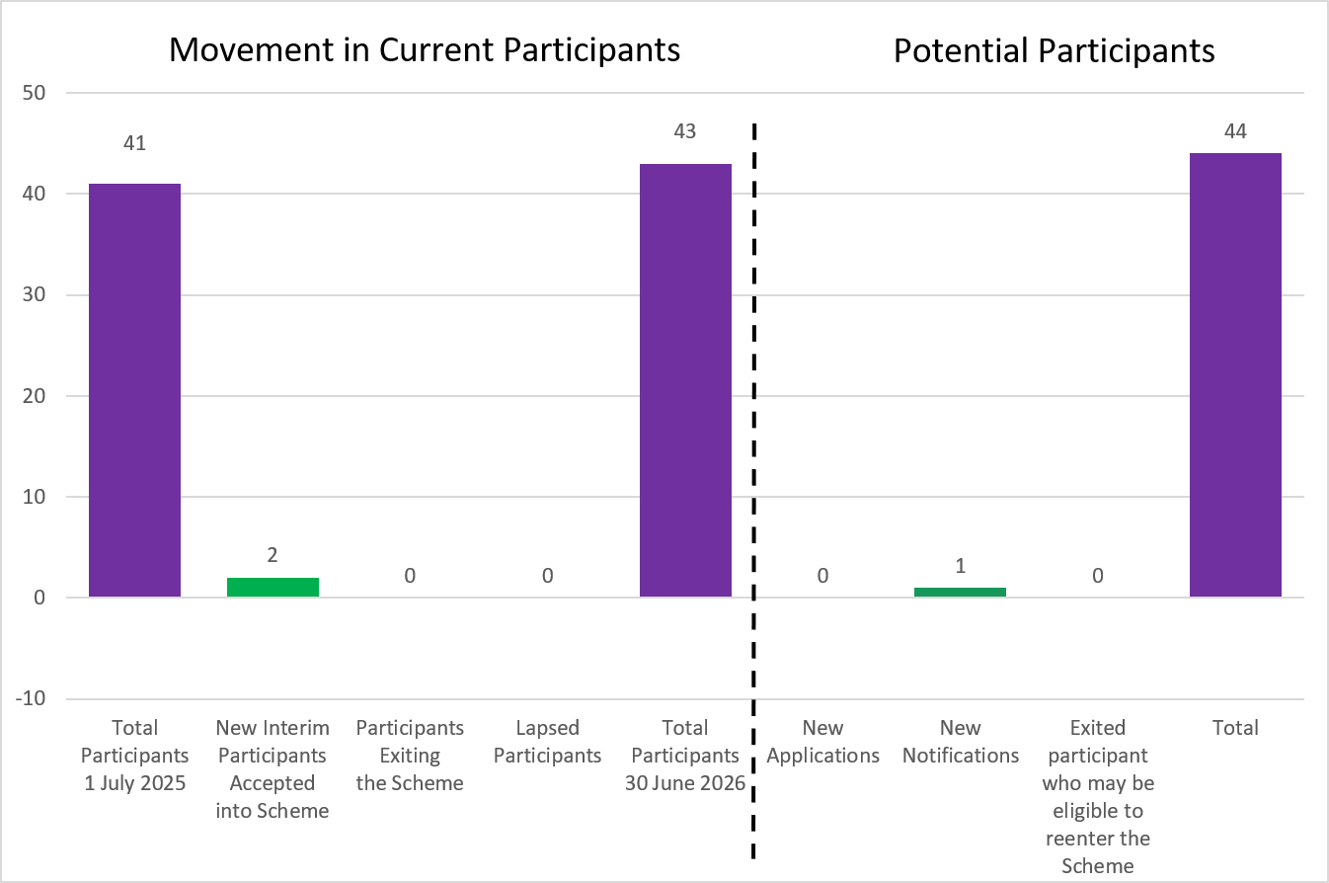
Figure 2 provides the age ranges for the 48 participants in aggregate, as at the date of their accident. This shows that there are 14, or 29 per cent of participants in the younger age groups (0-9 and 10-19 age bands). Given the younger age profile of the ACT’s scheme, and noting the expected lifespan or longevity of these individuals, the scheme will face significant treatment and care costs over many years to come.
Figure 2: Participant demographics

The scheme covers five types of catastrophic injuries – traumatic brain injury, spinal cord injury, amputations, burns, and vision loss. The category of injury for the participants accepted into the scheme since 1 July 2025, was traumatic brain injury.
For the 48 participants in aggregate, the injury category of 34 participants (74 per cent) accepted into the scheme were due to a traumatic brain injury, thirteen participants (27 per cent) due to spinal cord injury and one participant for an amputation (2 per cent). It is common for participants of the scheme to have sustained more than one injury category. Participants have been accepted into the scheme for combinations of spinal cord injury and traumatic brain injury, traumatic brain injury and permanent blindness, and traumatic brain injury and amputations.
Figure 3: Participant injury type
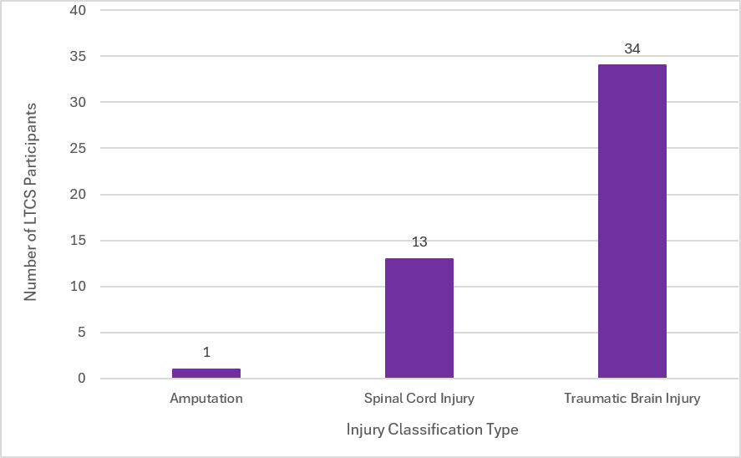

Circumstances of the accident
The below outlines each participants’ role in the accident leading to their catastrophic injury including 48 aggregate participant numbers up until the end of June 2026.
Of the 42 scheme participants who have been injured in a motor vehicle accident, including four from the work injury category who were driving at the time of the injury:
- nine were passengers (21 per cent);
- seven were pedestrians (17 per cent);
- five were riding bicycles (12 per cent);
- one was riding an electric scooter (2 per cent); and
- 24 were drivers (57 per cent), including six motorcycle riders (14 per cent).
For the six work injury participants, two were injured because of a work site incident, and four were injured in work related motor vehicle accidents and are included in the motor accident numbers above. Three of these four accidents resulted from journey claims.
Figure 4: Participant's role in accident
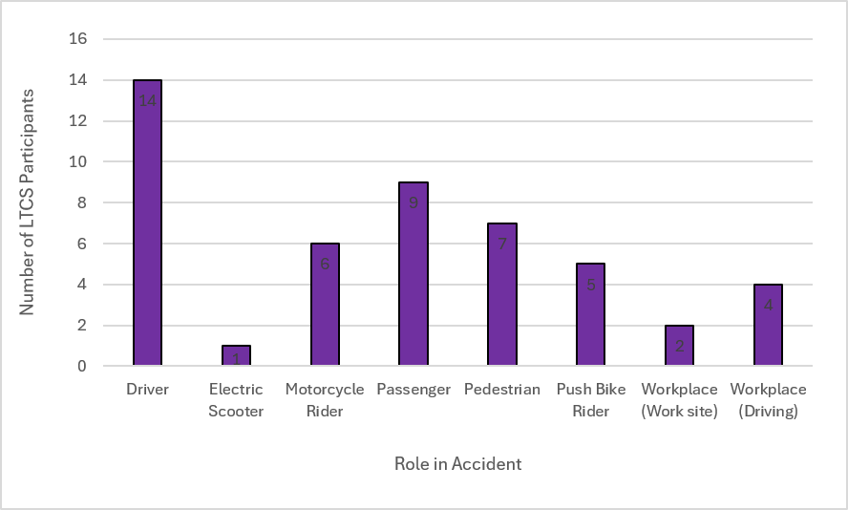

Provided Treatment, Rehabilitation and Care
In 2025-26, the LTCS scheme spent a total of $10 million on services for participants (down by 12 per cent compared with the previous year). Attendant care services (66 per cent) were the largest category of participant expenses reflecting the high care needs (severity and complexity of care) needed by many of the scheme’s participants. This cost has decreased compared with last year due to a reduction in the care requirements of some existing participants.
The second highest expense category relates to equipment needs of the participants (6 per cent), which tends to vary each year depending on the participants’ requirements and their need to purchase new or replace and update existing equipment. Rehabilitation needs (6 per cent), travel costs (6 per cent), case management (4 per cent) and medical care (4 per cent) were the next largest expense categories.
Figure 5: Participant benefit payments 2025-26
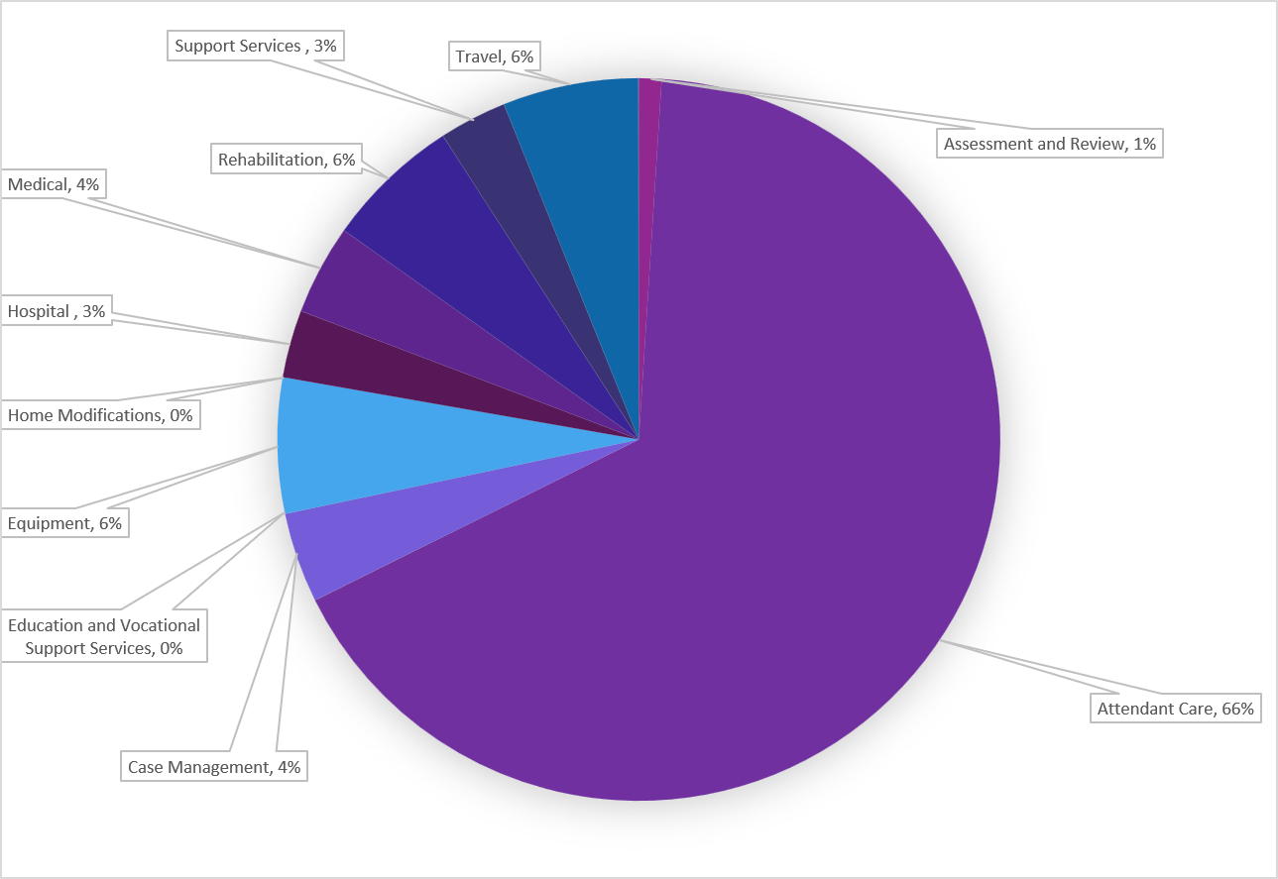

Accessing Services – how the scheme works with participants
The LTCS scheme provides reasonable and necessary treatment, rehabilitation, and care as it is required throughout the person’s life. The scheme also assists participants to plan their rehabilitation and care services.
Participants are supported as needed by a LTCS scheme coordinator. A case manager also supports the participant to help plan and source services as needed.
The coordinator works with the participant and their service providers to request approval for services. Services are organised as required and participants and their families are actively involved with each of these requests. Usually, payment of approved treatment and care needs is made by the LTCS scheme directly to the supplier of the services.

Addressing the Carers Recognition and Disability Inclusion Acts
During the reporting period, the LTCS scheme continued to uphold the Care Relationship Principles contained in the Carers Recognition Act 2021.
The scheme continues to recognise the significant role of carers and families in supporting participant recovery, rehabilitation, and community participation. Carers were engaged, where appropriate, in assessment, planning and review processes, and their perspectives were considered in decisions affecting participants. LTCS scheme provided information and support that recognised the diverse needs of carers, and promoting awareness of the Care Relationship Principles among staff and stakeholders.
Carers and attendant care workers (excluding those in care relationships) are credentialled by iCare NSW and must hold certification against the Attendant Care Industry Management System Standard (ACIMSS).
The LTCS scheme contributes to the objectives of the Disability Inclusion Act 2024 by supporting people with catastrophic injuries to participate in community life, access appropriate treatment and supports, exercise choice and control, and overcome barriers to accessibility. Throughout the reporting period, the LTCS scheme continued to promote participant-centred practice, health and wellbeing, community participation, and engagement with participants, families and carers in support planning and decision-making.

Performance analysis
The LTCS scheme’s 2025-26 performance indicators are included in the Budget Portfolio Statements for the LTCS fund and are reported as part of the LTCS fund’s Statement of Performance.

Explanation of performance indicators

LTCS levies determined during the fourth quarter
The LTCS levies are the key funding source for the scheme, with a levy applying to all Motor Accident Injuries insurance policies payable at the time of vehicle registration and a levy applying to private sector workers’ compensation insurers and self-insurers. As required by the LTCS Act, the levies are set by the LTCS Commissioner based on independent actuarial advice. The level at which the levies are set in any given year is intended to provide sufficient funds to meet the costs of all estimated present and future liabilities of new participants of the LTCS scheme in that year. The LTCS levies are for a financial year and are decided in the fourth quarter ending 30 June before the commencement of a new financial year on 1 July.
In accordance with section 84 of the LTCS Act, before the beginning of the contribution period the LTCS Commission obtains a report from the scheme’s actuary in relation to the amounts needed to be contributed to the LTCS fund for the contribution period.
Two actuarial reports for the 2026-27 contribution period were provided by the scheme Actuary, Finity Consulting Pty Ltd, for the purposes of setting the 2026-27 LTCS levy for motor vehicle injuries and the LTCS levy for work injuries.
For the 2026-27 contribution period the LTCS Commissioner determined that the LTCS levies remain unchanged from the 2025-26 levels. The LTCS levy for a twelve-month Motor Accident Injuries insurance policy was set at $110.40 for all motor vehicles except those that are part of the ACT’s Veteran, Vintage and Historic Registration scheme (VVHR). The LTCS levy for the VVHR scheme was set at $22.00 for a 12-month MAI policy.
The total LTCS levy payable by private sector workers’ compensation insurers and self-insurers were set at $8 million.
The levy determinations for the 2026-27 contribution period for motor vehicles and private sector workers’ compensation insurers and self-insurers, were notified on the Legislation Register on 28 April 2026 and 28 May 2026, respectively.
The LTCS Commissioner determined these LTCS levies based on the best available data. As the scheme will only be in its thirteenth year of operation for motor vehicle accidents and in its eleventh year of operation for work injury accidents, a high degree of uncertainty remains with respect to the number of participants and the costs of providing services. By the very nature of the injury type covered by the scheme, the costs of the scheme can be expected to be volatile from year to year. Further, it will take many years of experience before more robust scheme data becomes available. The LTCS Commissioner will continue to reassess the levy amounts yearly based on updated advice provided by an independent actuary.

Decision on applicant eligibility for participation in the LTCS scheme within ten business days of receiving all relevant information
Over the past 12 months, the LTCS scheme has demonstrated robust performance in meeting its service delivery commitments, achieving the key performance indicator of completing assessments within 10 business days of receiving all relevant information, for 100 per cent of participants assessed. All seven participant applications (interim and lifetime) referred to the scheme were finalised within the required period, reflecting the team's responsiveness, streamlined processes, and commitment to providing timely and effective support. This achievement ensures participants can access the services and assistance they need without unnecessary delay and highlights the LTCS's continued focus on delivering high-quality, client-centred outcomes.

Annual Participant Feedback; Satisfaction and Outcomes from the Survey
The LTCS scheme assesses participant experience annually. A survey of the LTCS scheme participants was conducted by MODD Research + Evaluation between March and May 2026. MODD Research + Evaluation are a social research consultancy that specialises in undertaking research of services in the disability and health sectors and are contracted to undertake the survey on behalf of the LTCS Commissioner.
This year’s survey sought feedback to understand participant perceptions of, and experience with the support and communication provided during key transition points, such as the shift of the primary contact from the nominated person to the participant; and the implications of trauma related difficulties with information processing and retention for the scheme’s ability to meet participant needs.
Interviews were completed with representatives of 14 of the 19 invited participants, including both Interim and Lifetime participants and their nominated persons. As the number of participants has increased, a small cohort are surveyed each year rather than the full complement of participants.
The research demonstrated very strong outcomes for participants, with all respondents satisfied with how the scheme met their needs. Participants reported positive progress towards their recovery, participation, and maintenance goals. LTCS-funded services, equipment, and case management were identified by the participants as key contributors to these outcomes. Most participants had established goals through their My Plan and felt they were making good progress, even where recovery had been affected by factors such as ongoing medical treatment or surgery.
Satisfaction with scheme-funded supports remained high across all service categories. Participants expressed strong satisfaction with case management, physiotherapy, occupational therapy, psychology and psychiatry services. High levels of satisfaction were also reported for equipment provision, home and vehicle modification, attendant care, exercise programs and vocational or education support. These findings indicate that scheme services continue to effectively support participants' independence, wellbeing, and achievement of personal goals.
Case management was identified in the survey responses as a significant strength of the scheme. All participants had a current case manager and were satisfied with the support received. Participants reported that case managers understood their injuries, priorities and recovery goals, maintained regular communication, monitored progress and provided valuable support in navigating services. Participants also reported positive experiences with their Single Point of Contact (SPOC) and identified no improvements required.
The survey also highlighted the important role case managers and coordinators play during key life and scheme transition points. Participants who had experienced events such as entering the scheme, undergoing their two-year reviews, changing providers, moving house or returning to study reported receiving timely information, coordinated support and assistance to ensure smooth transitions.
Participants demonstrated strong health literacy and confidence in managing their injury-related needs. Most indicated they understood the health advice provided to them, knew how to access appropriate support, and felt that they had sufficient control and choice over the services they receive and who provides them.
Feedback was very positive, with only limited-service concerns reported and most issues resolved or progressing towards resolution. Strong case manager and coordinator relationships continue to support positive participant experiences, while recurring delays in mobility equipment and gym memberships highlight opportunities for broader organisational improvement.
Participant feedback reflected the meaningful contribution of scheme supports to participant's daily lives, with many expressing gratitude for the scheme and its life-changing impact, highlighting the value of the supports received and the trusted relationships developed with case managers and coordinators.

Key Survey Result Highlights
- 100 per cent satisfied with how the scheme meets their needs (14/14).
- 93 per cent reported satisfactory progress towards recovery, participation, or maintenance goals.
- 100 per cent satisfied with case management services.
- 86 per cent reported no service-related problems in the previous nine months.
- 92 per cent satisfied with the timeliness of accessing services (12/13).
- 78 per cent satisfied with the timeliness of accessing equipment (7/9).
- 93 per cent agreed they have sufficient control and choice over supports and service providers.
- 79 per cent (11/14) provided unsolicited positive comments about the scheme and its benefits.
Overall, the 2026 research confirms that the LTCS scheme continues to deliver highly valued, participant-centred supports that effectively meet participants’ needs, contribute to positive outcomes, and support independence, recovery, and quality of life.

Overall Lifetime Care and Support scheme Outlook
Strategic priorities for the LTCS Commissioner in 2026-27 include:
- administering the LTCS scheme in accordance with the requirements of the LTCS Act and Guidelines;
- issuing / amending guidelines and determinations under the LTCS Act when required;
- collecting annual feedback from participants on their expectations and experience with the LTCS scheme and in consultation with our service partner, the NSW LTCSA, implementing improvements when required to the way LTCS scheme benefits are delivered to ACT participants;
- assessing future funding requirements of the fund and levy setting; and
- undertaking investments in accordance with the fund’s investment strategy.

Contact
Further information, please contact:
Nicola Clark
Executive Branch Manager, Insurance, Economic and Financial Group
Lifetime Care and Support Commissioner of the ACT
Nicola.Clark@act.gov.au

Motor Accident Injuries Commission

Transmittal Certificate
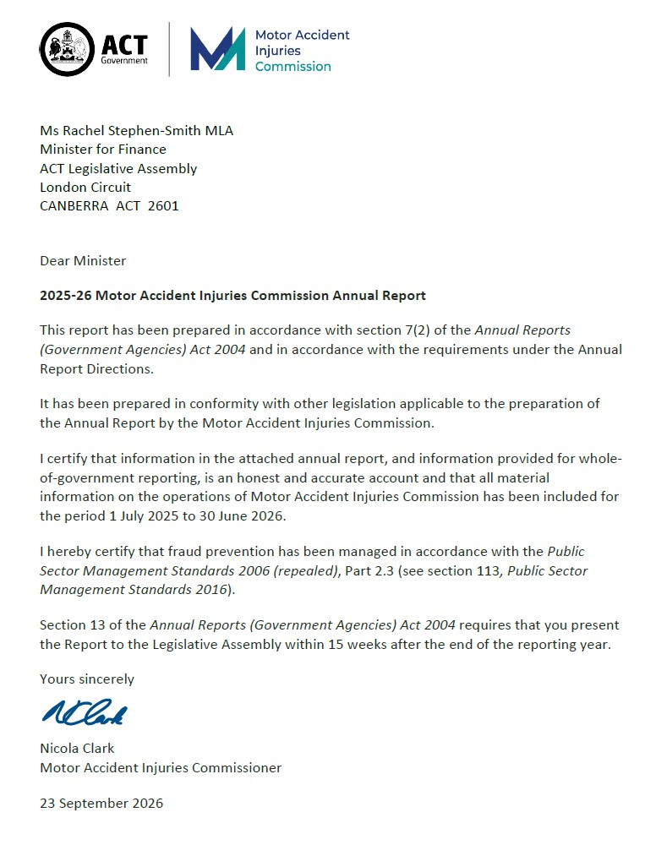

Compliance statement
The 2025-26 Motor Accident Injuries Commission (MAI Commission) Annual Report must comply with the Annual Reports (Government Agencies) Directions 2026 (the Directions) made under section 8 of the Annual Reports (Government Agencies) Act 2004. The Directions are found at the ACT Legislation Register.
The compliance statement indicates the subsections, under Parts 1 to 5 of the Directions, that are applicable to the MAI Commission and the location of information that satisfies these requirements.

Part 1 Directions overview
The requirements under Part 1 of the Directions relate to the purpose, timing and distribution, and records keeping of annual reports. The 2025-26 MAI Commission Annual Report complies with all subsections of Part 1 under the Directions.
To meet Section 15 Feedback, Part 1 of the Directions, contact details for the MAI Commission are provided within the 2025-26 MAI Commission Annual Report to provide readers with the opportunity to provide feedback.

Part 2 Reporting entity annual report requirements
The requirements within Part 2 of the Directions are mandatory for all reporting entities and the MAI Commission Annual Report complies with all subsections. The information that satisfies the requirements of Part 2 is found in the MAI Commission Annual Report as follows:
- Transmittal Certificate, see the previous page.
- Organisational Overview and Performance Analysis, see the Organisational Overview and Performance section below. All other subsections are contained within the CMTEDD Annual Report.
- Financial Management Reporting: All financial management reporting is included in Volume 2 of the CMTEDD Annual Report.

Part 3 Reporting by exception
The MAI Commission has no information to report by exception under Part 3 of the Directions for the 2025-26 reporting year.

Part 4 Directorate and public sector body specific annual report requirements
Part 4 of the Directions is not applicable to the MAI Commission.

Part 5 Whole of government annual reporting
All subsections of Part 5 of the Directions apply to the MAI Commission. Consistent with the Directions, the information satisfying these requirements is reported in one place for all reporting entities as follows:
- Bushfire Risk Management, see the annual report of the Justice and Community Safety Directorate.
- Human Rights, see the annual report of the Justice and Community Safety Directorate.
- Legal Services Directions, see the annual report of the Justice and Community Safety Directorate.
- Public Sector Standards and Workforce Profile, see the annual State of the Service Report.
- Territory Records, see the annexed report within this 2025-26 CMTEDD Annual Report.
ACT Public Service directorate annual reports are found at the following web address: www.cmd.act.gov.au/open_government/report/annual_reports

Organisational overview and performance

Organisational overview
The Motor Accident Injuries (MAI) Commission is a Territory authority established under the Motor Accident Injuries Act 2019 (MAI Act). The MAI Commission started operations on the commencement of the MAI Act on 1 February 2020.
The Executive Branch Manager of the Insurance Branch, Economic and Financial Group, Chief Minister, Treasury and Economic Development Directorate (CMTEDD) was appointed by the Minister as the MAI Commissioner for a period of 5 years commencing from 16 August 2024. The Executive Group Manager of the Economic and Financial Group, CMTEDD was also appointed by the Minister in 2024 as the Acting MAI Commissioner when the MAI Commissioner is unavailable. An acting Executive Branch Manager performed the functions of the MAI Commissioner for some of the reporting period, with an appointment finalised late in 2025-26. The functions of the MAI Commission are supported by the Insurance Branch, Economic and Financial Group, CMTEDD.

Principal objectives
The objectives of the MAI Act are specified in section 6 of the Act. The objectives include:
- Ensuring benefits are available to support all people injured in motor accidents on a no-fault basis, subject to some exclusions and limitations.
- Encouraging early and appropriate treatment and care of people injured in motor accidents to achieve optimum recovery and return to pre-accident levels of activity and work.
- Supporting people injured in motor accidents to access defined benefits.
- Promoting and encouraging the early, quick, cost-effective and just resolution of disputes.
- Keeping the costs of motor accident injury insurance at an affordable level, including through the prevention of accidents by contributing to campaigns.
- Providing for the licensing and supervision of insurers providing motor accident injury insurance, including keeping a register of applications and claims.

Functions
The MAI Commission’s functions are extensive and include providing information and assistance on the MAI Scheme. The MAI Commission has a strong monitoring and regulatory role in relation to the provision of defined benefits by insurers. The MAI Commission’s functions are detailed in section 25 of the MAI Act. Its responsibilities include:
- Regulating the licensing of insurers under the MAI Scheme.
- Reviewing premiums to ensure they fully fund the present and likely future costs of the scheme but are not excessive.
- Monitoring insurers’ compliance with their obligations under the Act.
- Providing information to the public about the MAI Scheme.
- Managing complaints about the market practices of licensed insurers and the handling practices of insurers under the MAI Scheme.
- Issuing, monitoring and reviewing the MAI guidelines and other statutory instruments under the Act.
- Monitoring and advising the Minister about the administration, efficiency and effectiveness of the MAI Scheme.
The MAI Commission is a self-funded statutory authority. The annual Motor Accident Levy (MA Levy) was $14 for 2025-26 (2024-25: $14). The annual MA Levy of $14 is payable in relation to MAI policies issued with effect from 1 July 2023, except for veteran, vintage and historic (VVH) registration scheme vehicles and modified VVH vehicles. These VVH vehicles have an annual MAI levy of $3.50 in 2025-26 (2024-25: $3.50) per MAI policy. The annual levy applies for a full year policy and is pro­rated for shorter registration periods, which can be purchased for 3 month or 6 month periods. This levy has been estimated to fully fund the MAI Commission, noting the funding collected varies based on the number of vehicles registered in the ACT each year, to which the levy is applied.

Highlights

Operation of the MAI Scheme
The MAI Scheme has now been in effect for over six years. During the reporting year the Commission completed fourteen of the action items from the Minister’s review into the Motor Accident Injuries Act 2019 (the 2023 Three-year review). One action remains in progress, relating to the determination of net profits for licensed insurers. This work continues. During 2025-26, new and updated guidelines were made to ensure operations of the scheme remain optimal.
The legislation requires the Minister to review the operation of the MAI Act every three years following the anniversary on 1 February 2026. The MAI Commission, as the statutory authority, supports the Minister’s review through information and data, including a report provided by the Scheme Actuary. The review itself is conducted by Treasury. The Scheme Actuary’s report was provided to Treasury in May 2026. The Government released the report with terms of reference and a discussion paper in July 2026. The MAI Commission expects to provide additional information and data to the reviewers in 2026-27.
Following a tender process for the Defined Benefits Information Service (DBIS) in March 2025, CARE Inc began operating the DBIS under a revised service scope from 1 October 2025. The revised scope included appointing a social worker to provide additional support alongside the legal assistance and information available through the DBIS. Higher than expected use of the social worker has demonstrated a need for this support in the Canberra community.

Competition and premium reductions
Since July 2013, there have been four licenced insurers in the ACT CTP / MAI insurance market, NRMA Insurance and three Suncorp brands being AAMI, APIA and GIO. There is evidence that competition has driven the price of premiums lower. Since competition commenced in the ACT market in July 2013 until 30 June 2026, the average private passenger vehicle premium has fallen by $186.52 or 32 per cent. Figure 1 shows premiums from 2018, just prior to the MAI Scheme’s introduction.
Between 2018 and the months immediately preceding the commencement of the MAI Scheme on 1 February 2020, premiums reflected the CTP Scheme design (common law, no caps on compensation). Premiums since 1 February 2020 reflect the MAI Scheme, a hybrid defined benefits common law scheme. Motorists continue to also benefit from product choice and various offers from the insurers.
Figure 1: CTP / MAI premium prices since February 2018
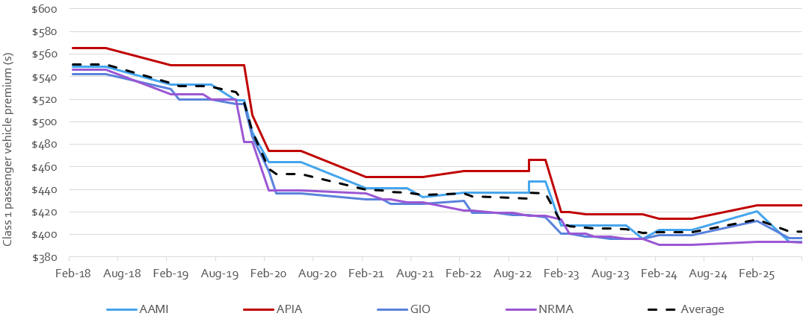

Insurer Market Share
Market share indicates the proportion of the market held by each insurer and provides an indication of how the ACT community is responding to a competitive market. Figure 2 shows the average market share over each of the financial years from 2018-19 through to the end of 2025-26. Market share is based on premiums collected by insurers.
Over 2025-26, NRMA and the Suncorp Group held 64 per cent and 36 per cent of the market respectively. Relative to the 2024-25 market share:
- NRMA’s market share decreased 4 percentage points (pp).
- AAMI increased its market share 11 pp, in a switch in marketing by Suncorp. GIO’s market share decreased 7 pp. APIA’s market share remained flat, noting that APIA holds a relatively small market share.
Figure 2: Movement in insurers’ average market share since 2019-20
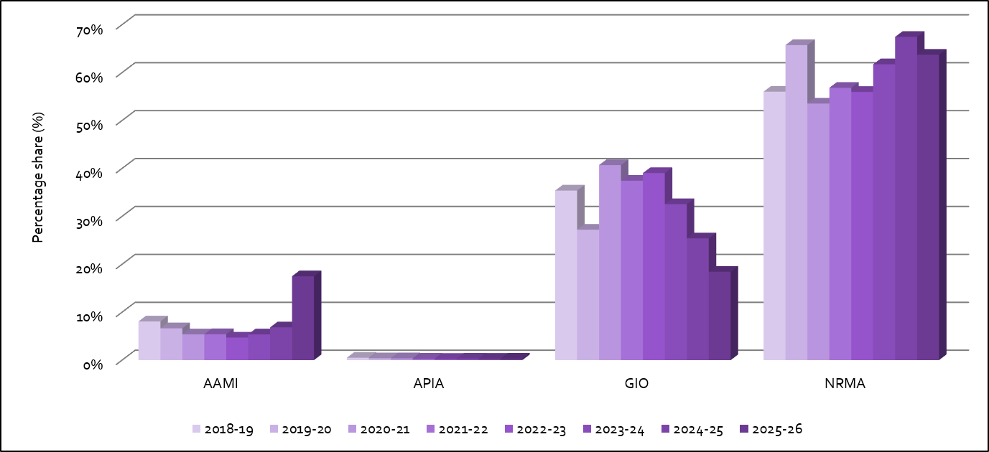

Premiums and scheme affordability
One of the objectives of the MAI Act is to keep the costs of insurance at an affordable level. The premiums charged by insurers reflect the benefit structure underlying the ACT’s insurance scheme. The MAI Scheme design provides fairer, faster and comprehensive support for Canberrans if they are injured in a motor accident, regardless of whether they were at-fault in an accident or not. Everyone who is injured in a motor vehicle accident is entitled to receive treatment, care, and lost income benefits, for up to five years. People who are more seriously injured and were not at-fault in the accident are able to make a claim for further compensation through common law. Insurers reduced their premiums because of the scheme design compared to premiums under the previous CTP Scheme (see Figure 1 and prior annual reports).
As shown in Figure 3, affordability, measured by premiums as a proportion of ACT average weekly earnings (AWE) improved between 2024-25 and 2025-26. Average premiums have fallen as a proportion of AWE by 12 pp over the period 2018-19 to 2025-26.
Figure 3: Average premiums for private passenger vehicles and as a proportion of ACT average weekly earnings
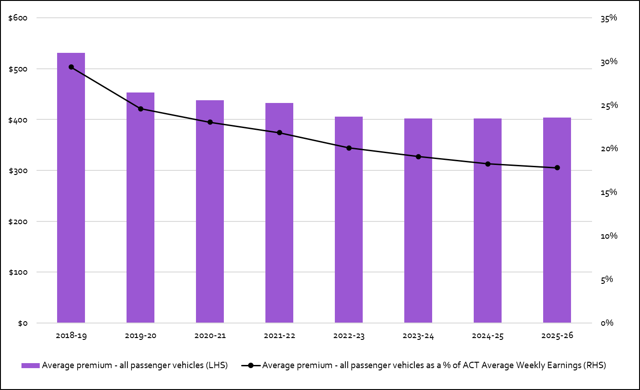
Note: The average CTP / MAI premium is for a class 1 passenger vehicle based on a 12-month policy.

Maintaining claims statistics for the MAI Scheme
The MAI Commission maintains an ICT system known as the MAI Register to assist the Commission in monitoring compliance as well as analysing how the MAI Scheme is performing against its objectives. It allows for an enhanced and systematic data capture and reporting, assisting Commission staff and the Scheme’s actuary in its functions.
Data is collected from licensed insurers and the ACT Nominal Defendant at regular intervals. The MAI Commission also has an arrangement with the ACT Civil and Administrative Tribunal Registry staff to provide information to the Commission on external reviews of insurers’ reviewable decisions and applications for the payment of death benefits. Deidentified information is reported on the Commission’s website through the MAI Scheme Quarterly reports. In 2026-27, the Commission will change the presentation of the reports to increase their accessibility online.
In addition, the MAI Commission collects information about legal fees and related costs from lawyers providing legal representation to injured parties under the scheme in certain circumstances.

MAI Scheme monitoring and insurer compliance
The MAI Commission adopts a risk-based compliance framework, with a strategic approach taken in scheduling compliance activities and in the use of remediation/enforcement tools. The framework can be found on the MAI Commission’s website. Under the framework the Commission monitors the operational aspects of the MAI Scheme and gathers information on insurer compliance through multiple sources.
The Commission meets quarterly with MAI insurers and the ACT Nominal Defendant with a focus on:
- operational aspects of the MAI Scheme including any significant matters arising from applications to the scheme; and
- insurer compliance and updates on any remediation activities.
As part of the compliance framework, the Commission reviews data in the MAI Register for quality and consistency with the MAI Act, regulations and guidelines. Data from the register also assists in identifying trends and potential risks in each insurer’s systems and processes for administering the scheme.
Feedback on the operation of the scheme is also gathered through periodic discussions with the authorised providers for the DBIS and independent medical examinations, any complaints and from direct community enquiries regarding the scheme through the Commission’s website, telephone calls and correspondence. The Commission also reviews for matters disclosed in the published decisions of the ACT Civil and Administrative Tribunal.
MAI insurers must also report conduct to the Commission they identify through their own business activities, which is likely to cause a significant breach of the scheme legislation. The Commission actively works with insurers, so all non-compliance identified is appropriately addressed, including through providing appropriate feedback and the development of improvement plans. The Commission can also direct an insurer to take, or not take certain actions to rectify their compliance, and may impose financial penalties subject to certain criteria, including a public interest test in the legislation.
The Commission received one notice of “reportable conduct” during the reporting period and was assured that the notifying insurer had already taken voluntary action to address the issue identified. The Commissioner also withdrew a direction notice on being satisfied the insurer was appropriately addressing compliance findings following an investigation of a complaint.
In July 2025, insurers were issued the annual self-assessment tool covering three assessment areas being income replacement payments, quality of life benefit applications and the handling of common law claims. The self-assessment resulted in MAI insurers providing improvement plans for their processes for the handling of quality of life applications. These plans were to rectify shortcomings identified through using the tool.
One insurer’s procedures for handling common law claims also required further enhancements. Internal changes resulted from this risk being identified. The Commission continues to actively monitor the implementation of plans provided by insurers. An assurance audit into the quality of life benefit process took place in the second half of the reporting year. The audit found that overall, there was a reasonable to high level of compliance by insurers, with recommendations being made to enhance some internal procedures. Insurers are putting steps in place to embed feedback and agreed recommendations from the audit. The audit report is available on the Commission’s website.

Road safety initiatives
The MAI Commission provided City and Environment Directorate with funding of $127,000 (excl GST) in 2025-26 to deliver road safety strategies with initiatives directed at supporting and promoting the prevention of motor accidents and the safe use of motor vehicles.
The following road safety strategies were supported:
- $38,000 for the ‘Stop it or Cop it” drink and drug driving campaign;
- $80,000 for the ‘Always On” campaign for digital road safety signage at petrol stations; and
- $9,000 for an extension of the Dangerous Driving initiative for targeted school facilitation.

MAI Scheme Statistics
The MAI Commission publishes scheme statistics quarterly. The quarterly reports up to and including the 30 June 2026 quarterly report are available at www.treasury.act.gov.au/maic/scheme-knowledge-centre
Below are some of the key statistics for the period 1 July 2025 to 30 June 2026.
- 440 applications were received for ACT accidents, 403 of which were complete applications and 37 are incomplete.
- A complete application is where the insurer has all the information it needs to assess liability.
- Further applications will be received for accidents that occurred prior to 30 June 2026 given the time injured people have to make an application to the scheme. It is expected to take some time for application numbers to reach maturity and for the community to fully engage with the new scheme.
- In addition to the 440 applications for ACT accidents, there are 43 applications for interstate accidents for which an ACT insurer might be liable.
Figures 4 to 8 below provide profile information about scheme applicants (with a complete application) from 1 July 2025 to 30 June 2026.
- 93 per cent of complete applications were accepted by insurers in 2025-26.
- 11 per cent of applicants were either at fault in the accident or it was a blameless accident, down from 18 per cent in 2024-25 and 17 per cent in 2023-24. This is a noticeably lower percentage than prior years, and an area the MAI Commission will consider focusing on in 2026-27 given a benefit of the MAI Scheme being a no-fault scheme is that everyone injured in a motor vehicle accident can receive defined benefits. There is no longer a need to show that someone else was at fault for the accident.
Figure 4: MAI Applicant fault status from 1 July 2025 to 30 June 2026
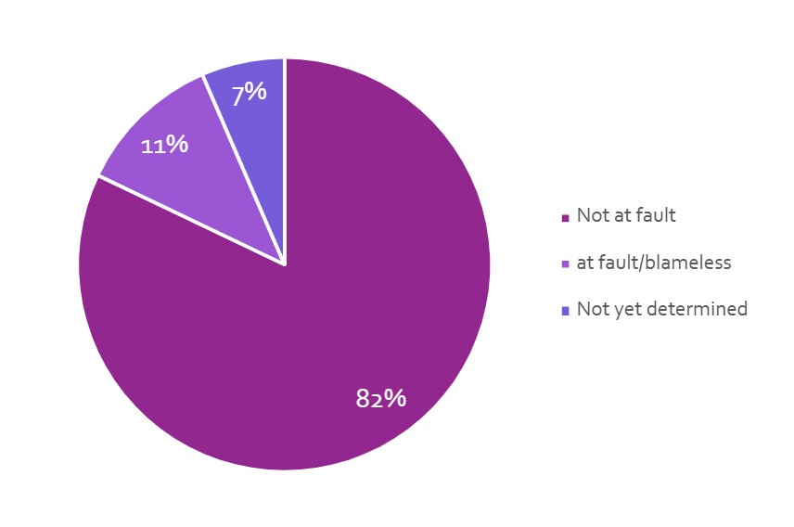
- Applicants aged 30 to 44 made the highest number of applications to the scheme
Figure 5: Age groups of MAI applicants from 1 July 2025 to 30 June 2026
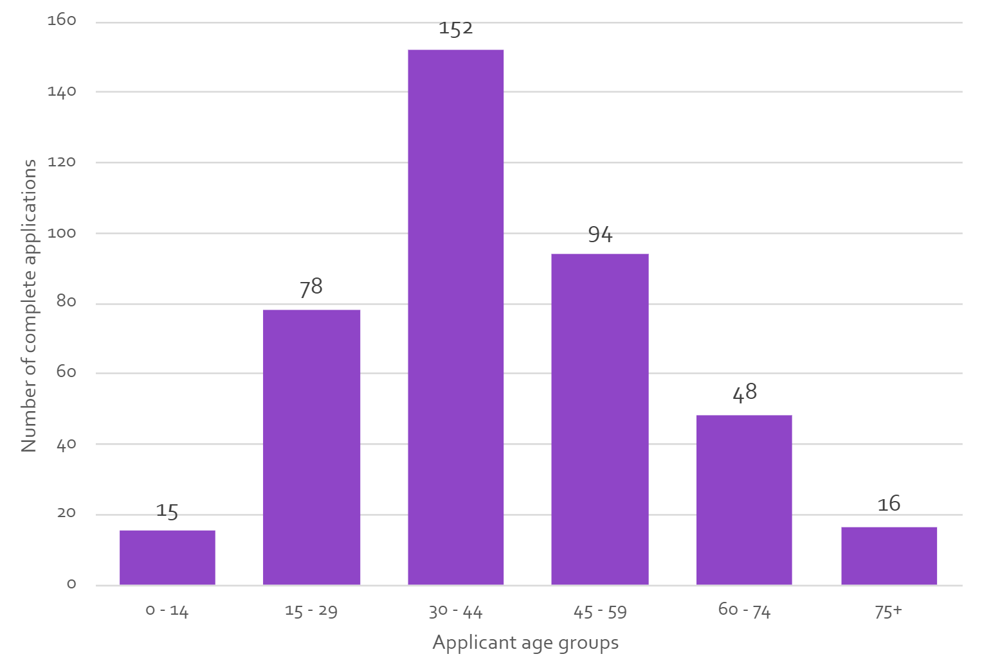
- Most applicants (59 per cent) were driving a motor vehicle at the time of the accident.
Figure 6: Applicants’ role in the accident, for MAI applications from 1 July 2025 to 30 June 2026
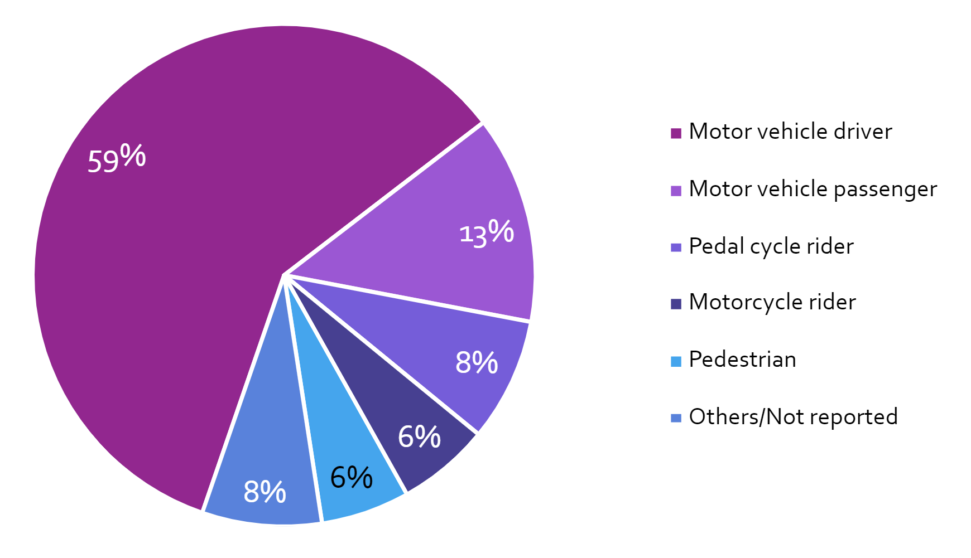
- Of those applicants who declared their work status, the majority were earning an income prior to their accident.
Figure 7: Applicants’ pre-accident work status, for MAI applications from 1 July 2025 to 30 June 2026
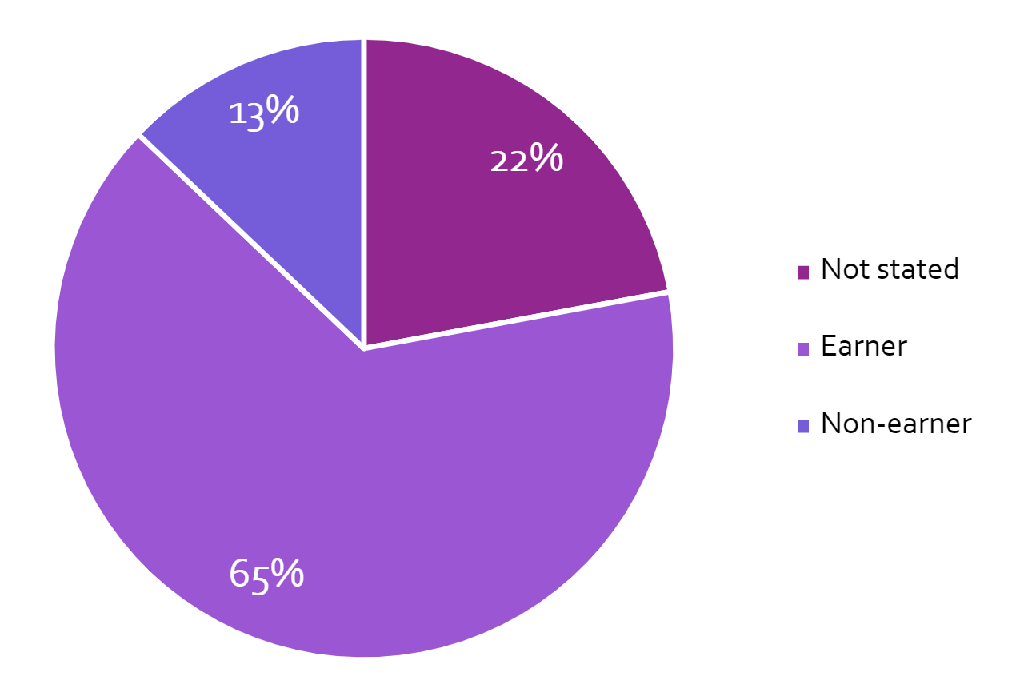
- The highest level of injury severity for over half of the applicants was minor.
Figure 8: Distribution of MAI applicants by Highest Injury Severity from 1 July 2025 to 30 June 2026
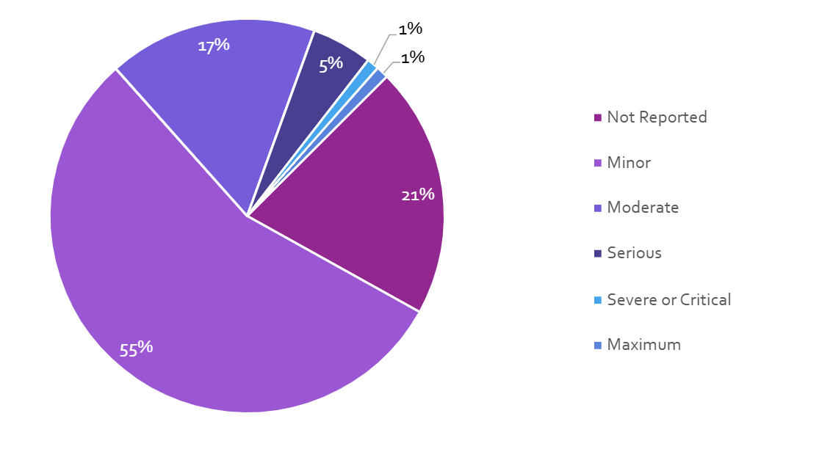
Figures 9 to 14 below provide operational and payment information about the MAI Scheme from 1 July 2025 to 30 June 2026.
- In 2025-26, the scheme paid out more than $46,743,000, which was an increase of 21 per cent compared to 2024-25 payments. The number of applications with payments made was 8 per cent higher than in 2024-25. 54 per cent of the payments related to payments for treatment and care benefits, and income replacement benefits. Common law payments are now occurring more as the scheme continues to develop.
Figure 9: Distribution of payments by type from 1 July 2025 to 30 June 2026 (includes payments related to interstate accidents)
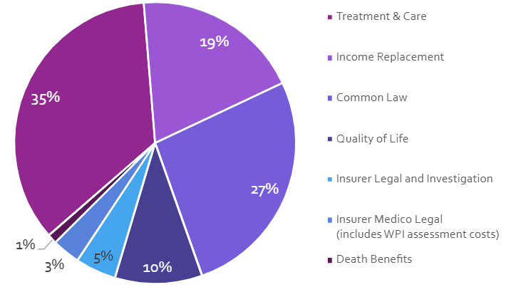
952 applicants received treatment and care payments in 2025-26. The first treatment and care payment was made in 9 days on average (median) after an insurer received a complete application. 64 per cent of first payments were made within two weeks. This reflects a key benefit of the scheme, that injured people can receive timely treatment and care and income replacement assistance.
Figure 10: Weeks until first treatment & care payment from 1 July 2025 to 30 June 2026
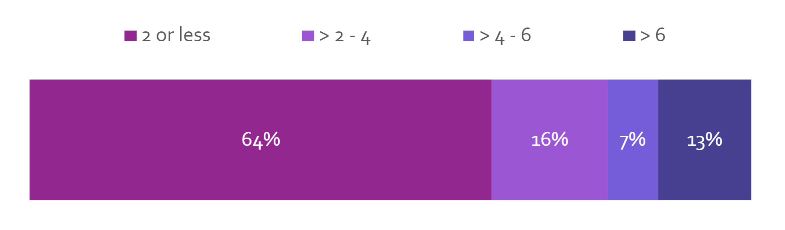

- 389 applicants received income replacement payments in 2025-26. The first income replacement payment was made in 21 days on average (median) after an insurer received a complete application. 65 per cent of first payments were made within four weeks. Income replacement payments can be made only after liability has been accepted by the insurer.
Figure 11: Weeks until first income replacement payment from 1 July 2025 to 30 June 2026
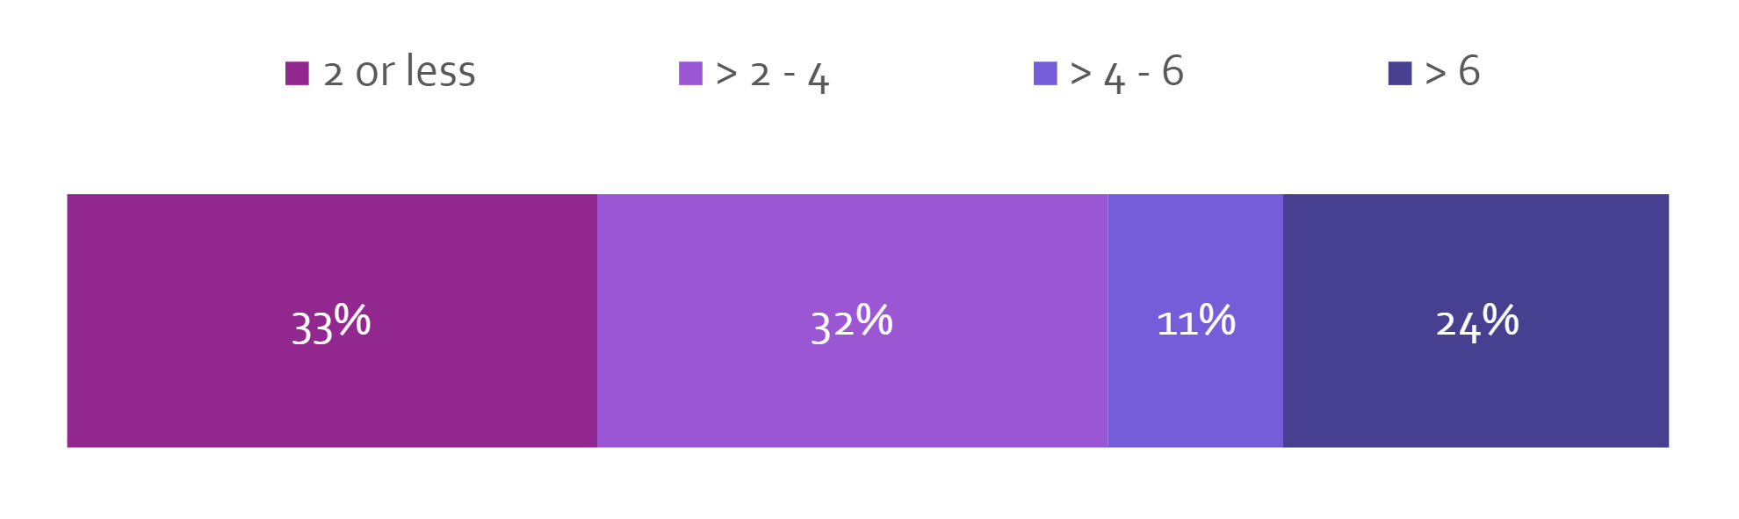
- There were 199 whole person impairment (WPI) assessments (generally for each body system that is referred) associated with 90 applications in 2025-26. Where multiple body system assessments occur, a process is undertaken to calculate the total degree of permanent impairment of the injured person. Of the 90 WPI determinations made, 30 per cent of applications had a WPI determination of 5 per cent or greater.
Figure 12: WPI Determinations from 1 July 2025 to 30 June 2026
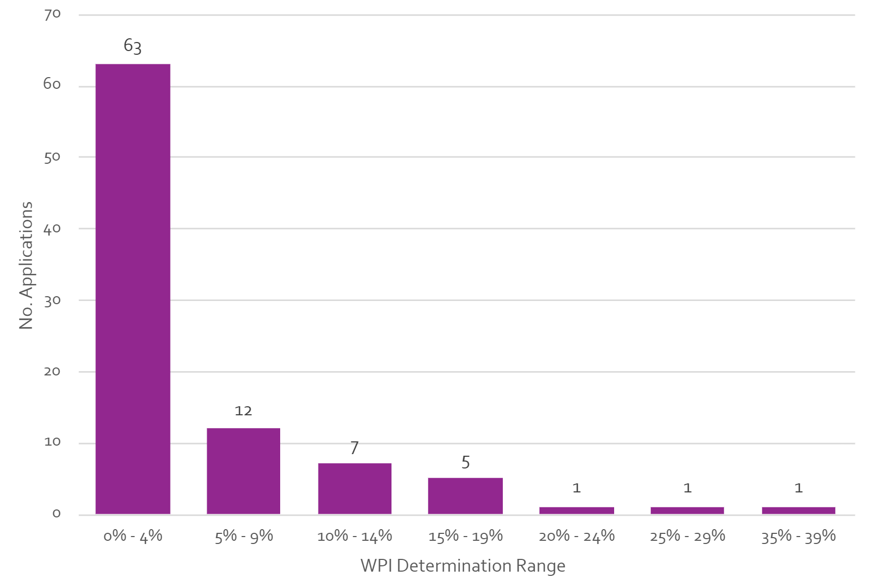

- 110 internal reviews were requested by 66 applicants in 2025-26. Over 90 per cent of the internal reviews have concluded.
Figure 13: Internal Reviews by outcome from 1 July 2025 to 30 June 2026
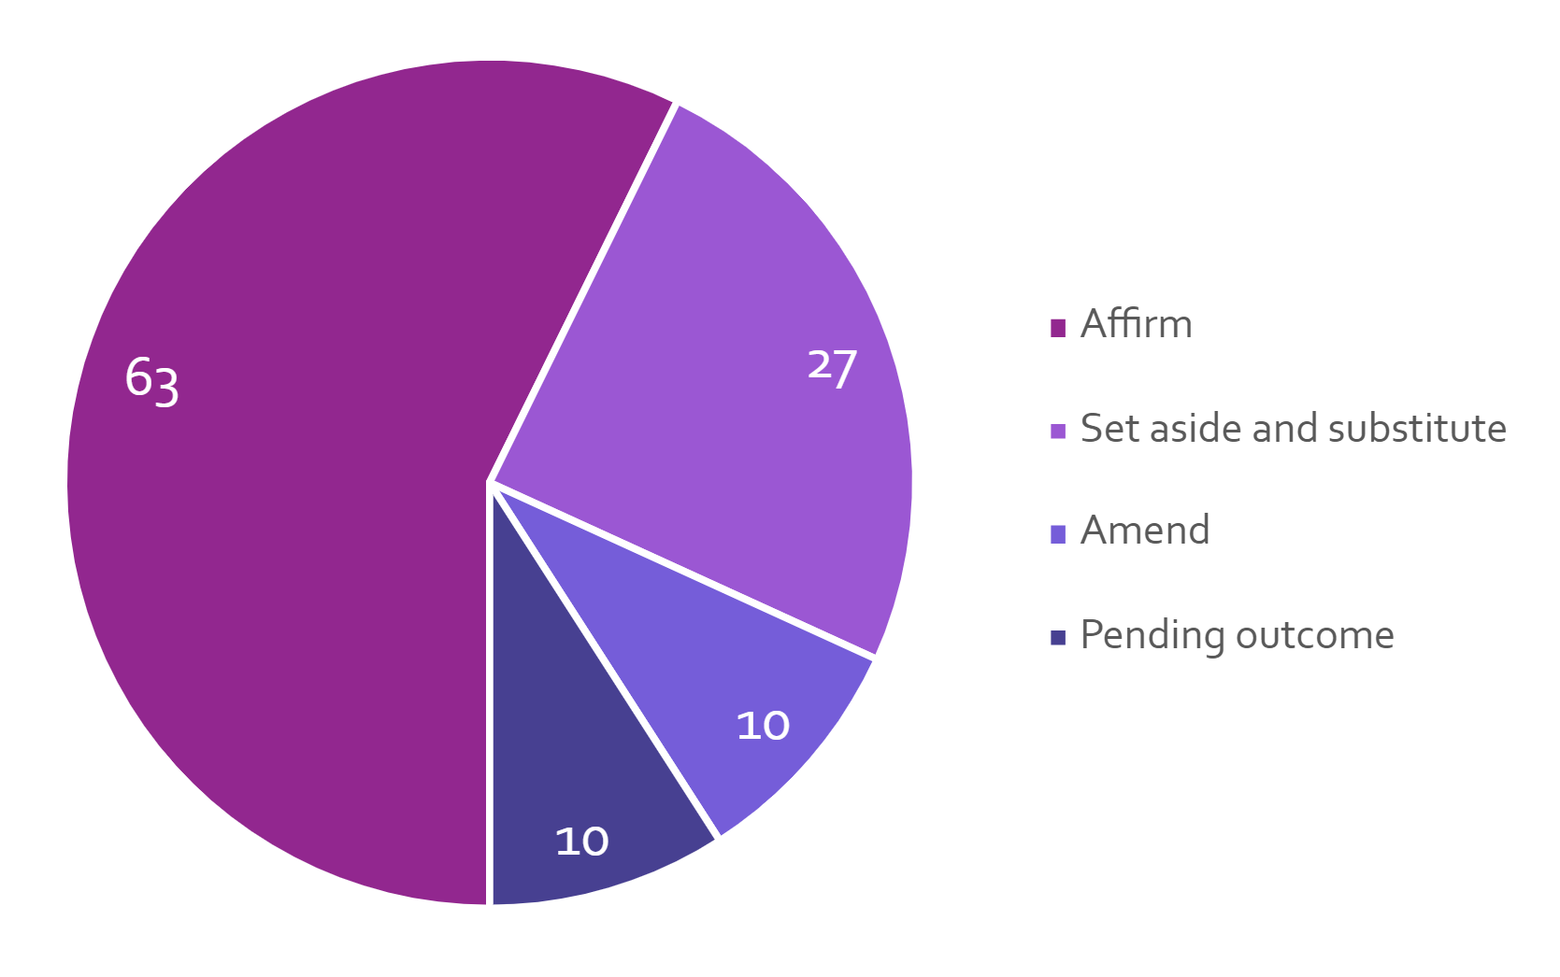
- Applicants requested 10 External Reviews or Death Benefits decisions in 2025-26.
Figure 14: External Reviews by outcome from 1 July 2025 to 30 June 2026
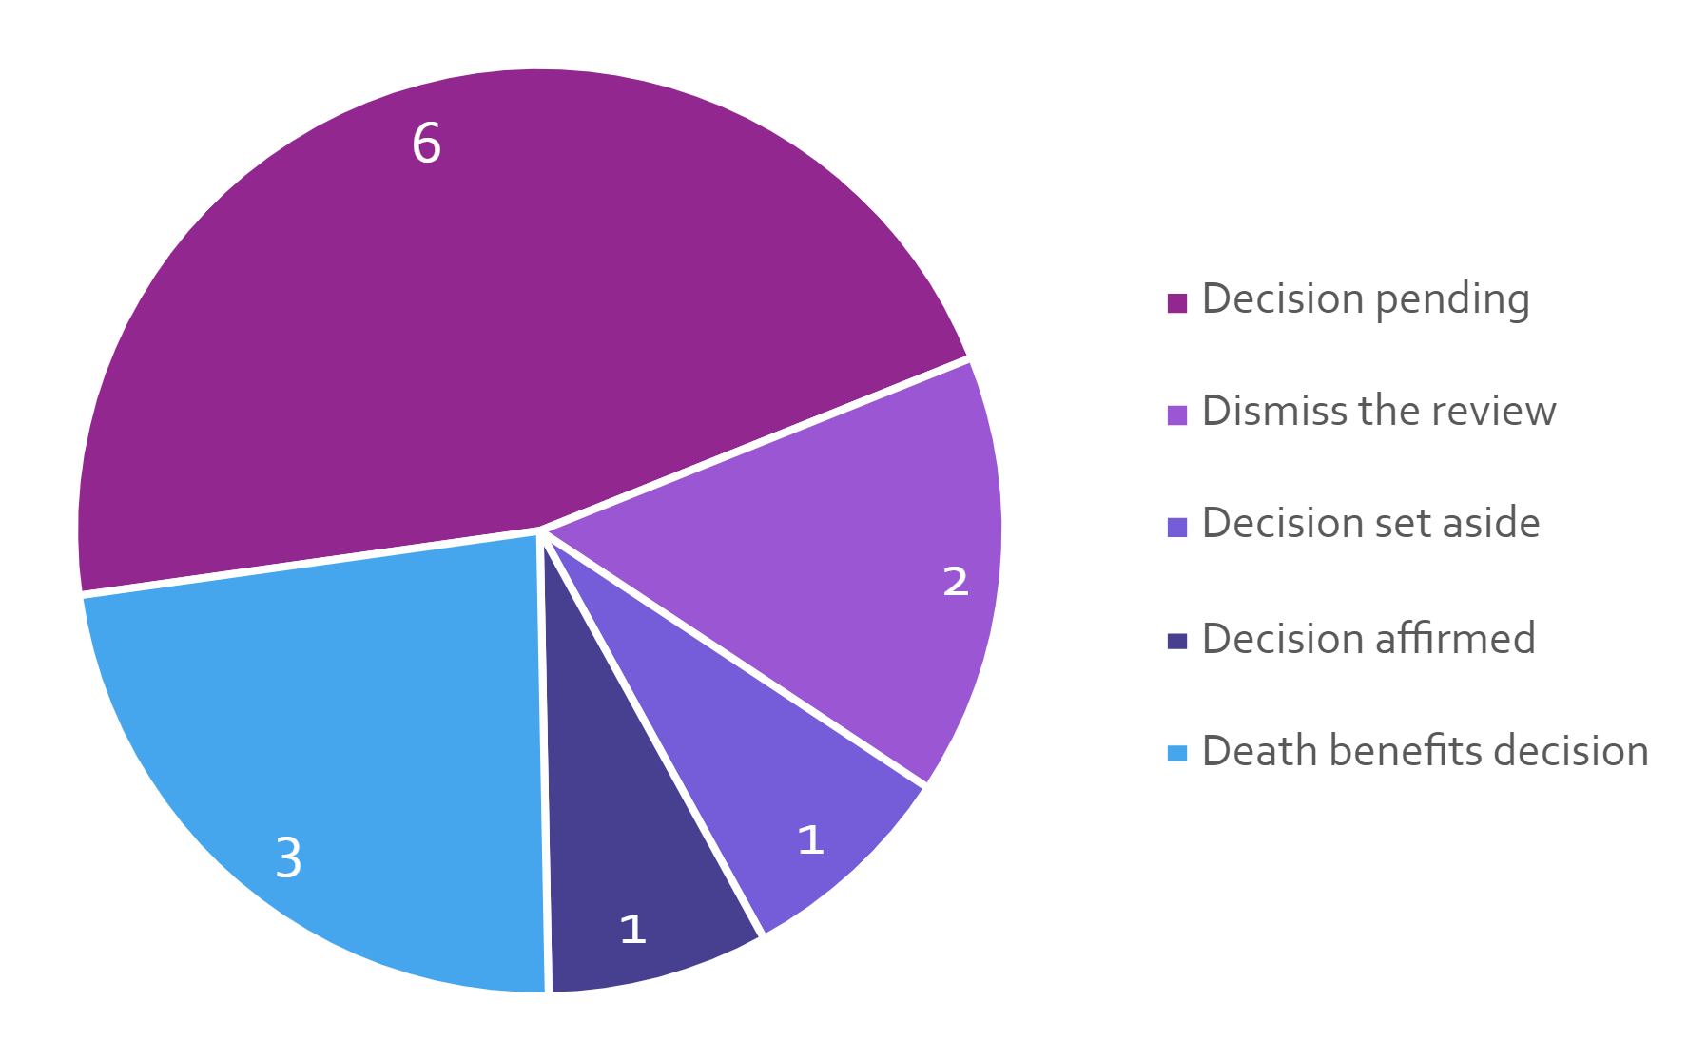

Premium determinations, loadings and levies
Under section 315 of the MAI Act insurers are only permitted to charge a premium approved by the MAI Commission. The MAI Commission will normally receive a premium filing from each licensed insurer at least annually. The Commission assesses each premium filing based on expert independent actuarial advice, and may approve a premium if it is assessed that it will fully fund the insurer’s liabilities and is not considered to be excessive. If a premium filing is not received within a year, the Commission will review and assess the existing premium in accordance with the same criteria.
A premium filing assessment includes consideration of estimated claims frequency, claim size, investment returns, administrative expenses and insurer profit – generally all the elements that make up the overall cost of service for an insurer participating in the MAI Scheme insurance market. The MAI Scheme is a long-tailed personal injury scheme. There will be a timing mismatch between when the premiums are collected and when benefits are paid. Premiums collected in a given year are to cover the current and future costs of personal injuries from motor accidents that occur in that year. The costs associated with these personal injuries can occur over many subsequent years.
Premiums collected have declined from $156 million in the first year of the MAI Scheme to around $146 million in 2025. Payments to date are below ultimate costs estimates, reflecting still the immaturity of claims. Early indications do suggest the scheme is delivering improved affordability with premiums and early access to benefits. With defined benefits being paid earlier people are receiving treatment and care and income replacement that many may not realise would have been paid much later under the previous scheme.
The role of the Scheme Actuary is to provide expert actuarial advice to the MAI Commission. This role is currently performed under contract by Finity Consulting Pty Limited.

Motorcycle premium support and loading
For motorcyclists, who are expected to have more and higher cost claims under the MAI Scheme, premium affordability has been maintained through a subsidy from other vehicle classes that is reflected in premiums.
The most recent Motorcycle Premium Support and Premium Loading amounts for premiums commencing from 1 April 2026 were communicated to insurers and published in a notifiable instrument on the ACT Legislation Register.
The premium support is the amount that each motorcycle MAI premium is subsidised, while the premium loading is the amount that is included in premiums for most other vehicle classes to fund the motorcycle subsidies.

Nominal Defendant
The Nominal Defendant is a statutory office which exists to enable persons to be supported for injuries caused by uninsured, unidentified motor vehicles for which a MAI or interstate CTP insurer cannot be identified and vehicles with an unregistered vehicle permit. Under section 16 of the MAI Act the ACTIA is the Nominal Defendant.
The Nominal Defendant is largely funded by a Nominal Defendant Loading that is part of the premiums paid by motorists. The MAI Scheme’s assessed Nominal Defendant Loading is published in a notifiable instrument on the ACT Legislation Register.

Lost investment income loading
The insurer’s lost investment income loading applies to premiums on policies with a duration of less than 12 months (‘Short Term Premiums’). The MAI Scheme’s lost investment income loading is published in a notifiable instrument on the ACT Legislation Register.

Performance analysis

Explanation of performance indicators
The MAI Commission’s 2025-26 performance indicators were included in its Statement of Intent and reported as part of the Commission’s Statement of Performance. For the 2024-25 financial year, the MAI Commission’s performance against the indicators was as follows.
- MAI Premium filings are reviewed by the Scheme Actuary and are approved in accordance with the MAI Act, including fully funding the scheme
The MAI Commissioner is required to approve or reject a premium application under section 319 of the MAI Act. Under section 318, there are two key grounds on which the MAI Commissioner is permitted to reject a premium filing: the premiums applied for by MAI insurers are too low (the fully funded test); or are too high (the excessive premium test). All premium filings by licensed MAI insurers were reviewed by the Scheme Actuary to ensure they met these tests. This ensures that the scheme is able to pay out all present and future liabilities. The Scheme Actuary considered that all insurers’ premiums met the fully funded and not excessive test.
For the 2025-26 year, the de novo filing year was adjusted to commence 1 April. This adjustment was made due to compressed timing created by the 1 February date established on the scheme’s commencement.
Consistent with premium streamlining arrangements, the MAI Commissioner approved premium partial filings if the change in premiums was within the permitted set bands and above the agreed minimum amount.
Premium filings for the MAI Scheme that were assessed and approved in accordance with the Act, were received from:
- AAMI, APIA, GIO and NRMA full de novo filings (received October 2024) and approved in November 2024 for MAI premiums commencing 1 April 2026; and
- AAMI and GIO partial filings (received March 2026) and approved May 2026 for MAI premiums commencing 9 June 2026.
- Insurer MAI premiums for all vehicle classes are published on the MAI Commission’s website
The MAI Commission publishes the applicable MAI premiums for all vehicle classes on the MAI Commission’s website at www.treasury.act.gov.au/maic. The aim is to publish this information six weeks before the effective date and this indicator was met.
- Promote public awareness of the causes of motor accidents through funding measures directed at reducing causes of motor vehicle accidents
The MAI Commission contributed $127,000 (excl GST) in 2025-26 towards road safety initiatives directed at supporting and promoting the prevention of motor accidents and the safe use of motor vehicles. The initiatives aimed to reduce the number and/or severity of injuries arising from motor accidents (consistent with the relevant objective under the MAI Act). See the earlier Road Safety Initiatives section of this report for details of the funding provided.
- Reporting on the Scheme’s statistics
Reports on the MAI Scheme for each quarter during 2025-26 were published on the MAI Commission website within target timeframes.
- Queries handling within ten working days of receipt of the query.
All queries received by the MAI Commission were responded to within ten working days of receipt.
- Complaints handling within twenty working days of receipt of the required information.
For 2025-26 the Commission received a total of two complaints. Both met the KPI of 20 working days on receipt of all the required information.

Outlook
Priorities for the MAI Commission in 2026-27 include:
- Providing information and assistance to the Government’s 2026 Three-year Review of the MAI Act.
- Issuing additional guidelines and regulations under the MAI Act, as required.
- Promoting and distributing information about the MAI Scheme, including via the MAI Commission website.
- Assessing MAI premium filings and monitoring premium processes.
- Maintaining an ICT system for the scheme’s data requirements and reporting on the scheme’s statistics.
- Monitoring the scheme’s performance and undertaking compliance activities.
- Contributing to the Government’s road safety initiatives that assist in reducing motor accidents and personal injuries and mitigating their impact.

Risk Management
The MAI Commission has a risk management plan. The MAI Commission has overall responsibility for risk management, and for ensuring compliance with the risk management plan.
The risk management plan identifies the key risk areas as operational, financial, legal and reputational risk. The risk management plan has identified the following potential risks:
- The Commission not meeting stakeholder expectations.
- Insufficient staff and/or resources available to achieve outcomes.
- Failure to meet legislative requirements.
- Failure of the ICT System for the MAI Scheme.
These risks are mitigated through the use of appropriate governance structures, application of risk-based management strategies and financial reporting processes.

Contact
Further information, please contact:
Nicola Clark
Executive Branch Manager, Insurance, Economic and Financial Group
Lifetime Care and Support Commissioner of the ACT
Nicola.Clark@act.gov.au

Office of the Nominal Defendant of the ACT

Transmittal Certificate
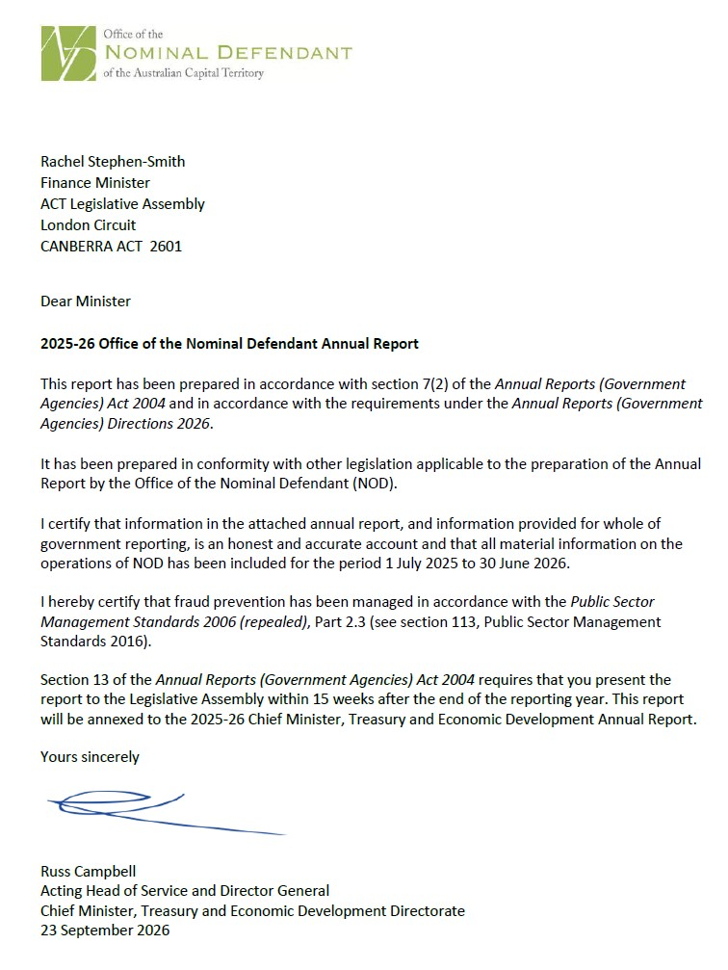

Compliance Statement
The 2025-26 Office of the Nominal Defendant of the ACT Annual Report must comply with the Annual Reports (Government Agencies) Directions 2026 (the Directions) made under section 8 of the Annual Reports (Government Agencies) Act 2004. The Directions are found at the ACT Legislation Register: www.legislation.act.gov.au
The compliance statement indicates the subsections, under Parts 1 to 5 of the Directions, that are applicable to the Office of the Nominal Defendant of the ACT and the location of information that satisfies these requirements.

Part 1 Directions Overview
The requirements under Part 1 of the Directions relate to the purpose, timing and distribution, and records keeping of annual reports. The 2025-26 Office of the Nominal Defendant of the ACT Annual Report complies with all subsections of Part 1 under the Directions.
In accordance with section 15 (Feedback) of Part 1 of the Directions, contact details for the Office of the Nominal Defendant of the ACT are provided in this Annual Report to enable readers to provide feedback.

Part 2 Reporting Entity Annual Report Requirements
The requirements within Part 2 of the Directions are mandatory for all reporting entities and the 2025-26 Office of the Nominal Defendant of the ACT Annual Report complies with all subsections. The information that satisfies the requirements of Part 2 is found in the 2025-26 Office of the Nominal Defendant of the ACT Annual Report as follows:
- A. Transmittal Certificate, see the previous page.
- B. Organisational Overview and Performance Analysis, see the Organisational Overview and Performance section below. The following subsections, contained within the 2025-26 ACT Insurance Authority Annual Report, apply to the Office of the Nominal Defendant of the ACT:
- Risk Management
- Internal Audit
- Fraud Prevention
- Freedom of Information
- Community Engagement and Support
- Aboriginal and Torres Strait Islander Reporting
- Disability Inclusion Act 2023 Reporting
- Multiculturalism Act 2023 Reporting
- Period Products and Facilities (Access) Act Reporting
- Work Health and Safety
- Ecological Sustainability Reporting
- Carer and carer support: Reporting under the Carers Recognition Regulation 2021
- C. Financial Management Reporting: All financial management reporting is included in the CMTEDD Annual Report.

Part 3 Reporting by Exception
The Office of the Nominal Defendant of the ACT has no information to report by exception under Part 3 of the Directions for the 2025-26 reporting year.

Part 4 Directorate and Public Sector Body Specific Annual Report Requirements
Part 4 of the Directions is not applicable to the Office of the Nominal Defendant of the ACT.

Part 5 Whole of Government Annual Reporting
All subsections of Part 5 of the Directions apply to the Office of the Nominal Defendant of the ACT. Consistent with the Directions, the information satisfying these requirements is reported in one place for all reporting entities as follows:
- Bushfire Risk Management, see the Annual Report of the Justice and Community Safety Directorate.
- Human Rights, see the Annual Report of the Justice and Community Safety Directorate.
- Legal Services Directions, see the Annual Report of the Justice and Community Safety Directorate.
- Public Sector Standards and Workforce Profile, see the annual State of the Service Report.
- Territory Records, see the annexed report within this 2025-26 CMTEDD Annual Report.
ACT Public Service Directorate Annual Reports are found at the following web address: https://www.act.gov.au/open/annual-reports

Organisational Overview and Performance

Organisational Overview
The ACT Insurance Authority is the Nominal Defendant of the ACT as defined under section 16 of the Motor Accident Injuries Act 2019 (the Act). Under section 330(1) of the Act, the MAI Commission (the Commission) established the Nominal Defendant Fund (the Fund). Prior to the commencement of the Motor Accident Injuries (MAI) Scheme on 1 February 2020, the Fund was established under the Compulsory Third-Party (CTP) Insurance Scheme.
The purpose of the Fund is to:
- provide a safety net mechanism to pay defined benefits and motor accident injury claims made by injured parties where:
- the vehicle involved does not have a motor accident insurance policy; or
- the injured person is unable to identify the driver and/or vehicle;
- ensure that persons, who are injured in the circumstances listed above, receive the same entitlements as an injured person would receive where the vehicle did have motor accident insurance;
- collect recoveries from uninsured at-fault drivers to the sum paid out by the Fund; and
- receive levies collected from licensed insurers in the Territory, as well as contributions from the Australian and ACT Governments.
Funds required to satisfy the cost of claims and other relevant expenses for the Fund are not guaranteed by the ACT Government. Part 6.9 of the Act requires the Commission to determine and collect contributions from licensed insurers and recognised self-insurers, to meet the cost of nominal defendant claims.

Functions
The Fund exists to enable anyone who is injured in a motor vehicle accident where there is no motor accident insurance to be compensated. The Fund meets the costs for individuals for treatment, care and lost income benefits for up to five years. Where possible, the Fund also recovers costs of claims from the at-fault driver of an unregistered vehicle.
The Fund’s administrative operations are subject to the same governance controls in relation to risk management, fraud prevention and records management as the ACT Insurance Authority. The reporting on these operations is included in the relevant sections of the 2025-26 ACT Insurance Authority Annual Report.
The ACT Insurance Authority also has oversight for workplace health and safety and associated risk management, accommodation, facilities management and workplace environmental management for the Fund. Reporting on these issues is contained in the 2025-26 ACT Insurance Authority Annual Report.

Internal Accountability
As a small reporting entity, the Fund does not have any complex internal accountability structures and processes. As stated above, all administrative operations and governance controls of the Fund are overseen by the ACT Insurance Authority.

Performance Analysis

Revenue
The Commission imposes a levy on licensed insurers and recognised self-insurers to meet the cost of nominal defendant claims in accordance with the Act. The funds required to meet the cost of nominal defendant claims are apportioned among the insurers having regard to the amount of motor accident premium income they receive. Funds are transferred from the Commission to the Fund on a quarterly basis.
Total levy, interest and distributions income recognised by the Fund during the 2025-26 financial year was $7.809 million.
In addition, revenue is received by the Fund from the following sources:
- any penalties or penalty interest imposed under the Act;
- amounts recovered by the Fund;
- unregistered vehicle permits liability contributions;
- unregistered vehicle fines liability contributions; and
- interest accruing from investments.
The following table details funds received as other revenue during the period.
Table 1: Other Revenue
Source | Amount ($m)
Unregistered vehicle permits | $0.241
Unregistered vehicle fines | $0.066
Uninsured owners and drivers | $0.010
Interstate MAI scheme recoveries | $1.435
Claims management fee – Interstate MAI scheme | $0.036
Total | $1.788
There are currently 89 ‘recovery only’ claim files open. These files are claims that have either settled or been finalised and the Fund is pursuing recovery from unregistered vehicle owners and/or the drivers of unregistered vehicles responsible for the accident.
Where the Fund has made payments on a claim involving an uninsured motor vehicle, attempts are made to recover the cost of those payments from the owner or driver concerned.
Recovery prospects are often poor as it can be difficult to identify or locate the at-fault driver or owner, and, when located, they may not have the capacity to repay any/all the costs incurred.
The Office of the Nominal Defendant of the ACT financial statements are reported in the 2025-26 CMTEDD Annual Report.

Claims
During the reporting period, the Fund received forty-seven (47) applications for defined benefits under the MAI Scheme, three (3) applications for defined benefits and common law under the MAI Scheme, and one (1) application under the previous Compulsory Third-Party scheme. Twenty-one (21) of the applications for defined benefits were being managed by the Nominal Defendant on behalf of interstate insurers.
There were forty-eight (48) open claims arising from applications received during the reporting period that remained open as at 30 June 2026 with a combined total provision for all outstanding claims of $25.018 million.
Table 2: Claim Types
 | Number | Percentage (%)
Unregistered and/or uninsured vehicles | 12 | 25
Unidentified vehicles | 13 | 27
Referred to another insurer | 1 | 2
Vehicles with unregistered vehicle permits | 1 | 2
Interstate insured vehicles | 21 | 44
Total | 48 | 100
An estimate of the provision for claims payable is completed annually by an independent actuary. Ernst & Young was engaged to provide current year actuarial services.
The movement in the provision for claims payable can either reduce claims expense in the case of a reduction in liability or increase claims expense in the case of an increase in liability.

Claims Frequency and Vehicle Registrations
As at 30 June 2026, the Australian Capital Territory has 344,228 registered vehicles.
For the financial year ending 30 June 2026, the ultimate claim frequency is estimated at approximately 0.064 claims per 1,000 vehicles registered.
A comparison between the number of vehicles registered and the number of ultimate claims estimated to be made to the Fund for each accident year is shown in the following chart:
Figure 1: Claim Frequency and Vehicle Registrations
Notes:
- Source: Nominal Defendant Liability Valuation Report as at 30 June 2026 produced by EY Actuarial Pty Limited.
- The vehicle registrations for 2026 are sourced from Road User Services ACT, and other years from previous actuarial reports.
- Claim frequency refers to the number of road incidents giving rise to a claim, irrespective of the number of claimants. The measure is expressed per thousand vehicles registered.

Average Claims Size
A comparison between the estimated ultimate average size of a claim and the estimated ultimate cost of a motor accident policy is shown in the following chart for each accident year. For the most recent financial year ending 30 June 2026, the ultimate average claim size is estimated to be $0.183 million while the ultimate average motor accident claim per policy cost is estimated to be $11.70.
Figure 2: Average Claim Size and Cost Per Policy by Accident Year (inflated and undiscounted)
Notes:
- Source: Nominal Defendant Liability Valuation Report as at 30 June 2026 produced by EY Actuarial Pty Limited.
- Average claim size and cost per policy (CPP) are in expected payment date values, but without allowance for time value of money (i.e. present value discounting), and are gross of all recoveries.
- The historical data component is sourced from previous actuarial reports.

Total Expenses
The total expenses incurred by the Fund during the year were $5.381 million, which includes a total claims expense of $4.471 million and $0.811 million for supplies and services.

Balance Sheet
The Fund had total assets of $56.870 million and liabilities of $25.817 million as at 30 June 2026, with total equity of the Fund of $31.053 million.

Scrutiny
There were no inquiries or reviews from the ACT Audit Office, the ACT Ombudsman, the ACT Integrity Commission, or any Legislative Assembly Committees in 2025-26. The only scrutiny from the Audit Office during the reporting year was for the audit of the 2024-25 Financial Statements.

Freedom of Information
The Freedom of Information Act 2016 (FOI Act) gives individuals the legal right to:
- Access government information unless access to the information would, on balance, be contrary to the public interest;
- Ask for personal information to be changed if it is incomplete, out-of-date, incorrect or misleading; and
- Appeal a decision about access to a document, or a decision in relation to a request to amend or annotate a personal record.
In accordance with section 96 of the FOI Act, the Fund is required to report on the operation of the FOI Act in relation to the Fund for the reporting year. CMTEDD manages FOI applications on behalf of the Fund and reporting requirements are detailed in Volume 1 of the CMTEDD 2025-26 Annual Report.
Further information relating to FOI, including how to make an FOI application, what details you need to make an application, and contact details for the CMTEDD Information Officer, can be found on CMTEDD’s website https://www.cmtedd.act.gov.au/functions/foi. There are also details of requests received by the directorate listed on the Freedom of Information Disclosure Log for CMTEDD.

Community Engagement and Support
The Fund has nothing to report against this section. The Fund does not undertake any community engagement or support in performing its functions.

Aboriginal and Torres Strait Islander Reporting
The Fund is committed to progressing actions towards the National Closing the Gap Agreement (the National Agreement) and working towards goals of the ACT Aboriginal and Torres Strait Islander Agreement 2019–28 (the ACT Agreement). Refer to the CMTEDD Annual Report for more detailed information on CMTEDD’s priority actions, programs, engagements and activities during the reporting period. The Fund does not undertake any Aboriginal and Torres Strait Islander programs, projects and/or initiatives other than those delivered by CMTEDD.
For further information on progress on implementing both the National Agreement and the ACT Agreement, refer to section B.9 of the ACT Insurance Authority Annual Report 2025-26.

Disability Inclusion Act 2023 Reporting
The Fund is committed to progressing actions towards the Disability Inclusion Act 2023. Refer to the CMTEDD Annual Report for more detailed information on CMTEDD’s priority actions, programs, engagements and activities during the reporting period. The Fund does not undertake any disability inclusion programs, projects and/or initiatives other than those delivered by CMTEDD.

Multiculturalism Act 2023 Reporting
The Fund is committed to progressing actions towards the Multiculturalism Act 2023. Refer to the CMTEDD Annual Report for more detailed information on CMTEDD’s priority actions, programs, engagements and activities during the reporting period. The Fund does not undertake any multicultural programs, projects and/or initiatives other than those delivered by CMTEDD.

Period Products and Facilities (Access) Act Reporting
Workplaces provide appropriate toilets, sanitary waste disposal facilities and handwashing facilities in a way that respects the dignity of the individuals. The ACTPS Employment Portal includes detailed information about Menstruation and Menopause Leave and flexible working arrangements for ACTPS staff.

Ecological Sustainability Reporting
Information on the Fund’s operational consumption data captured at a directorate level can be found in the Ecological Sustainability Reporting section of the CMTEDD Annual Report 2025-26.

Carer and Carer Support: Reporting under the Carers Recognition Regulation 2021
The Fund recognises the important contribution that carers make to the Canberra community and is committed to supporting employees who have caring responsibilities in accordance with the principles of the Carers Recognition Act 2021.
During 2025-26, the Fund promoted and upheld the care relationship principles through its people and culture practices, including:
- providing flexible working arrangements to help employees balance work and caring responsibilities, including flexible hours, hybrid working arrangements and access to leave provisions;
- supporting employees to access personal leave, carer's leave and other workplace flexibility measures where required;
- ensuring managers are aware of their responsibilities to support employees with caring responsibilities and to consider individual circumstances when making workplace decisions; and
- promoting a workplace culture that values diversity, inclusion and employee wellbeing, including recognising that carers may have needs distinct from those of the person they care for.
During 2025-26, the Fund did not administer any programs or services specifically targeted to people in care relationships and did not fund other organisations to provide targeted carer support services. Accordingly, the Fund's activities under the Carers Recognition Act 2021 were focused on supporting employees with caring responsibilities and promoting awareness of the care relationship principles within the workplace.

Financial Management Reporting

Government Contracting
The Fund engages consultants to perform specialised actuarial and legal services. The procurement selection and management processes for all contractors, including consultants, complied with the Government Procurement Act 2001 and the Government Procurement Regulation 2007.
The ACT Government Contracts Register, records contracts with suppliers of goods, services, and works with a value of $25,000 or more, and is available online.
A full search of Office of the Nominal Defendant of the ACT contracts notified with an execution date from 1 July 2025 to 30 June 2026 can be made at https://www.tenders.act.gov.au/contract/search.

Further information
Damian Black
General Manager, ACT Insurance Authority
ACTInsuranceAuthority@act.gov.au

Public Sector Workers Compensation Fund

Transmittal Certificate

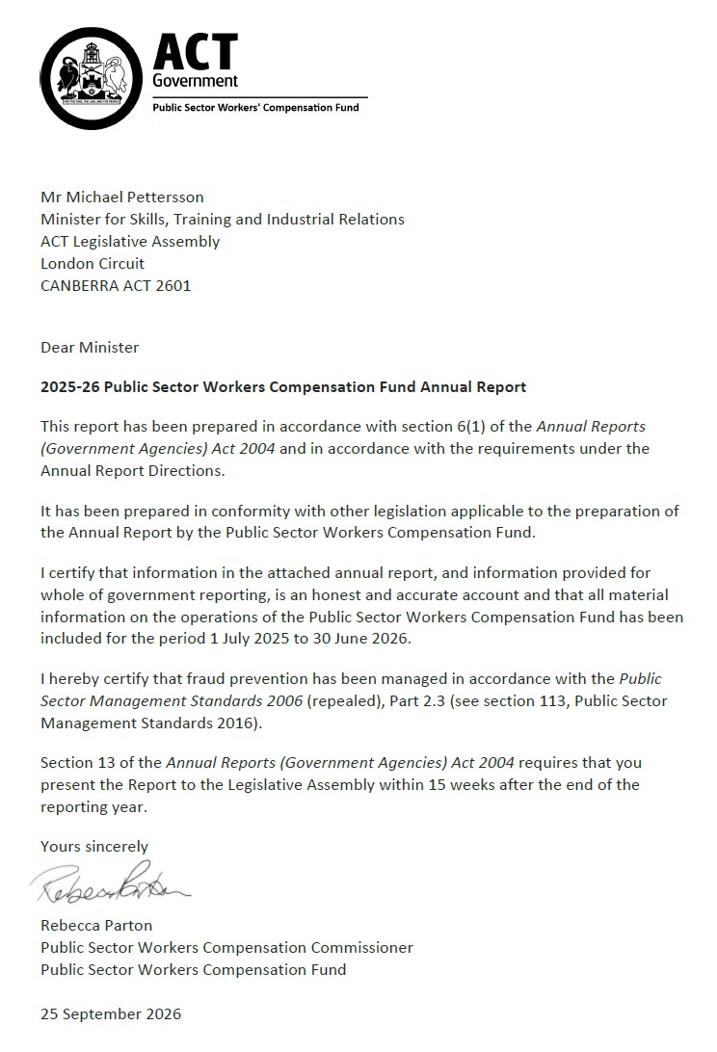

Compliance statement
The 2025-26 Public Sector Workers Compensation Fund (PSWC fund) Annual Report must comply with the Annual Reports (Government Agencies) Directions 2026 (the Directions) made under section 8 of the Annual Reports (Government Agencies) Act 2004. The Directions are found at the ACT Legislation Register.
The compliance statement indicates the subsections, under Parts 1 to 5 of the Directions, that are applicable to the PSWC fund and the location of information that satisfies these requirements.

Part 1 Directions overview
The requirements under Part 1 of the Directions relate to the purpose, timing and distribution, and records keeping of annual reports. The 2025-26 PSWC Fund Annual Report complies with all subsections of Part 1 under the Directions.
To meet Section 15 Feedback, Part 1 of the Directions, contact details for the PSWC fund are provided within the 2025-26 PSWC Fund Annual Report to provide readers with the opportunity to provide feedback.

Part 2 Reporting entity annual report requirements
The requirements within Part 2 of the Directions are mandatory for all reporting entities and the PSWC Fund Annual Report complies with all subsections. The information that satisfies the requirements of Part 2 is found in the PSWC Fund Annual Report as follows:
- Transmittal Certificate, see the previous page.
- Organisational Overview and Performance Analysis, see the Organisational Overview and Performance section below. All other subsections are contained within the CMTEDD Annual Report.
- Financial Management Reporting, see the Financial Management Reporting section.

Part 3 Reporting by exception
The PSWC fund has no information to report by exception under Part 3 of the Directions for the 2025-26 reporting year.

Part 4 Directorate and public sector body specific annual report requirements
Part 4 of the Directions is not applicable to the PSWC fund.

Part 5 Whole of government annual reporting
All subsections of Part 5 of the Directions apply to the PSWC fund. Consistent with the Directions, the information satisfying these requirements is reported in one place for all reporting entities as follows:
- Bushfire Risk Management, see the annual report of the Justice and Community Safety Directorate.
- Human Rights, see the annual report of the Justice and Community Safety Directorate.
- Legal Services Directions, see the annual report of the Justice and Community Safety Directorate.
- Public Sector Standards and Workforce Profile, see the annual State of the Service Report.
- Territory Records, see the annexed report within this 2025-26 CMTEDD Annual Report.
ACT Public Service directorate annual reports are found at the following web address: www.cmd.act.gov.au/open_government/report/annual_reports

Organisational overview and performance

Organisational overview
The PSWC fund is established under the Public Sector Workers Compensation Fund Act 2018 (the PSWCF Act) and commenced operations on 1 March 2019.
The PSWCF Act provides a financial and prudential governance framework to support the Territory’s workers’ compensation self-insurance arrangements for public sector employees, which are delivered under a licence issued by the Safety Rehabilitation and Compensation Commission in accordance with the Safety Rehabilitation and Compensation Act 1988 (Cwlth) (SRC Act).
The PSWCF Act is administered by CMTEDD. The functions of the PSWC fund are supported by the Work Safety Group, CMTEDD.
The PSWC fund was designed to ensure the effective management of the Territory’s workers’ compensation assets and features governance and management arrangements in relation to those assets. The PSWC fund is integral to the Territory’s compliance with its self-insurance licence.
The PSWC fund is administered by the Public Sector Workers Compensation Commissioner (PSWC commissioner) who is responsible for:
- managing the PSWC fund.
- advising the Minister about the administration, efficiency and effectiveness of the PSWC fund.
- in relation to a licence granted to the Territory under section 103 of the SRC Act:
- managing the Territory’s liability under the SRC Act.
- managing claims under the SRC Act.
The PSWC fund is funded by the Territory, including from annual contributions apportioned by the PSWC commissioner amongst Territory directorates and agencies. Assets are invested, with earnings retained to help meet workers’ compensation costs.

Internal accountability
The person occupying position number E00727 is appointed to the role of the PSWC commissioner for a period of three years to 29 February 2028.
As at 30 June 2026 the position is occupied by Ms Rebecca Parton, Executive Group Manager, Work Safety Group, Office of Industrial Relations and Workforce Strategy, CMTEDD.
Section 24 of the PSWCF Act establishes a Public Sector Workers Compensation Advisory Committee with the following functions:
- to keep informed of the operations of the PSWC fund to provide advice to the Minister in relation to the PSWC fund.
- to assist in meeting the Territory’s liabilities under the SRC Act by providing advice about claims management in relation to injured employees of the Territory.
Section 26 of the PSWCF Act stipulates the advisory committee consists of:
- the PSWC commissioner;
- three members appointed by the Minister to represent the interests of workers; and
- two members appointed by the Minister to represent the interests of public sector bodies and territory instrumentalities.
The Chair of the advisory committee as at 30 June 2026 was Ms Rebecca Parton, PSWC commissioner. The advisory committee met four times during 2025-26. Membership of the advisory committee during the year and the number of meetings each member attended is included in the table below.
Table 1: Membership and attendance of the Public Sector Workers Compensation fund Advisory Committee 2025-26
Name | Role | Meetings attended
Michael Young | Chair | 3
Rebecca Parton | Chair | 1
Melissa Payne | Member | 4
Matthew Peterson | Member | 4
Damian Black | Member | 3
Alex McPherson | Member | 1
Kasey Tomkins | Member | 2
Susie Walford | Member | 4
Notes:
All meetings of the committee occurred in accordance with Section 27 of the PSWCF Act and the committee’s terms of reference.
Michael Young resigned from his position as PSWC commissioner and Chair of the committee on 15 March 2026.
Rebecca Parton was appointed PSWC commissioner, and Chair of the committee from 16 March 2026.
Damian Black and Alex Mcpherson attended meetings for periods while they were acting in the role of ACT Insurance Authority General Manager.

Remuneration
The PSWC commissioner does not receive any additional remuneration. Other members for of the advisory committee may be reimbursed for any interstate travel costs incurred to attend committee meetings in person.

Performance analysis

Overview
The PSWC fund’s 2025-26 performance indicators are included in the 2025-26 Budget Portfolio Statements for the PSWC fund and are reported on as part of the PSWC fund’s Statement of Performance in Volume 2.2 of the CMTEDD Annual Report.

Explanation of performance indicators
- Reduce the ACT public sector incidence of serious workplace injury
This accountability indicator is sensitive to public sector injury prevention activities and aligns with targets from national and ACT Public Sector work health and safety strategies. A serious workplace injury is an accepted workers’ compensation claim that results in the injured person being unable to perform their usual role for one or more weeks. This accountability indicator measures the number of ACT public sector workers’ compensation serious claims, per 1,000 employees. Improved performance in relation to serious workplace injuries is indicative of improvements in injury prevention and management, for example from programs such as early intervention physiotherapy and safety auditing.
- Achieve a conformance rating of 85 per cent or higher in the annual audit of the ACT workers’ compensation self-insurance rehabilitation management system.
It is a requirement of the SRC Act that the Territory maintains a rehabilitation management system that complies with Australian Government guidelines and that conformance is audited annually. The 2025-26 independent audit was completed on 4 May 2026.
- Maintain a PSWC fund asset to liability ratio greater than or equal to 100 per cent
This accountability indicator aligns with the PSWC fund requirements under the Public Sector Workers Compensation Fund (Investment and Funding Ratio) Management Guidelines 2019 (No 2). An asset to liability ratio of 100 per cent or more indicates that the PSWC fund holds sufficient assets to meet the expected lifetime cost of public sector workers’ compensation claims.
- Achieve a conformance rating of 85 per cent or higher in the annual audit of the ACT workers’ compensation self-insurance claims management system
It is a requirement of the SRC Act that the Territory maintains a claim management system that complies with Australian Government guidelines and that conformance is audited annually. The 2025-26 independent audit was completed on 4 May 2026.

Highlights
The key priorities for the PSWC fund during the 2025-26 financial year were:
- developing and deploying best practice health, wellbeing and return to work strategies, policies and interventions for the ACT public sector.
- ensuring the effective and efficient management of new and existing ACT public sector workers’ compensation claims.
- ensuring the effective and efficient management of the PSWC fund assets in accordance with the PSWC fund investment guidelines.
- continuously improving injured worker and directorate satisfaction with workers’ compensation insurance and rehabilitation services.
In 2025-26, the PSWC fund:
- received 744 new claims (677 in 2024-25).
- finalised 877 claims (894 In 2025-25).
Table 2: ACT Public Sector Workers Compensation Claims in 2025-26
 | Number
Total claims opened during the reporting period | 744
Total claims closed during the reporting period | 877
Total reopened claims during the reporting period | 272
Current open claims (as at 30 June 2025) | 1,427

Outlook
In 2026-27, the PSWC fund will continue to progress the strategic and operational priorities from 2025-26, ensuring the effective and efficient management of the fund’s assets and liabilities.
Key focus areas of the PSWC fund in undertaking its functions in 2026-27 will include the ongoing review of the SRC Act, and engagement with the Safety, Rehabilitation and Compensation Commission for the renewal of the self-insurance licence and the requirement to transition work health and safety arrangements and systems to align with ISO45001.

Scrutiny
Scrutiny of the PSWC fund’s activities is undertaken by a number of bodies including Committees of the ACT Legislative Assembly, the ACT Auditor-General and the ACT Ombudsman.
There were no Ombudsman reports in 2025-26 in relation to the Fund.

Financial management reporting

Government contracting
The Territory and the PSWC fund have engaged, pursuant to Sections 23 and 30 of the PSWCF Act, a claims manager responsible under Section 23 for the following:
- investigating claims;
- assessing the Territory’s liability in relation to claims under the SRC Act, including initial liability and ongoing liability;
- calculating benefits and authorising payments under the SRC Act;
- paying amounts in relation to provisional liability medical costs;
- paying amounts in relation to workers’ compensation claims; managing claim data;
- managing disputes in relation to claims made against the Territory under the SRC Act; and
- anything else prescribed by regulation under the PSWCF Act.
EML Solutions Pty Ltd (EML) are currently engaged as a third-party administrator to provide claims management services for the PSWC fund.
During 2025-26 an open market procurement process for the management of workers compensation claims was undertaken in advance of the current contract expiring in 2027.
A new contract has been established with EML to deliver these services. The contract will commence in March 2027 until March 2031. All other financial management reporting is included in Volume 2.2 of the CMTEDD Annual Report.

The PSWC fund, has complied with the Government Procurement Act 2001 during the reporting year, except as specified below:
Description of non-  compliance | Section and subsection of Government Procurement Act 2001 to which the non-compliance relates | Reason for non-compliance | Steps taken to rectify non-compliance
Contract not notified within required timeframe | Government Procurement Act 2001 Section 14(1)  Government Procurement Regulation 2007 (the Regulation) Section 12C | A breach occurred due to delays in obtaining advice and finalising approvals relating to contractual matters, resulting in notification not occurring within the prescribed 21-day timeframe. | Following identification of the breach, the contract was notified and remedial action undertaken. Relevant staff were counselled on their compliance obligations to prevent recurrence.  Staff involved with procurement activities were directed to complete required training before undertaking future procurement processes.
Notifiable invoices were not notified to the Notifiable invoices Register.  Several of these invoices relate to the 2025-26 reporting period with the remaining in previous reporting periods. | Government Procurement Act 2001 Section 14 (1) | The noncompliance resulted from a misinterpretation of the definition of a notifiable invoice, leading to the omission of a required notification. | A comprehensive review of current and historical invoices and their related contracts has been undertaken.  All related contracts were notified in the appropriate timeframes.  All identified notifiable invoices have now been notified to the Notifiable Invoices Register.  Financial management governance guidance and associated processes have been updated to clarify notification requirements, strengthen internal controls, and ensure the timely identification and notification of notifiable invoices.

Contact
For further information, please contact:
Rebecca Parton
Executive Group Manager, Work Safety Group
Public Sector Workers Compensation Commissioner
Rebecca.parton@act.gov.au

