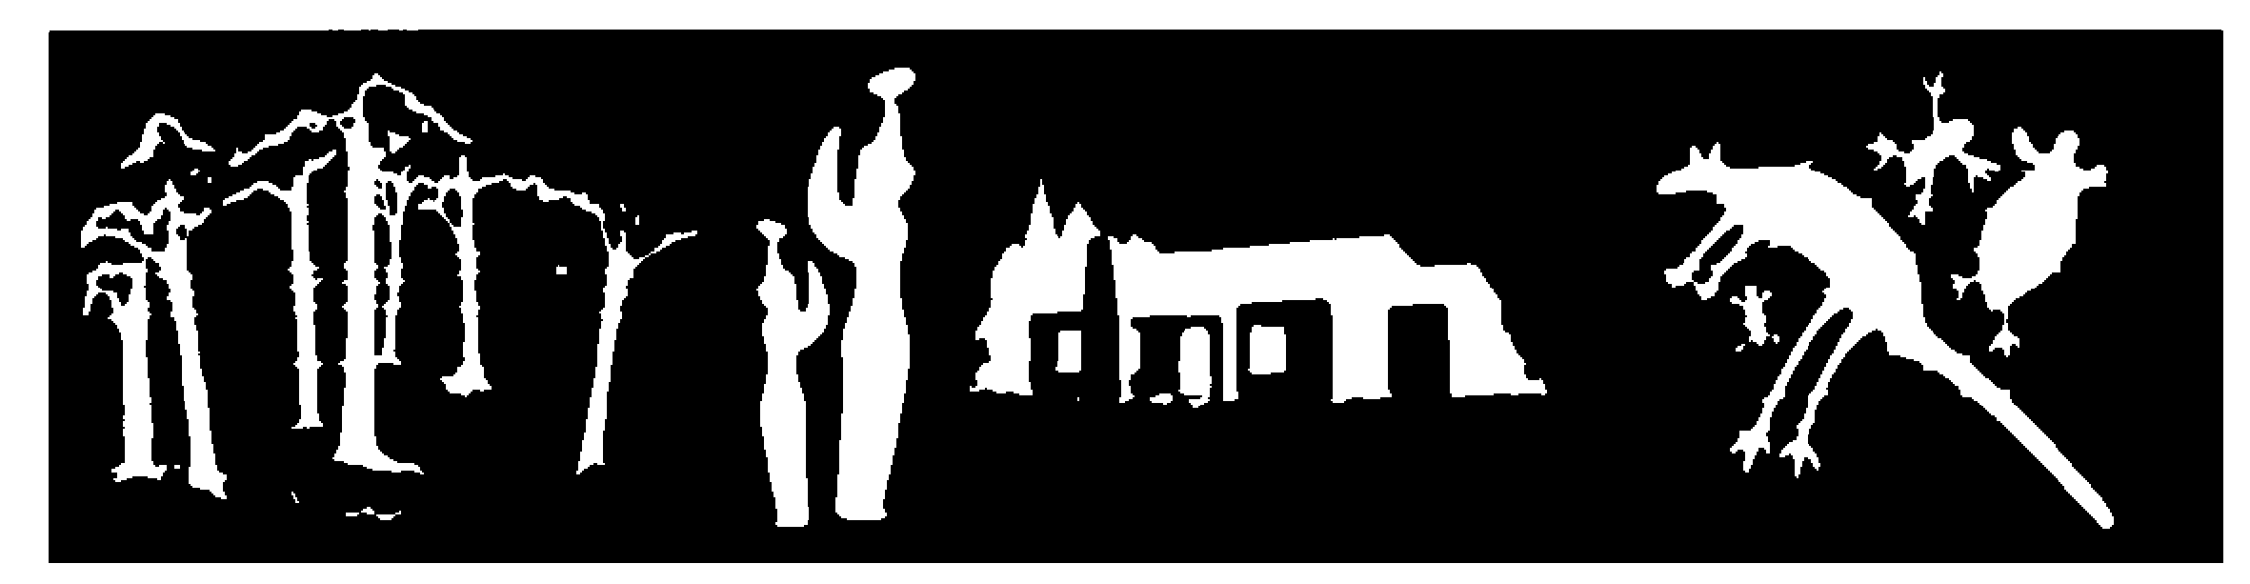
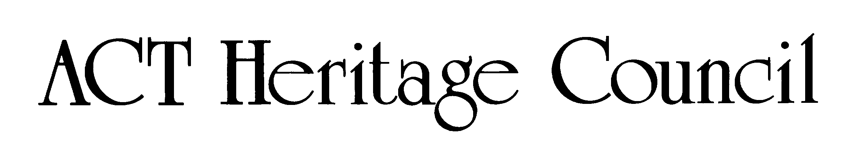

Public consultation for the provisional registration of Paterson House

Paterson House
Status: Open
Consultation period: 12 June – 9 July 2026

We are looking at
Paterson House is provisionally registered on the ACT Heritage Register as an important example of late 20th-century organic architecture in Canberra, designed and built by renowned architect Enrico Taglietti in 1968.
You can view the Paterson House provisional registration on the ACT Legislation Register.
Under the Heritage Act 2004, provisional registration is the first step by the ACT Heritage Council to decide if a place or object is important to the ACT’s heritage.
The Council want to hear what you think about its initial assessment to see if you think they got it right, or if there is other information to consider. For more information on the registration process, read the ACT Heritage Council Heritage Assessment Policy.
The Council's initial view of heritage significance is in the feedback form, but you may find the following summary helpful.
Paterson House
Paterson House at 7 Juad Place in Aranda was designed by architect Dr Enrico Taglietti AO and completed in 1968. The house demonstrates many of the principal characteristics of the late 20th-century sculptural organic style of architecture as practiced by Taglietti, characterised by an integrated relationship with its surroundings, sculptural features, and expressed building materials.
The house is embedded in the hillside and emerges from the craggy landscape as an imposing fortress-like structure with a façade made of exposed concrete brick. The house interfaces with the surrounding bushland through the careful positioning of timber framed windows and by blending in with the environment through the colour of its exposed concrete bricks and natural timber elements.
Paterson House features Taglietti’s signature prominent timber fascia, overhanging eaves, horizontal roof, wedge shaped windows, dedication to privacy through a sheltered courtyard and enclosed balcony, interlocking spatial volumes, open plan areas, as well as prominent rainwater spouts.
The house is of high integrity and has remained substantively unaltered. It was a complete commission with Taglietti also designing the interior fixtures. Taglietti considered it one of his most important residential designs in the ACT.

Timeline
11 June 2026 – place/object is provisionally registered.
12 June 2026 – public consultation starts.
9 July 2026 – public consultation ends.
10 November 2026 – provisional registration period ends.

How to provide your comments
Read the background document to understand what is being proposed. Have your say by completing the feedback form and emailing it to the Council at heritage.registrations@act.gov.au.
Download the feedback form.
You can also send us your feedback in an email.
Comments provided through the form are considered formal statutory consultation comments. The statutory consultation notice can be found on the ACT Government's Find a Public Notice site.

We will use your views to
The Council will consider all comments before making a final decision about including Paterson House on the Heritage Register. This is the opportunity for you to say if you think the Council has it right or wrong, or if there is anything else they should consider.
A common outcome of consultation is the Council confirming or rethinking what is included in their assessment, or what a final decision may look like.
This can involve changing boundaries or adding or removing features that make up the significant fabric of the place.

Contact us
If you have questions or want to learn more about a project, contact ACT Heritage via heritage.registrations@act.gov.au or 13 22 81.

