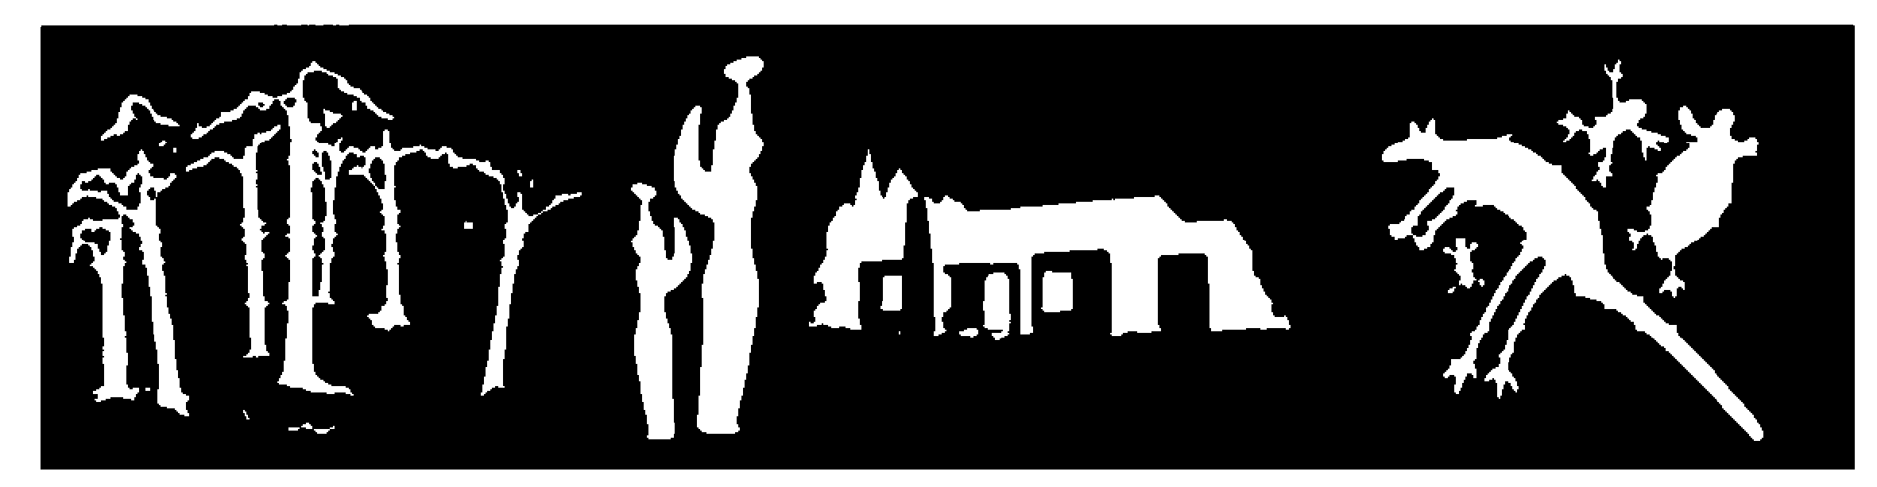
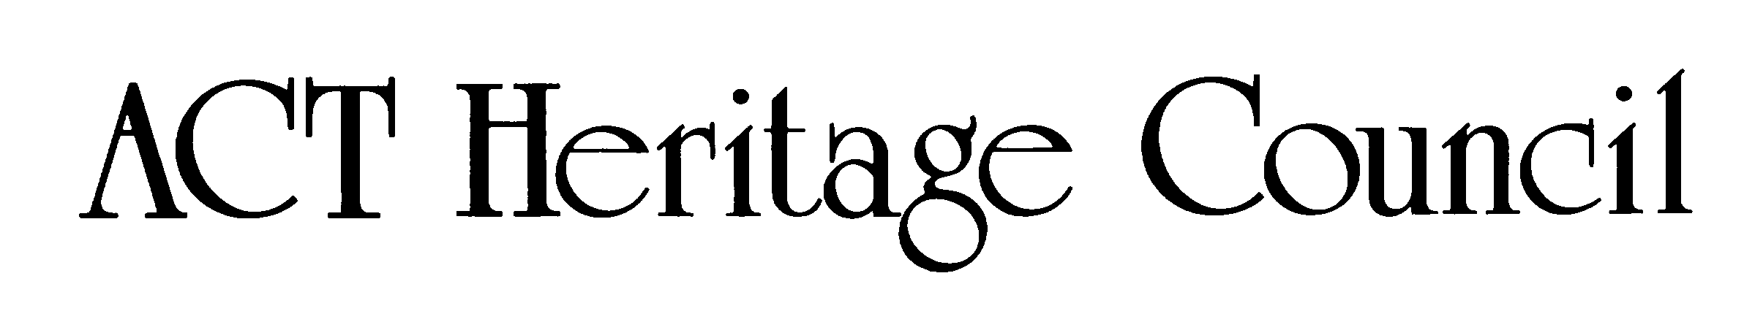

Comments on the provisional registration of Paterson House
***please note that only comments received during the public consultation period will be valid for certain provisions under section 13 and/or review under part 17 of the Heritage Act 2004. This includes comments received no earlier than 12am on 12 June 2026 and no later than 11:59pm on 09 July 2026***
Background
The Council has provisionally registered Paterson House to indicate that it intends to decide on whether to permanently include it on the ACT Heritage Register.
The provisional registration sets out Paterson House’s heritage values that the Council thinks are important to the ACT and why. This public consultation is to hear the views of the ACT community.
The provisional registration states Paterson House meets the following criteria under the Heritage Act 2004:
(d) importance in demonstrating the principal characteristics of a class of cultural or natural places or objects
Please read the provisional registration decision and the background information documents before starting.
Privacy statement
This document fulfils the role of public consultation under section 37 of the Heritage Act 2004 (the Act), and the collection of personal information as authorised by the Act.
If you make a comment, you will be considered an interested person under section 13 of the Act. For this reason, respondents are asked to provide contact details so functions under the Act relating to notification of interested persons can be fulfilled.
If you do not provide your identity or contact details the ACT Heritage Council will be unable to give you notice of decisions as an interested person. Also, you may not be able to be identified as an interested person entitled to appeal rights under the Act.
The personal information on this survey is collected by the City and Environment Directorate (CED) and provided to the ACT Heritage Council.
All personal information provided will be collected, used and stored in accordance with the Information Privacy Act 2014, CED’s Information Privacy Policy and CED’s Information Privacy Policy - Annex.
These documents contain information about how you may access or seek to correct your personal information held by CED and how you may complain about an alleged breach of the Territory Privacy Principles.

Section 1 - ACT Heritage Council considerations – place
The boundary on the map (Figure 1) and the attributes listed below identify the proposed heritage values of Paterson House.
Do you agree with the following values or do you have changes you want the Council to consider?
Exterior features that are demonstrative of organic style architecture:
  - Embedded in the hillside
  - Three rainwater spouts on the front wall
  - Steep and massive battered walls of bare concrete brick
  - Wide, overhanging eaves consisting of prominent timber fascia and timber soffits
  - Long horizontal flat roofs
  - Timber window frames, framing views
  - Deep and fully enclosed bare concrete brick terrace to the front
  - Circular walled courtyard to rear

Interior elements that are demonstrative of organic style architecture:
  - Consideration of sound and its flow through interior spaces through sound dampening materials in the ceiling
  - Open connection between spaces (living/dining/kitchen)
  - Framed view from the living area and balcony that include nearby hills and surrounding treetops
  - Expressed timber skirting throughout
  - Johnstone River wood floorboards
  - Built-in timber sideboard in dining area
  - Built-in timber cupboards throughout
  - Feature curved cantilevered timber staircase
  - Timber kitchen benchtop
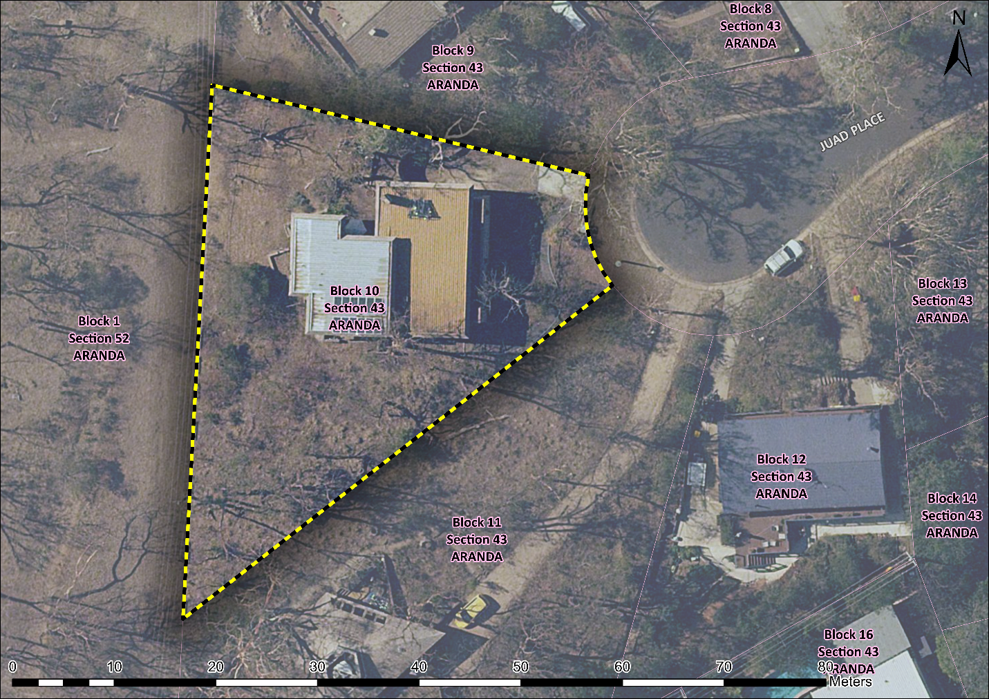
Figure 1 – Provisional registration boundary for Paterson House

Your comments on the proposed boundary and features that describe the significant attributes of the place:
Click here to enter text.

Section 2 - ACT Heritage Council considerations - significance
A place or object has heritage significance if it meets with one or more of the eight heritage significance criteria as defined under section 10 of the Heritage Act 2004.
The heritage significance criteria are labelled (a) to (h). Your comments are most useful when addressed against each of these criteria or when focusing on the ones relevant to your argument. However, you may choose to only leave a general comment by skipping to the General Comments section.
The ACT Heritage Council has determined that Paterson House is likely to have heritage significance under criterion (d). The criteria that are not met can also be commented on.
Table 1 Criteria that the Council consider have been met.
Criterion | (a) | (b) | (c) | (d) | (e) | (f) | (g) | (h)
Met | No | No | No | Yes | No | No | No | No
While the Council will independently assess and research any claims you make against the criteria, it may be helpful to refer to the Heritage Assessment Policy as a guide to providing the strongest argument with appropriate evidence.

(a) importance to the course or pattern of the ACT’s cultural or natural history
Does not meet criterion.
The Council is not satisfied on reasonable grounds that the place is likely to meet this criterion.
Built in 1968, Paterson House has a clear association with Canberra’s early development, driven by National Capital Development Commission (NCDC). The NCDC engaged modernist architects of national and international renown to design buildings throughout the capital. A thematic heritage study of modernist houses in the ACT details the role of the NCDC in shaping Canberra’s urban landscape. Taglietti was part of a larger cohort of architects drawn to the capital by the possibilities of this era of planning and development.
Paterson House reflects the shift at the time from government designed and built housing driven by the NCDC to private development where the individual owner commissioned an architect. The house is one of several modernist buildings connected with leading Australian scientists of the mid-century and reflects the growth and cultural importance of Australian science as well as modernist architecture in the 1960s and 1970s.
Although Paterson House has a clear association with this shift in Canberra’s early development, and this association is evident in the physical fabric of the place, many other buildings in Canberra exhibit this link. Canberra is home to many privately commissioned mid-century modernist residential buildings designed by well-known architects. Indeed, Canberra is home to a disproportionate stock of modernist housing when compared to other Australian capital cities. Prior to designing Paterson House, Taglietti had already completed the Gibson House in Red Hill (1965), the McKeown House in Watson (1965), Souillac House in Griffith (1967), and the Dingle House in Hughes (1968).
The Council believes that Paterson House provides evidence of a historical quality that is relatively common in the ACT. Paterson House does not meet the threshold indicator of exceptionality and rarity in this regard.

Your comments on criterion (a):
Click here to enter text.

(b) has uncommon, rare or endangered aspects of the ACT’s cultural or natural history

Does not meet criterion.

The Council is not satisfied on reasonable grounds that the place is likely to meet this criterion.
While Paterson House features unique design elements of Taglietti, it is not sufficiently uncommon as a mid-century modernist house.
Canberra is home to a disproportionate number of modernist residential housing when compared to other Australian capital cities. At a residential scale, Enrico Taglietti had already completed the Gibson House in Red Hill (1965), the McKeown House in Watson (1965), Souillac House in Griffith (1967), and the Dingle House in Hughes (1968) when he was commissioned by the Patersons in 1967.

The table below provides more detail on other Taglietti-designed residential houses in the ACT and their registration as well as nomination status:
Year | Dwelling | Heritage Listed? | Nominated?
1965 | Gibson House | No | No
1965 | McKeown House | Yes - 2026 | No
1967 | Souillac House | No | No
1968 | Dingle House | Yes - 2008 | No
1968 | Paterson House | No | Yes - 2011
1970 | Glenlyle Killen House | No | No
1971 | Evans House | No | Yes - 2011
1973 | Wood House | No | Yes - 2011
1975 | Green House | No | No
1977 | Gentle House | No | No
1983 | Mijuscovic House | No | Yes - 2022
1997 | Lo Hu Min House addition (Canberra) | No | No
2001 | House at Flinders Way | No | No
The table below compares the features of Paterson House to the significant features of McKeown House and Dingle House (the 2 residential houses by Taglietti on the ACT Heritage register):
Dwelling | Common features | Unique features
McKeown House | - Minimum pitch / flat roof  - Deep, horizontal timber fascia  - Concrete gutter (large)  - White-painted, rendered brick walls  - Built-in timber cabinetry  - Open plan design  - Tapered garden walls  - Copper box lights  - Johnstone River wood parquetry  - Expressed timber beams and rafters in the ceiling  - Geometric highlight windows with timber frames  - Tapered garden walls  - Rendered brick | - Concrete pond water feature in the front garden  - Oil tank above the pond in the front garden  - Large projecting external timber beams  - An addition, also designed by Taglietti, built 30 years later that contrasts & complements the main house, showing how Taglietti’s design evolved to suit the ACT climate  - Connecting cabinet between kitchen pantry and exterior  - Timber enclosed balcony (part of the addition)
Dingle House | - Horizontal roof  - Asymmetrical massing  - Courtyard walls  - Exposed timber roof beams  - Timber fascia  - Highlight windows  - Open plan design  - Copper box lights  - Rendered brick | - An open veranda with timber and steel balustrade
Paterson House | - Wide, overhanding eaves consisting of prominent timber fascias  - Long, horizontal flat roof  - Prominent rainwater spouts  - Exposed timber beams  - Timber window frames  - Open floor design (living/dining/kitchen)  - Johnstone River parquetry  - Built-in timber fixtures | - Embedded within uniquely steep site  - Prominent ‘fortress’-like appearance  - Deep and fully enclosed brick front terrace  - Feature curved cantilevered staircase  - Taglietti’s first open-plan kitchen  - Consideration of sound through sound dampening materials  - Circular walled courtyard to rear  - Exposed brick
While Paterson House features unique design elements by Taglietti not present in his other designs that are recognised on the ACT Heritage Register, it does not meet the threshold indicator of rarity. There are many other mid-century modern houses and many other Taglietti-designed places in the ACT.

Your comments on criterion (b):
Click here to enter text.

(c) potential to yield important information that will contribute to an understanding of the ACT’s cultural or natural history
Does not meet criterion.
The Council is not satisfied on reasonable grounds that the place is likely to meet this criterion.
Due to its prominence in Australian architectural circles and a broader examination of Taglietti’s contribution to the built environment of Canberra, Paterson House has been well documented and studied. Several architectural publications, including popular news articles as well as architectural journal articles and books, examine the house. Many of these publications are cited in the background research document for this assessment.
The Council believes that Paterson House provides a further example of a type which is already well studied and documented. It is unlikely to provide any further, better understanding of mid-century Modernism and organic style architecture beyond what it already has.

Your comments on criterion (c):
Click here to enter text.

(d) importance in demonstrating the principal characteristics of a class of cultural or natural places or objects
MEETS CRITERION.
The Council is satisfied on reasonable grounds that the place is likely to meet this criterion.
Paterson House demonstrates the principal characteristics of mid-century Modernism (i.e. focus on functionality, use of materials like concrete and glass, and rejection of traditional ornamentation in favour of clean lines) and sculptural organic style architecture (i.e. integration with nature, use of natural materials, flow and continuity between spaces, geometric forms, sculptural features).
Modernism is expressed at Paterson House through big glass windows and the characteristically horizontal roof of the house. Exposed concrete features prominently on the exterior of the house. Modernism is also expressed through the overall functional layout and design of the house, especially the open plan kitchen, dining and living areas. The simplicity and modern look of the Taglietti-designed fixtures are another aspect of this design.
Sculptural organic style architecture is expressed at Paterson House through the way it is built into the steep site and emerges from it as an imposing fortress.
Further examples are the 3 highly visible rainwater spouts and large geometric windows that are carefully placed to provide intentionally framed views of the surrounding environment. The natural tones of the exposed concrete bricks and the external timber elements interface with the surrounding bushland environment. The courtyard and enclosed balcony create links between the interior and exterior.
Organic style architecture is also expressed through the extensive use of timber. The house has wide, overhanging eaves consisting of prominent timber fascias and timber soffits. On the inside timber is visible through exposed timber beams and Taglietti-designed timber fixtures. These include the sideboard in the dining room, timber cupboards throughout, timber kitchen bench tops, timber parquetry, and a curved cantilevered timber staircase.
Paterson House is one of four houses Taglietti considered to be of notable importance in his Canberra work (the others being McKeown House, Dingle House, and Mijuscovic House).
Paterson House meets the threshold indicator of distinctiveness, intactness/integrity, and representativeness.

Your comments on criterion (d):
Click here to enter text.

(e) importance in exhibiting particular aesthetic characteristics valued by the ACT community or a cultural group in the ACT
Does not meet criterion.
The Council is not satisfied on reasonable grounds that the place is likely to meet this criterion.
While Paterson House exhibits the aesthetic characteristics of organic style architecture, it is doubtful that these characteristics are valued by the ACT community, let alone a particular cultural group.
The threshold indicator of ‘valued by the ACT community’ must be objectively tested and/or clearly demonstrated. While Paterson House is clearly valued among architects and those passionate about architecture and ACT heritage, this does not qualify as the broader ACT community nor a cultural group. Simply being the work of a highly regarded architect is not sufficient to meet the assessment threshold of wider recognition in the broader ACT community.
While the work of Taglietti is becoming increasingly popular in the ACT, Paterson House has not been shown to be valued by the ACT community for exhibiting particular aesthetic characteristics.

Your comments on criterion (e):
Click here to enter text.

(f) importance in demonstrating a high degree of creative or technical achievement for a particular period
Does not meet criterion.
The Council is not satisfied on reasonable grounds that the place is likely to meet this criterion.
While Paterson House exhibits a high degree of creative achievement in the context of residential architectural design, this achievement is not sufficiently beyond the ordinary within the context of the ACT. Due to the substantial development that took place after the NCDC was established, Canberra is home to many mid-century modernist buildings, including residential buildings.

Your comments on criterion (f):
Click here to enter text.

(g) has a strong or special association with the ACT community, or a cultural group in the ACT for social, cultural or spiritual reasons
Does not meet criterion.
The Council is not satisfied on reasonable grounds that the place is likely to meet this criterion.
There is insufficient evidence to demonstrate that Paterson House has strong or special associations with the ACT community, or a cultural group in the ACT for social, cultural or spiritual reasons. As a private residence, it is not expected to have a broad appeal to the community, and it has not been associated with a cultural group within the ACT.
Professional groups and special interest groups do not qualify as ‘the ACT community’ nor ‘a cultural group’. Community or cultural group concern for Paterson House is not clearly demonstrated.

Your comments on criterion (g):
Click here to enter text.

(h) has a special association with the life or work of a person, or people, important to the history of the ACT
Does not meet criterion.
The Council is not satisfied on reasonable grounds that the place is likely to meet this criterion.
While Paterson House has a clear association with the work of architect Dr Enrico Taglietti AO, there is insufficient evidence to suggest that it has a special association when compared to his other works.
Although Paterson House was a complete commission from start to finish, with Taglietti designing the fixtures, by the time Taglietti designed it in 1965 he had already been commissioned for a range of residential and commercial buildings.
Prior to designing Paterson House, Taglietti had already completed the Gibson House in Red Hill (1965), the McKeown House in Watson (1965), Souillac House Griffith (1967), and the Dingle House in Hughes (1968).
He had also already been commissioned to design the Town House Motel in Canberra (1961), Noah’s restaurant (1961), and the Cinema Centre (1964). The commercial venues arguably created significantly more visibility and occupied a more prominent role in his career as an architect than Paterson House.
Although the association of Paterson House with Taglietti is a close one, it is not an exceptional one. Paterson House does not meet the threshold indicator of exceptionality.

Your comments on criterion (h):
Click here to enter text.

Section 3 – General comments
Enter here any information or make a general comment about the proposed provisional registration that does not address any of the criteria. Remember that the outcome of the heritage assessment is directly linked to the criteria and submissions are more likely to affect the outcome if they specifically address the criteria and the Council’s proposed assessment against them.
I support the proposed heritage registration? Choose an item.
Please include any further comments to your submission:
Click here to enter text.

Section 4 - Demographics
Your personal details are confidential and will not be publicly visible, but this is required for you to be kept informed and to be counted as an ‘interested person’ (refer to the Privacy Statement at the beginning of the document).
If you do not provide your identity or contact details, then the ACT Heritage Council will be unable to give you notice of decisions as an interested person under the Act. Also, you may not be able to be identified as an interested person entitled to appeal rights under the Heritage Act 2004.
First Name: Click here to enter given name.
Last Name: Click here to enter surname.
Preferred contact details (phone, email, postal address):
Click here to enter address.
Age range: Click to choose an age range.
Relationship to the place: Click to choose a category.
Have you ever provided comments on other heritage registrations? Click to select.

What next?
After you have saved this form, it can be emailed to heritage.registrations@act.gov.au or printed and mailed to:
The Secretary
ACT Heritage Council
GPO Box 158
Canberra City ACT 2601

GML Heritage. 2024. Modernist Houses in the Australian Capital Territory: Thematic Heritage Study. Canberra. pp. 28ff. Retrieved from https://gml.com.au/projects/thematic-heritage-study-act-modernist-houses/
Ibid.
Drawn from: Charlton, Favaro, & Jones. 2007. The Contribution of Enrico Taglietti to Canberra’s Architecture. Royal Australian Institute of Architects (RAIA), ACT Chapter. Canberra. pp. 122-126.
No longer existent

