­­



**TRAINING  
INITIATIVE  
FUNDING  
AGREEMENT**

APPLICATION GUIDELINES



June 2023 | Version 2.0

**Skills Canberra**

Chief Minister, Treasury and Economic Development Directorate

220 London Circuit, Canberra ACT 2601

Phone: 02 6205 8555

Fax: 02 6205 8448

Email: [skills@act.gov.au](mailto:skills@act.gov.au)

Web: <https://www.act.gov.au/skills>

# VERSION CONTROL

|  |  |  |  |
| --- | --- | --- | --- |
| Version | Effective date | Status | Details |
| 2.0 | 3 July 2023 | New Release | N/A |

It is the responsibility of the user to ensure that this is the current and complete document.   
The latest version is located on the [Skills Canberra website](https://www.act.gov.au/skills/publications).

# GLOSSARY OF TERMS

|  |  |
| --- | --- |
| ACT | Australian Capital Territory |
| ACT Standards | ACT Standards for Delivery of Subsidised Training, schedule to the Agreement |
| Agreement | Training Initiative Funding Agreement |
| Associate | has the meaning referred to in the Agreement |
| ASQA | Australian Skills Quality Authority |
| AVETMISS | Australian Vocational Education and Training Management Information Statistical Standard |
| Compliance Guides | the Guides which set ACT requirements for compliance with the ACT Standards for each Training Initiative. |
| Disallowed Persons | has the meaning referred to in the Agreement |
| RTO | registered training organisation |
| Skills Canberra | Skills Canberra branch of the Chief Minister, Treasury and Economic Development Directorate |
| Subsidised Training | has the meaning referred to in the Agreement |
| Training Initiative | the Training Products funded by the ACT, and listed for delivery on the ACT Qualifications Register. Includes the Australian Apprenticeships and Skilled Capital training initiatives |
| Territory | 1. In a geographical sense, the Australian Capital Territory; and 2. In any other sense, the body politic established by section 7 of the *Australian Capital Territory (Self-Government) Act 1988* (Cth). |
| VET | vocational education and training |

# KEY DATES

|  |  |
| --- | --- |
| 3 July 2023 | Applications open. Training Initiative Funding Agreement template, Application SmartForm, Application Guidelines and Frequently Asked Questions (FAQs) available |
| 11 August 2023 | Application closing date for RTOs seeking to hold an Agreement from 1 October 2023 |
| 11 – 15 September 2023 | RTO outcome notification for applications received on or before 11 August 2023 |
| 30 September 2023 | Expiry of Training Initiative Funding Agreement (1 October 2019 – 30 September 2023) |
| 1 October 2023 | Commencement of new Training Initiative Funding Agreement |

# 1.0 About the publication

These Guidelines provide important information about how registered training organisations (RTOs) apply for a contractual agreement to deliver Subsidised Training in the ACT.

The Guidelines include:

* an overview of the Agreement
* an overview of the application process
* how applications will be assessed
* the steps following application outcome notification.

# 2.0 Introduction

The ACT Government contributes funding on behalf of the Commonwealth and the Territory towards the cost of delivering Subsidised Training for selected Training Initiatives in the ACT. Skills Canberra has responsibility for the oversight and promotion of quality VET in the ACT and administers the funding for each initiative.

The ACT Training Initiative Funding Agreement (Agreement) is the contractual arrangement between the Territory and RTOs delivering ACT Government-funded Training Initiatives.

Initiatives under the Agreement may target specific participant groups, such as equity groups, or specific skills and qualifications. Specific initiatives are identified on the [Skills Canberra website](https://www.act.gov.au/skills/home).

RTOs seeking access to ACT Government funding must hold an Agreement with the Territory. RTOs that wish to only deliver fee-for-service training for Australian Apprentices in the ACT are not required to have an Agreement but are required to complete a [RTO Nomination for ACT Fee-for-Service Delivery form](https://www.act.gov.au/skills/publications).

RTOs must hold an approved Agreement prior to delivering ACT Government Training Initiatives, including:

* Australian Apprenticeships (User Choice)
* Skilled Capital.

Holding an Agreement does not guarantee funding.



# 3.0 Eligibility

To be granted an Agreement, the RTO must satisfy the mandatory eligibility criteria and meet the minimum assessment benchmark.

3.1 Mandatory criteria

To be eligible for an Agreement, the RTO must:

* hold a current registration with the Australian Skills Quality Authority (ASQA)
* hold all insurance cover as specified in the Agreement
* be able to report training delivery information using an AVETMISS compliant student management system
* not have had an agreement with the Territory terminated within the last seven years
* agree to supply financial information to the Directorate’s nominated Independent Financial Assessor unless an exemption applies (refer 4.2 Financial Viability Assessment).

The Territory has complete discretion to reject an application for any of the following reasons:

* the applicant is a Disallowed Person
* the applicant is in default of any previous agreement with the Territory
* the applicant has any outstanding debt payable to the Territory under a previous agreement
* any other matter, if at the commencement of the Agreement, the applicant is unable to comply with any aspect of the Agreement.

In determining eligibility, the Directorate also seeks to identify whether the applicant has any dealings with Disallowed Persons. The Eligibility section of the application includes questions about any persons or entities (Associates) associated with the applicant that has:

* had its agreement in the ACT or any other Australian jurisdiction terminated, suspended and/or conditions placed upon its access to entitlements under the agreement
* had its RTO registration refused, revoked, cancelled, suspended and/or conditions imposed on its registration by ASQA, or
* has been responsible for any of the aforementioned matters.

Where an applicant indicates ‘yes’ to any of these questions it is possible that the Associate may be classified as a Disallowed Person. The applicant must contact the Directorate to discuss the matter and record the outcome of the discussion in the application details field.

The Directorate reserves the right to consider the matters discussed with the applicant and any additional information available to it in making determinations, at its discretion, on an RTO’s initial or continuing eligibility for an Agreement.

The phrase ‘otherwise dealt with’ in the context of the Eligibility section refers to dealings with a person or entity relating to any aspect of the administration and/or operations of an RTO.

An application will not be able to be submitted where the applicant does not satisfy all the eligibility criteria.

3.2 Weighted indicator assessment

Applications that satisfy the eligibility criteria and RTO obligations will proceed to assessment against a series of quality and performance indicators. Refer to section 4.3 for further information.

# 4.0 Application Overview

Figure 1 illustrates the steps involved in the application process.

###### Figure 1

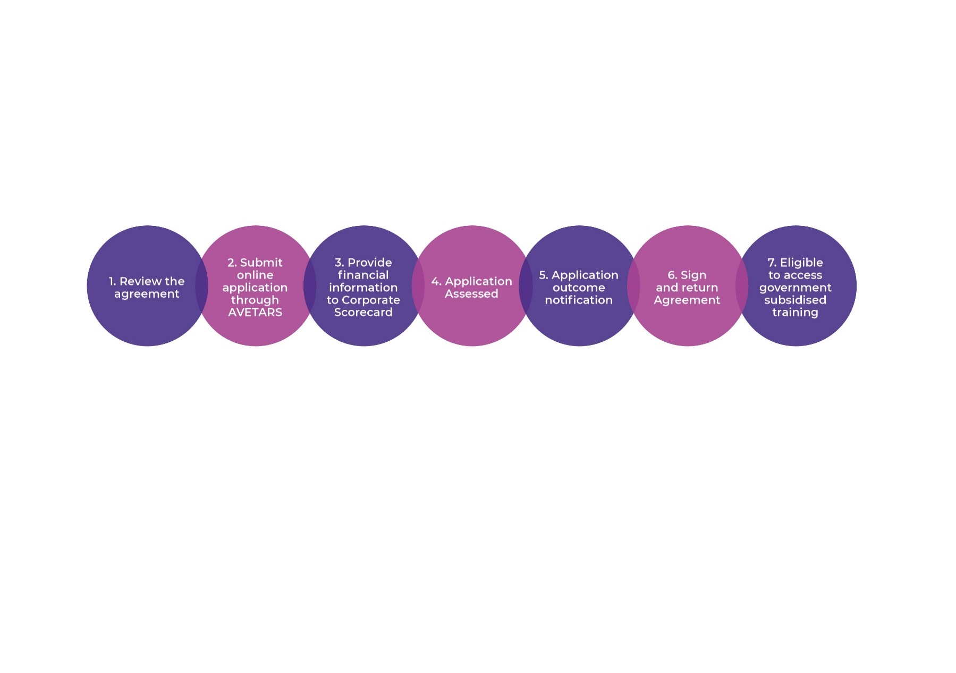

4.1 Online application SmartForm

To apply for an Agreement, RTOs must complete and submit an application through the [ACT Vocational Education and Training Administration Records System](https://avetars.act.gov.au/) (AVETARS). AVETARS is the online system used by the Directorate to manage vocational education and training initiatives in the ACT. The online application SmartForm will collect information in the following categories:

* RTO details
* Past performance
* Enrolment history
* RTO leadership
* Engagement
* Financial health
* Legal information
* Meeting the needs of learners
* Program quality

The online application SmartForm can be accessed on AVETARS using the following link: <https://avetars.act.gov.au/forms/training_initiative_funding_agreement_application/responses>

An application must:

* be submitted using the online application SmartForm
* include the appropriate information in every mandatory field of the online application SmartForm
* include the declaration made by the most senior executive of the RTO.

Once the application is submitted, the RTO will receive confirmation of receipt via email.

The Directorate reserves the right to:

* refuse to consider an incomplete application
* not offer an Agreement to the RTO for an identified reason, by giving written notice
* seek the advice of persons who may include employers, students or industry members to assist in the assessment or review of any application
* seek further information from the RTO and contact other persons or organisations including those identified in the application for verification purposes
* provide information about the RTO and its application to ASQA, other relevant government agencies and third parties engaged by the Directorate.

Applying in accordance with this process does not guarantee that an Agreement will be offered, nor guarantee that funding will be available to the RTO.

4.2 Financial viability assessment

### The RTO will be required to supply financial information to an Independent Financial Assessor for a financial viability assessment, the results of which will be used to determine the RTO’s score for the financial performance indicator. Equifax Australasia Credit Ratings Pty Ltd, trading as Corporate Scorecard, is the Directorate’s nominated Independent Financial Assessor.

### The following types of RTOs are exempt from the financial viability assessment process:

* Technical and Further Education Institutes
* RTOs whose legal entity is a Government agency
* ACT Government and Independent Schools.

### Shortly after submission of the application for an Agreement, the RTO will be contacted by Corporate Scorecard and will receive an email with instructions for providing the required financial information for the assessment. The RTO will need to respond to a questionnaire and submit audited financial statements for the previous two years i.e., 2020/2021 and 2021/2022 or 2021/2022 and 2022/2023 (if available).

### RTOs that have previously undertaken a financial viability assessment using 2020/2021 and 2021/2022 financial information will not need to undertake a new assessment unless there has been in a change in control. Such RTOs will be contacted by Skills Canberra and given a choice to undertake a new assessment or use their previous assessment for their application.

### On completion of the financial viability assessment, Corporate Scorecard will provide a report to the Directorate for consideration as part of the RTO’s application assessment. For successful applicants, the financial viability assessment will remain valid for the full term of the Agreement unless there is a change in control.

### All financial information provided to Corporate Scorecard will be treated in strict confidence.

### Failure to supply the required financial information to Corporate Scorecard will result in rejection of the RTO’s application.

4.3 Application assessment

Applications will be assessed on receipt of the online application SmartForm and the financial viability assessment report from Corporate Scorecard.

The assessment process uses a two-tiered assessment methodology. In tier one, the RTO is assessed against the mandatory criteria outlined in section 3.1. In tier two, the RTO is grouped, assessed and scored against the suite of indicators below. The score received for each indicator will form an overall aggregate score. The RTO’s aggregate score must meet the minimum assessment threshold determined by the ACT Government to be granted an Agreement. Decisions of the assessment process are final, and there is no provision for review or appeal.

RTOs that apply on or before 11 August 2023 will be notified of the assessment outcome by 15 September 2023. The anticipated assessment time for applications received after 11 August 2023 is two months.

#### 4.3.1 Indicators

Applications will be assessed against a series of quality and performance indicators. Information relevant to each indicator will be collected from Directorate data sources and from information provided by the RTO through the application process. Information may also be sought from other parties where relevant. For example, information may be requested from ASQA or other State Training Authorities and/or a third party may be engaged to assess an RTO’s capacity to deliver high risk qualifications.

Indicators have been grouped into the following categories:

###### Table 1: Quality and performance indicators

|  |  |  |  |  |  |
| --- | --- | --- | --- | --- | --- |
| Indicator Category | Contractual compliance and performance | Stakeholder engagement | Trainer and staff quality | Service quality and outcomes | Financial performance |
| Approximate weighting | 25% | 15% | 20% | 35% | 5% |
| Example indicators within category | Has the RTO previously held an agreement?  Compliance with ASQA accreditation | Assessment of responses from referees  Analysis of industry engagement (by RTO grouping) | Ratio of students to teachers in the ACT  Analysis of RTO leaders’  qualifications and experience (by RTO grouping) | Analysis of the support strategies the  RTO has in place for students  Student completion rates in previously funded programs (by RTO grouping) | Analysis of the financial assessment report provided by Corporate Scorecard |

Some indicators require a written response in a free text field. Responses in these fields are assessed by Directorate personnel and a score awarded based on a set of defined parameters. Responses that comprehensively address the criteria requirements and contain specific examples are more likely to achieve a higher score.

#### 4.3.2 Benchmarks

A minimum benchmark has been determined for each indicator. Applications will be assessed against these benchmarks. Achievement of the benchmark will result in the full weighted score for that indicator. Failure to meet the benchmark will result in a zero score for that indicator. The benchmarks have been determined by the ACT Government and validated by external expert consultants, follow best practice principles, and employ statistical mean-variance techniques.

#### 4.3.3 RTO groupings

To ensure RTOs with similar characteristics are assessed fairly, each RTO will be assigned a grouping based on the RTO’s characteristics for each indicator. These characteristics may include, but are not limited to:

* Size of the RTO
* Length of registration
* Head office location
* Student cohort
* Focus of operations
* Organisation type
* Modes of delivery

RTO groupings may determine which weightings and benchmarks are applied during the application assessment.

#### 4.3.4 Weightings

Not every indicator is valued equally. Each indicator has been weighted based on its relevance to quality VET and ACT Government priorities. As illustrated in Table 1, the greater the relevance, the higher the assigned value. Performing well in highly valued indicators brings an RTO closer to the threshold score they need to attain to be approved for an Agreement. Weightings have been determined by the ACT Government and validated by external expert consultants.

###### Table 2 – Weighted indicators\*

|  |  |  |
| --- | --- | --- |
| Indicator | Weighting | Assigned Value |
| 1 | High | 50% |
| 2 | Medium | 30% |
| 3 | Low | 20% |

*\*For illustrative purposes only*

#### 4.3.5 Scoring

The weighted score from each indicator where the benchmark is achieved will be combined to form an aggregate score for the RTO. As illustrated in Table 2, the RTO’s final score will be determined by the number of indicators where the benchmark is achieved and the relative weightings of those indicators.

###### Table 3 – Scoring example\*

|  |  |  |  |  |
| --- | --- | --- | --- | --- |
|  | Indicator 1  (50%) | Indicator 2  (30%) | Indicator 3  (20%) | Score |
| RTO 1 | ✓ | ✓ | ✓ | 100% |
| RTO 2 | ✓ | ✗ | ✗ | 50% |
| RTO 3 | ✗ | ✓ | ✓ | 50% |
| RTO 4 | ✗ | ✓ | ✗ | 30% |

*\* For illustrative purposes only*

Failure to meet the minimum assessment threshold will result in an unsuccessful application outcome.

4.4 Application outcome notification

Following application assessment, RTOs will be notified of the application outcome. The types of outcomes are:

#### 4.4.1 Successful RTOs

Successful RTOs will receive a letter of determination advising the successful application outcome. The RTO must then complete a series of steps to ensure final approval for an Agreement, detailed below.

###### Figure 2

Steps following successful notification:

|  |  |
| --- | --- |
| 1. RTO acceptance | * Accept the terms of the Agreement * Print the Agreement * Sign the Agreement (last page) * Scan and email the entire signed Agreement to the Directorate (via [skills@act.gov.au](mailto:skills@act.gov.au)). |
| 2. ACT government supplier registration   (for new suppliers or to update existing supplier information) | * RTO to complete and submit the online Supplier Registration SmartForm (the SmartForm hyperlink will be provided with the letter of determination) * Directorate will verify the RTO status as an approved ACT Government supplier |
| 3. Final approval | * Directorate will sign the Agreement on behalf of the Territory * Directorate will scan and email final signed version to the RTO |

#### 4.4.2 Unsuccessful RTOs

Unsuccessful RTOs will receive a letter of determination detailing the unsuccessful application outcome.

Unsuccessful applicants may request verbal feedback from the Directorate. Requests for feedback must be submitted in writing (via [skills@act.gov.au](mailto:skills@act.gov.au)). The Directorate will not enter into justification for the selection of successful RTOs and will not debate the assessment process.

Unsuccessful RTOs will be eligible to reapply six months following the date of the notice of unsuccessful outcome.



4.5 Commence enrolment in ACT

Once the RTO has been approved for an Agreement, it is eligible to access Subsidised Training in the ACT.   
A summary of each initiative is shown below.

###### Table 4 – Overview of funding initiatives

|  |  |  |
| --- | --- | --- |
| Initiative | Overview | Initiative requirements |
| Australian Apprenticeships | Australian Apprenticeships (User Choice) is a national funding policy for Australian Apprenticeships promoting choice in training services provided to employers and Australian Apprentices.  A key feature of Australian Apprenticeships is more flexibility for the users (employers and Australian Apprentices) of the training system. User Choice is a model for achieving client responsive training which means that businesses and Australian Apprentices can select their own registered training organisation (RTO) and negotiate how, where and when the training and assessment is to occur. | [ACT Quality Framework – ACT Standards Compliance Guide for Australian Apprenticeships](https://www.act.gov.au/skills/publications) |
| Skilled Capital | The Skilled Capital initiative aims to improve access to high quality training in areas of skills need and maximise improved employment outcomes for students. The initiative also provides a comprehensive range of support services to ensure students accessing training receive the help they need to successfully complete their chosen training program. | [ACT Quality Framework – ACT Standards Compliance Guide for Skilled Capital](https://www.act.gov.au/skills/publications) |

# 5.0 Correction and update of application

If at any time prior to receiving the assessment outcome notification, the RTO becomes aware that the Application SmartForm it has submitted:

* contains errors or omissions, and/or
* circumstances have changed such that the application is no longer correct,

the most senior executive of the RTO must immediately advise the Directorate in writing (via [skills@act.gov.au](mailto:skills@act.gov.au)) providing details of the errors/changes and/or omissions. The information provided by the RTO will be considered and the RTO will be informed as to whether it will be required to submit a new application.





ACTGov_inline_black.wmf

Skills Canberra

Chief Minister, Treasury and Economic Development Directorate