
Digital Canberra acknowledges the Ngunnawal people as traditional custodians of the ACT and recognise any other people or families with connection to the lands of the ACT and region.
We respect the Aboriginal and Torres Strait Islander people, particularly our Aboriginal and Torres Strait Islander staff and their continuing culture and contribution they make to the Canberra region and the life of our city.

Contact for this report
General enquiries about this report should be directed to:
Digital Canberra Governance, Assurance and Risk
Phone: (02) 6207 8462
DCBR.Reporting@act.gov.au

Freedom of Information
Freedom of Information requests can be made through the ACT Government online form Freedom of Information (FOI) request or by emailing DigitalCanberraFOI@act.gov.au.

Accessibility
The ACT Government is committed to making its information, services, events and venues as accessible as possible. If you have difficulty reading a standard printed document and would like to understand the alternative formats available for documents or publications, please call 13 22 81.
If English is not your first language and if you require a translator or interpreter, please contact us through the Translating and Interpreting Service (TIS) or call 13 14 50.
If you have difficulty hearing or using your voice, please contact us through the National Relay Service (NRS):
- Teletypewriter (TTY) users please dial 13 36 77 and when prompted type 13 22 81 then GA (go ahead) or visit www.accesshub.gov.au to make an internet relay or captioned relay call.
- Speak and Listen users please dial 13 36 77 and when prompted ask for 13 22 81 and then say “go ahead”.
- Internet relay users please connect to the NRS and then ask for 13 22 81.
For more information on these services visit www.accesshub.gov.au
ISBN: 978-0-642-61156-7
© Australian Capital Territory


This work, the Digital Canberra Annual Report 2025–26, is licensed under a Creative Commons Attribution 4.0 licence. You are free to re-use the work under that licence, on the condition that you credit the Australian Capital Territory Government as author, indicate if changes were made and comply with the other licence terms.
The licence does not apply to the ACT Coat of Arms, the Digital Canberra logo and branding, images, artwork, photographs and any material protected by trademark.
Photo credits: ReeldealHD images/stock.adobe.com, Pedro Merino/Stocksy/stock.adobe.com, peopleimages.com/stock.adobe.com.
Information about the directorate and an electronic version of this annual report can be found on the website: https://www.act.gov.au/open/digital-canberra-annual-reports.

Contents
Foreword 7
PART A: Transmittal Certificate and Compliance Statement 9
Abbreviations and acronyms 10
Glossary 12
Transmittal Certificate 13
Compliance Statement 14
PART B: Organisational overview and performance 16
Organisational overview 17
Our purpose 17
Vision, mission and values 19
Clients and stakeholders 22
A journey of transformation 23
Organisation chart 24
Internal accountability 25
Remuneration 28
Governance committees 28
Projects and programs 30
Performance summary 32
Future priorities 41
Living our vision and mission in 2026–27 43
Performance analysis 45
Output Classes and Accountability Indicators 45
Scrutiny 48
Risk management 52
Internal audit 55
Fraud prevention 57
Freedom of Information 60
Community engagement and support 63
Community engagement – stakeholder and business engagement/consultation 63
Aboriginal and Torres Strait Islander reporting 64
Progress in Implementing the National Agreement on Closing the Gap 64
Priority reforms 64
Responses to review and accountability processes 65
ACT Aboriginal and Torres Strait Islander Agreement commitments 65
Progress on existing programs, projects and initiatives 66
New programs, projects and initiatives 66
Disability Inclusion Act 2024 reporting 70
Multiculturalism Act 2023 reporting 71
Period Products and Facilities (Access) Act 2023 reporting 72
Work health and safety 73
WHS consultation arrangements 73
Top three WHS risks 75
Reported incidents 75
Enforcement measures 75
Injury prevention 76
Mental health and wellbeing support 77
WHS and wellbeing future focus 79
Human resources management 80
Culture, attraction and retention 80
Workforce planning and employment strategies 81
Capability 82
Learning and development programs and activities 82
Staffing profile 84
Ecological sustainability reporting 89
Support to the Commissioner for Sustainability and Environment 89
Business area activities 89
PART C: Financial management reporting 93
Management discussion and analysis 94
General overview 94
Financial performance 95
Financial position 99
Outlook 99
Financial Statements 100
Capital works 150
Capital works 2025–26 150
Reconciliation schedules 152
Asset management 153
Assets managed 153
Asset maintenance and upgrades 154
Government contracting 155
Statement of Performance 158

Foreword
 | I am pleased to present Digital Canberra’s 2025–26 Annual Report.  This year marked the establishment of Digital Canberra, bringing together the ACT Government’s digital, technology, data and cyber security capabilities into a single directorate. While this was an important organisational milestone, our purpose is much broader than technology. We exist to help make government services easier to access, easier to use and easier to trust.

Digital Canberra was created to strengthen whole-of-government leadership, enable directorates to deliver better services and ensure digital, technology, data and artificial intelligence (AI) investments deliver meaningful outcomes for the community. Every investment, platform and capability should contribute to better services, stronger government capability and greater public value.
Throughout our first year, we focused on building the foundations of the ACT Government’s newest directorate while continuing to deliver and support critical services across government. We worked closely with directorates, agencies and partners to strengthen cyber security, improve digital capability, advance digital health transformation, enhance service delivery and support the implementation of the ACT Digital Strategy and ACT Digital Health Strategy.
Together with our partners, we supported major Territory projects including the Canberra Hospital Expansion Critical Services Building, the North Canberra Hospital transition, the Canberra Theatre redevelopment and the Yurauna building at the Canberra Institute of Technology (CIT). We also delivered the Payroll Capability and Human Resource Management Program, modernising core workforce and payroll systems to support a more contemporary and sustainable ACTPS.
We continued to strengthen the Territory’s cyber resilience through the whole-of-government Cyber Uplift Program and progressed key digital health initiatives, including the expansion of the Digital Health Record and the introduction of DHR Link, improving information sharing between public health services and primary care providers. We also commenced a pilot of ambient AI technology to explore new ways of improving clinician experience and patient care.
This includes our commitment to supporting the ACT Government's Closing the Gap priorities. By embedding cultural inclusion into our approach to digital transformation and service design, and by working in partnership across government and the community, we aim to help reduce inequity, expand access to opportunities and services, and deliver better outcomes for Aboriginal and Torres Strait Islander peoples.

These achievements demonstrate the dedication of our people and the value of collaboration across government. They also reinforce a principle that sits at the heart of Digital Canberra: digital, technology, data and AI are enablers, not the outcome. Their value is realised when they simplify services, strengthen trust and improve the lives of Canberrans.
As we continue our transformation journey, we remain focused on building a connected, innovative, inclusive and digitally enabled ACT Government. We will continue working with our partners across government, industry, academia and the community to deliver trusted, secure and inclusive services designed around people's needs and to create a future where government is simpler, more connected and easier to deal with.
I thank the people of Digital Canberra and our partners across the ACTPS for their professionalism, commitment and contribution throughout this foundational year.
Dr Christina Igasto
Director-General, Digital Canberra



Part A

Transmittal Certificate and Compliance Statement

Abbreviations and acronyms
Abbreviations | Acronyms
3LM | Three Line Model
ACAT | ACT Civil and Administrative Tribunal
ACCOs | Aboriginal Community Controlled Organisations
ACTIA | ACT Insurance Authority
ACTIC | ACT Integrity Commission
ACTPS | ACT Public Service
AI | Artificial Intelligence
ANU | Australian National University
ARC | Audit and Risk Committee
ARIn | Attraction and Retention Incentive
ARMI | Assurance Risk Management and Integrity
ATSIEB | Aboriginal and Torres Strait Islander Elected Body
BMS | Building Management System
BUCOs | Business Unit Contact Officers
CED  CHS | City and Environment Directorate  Canberra Health Services
CIO | Chief Information Officer
CIT | Canberra Institute of Technology
CMTEDD | Chief Minister, Treasury and Economic Development Directorate
DCBR | Digital Canberra
DDTS | Digital, Data and Technology Solutions
DHR | Digital Health Record
DPRAC | Digital Policy Risk and Assurance Committee
DSD | Digital Solutions Division
EAP | Employee Assistance Program
EDRMS | Electronic Document and Records Management System
FBT | Fringe Benefits Tax
FOI | Freedom of Information
FTE | Full-time Equivalent
GP | General Practice
HCSD | Health and Community Services Directorate
HEV | Hybrid Electric Vehicle
HR | Human Resources
HSR | Health and Safety Representative
ICE | Internal Combustion Engine
ICT | Information and Communication Technology
ICU | Intensive Care Unit
IDS/G | Indigenous Data Sovereignty and Governance
MaaS | Mobility as a Service
MLA | Member of the Legislative Assembly
MoG | Machinery of Government
NCH | North Canberra Hospital
NRS | National Relay Service
PACT | Procurement ACT
PC-HRM | Payroll Capability and Human Resource Management
PHEV | Plug-in Hybrid Electric Vehicle
RED | Respect, Equity and Diversity
SAMP | Strategic Asset Management Program
SEM | Senior Executive Management
SERBIR | Senior Executive Responsible for Business Integrity and Risk
WHS | Work Health and Safety
WhoG | Whole-of-government

Glossary

Aboriginal and Torres Strait Islander Procurement Policy
The policy supports cultural change within the Territory to reduce some of the barriers to government procurement encountered by Aboriginal and Torres Strait Islander enterprises. Each Territory Entity is required to identify and act on opportunities for Aboriginal and Torres Strait Islander enterprises in its procurement activities. The policy encourages Territory officers to seek quotes from relevant Aboriginal and Torres Strait Islander Enterprises wherever possible, driving growth in economic participation for Aboriginal and Torres Strait Islander enterprises through an increase to the Government’s spend with Aboriginal and Torres Strait Islander enterprises.

ACT Remuneration Tribunal
Under the Remuneration Tribunal Act 1995 the ACT Remuneration Tribunal must inquire into and determine the remuneration, allowances and other entitlements to be granted to particular public offices every year.

One government
The ACTPS approach to priority setting, policy development and implementation, program and service delivery and communications and engagement, through a culture and way of working that enhances coordination, cohesion and alignment of effort to better serve the ACT Government and Canberra citizens.

Whole-of-government
Refers to matters, issues or arrangements affecting or applicable to the whole of the ACTPS.

Tell us once
Refers to our commitment to improve community-facing services, making it easier for individuals and businesses to access government services while reducing administrative burden and enabling more seamless interactions with government, advancing trusted digital identity through consent-based data sharing.

Transmittal Certificate

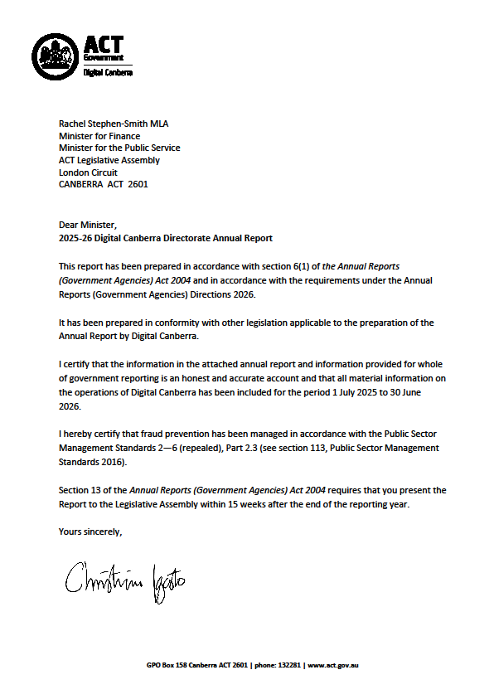

Compliance Statement
The Digital Canberra Annual Report 2025–26 must comply with the Annual Report Directions (the Directions) made under section 8 of the Annual Reports (Government Agencies) Act 2004. The Directions are found at the ACT Legislation Register: www.legislation.act.gov.au.
This Compliance Statement indicates the subsections, under Parts 1 to 5 of the Directions, that are applicable to Digital Canberra and the location of information that satisfies these requirements:

Part 1: Directions Overview
The requirements under Part 1 of the Directions relate to the purpose, timing and distribution and records keeping of annual reports. The Digital Canberra Annual Report 2025–26 complies with all subsections of Part 1 under the Directions.
To meet Section 15 Feedback, Part 1 of the Directions, contact details for Digital Canberra are provided within the Digital Canberra Annual Report 2025–26 to provide readers with the opportunity to provide feedback.

Part 2: Reporting Entity Annual Report Requirements
The requirements within Part 2 of the Directions are mandatory for all reporting entities and Digital Canberra complies with all subsections. The information that satisfies the requirements of Part 2 is found in the Digital Canberra Annual Report 2025–26 as follows:
- Transmittal Certificate, see page 13.
- Organisational Overview and Performance, inclusive of all subsections, see page 17.
- Financial Management Reporting, inclusive of all subsections, see page 93.

Part 3: Reporting by Exception
The Digital Canberra Annual Report 2025–26 has nil information to report by exception under Part 3 of the Directions for the 2025–26 reporting year.

Part 4: Directorate and Public Sector Body Specific Annual Report Requirements
The Digital Canberra Annual Report 2025–26 has nil information to report in relation to Directorate and Public Sector Body specific annual report requirements.

Part 5: Whole-of-government Annual Reporting
All subsections of Part 5 of the Directions apply to Digital Canberra. Consistent with the Directions, the information satisfying these requirements is reported in the one place for all ACTPS directorates, as follows:
- Bushfire Risk Management – see the annual report of the Justice and Community Safety Directorate
- Human Rights – see the annual report of the Justice and Community Safety Directorate
- Legal Services Directions – see the annual report of the Justice and Community Safety Directorate
- Public Sector Standards and Workforce Profile – see the annual State of the Service Report
- Territory Records – see the annual report of Chief Minister, Treasury and Economic Development Directorate (CMTEDD)
ACTPS Directorate annual reports are found at the following web address: https://www.act.gov.au/open/annual-reports.

Part B

Organisational overview and performance

Organisational overview

Our purpose
Digital Canberra exists to make government services easier to access, easier to use and easier to trust.
We lead the ACT Government’s digital, technology, data, cyber security and AI agenda, enabling directorates to deliver trusted, secure, inclusive and user-centred services for the ACT community. We provide trusted strategic advice, enterprise leadership, shared capabilities, platforms, expertise and assurance to support Ministers and government priorities, connect government and improve outcomes for Canberrans.
Established through the 2025 ACT Machinery of Government changes, Digital Canberra brings together critical capabilities from across government. This provides a foundation for stronger whole-of-government leadership, more coordinated investment, responsible innovation and a more connected approach to service delivery.
Our purpose is not technology for technology’s sake. Digital, technology, data, cyber security and AI are enablers. Their value is measured by how effectively they:
- improve outcomes for the community
- make services simpler, more accessible and easier to navigate
- enable directorates to deliver responsive, high-quality services
- support evidence-based policy and government decision-making
- strengthen security, resilience and community trust
- reduce duplication and administrative burden
- deliver sustainable value from public investment
We design services and capabilities around the needs of people, businesses, frontline employees and service delivery partners. Canberrans should not need to understand government structures, navigate disconnected systems or repeatedly provide information that government already holds. We work across organisational boundaries to create trusted, seamless and connected experiences that make interactions with government simpler.
We support directorates by providing secure and resilient infrastructure, shared platforms, enterprise architecture, digital and service design, data capabilities, cyber security leadership, investment assurance and specialist expertise. By building reusable whole-of-government capabilities, we help directorates focus on their core responsibilities and deliver better services to the community.
We lead the implementation of the ACT Digital Strategy and ACT Digital Health Strategy, strengthen whole-of-government cyber security and digital resilience and provide strategic leadership across digital, technology, data and AI. We also operate critical technology and infrastructure supporting government administration and essential services, including health and education.
We promote the safe, secure, ethical and responsible use of data and emerging technologies. Through strong governance, privacy protections, sound judgement and effective stewardship, we seek to earn and maintain the trust that enables innovation and digital transformation.
Working in partnership with directorates, industry, academia and the community, we translate strategy into practical outcomes through five areas of focus.

Community-facing services
- Deliver accessible, trusted, inclusive and user-centred digital services.
- Simplify how people and businesses interact with government.
- Apply user-centred design to reduce complexity, duplication and administrative burden.
- Develop connected service experiences that work across organisational boundaries.
- Enable trusted digital identity, consent-based data sharing and ‘tell us once’ capabilities.

Whole-of-government digital foundations
- Modernise and operate secure, resilient and scalable infrastructure, platforms and shared services.
- Strengthen cyber security, privacy, resilience and preparedness across government.
- Consolidate and reuse enterprise capabilities to improve consistency, sustainability and value for money.
- Improve the stewardship and assurance of digital, technology and data investments.

Data and responsible innovation
- Improve the quality, integrity and usability of government data.
- Strengthen data governance, sharing and stewardship for public benefit.
- Enable evidence-based policy, service planning and investment decisions.
- Support the safe, secure and responsible adoption of AI.
- Anticipate emerging technologies, opportunities and risks.

Digital health transformation
- Deliver priority digital health initiatives that support safer, more connected and efficient healthcare.
- Continue implementing the ACT Digital Health Strategy.
- Modernise clinical and administrative systems supporting integrated and person-centred care.
- Strengthen the coordination and governance of digital health investment.

ACT Public Service capability and strategic advice
- Enable directorates through shared platforms, enterprise capabilities, specialist expertise and practical support.
- Provide Ministers, government and directorates with trusted, strategic and evidence-based advice on digital, technology, data, cyber security, AI, architecture and investment.
- Build digital, technology, data, cyber security and AI capability across the ACTPS.
- Support a skilled, sustainable and future-ready workforce.
- Serve as a trusted adviser, delivery partner and enterprise leader, helping translate government priorities into practical and sustainable outcomes.
Through this purpose, Digital Canberra will help create a more connected, capable and responsive ACT Government, where digital and technology work across organisational boundaries, directorates are better equipped to deliver services and the community experiences government as simple, seamless and trusted.

Vision, mission and values

Our vision
Our vision is for a connected, innovative and digitally enabled ACT Government that delivers trusted, secure and inclusive services designed around the needs of the community.
Digital Canberra exists to harness the power of digital, technology, data and AI to improve outcomes for Canberrans, strengthen the capability of government and enable directorates to deliver high-quality, responsive and community-focused services. Through whole-of-government leadership, strategic partnerships and a commitment to the ACTPS values of respect, integrity, collaboration and innovation, we are building a modern digital ecosystem that is secure, resilient and responsive to the needs of our community.
We work across government, with industry, academia and the community to design and deliver seamless, user-centred services that are easier to access and use. By strengthening digital capability, improving the stewardship of digital, technology and data investments, enabling responsible innovation and providing the platforms, tools and expertise that support service delivery across government, we will help create better experiences for individuals and businesses while supporting Ministers and government to deliver on their priorities.
As Digital Canberra continues its transformation journey, our ambition is to be a trusted partner and enterprise leader that connects government, enables directorates, unlocks the value of digital, technology and data and drives the digital transformation needed to support an inclusive and sustainable future for the ACT community.

Examples of our vision in action:
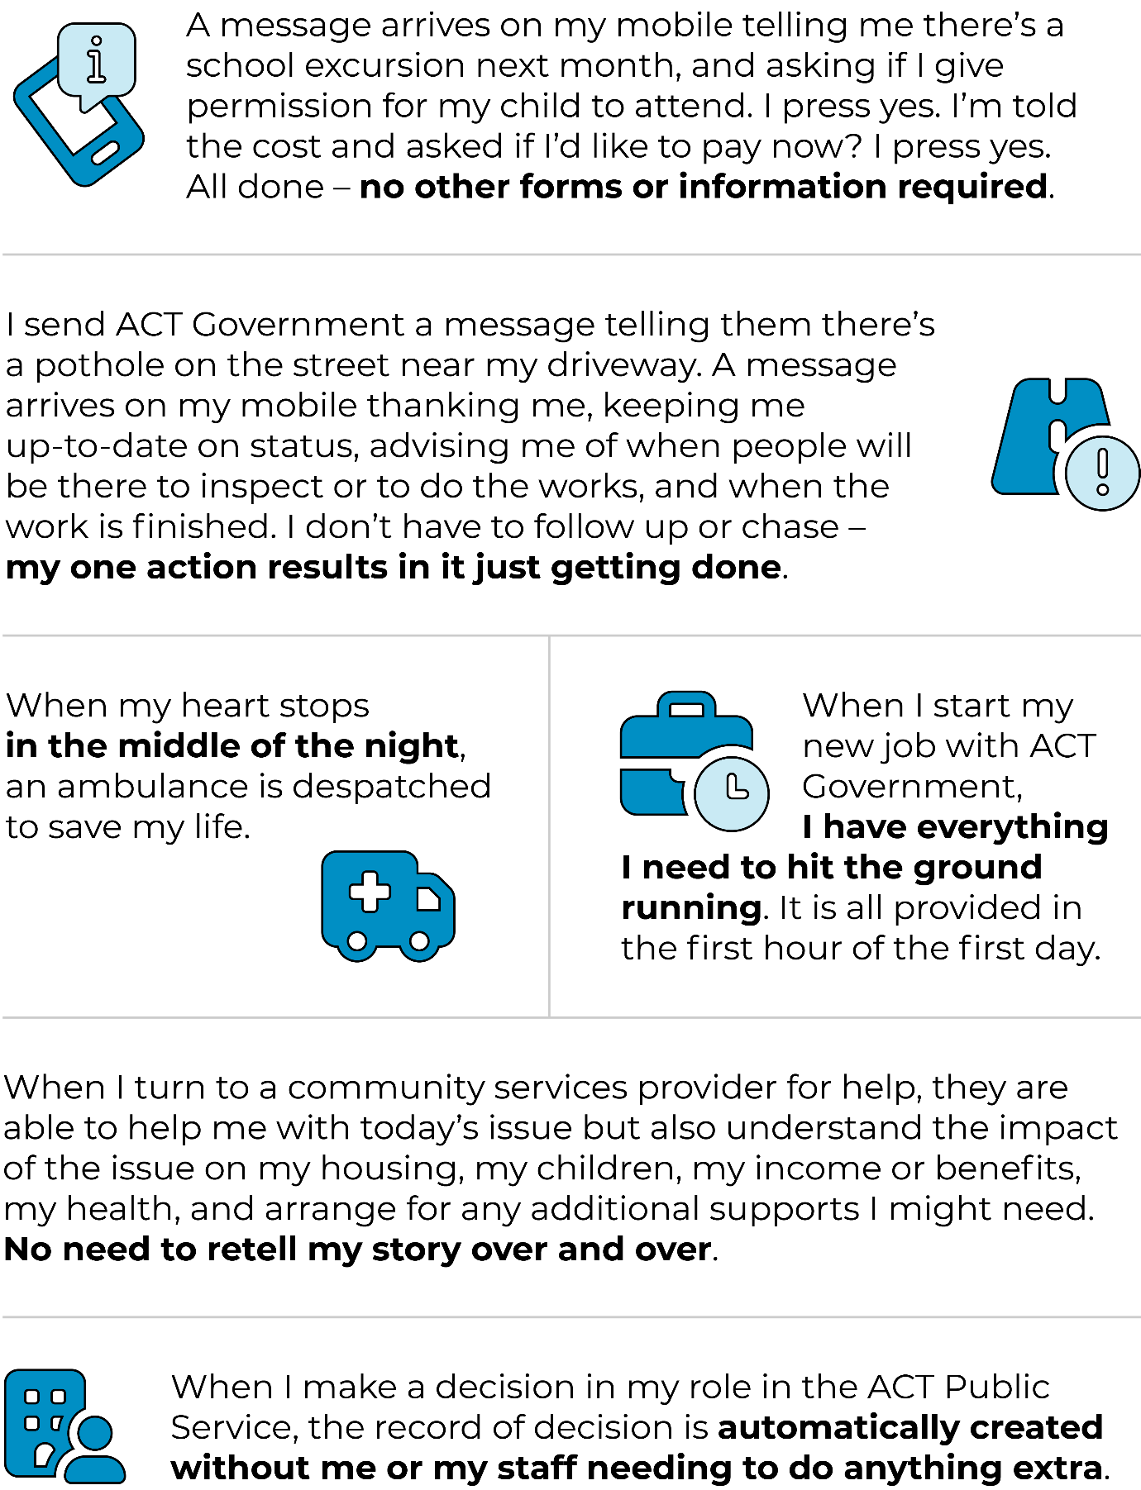

Our mission
Our mission is to make government services easier to access, easier to use and easier to trust.
We do this by harnessing digital, technology, data and AI to improve outcomes for Canberrans, enable directorates to deliver better services, support government priorities and strengthen the capability of the ACTPS.
Every investment, platform and capability we deliver should contribute to three outcomes:
- Improved outcomes for the community through accessible, trusted, inclusive and user-centred services.
- Better service delivery and capability across government by enabling directorates through shared platforms, enterprise capabilities, expertise and digital leadership.
- Greater value and efficiency for government through coordinated investment, responsible innovation and the sustainable stewardship of public resources.

Our values
Digital Canberra embodies the ACTPS values of Respect, Integrity, Collaboration and Innovation. These values guide how we lead, how we partner across government and with the community and how we deliver on our mission to make government services easier to access, easier to use and easier to trust.
We are powered by people with deep expertise, a strong sense of public purpose and a shared commitment to improving outcomes for the ACT community. The ACTPS Values and Signature Behaviours shape every decision we make and every service we help deliver.

Respect
We listen, learn and act with empathy, fairness and professionalism. We value diverse perspectives, lived experiences and expertise, recognising that better outcomes are achieved when people feel heard, included and respected.

Integrity
We provide honest, evidence-based advice and exercise sound judgement and discretion in all that we do. We act with transparency, accountability and professionalism, serving as trusted stewards of public resources, data and technology. We take responsibility for our decisions and commitments, building trust across government and with the community.

Collaboration
We work as one government, partnering with directorates, industry, academia and the community to design and deliver connected, inclusive, user-centred services. We share knowledge, build capability and create solutions that deliver lasting value across the ACTPS.

Innovation
We embrace curiosity, continuous improvement and responsible innovation. We harness digital, technology, data and AI to solve problems, remove barriers, strengthen government capability and improve outcomes for the community we serve.

Clients and stakeholders
We provide strategic policy advice and high-level support to our Minister, Rachel Stephen-Smith MLA, who was Minister for the Public Service and Minister for Health as at 30 June 2026.
We support and assist many other key stakeholders and clients including:
- the ACT Cabinet and Ministers
- the ACT Legislative Assembly
- the ACT community
- the ACT Aboriginal and Torres Strait Islander Elected Body
- community councils and groups
- industry and business institutions
- higher and vocational education institutions
- the ACT Government directorates, agencies and authorities.

A journey of transformation
The transformation that led to the creation of Digital Canberra began in December 2024, when the ACT Government announced a series of Machinery of Government changes designed to better align public service administration and resources with government priorities. These changes marked the beginning of a broader effort to strengthen accountability, improve coordination across government, enhance information sharing and build stronger policy capability to support Ministers and deliver better outcomes for the Canberra community.
A significant milestone in this transformation was reached on 1 July 2025 with the establishment of Digital Canberra through the integration of the Digital, Data and Technology Solutions (DDTS) Group and ACT Health’s Digital Solutions Division (DSD). The new directorate brought together the ACT Government’s largest digital, data and technology capabilities under a single organisation for the first time.
The creation of Digital Canberra represented more than an organisational restructure. It established a new foundation for a whole-of-government approach to digital, data and technology leadership. By unifying previously separate technology functions, Digital Canberra was positioned to strengthen the coordination and governance of technology investment, build digital capability across the public sector and accelerate the delivery of modern, secure and user-centred services for the ACT community.
Throughout 2025-26, the focus shifted from establishment to integration and capability building. As a newly formed directorate, Digital Canberra undertook the substantial task of creating the foundations required to operate as a standalone entity. This included establishing governance and compliance frameworks, developing corporate systems and processes and engaging with directorates across government to better understand existing technology capabilities, service dependencies and future transition opportunities.
Recognising that technology functions underpin many critical frontline and business services, Digital Canberra adopted a phased and measured approach to transformation. This approach ensured continuity of service delivery while progressively bringing together technology capabilities from across government into the new directorate.
A major milestone in this journey was achieved through the completion of consultation on the first phase of the City and Environment Directorate (CED) transition. As the ACT Government’s third largest technology workforce, CED represented a significant addition to Digital Canberra’s growing capability. The transfer of CED technology functions in July 2026 marked an important step towards the vision of a more coordinated, strategic and sustainable digital ecosystem across the ACTPS.
While the establishment phase focused on building capability and laying foundations, these achievements also positioned Digital Canberra for the next stage of its evolution: driving whole-of-government digital transformation, strengthening enterprise leadership and maximising the value of digital, technology and data to improve services and outcomes for the ACT community.

Organisation chart
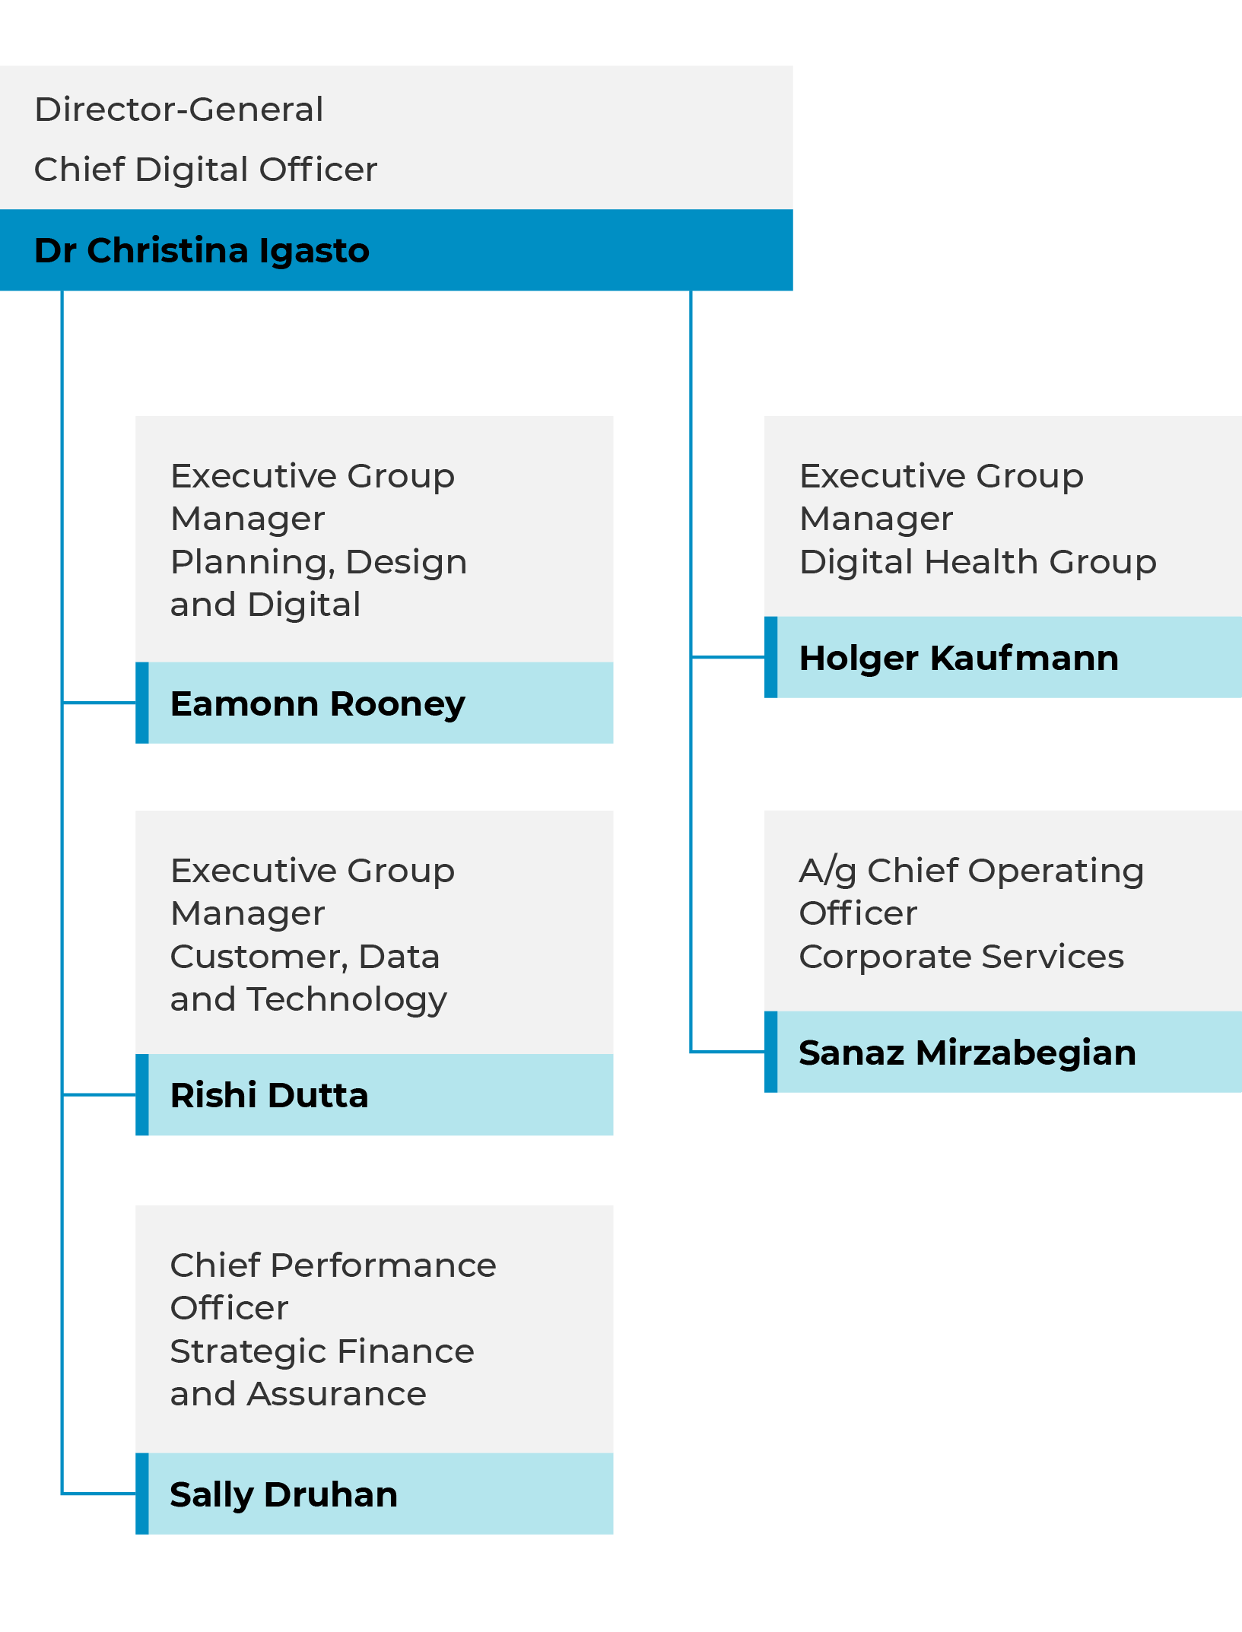

Internal accountability
Senior Executive Service (SES) and their responsibilities

Dr Christina Igasto – Director-General and ACT Government Chief Digital Officer
 | The Director-General leads the ACT Government’s digital, technology, data, cyber security and AI agenda, providing whole-of-government leadership to drive digital transformation, strengthen government capability and improve outcomes for the ACT community.
The Director-General is responsible for leading the ACT Government’s digital, technology, data, cyber security and AI agenda, with a focus on making government services easier to access, easier to use and easier to trust. The role provides whole-of-government leadership across digital policy, service transformation, technology investment, cyber security, data, AI, innovation and ICT operations, enabling directorates to deliver secure, trusted and community-focused services that improve outcomes for Canberrans.
As the ACT Government’s Chief Digital Officer, the Director-General serves as a trusted adviser to Ministers, Cabinet and directorates, providing strategic advice on digital, technology, data and emerging technologies. The role oversees major digital transformation programs and investments, enables directorates to deliver high-quality, community-focused services and ensures government investments deliver secure, trusted and sustainable outcomes for Canberrans.
Dr Christina Igasto commenced as Director-General and ACT Government Chief Digital Officer on 25 May 2026.

Bettina Konti – Interim Director-General and ACT Government Chief Digital Officer
 | The Interim Director-General was responsible for leading the establishment of Digital Canberra through the amalgamation of Digital Data and Technology Solutions and the Digital Solutions Division. This included implementing the systems, governance and processes necessary to meet all legislative, operational and financial accountability requirements.
The role was accountable for ensuring the ongoing delivery of commitments and priorities across both organisations during the transition period. While also continuing to oversee the implementation of key whole-of-government ICT initiatives, including the Public Sector HR Management program and the Digital Health Record (DHR). The Interim Director-General’s tenure ended with the commencement of the Director-General in the role.

Sally Druhan – Chief Performance Officer
 | The Chief Performance Officer commenced with the directorate on 25 May 2026. Appointed to lead the Shared Corporate and Enabling Services project, a critical initiative supporting the establishment of Digital Canberra and the future delivery of corporate and enabling services.

Rishi Dutta – Executive Group Manager, Customer, Data and Technology
 | The Executive Group Manager leads the Customer, Data and Technology Group, providing strategic leadership across whole-of-government technology, data, AI and cyber security services. The role drives the delivery of secure, customer-focused and future-ready technical services for the ACT Government, oversees major programs and ICT service delivery and manages significant workforce and financial responsibilities.
The Executive Group Manager represents Digital Canberra and the ACT Government in senior forums and works across government to enable the delivery of government services for all Canberrans.

Holger Kaufmann – Executive Group Manager, Digital Health
 | The Executive Group Manager leads the Digital Health Group and is responsible for the strategic direction, governance and delivery of digital health services across the ACT’s public health system. The role oversees digital health strategy, clinical systems, technology operations, digital health cyber security, data and reporting capabilities and the delivery of major digital health programs.
Working closely with clinical, operational and government stakeholders, the Executive Group Manager drives digital health innovation, supports the safe and effective use of technology in healthcare and ensures digital investments align with organisational priorities and national health reform agendas.

Sanaz Mirzabegian – Chief Operating Officer
 | The Chief Operating Officer leads the Corporate Services Group, which provides the core enabling functions that support Digital Canberra. The Group delivers communications and engagement, ministerial and government services, people and capability functions and organisational transition activities across the directorate.
The Chief Operating Officer provides strategic advice and support to Digital Canberra, Senior Executives and Ministers. In addition, the role promotes organisational integrity as Digital Canberra's Senior Executive Responsible for Business Integrity and Risk and serves as a Public Interest Disclosure Officer and Chair of the Work Health and Safety Steering Committee.
The Chief Operating Officer also led the Strategic Finance and Assurance Group in 2025–26. The Group provides strategic leadership across finance, governance, risk management and assurance functions for Digital Canberra. The Group is responsible for financial management, budgeting and reporting, governance and strategy, corporate performance reporting, assurance and risk management, internal audit, portfolio management and strategic sourcing.

Eamonn Rooney – Executive Group Manager, Planning, Design and Digital
 | The Executive Group Manager of Planning, Design and Digital plays a critical strategic leadership role in advancing the ACT Government’s vision of a connected, inclusive, innovative and digitally enabled Canberra.
The role supports Ministers and Government by driving strategic digital policy, innovation and technology-enabled services that improves the delivery of community-facing services, ensuring Canberrans can access government services that are modern, secure, accessible, inclusive and user-centred. This includes accountability for the ACT Digital Account and the Government’s technology investment framework and pipeline; leading research, analysis and policy development to inform strategic decision-making; providing business analysis, enterprise architecture, design and digital advisory services for major government initiatives; and delivering significant ICT and digital transformation programs that enhance frontline and community-facing services across the ACTPS. Through a focus on innovation, investment stewardship and whole-of-government outcomes, the role helps maximise the value of technology and data to support Ministers in delivering better government services, with a focus on improving outcomes for the ACT community.

Remuneration
Full-time holders of public office, which includes Digital Canberra Senior Executives, are listed in Schedule 1 of the Remuneration Tribunal Act 1995 and the Tribunal must make determinations every twelve months in relation to remuneration, allowances and other entitlements.
The annual determinations for full-time holders of public office usually take effect from 1 July each year and currently include remuneration, salary packaging, relocation entitlements, vehicles, travel, employer provided fringe benefits tax (FBT) and superannuation.
The current Tribunal determination can be viewed at Determinations - ACT Remuneration Tribunal.

Governance committees
Our governance committees set the foundation for good governance across our digital, data, cyber security and corporate operations and support transparent and accountable decision-making.
The Director-General has overall accountability for Digital Canberra’s strategic direction and operational performance. The following committees support the Director-General and delegates, in exercising their authority.

Table 1: Digital Canberra governance committees
Committee | Purpose
Strategic governance
Digital Canberra Senior Executive Meeting | This meeting of our most Senior Executives is Digital Canberra’s key decision-making forum. It supports the Director-General to set and promote strategic direction, ensures legislative and governance obligations are met and reviews business performance to ensure Digital Canberra is operating efficiently and effectively.
Digital Canberra Audit and Risk Committee | Established as an independent entity, the Audit and Risk Committee (ARC) provides advice to the Director-General and supports effective governance, risk management and internal control arrangements for Digital Canberra.
Technology Investment Review Committee | The Technology Investment Review Committee reviews all Budget business cases that include a technology component and provides advice to government on their suitability and likelihood of success.
Enterprise Architecture governance
Design Authority | Provides strategic direction and overarching design governance, policies and standards.
Architecture Review Board | Ensures that changes to the digital and data environment remain in alignment with strategic direction and that the enterprise architecture is consistent and aligned with strategy.
Technical Architecture Council | Supports the Design Authority and Architecture Review Board by performing the technical assurance component of architecture governance.
Project governance
Planning and Initiation Board | The governing authority for new work take-on requests in Digital Canberra over and above planned projects or business as usual activities (i.e. new capability development, projects).
Project Portfolio Board | Oversees the execution and delivery of projects that have been approved by the Planning and Initiation Board.
Corporate governance
Work Health and Safety Tier 1 Committee | Provides strategic oversight of WHS matters, supports consultation on emerging risks and initiatives and promotes continuous improvement in health, safety and wellbeing outcomes.

Digital Canberra was also represented on several cross-jurisdictional digital, data and cyber security committees and working groups including:
- AI Advisory Group
- Cyber Security Quarterly Review Group
- Data Management Group
- Data Reform Group
- Digital and Data Ministers Meeting
- Digital Records Capability Working Group
- Digital Records Governance Committee
- National Disability Data Asset Implementation Working Group
- National Security Group
- PC-HRM and other program specific boards
- Technology Governance Group
- Technology Leadership Group

Projects and programs

Tier 1 projects
Digital Canberra leads or supports the delivery of technology uplift projects across the ACT Government. We manage three tiers of technology projects and programs, with Tier 1 being strategically significant initiatives with high risk, complexity and investment.
Our projects and programs aim to enhance whole-of-government digital capability, modernise systems and improve service delivery. We also support the technology implementation of infrastructure initiatives led by other directorates such as the Canberra Theatre redevelopment, the CIT expansion and the new Critical Services Building, at Canberra Hospital.
The following is a list of the Tier 1 technology projects Digital Canberra was involved in during 2025–26, which have been delivered or are still in delivery.

Table 2: Tier 1 technology projects in 2025–26
Project Name | Description
NCH Transition Project | This project supports the North Canberra Hospital (NCH) transition by funding commercial, capital and ICT-related work needed to assess claims and implement required technology changes.  Digital Canberra is supporting Canberra Health Services (CHS) in the delivery of this project.
ACTIC Separation Program | This project supports the ACT Integrity Commission (ACTIC) to separate most of its ICT services from the ACT Government environment and move to a third-party provider.  Digital Canberra is supporting the Integrity Commission in the delivery of this project.
CIT Yurauna – Bruce | This project supported the new Yurauna building at CIT Bruce by providing digitally enabled learning spaces for education, child care and culturally respectful services.  Digital Canberra supported CIT in the delivery of this project.
CIT Heritage Migration | This project moved the CIT systems away from legacy technology to Microsoft-based technologies to make the environment modern, supportable and secure.  Digital Canberra supported CIT in the delivery of this project.
CIT Woden Campus | This project supported the building and commissioning of the CIT Woden Campus, which is intended to provide modern, digitally enabled education and training facilities.  Digital Canberra supported CIT and Infrastructure Canberra in the delivery of this project.
Canberra Theatre Redevelopment – ICT infrastructure Consultancy | This project supports the redevelopment of the Canberra Theatre by providing ICT infrastructure consultancy for the new and redeveloped theatre facilities and ensuring the redeveloped venue has the right technology foundations to support large-scale performances and operations.  Digital Canberra is supporting Infrastructure Canberra in the delivery of this project.
9 Sandford St.  BMS Server Remediation | This project upgraded the building management system (BMS) responsible for controlling air conditioning, lighting, blinds and solar and integrated it with other systems as required to improve security, access and compliance.
Windows 11 Rollout | This project upgraded the whole-of-government desktop operating environment so that it remains modern, supported and secure.  This is a Digital Canberra-led project.
Upgrade Chris21 and HR21 | This project is to upgrade the core HR and payroll systems, Chris21 and HR21, to agreed versions with improved functionality, supporting the move away from legacy systems and enabling the use of modern enterprise capabilities.  Chris21 is the core Human Resources Management System responsible for storing employee information and manages payroll, leave recruitment, workforce data, reporting and other HR processes. HR21 is the employee and manager self-service portal that sits on top of Chris21 that employees use to view payslips, check leave balances, update personal and bank details. Managers can also access certain employee information and approvals through HR21. It is also a project in the PC-HRM Program, led by Digital Canberra.
Design and Implementation of a WhoG Time and Attendance System | This project is to design and implement a whole-of-government Time and Attendance system that can be used by all directorates and integrated with Chris21. It replaces fragmented or manual time, attendance and rostering arrangements with a more consistent digital capability.  It is a project in the PC-HRM Program, led by Digital Canberra.
Critical Services Building | This project is part of the broader Canberra Hospital Expansion that delivered the Critical Services Building at the Canberra Hospital. It includes new emergency department treatment spaces, Intensive Care Unit (ICU) beds, paediatric ICU beds, family areas and operating theatres.  Digital Canberra supported the delivery of this project through the building construction and commissioning phases.
Next Generation Ticketing Mobility as a Service Solution (MyWay+) | This project replaced the legacy MyWay ticketing and fares system, along with the NXTBUS real-time passenger information service, with MyWay+, a modern Mobility-as-a-Service (MaaS) solution delivered by NEC Australia.

Programs
Digital Canberra leads and supports the delivery of technology programs, which are structured groups of related technology projects that involve other areas across the ACT Government and contribute to a common outcome.
Programs underway during the 2025–26 reporting period included:

Table 3: Digital Canberra technology programs in 2025–26
Program name | Description
Strategic Asset Management Program (SAMP) | The Strategic Asset Management Program (SAMP) is a long-term initiative designed to improve how Digital Canberra manages and invests in its ICT infrastructure assets, such as servers, networks, platforms and supporting technology. The program aims to move away from responding to problems as they occur and instead adopt a planned, risk-based approach to maintaining and replacing technology assets.
WhoG Cyber Uplift Program | The whole-of-government Cyber Uplift Program is a multi-year program designed to improve the cyber security of ACT Government systems, data and technology services. Its purpose is to strengthen the ACT Government's ability to prevent, detect, respond to and recover from cyber threats while reducing risks associated with ageing technology and increasing compliance with national security obligations.
Payroll Capability and Human Resource Management (PCHRM) | The Payroll Capability and Human Resource Management (PC-HRM) Program is a major whole-of-business transformation program designed to modernise the ACTPS payroll, workforce management and human resource systems. The program aims to improve the reliability, security and usability of payroll and HR systems while reducing manual processes, improving employee self-service capabilities and supporting more efficient workforce management across government.

Performance summary
Throughout 2025–26, Digital Canberra took active, intentional steps to live our vision and mission, delivering initiatives aligned with our purpose.

Delivering improved digital access and services for the community

Continued enhancement of community-facing digital platforms to simplify how people interact with government services, reducing duplication and improving ease of access.
In 2025–26, Digital Canberra made online government services easier and safer to use. We enhanced the ACT Digital Account through improved security and user experience features. We also strengthened the underlying technology platform and digital identity services that support government service delivery. This helped people access services online, connect with government more easily and have stronger safeguards for their personal information.
These digital foundations:
- delivered improvements to online identity proofing, authentication and account management, making it easier for people to securely access digital services.
- made online identity checks easier to complete by providing supporting information and more secure by enhancing authentication methods, so people could access services with greater confidence.
- made access to routine online services simpler and more consistent by improving the usability of the customer interface based on feedback.
- enabled 262,005 digital transactions across services such as Working with Vulnerable People registration, housing services, MyWay+, School Parent Portal, occupational licensing and some Road Transport services.

Delivery of user-centred service design initiatives that streamline business processes and reduce administrative burden for both the community and government.
In 2025–26, we built digital tools and systems that helped government services work together more effectively. We connected services, expanded change-of-circumstances capabilities and developed consent-based information sharing functions that enable trusted sharing of customer information. This means people do not need to repeat the same steps across different services.
This helped us:
- reduce the need for Canberrans to give the same information more than once
- give people more control over how we use their information
- support more reliable and consistent services across government
- enable and support appropriate information sharing between systems and services in safer and more consistent ways
- develop reusable integration capabilities that can be adopted by multiple government services, reducing duplication and delivery effort.
We supported government efficiencies through technology, delivering critical upgrades to ACT Government staffing management systems including the payroll and HR platforms. These were successfully transitioned to the latest supported versions reducing technology risk and ensuring ongoing vendor support, security and system stability.
We modernised rostering and time and attendance from manual processes to a digital platform, reducing manual effort, improving data quality and streamlining time, attendance and leave management.

Strengthening whole-of-government digital foundations

Uplift of core digital infrastructure, including cloud-based platforms and shared digital services, to improve resilience, scalability and value for money.
In 2025–26, we delivered ICT infrastructure and services to support the ACT Government, including:
- ICT infrastructure for the new Garran Primary and Strathnairn Primary Schools.
- Trial of digital signage and Cyber Lab initiatives in select schools.
- Connectivity for ACT Health accounts, Multi-Factor Authentication and Setup Self Password Reset functionality.
- Upgraded the Picture Archiving and Communication System to ensure uninterrupted diagnostic imaging services for the ACT public health system.
- ICT upgrades for North Canberra Hospital transition.
- Network infrastructure for the new Molonglo Joint Emergency Services Station.
- Modernisation of the Territory Radio Network to support connectivity for ACT government services, as well as upgrades to the Emergency Triple Zero network.
- ICT infrastructure for the new CIT Woden Campus.
- Modernised CIT’s critical business systems by successfully migrating core platforms from legacy technology to modern solutions, improving security, reliability and performance.
- Migrated ACT Leave onto the ACT Government network, to create a more secure, resilient and standardised ICT environment.
- Successfully separated ACTIC’s ICT services from the ACT Government environment, reinforcing its independence from the agencies it oversees while preserving records continuity and strengthening security controls.
Refreshing ICT assets such as laptops and mobile phones enables Digital Canberra to deliver secure, sustainable government services by reducing technology risk and improving service reliability.
In 2025–26, we established foundations for a more strategic and sustainable approach to asset management, improving asset visibility and investment decision-making. By consolidating separate data sources, we enabled risk-based asset management, long-term forecasting and future technology investments.
We improved service consistency, reduced duplication, increased automation and strengthened enterprise platform management to support more efficient and scalable service delivery across government. During 2025–26, we:
- consolidated ICT support services, improving customer experience, reducing duplication and creating a more consistent whole-of-government approach to ICT service delivery.
- realigned resources to strengthen enterprise platform management and support the ACT Government's strategic direction for service management.
- assessed more than 150 ICT processes, reducing unnecessary manual review activities, improving understanding of end-to-end service management processes and identifying opportunities to simplify and standardise service delivery.
- progressed workflow automation initiatives to further reduce manual effort and enable staff to focus on higher-value customer support and service improvement activities.

Strengthening of cyber security capabilities and governance to protect government and community data to earn and maintain trust in our digital services.
We helped build trust in digital services by strengthening governance. This included reviewing and enhancing policies, operational procedures and governance arrangements, records management and digital account lifecycle management. This helped us:
- improve the rules and processes that guide digital identity services
- strengthen safeguards for privacy, consent, accessibility, identity checks, records management and account management
- continue to design and administer digital services with privacy, accessibility and community needs in mind.
The responsible disclosure of vulnerabilities allows us to address issues early, improving our cyber security resilience. In 2025–26, Digital Canberra developed a dedicated website (Report a system security vulnerability) to make it easy for members of the public to report system vulnerabilities when they discover them.

Improved use of data and analytics to inform policy development, service planning and investment decisions.
As one of the leading digital agencies in the ACT, Digital Canberra led participation in national data integration partnerships and the national data agenda. In 2025–26 we hosted forums, participated in national programs and led ACT Government work to progress data deliverables and improve engagement around data integration initiatives.
Demonstrating our commitment to data-driven business, Digital Canberra leads coordination of an assessment process that measures the ACT Government’s data maturity. First introduced in 2022 and last conducted in 2024, this year’s assessment confirmed that there have been targeted improvements in how data is used to inform decision-making, alongside clearer articulation of data principles and strategic intent. It also highlighted that directorate-level cyber security practices show continued consideration, ensuring that this remains a strong and mature capability across government.
Digital Canberra manages the ACT Government’s Open Data Portal. Viewed around 310,000 times in 2025–26, the portal hosts datasets from across government, free for the public to view and download. These datasets provide essential information to the ACT community to improve all aspects of daily life. The significant number of requests for information and downloads demonstrates the value of this resource to the Canberra community.

In 2025–26 we:
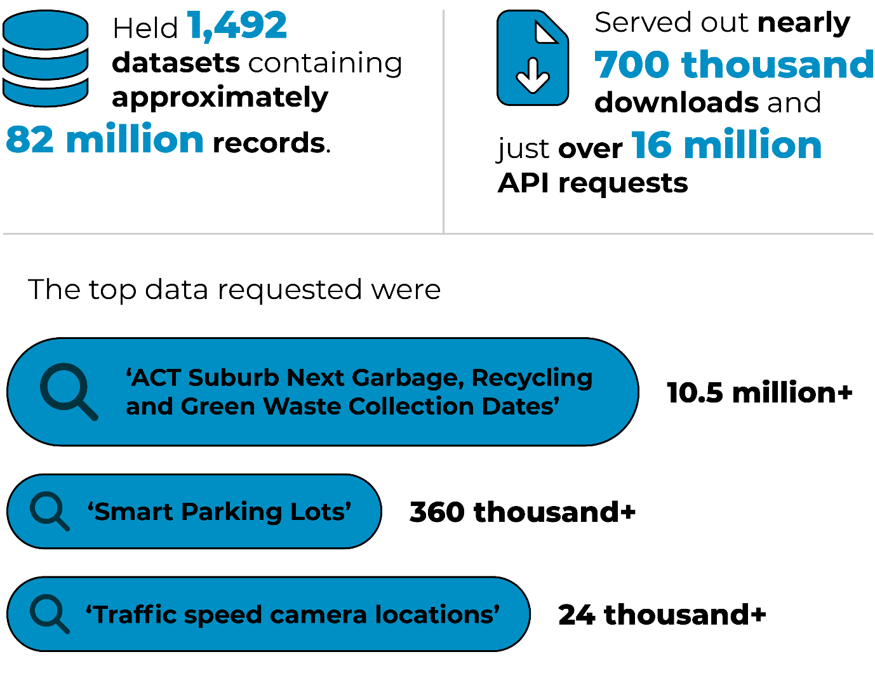

Leadership in digital health transformation
Delivery of priority digital health initiatives that support safer, more connected and more efficient healthcare delivery across the Territory.

Digital Health Record (DHR) Link
- Throughout the 2025–26 reporting period, Digital Canberra expanded access to digital health information to General Practice through DHR Link. DHR Link was delivered to all interested ACT practices, representing 74% of all GP practices in the Territory, with over 400 DHR Link accounts created.
- This expansion strengthens continuity of care between ACT public health services and primary care, reducing reliance on manual information-sharing processes and supports safer, more informed clinical decision-making.

Highlights:
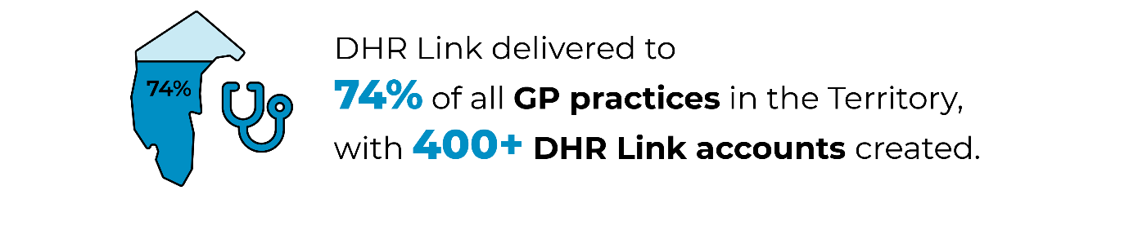

Table 4: DHR status from go-live to 30 June 2026
Benefit | Digital Health Record (DHR) performance
Medication alerts and action taken | 3,755 medications were replaced after receiving a warning to check the dose.  128,708 medications were updated after receiving a warning that the drug contained an active or inactive ingredient that the patient was allergic to.  59,155 medications were removed after receiving a warning of a duplicate order.  151,828 therapy orders were removed after receiving a warning of a duplicate therapy.
Results released to patients | 86% of results were released to MyDHR within one day in the past year.  2,552,111 results have been sent directly to patients’ MyDHR accounts within one day of the test being resulted.
Engagement with MyDHR | 285,530 patients have an active MyDHR account, with 45,635 patients logging into MyDHR in June 2026.  136,665 general questionnaires were submitted in MyDHR, allowing clinicians to provide better care and pre-populating information in the patients’ charts.  24,426 patient consent forms for DHR Link were signed via MyDHR
Beaker draws saved | 311,521 patient draws have been saved by adding on to an existing lab order, meaning patients had to undergo fewer blood tests.
Increased communication among staff | 10,692,026 messages sent via secure chat since go-live
Effectiveness of Rover for medication administration | 5,562,936 medications administered by nurses using Rover, a tool allowing nurses and clinical staff to document care, administer medications and access patient information directly at the bedside.  27% of all medications have been administered with Rover in the past year.

Voluntary Assisted Dying services
- Digital Canberra partnered with (CHS) and the Health and Community Services Directorate (HCSD) to deliver the ICT and digital health capabilities required to support the introduction of Voluntary Assisted Dying services in the ACT. This work enabled the safe and effective commencement of a new health service for the community.

Notifiable Disease Management System
- By delivering the Notifiable Disease Management System in 2025–26, Digital Canberra was able to strengthen public health, clinical information sharing and disease surveillance.
- The system enables more effective public health surveillance by improving the collection, management and reporting of communicable disease information.

Integrated Operations Centre and Territory-wide operational visibility
- Digital Health staff worked alongside hospital operational teams to develop dashboards within the DHR that bring key operational information together in one place.
- The dashboards provide enhanced visibility of Emergency Department activity, ward capacity, patient flow and discharge forecasting. These improvements allow for a more coordinated and informed approach to managing health service demand and emerging operational pressures. This represents an important step forward in using DHR data to provide a connected, system-wide view of health service operations.

Use of AI in health services
In 2025–26, we commenced a pilot of ambient AI technology to evaluate its ability to support clinical documentation safely and effectively across the ACT public health system.
The pilot forms part of Digital Canberra’s broader approach to exploring innovative technologies that can improve clinician experience and support the delivery of safe, efficient and patient-centred healthcare while maintaining appropriate safeguards, human oversight and accountability. It operates under established clinical governance, privacy and cyber security controls and has been approved through relevant governance processes.
The anticipated benefits of introducing AI in health services include:
- reducing administrative burden, lowering documentation workload and cognitive load
- improving documentation quality
- supporting more patient-focused consultations.
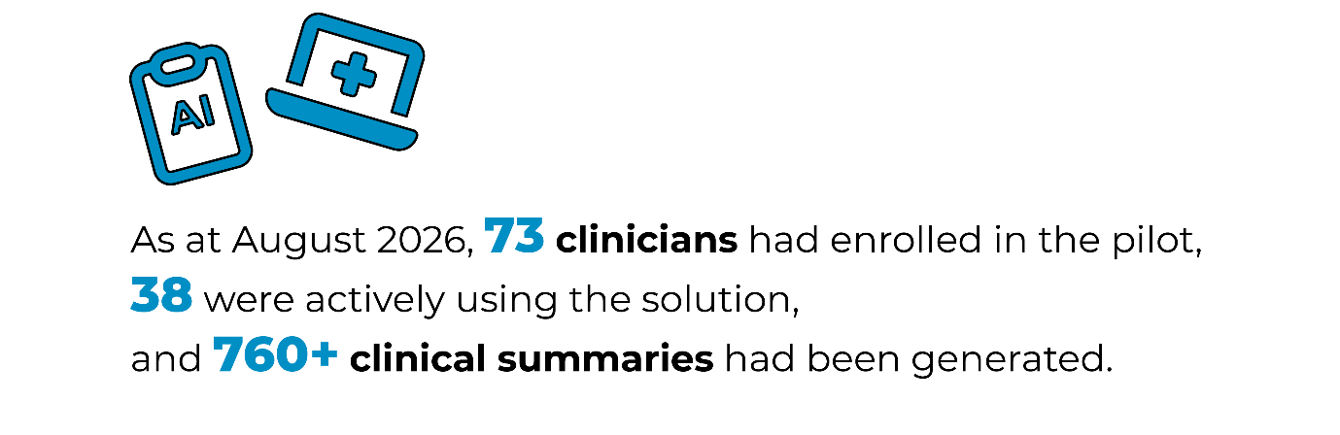

Ongoing implementation of the ACT Digital Health Strategy, including modernisation of clinical and administrative digital systems that support integrated, person-centred care.
Throughout the 2025–26 reporting period, Digital Canberra created and extended capability for several important systems, including:
- the update of critical communication systems to improve reliability and safety for clinical staff
- delivery of an enterprise data platform to meet the expanding data requirements of the health system
- several capital upgrades delivering IT capability for pathology labs, hospital wards and care centres.
We were able to enhance the security, reliability and resilience of strategic systems through investment in both technology and process. This resulted in several benefits:
- change related system outages decreased significantly and the availability of systems experiencing issues was greatly improved
- issues referred to the service desk were increasingly resolved on first contact, improving stakeholder efficiency and satisfaction
- ongoing cost efficiencies through continual decommissioning of legacy systems and the implementation of automated rightsizing of cloud resources.
Through delivering a broad program of digital and clinical capability improvements we were able to strengthen health technology capability across ACT public health services. These initiatives supported modernisation of workplace technology by:
- improving clinical and diagnostic systems
- enhancing medication management capabilities
- strengthening secure collaboration and information sharing
- progressing future digital health opportunities across the ACT health system.
We secured Commonwealth funding to progress the implementation of ePrescribing in ACT public hospitals, supporting a Commercial Impact Assessment to understand the requirements to implement and operationalise ePrescribing in ACT public hospitals.

Coordination and governance of major digital health investments to ensure alignment with Territory health priorities and service delivery needs.
- The Business Intelligence and Data Hub enhanced the planning, governance and delivery of reporting and data products improving visibility of the delivery pipeline, supporting more informed prioritisation decisions and enabling a more responsive service for stakeholders.
- We partnered with Canberra Health Service to improve alignment on digital health priorities, decision-making and strategic planning for digital health systems.
- Partnered with national and jurisdictional stakeholders to inform the development of ePrescribing conformance requirements to ensure they meet the health service operational, clinical and Information Technology requirements.
- Through strengthening governance and assurance arrangements for the Digital Health Record and related clinical applications, Digital Canberra has improved upgrade assurance, issue escalation, hazard visibility and clinical risk management. This supported safer system changes, clearer decision-making and improved executive oversight of risks affecting critical digital health services.
- During 2025–26, we led the development of the ACT Health Services AI Governance Framework, which establishes a foundation for the safe, ethical and responsible use of AI across ACT Health.

Building capability across the ACT Public Service

Investment in digital, data and technology capability uplift across the ACTPS, supporting a more skilled, sustainable and future ready workforce.
In 2025–26, Digital Canberra expanded whole-of-government AI capability uplift activities through information sessions, workshops, support programs and targeted guidance materials to support responsible use of AI across government.

We developed and launched the ACTPS AI Essentials eLearning package to strengthen workforce capability and support the safe, secure and ethical use of AI across the ACTPS. The training covers AI fundamentals, approved tools, privacy, security, human oversight and responsible use obligations.
We were able to strengthen whole-of-government digital capability by coordinating compliance of all directorates’ ACT branded SMS services with the requirements of the new Commonwealth SMS Sender ID Register.

Strengthening Digital Canberra’s role as a trusted advisor, providing strategic guidance on digital investment, architecture, data and cyber security.
Throughout 2025–26, Digital Canberra worked to further strengthen our role as one of the leading digital agencies in the ACT. We continued to implement whole-of-government governance frameworks and policies to support safe, secure and ethical implementation of digital initiatives and to help government make better-informed investment decisions.
We supported partners across government to deliver better digital outcomes, providing expert advice and support throughout the planning, procurement and delivery of digital and technology-enabled services.
Working with directorates, we strengthened consideration of user needs, risks, costs, opportunities and service design quality, helping to better position initiatives to deliver their intended benefits. This advice supported directorates to consider digital inclusion and accessibility principles as a part of good service design, contributing to delivery of government services that better meet the needs of the Canberra community.
Digital Canberra participated in activities throughout 2025–26 to raise our profile and engage with students studying at local facilities and build networks with industry colleagues, further establishing our reputation as one of Canberra’s leading digital agencies. Activities included:
- Participating in the AI CoLab, a cross-sector collaborative forum focused on AI adoption, delivering workshops and presentations to public servants, Academics, students, industry and civil society members.
- Attending the ANU AI Conference to present to academics and industry on AI Governance in government and to build connections with students for further collaborations.
- Attending the CIT Robotics Expo to engage with students and promote Digital Canberra as an employer of choice and to build positive engagement with prospective employees.

Future priorities
The establishment of Digital Canberra marked the beginning of a long-term transformation to create a more connected, innovative and digitally enabled ACT Government. Building on the foundations established in our first year, we will continue this journey by harnessing digital, technology, data and AI to improve community outcomes, strengthen government capability and deliver modern, trusted and accessible services for all Canberrans.
Digital Canberra’s strategic and operational priorities in 2026–27 include:
- Embedding a cohesive sustainable and contemporary digital, data and technology operating model, including strengthened governance, integrated ways of working, consolidated delivery and assurance functions and clear investment oversight to enable sustainable, coordinated and scalable outcomes across government.
- Establishing a sustainable, efficient and fit for purpose corporate and enabling services function to support Digital Canberra’s expanded mandate. Streamline internal processes, leverage combined and shared services and build long term organisational and workforce capability.
- Improving design quality, delivery discipline and governance across digital initiatives by aligning projects, advice and whole-of-government support to the ACT Government’s Best Practice Design and Delivery guidance.
- Strengthening technology investment assurance through consistent application of the ACT Government’s Technology Investment Framework to improve value for money, consistency and long-term sustainability.
- Consolidating the ACT Government’s technology footprint by prioritising fewer, scalable platforms that deliver full function capabilities while maintaining the agility to adapt and implement change efficiently.
- Advancing trusted digital identity, consent-based data sharing and ‘tell us once’ capabilities to improve community-facing services, making it easier for individuals and businesses to access government services while reducing administrative burden and enabling more seamless interactions with government.
- Strengthening cyber security capability across government systems and environments. Aligning them with national critical infrastructure reforms and obligations, with a focus on resilience, incident preparedness and achieving consistent cyber maturity across the ACT Government.
- Extending digital health connectivity beyond the public health system, to improve information sharing with private and community-based health providers. Further expansion of the ACT Digital Health Record and related services, in line with the ACT Digital Health Strategy.
- Improving the quality, integrity and usability of priority datasets through targeted data uplift and maturity initiatives. Strengthening clinical, operational and corporate data underpinning service delivery, reporting and evidence-based decision-making.
- Strengthening data governance, sharing and stewardship across government. Continuing support for directorates to embed the ACT Data Governance and Management Framework and enable responsible, secure and ethical data sharing for public benefit.
- Supporting the ACT Government’s participation in national digital, data and cyber priorities. Including providing advice and guidance to support disability sector reforms, delivery of the National Firearms Register as part of broader national firearms reform and commitments under the Intergovernmental Agreement on Data Sharing.
- Enhancing cross directorate collaboration, leadership and foresight, through committees and governance forums that promote cooperation, innovation and coordinated decision-making.
- Anticipating emerging technologies and risks and strengthen ACT Government capability across digital service delivery, project and program management, strategic platforms, cyber security, data, AI and technology investment.
- Building on the ACT Government’s AI policy, framework and governance foundations to support the safe, secure and responsible adoption of AI across government. This will include strengthening oversight and assurance, building confidence in use and broader workforce and leadership capability, while enabling enterprise transformation with AI and the development and delivery of innovative, frontline and community-focused solutions that improve service delivery and outcomes for the ACT community.

Living our vision and mission in 2026–27
In 2026–27, Digital Canberra will continue the next phase of its transformation journey, building on the foundations established through the creation of the directorate. Guided by our vision of a connected, inclusive, innovative and digitally enabled ACT Government, we will harness digital, technology, data and AI to make government services easier to access, easier to use and easier to trust.
Our focus will remain firmly on improving outcomes for the community, enabling directorates to deliver high-quality services, strengthening whole-of-government capability and ensuring every investment delivers lasting public value. Through collaboration with directorates, industry, academia and the community, we will continue to build the digital foundations, shared capabilities and trusted services that support a modern, secure and responsive ACT Government.
We are committed to advancing Closing the Gap by embedding Aboriginal and Torres Strait Islander perspectives in the design, delivery and governance of digital, data and technology initiatives. By strengthening cultural capability, supporting self-determination and fostering genuine partnerships, we will help ensure government services are more inclusive, accessible and responsive, contributing to better outcomes for Aboriginal and Torres Strait Islander peoples across the ACT.

Delivering trusted, secure and resilient government services
We will strengthen cyber security, digital resilience, data governance and information management across government to protect critical services, maintain public trust and support evidence-based decision-making. This includes advancing the ACT Government's Cyber Uplift Program, improving cyber maturity across government systems, strengthening Transport Canberra payment security, uplifting data governance capability and enhancing the resilience of critical health, emergency services and legislative systems.

Enabling community-focused digital services
We will continue to improve the way Canberrans interact with government by delivering simpler, more connected, inclusive and user-centred services. This includes enhancing the ACT Digital Account, advancing trusted digital identity capabilities, modernising ACT Courts and Tribunal systems and supporting life events through more seamless service experiences. We will embed digital inclusion, privacy, security and accessibility in the design and delivery of digital services, creating trusted and equitable experiences for all Canberrans.

Driving innovation and responsible use of AI
We will build on the ACT Government's AI policy, governance and assurance foundations to support the safe, secure and responsible adoption of AI across government. This includes capability uplift, guidance, assurance activities and robust governance arrangements that ensure appropriate human oversight and accountability for the use of AI. We will also explore innovative applications such as ambient AI technology to improve service delivery, enhance frontline experiences and support better outcomes for the community.

Strengthening whole-of-government capability
We will continue to strengthen technology investment governance, enterprise architecture, design and delivery practices to improve the quality, sustainability and value of government investments. Through greater use of shared platforms, automation, operational data and enterprise capabilities, we will support more integrated, efficient and consistent service delivery across the ACTPS.

Advancing digital health transformation
We will continue to deliver the ACT Digital Health Strategy and strengthen digital connectivity across the health system. Key priorities include expanding and enhancing the Digital Health Record, supporting improved information sharing between health providers, modernising core clinical systems and infrastructure and delivering innovative technologies that improve patient care, clinician experience and health outcomes.

Supporting critical infrastructure and government priorities
We will continue to partner across government to deliver digital capabilities that support major Territory priorities and infrastructure investments, including health, education, justice, emergency services, housing and city development initiatives. These investments will help ensure government services remain secure, reliable and fit for purpose while supporting the long-term needs of our growing community.

Building the foundations for the future
As Digital Canberra matures, we will continue to strengthen our role as a trusted adviser, enterprise leader and enabler of service delivery across government. By investing in capability, innovation, resilience and shared foundations, we will help create a future where government services are increasingly connected, proactive and responsive to community needs.
Ultimately, our success will be measured not by the technology we deploy, but by the outcomes we achieve for Canberrans and our ability to make government services simpler, more accessible and easier to trust.

Performance analysis
Digital Canberra’s performance during 2025–26 was measured by eight Accountability Indicators across two Output Classes as determined by the 2025–26 Digital Canberra Budget Statement. Our full results are reported in the Digital Canberra Statement of Performance 2025–26 at the end of this Annual Report.
Accountability indicators measure our performance in providing each class of the outputs identified in the Budget Statement.
Outputs are the goods produced or services provided by, or on behalf of, Digital Canberra to the ACT Government and community. For us, this is digital government services and ICT support to ACT directorates and agencies. Outputs allow us to measure the cost to provide our services. Outputs are grouped into similar categories known as Output Classes.

Output Classes and Accountability Indicators
Digital Canberra’s Output Classes and Accountability Indicators for 2025–26 are below. For a full description of the Accountability Indicators and performance variance commentary, please see the Statement of Performance at the end of this report.

Output Class 1: Digital Strategy and Solution Delivery
Through the Digital Strategy and Solution Delivery output, Digital Canberra:
- Supports the digital and data transformation of government services and provides strategy, policies, advice and support for many aspects of technology and data development and implementation.
- Delivers a range of technology and data services, including technology infrastructure, cyber security, AI, software applications development and other technology components of projects to directorates and agencies.
- Manages the day-to-day operation of the technology environment for ACT Government.
Digital Canberra will deliver this output by taking advantage of digital, data, and technology to achieve:
- better services for the community
- greater engagement and better outcomes for business and academia
- a more sustainable and efficient government spend on Digital services and initiatives
- a more productive, engaged and digitally capable workforce
- an ACT Government ICT catalogue of services, affirmed through service level support agreements
- the management of the ACT Government’s data and communications policy, services and network
- provision of general service and help desk functions.

Table 5: Accountability Indicators Output 1.1
 | Accountability Indicators Output 1.1 | 2025–26  Target | 2025–26  Result | Variance (%)*
- Maturing our data and AI ecosystem |  | 3 | 3 | 0
- The value delivered through technology investment improves |  | 3 | 2 | (33%)
- Delivery of joined up services achieves benefits for the community and for government |  | ≥99.99% | 100% | 0
- ICT requests made via the OneGov Service Centre are completed within Service Level Agreement timeframes |  | 90% | 93% | 3%
- Average time taken for telephone ICT service requests to be answered by a Service Desk Officer |  | 80% | 78% | (3%)
- Number of successful attacks on internally hosted ACT Government websites |  | 0 | 0 | 0

Output 1.2: Digital Health Enablement and System Support
The Digital Health Enablement and System Support output supports the ACT public health system by delivering and maintaining the digital foundations required for clinical and operational excellence. It includes:
- Governance and delivery of the ACT Digital Health Strategy, including oversight of major digital health programs and platforms.
- Provision of secure, high availability digital infrastructure and services HCSD and CHS.
- Development and maintenance of digital health platforms, including the Digital Health Record (DHR), health integration services and analytics environments.
- Cyber security operations and risk management for health-related digital assets, ensuring compliance with national standards and protection against emerging threats.
- Support for innovation in digital health, including pilot programs, proof of concept initiatives and the adoption of emerging technologies.
- Collaboration with national digital health bodies and alignment with Commonwealth digital health initiatives to ensure interoperability and strategic coherence.

Table 6: Accountability Indicators Output 1.2
 | Accountability Indicators Output 1.2 | 2025–26  Target | 2025–26  Result | Variance (%)*
a. ACT health system digital services are reliable and efficient:
- Percentage of calls answered measures all phone calls placed to the Digital Health Group’s Service Desk answered within 240 seconds |  | 80% | 70% | (13%)
- Percentage of JIRA requests for assistance resolved within the 24-hour Service Level Agreement timeframe |  | 80% | 86% | 8%
* Variances where the metric is a percentage are calculated by subtracting the target from the result and dividing the difference by the target. Variances are rounded up to the nearest whole number.

Performance against Accountability Indicator targets
Digital Canberra met six of the eight Accountability Indicator targets (within +/- 5% variance) in 2025–26 and two of our Indicator targets were exceeded.
Of the two performance results that did not meet their targets within variance:
Indicator 1.1.b – The value delivered through technology investment improves – met 2 of its 3 target activities. The target that was not met relates to ICT enterprise architecture and the publication of three approved ‘patterns’ (reusable, standardised ICT solutions).
As explained in the variance commentary in the Statement of Performance, the third of the three required patterns was approved in July 2026, just outside the reporting period.
Indicator 1.2.a.i – Percentage of calls answered measures all phone calls placed to the Digital Health Group’s Service Desk answered within 240 seconds – achieved a 70% result against its 80% target.
The variance commentary explains that performance was affected by higher-than-anticipated staff vacancies and turnover during the reporting period, as well as an increased focus on resolving customer issues at the first point of contact to improve customer experience and overall service delivery.
While this approach increased average call handling times, it enabled more issues to be resolved during the initial interaction, reducing the need for follow-up contact or escalation to other support teams.

Scrutiny
Digital Canberra’s activities are subject to scrutiny by a range of accountability and integrity bodies, including committees of the ACT Legislative Assembly, the ACT Auditor-General, the ACT Ombudsman and the ACT Integrity Commission.
During the reporting period, the ACT Audit Office undertook assurance engagements relating to Digital Canberra’s Statement of Performance and the audit of the directorate’s financial statements. As part of the financial statements audit, the ACT Audit Office also reviewed controls relating to computer information systems and the CHRIS21 application.
Separately, an audit of the Digital Health Record commenced during the reporting period.
The audit focuses on two key aspects of the Digital Health Record implementation:
- Program implementation – examining the planning, design, governance, procurement, delivery and implementation activities undertaken to establish the Digital Health Record.
- Benefits realisation – assessing the arrangements in place to identify, manage, monitor and evaluate whether the intended benefits of the Digital Health Record are being achieved following implementation.
The reports arising from these activities were not finalised by 30 June 2026 and any findings will be reported in the 2026–27 Annual Report.

ACT Auditor-General reports
No audits recommendations from the ACT Auditor-General were relevant to Digital Canberra in 2025–26.

ACT Ombudsman reports
There were no ACT Ombudsman recommendations relevant to Digital Canberra in 2025–26.

ACT Legislative Assembly Committees

Table 7: Responses to Legislative Assembly Inquiry Reports
Report Title | Recommendation number and summary | Status and action in reporting year
Report on the inquiry into invoicing and payments for Digital Health Record Hosting Services | Recommendation 4: ACT Health should implement assurance processes to ensure invoices are validly paid in line with delegations; and implement controls to ensure that invoices associated with a Purchase Order are approved for payment by an appropriate delegate. | Completed.  The recommendation transferred to Digital Canberra following the MoG changes.  The action was previously reported to the Digital Policy Risk and Assurance Committee (DPRAC), which provided oversight of policy, risk and assurance matters relating to the former Digital Services Division (DSD) and the Digital Health Record and has since been verified as closed.
Report on the inquiry into the effectiveness of Fix My Street | Recommendation 5: The Committee recommended that the ACT Government continue to invest in improving the effectiveness of Fix My Street.  “Responsibility for the Fix My Street technology solution will transition to Digital Canberra later in 2026 in line with the Machinery of Government changes currently underway. This transition is expected” | Completed  The City and Environment Directorate Technology Branch transitioned to Digital Canberra on 1 July 2026. This transition will support greater integration, consistency and long-term sustainability of the platform.  Government response: Agreed.  “The ACT Government will continue to consider investments in enhancing the effectiveness of the Fix My Street service, including identifying opportunities for ongoing improvement and optimisation. Any future enhancements will be considered in the context of broader government priorities and subject to funding decisions.
Report of the inquiry into procurement and delivery of MyWay+ | Recommendation 3:  “ACT Government to conduct an internal review of risk management within the MyWay+ project, with a view to identifying and implementing specific process changes in how risks are managed and mitigated in large digital procurements.” | In progress  The directorate is incorporating lessons from the MyWay+ post-implementation review into the development of a strengthened risk management framework for major digital procurements. This framework will support more consistent identification, monitoring and escalation of project risks across government major digital investments and procurements.
 | Recommendation 5:  “Commencing with the 2026–27 financial year, dedicated narrative on project management performance uplift in general and each current Tier 1 technology project will be included in Organisational Overview and Performance of the Digital Canberra annual report.” | Completed  An overview of all Tier 1 technology projects managed by Digital Canberra is published in this Annual Report (see the Overview section). Future Digital Canberra Annual Reports will include information on Tier 1 technology projects.
 | Recommendation 6:  “ACT Government require the cross-directorate structured program of internal project management reform, including a focus on ensuring compliance with accessibility requirements and standards, particularly in relation to projects that are subject to major contract variations that result in changes to delivery schedules.” | In progress  The directorate is progressing a structured program of project delivery uplift, including enhanced governance, assurance and accessibility controls for major digital projects. Findings from the MyWay+ reviews will inform future reforms.
 | Recommendation 7:  “ACT Government to produce a manual for best practice community testing programs for complex projects with important public facing aspects or functions and that the ACT Government apply these procedures to test all major complex projects.” | In progress  Digital Canberra is engaging with the community, ensuring we are supporting the needs of our customers by strengthening our approach to user-centred design and community testing. This ensures major public-facing digital services are informed by structured engagement, co-design and end-user validation activities throughout the project lifecycle.
Select Committee on Estimates 2019–20 – Inquiry into the Appropriation Bill 2019–20 and the Appropriation (Office of the Legislative Assembly) Bill 2019–20 | Recommendation 37:  “The Committee recommends that the ACT Government include applications for Seniors Cards in the new online services package.” | Completed  An integrated concession management capability has been established as a whole-of-government capability leveraging the ACT Digital Account and is available for use by ACT Government directorates. Digital Canberra remains engaged through the Seniors Card Program Reference Group and is ready to work with HCSD to support online Seniors Card verification when funding to update systems used for the administration of this program becomes available.  With the ACT Digital Services and Capability Roadmap now wrapped up and the capability to integrate with the Seniors Card system of record established, the ACT Government has the foundational capability required to support online Seniors Card concession services. Subject to future Government investment and modernisation of the underlying Seniors Card system, this capability can be implemented as needed.

Risk management
Digital Canberra is committed to the continuous development of a strong risk management culture that supports informed decision-making and effective service delivery. During the reporting period, we established the foundations of an integrated governance, risk, business continuity and resilience framework. This framework enhances oversight of strategic and operational risks, strengthens organisational resilience and supports the directorate in delivering our objectives within a rapidly evolving digital landscape.

Risk Management Plan
Our Risk Management Plan provides the foundation for effective risk management. It aligns with the ACT Government Risk Management Policy and Framework and the principles of the AS ISO 31000:2018 Risk Management Guidelines. This plan establishes governance, accountability, escalation and reporting arrangements and supports the integration of risk management into planning, decision-making and operations. It applies across strategic, operational and specialist risk domains including fraud and corruption prevention, cyber and protective security, business continuity, work health and safety and legislative compliance.

Strategic and operational risk management
Our strategic and operational risk profile reflects our growing responsibility for critical digital infrastructure, government information and technology services that support agencies, frontline services and the Canberra community.
Key areas of focus included cyber security, service reliability and resilience, workforce capability, major digital transformation initiatives, data governance, third-party technology risks and the safe adoption of emerging technologies such as AI. Risk management activities protect Digital Canberra’s operations, supporting continuity and reliability across health, education, emergency services, regulatory functions and other essential government services.
As a newly established directorate, Digital Canberra prioritised building organisational risk maturity through strengthened governance, clear accountability, improved assurance processes and enhanced reporting and oversight arrangements. These foundations help to foster a culture of proactive risk management and develop greater organisational resilience to support improved outcomes for government, frontline services and the community.
The directorate’s risk management activities are undertaken at the strategic, group and branch levels and are supported by program and project-specific risk management practices. This integrated approach enables Digital Canberra to identify, assess and manage risks across its operations, while ensuring significant or emerging risks are escalated and considered at the strategic level where appropriate.
The transfer of Chief Information Officer (CIO) functions from other ACT Government directorates into Digital Canberra established a distinct risk profile for the directorate. To support effective oversight and management of transition-related risks, we also developed a Strategic Transition Risk Register to monitor key risks, dependencies and opportunities associated with the integration of functions and services.

Governance and oversight
Digital Canberra continues to strengthen governance and oversight arrangements as we mature in our role as the ACT Government's lead agency for digital, data, technology and cyber security. The Senior Executive Management (SEM) Group provides oversight of strategic and operational risk management across the directorate, ensuring risk considerations are integrated into planning, investment, service delivery and organisational performance.
The ARC oversees the effectiveness of the directorate's Risk Management Framework and provides independent advice to the Director-General on the adequacy of governance, risk and assurance arrangements. The Safety and Wellbeing Committee continues to support the management of workforce health, safety and wellbeing risks.
The Three Lines Model (3LM) underpins the directorate’s Strategic Audit Program. The program outlines activities across the three lines of defence to provide assurance to the SEM Group, senior management and the ARC about the adequacy and effectiveness of risk management practices, controls and treatments.
Risk information informs assurance planning and supports a risk-based approach to internal audit activities. This helps focus assurance efforts on areas of greatest organisational risk and significance.
As the central point of key digital, data and technology services that support government operations and frontline service delivery, Digital Canberra also contributes to the identification and management of whole-of-government risks through participation in cross-government governance forums, committees and working groups. This collaborative approach supports enterprise-wide visibility of emerging risks and strengthens the ACT Government's overall resilience and capability.

Risk capability and awareness
During 2025–26, Digital Canberra continued to build risk management capability and awareness across the directorate through training, workshops and engagement activities. These activities promoted a stronger risk-aware culture across the directorate. A total of 88 employees participated in risk-related learning and development activities. These activities were delivered internally and in partnership with the ACT Insurance Authority (ACTIA).

Resilience management
As the ACT Government’s leader in digital services, the directorate plays an important role in maintaining the resilience of shared technology platforms, information assets and digital services used across government. Insights from risk management, assurance activities, reviews, incidents and business continuity activities inform ongoing improvement and future planning.

Business continuity arrangements
We are committed to maintaining essential services during and after disruptive events. In 2025–26, Digital Canberra strengthened our business continuity capability by developing and implementing a directorate-wide Business Continuity Framework and Plan and a Disaster Recovery Plan aligned with ACT Government guidance and standards. We continue to refine these arrangements through Business Impact Analysis assessments for key business areas.
Together, these arrangements support the continuity of Digital Canberra’s critical services and provide a framework for responding to technology disruptions that affect service delivery.

Contact
For further information, please contact:
Assurance, Risk Management and Integrity (ARMI)
DCBR.ARMI@act.gov.au

Internal audit
The Director-General established the Digital Canberra Internal Audit function in accordance with the ACT Government Framework for Internal Audit Committee and Function and the Director-General Instructions. The Internal Audit function is governed by the Digital Canberra Internal Audit Charter, which sets out its purpose, authority, responsibilities, reporting relationships and operating arrangements.
Internal Audit provides independent and objective assurance and advisory services designed to improve governance, risk management and internal control processes. The function is delivered by the Assurance, Risk Management and Integrity team within the Governance, Assurance and Risk branch. To maintain organisational independence, the Internal Audit function reports functionally to the ARC and the Director-General and administratively to the Executive Branch Manager, Governance, Assurance and Risk. Internal Audit activities are undertaken in accordance with the International Professional Practices Framework, including the Global Internal Audit Standards and the Institute of Internal Auditors' Code of Ethics.
During 2025–26, Digital Canberra focused on establishing the foundational governance arrangements necessary to support a mature internal audit capability. This included developing a draft Strategic Audit Plan and commencing the design of a Digital Canberra Strategic Audit Program.
The draft Strategic Audit Plan was informed by internal audit priorities identified across the former Digital, Data and Technology Solutions and Digital Health Group functions. Development of the Strategic Audit Program included consultation with the ARC and senior executives and consideration of the Digital Canberra Strategic Risk Register, group-level risk registers, assurance mapping activities and relevant ACT Audit Office performance audit programs.
No internal audit reviews were undertaken during 2025–26, as the reporting period was focused on establishing the Internal Audit function, governance framework and forward audit planning program to support future assurance activities.

Audit and Risk Committee
In accordance with the Financial Management Act 1996 and the ACT Government Framework for Internal Audit Committee and Function, the Director-General established the ARC during 2025–26 to support effective governance, risk management and internal control arrangements.
The Committee comprises four members: an Independent Chair, an Independent Deputy Chair, an Independent Member and a Senior Executive representative from another ACT Government directorate. Independent members are engaged under consultancy service contracts. Details of these engagements are available on the Procurement ACT Contracts Register.
The Committee operates in accordance with the Digital Canberra ARC Charter and the Framework and provides independent advice and assurance to assist the Director-General in overseeing:
- the effectiveness of governance, risk management and internal control systems
- the integrity of financial and performance reporting
- productive relationships with external review, assurance and oversight bodies
- internal and external audit activities and responses to audit recommendations
- compliance with applicable legislation, policies and regulatory requirements.
The Committee convened for its inaugural meeting in June 2026. During the reporting period, its primary focus was the establishment of governance arrangements, including the endorsement of foundational committee processes and consideration of Digital Canberra’s risk and assurance environment. Membership and attendance details are outlined below.

Table 8: Audit and Risk Committee Membership and Attendance 2025–26
Name | Position | Duration | Meetings Attended
Lisa Berwick | Independent Chair | 14 May 2026 to 14 May 2029 | 1
Jeremy Chandler | Independent Deputy Chair | 14 May 2026 to 14 May 2029 | 1
Chris Davies | Independent Member | 14 May 2026 to 14 May 2029 | 1
Craig Gillman | Senior Executive Officer from another ACT Government Directorate | 5 May 2026 to 5 May 2029 | 1
The Digital Canberra ARC Charter allows observers to attend each meeting at the discretion of the Chair. The representatives from the ACT Audit Office and Digital Canberra key stakeholders regularly attend the ARC to brief the committee on matters of strategic importance.

Contact
For further information, please contact:
Assurance, Risk Management and Integrity
DCBR.ARMI@act.gov.au

Fraud prevention

Fraud prevention approach
Digital Canberra adopts a zero-tolerance approach to fraud and corruption. We are committed to the continuous development and maintenance of a strong integrity culture through effective prevention, detection and response measures.
During 2025–26, Digital Canberra established the foundations of its fraud and corruption control framework through the development of a Fraud and Corruption Prevention Plan (the Plan) and a Fraud and Corruption Risk Register (the Register), aligned with relevant legislative, policy and integrity requirements. As part of this work, Digital Canberra undertook its inaugural fraud and corruption risk assessment to identify, assess and prioritise fraud and corruption risks across the organisation.
The Plan and Register are supported by a Conflict-of-Interest Guideline and a Gifts, Benefits and Hospitality Guideline. Together, these documents promote awareness of fraud and corruption risks and provide clear guidance for staff on their responsibilities in relation to prevention, detection and reporting of fraud and corruption risks.
The fraud and corruption risk assessment informed the development of the Register, which identifies key fraud and corruption risks and supports ongoing risk treatment, monitoring and review activities. Risks identified during the reporting period included procurement and contract management, management of public funds and assets, recruitment processes, conflicts of interest, misuse of authority and unauthorised access to or disclosure of sensitive information. As the ACT Government's lead digital delivery agency, we also considered risks associated with information management, system access and the protection of sensitive government information.
Consistent with Digital Canberra's focus on establishing foundational governance, integrity and assurance arrangements during 2025–26, the Senior Executive Responsible for Business Integrity and Risk (SERBIR) function was established and Public Interest Disclosure Officers were appointed. The SERBIR provides leadership and oversight of integrity, fraud and corruption prevention activities and supports effective reporting and escalation arrangements for integrity-related matters.
These arrangements support the implementation of the Plan and provide strengthened governance oversight of fraud prevention, reporting and integrity management activities.
The SERBIR reports directly to the Director-General and the ARC. The ARC receives regular updates on fraud and corruption prevention activities and any reported integrity matters as part of its oversight responsibilities.
The appointments were notified to the ACTIC and the Public Sector Standards Commissioner.

Fraud and corruption prevention activities
As part of establishing Digital Canberra’s integrity framework, an Integrity Program was developed to support implementation of the Fraud and Corruption Prevention Plan and associated risk treatments. The program provides a structured approach to building integrity awareness, strengthening transparency and accountability and fostering a culture of fraud prevention.
During the reporting period, a range of prevention and detection activities were undertaken, including:
- promoting integrity awareness through staff communications, including messages from the SERBIR.
- reviewing the Fraud and Corruption Risk Register and group and branch risk registers, to identify and assess integrity-related risks.
- establishing a dedicated intranet site providing staff with access to integrity policies, guidance materials and educational resources.
- monitoring and evaluating fraud and corruption controls through quarterly integrity reports provided by the SERBIR to the ARC.
- providing advice and guidance to staff on integrity-related matters.
- maintaining a central register of conflict-of-interest declarations and gifts, benefits and hospitality, with appropriate governance oversight.
Fraud and corruption awareness was promoted through internal communications, guidance materials and integrity resources. No formal fraud and corruption awareness training was delivered during 2025–26. As Digital Canberra continued its establishment, awareness activities focused on communications, guidance materials and the development of integrity resources to support staff understanding of fraud and corruption prevention responsibilities.
Digital Canberra will continue to build on these foundations by monitoring emerging fraud and corruption risks, strengthening staff capability and enhancing our fraud and corruption control framework. These will support the directorate to maintain the trust and confidence of government, stakeholders and the community.

Collaboration with the ACT Integrity Commission
The directorate works collaboratively with the ACTIC to identify and manage integrity-related risks. This includes implementing processes to receive, assess and manage reports of suspected fraud, corruption and other integrity-related matters and referring matters to the ACTIC where appropriate.
The directorate also used guidance, resources and better-practice materials published by the Commission to strengthen integrity awareness and capability across the directorate.

Investigations of fraud and corruption matters
No suspected fraud and corruption matters, or other significant integrity-related matters, were reported to the SERBIR during the reporting period.
Consequently, no investigations were undertaken and no matters were referred to external agencies.
Digital Canberra is not aware of any confirmed instances of fraud or corruption since its establishment.

Contact
For further information, please contact:
Assurance, Risk Management and Integrity (ARMI)
DCBR.ARMI@act.gov.au

Freedom of Information
Digital Canberra is committed to openness and transparency through the proactive publication of information and the effective administration of Freedom of Information access applications.
The Freedom of Information Act 2016 (the FOI Act) provides a right of access to government information. Section 96 of the FOI Act sets out the FOI reporting requirements for agencies and Ministers.

Making an access application
To apply for access to information from Digital Canberra under the FOI Act, submit an online form at Freedom of Information (FOI) request or email digitalcanberrafoi@act.gov.au.
The FOI disclosure log for Digital Canberra can be accessed online here: Digital Canberra disclosure log - ACT Government Transparency Portal. Disclosure logs from other directorates and agencies can be accessed online here: FOI disclosure logs - ACT Government Transparency Portal.

Availability of open access information
Open access information is publicly available government-held information that can be freely used, reused and redistributed (noting any copyright and attribution requirements). Open access information includes agencies’ functional information, policies, budgetary papers, information about government grants and other categories of government-held information listed under Section 23 of the FOI Act.

Table 9: Availability of open access information (Section 24 of the FOI Act)
 | Number
Number of decisions to publish open access information | 18
Number of decisions not to publish open access information | 0
Number of decisions not to publish a description of open access information withheld | 0

Table 10: FOI applications received and decisions made
 | Number
Number of access applications received | 6
Number of applications where access to all information requested was given | 1
Number of applications where access to only some of the information requested was given (partial release) | 2
Number of applications where access to information was refused | 0
Number of applications where Digital Canberra did not hold information | 0
Number of applications transferred, withdrawn, completed outside of the FOI Act or still pending a decision on 30 June 2026 | 3

FOI processing timeframe
Section 40 (1) of the FOI Act states that an access application must be decided no later than 30 working days after receipt. Under section 40 (2) of the Act, if a relevant third party is consulted the period under subsection (1) is extended by 15 working days. The statutory timeframe is also met if an extension of time is negotiated/granted as provided for in sections 41 and 42 of the Act.

Table 11: Processing timeframes
 | Number
Total applications decided within the statutory timeframe | 2
Applications not decided within the statutory timeframe¹ | 1
Number of days exceeding statutory timeframe | 35
Note: ¹ One application processed by CMTEDD on behalf of Digital Canberra under a Memorandum of Understanding for corporate services, which also encompassed FOI services.

Amendment to personal information
There were no requests made to amend personal information in the reporting period.

Applications for Ombudsman review
There were no applications for Ombudsman review under section 74 of the FOI Act.

Applications for ACT Civil and Administrative Tribunal (ACAT) review
There were no applications for ACAT review under section 84 of the FOI Act.

Charges collected from access applications
In 2025–26, Digital Canberra did not collect any charges to process access applications.

Contact
For further information, please contact:
Peita Bonato
Executive Branch Manager, Ministerial and Government Services
DigitalCanberraFOI@act.gov.au

Community engagement and support
Our policies, programs and services are enriched by input from stakeholders and the ACT community. Digital Canberra is committed to creating opportunities for the community and stakeholders to have their say on what is important to them and to help shape the way we live.
In 2025–26, Digital Canberra initiated stakeholder engagement activities to respond to the needs of the community and of business and industry.

Community engagement – stakeholder and business engagement/consultation

The Jury Service Portal
In October 2025 and June 2026, Digital Canberra, in partnership with ACT Courts and Tribunals, conducted two community engagements to support the development of a jury management system. These engagements focused on co-designing the concept and conducting system testing for the Jury Service Portal.
Overall, 17 people were engaged through the community engagement process, with nine citizens in the co-design session and eight citizens in the system testing session. The engagement targeted a diverse range of ACT residents who were likely to be impacted by the Jury Service.
The co-design session provided valuable guidance ahead of the development process, particularly understanding the types of information citizens needed and at what point it was required for them to successfully navigate the process.
System testing was conducted through one-on-one online co-design sessions, using a prototype as the basis for discussion. The findings from the co-design session informed the final design and the developed solution.
The system testing sessions produced insights on notifications (content and timeliness) and how supporting information could be clearer. This process is a key part of the ‘Trial, test, refine’ stage of the ACT Government Design Practice to ensure the solution works as designed and expected for the end users. The findings from the system testing session were assessed by the project and priority findings are being incorporated into the solution.

Digital Health Record Link rollout
From February to April 2026, Digital Canberra consulted with General Practices to encourage take-up of Digital Health Record Link, a platform which supports Canberrans with sharing their public health information with their GP. Ninety of the 109 General Practices contacted via email and through practice visits have signed up and linked to the DHR system. Feedback provided on the system is being captured and will be considered for future improvement.
Aboriginal and Torres Strait Islander reporting

Progress in Implementing the National Agreement on Closing the Gap
Digital Canberra has considered the Closing the Gap principles across planning, governance, decision-making, reporting and technology enablement activities. During 2025–26, we designed and progressed ACT Government Indigenous Data Sovereignty initiatives, contributed to the national Data Policy Partnership, aligned directorate responsibilities to Closing the Gap commitments and supported ACT Aboriginal and Torres Strait Islander Agreement implementation.
As the ACT Government lead for Indigenous Data Sovereignty and Governance work programs, Digital Canberra has focused on building the data, reporting and transparency foundations required to improve outcomes and accountability for Aboriginal and Torres Strait Islander peoples.

Priority reforms
- Established and strengthened partnerships through ongoing engagement with the Aboriginal and Torres Strait Islander Elected Body. Representation of the Territory in the national Data Policy Partnership. Collaboration with other ACT Government directorates on Indigenous Data Sovereignty and Governance initiatives under a Data Reform Group sponsored program.
- Progressed Indigenous Data Sovereignty and Indigenous Data Governance programs supporting Priority Reform Four of the National Agreement on Closing the Gap. This included development of data governance arrangements, data visibility and sharing approaches and early exploration of data partnerships with the Elected Body.
- Commenced a cultural capability uplift program and development of foundational frameworks to improve cultural safety, cultural capability and institutional accountability across the directorate.
- Supported establishment and ongoing maintenance of ACT Closing the Gap and ACT Aboriginal and Torres Strait Islander Agreement reporting capabilities, improving transparency and access to information.
- Commenced development of a strategic roadmap to enhance ACT Government reporting, data standards and dashboard capabilities, interoperability and data integration across directorates and domains.

Responses to review and accountability processes
Digital Canberra responded to obligations arising from the Public Sector (Closing the Gap) Legislation Amendment Act 2025, National Agreement on Closing the Gap priorities and ACT Aboriginal and Torres Strait Islander Agreement commitments. Actions included:
- embedding Closing the Gap obligations within 100 per cent of Senior Executive performance agreements
- establishing governance and program leadership arrangements
- commencing workforce initiatives to strengthen cultural capability and Aboriginal and Torres Strait Islander participation
- progressing a directorate roadmap aligned to Closing the Gap reporting and governance cycles.

ACT Aboriginal and Torres Strait Islander Agreement commitments

Table 12: Aboriginal and Torres Strait Islander Agreement commitments
Commitment | Status
Establish ACT-wide Data and Impact Monitoring Platform | Planning and roadmap development underway.
Transparency Portal reporting on First Nations languages spoken in the Territory using 2026 Census data | Scheduled for future reporting once 2026 Census data becomes available from June 2027 onwards.
Regular meetings with the Elected Body to progress Indigenous Data Sovereignty arrangements in the ACT | In progress through Indigenous Data Sovereignty and Governance program.
Support and progress national Closing the Gap Priority Reform Four through participation in the Data Policy Partnership | Ongoing, through close engagement with the Elected Body and leading ACT implementation of national work programs, as appropriate.
Embed cultural capability and cultural safety frameworks | Cultural capability uplift program commenced.
SES Closing the Gap obligations | 100% of Senior Executives (SES) completed Closing the Gap training and embedding Closing the Gap specific obligations within performance agreements.

Progress on existing programs, projects and initiatives
- Progressed Indigenous Data Sovereignty and Governance initiatives, including a review of ACT Government datasets relating to Aboriginal and Torres Strait Islander peoples and Country. Also, through delivery of Indigenous Data Sovereignty and Governance (IDS/G) training to uplift leadership capability.
- Actively contributed to the national Data Policy Partnership.
- Supported maintenance and enhancement of ACT Closing the Gap reporting capabilities.
- Commenced planning for public housing repairs and maintenance digital enablement initiatives.
- Identified and mapped Directorate responsibilities against ACT Government Closing the Gap commitments.
- Consulted with the ACT’s First Nations community including the Elected Body, ACT Cultural Advisors and the ACT Cultural Transformation Group to support key data and AI initiatives in the 2026 Data Maturity Assessment and development of an AI eLearning Module.
- Commenced a pilot to include a cultural content marker within the Objective Electronic Document and Records Management System (EDRMS). Subject to pilot outcomes, the capability will be expanded across participating ACT Government EDRMS environments to improve the identification, searchability and accessibility of records with cultural significance.
In addition, Digital Canberra supports the delivery of Closing the Gap initiatives led by other directorates, where enabling technology, digital capability, data management, reporting or analytics functions are required, consistent with its role as the ACT Government’s central technology and digital function.

New programs, projects and initiatives

Indigenous Data Sovereignty and Governance (IDS/G)
Digital Canberra co-leads, with the Policy and Cabinet Division in the Chief Minister, Treasury and Economic Development Directorate (CMTEDD), Priority Action 43 under Phase 3 of the ACT Aboriginal and Torres Strait Islander Agreement.
- This works seeks to improve public visibility of data assets relevant to Aboriginal and Torres Strait Islander peoples and Country.
- During 2025–26, Digital Canberra and CMTEDD coordinated an ACT Government review of datasets relating to Aboriginal and Torres Strait Islander peoples and Country. The review identified data assets held across ACT Government directorates and will support future work to improve data visibility, governance and access for community, through and in close collaboration with the Elected Body.
- This work contributes to Priority Reform Four of the National Agreement on Closing the Gap and will inform development of future data-sharing arrangements and governance mechanisms.

Data analytics and reporting
Digital Canberra leads delivery of the ACT Government response to recommendation 29 of the Truth through Transparency report, to establish an ACT-wide service and standards that support data and analytics, monitoring and reporting.

Digital Reform Roadmap for Closing the Gap
Digital Canberra commenced development of a strategic Closing the Gap digital reform roadmap. The roadmap will include milestones for:
- strengthening data governance
- enhancing data sharing and transparency
- progressing dashboard and reporting capabilities
- supporting Indigenous Data Sovereignty principles
- improving integration between government systems
- strengthening outcome measurement across priority sectors

No actions undertaken
- N/A

Table 13: Requirements under the National Agreement
Priority Reform Area | Connection to ACT Agreement Focus Area | Status | 2025–26 Actions Summary
Formal partnerships and shared decision- making | Community Leadership | In Progress | Digital Canberra continued engagement with the Aboriginal and Torres Strait Islander Elected Body (ATSIEB) and contributed to cross-government partnerships supporting Indigenous Data Sovereignty and Indigenous Data Governance initiatives. Digital Canberra also participated in national Data Policy Partnership activities and commenced development of a Closing the Gap reform roadmap informed by Aboriginal and Torres Strait Islander perspectives.
Building the Community-controlled Sector | Connecting the Community | In Progress | Digital Canberra supported initiatives that strengthen Aboriginal Community Controlled Organisations' access to government data through Indigenous Data Sovereignty reforms and data partnership discussions with the Elected Body and community stakeholders. Digital Canberra also worked to ensure digital systems and procurement settings do not create barriers for Aboriginal businesses and ACCOs.
Transforming government organisations | Cultural Integrity | In Progress | During 2025–26, Digital Canberra commenced a cultural capability uplift program, developed foundational cultural capability frameworks, aligned organisational responsibilities to Closing the Gap commitments and supported implementation of whole-of-government cultural safety and anti-racism reforms.
Shared access to data and information at regional levels | Community Leadership / Data Reform | In Progress | Digital Canberra led and supported initiatives to improve data governance, data sharing, reporting and transparency across government. This included progressing Indigenous Data Sovereignty and Governance reforms, supporting Closing the Gap reporting capabilities and planning for an ACT-wide data and impact monitoring platform to improve access to meaningful, evidence-based information for Aboriginal and Torres Strait Islander communities.  Consultation  Aboriginal and Torres Strait Islander Elected Body and community stakeholders.  Comment  Stakeholders highlighted the importance of Aboriginal and Torres Strait Islander control over data, transparent reporting and improved access to information that supports community-led decision-making.  Action  Digital Canberra continued development of Indigenous Data Sovereignty and Governance initiatives, supported reporting and dashboard capabilities and commenced planning for enhanced whole-of-government data integration and transparency arrangements.
Productivity Commission recommendations |  | In Progress | Digital Canberra commenced planning for an ACT-wide data and impact monitoring capability and continued work to improve data integration, reporting and outcome measurement across government service systems including housing, health, education and justice.
Joint Council on Closing the Gap |  | In Progress | Digital Canberra’s Indigenous Data Sovereignty and Governance work program supports implementation of Priority Reform Four and contributes to broader National Agreement objectives relating to data access, accountability and Aboriginal and Torres Strait Islander-led decision-making.

Disability Inclusion Act 2024 reporting
The Disability Inclusion Act 2024 provides reporting entities with a legislated framework to address barriers to and promote the inclusion of people with disability in the ACT.
Digital Canberra continued to support the objectives of the Disability Inclusion Act 2024 and ACT Disability Strategy through the design, delivery and enhancement of accessible digital services that improve access to ACT Government information and services for all Canberrans.
During 2025–26, Digital Canberra progressed enhancements to the ACT Digital Account, including improved user experience, identity verification and account recovery functionality and expanded the range of services available through digital channels. These initiatives reduced barriers to accessing government services and supported more inclusive participation in community life.
Digital Canberra also continued to embed user-centred and co-design approaches across its work. Through the ongoing implementation of the Guiding Best Practice Design and Delivery Framework and the delivery of digital transformation initiatives, the directorate promoted the design of services that better meet the needs of diverse users, including people with disability. Workforce capability initiatives, including digital skills development and technology education programs, further supported a culture of inclusion and accessibility across the ACTPS.

Multiculturalism Act 2023 reporting
The Multiculturalism Act 2023 commits the ACT Government to a whole-of-government approach to reporting. This includes reporting on the Charter for Multiculturalism to ensure the ACT continues to grow as an inclusive jurisdiction which values and promotes cultural and linguistic diversity.
Digital Canberra supported the objectives of the Multiculturalism Act 2023 by improving equitable access to government services through digital technology and service transformation initiatives. During 2025–26, the directorate continued to enhance the ACT Digital Account and onboard additional services through the ‘Tell Us Once’ capability. By progressing mobile application improvements that make government services easier to access and navigate we reduced barriers and improved access to government services regardless of cultural or linguistic background.
The directorate’s commitment to co-designing solutions that meet community needs were reflected in its ongoing digital service delivery activities and the establishment of a dedicated communications and engagement capability. Through these initiatives, Digital Canberra strengthened our ability to engage with stakeholders, improve access to information and support inclusive service delivery across government. Workforce planning and capability initiatives also supported the development of a diverse, adaptable and community-focused workforce.

Commitment to compliance
As a newly established directorate, Digital Canberra continues to mature its core governance, planning and assurance functions. During 2026–27, Digital Canberra will review its approach to meeting obligations under relevant legislation, including the Multiculturalism Act 2023 and Disability Inclusion Act 2024 and will develop appropriate mechanisms to support and track compliance. This will include considering how legislative commitments and associated reporting requirements are embedded within directorate, group and branch business planning processes and how delivery against those commitments is monitored and reported. This work will support a more coordinated and sustainable approach to meeting Digital Canberra's legislative obligations as the organisation continues to develop.

Period Products and Facilities (Access) Act 2023 reporting
The Period Products and Facilities (Access) Act 2023 establishes a framework to support equitable access to period products and facilities and contribute to the reduction of period poverty in the ACT.
Digital Canberra's primary role is the delivery of enabling digital services, platforms and technology solutions for the ACT Government and community. Digital Canberra does not manage public facilities or administer programs under the Act and therefore has no direct responsibilities under its provisions.
During 2025–26, Digital Canberra had no specific activities to report under the Act.

Work health and safety
Digital Canberra is committed to providing a safe, healthy and supportive workplace where the health, safety and wellbeing of employees, contractors and visitors are a fundamental priority. Through a proactive approach to work health and safety (WHS) and effective risk management, we aim to prevent workplace injury and illness, promote positive physical and psychological wellbeing and foster a strong safety culture.
WHS is managed in accordance with the requirements of the Work Health and Safety Act 2011 (the WHS Act) and relevant whole-of-government policies and procedures. As a newly established directorate, Digital Canberra has continued to access WHS systems, services and specialist support through partnership arrangements with CMTEDD, while building its internal corporate capability.
Digital Canberra has continued to strengthen its approach to risk management during 2025–26, undertaking both proactive and responsive assessments to identify and manage workplace health and safety risks. Focus was placed on psychosocial hazards, organisational change and emerging risks associated with the directorate's constantly evolving establishment and operating environment.

WHS consultation arrangements

WHS resources
The Safety, Wellbeing and Injury Management (SWIM) team comprises a Director, Safety, Wellbeing and Injury Management, supported by 2.0 FTE dedicated WHS resources and 2.0 FTE dedicated injury management resources.
The SWIM team is supported by Human Resources practitioners, Business Unit Contact Officers (BUCOs) and Health and Safety Representatives (HSRs) and a network of Respect, Equity and Diversity Contact Officers across the directorate who all promote and support a safe, respectful and inclusive workplace culture.

Worker consultation arrangements
Digital Canberra values the benefits of effective and collaborative consultation with employees, HSR’s and other stakeholders to continuously improve work health and safety outcomes across our directorate. Effective consultation supports the identification and management of WHS risks and contributes to a positive safety culture.
Effective collaboration with our workers and representatives also ensures employee perspectives inform our health, safety and wellbeing initiatives.

WHS committees
In 2025–26, Digital Canberra established a tiered WHS consultation framework comprising a directorate-wide WHS Committee (Tier 1), Digital Canberra WHS Network (Tier 2) and Local WHS Committees (Tier 3).
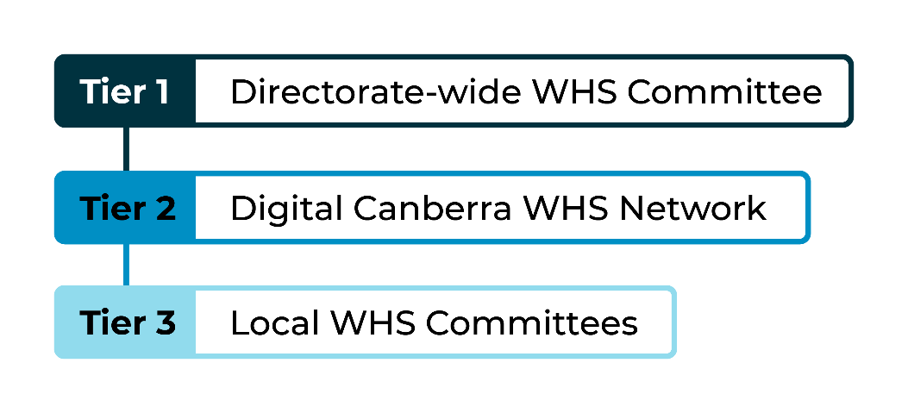
The Tier 1 WHS Committee provides strategic oversight of WHS matters, supports consultation on emerging risks and initiatives and promotes continuous improvement in health, safety and wellbeing outcomes.
The Tier 1 Committee was the primary consultative forum during the reporting period, with further development of Tier 2 and Tier 3 consultation arrangements occurring as part of Digital Canberra’s ongoing WHS maturity program. The SWIM team supports these arrangements and works collaboratively with business areas, HSRs, BUCOs and employees to strengthen WHS performance across the directorate.

Health and Safety Representatives
As of 30 June 2026, Digital Canberra had 15 elected Health and Safety Representatives (HSRs).
Appointed under the Work Health and Safety Act 2011, HSRs represent workers on WHS matters and play a vital role in supporting consultation between workers and management. HSRs contribute to the identification and management of workplace risks, promote safe work practices and help foster a positive safety culture across the directorate.

WHS audits
A WHS management system audit was conducted by KPMG during the reporting period. The audit assessed Data, AI and Digital Records' compliance with the CMTEDD PeopleSafety WHS Management System using the PeopleSafety Baseline WHS Audit Tool 2025.
The audit achieved an overall compliance score of 79 per cent and found WHS arrangements were generally established and operating effectively. Seven recommendations for corrective action and ten opportunities for improvement were identified. An action plan was developed to address the findings and support continuous improvement in WHS governance, risk management and assurance practices.

Top three WHS risks
During 2025–26, the SWIM team prioritised the following key WHS risks enhancing the safety, health and wellbeing of workers across Digital Canberra.

Psychosocial hazards
We continued to identify and manage psychosocial hazards through consultation, psychosocial risk assessments, manager capability development, early intervention strategies and employee wellbeing initiatives. This included the ongoing development, implementation and review of psychosocial risk assessments to support the identification and management of psychosocial risks.

Change fatigue
As a newly established directorate experiencing significant organisational change, Digital Canberra monitored risks associated with workload, uncertainty, role clarity and employee wellbeing. Controls included change management activities, employee consultation, leadership communication, wellbeing support services and targeted engagement activities to support employees through periods of change.

Musculoskeletal disorders
Digital Canberra implemented a range of early intervention and injury prevention initiatives to minimise the risk and impact of musculoskeletal injuries. These initiatives included ergonomic assessments, workplace adjustments, rehabilitation support, ergonomic education and early intervention strategies to assist employees to remain at work or return to work safely and sustainably.

Reported incidents
Digital Canberra encourages the reporting of incidents, hazards and near misses to support learning, prevention and continuous improvement. Reported incidents are reviewed to identify contributing factors, implement corrective actions and reduce the likelihood of recurrence.
During 2025–26, 56 workplace accidents and incidents were reported across the Directorate. One incident required notification to WorkSafe ACT under section 38 of the Work Health and Safety Act 2011. Of these reported incidents, 11 were hazardous situations and 45 were incidents reported through Digital Canberra’s Safety Portal.

Enforcement measures

Improvement Notices
During 2025–26, WorkSafe ACT issued one Improvement Notice to Digital Canberra. The notice required the directorate to review and strengthen its psychosocial hazard management arrangements, including ensuring risk assessments were targeted, comprehensive and current.
In response, we undertook a review of our psychosocial risk management practices and implemented actions to strengthen the identification, assessment and management of psychosocial risks. All actions associated with the Improvement Notice were completed within the required compliance timeframe and the notice was subsequently closed.

Prohibition notices
No prohibition notices were issued to Digital Canberra during 2025–26.

Non-disturbance notices
No non-disturbance notices were issued to Digital Canberra during 2025–26.

Enforceable undertakings
Digital Canberra was not subject to any enforceable undertakings during 2025–26.

Failure to comply with safety duties
No findings of failure to comply with safety duties under Work Health and Safety legislation were recorded for Digital Canberra during 2025–26.

Injury prevention
During the year, Digital Canberra reinforced our commitment to WHS and employee wellbeing through a range of strategic initiatives, operational improvements and targeted support programs.

Training and capability building
Digital Canberra continued to invest in building organisational capability to support a safe, healthy and psychologically safe workplace.
In addition to maintaining mandatory WHS training requirements, including First Aid, Emergency Warden and Health and Safety Representative (HSR) training, we delivered a range of initiatives to strengthen WHS knowledge and leadership capability across the organisation.
Acknowledging the risk profile of psychosocial hazards, we delivered awareness and risk management training to equip participants with practical skills to identify, assess and manage psychosocial hazards and contribute to a psychologically safe workplace.
The directorate also delivered targeted training and awareness activities to strengthen leadership capability in relation to employee wellbeing, workplace adjustments and health and safety responsibilities. These initiatives supported managers to develop confidence in identifying emerging risks, engaging in meaningful consultation and fostering positive workplace cultures.
Through regular communications, workshops and consultation activities, we continued to promote awareness of WHS obligations, available support services and individual responsibilities for maintaining a safe and healthy workplace.

Injury prevention and physical wellbeing
Digital Canberra continued to implement a range of injury prevention, early intervention and rehabilitation initiatives to support employee health, wellbeing and sustainable participation at work.
Managers and employees were provided with coaching, advice and tailored support to assist with early intervention, injury management and return-to-work processes. Emphasis was placed on supporting recovery from both compensable and non-compensable injuries and illnesses and facilitating timely access to suitable workplace supports.
The directorate promoted a systems-based approach to injury prevention through ergonomic assessments, workplace adjustments and proactive risk management strategies designed to reduce the likelihood and impact of workplace injuries, particularly musculoskeletal disorders.
Through partnership arrangements with CMTEDD's Reasonable Adjustment Service, employees and managers were able to access specialist support from Workplace Rehabilitation Providers to identify and implement appropriate workplace adjustments. These services assist employees to safely perform the inherent requirements of their role, reduce barriers to participation and support successful return-to-work outcomes.
Digital Canberra also delivered injury prevention and rehabilitation awareness sessions for senior leaders and managers to strengthen understanding of their role in supporting employee recovery, workplace participation and sustainable return-to-work outcomes.
These initiatives contributed to our ongoing commitment to preventing workplace injury, promoting employee wellbeing and supporting positive return-to-work outcomes.

Mental health and wellbeing support
The directorate continued to prioritise mental health and psychological safety, delivering a broad range of initiatives to support staff and volunteers.

Counselling and psychological services
Digital Canberra employees had access to a range of confidential support services aimed at promoting mental health, wellbeing and early intervention. These included the Employee Assistance Program (EAP), critical incident support services where required and access to Before Blue, a free and confidential early intervention mental health coaching service delivered by Beyond Blue.

Support networks
Digital Canberra staff were able to connect with the Respect, Equity and Diversity (RED) Contact Officers and the BUCO network, both focussed on fostering positive workplace culture through providing peer-based assistance and guidance.

Wellbeing engagement
Digital Canberra actively promoted health, safety and wellbeing through a range of awareness campaigns, events and communication activities throughout the reporting period. These initiatives were designed to strengthen employee connectedness, foster inclusion and contribute to a psychologically safe workplace where employees feel respected, valued and supported.
Activities included participation in National Reconciliation Week, Harmony Week, Diwali celebrations, International Women's Day, Wear it Purple and The Push-Up Challenge.

Mental health and wellbeing ongoing promotion
Wellbeing resources, support services and educational materials were also promoted through internal communication channels to increase awareness, encourage help-seeking behaviours and support positive health and wellbeing outcomes across the directorate.

WHS and wellbeing future focus
Digital Canberra remains committed to fostering a safe, healthy and inclusive workplace that enables our people to thrive. Across 2025–26, we have continued to build our work health and safety and wellbeing capability while embedding a positive organisational culture founded on collaboration, respect and continuous improvement.

Active participation in the ACTPS Your Voice Survey has provided valuable insights into employee experience and wellbeing, helping to shape strategic priorities and inform future initiatives. Digital Canberra also actively contributed to the ACTPS Your Voice Community of Practice, collaborating with other directorates to share learnings, identify opportunities for improvement and support a coordinated approach to enhancing employee engagement and workplace culture across the ACTPS.

In response to employee feedback and emerging organisational needs, we are progressing the development of our first Wellbeing Plan. The plan will provide a strategic framework to support the physical, psychological and social wellbeing of employees. With a focus on psychological safety, social connection, healthy work practices, inclusion and workforce resilience. Development of the plan will be informed by employee feedback, whole-of-government priorities and contemporary wellbeing approaches.

Digital Canberra will also continue to strengthen our approach to managing psychosocial hazards through participation in whole-of-government forums and communities of practice. These collaborative arrangements support the sharing of knowledge, coordinated action and the adoption of best-practice approaches to psychosocial risk management across the ACTPS.

Together, these initiatives demonstrate Digital Canberra's commitment to continuous improvement, evidence-based decision-making and proactive investment in the health, safety and wellbeing of its workforce.

Performance Against Australian Work Health and Safety Strategy
Target: Reduce the incident rate of claims resulting in one or more weeks off work by at least 10 per cent, measured as the rate per 1,000 FTE employees.

In 2025-26, Digital Canberra did not achieve the ACTPS Work Health Safety and Wellbeing Strategy target to achieve a 10 per cent reduction over five years (to 2028-29), or a 2 per cent reduction year on year from the result achieved in 2024-25.

The Digital Canberra target was set at an incidence rate of 2.39 per 1,000 full-time employees resulting in one or more weeks off work, with 3.31 claims per 1,000 full-time employees achieved.

Human resources management
Digital Canberra fosters a productive, inclusive and high-performing workplace culture through the delivery of a broad range of human resources policies, programs, advisory services and workforce initiatives that support a safe, engaged and capable workforce.
We enable this by providing strategic and operational workforce support to managers and employees across the directorate, including:
- recruitment and employee lifecycle support
- workforce capability and development
- leadership development, coaching and organisational culture initiatives
- industrial and employee relations advice and support
- workplace health and safety (WHS), wellbeing and injury management.

Culture, attraction and retention
Digital Canberra was established on 1 July 2025 as a new ACT Government organisation bringing together people, functions and expertise from across government.
During its first year of operation, we focused on supporting employees through organisational transition and fostering a cohesive organisational culture. Priority was given to embedding new ways of working, promoting ACTPS values and expected workplace behaviours and supporting employees through a period of significant organisational change.
Key activities included:
- supporting the transition of employees and functions into Digital Canberra
- promoting ACTPS values and expected workplace behaviours
- supporting employees and leaders through organisational change
- establishing organisational structures and governance arrangements to support a unified operating model
- implementing foundational people management processes and practices.
Supporting positive workforce culture, our staff continued to benefit from flexible working conditions, predominantly working in a hybrid capacity, with employees working across both office and remote settings, enabling work life balance.
The emphasis on human resource management will continue as business areas embed new structures and build organisational capability to ensure our workforce practices align with the directorate’s evolving operating model and strategic objectives.
Throughout 2025–26, Digital Canberra delivered initiatives that enhanced employee capability, supported organisational effectiveness and promoted employee wellbeing. These will be further enhanced with the development and implementation of future workforce strategies.

Attraction and Retention Incentives
An Attraction and Retention Incentive (ARIn) is a special, position-based arrangement used where the standard enterprise agreement pay and conditions may not be sufficient to attract or retain people with critical or hard-to-source skills. An ARIn can provide additional pay and/or different conditions, recorded in a written agreement between the Director-General and the employee. These are discretionary, time-limited and reviewable arrangements rather than an ongoing entitlement and must be justified by the technical requirements of the position and recruitment or retention circumstances.
Digital Canberra currently has 19 employees on ARIns at the classifications outlined in the table below:
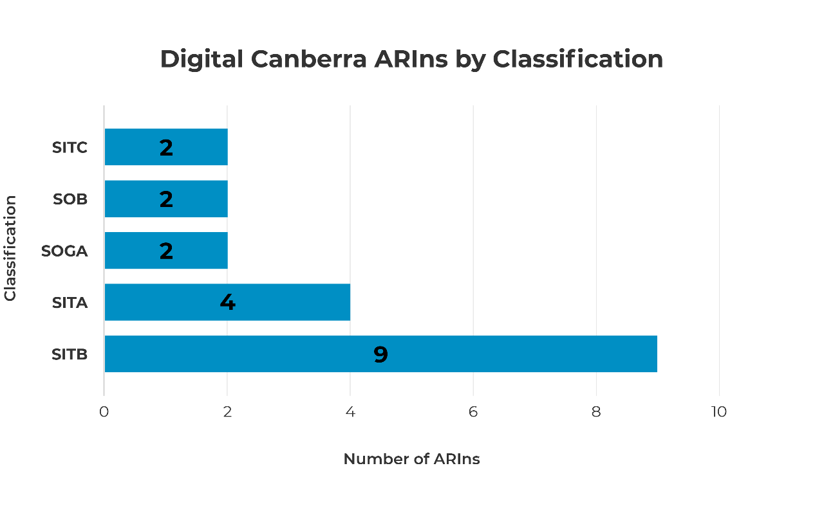

Workforce planning and employment strategies
During the reporting period, Digital Canberra focused on establishing the workforce foundations required to support the delivery of its strategic objectives and services.
Key activities included:
- resourcing critical corporate functions, including people and culture, finance, governance, procurement and business support
- supporting recruitment activities to fill critical roles and maintain service delivery
- implementing foundational workforce management policies, processes and systems
- establishing workforce governance arrangements to support effective decision-making
- commencing workforce planning activities to identify future workforce and capability requirements and support long-term attraction, retention and capability-building strategies.
These activities have established the foundations for a sustainable and capable workforce and will inform future workforce strategies, capability development initiatives and workforce investment decisions.

Capability
In 2025–26, Digital Canberra focused on building the foundations of a workforce capability function while supporting employees through the transition from HCSD and CMTEDD. Key activities included:
- maintaining access to HCSD, CMTEDD and whole-of-government learning programs
- maintaining compliance with mandatory, legislative and regulatory training requirements
- supporting participation in leadership, mentoring and management development programs
- identifying workforce capability priorities aligned with Digital Canberra’s strategic objectives
- commencing work to establish a dedicated Digital Canberra learning library and workforce capability framework

Learning and development programs and activities
During 2025–26, Digital Canberra employees completed learning across a broad range of capability areas, including:
- workplace health and safety
- leadership and management
- procurement
- integrity
- risk management
- security and cyber security
- diversity and inclusion
- cultural capability and wellbeing
- data literacy
- digital capability
- professional development
As Digital Canberra was established on 1 July 2025, employees continued to access learning opportunities through HCSD, CMTEDD and whole-of-government learning libraries. This ensured employees could access a diverse range of learning resources while Digital Canberra's own learning and capability arrangements were being developed.
In addition to learning recorded in HRIMS Learning, Digital Canberra employees participated in several leadership development initiatives delivered through CMTEDD. Participation included:
- four mentors and five mentees in the 2026 CMTEDD Mentoring Program
- nine participants in the Supervisor Development Program
- four participants in the Advanced People Managers Program
- three participants in leadership coaching.
Additional Digital Canberra employees may have accessed coaching through arrangements not captured in these figures.
The tables below outline course offerings, course completions and participation in learning and development activities during 2025–26.

Table 14: Digital Canberra 2025/26 course completions
eLearning |  |  | Instructor-Led
 | No. of courses | No. of completions |  | No. of courses | No. of completions
CMTEDD Courses | 31 | 2138 |  | 17 | 182
ACTHD Courses | 122 | 632 |  | 9 | 16
ACTPS (WhoG) Courses | 66 | 2009 |  | 16 | 107
Total | 219 | 4779 |  | 42 | 305

Future learning and development
In 2026–27, Digital Canberra will continue to strengthen its workforce capability approach and establish the foundations of a dedicated capability function. Priorities include:
- developing a workforce capability framework
- strengthening leadership and management capability
- improving workforce capability planning and reporting
- establishing a dedicated Digital Canberra learning library aligned to the directorate's workforce capability requirements, strategic priorities and organisational culture.

Gender Action Plan and Gender Impact Assessment reporting
Digital Canberra recognises the importance of advancing gender equality and considering gender impacts in decision-making, policy development and service delivery.
During 2025–26, Digital Canberra's focus was on establishing foundational governance, planning and assurance arrangements as part of the organisation's establishment. As a result, a comprehensive Gender Action Plan and Gender Impact Assessment Report could not be developed during the reporting period.
Digital Canberra remains committed to embedding gender equality principles within its organisational planning and service delivery frameworks and as the organisation develops, Digital Canberra will progressively enhance its capability to undertake gender analysis, identify priority actions, engage with employees and stakeholders and support future reporting on gender equality outcomes.

Staffing profile
The staff numbers in the tables below represent Digital Canberra employees who received a payment on the last payday of 2025–26. The figures exclude board members and staff on leave without pay.
Recruitment and separation rates are defined as commencing or departing the ACTPS respectively for permanent employees and Executive Officers with long-term contracts.
Diversity data which may identify individuals has been removed from some tables.
Note: Workforce data contained within this section represents a point-in-time extract as at 30 June 2026. Due to the scale and complexity of Digital Canberra's establishment and the transition of functions and employees through Machinery of Government processes, a number of establishment records continued to reflect legacy organisational arrangements at the reporting date. During 2026-27, Digital Canberra completed an establishment data remediation and organisational alignment exercise to improve the accuracy and consistency of workforce reporting, organisational hierarchies and establishment structures. Consequently, future reporting may differ from 2025-26 presentations where legacy transitional arrangements have since been resolved.

Table 15: FTE (full-time equivalent) and headcount by business area
Business Unit | FTE | Headcount
Corporate Services Group
Communications and Engagement Branch | 10.8 | 11
Corporate Services – other | 1.0 | 1
Ministerial and Government Services Branch | 6.8 | 7
People and Capability Branch | 15.8 | 16
Customer, Data and Technology Group
ACT Cyber Security Centre | 40.8 | 41
Customer Engagement Services Branch | 217.5 | 219
Data, AI and Digital Records Branch | 29.9 | 30
Technology Services Branch | 137.7 | 139
Digital Health Group
Application Support Branch | 79.5 | 81
Capital Projects Team | 2.8 | 3
Executive Group Manager Office | 20.6 | 21
Future Capability Branch | 56.4 | 57
Technology Operations Branch | 105.7 | 107
Planning, Design and Digital Group
Design and Strategy Branch | 21.2 | 22
Digital Communities Branch | 25.4 | 26
Major Programs Branch | 31.8 | 32
Strategic Finance and Assurance Group
Governance and Risk Branch | 10.0 | 10
Strategic Finance Branch | 19.4 | 20
Strategic Finance – other | 2.0 | 2
Strategic Sourcing and Portfolio Management Branch | 49.3 | 50
Digital Canberra Executive | 19.9 | 20
Digital Canberra MOG Transition Team | 3.0 | 3
TOTAL | 907.4 | 918

Table 16: Headcount by classification group and gender
Classification Group | Female | Male | Non-Binary | Total
Administrative Officers | 93 | 59 | 0 | 152
Executive Officers | 13 | 11 | 0 | 24
General Service Officers & Equivalent | 0 | 4 | 0 | 4
Health Professional Officers | 7 | 4 | 0 | 11
Information Technology Officers | 46 | 152 | 1 | 199
Nursing Staff | 1 | 0 | 0 | 1
Senior Officers | 210 | 316 | 1 | 527
TOTAL | 370 | 546 | 2 | 918

Table 17: Headcount by employment category and gender
Employment Category | Female | Male | Non-Binary | Total
Casual | 0 | 0 | 0 | 0
Permanent  Full-time | 316 | 512 | 2 | 830
Permanent  Part-time | 29 | 13 | 0 | 42
Temporary  Full-time | 24 | 20 | 0 | 44
Temporary  Part-time | 1 | 1 | 0 | 2
TOTAL | 370 | 546 | 2 | 918

Table 18: Headcount by diversity group
Diversity group | Headcount | Percentage (%) of Agency Workforce
Aboriginal and/or Torres Strait Islander | 14 | 1.5%
Culturally and Linguistically Diverse | 316 | 34.4%
People with a disability | 35 | 3.8%

Table 19: Headcount by age group and gender
Age Group | Female | Male | Non-Binary | Total
Under 25 | 5 | 4 | 0 | 9
25-34 | 87 | 141 | 1 | 229
35-44 | 137 | 185 | 0 | 322
45-54 | 93 | 137 | 1 | 231
55 and over | 48 | 79 | 0 | 127
TOTAL | 370 | 546 | 2 | 918

Table 20: Average length of service by gender
 | Female | Male | Non-Binary | Total
Average years  of service | 9.4 | 9.2 | 4.8 | 9.3

Table 21: Permanent recruitment and separation rates
 | Recruitment rate (%) | Separation rate (%)
Digital Canberra | 6.8% | 4.0%

Table 22: Gender pay gap
Classification group | Female | Male | Pay gap (%)
Administrative Officers | 106,261 | 105,350 | -0.9%
Executive Officers | 262,711 | 245,901 | -6.8%
General Service Officers & Equivalent | 0 | 96,434 | 0.0%
Health Professional Officers | 158,590 | 163,983 | 3.3%
Information Technology Officers | 107,429 | 107,598 | 0.2%
Nursing Staff | 172,883 | 0 | 0.0%
Senior Officers | 152,562 | 153,674 | 0.7%
TOTAL | 139,352 | 137,140 | -1.6%
Note: Female overall average pay = $139,352; Male overall average pay = $137,140 resulting in a negative pay gap overall.

Contact
For further information, please contact:
People and Capability Branch
DCBRPeopleandCapability@act.gov.au
Ecological sustainability reporting

Support to the Commissioner for Sustainability and Environment
As an enabling service provider to ACT Government directorates, Digital Canberra has limited direct responsibility for the management of natural resources. However, the directorate contributes to ecologically sustainable development through initiatives that support the ACT's circular economy, including the responsible disposal, reuse, and recycling of ICT assets.

Business area activities

Improving waste, reuse and recycling
Digital Canberra reduces waste through the responsible management of surplus ICT equipment and participation in workplace recycling programs. ICT equipment that reaches the end of its useful life is reused, remarketed or recycled through contracted disposal arrangements. During 2025–26, Digital Canberra processed 15,920 ICT assets (335 pallets), generating returns of $547,550 to the ACT Government.
Highlights:
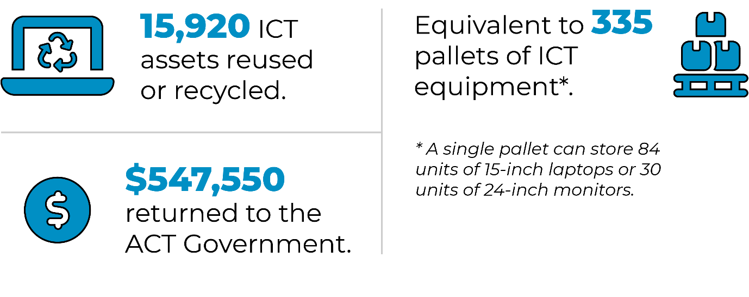
Digital Canberra staff were principally located at four ACT Government office sites:
- 220 London Circuit, Civic
- Winyu House, Gungahlin
- 2-6 Bowes Street, Phillip
- 5 Beaconsfield Street, Fyshwick
At these locations, staff participated in paper and cardboard recycling, co-mingled recycling, organics collection and landfill waste programs. The quantities of waste and recyclable materials collected during 2025–26 is outlined below.

Table 23: Digital Canberra waste and recycling at ACT Government offices
Item | 220 London Cct | Winyu House | 2-6 Bowes St.¹ | 5 Beaconsfield St¹ | TOTAL (tonnes)
Waste to landfill | 0.32 | 3.52 | Unavailable | Unavailable | 3.84
Co-mingle recycle | 0.06 | 1.07 | Unavailable | Unavailable | 1.13
Paper and cardboard | 0.09 | 2.30 | Unavailable | Unavailable | 2.39
Organics | 0.01 | N/A | Unavailable | Unavailable | 0.01
Note: ¹ At the time of writing, Digital Canberra’s recycling data for these locations was unavailable.

Promoting sustainable transport
Digital Canberra was established as a standalone directorate on 1 July 2025. During 2025–26, the Directorate accessed 12 vehicles to support service delivery. Management and funding responsibility for these vehicles remained with CMTEDD and HCSD under Memorandum of Understanding arrangement.
Preparatory work was undertaken during the reporting period to support the transition of fleet management responsibilities to Digital Canberra. The future fleet is expected to be based at Winyu House, Gungahlin; 2-6 Bowes Street, Phillip; and 5 Beaconsfield Street, Fyshwick and to support the ACT Government's sustainability objectives by using electric and hybrid vehicles where operationally appropriate.

Sustainability in procurement
In 2025–26, Digital Canberra incorporated environmental sustainability considerations into ICT procurement activities in accordance with the Government Procurement (Charter of Procurement Values) Direction 2020, including the Environmental Responsibility procurement value.
Environmental considerations will also inform future vehicle procurement decisions, with electric vehicle options assessed in accordance with the ACT's Zero Emissions Vehicles Strategy 2022-30.

Sustainable development performance
The following table outlines Digital Canberra's energy use and greenhouse gas emissions for 2025–26, based on office occupancy and fleet vehicle use.

Table 24: Sustainable Development performance
Indicator as of 30 June | Unit | Current FY² | Previous FY³ | Percentage change³
Stationary energy usage
Electricity | Kilowatt hours | 500,328 | N/A | N/A
Fossil fuel gas (non-transport) | Megajoules | 894,612 | N/A | N/A
Diesel (non-transport) | Kilolitres | 0 | N/A | N/A
Liquid Petroleum Gas | Kilolitres | 0 | N/A | N/A
Fleet vehicles
Zero Emissions Vehicles (ZEV) | Number | 6 | N/A | N/A
Plug-in Hybrid Electric Vehicles (PHEV) | Number | 2 | N/A | N/A
Hybrid Electric Vehicles (HEV) | Number | 0 | N/A | N/A
Internal Combustion Engine (ICE) Vehicles | Number | 4 | N/A | N/A
Water usage
Water | Kilolitres | 766 | N/A | N/A
Resource efficiency and waste
Waste to landfill | Tonnes | 3.84 | N/A | N/A
Co-mingled material recycled | Tonnes | 1.13 | N/A | N/A
Paper & cardboard recycled (incl. secure paper) | Tonnes | 2.39 | N/A | N/A
Organic material recycled | Tonnes | 0.01 | N/A | N/A
Material recycled (incl. co-mingle recycling, paper and cardboard recycling and organic recycling) | Tonnes | 3.53 | N/A | N/A
Greenhouse gas emissions⁴
Emissions from fossil fuel gas use (non-transport)⁵ | Tonnes CO₂-e | 46 | N/A | N/A
Emissions from diesel use | Tonnes CO₂-e | 5.72 | N/A | N/A
Emissions from petrol and E10 use | Tonnes CO₂-e | N/A | N/A | N/A
Emissions from Compressed Natural Gas (transport) where applicable | Tonnes CO₂-e | N/A | N/A | N/A
Emissions from refrigerants⁶ | Tonnes CO₂-e | N/A | N/A | N/A
Total emissions | Tonnes CO₂-e | 51.72 | N/A | N/A
Notes:
¹ Data for this reporting period was extracted at 9am on 3 August 2026. At the time of data extraction, the ACT Government Enterprise Sustainability Platform had 97.68% actual data, 1.68% estimated data and 0.64% accrued data.
² At the time of writing, Digital Canberra’s percentage of energy and emissions data at 2-6 Bowes Street, Phillip, was unavailable.
³ Digital Canberra was created as an ACT Government directorate on 1 July 2025. Only 2025–26 data is available.
⁴ Emissions reported include Scope 1 and Scope 2 emissions only. Scope 1 are direct emissions from sources owned and operated by the government, including emissions from transport fuel, fossil fuel gas and refrigerants. Scope 2 emissions from mains electricity are considered zero in the ACT due to the ACT’s 100% renewable electricity supply.
⁵ Emission factors used to calculate natural gas and fleet fuel are based on the latest National Greenhouse Accounts factors.
⁶ Refrigerant data across ACT Government is progressively being updated as new assets are identified and documented. Current data is therefore limited and accuracy will be improved in future reporting years.

Contact
For further information, please contact:
Governance, Business Planning and Reporting
DCBR.Governance@act.gov.au

Part C

Financial management reporting

Management discussion and analysis

General overview
In response to the ACT Public Service 2025 Taskforce Report the ACT Government announced number of Administrative Arrangements effective from 1 July 2025. This resulted in the formation of Digital Canberra as a new Directorate through the transfer of Digital, Data and Technology Solutions from the Chief Minister, Treasury and Economic Development Directorate and the Digital Solutions Division from the former ACT Health Directorate. These changes to the ACT Public Service (ACTPS) structure were designed to better deliver the ACT Government’s priorities and meet community and stakeholder expectations.
Digital Canberra supports the evolution of Canberra into a smart and connected digital city, through leading edge initiatives, cyber secure information and communication technology. In addition, Digital Canberra plays a pivotal role in delivering secure, reliable and responsive digital services that underpin the ACT public health system. With a key role in delivering the ACT Digital Health Strategy, Digital Canberra ensures digital infrastructure, platforms, and services are aligned with the Territory’s health priorities and are developed and maintained to support safe, high-quality, person-centred care.
Digital Canberra aims to optimise digital, data and technology solutions that add real value to support Canberra as an attractive place to live, work and invest. Digital Canberra supports and evolves technology and data solutions in open partnership and genuine co-design with government and the community. Through active listening and continuous learning, we design and deliver solutions that make it easy for people to access the services they need, save them time and achieve government priority outcomes.
In collaboration across the ACT Public Service, Digital Canberra will take advantage of digital, data and technology to achieve better services for the community, more sustainable and efficient government, a more productive, engaged and capable workforce, and secure, connected, and patient-centred digital solutions for the delivery of healthcare.
Community: We support an inclusive, progressive and connected Canberra by:
- managing citizen data in an open, safe and transparent way;
- building citizen-focused solutions and services;
- using data to support better community services; and
- designing business process change in line with best practice.
Government: We position data and technology at the heart of decision-making and provide robust whole-of-government advice and services by:
- leading strategic technology investment and procurement;
- leading Territory and government wide outcomes;
- driving cross-government and jurisdictional collaboration; and
- guiding data and cyber security governance and management best practices.
Workforce: We are an employer of connected, engaged and skilled staff by:
- growing capabilities across digital, data and technology; and
- being the trusted advisor for digital, data and technology services.
Healthcare: We support the digital transformation of healthcare delivery by:
- implementing innovative digital technologies across the health system and supporting information and communication technology (ICT) solutions that enable person-centred care; and
- ensuring the end-to-end governance, coordination, and delivery of strategic digital initiatives that support the Territory’s health priorities.

Financial performance
Organisations often regard the operating result reported in their financial statements as a key indicator of how effectively financial performance has been managed during the year. However, this measure is less meaningful for government or not-for-profit entities, where recognised income is largely determined by the timing of cash drawdowns from the Territory Banking Account rather than by revenue-generating activities. A prudent approach to cash management, only drawing down cash as it is needed can reduce income recognised and lead to lower operating results.
Digital Canberra evaluates its financial performance through Net Cost of Services. Net Cost of Services reflects the full cost of resources consumed in delivering the Directorate's operations, offset by revenue received from independent sources. This measure demonstrates the extent to which the Directorate relies on government funding to support its operations. Performance against budgeted Net Cost of Services provides an indication of the Directorate's budget management and financial sustainability.
Financial information is based on audited Financial Statements for 2025-26.
The Administrative Arrangements 2025 (No. 1), which took effect on 1 July 2025, established Digital Canberra as a new Directorate through the transfer of Digital, Data and Technology Solutions from the Chief Minister, Treasury and Economic Development Directorate and the Digital Solutions Division from the Health and Community Services Directorate (former ACT Health Directorate). While the 2025-26 Budget reflected the transfer of funding associated with the core operational functions of these business areas, further budget adjustments, including the transfer of related corporate support resources, were implemented during the year through instruments made under the Financial Management Act 1996 (FMA).
Net cost of services for 2025-26 was $320.2 million compared to the budget of $306.7 million. Detailed explanations of the expenditure and own-source revenue variances are outlined in the sections below.

Table 25: Net Cost of Services
 | Actual 2025-26  $m | Original Budget*  2025-26 $m
Total Expenditure | 401.2 | 402.1
Total own Source Revenue | 81.0 | 95.4
Net Cost of Services | 320.2 | 306.7
*Original Budget - Budget figures outlined in the 2025-2026 Budget Statements

Expenditure
Figure 1: Components of Expenditure

Table 26: Expenditure variations from Original Budget
 | Actual 2026  $m | Original Budget*  2026 $m | Budget to Actual Variance $m
Employee Expenses | 147.9 | 134.2 | (13.7)
Supplies and Services | 192.0 | 224.4 | 32.4
Depreciation and Amortisation | 51.7 | 43.5 | (8.2)
Other | 9.6 | - | (9.6)
Total Expenditure | 401.2 | 402.1 | 0.9
*Original Budget - Budget figures outlined in the 2025-2026 Budget Statements
Digital Canberra’s staffing level for 2025-26 was 858 FTEs, with Employee Expenses representing 37 per cent of total expenditure. Employee Expenses were higher than ‘Original Budget’ mainly due to the transfer of corporate functions and associated staff from the Health and Community Services Directorate to Digital Canberra following changes to the Administrative Arrangements implemented in 2025-26. Funding for these functions were not included in the ‘Original Budget’ for 2025-26 and was subsequently transferred to Digital Canberra during the latter part of the year through instruments made under the FMA.
Supplies and Services accounted for 48 per cent of total expenditure and mainly includes software licensing and support costs for whole-of-government systems, including the Digital Health Record, ServiceNow and Microsoft platforms, as well as expenditure relating to consultant fees, contractors and professional services for multiple ICT initiatives across ACT Government.
Supplies and Services expenses were lower than ‘Original Budget’ mainly due to funding for multiple projects and initiatives being reprofiled from 2025-26 to 2026-27 due to revised procurement timeframes and updated project schedules including the Enterprise Resource Planning - Strategy and Procurement and Securing our Information and Data for the Future. Reprofiling these funds ensures continuity of project activities, meeting contractual obligations and maintain delivery of critical digital transformation initiatives by realigning funding profiles with the amended program delivery expectations.
The variance was also due to expenses no longer being recognised following the transfer of the related appropriation and functions from the Health and Community Services Directorate to Digital Canberra. Ongoing budget allocations have been updated through the 2026-27 Budget Statements to reflect these revised arrangements.
Depreciation and Amortisation expenses were higher than ‘Original Budget’, primarily due to laptops and desktop computers being capitalised and added to the Directorate's asset base.
Other Expenses largely relates to balances previously recognised as Capital Works and Software Works in Progress for various projects transferred from the Chief Minister, Treasury and Economic Development Directorate to Digital Canberra as part of the implementation of Administrative Arrangements, which were expensed during the year following a comprehensive review of works in progress balances and available information.

Own source revenue
Figure 2: Components of Own Source Revenue

Table 27: Own Source Revenue variations from Original Budget
 | Actual 2026  $m | Original Budget*  2026 $m | Actual to Budget Variance $m
Sales of Goods and Services from Contracts with Customers | 73.7 | 81.8 | (8.1)
Grants and Contributions Income | 6.8 | 9.8 | (3.0)
Other | 0.5 | 3.8 | (3.3)
Total Own Source Revenue | 81.0 | 95.4 | (14.4)
*Original Budget – Budget figures outlined in the 2025-26 Budget Statements
Digital Canberra’s primary sources of independent income were revenue and cost recoveries generated through the delivery of operational and project related ICT services to other ACT Government agencies.
Total own source revenue of $81.0 million was lower than the 2025-26 ‘Original Budget’ by $14.4 million or 15.1 per cent. This was mainly due to revenue no longer being recognised following the transfer of the related appropriation and functions from the Health and Community Services Directorate to Digital Canberra. Ongoing budget allocations have been updated through the 2026-27 Budget Statements to reflect these revised arrangements.

Financial position

Table 28: Assets/Liabilities
 | Actual 2025-26  $m | Original Budget*  2025-26 $m
Total Assets | 315.2 | 283.1
Total Liabilities | 97.8 | 61.8
Net Assets | 217.4 | 221.3
*Original Budget – Budget figures outlined in the 2025-26 Budget Statements
Total Assets at 30 June 2026 mainly consists of Intangible Assets (35 per cent), Property, Plant and Equipment (33 per cent), Cash (16 per cent), Prepayments (9 per cent) and Receivables and Contract Assets (7 per cent). Total Assets were higher than ‘Original Budget’ mainly due to cash balances held at year end, which will be utilised to settle outstanding supplier invoices and other liabilities in July 2026.
Total Liabilities at 30 June 2026 mainly consists of Employee Benefits (55 per cent) and Payables and Contract Liabilities (32 per cent). Total Liabilities were higher than ‘Original Budget’ mainly due to higher accrued wages and salaries at year end, due to the timing of payroll cycles and Employee Benefit liabilities for staff relating to corporate functions which transferred from the Health and Community Services Directorate to Digital Canberra following changes to the Administrative Arrangements implemented in 2025-26. Budgets relating to these functions were not included in the ‘Original Budget’ for 2025-26 and were subsequently transferred to Digital Canberra during the year. The variance also reflects outstanding supplier invoices received at year end, which are expected to be settled in July 2026.

Outlook
The transfer of Chief Information Officer (CIO) functions from other ACT Government agencies to Digital Canberra is currently being progressed as part of Phase 2 of the implementation of the Administrative Arrangements 2025 (No. 1). The identified functions, together with the associated resources and funding, are expected to be progressively transferred to Digital Canberra during the 2026-27 financial year. The proposed transfers are expected to have a significant impact on the Directorate’s operations and net cost of services in future years.
At this stage, the financial impact of these transfers cannot be reliably quantified, as the scope, timing and implementation arrangements remain subject to future Government decisions and have not yet been finalised. Accordingly, financial impact associated with the transfers have not been incorporated into the forward estimates.

Financial

Statements

Financial Statements

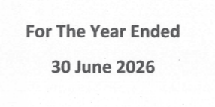
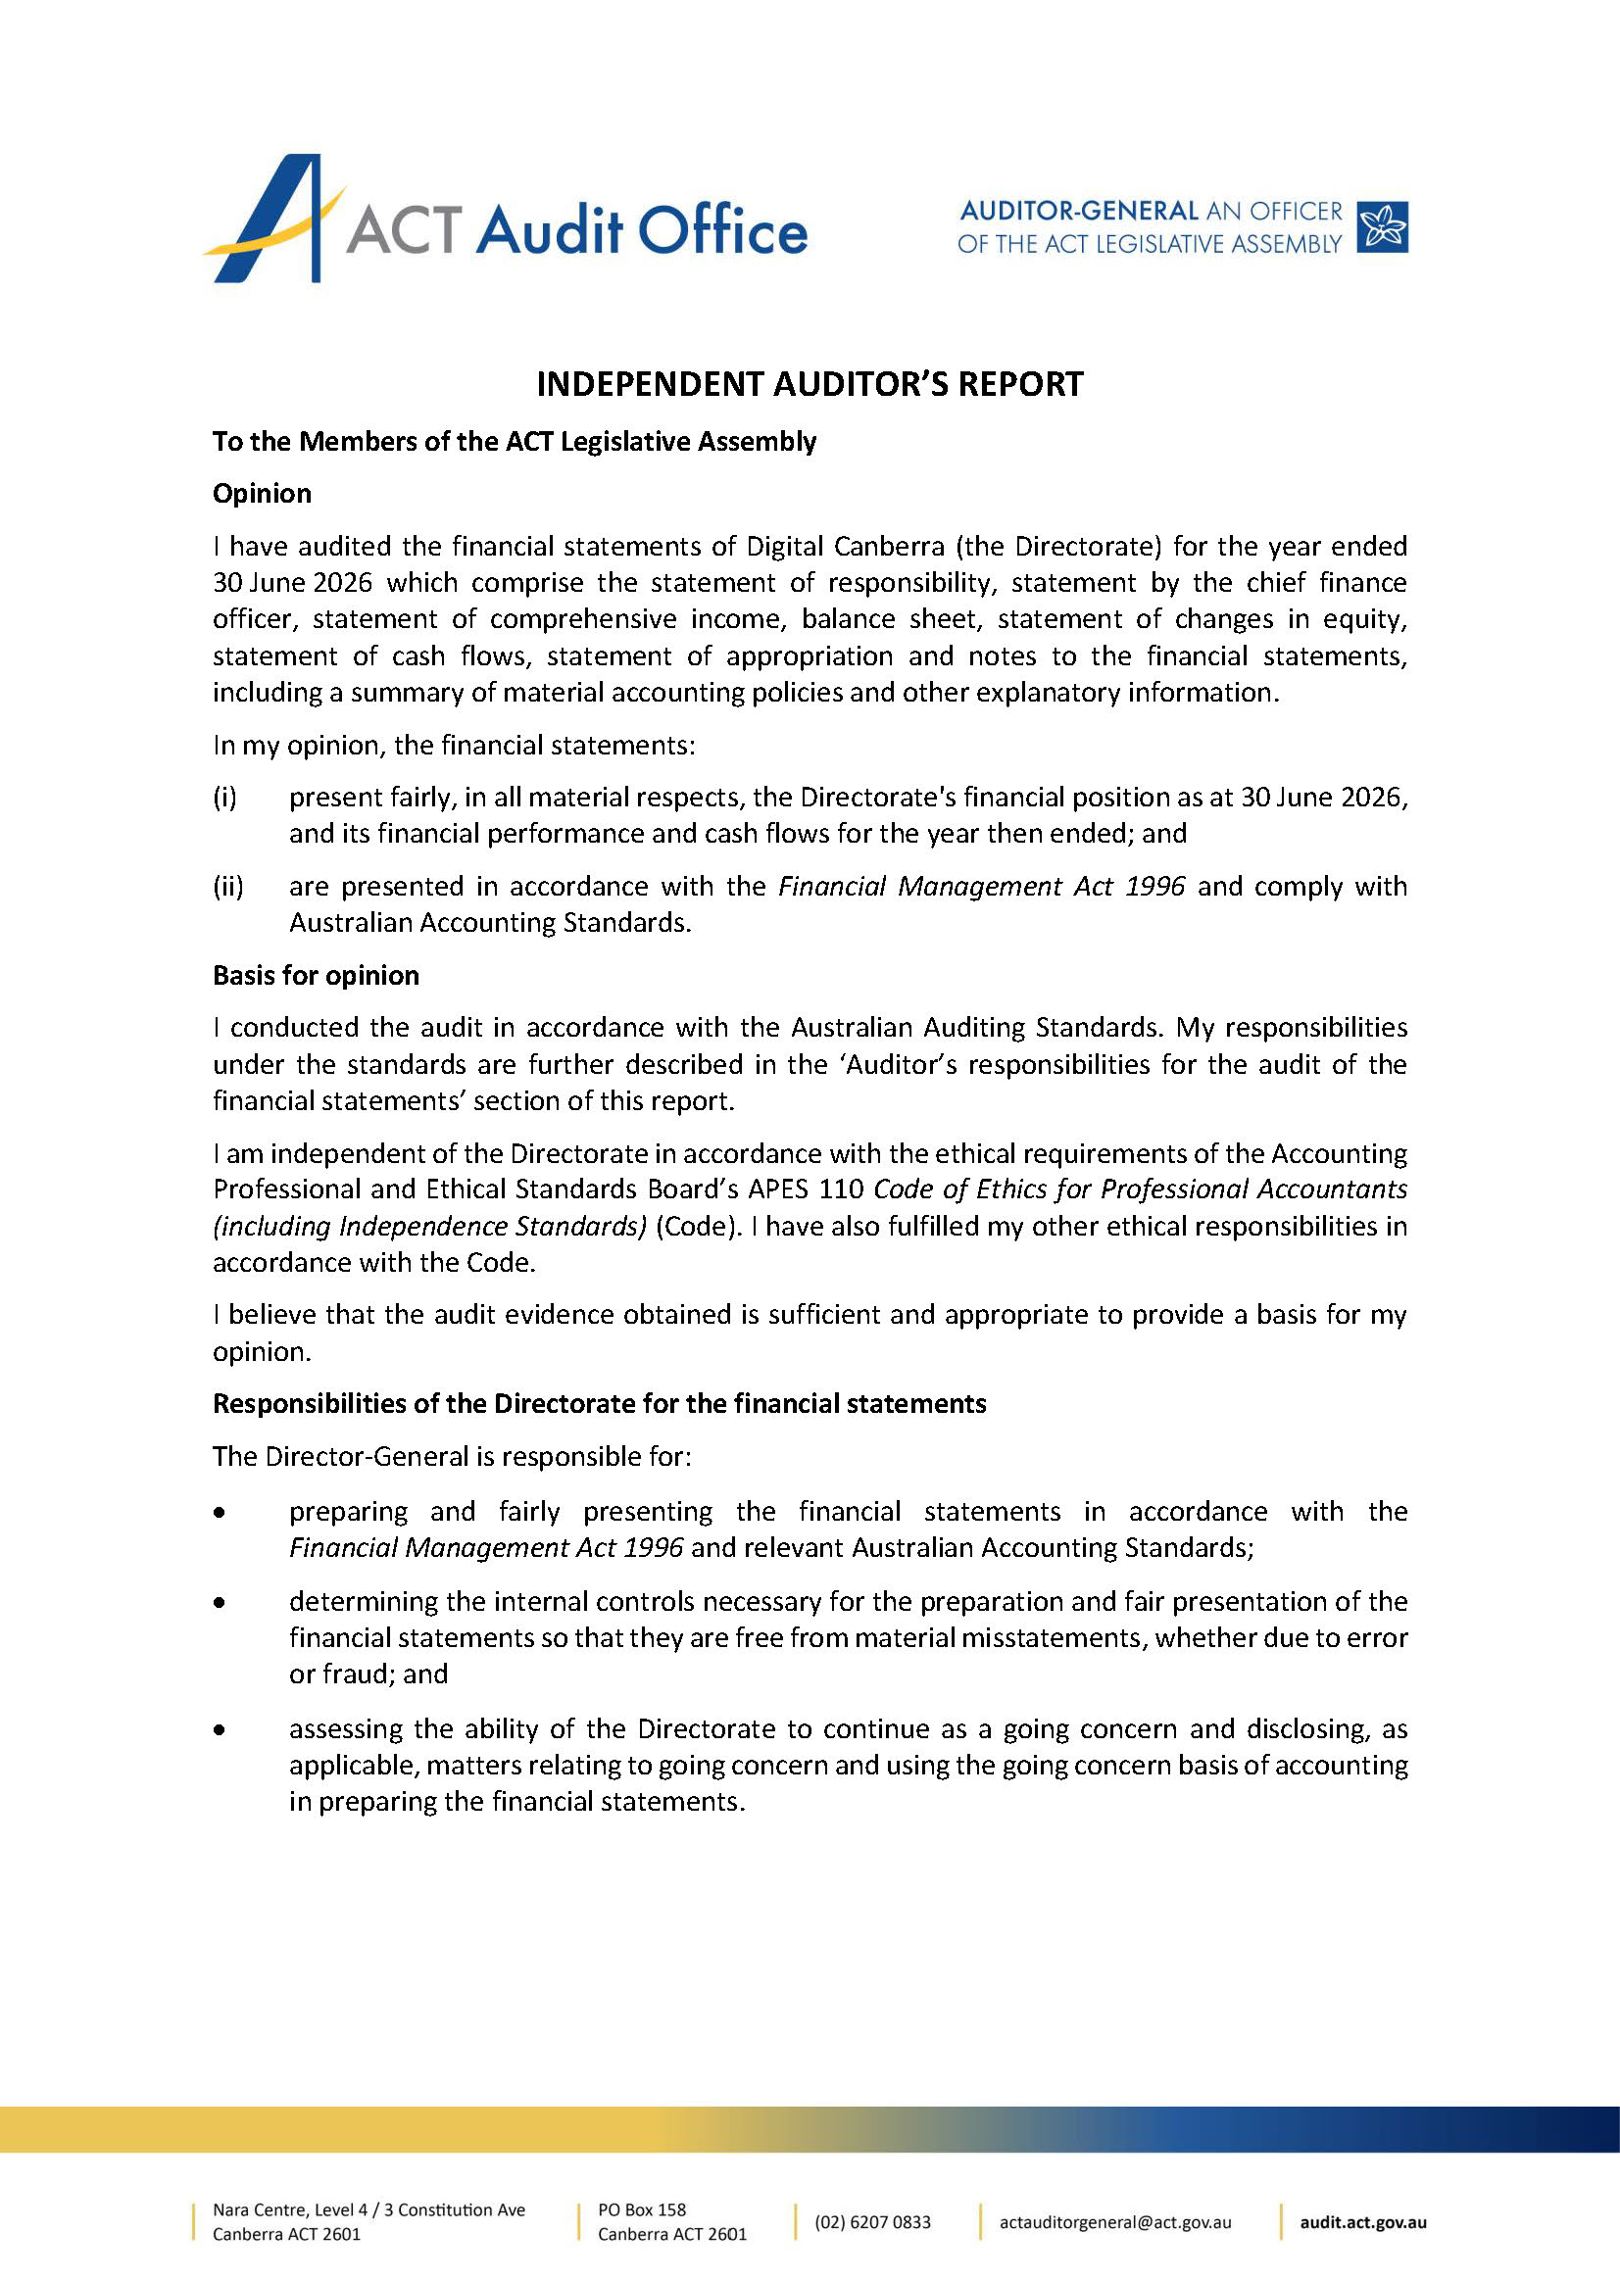
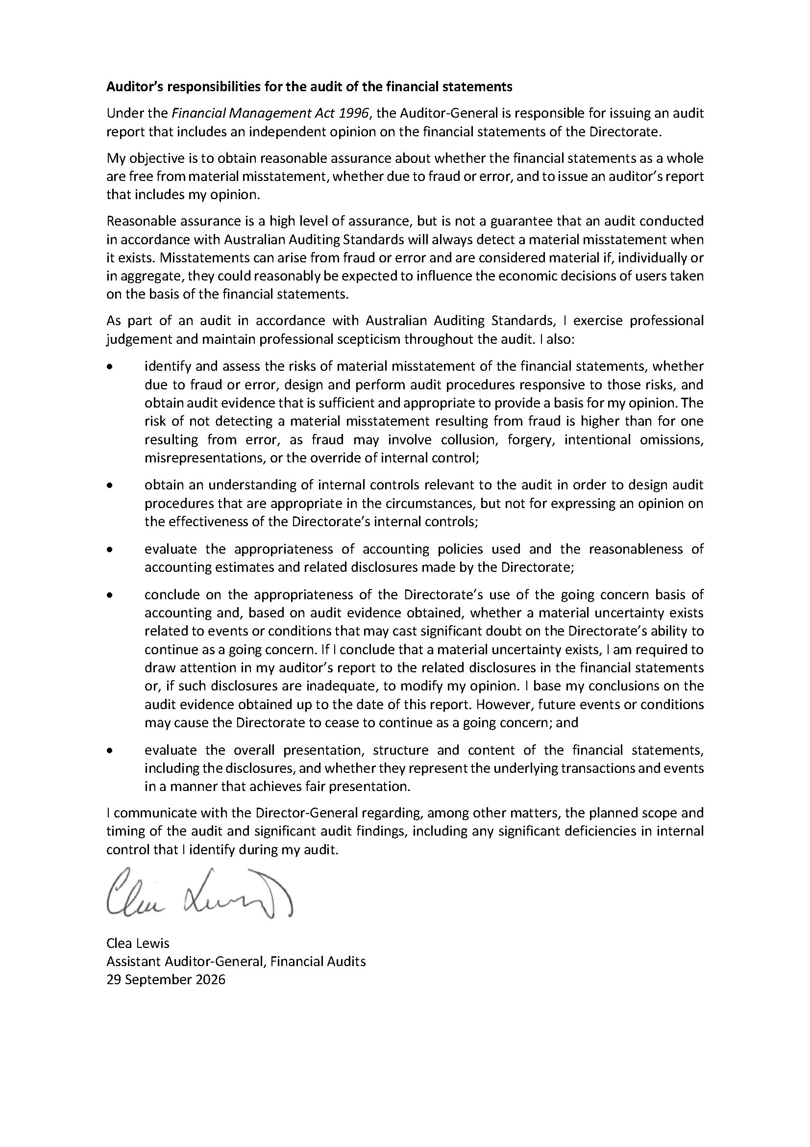
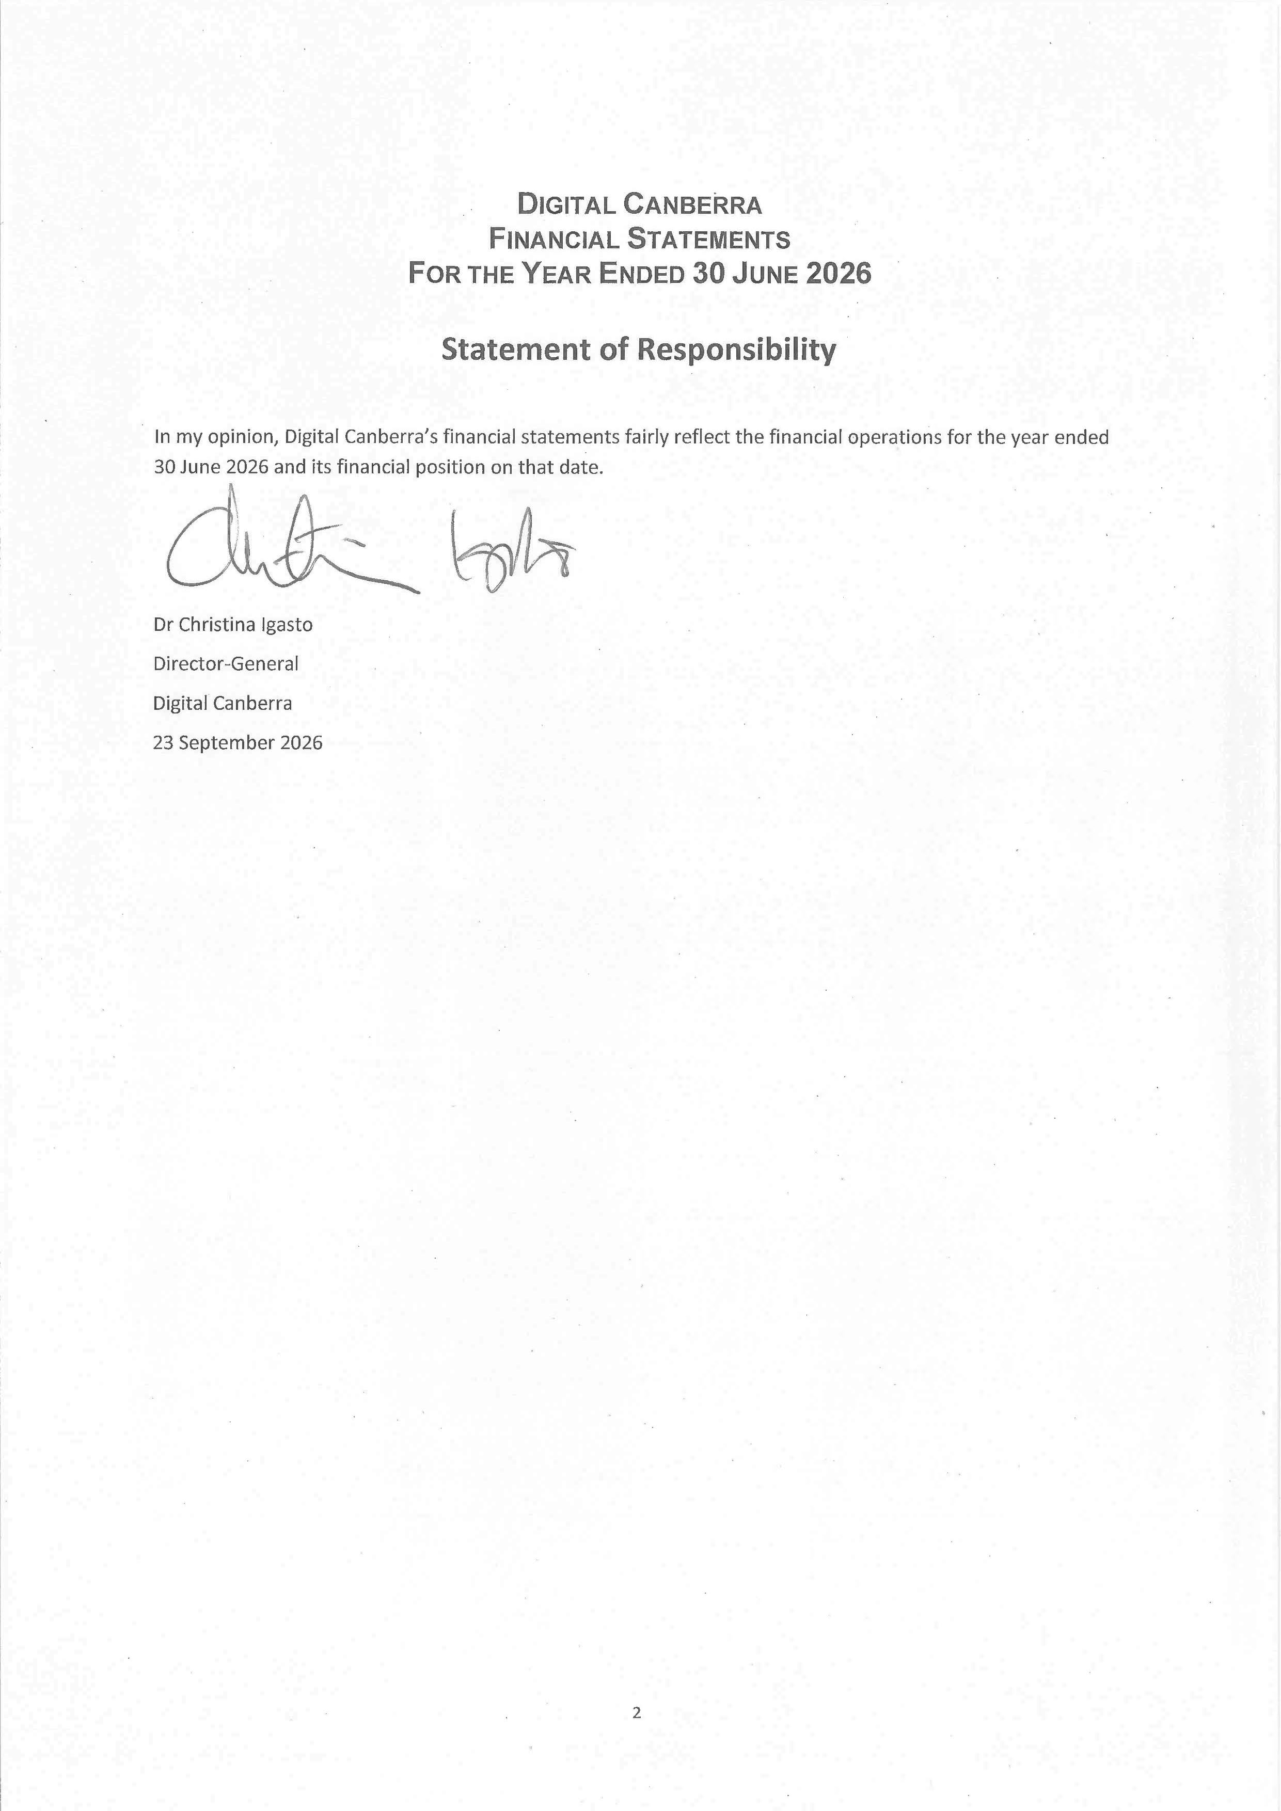
104

105
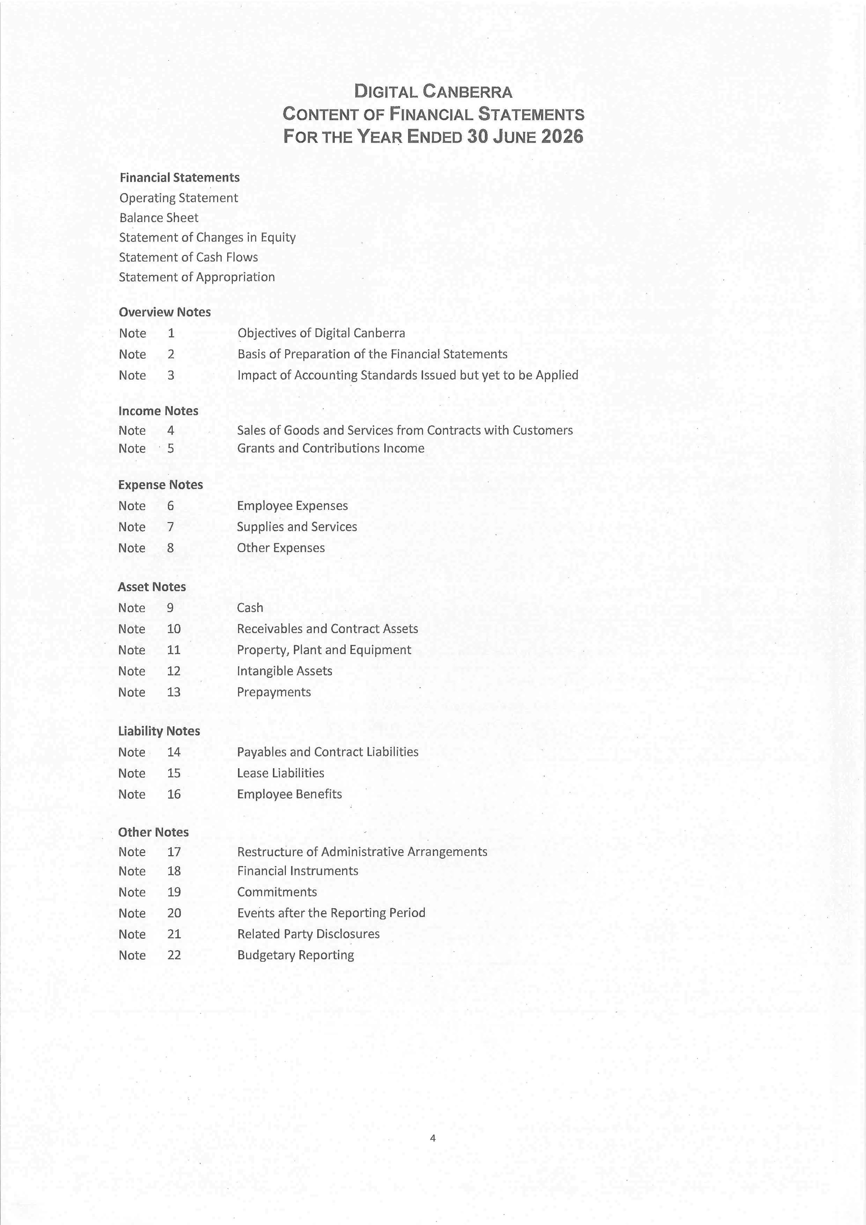
Page:
113
114
115
139
141
143
144
145
147
132
134
137

122
124
125
129
131
119
120
121
116
117
106
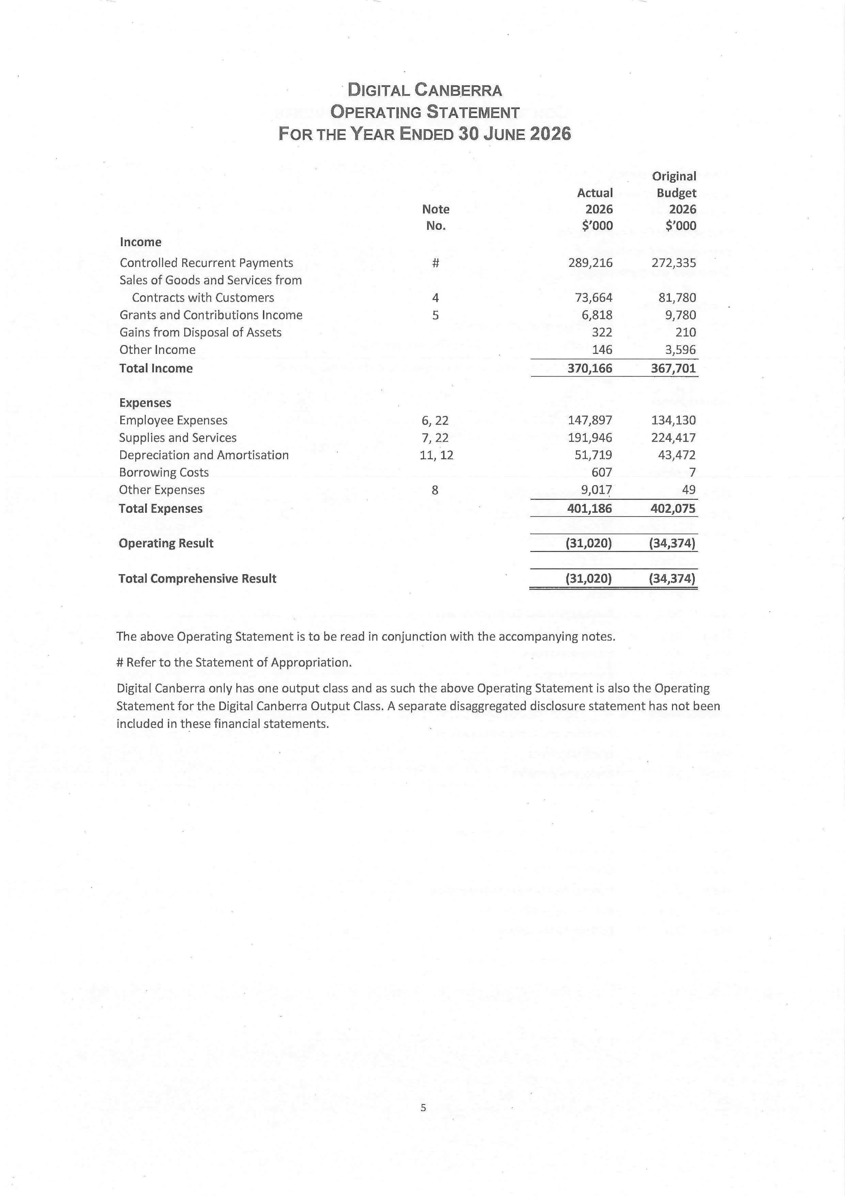
107
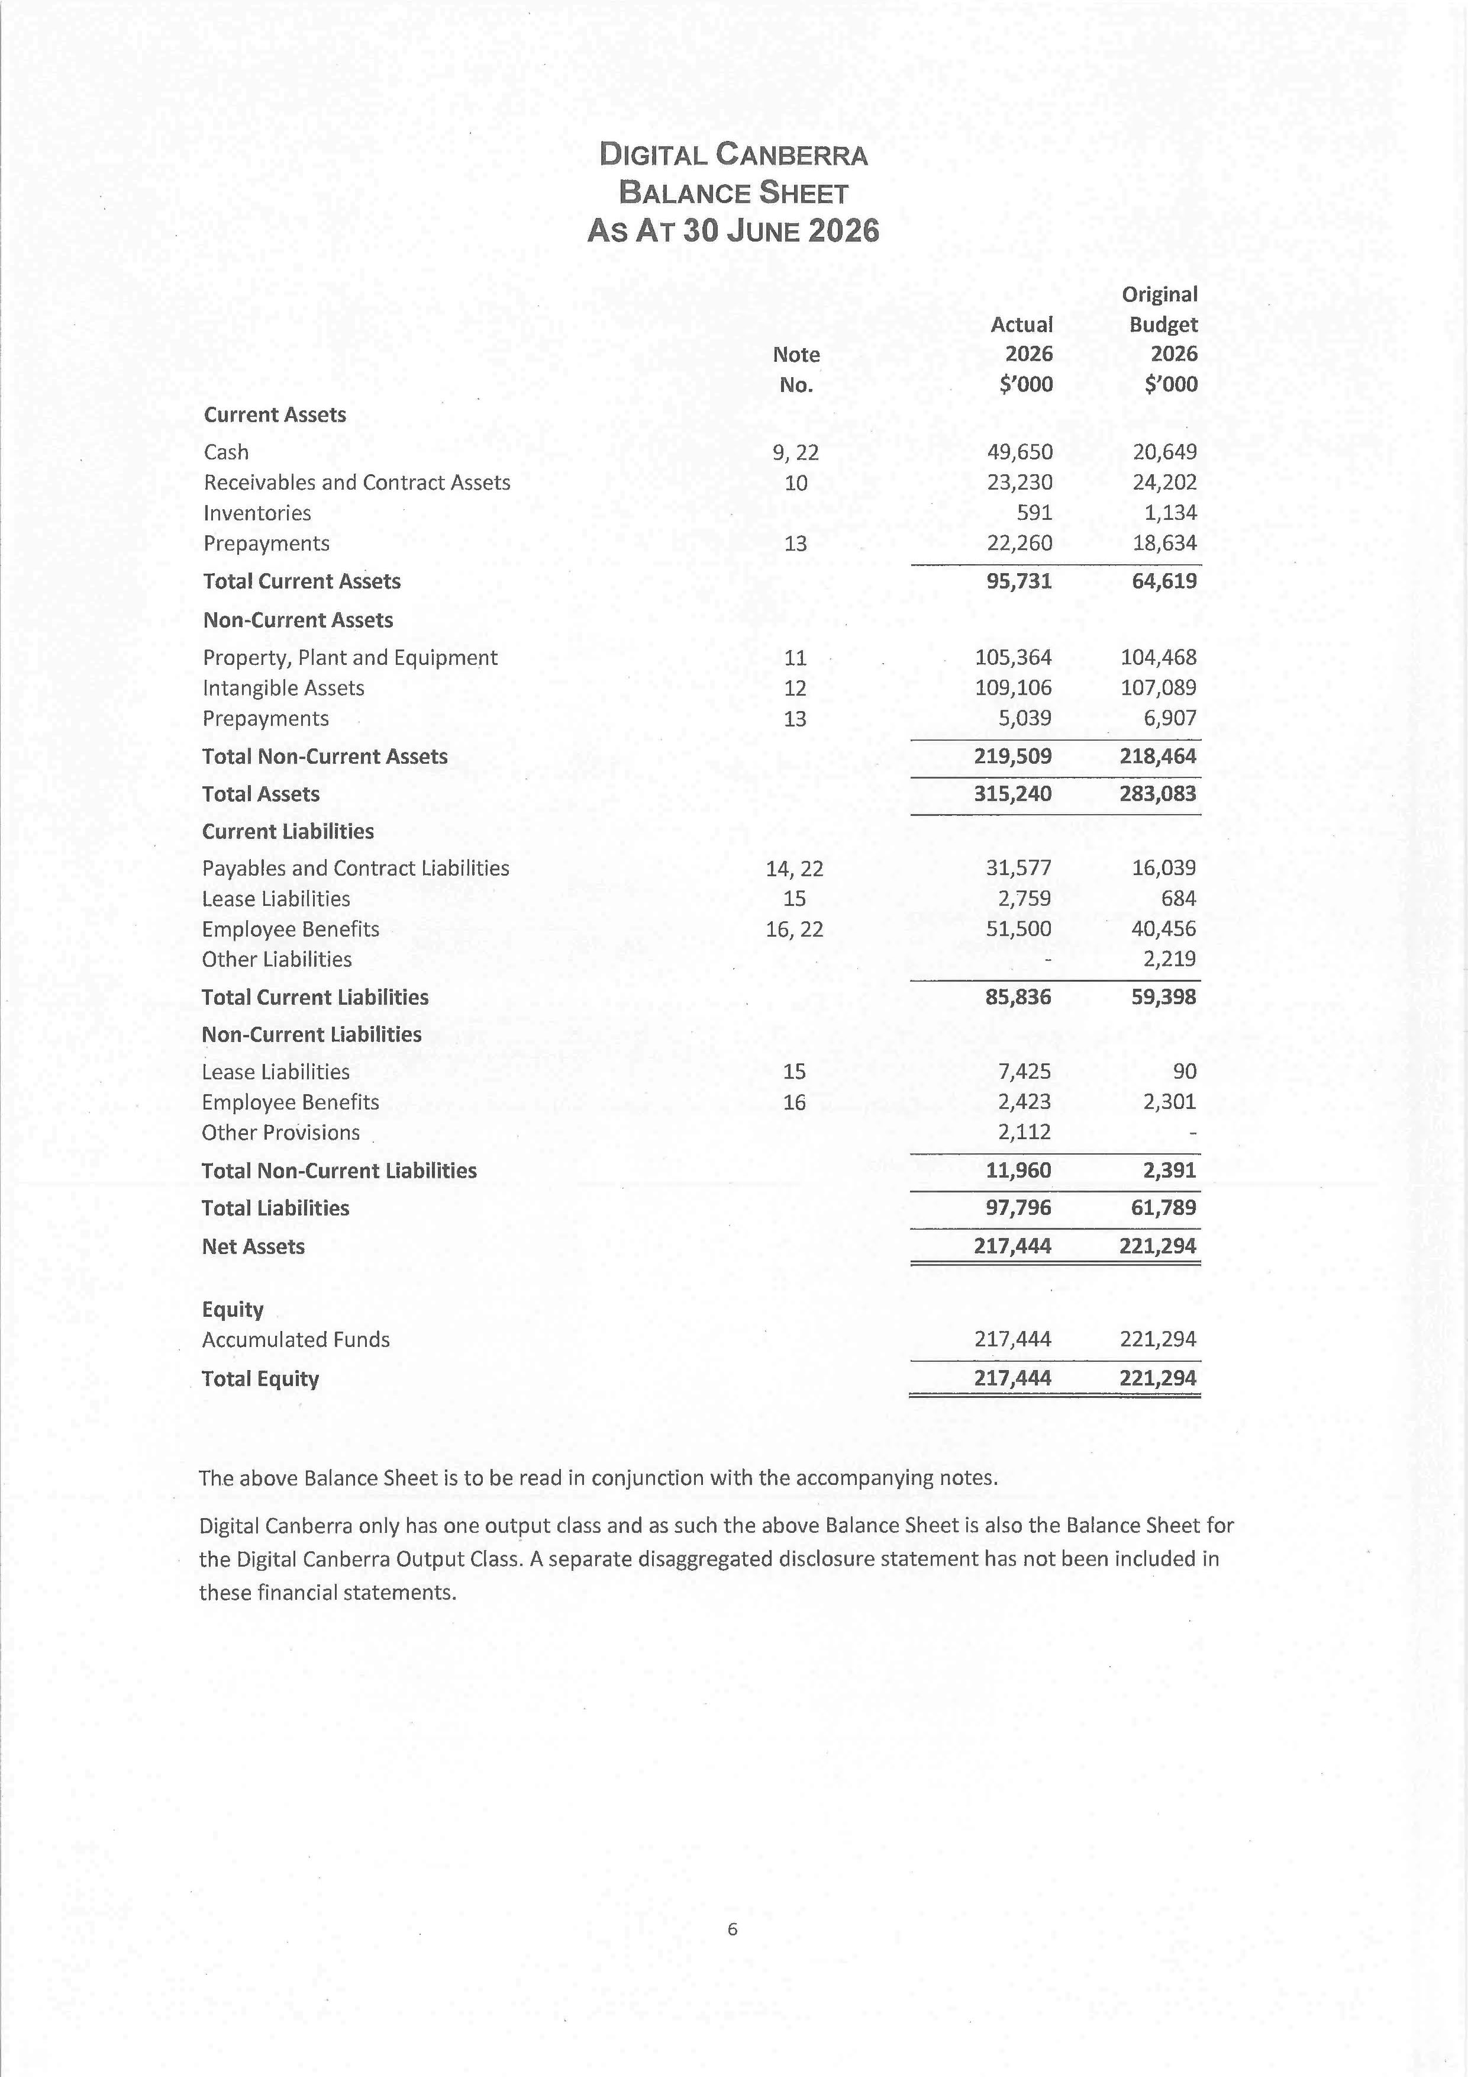
108
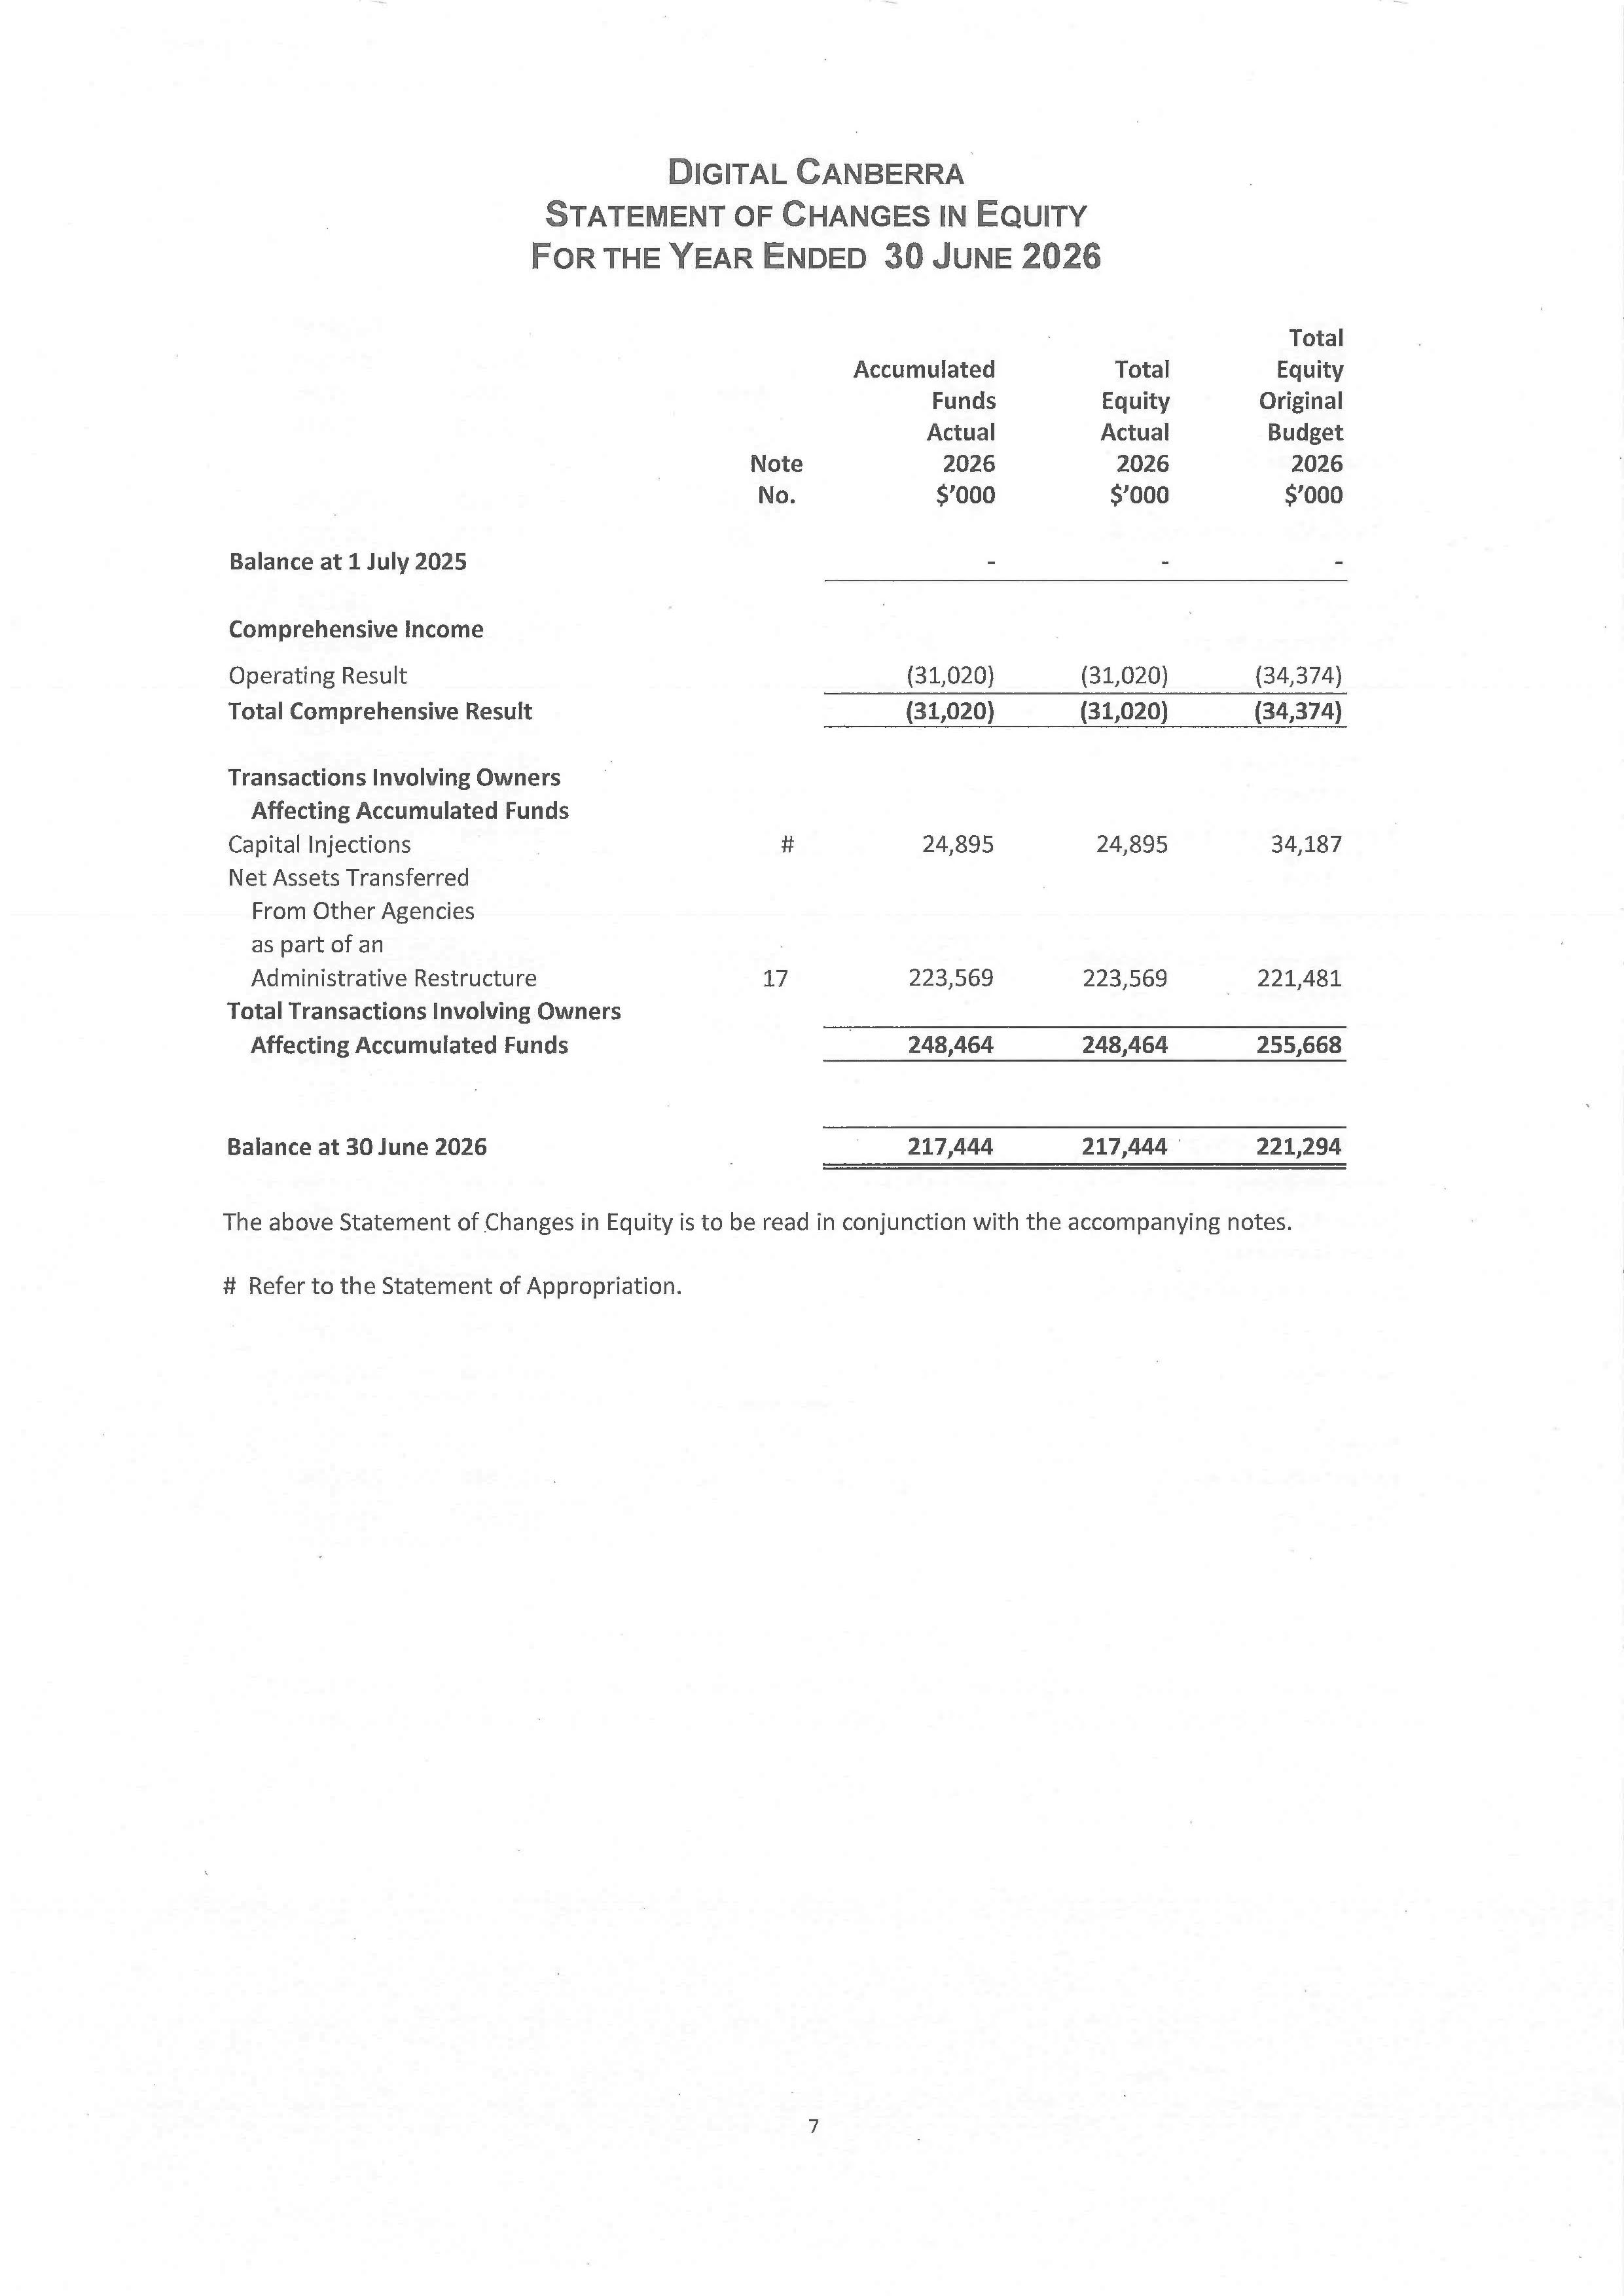
109
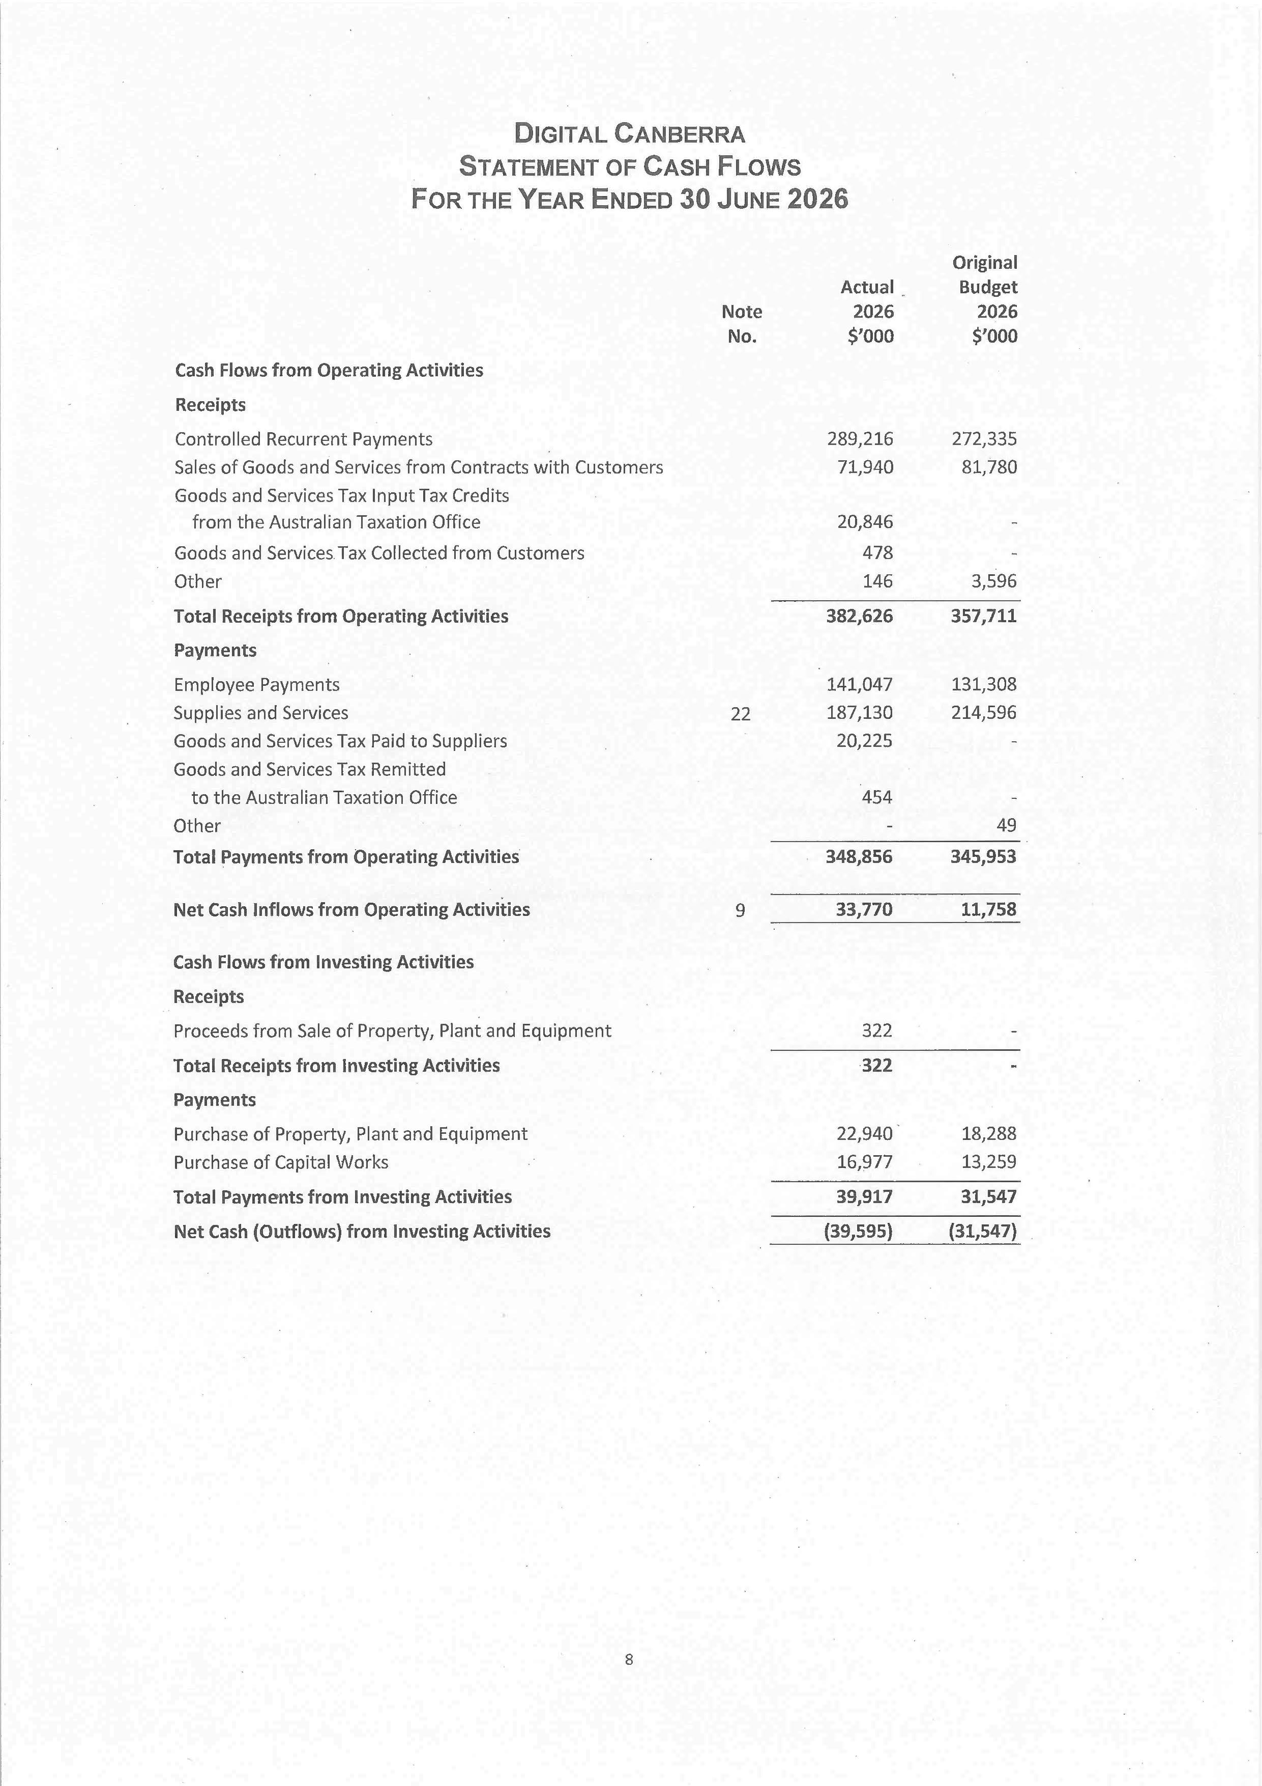
110
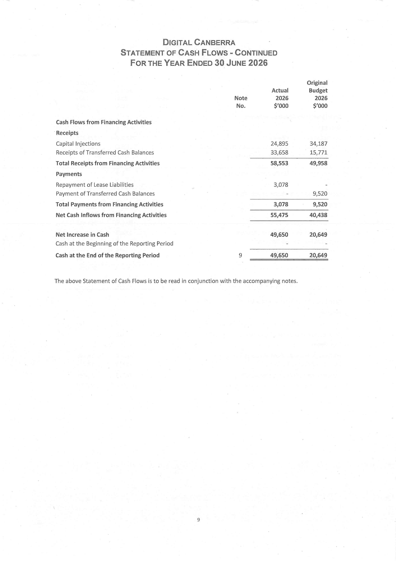
111
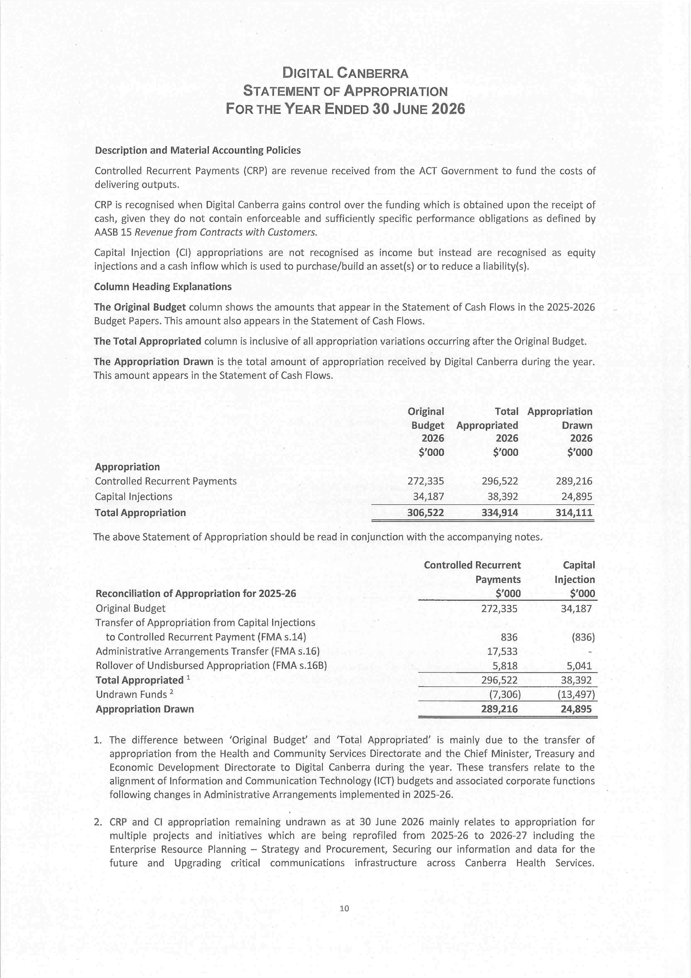
112
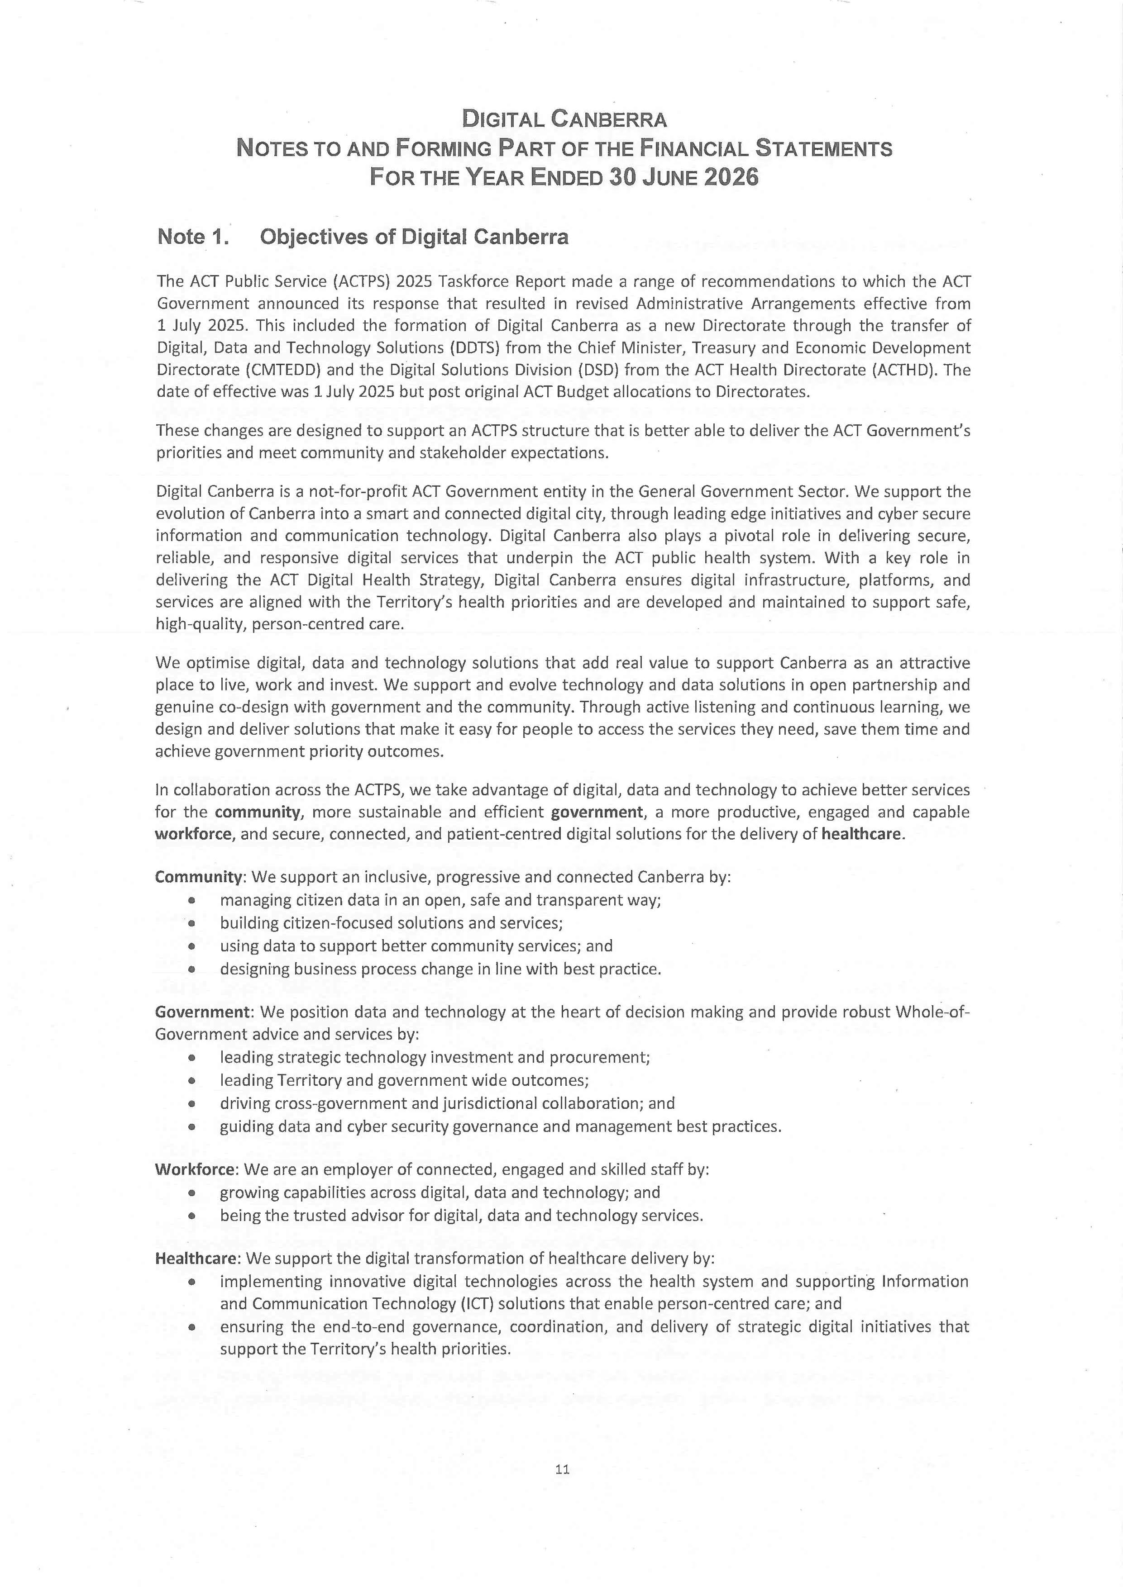
113
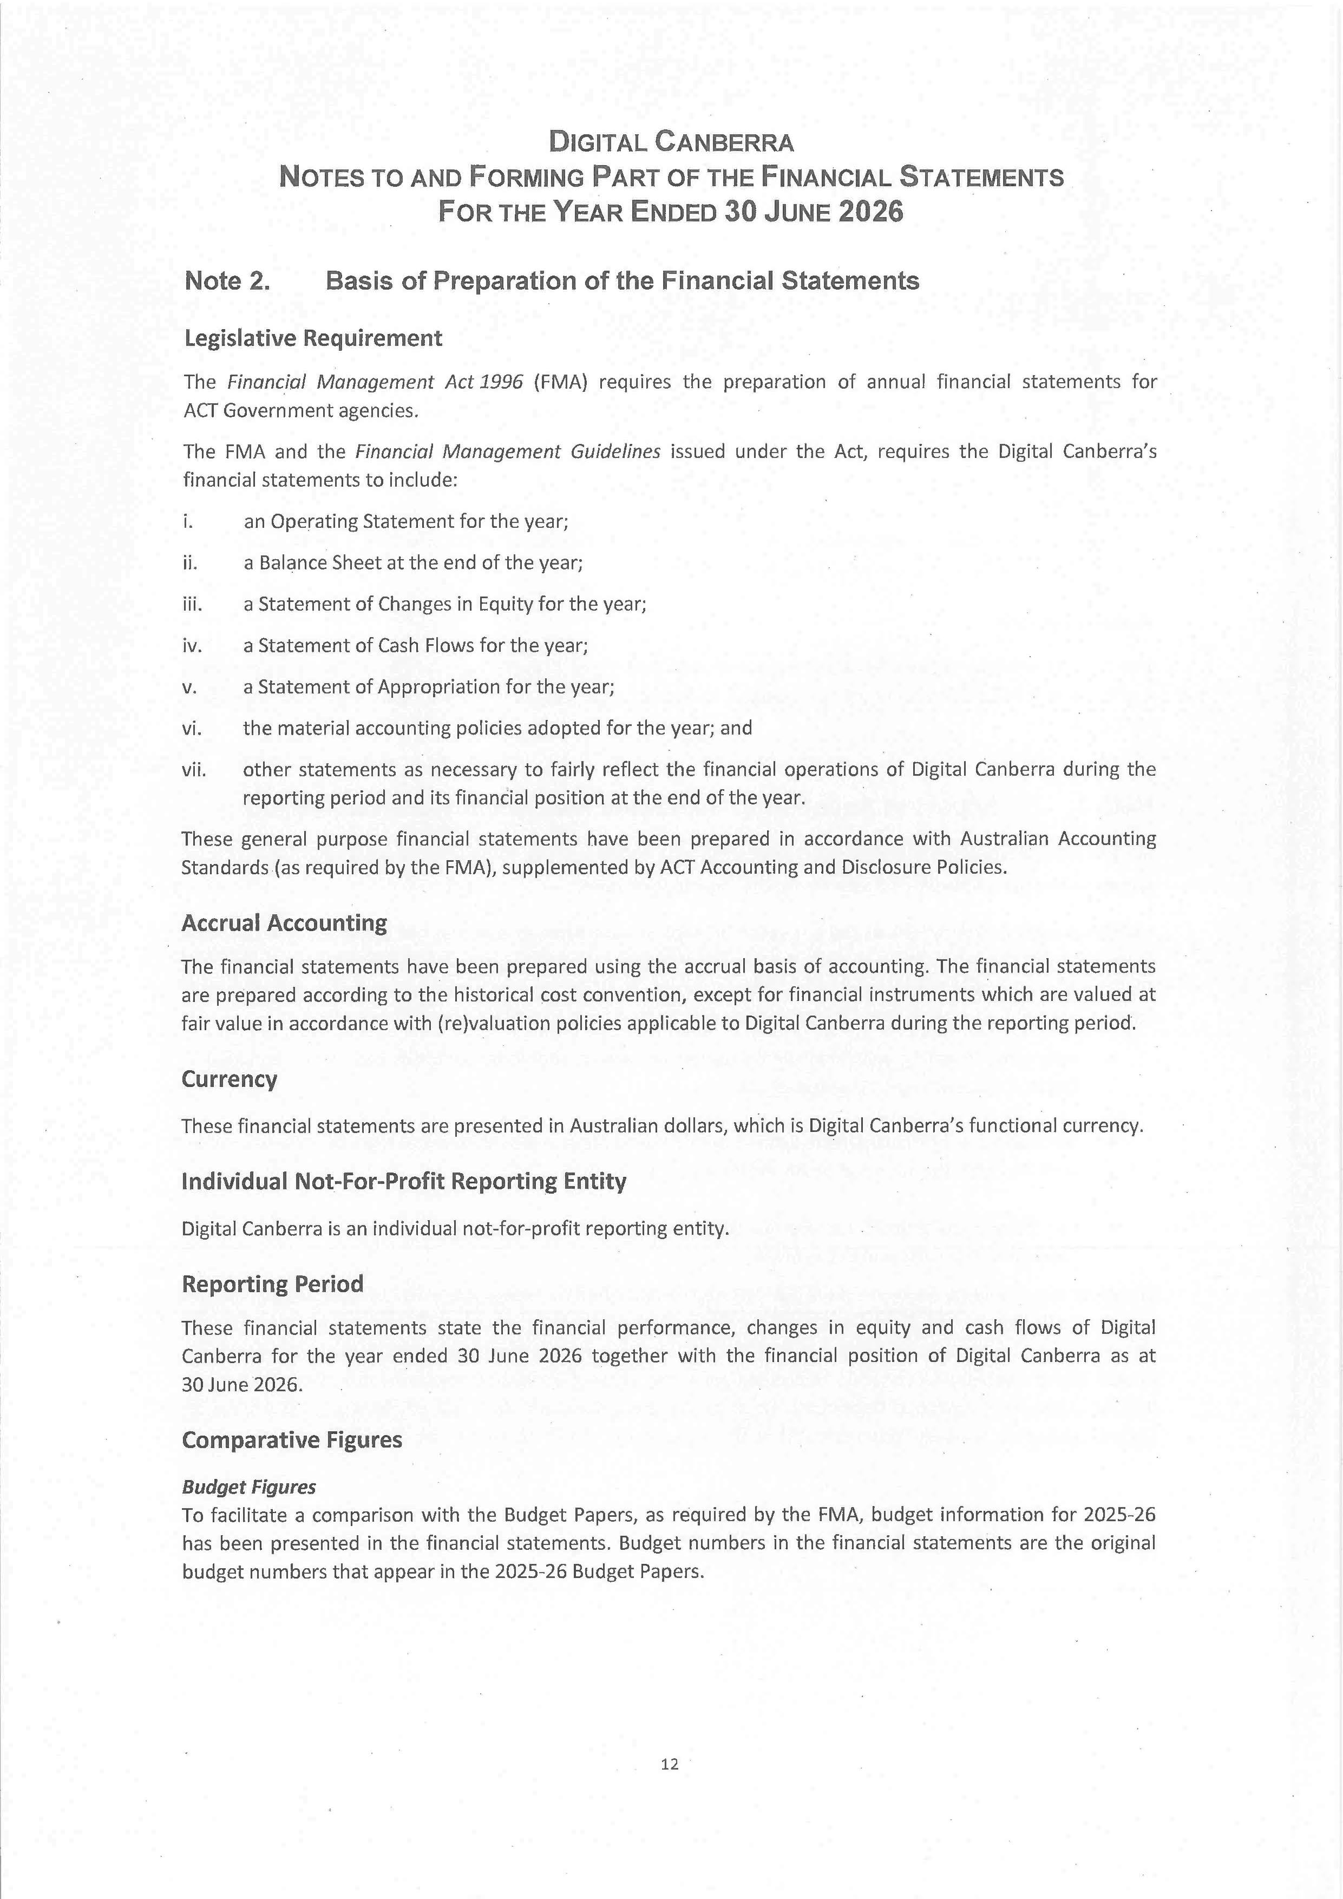
114
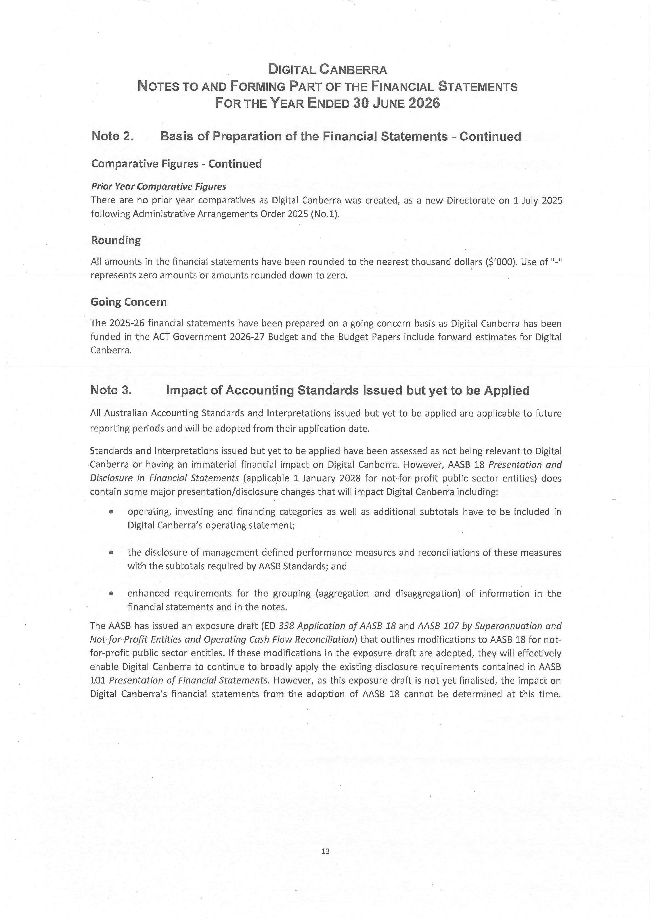
115
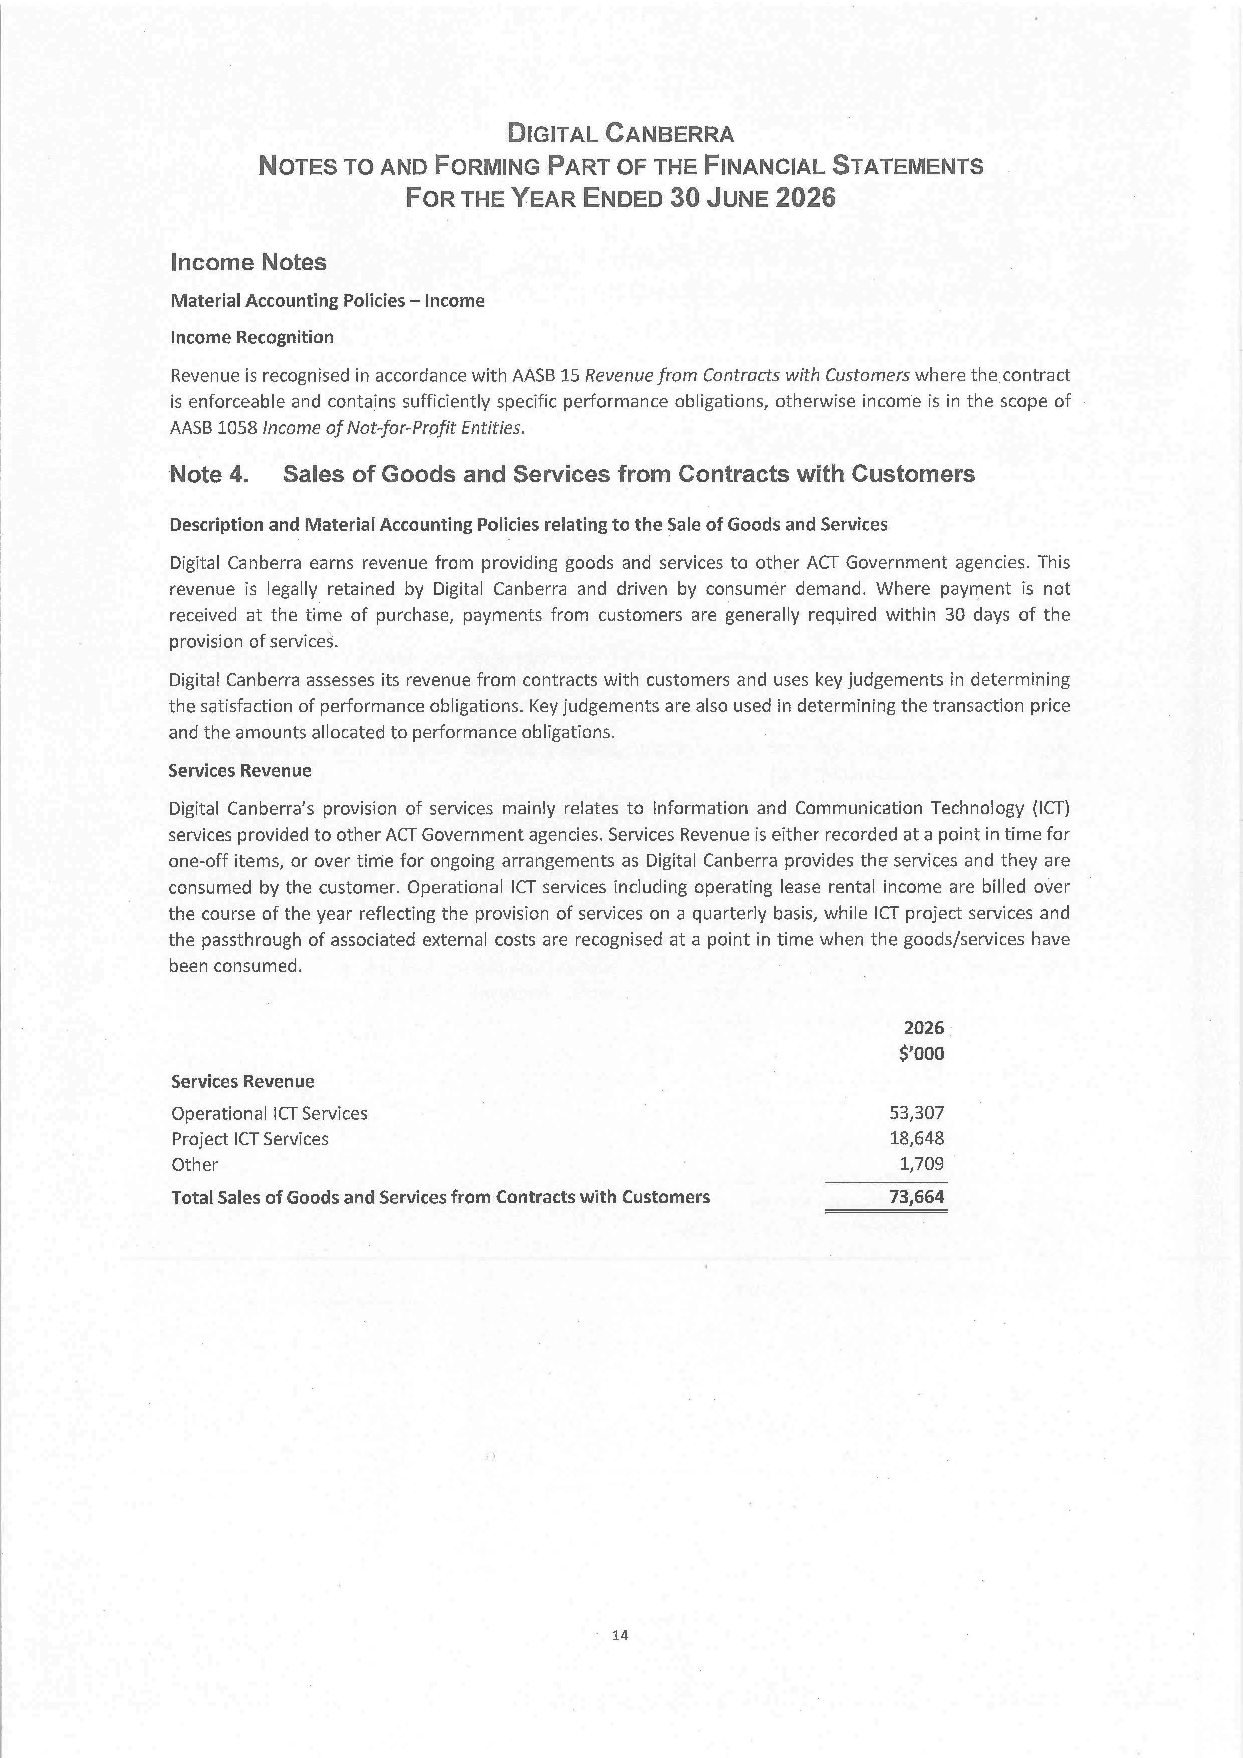
116
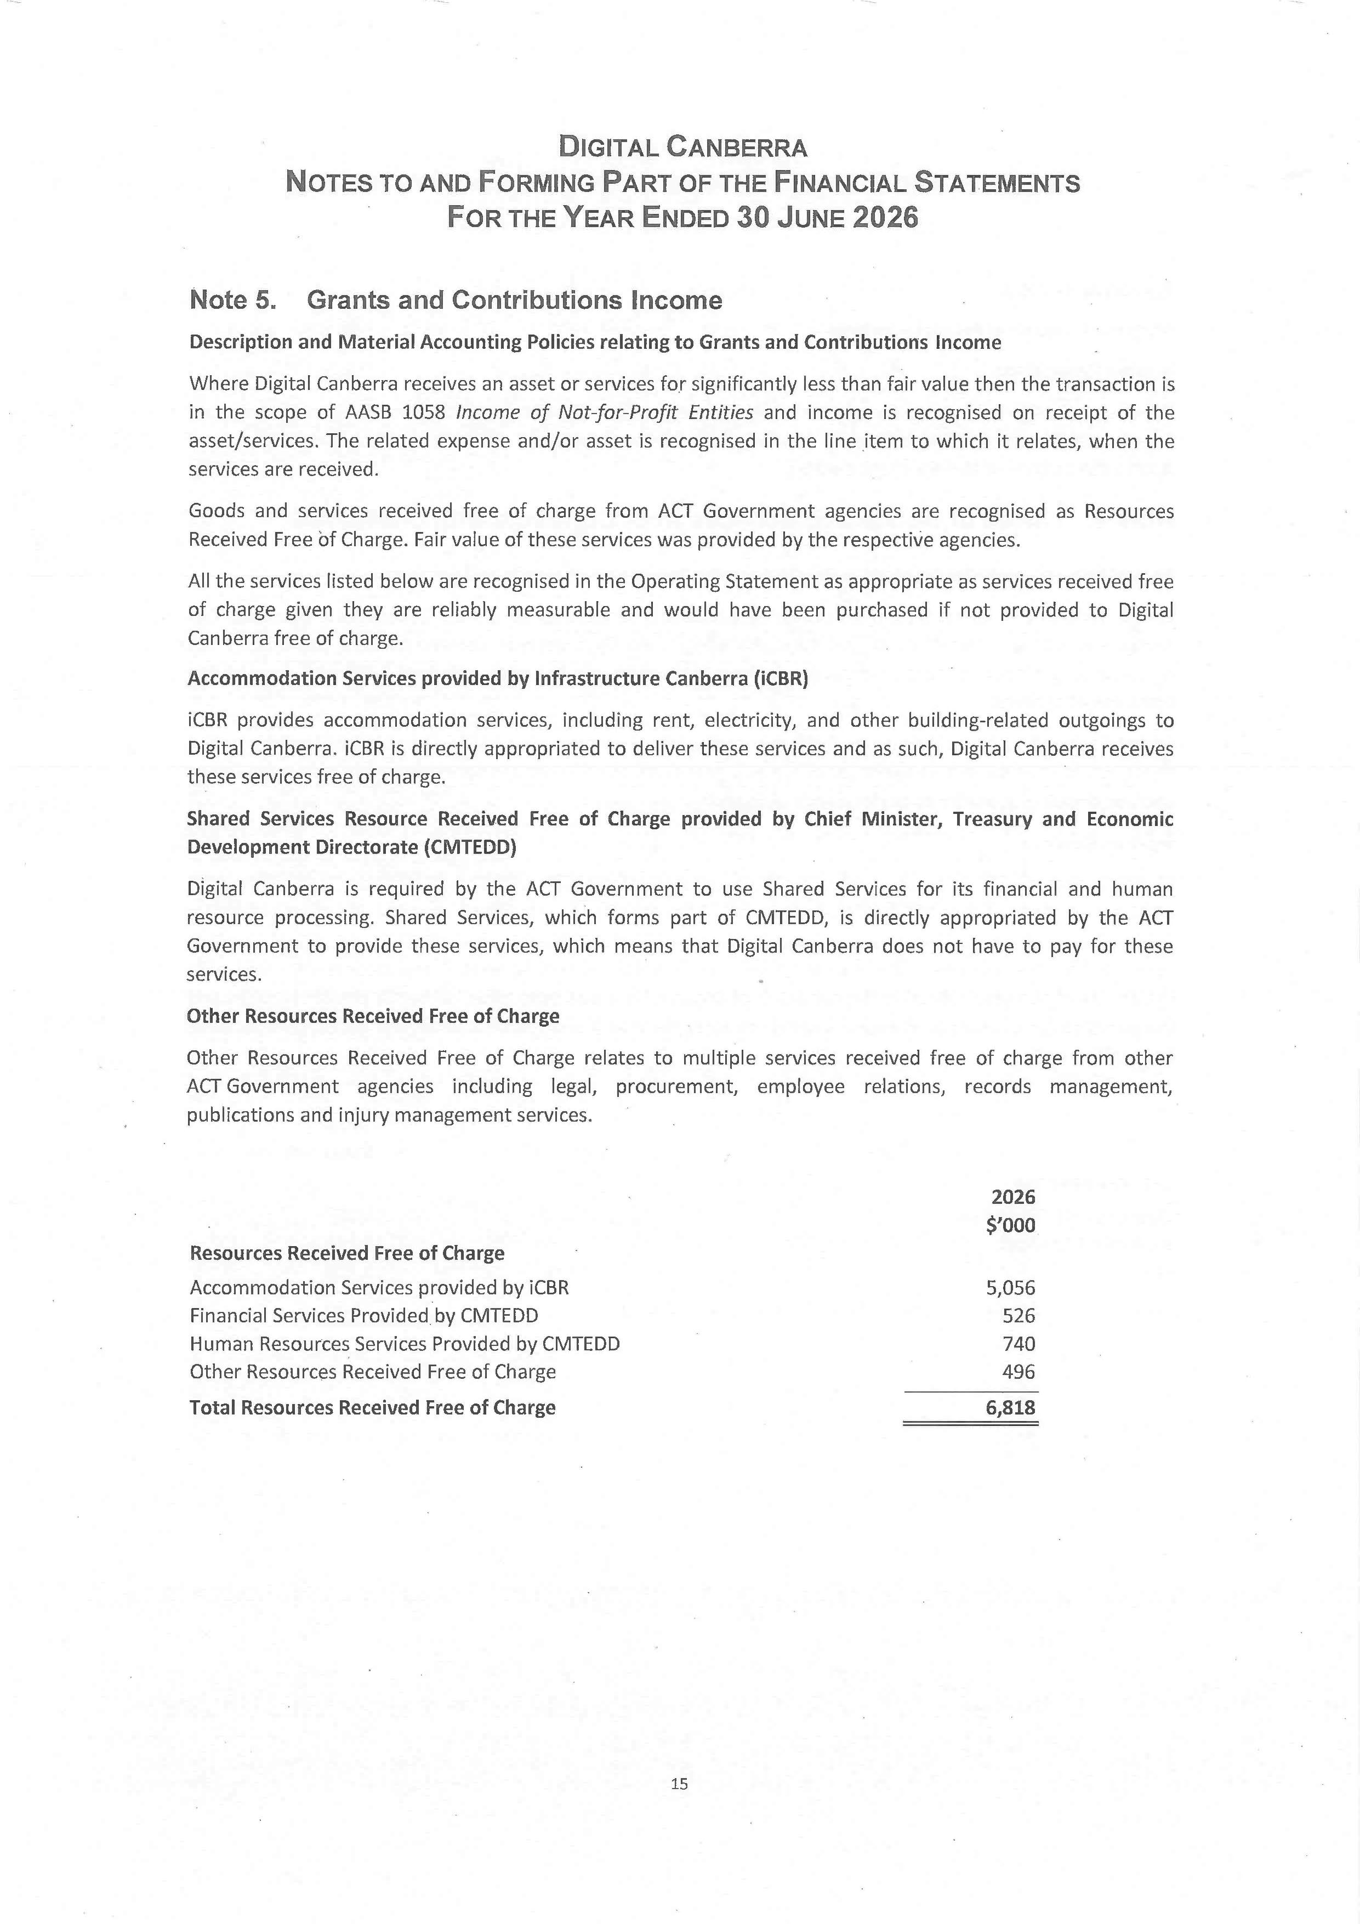
117
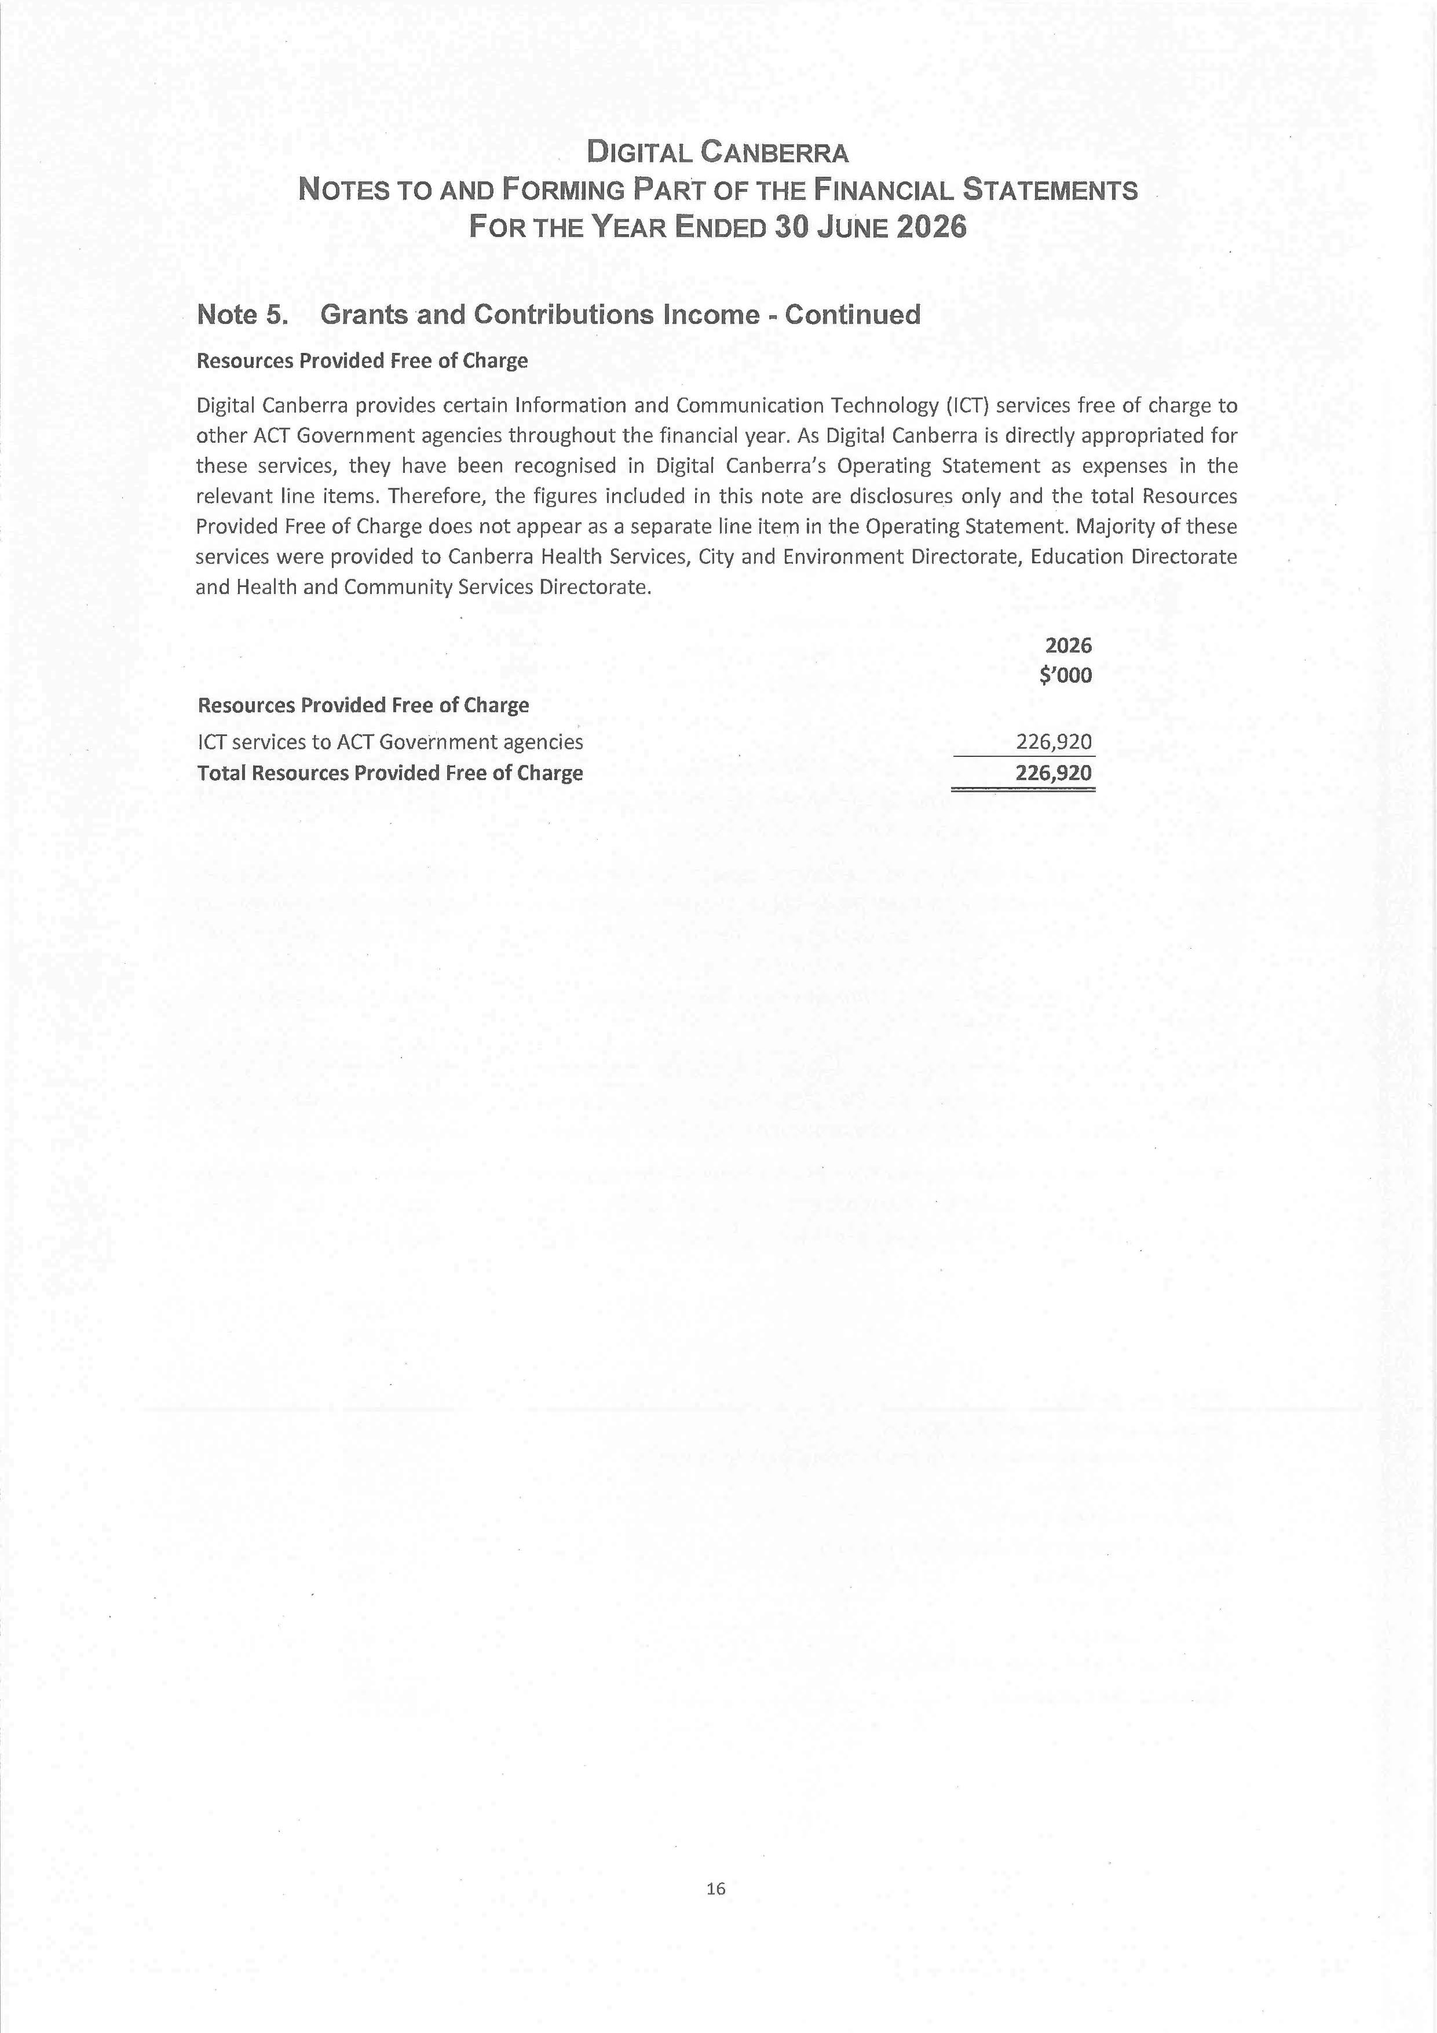
118
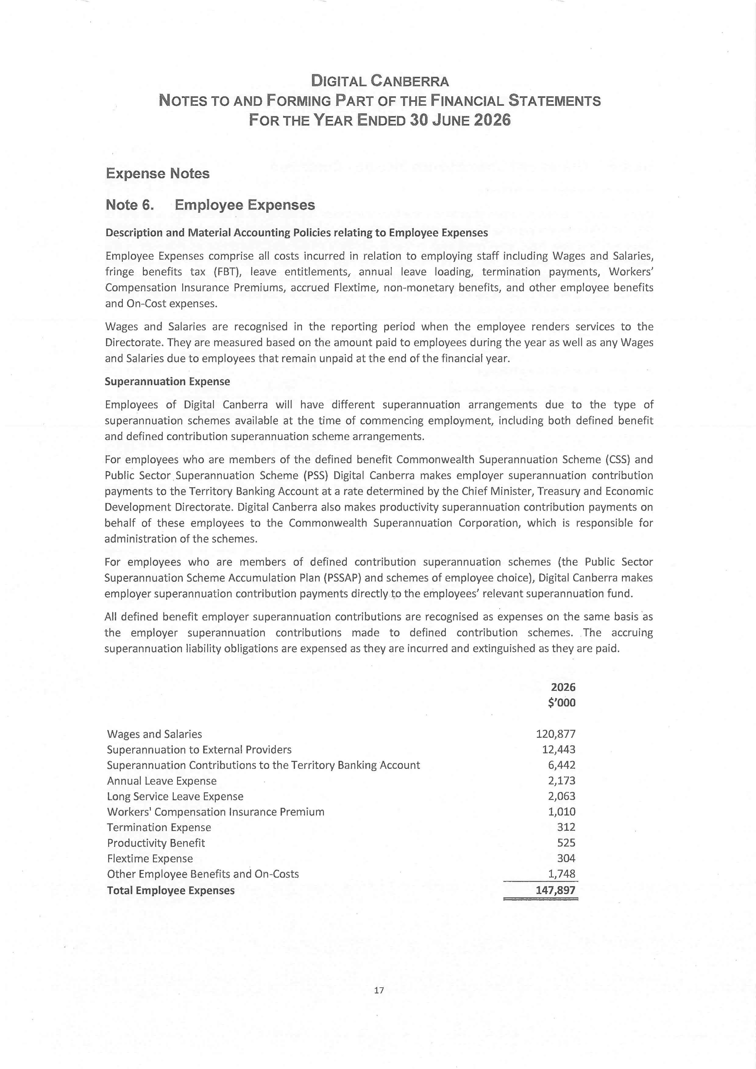
119
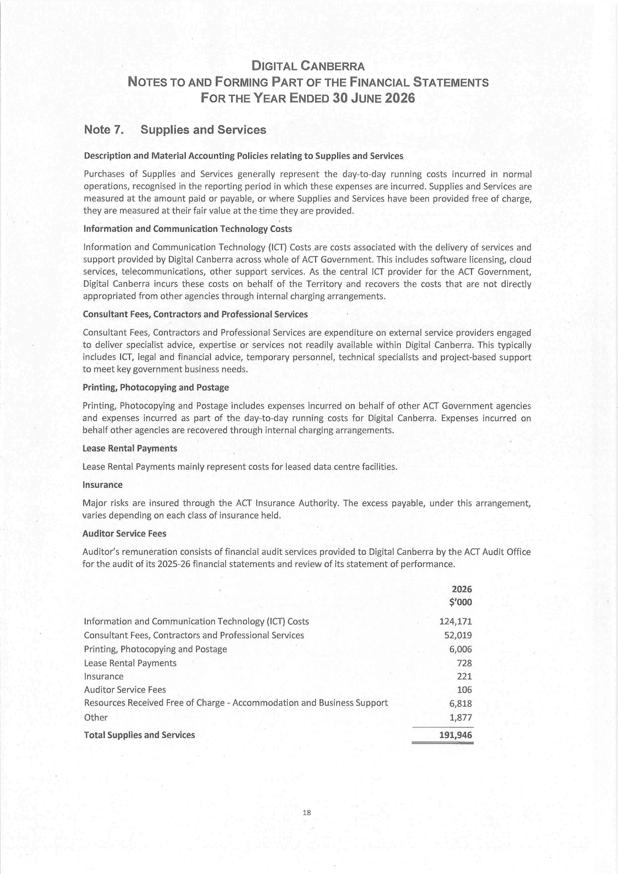
120
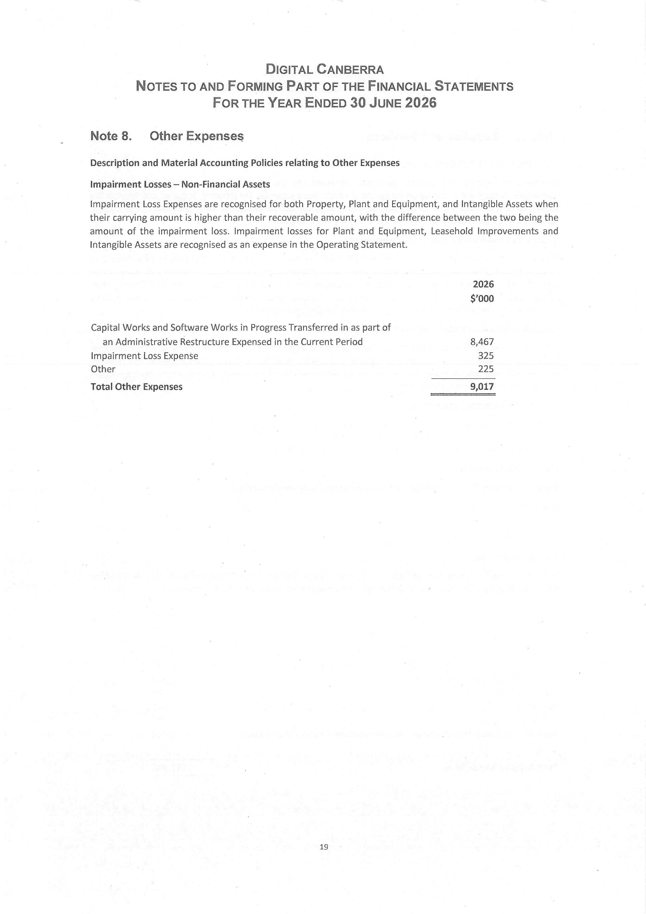
121

122
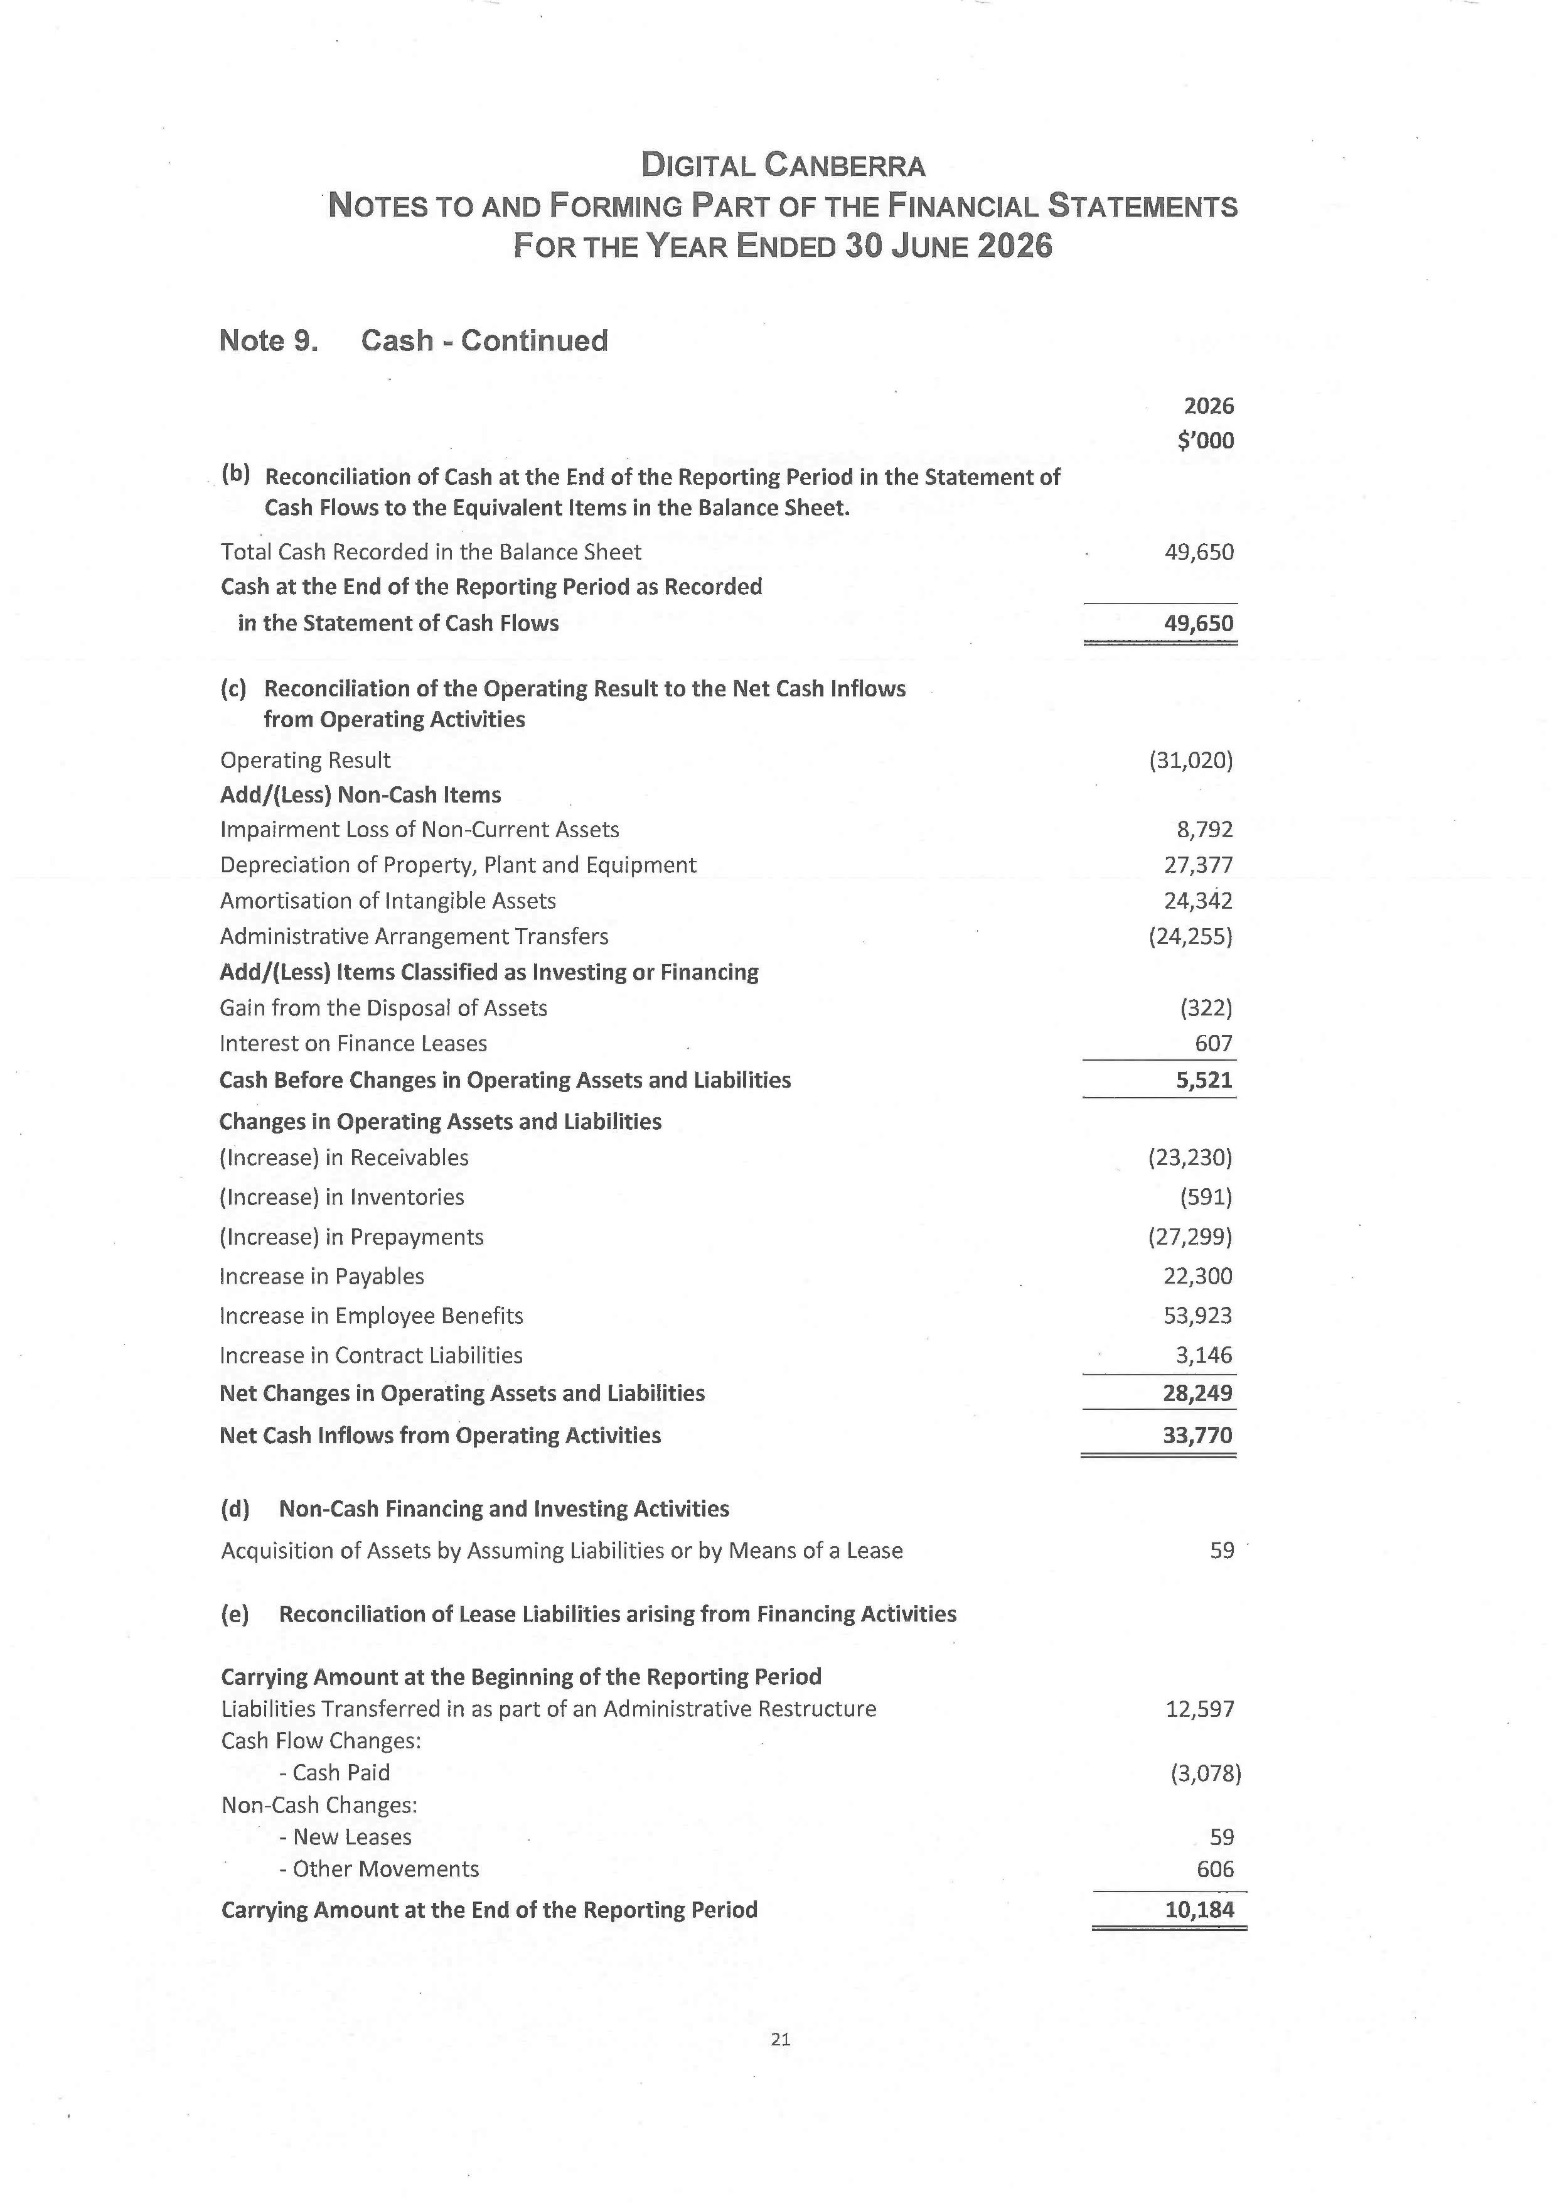
123
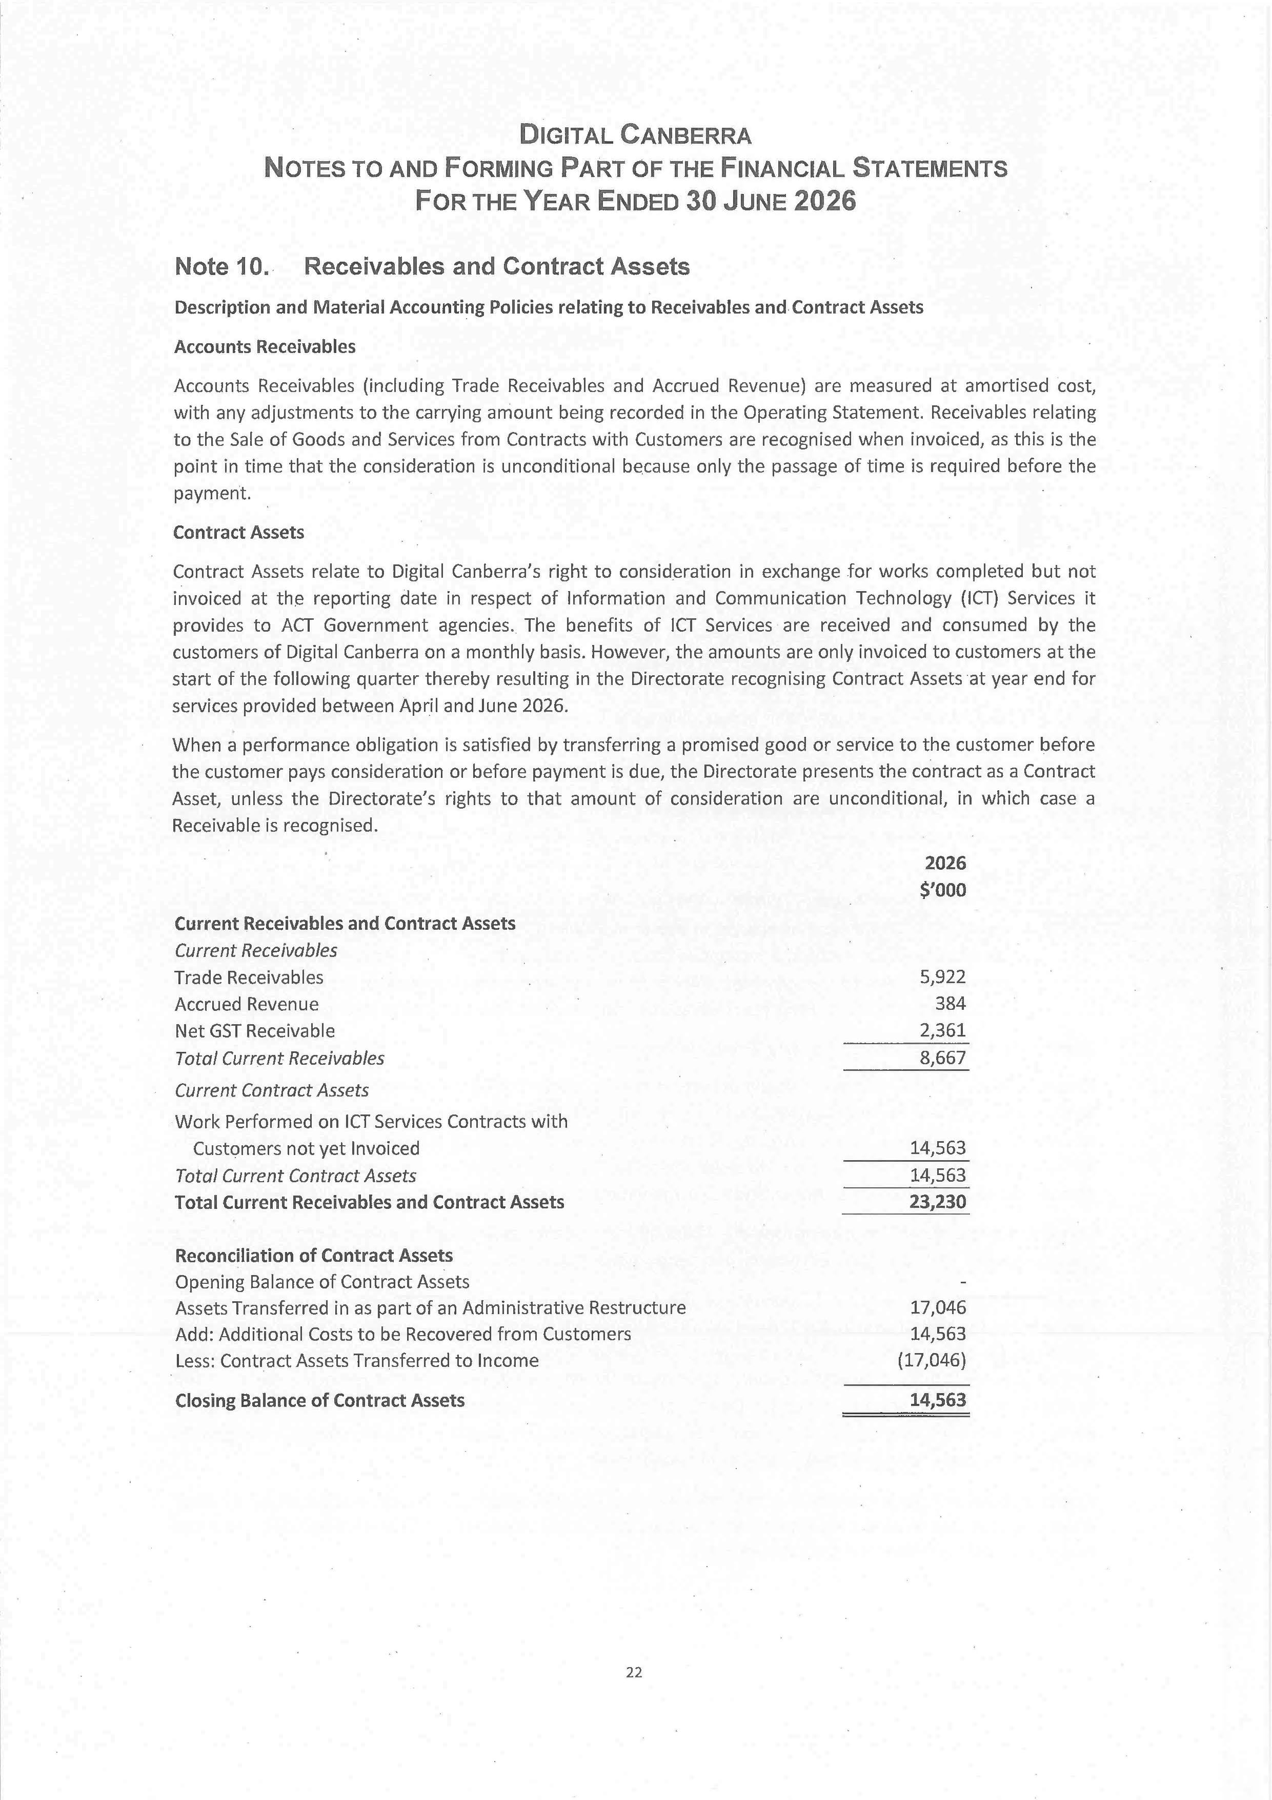
124
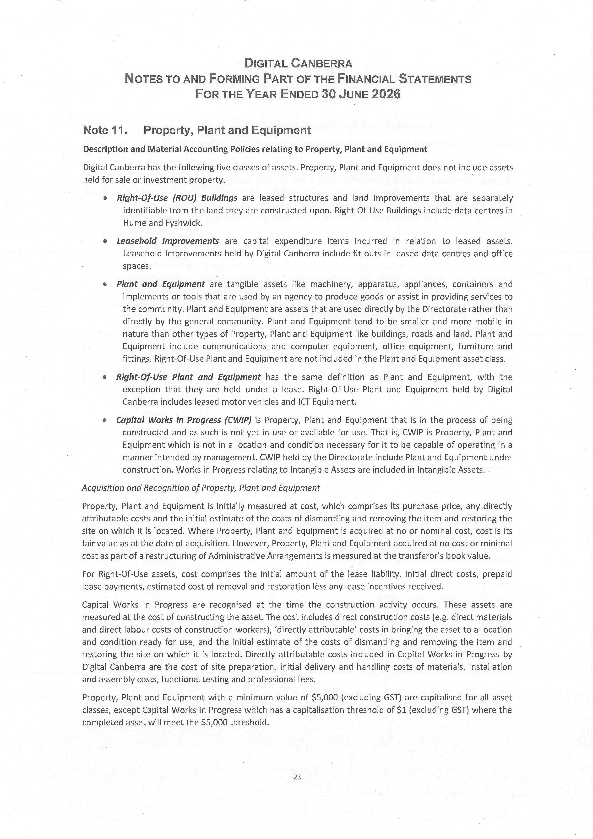
125
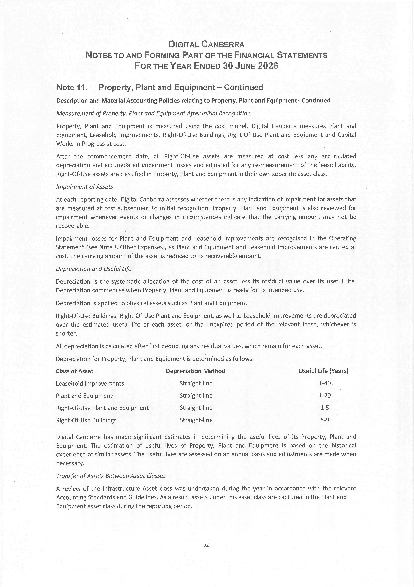
126
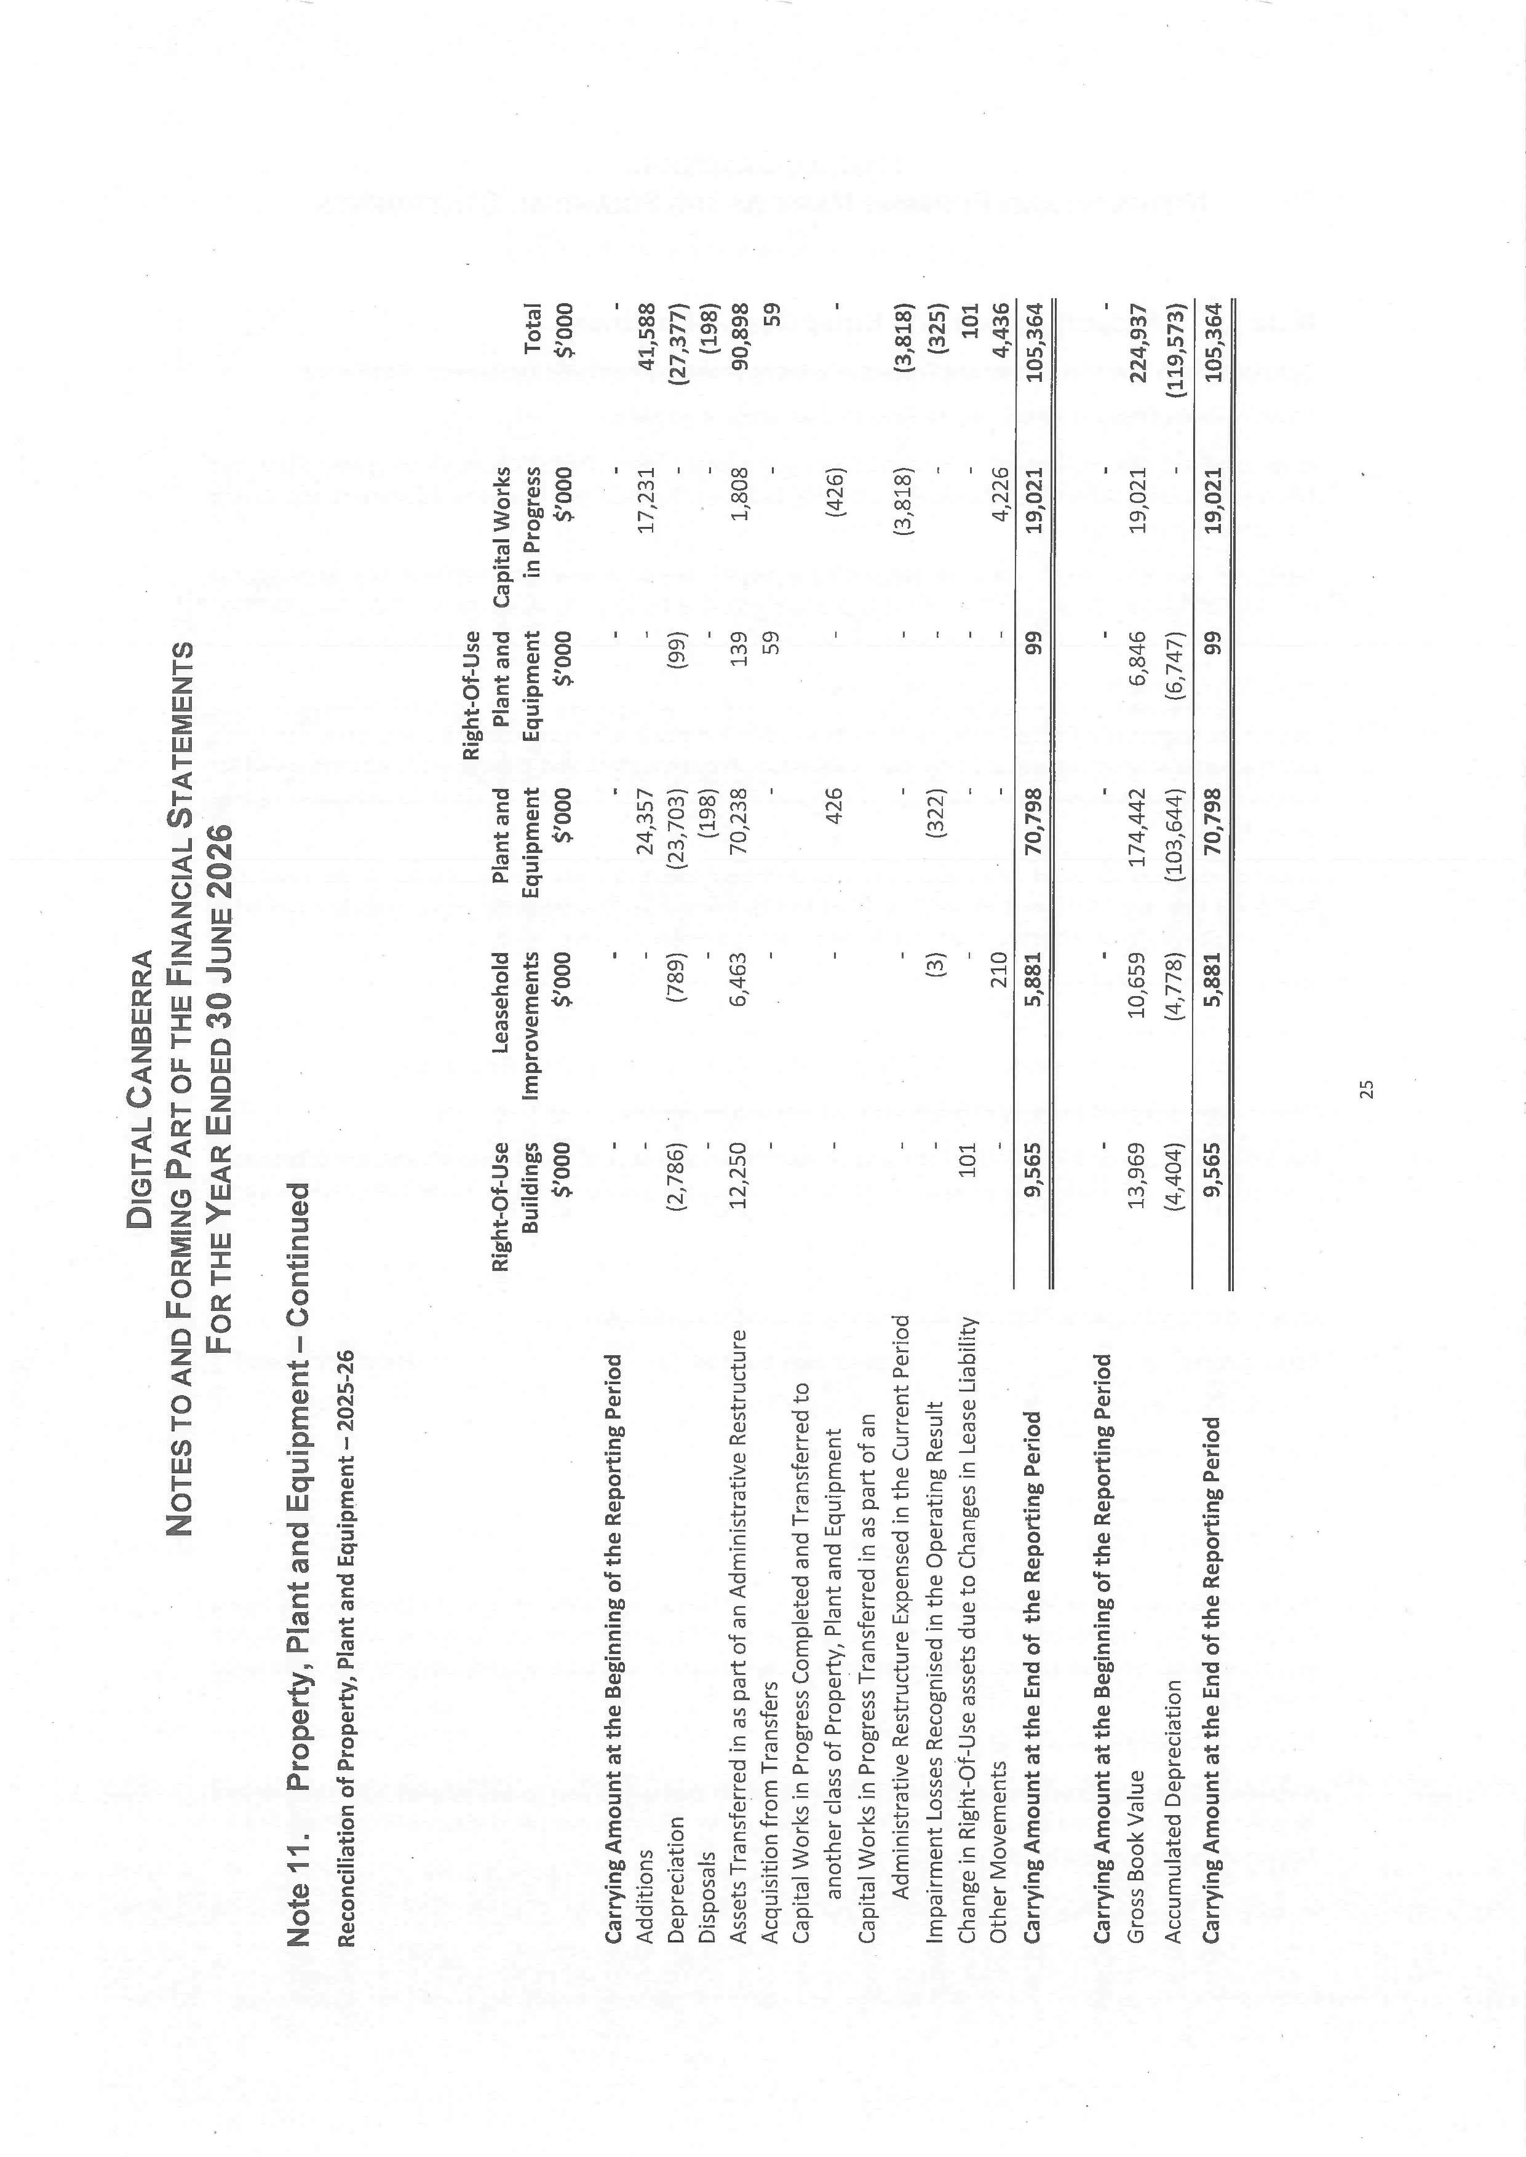
127
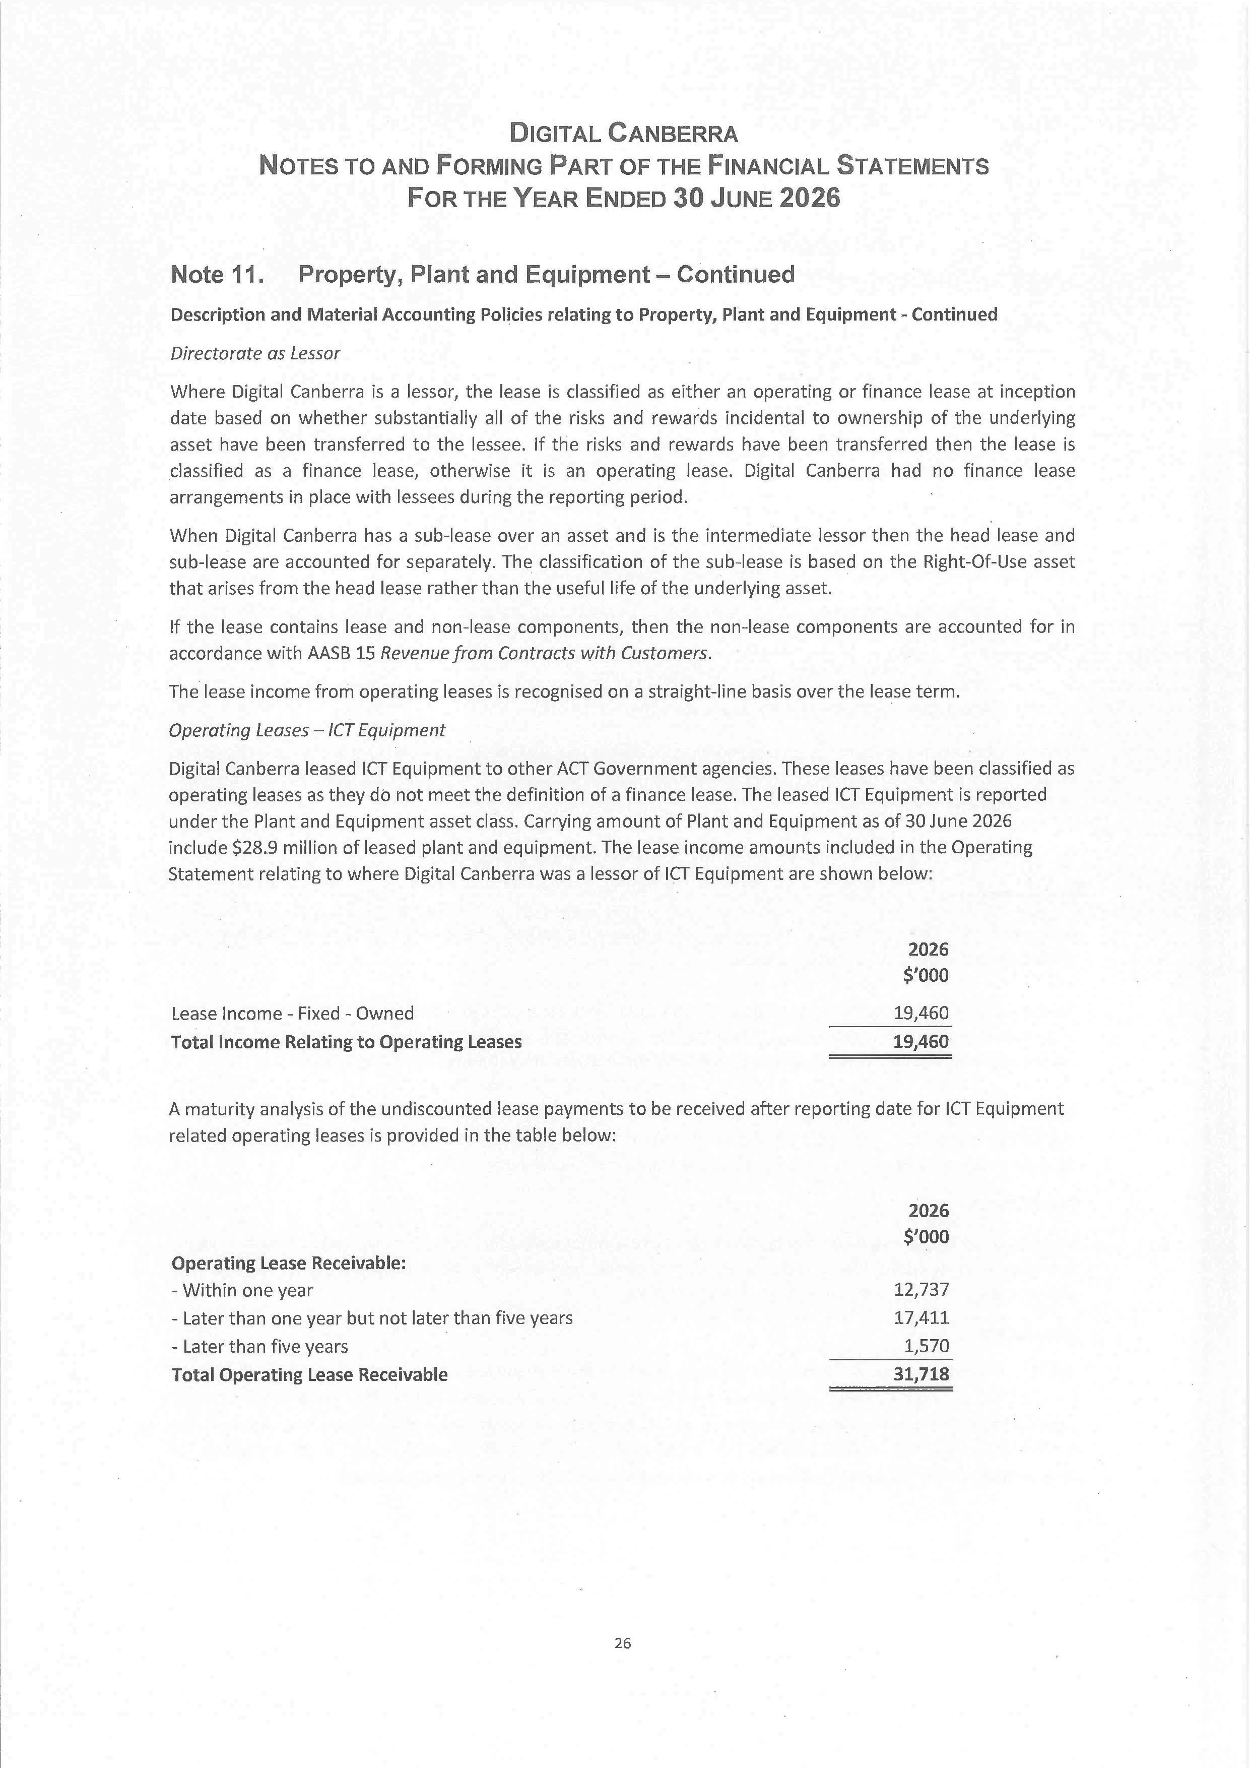
128
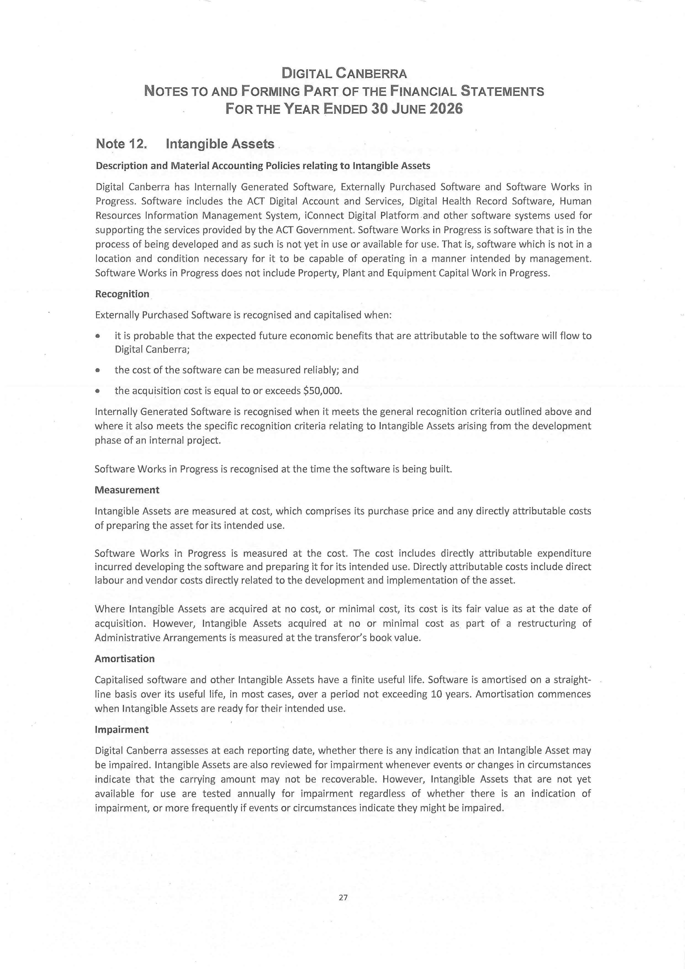
129
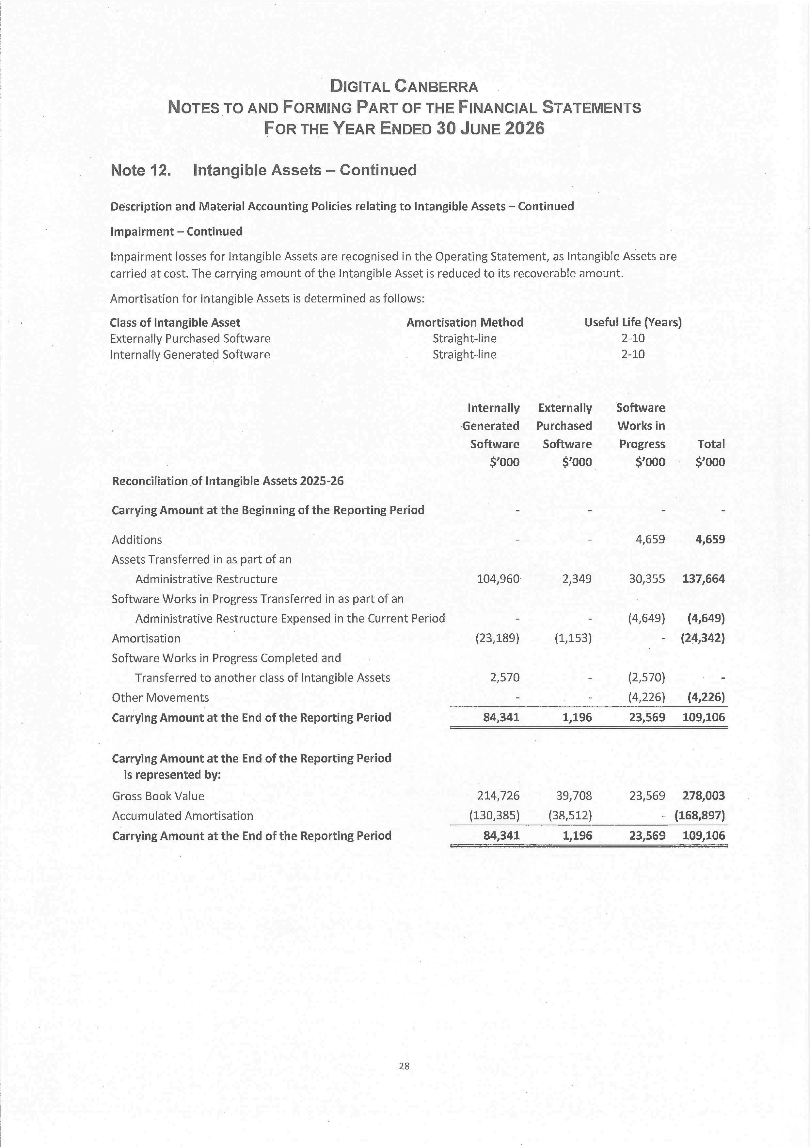
130
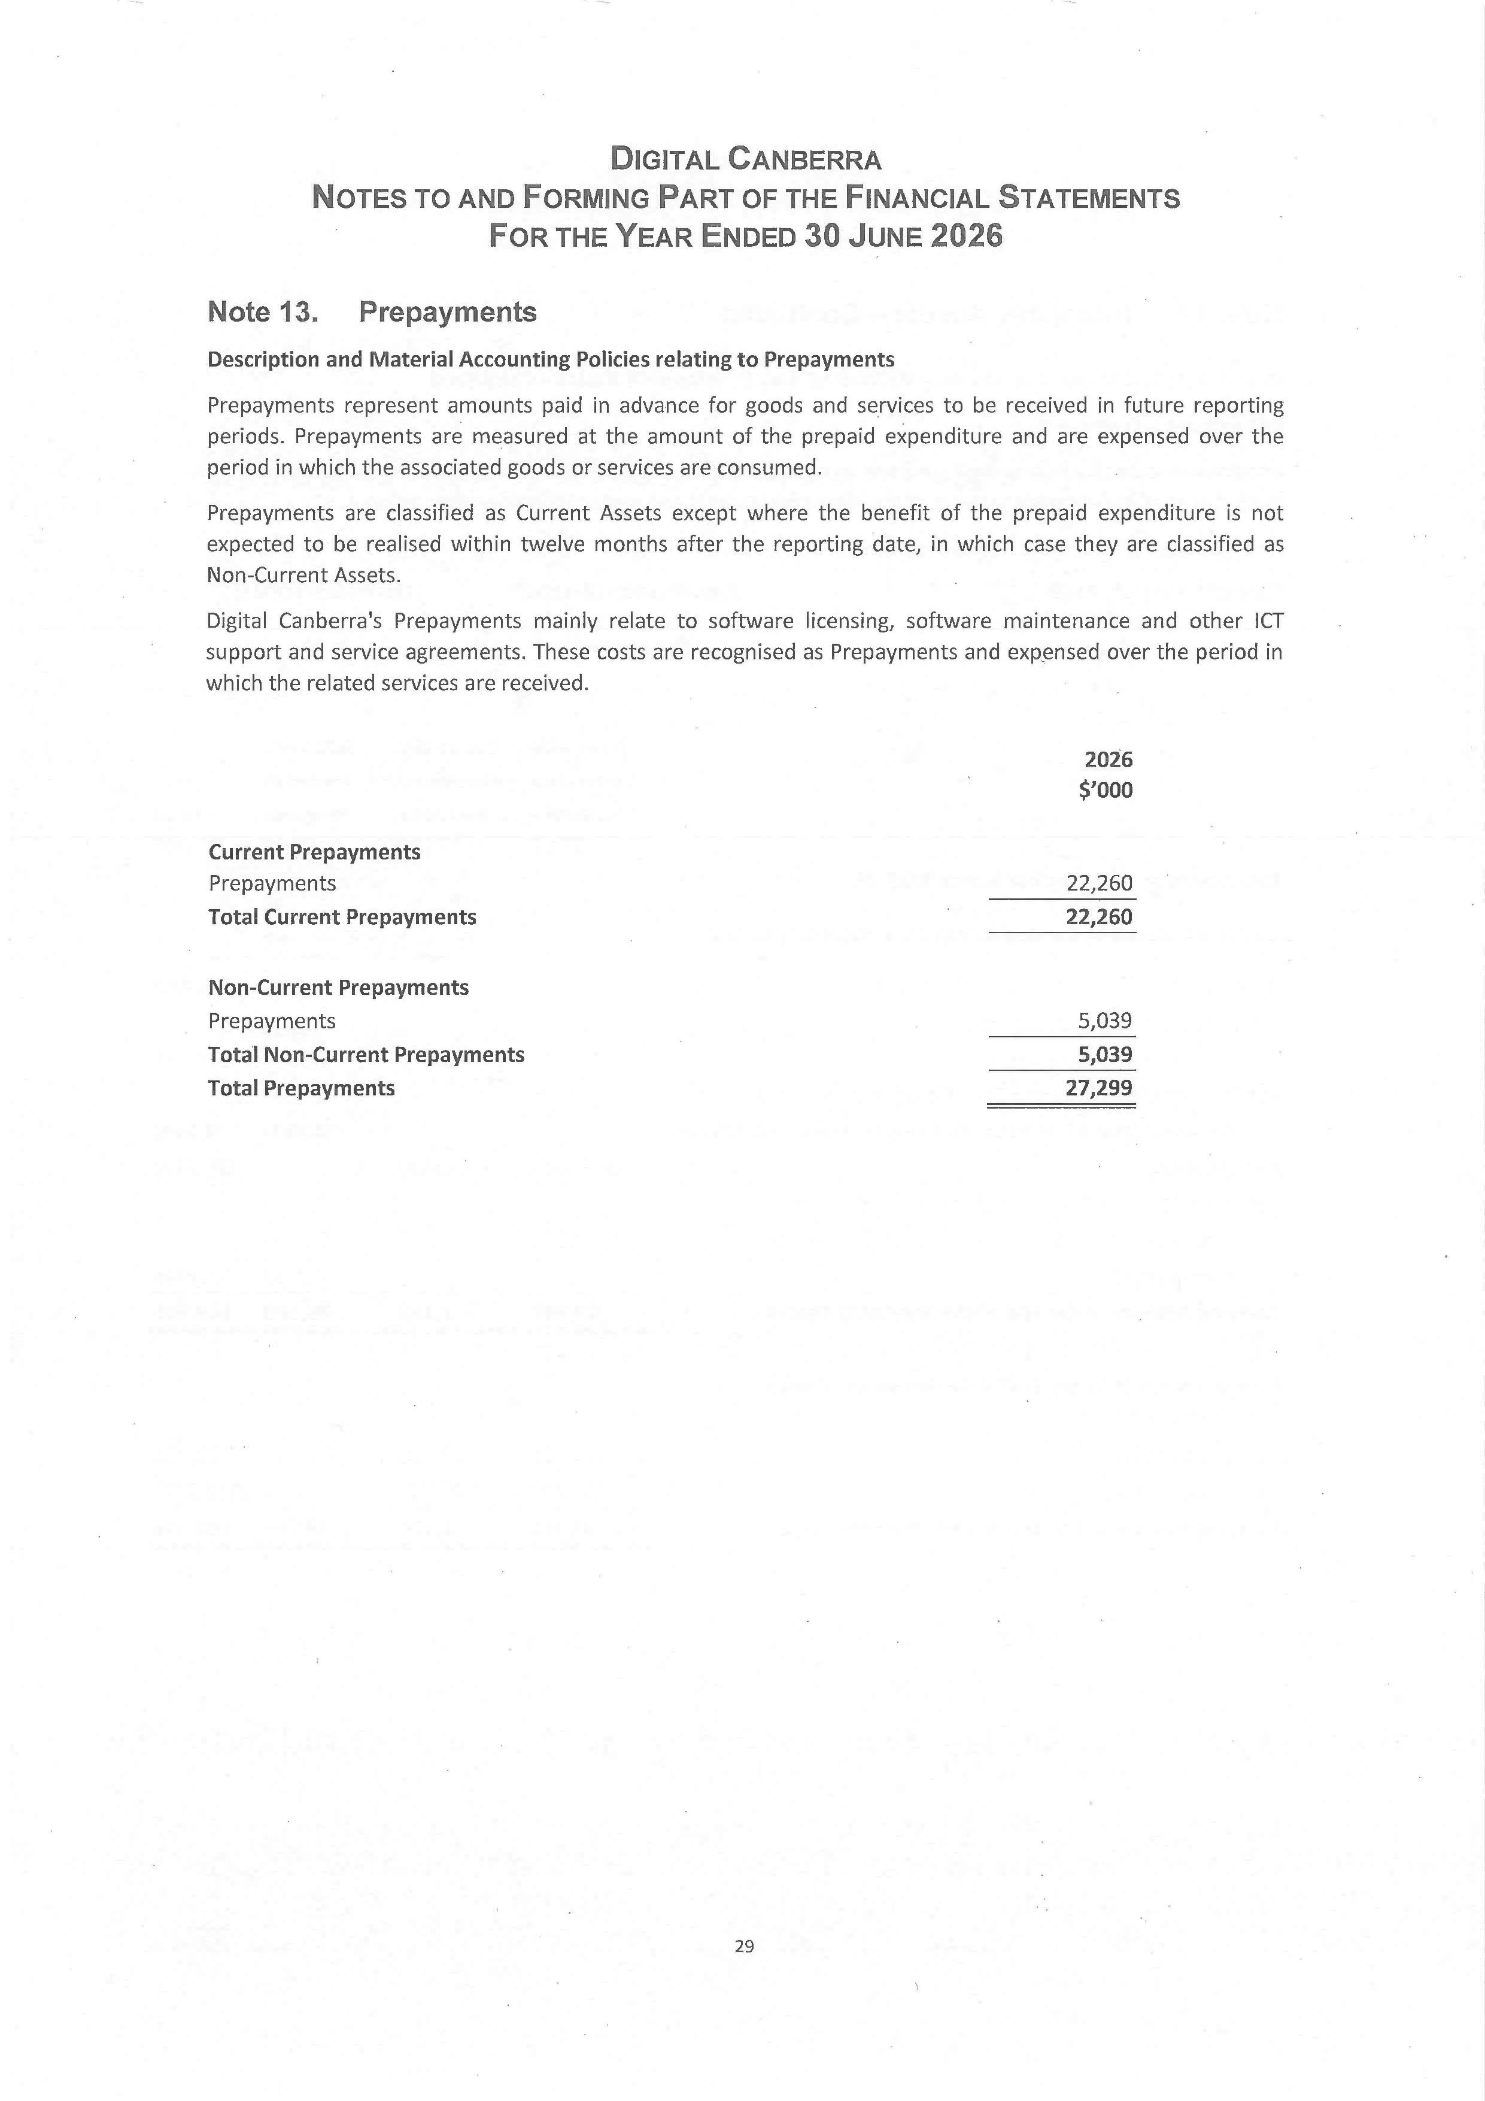
131
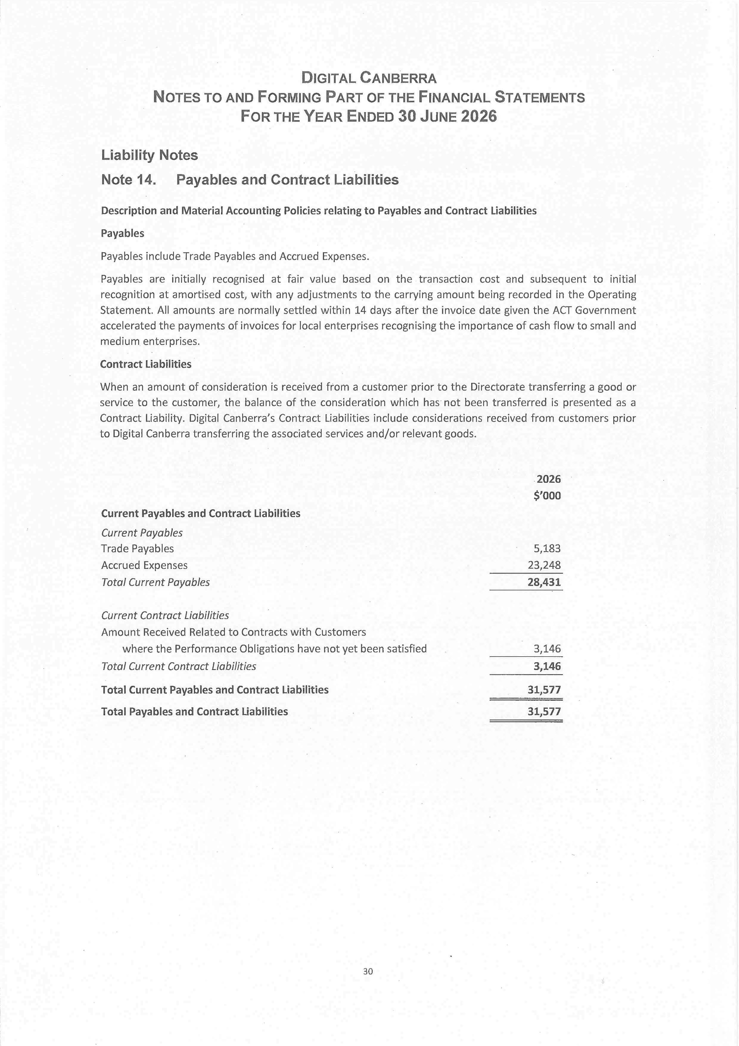
132
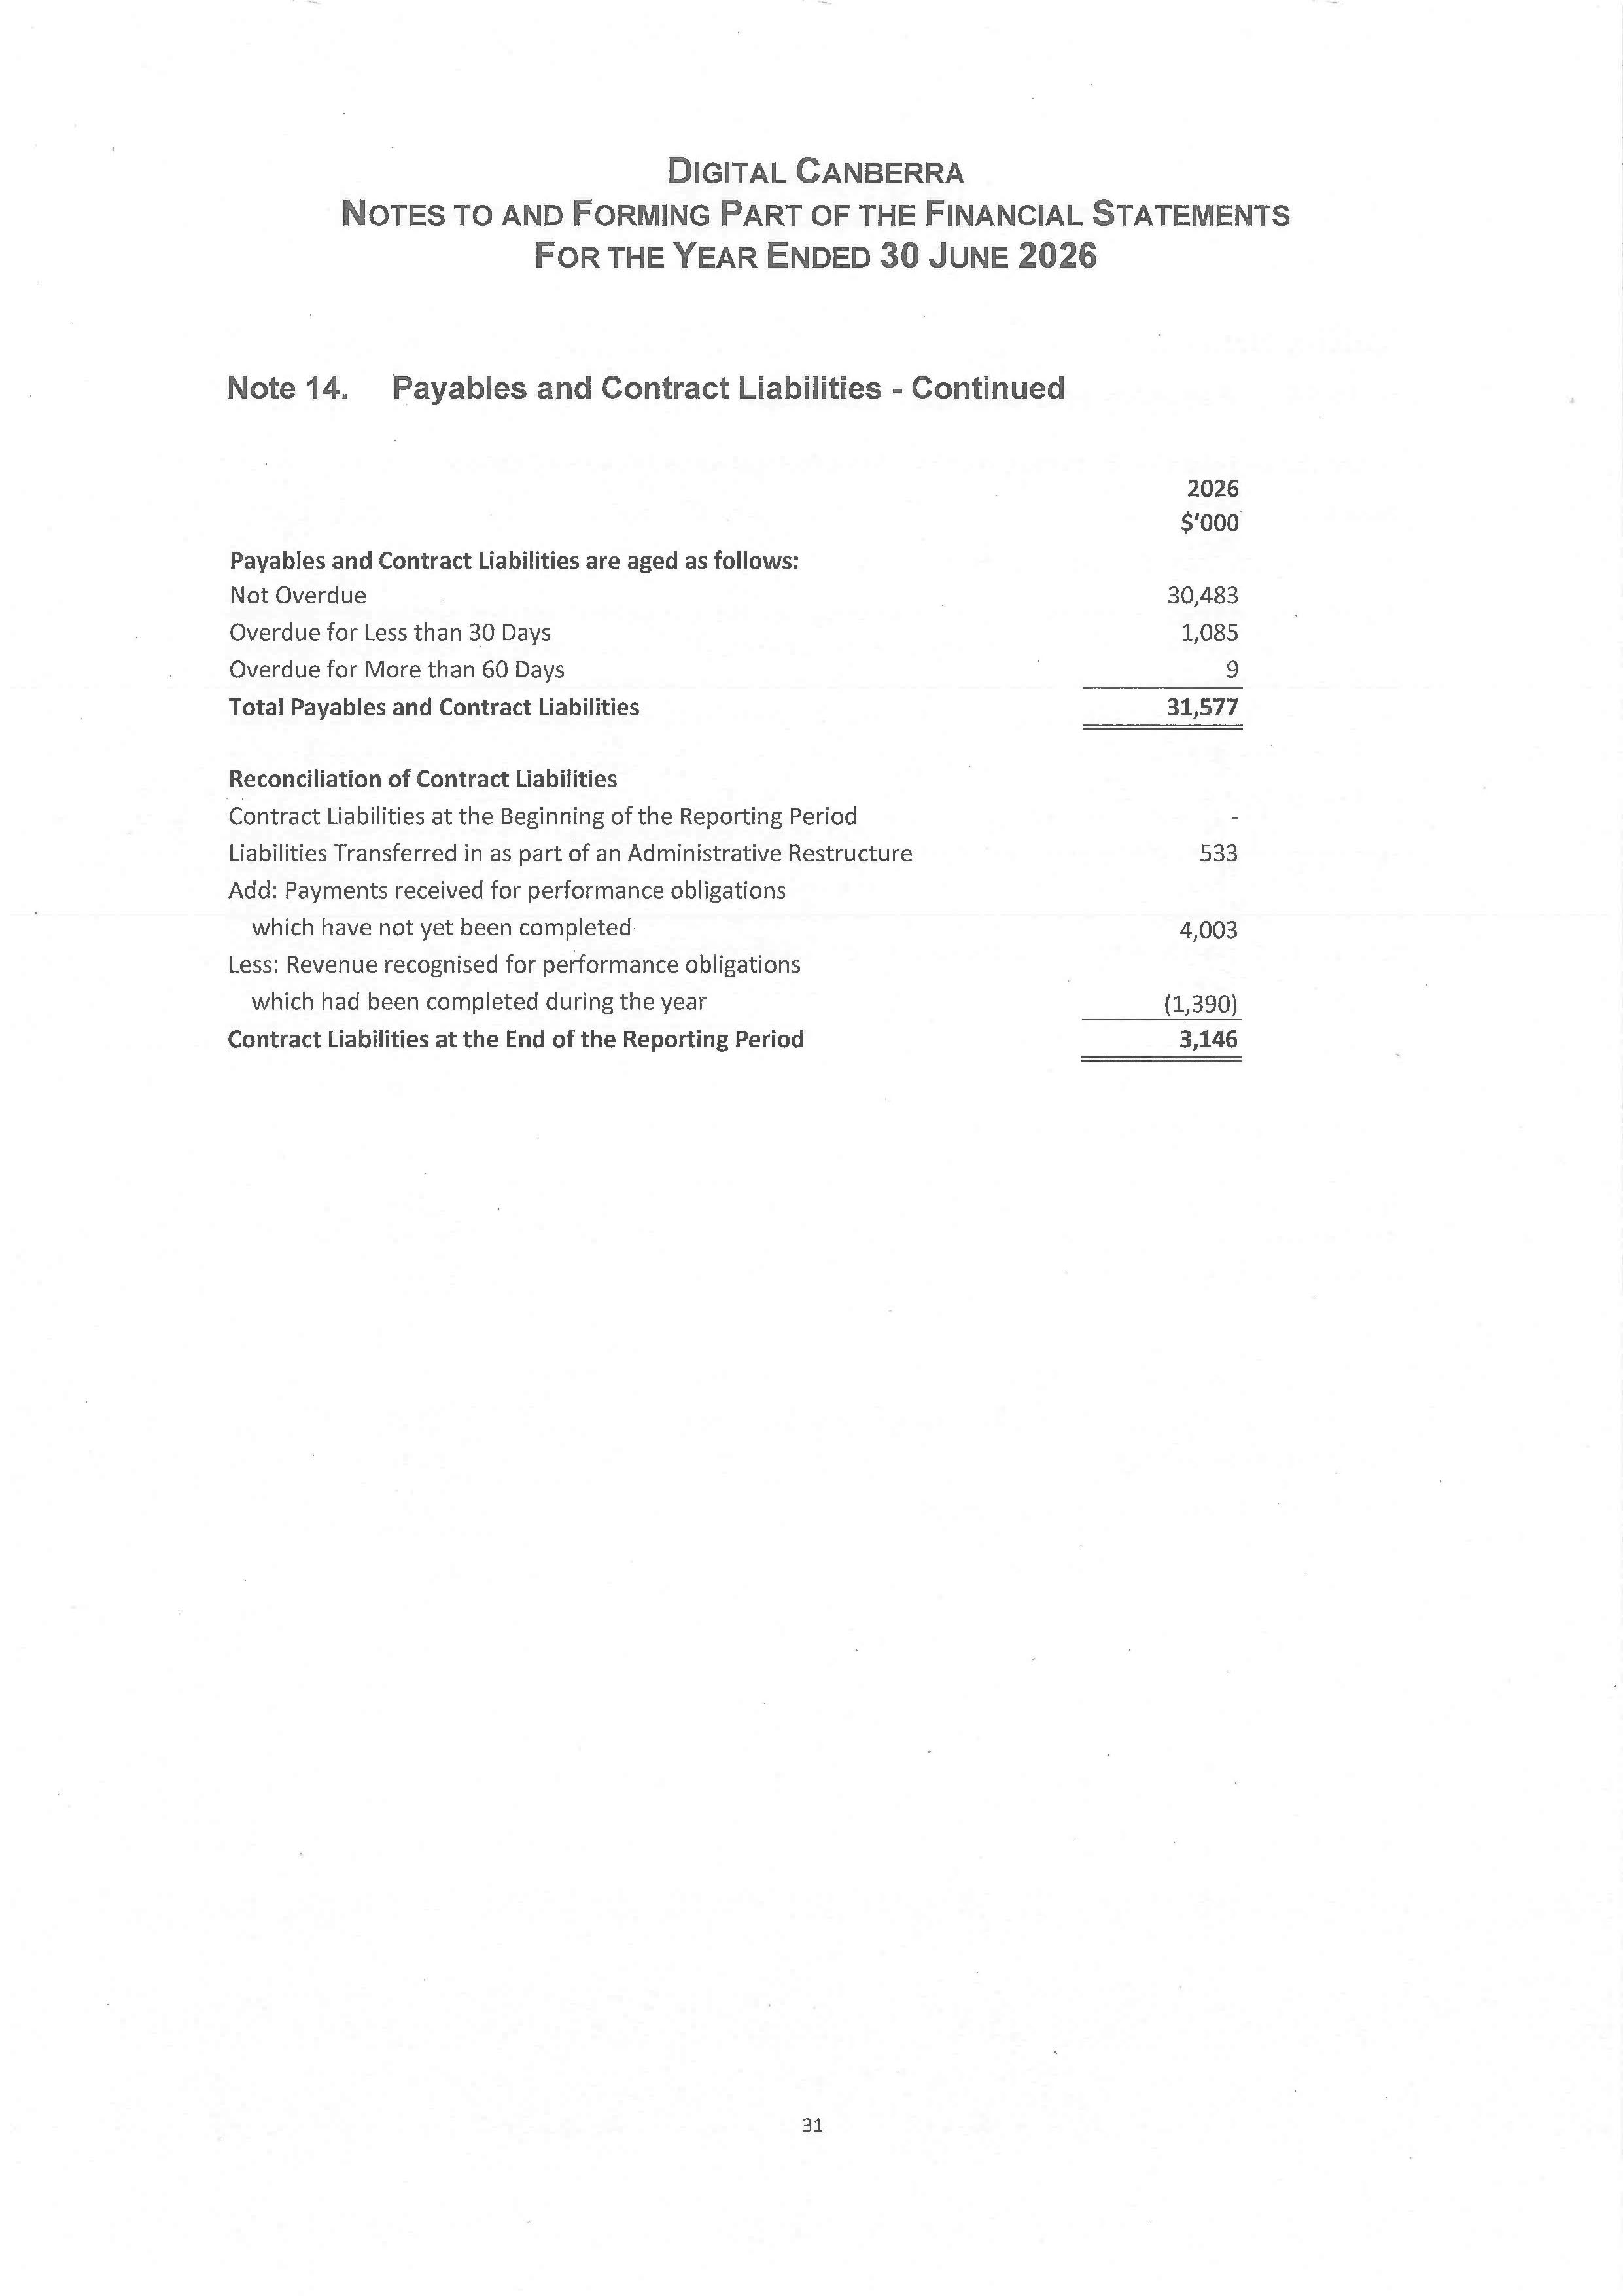
133
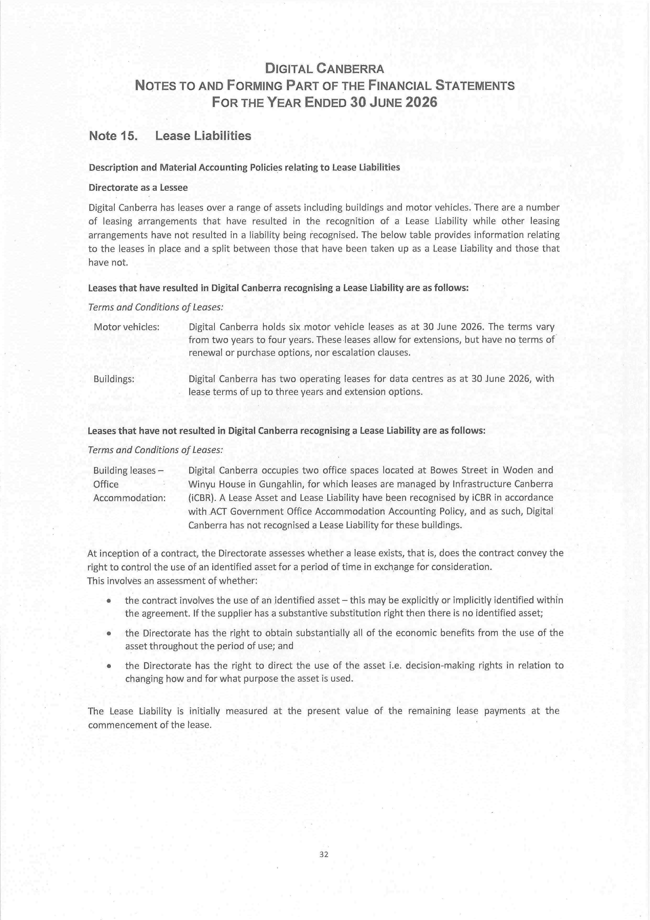
134
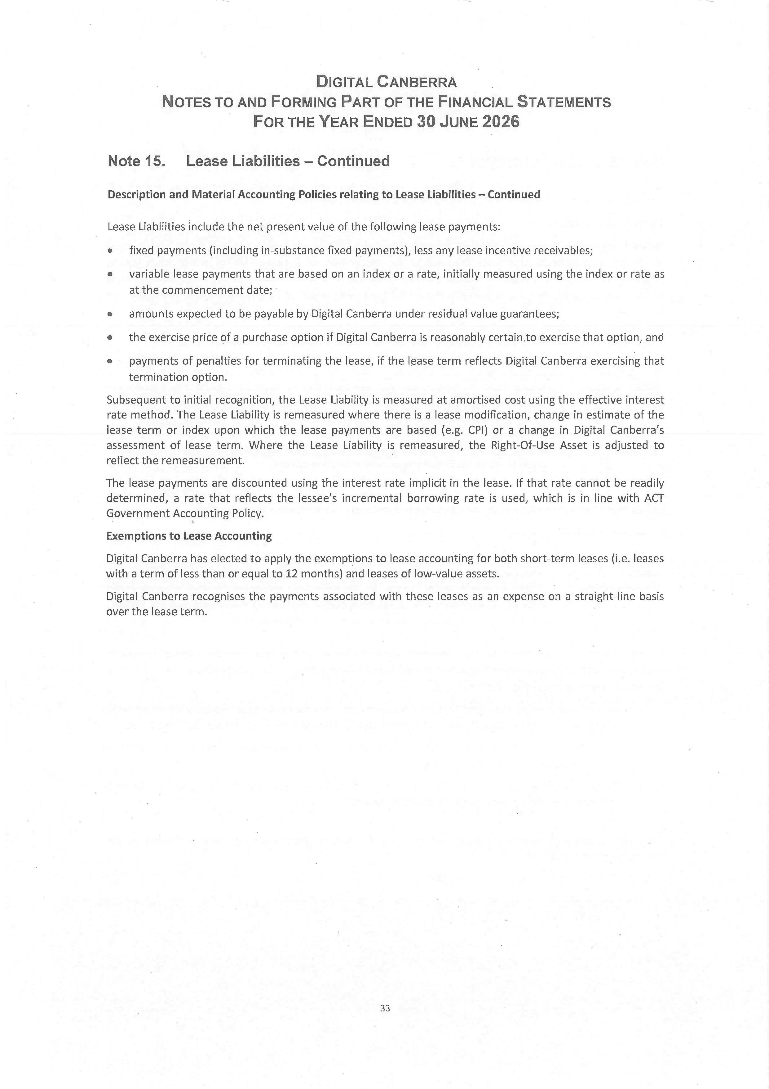
135
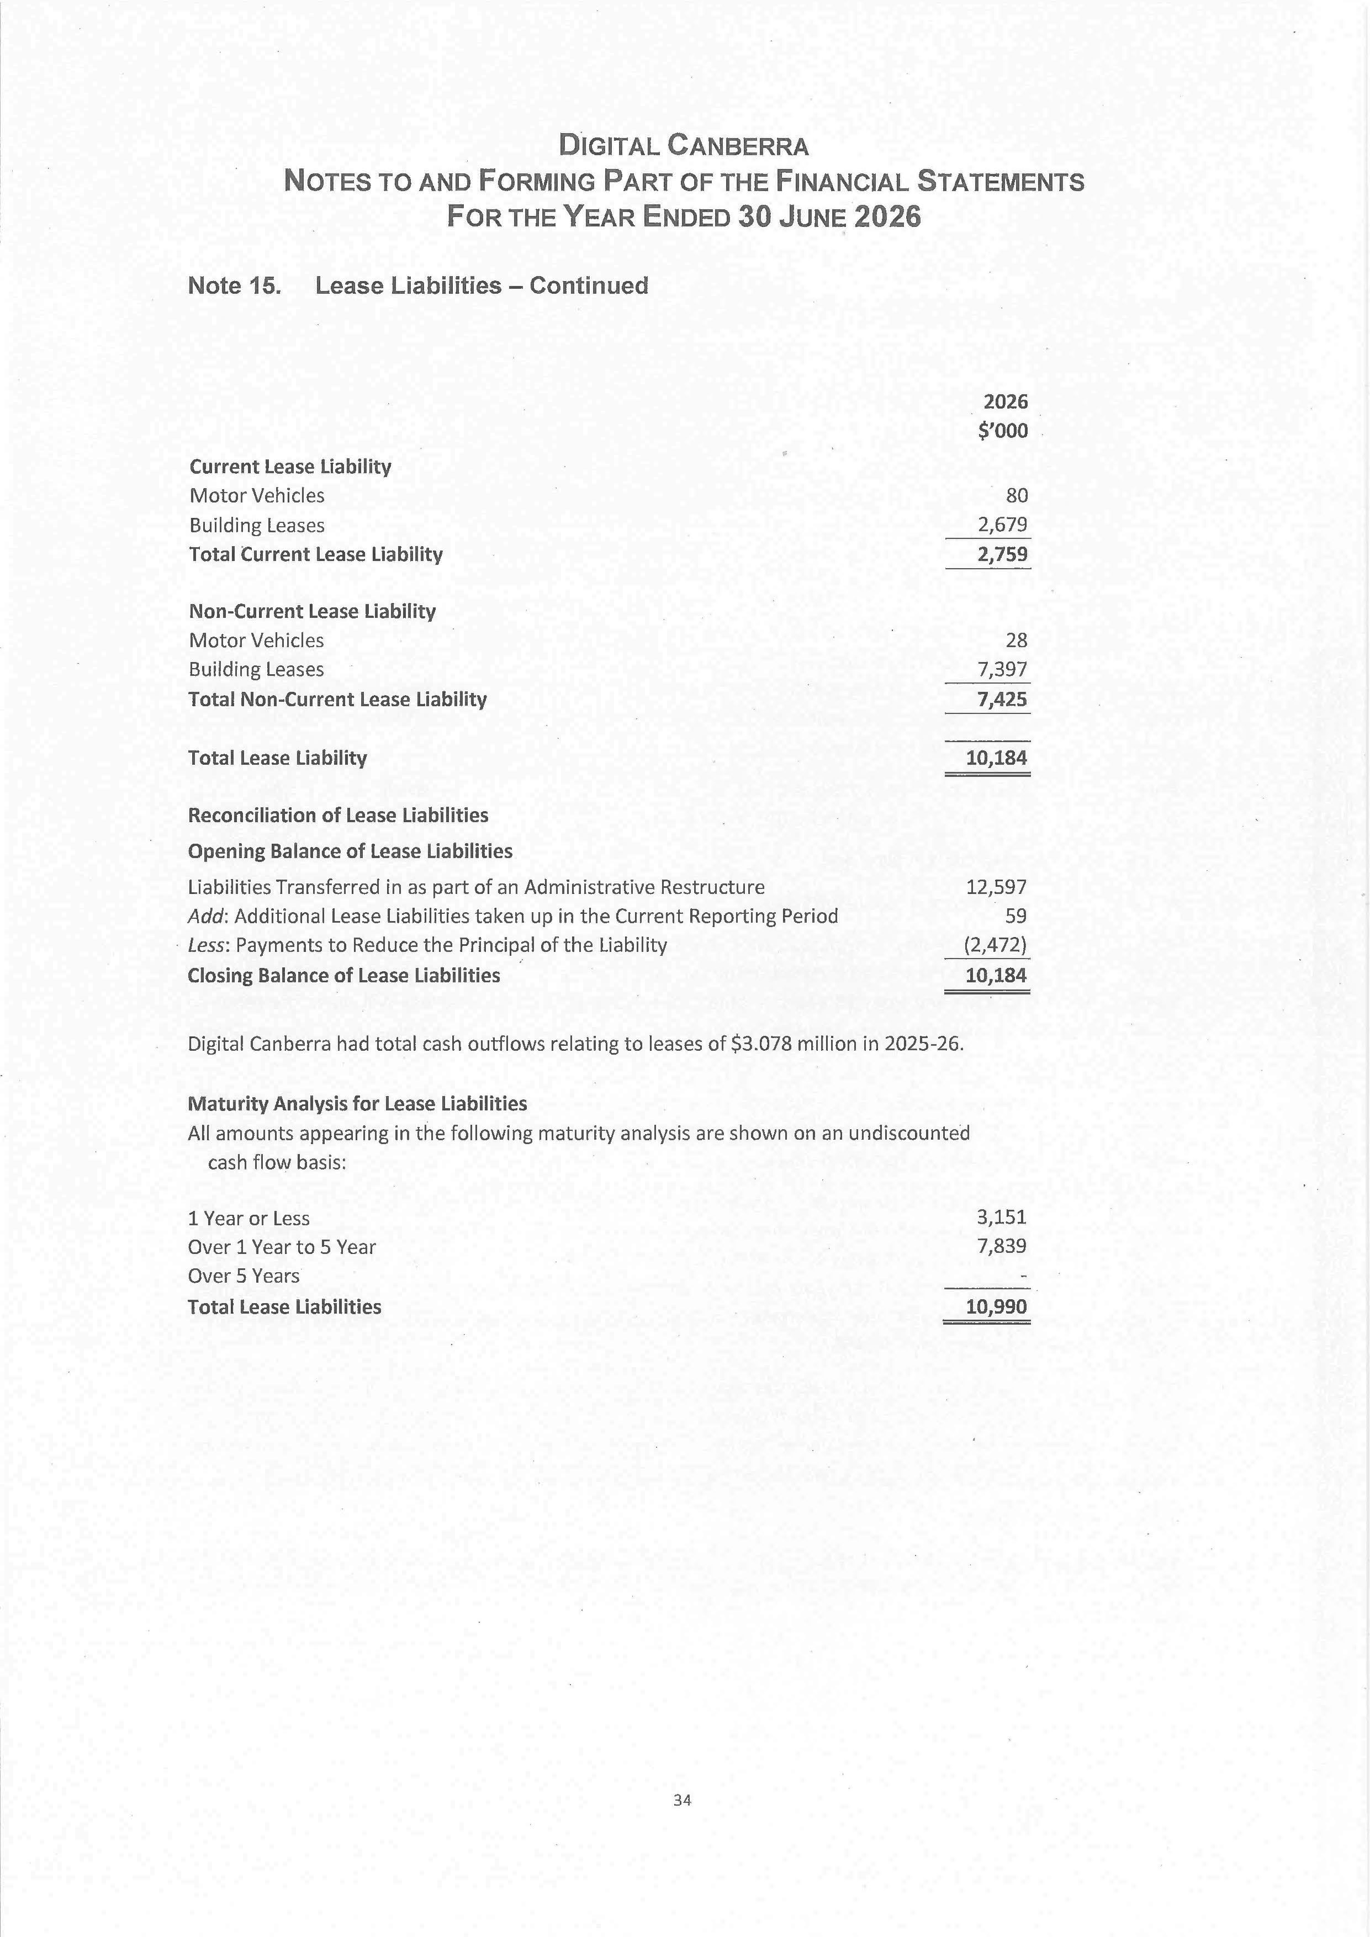
136
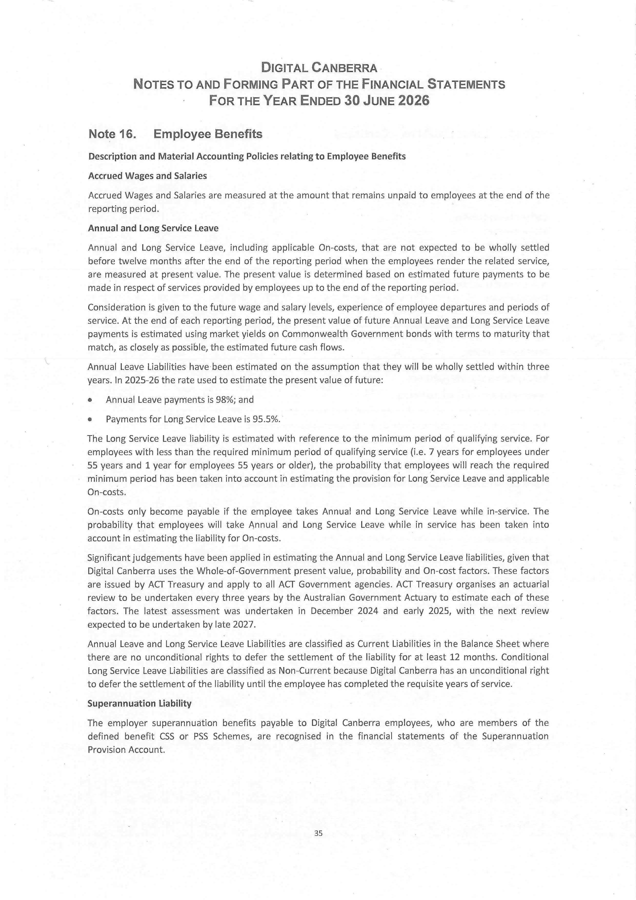
137
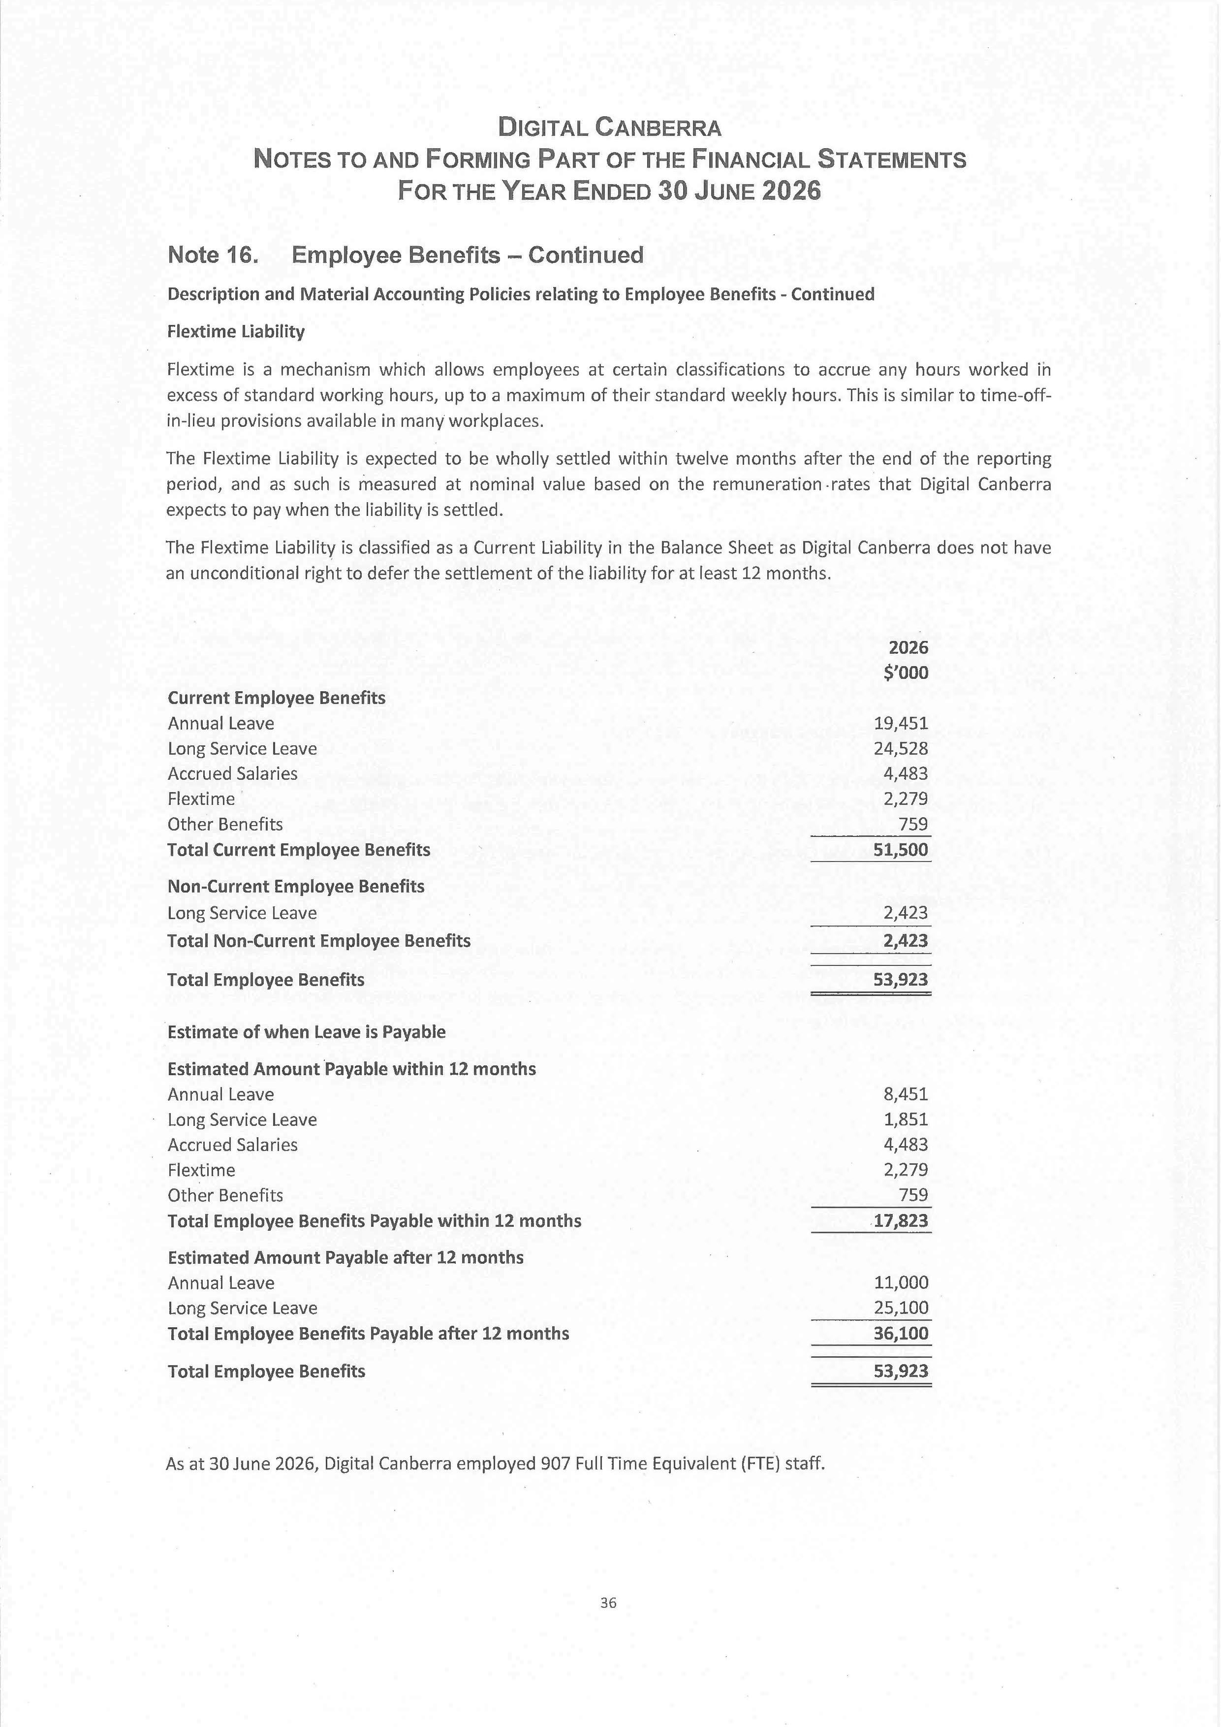
138
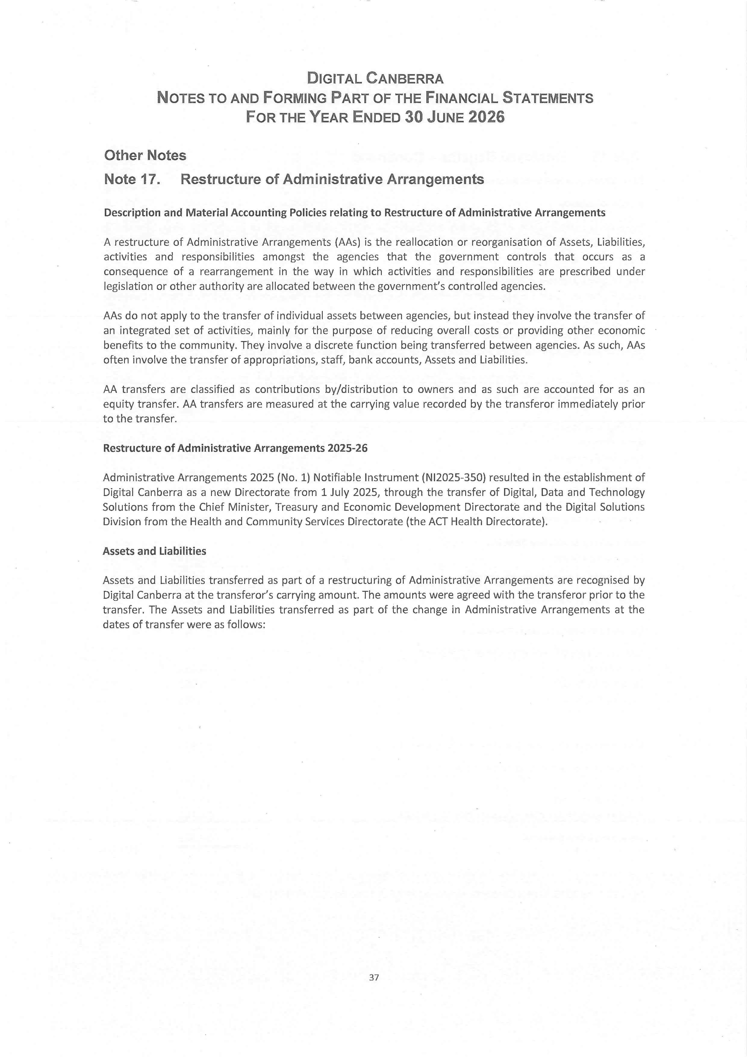
139
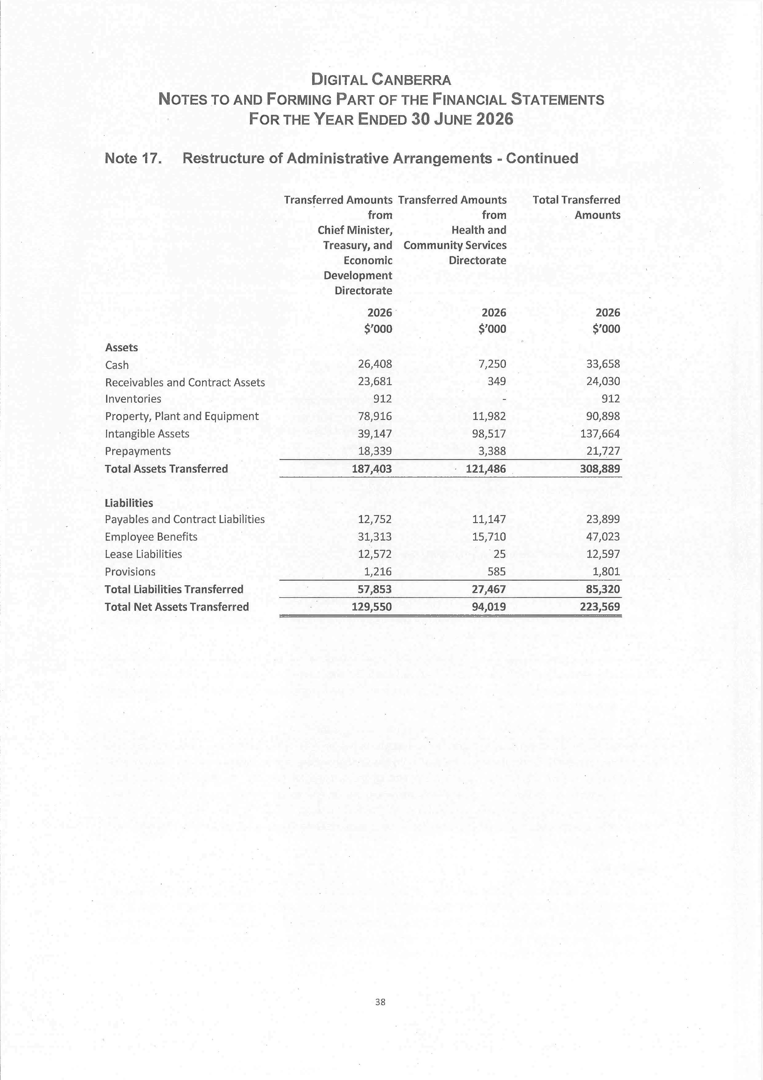
140
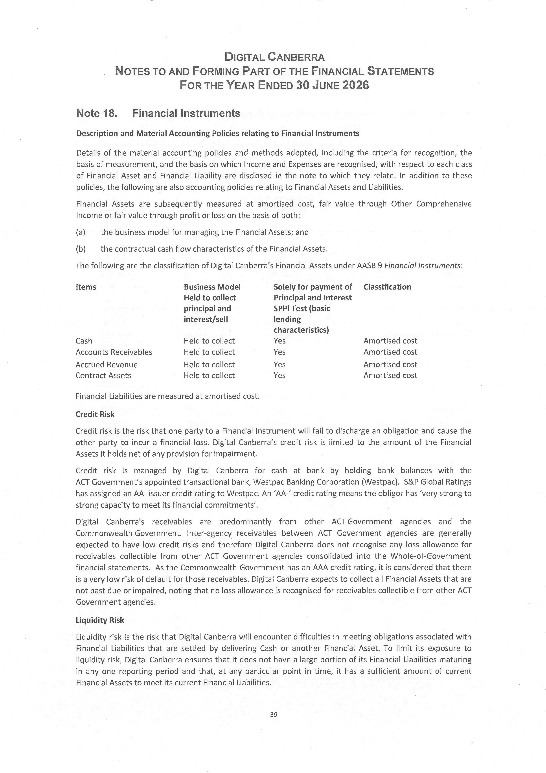
141
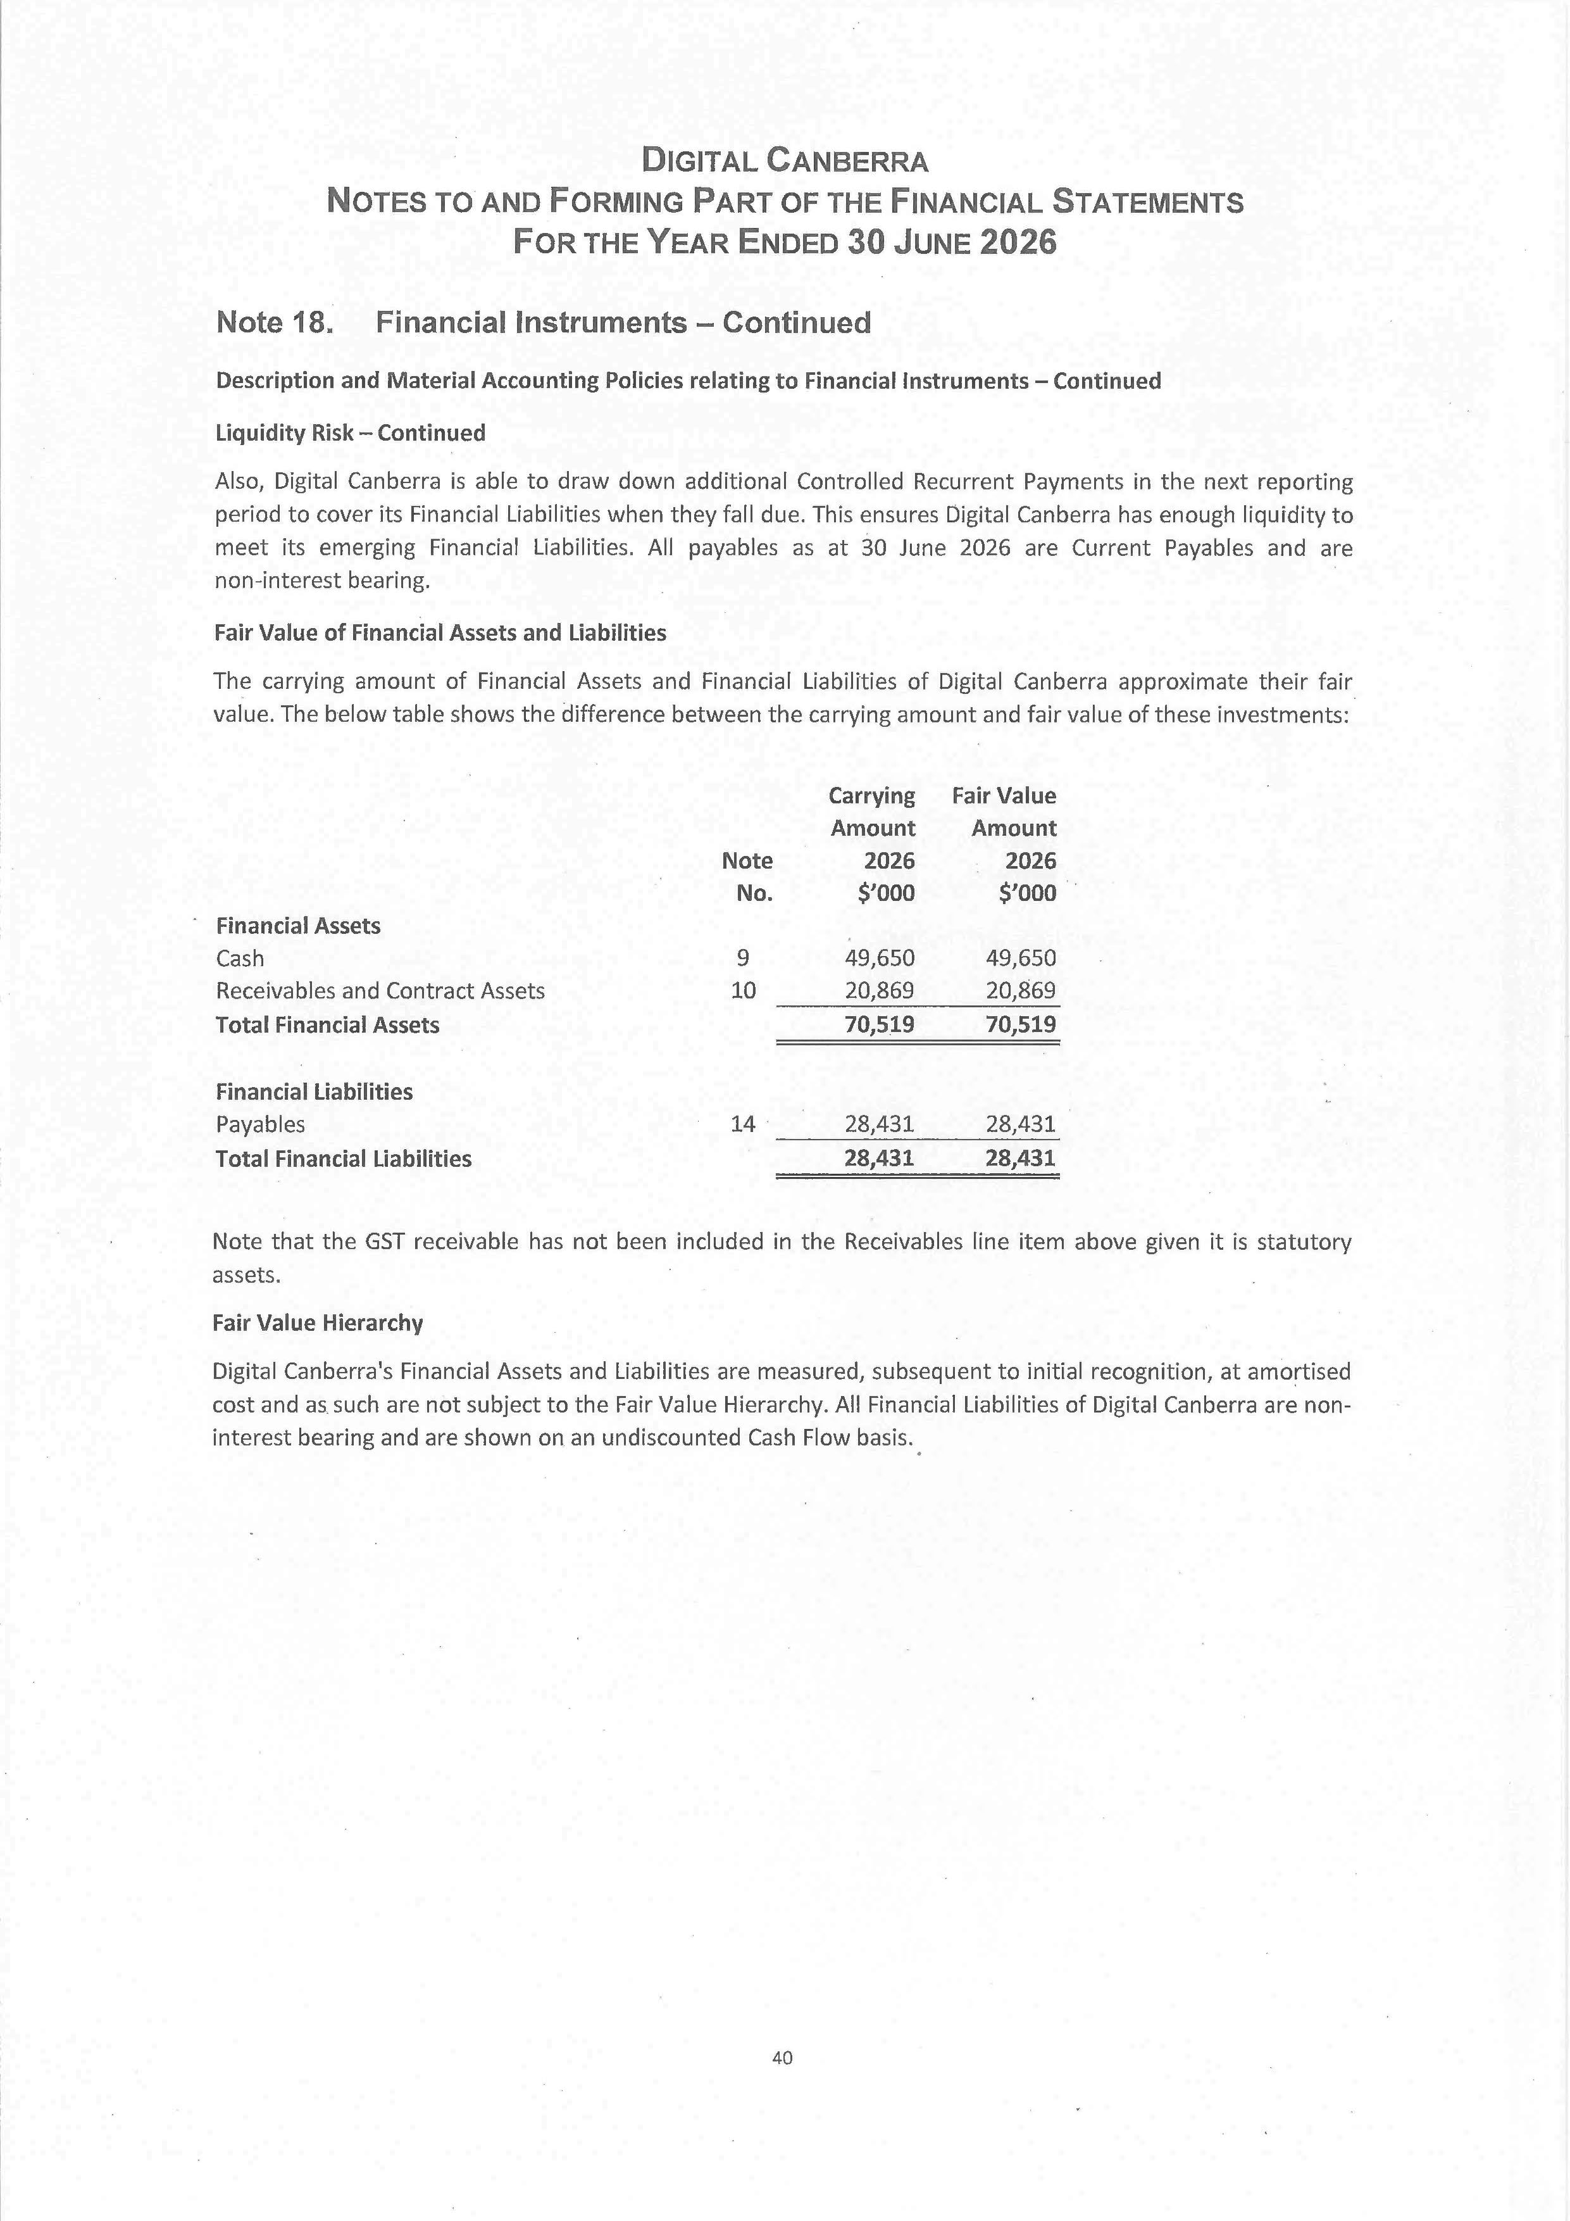
142
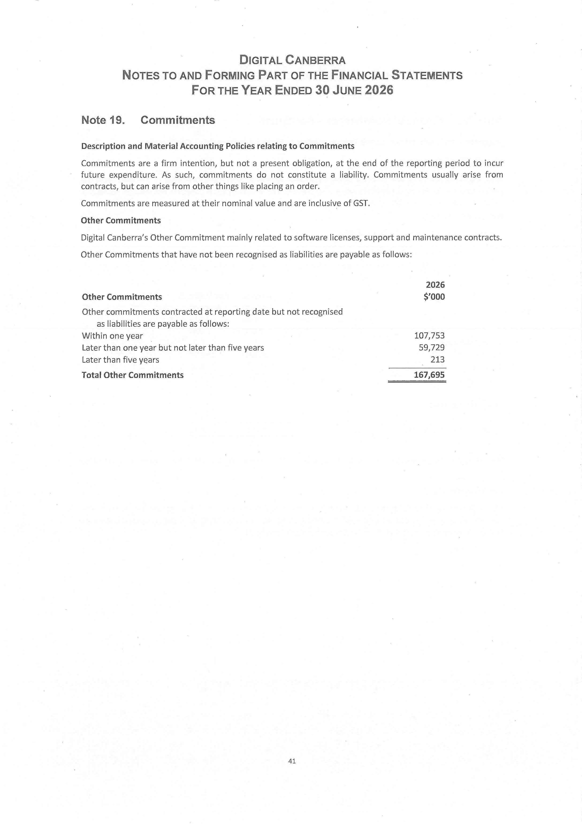
143
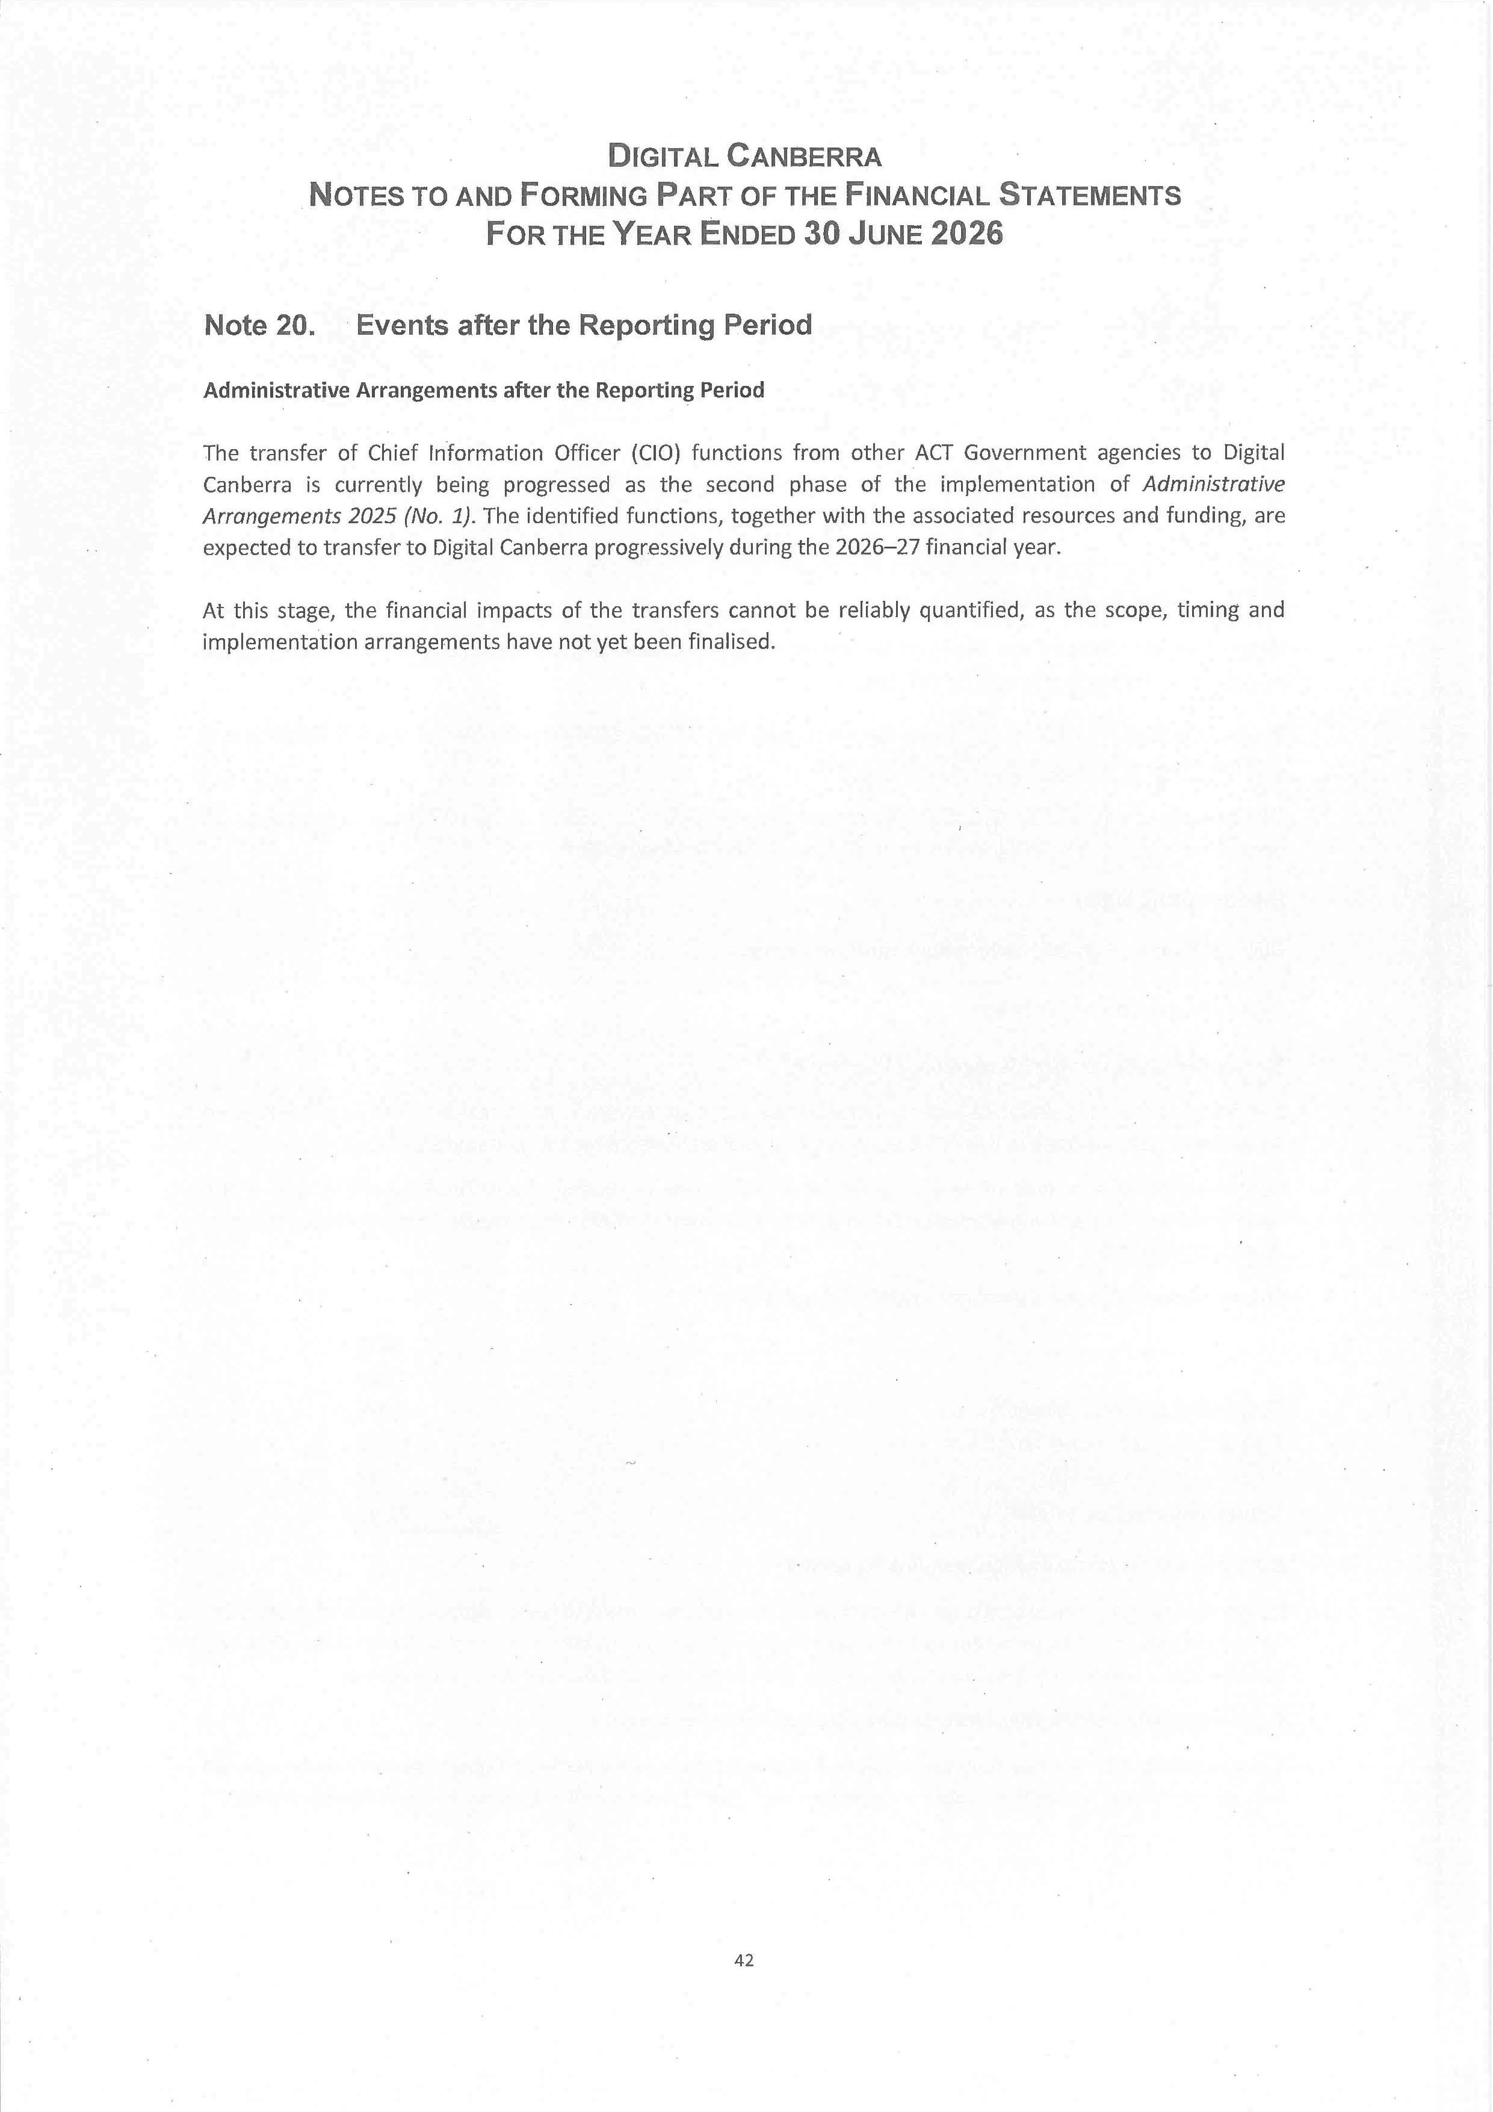
144
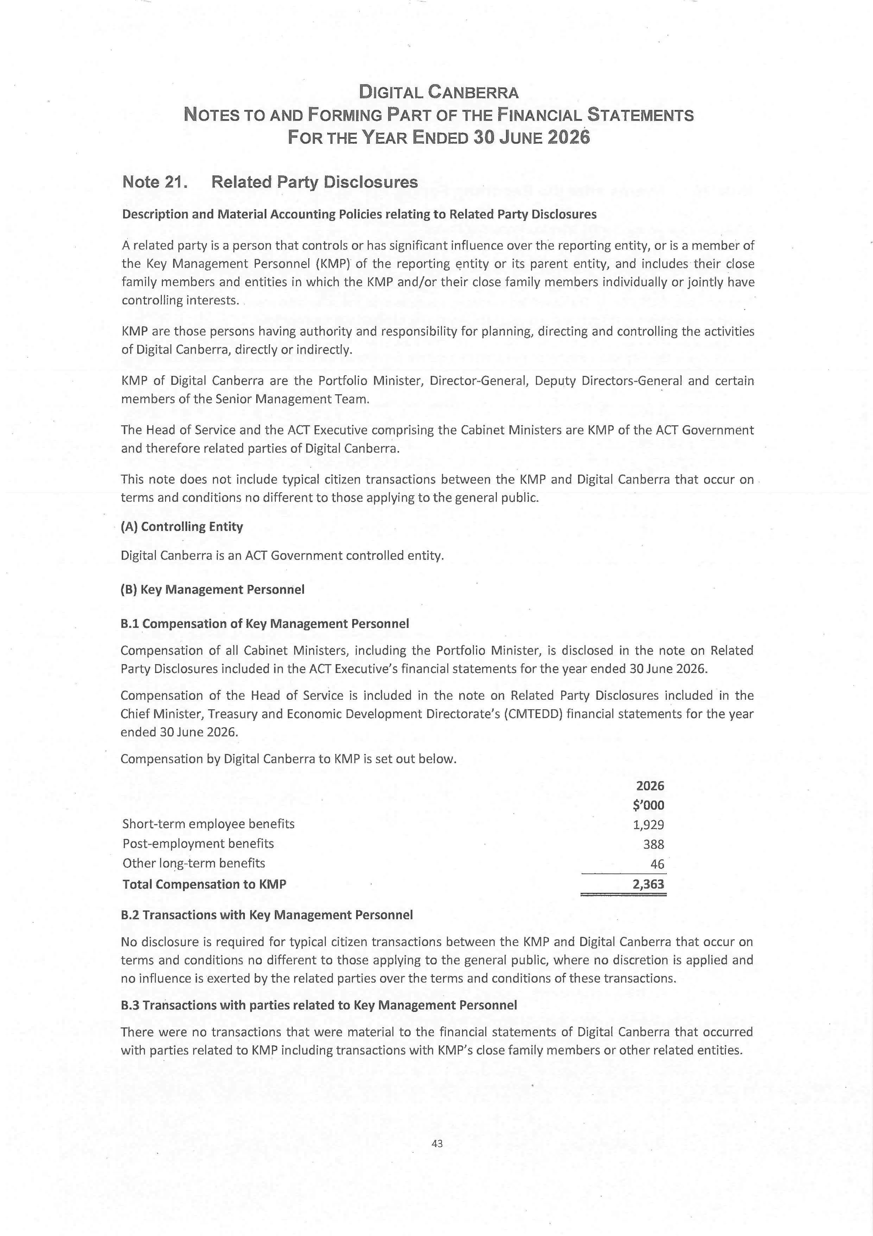
145
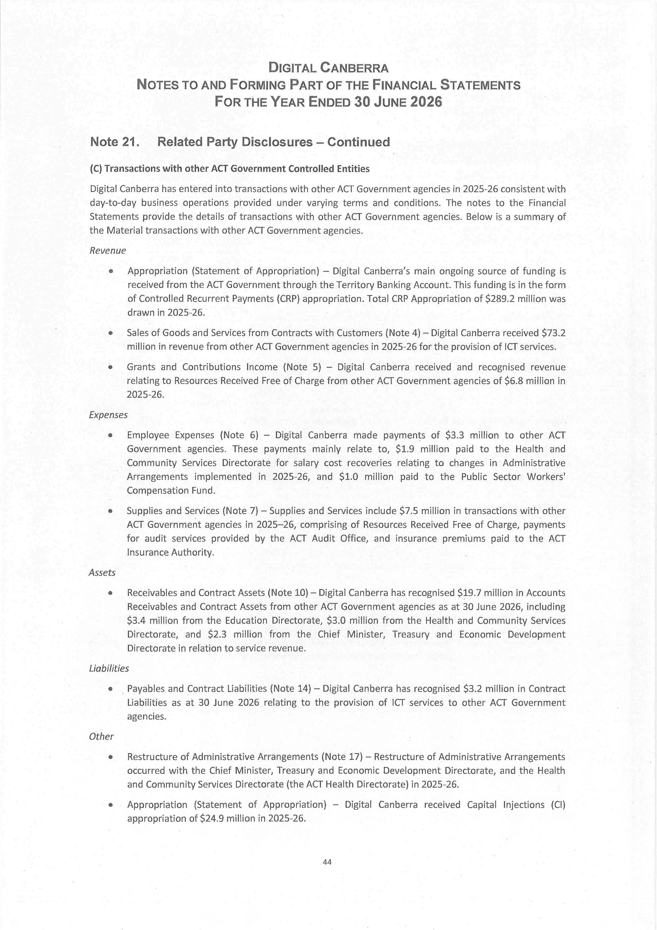
146
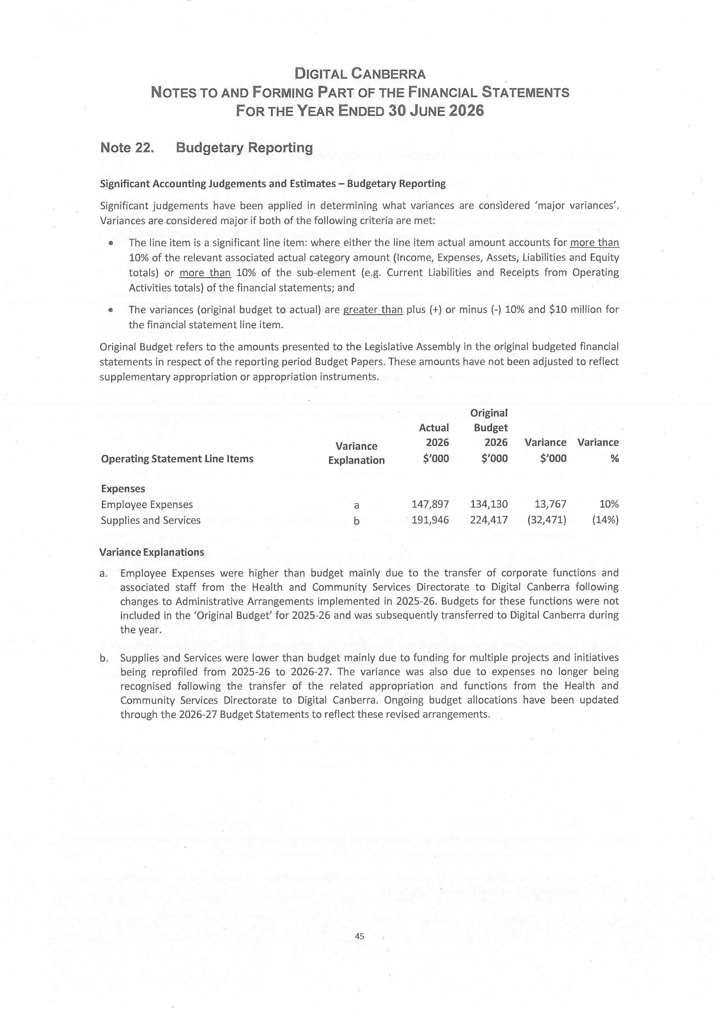
147
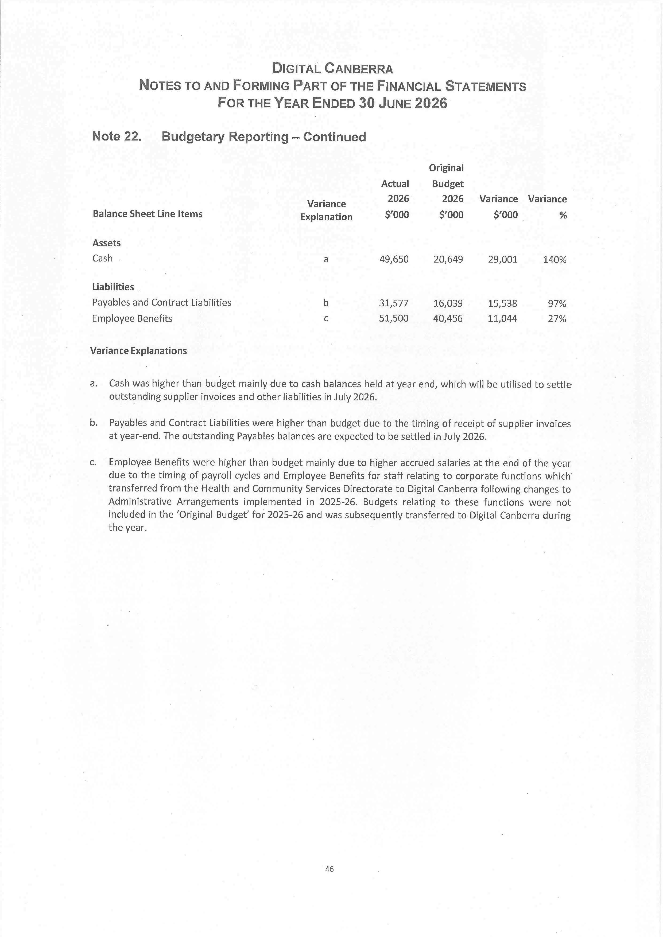
148
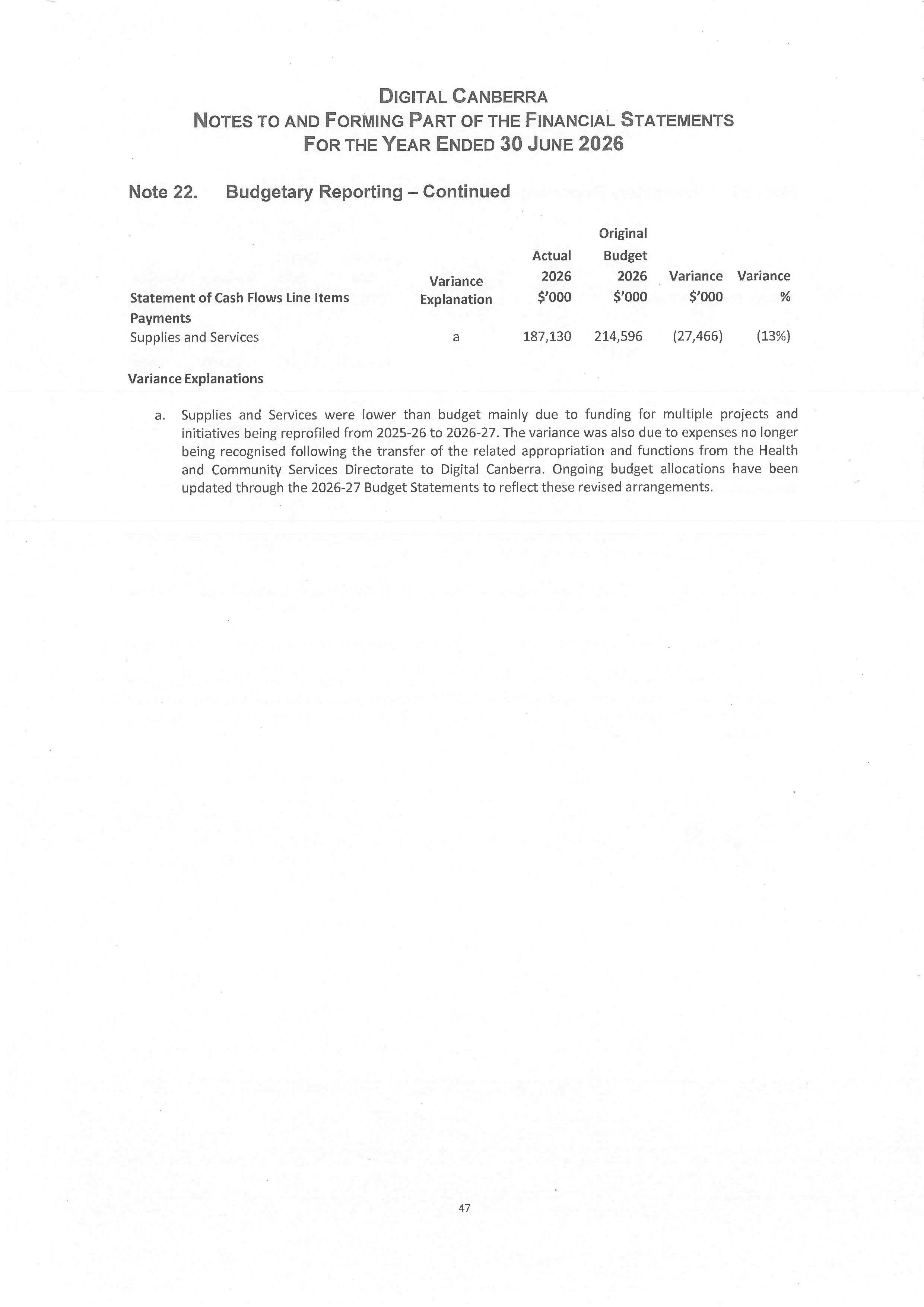
149

Capital works

Capital works 2025–26

Table 29: 2025–26 Capital works, new, in progress and complete projects
Projects | Estimated completion date | Original project value ($'000) |  | Revised project value ($'000) | Prior year expenditure ($'000) | 2025–26 Actual expenditure ($'000) | Total expenditure to date ($'000)
New Projects:
Delivering Payroll Capability and Human Resource Management | Jun-27 | 5,694 |  | 5,694 | 44 | 993 | 1,037
Investing in our digital future – upgrading digital systems and hardware | Sep-26 | 16,091 |  | 16,091 | - | 14,982 | 14,982
Investing in our digital future – continuing the delivery of the Digital Health Strategy | Jun-27 | 2,157 |  | 2,157 | - | 637 | 637
Total New Projects |  | 23,942 |  | 23,942 | 44 | 16,612 | 16,656
Works in Progress:
Ongoing delivery of the Digital Health Strategy | Jun-27 | 3,121 |  | 3,121 | 1,313 | 1,073 | 2,386
Improving Canberra’s health infrastructure – more capacity in the Critical Services Building | Dec-26 | 7,948 |  | 7,948 | 7,052 | 178 | 7,230
Improving Canberra’s health infrastructure – upgrading communications infrastructure across Canberra Health Services | Aug-27 | 11,328 |  | 6,078 | 905 | 221 | 1,126
Better care for our community – continuing delivery of the Digital Health Strategy | Jun-27 | 16,074 |  | 11,741 | 10,675 | - | 10,675
Better digital services – continuing to make Government services more accessible online | Jun-27 | 4,350 |  | 4,350 | 3,136 | 611 | 3,747
Digitising government services | Jun-27 | 476 |  | 476 | - | - | -
Investing in our digital future | Jun-27 | 7,821 |  | 7,821 | 6,491 | 571 | 7,062
Total Works in Progress |  | 51,118 |  | 41,535 | 29,572 | 2,654 | 32,226
Complete (pending final physical and financial acquittal):
Securing our information and data for the future | Jun-26 |  | 1,206 | 1,206 | - | 1,165 | 1,165
Total Completed |  | 1,206 |  | 1,206 | - | 1,165 | 1,165
Total Capital Works Program |  | 76,266 |  | 66,683 | 29,616 | 20,431 | 50,047

Reconciliation schedules

Table 31: Reconciliation of current year capital works program financing to capital injections as per cash flow statement
 | $'000
Original capital works program financing | 34,187
Total capital injections financing (as per 2025–26 Budget) | 34,187
Section 16B Rollovers from 2024-25 | 5,041
Section 14A Transfer of Appropriation from Capital Injections  to Controlled Recurrent Payments | (836)
Capital Injections not drawn in 2025–26 | (13,497)
Capital injections per cash flow statement | 24,895

Table 30: Reconciliation of Total 2025–26 expenditure to capital injections as per cash flow statement
 | $'000
Total 2025–26 Capital works program expenditure | 20,431
2025–26 Capital Works Program Expenditure as per Table 1 | 20,431
2025–26 Accrual (includes cash on hand) and other movements | 4,062
Capital injections for prior year expenditure | 402
Capital injections per cash flow statement | 24,895

Asset management

Assets managed

Table 32: Assets managed by Digital Canberra as at 30 June 2026
Asset | Property, plant and equipment ($million) | Intangible assets ($million) | Capital works in progress ($million) | Total value ($million)
Intangible Assets | - | 85.5 | 23.6 | 109.1
Plant and Equipment | 70.8 | - | 19.0 | 89.8
Right-of-use Buildings | 9.6 | - | - | 9.6
Leasehold Improvements | 5.9 | - | - | 5.9
Right-of-use Plant and Equipment | 0.1 | - | - | 0.1
Total | 86.4 | 85.5 | 42.6 | 214.5

During 2025–26, additions to Digital Canberra’s assets predominately included the following:
- $78.9 million of Property, Plant and Equipment and $39.1 million of Intangible Assets, including Capital Works in Progress relating to the transfer of assets from CMTEDD resulting from the restructure of Administrative Arrangements
- $98.5 million of Intangible assets and $12.0 million of Property Plant and Equipment, including Capital Works in Progress relating to the transfer of assets from HCSD resulting from the restructure of Administrative Arrangements
- $24.8 million for the purchase of ICT equipment and end user devices for use across the ACT Government
- $17.2 million in Capital Works in Progress, for the purchase of ICT Hardware.
During 2025–26, decreases in Digital Canberra’s assets predominately included the following:
- $27.4 million in Property, Plant and Equipment assets depreciation and $24.3 million in Intangible Assets amortisation
- $8.4 million in Capital Works in Progress recognised in a prior period but expensed in the current period. These balances were reclassified as expenses during the year following a comprehensive review of the works in progress balances and available information
- $0.5 million in Disposals and Impairment losses.

Asset maintenance and upgrades
Digital Canberra provides and manages digital services, platforms and technology solutions that support ACT Government operations and service delivery. The directorate does not own significant physical infrastructure assets that require maintenance or upgrade, but does deliver the ongoing maintenance, support, refresh and enhancement of digital systems, platforms and technology environments to ensure they remain secure, reliable and fit for purpose.

Government contracting
Digital Canberra has complied with the Government Procurement Act 2001 during the reporting year.
Digital Canberra was established at the start of financial year 2025–26, with immediate effect. Digital Solutions Division from the former ACT Health Directorate combined with Digital, Data and Technology Solutions Division from CMTEDD. Over the last financial year, Digital Canberra’s procurement continued to be conducted across HCSD, Procurement ACT (PACT) and the newly formed Digital Canberra Strategic Sourcing team. From 2026–27, procurement will be managed centrally under Digital Canberra Strategic Sourcing to ensure a central point of advice, procurement delivery and compliance tracking and reporting.
Digital Canberra has ensured compliant procurement. Value for money has been demonstrated to the delegate for each procurement through either a competitive process, pre-existing panel use, or continuation of existing agreements where selecting an alternative would not demonstrate appropriate value to justify changing products. In each instance this assessment was documented within an evaluation plan or brief.

Notifiable contracts
Notifiable contracts are published on Tenders ACT. This is processed through the procurement team that establishes the contract, with the public text version of the contract and procurement values published through Tenders ACT. Notifiable invoices are managed by Digital Canberra Strategic Finance.
The online ACT Government Contracts Register records contracts with suppliers of goods, services and works with a value of $25,000 or more.
A full search of territory entity contracts notified with an execution date from 1 July 2025 to 30 June 2026 can be made at https://www.tenders.act.gov.au/contract/search.

Secure Local Jobs Code
No exemptions were granted from the Secure Local Jobs Code throughout the financial year. Digital Canberra’s contracts where labour was the primary expense to the ACT Government were professional services, an excluded service (ANZSIC, Division M) per Section 12 AB of the Government Procurement Regulation 2007.

Confidential text
Where Confidential text has been identified in a contract, approval for exemption to publish the confidential information is sought through the Digital Canberra Director-General. This ensures the published text contract has removed only the text that has been approved as confidential.

Aboriginal and Torres Strait Islander Procurement Policy
Digital Canberra applied the Aboriginal and Torres Strait Islander Procurement Policy in 2025–26. Measures enacted under this policy included:
- Eleven unique Aboriginal and Torres Strait Islander enterprises were engaged through 69 requests for quotes. Five responded to tender and quotation opportunities. It should be noted that Measure 1 currently requires the use of “suitable systems” to issue and receive tenders and quotations.
  - PACT only has access to and visibility of, whole-of-government systems, which means their reporting does not include entity-specific systems as this would not be operationally viable, hence why the above data may not align with PACT reported figures.
  - The policy allows for each entity’s Chief Financial Officer to nominate any other Approved Systems that can be used to assess performance against this measure. A request to have the Digital Transformation Agency Marketplaces nominated is currently underway.
- Twelve unique Aboriginal and Torres Strait Islander enterprises attributed a value of addressable spend in the financial year.
- In 2025–26, Digital Canberra met the target for Measure 3 by achieving an addressable spend total of 2.44% against the target of 2.25%.
Highlights:
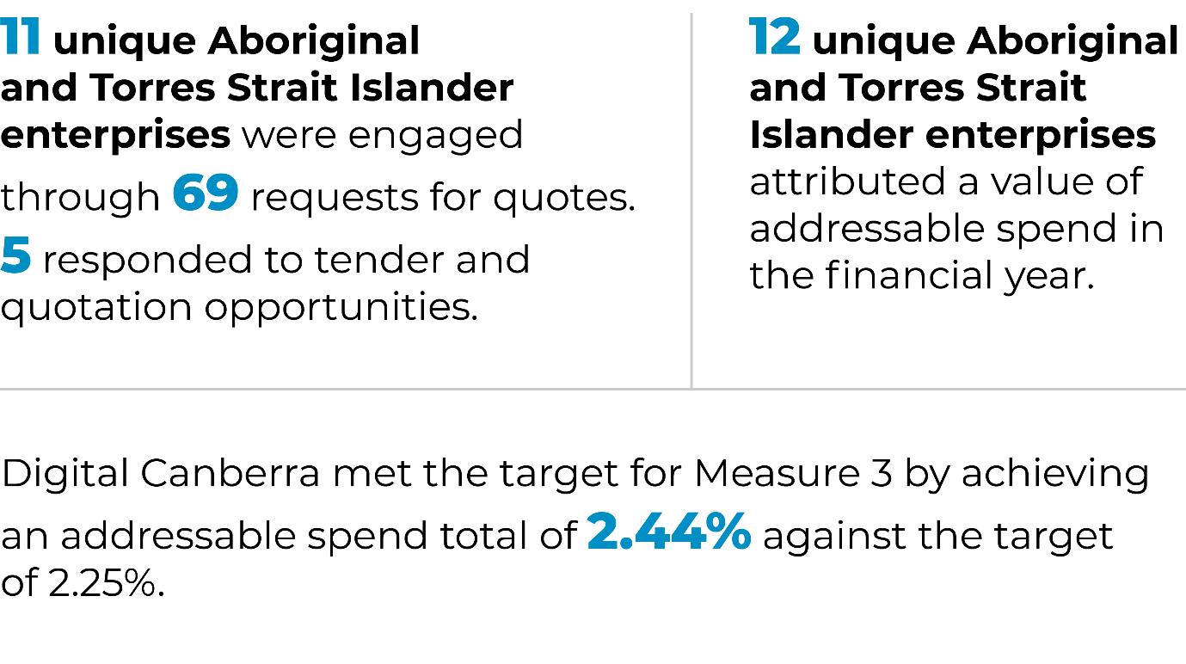
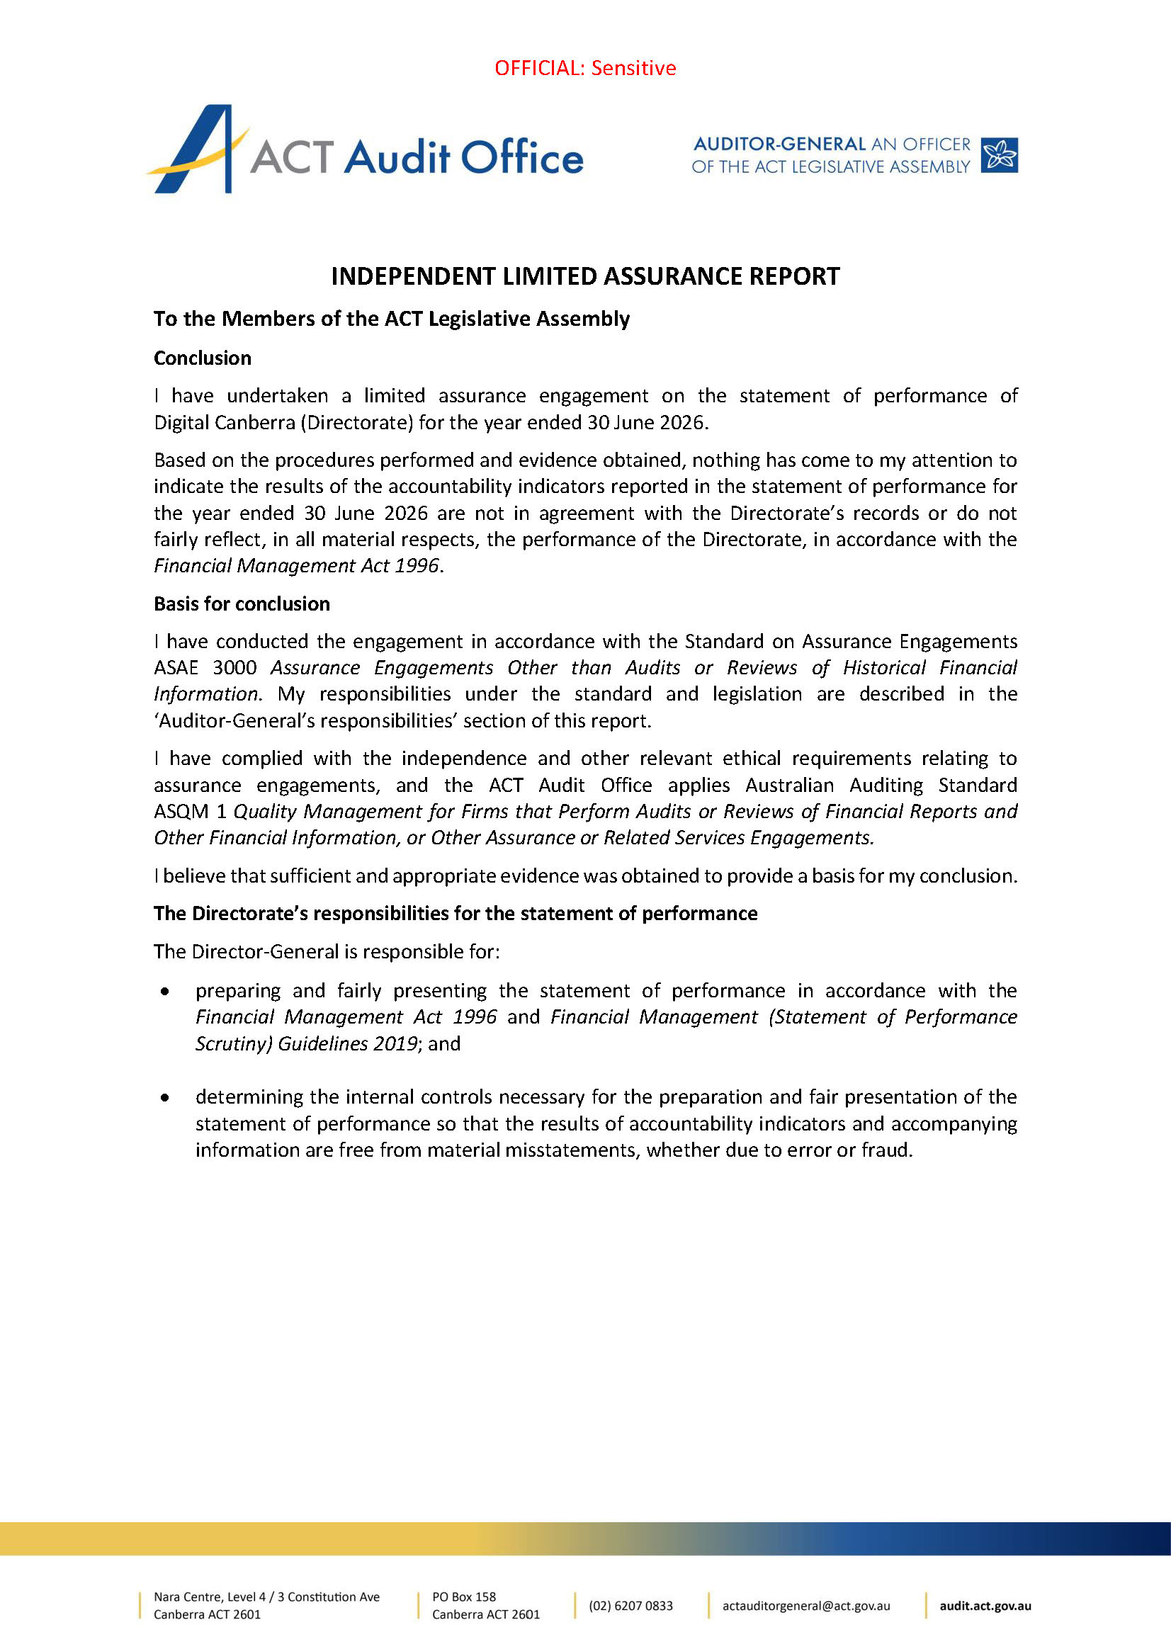

Procurement accreditation
Digital Canberra operates under a Level 2 accreditation and a request will be submitted in early 2026–27 to seek Level 3 accreditation. For higher value and/or higher risk procurements, Digital Canberra operates under the guidance of the PACT Level 4-accredited managed service. Digital Canberra has complied with the accreditation levels as required and has operated under the Government Procurement Act 2001 during the reporting year.
Digital Canberra has complied with the Government Procurement Act 2001 during the reporting year, noting the following exceptions:

Table 33: Digital Canberra Government Procurement Act 2001 compliance exceptions
Description of non-compliance | Section and subsection of Government Procurement Act 2001 to which the non-compliance relates – e.g. ‘Section 8(5)’ | Reason for non-compliance | Steps taken to rectify non-compliance
RITM5677509 – AARNet Variation.  RITM5748588 – DNAA ELA True Forward RITM5813345 – Provision of a Network Security Management Platform.  RITM5890766 – Rapid7 Variation #2.  RITM5929033 – ELA Contact Centres Variation. | Section 7 of the Government Procurement Act 2001 requires at 7(2)(a) The Territory entity's behaviour is ethical and there is evidence of this behaviour. | There is no evidence of Conflict-of-Interest forms having been provided for these contract variations. | Communication to the Strategic Sourcing Team regarding the need for Conflict-of-Interest Declarations when processing contract variations.

Statement of Performance
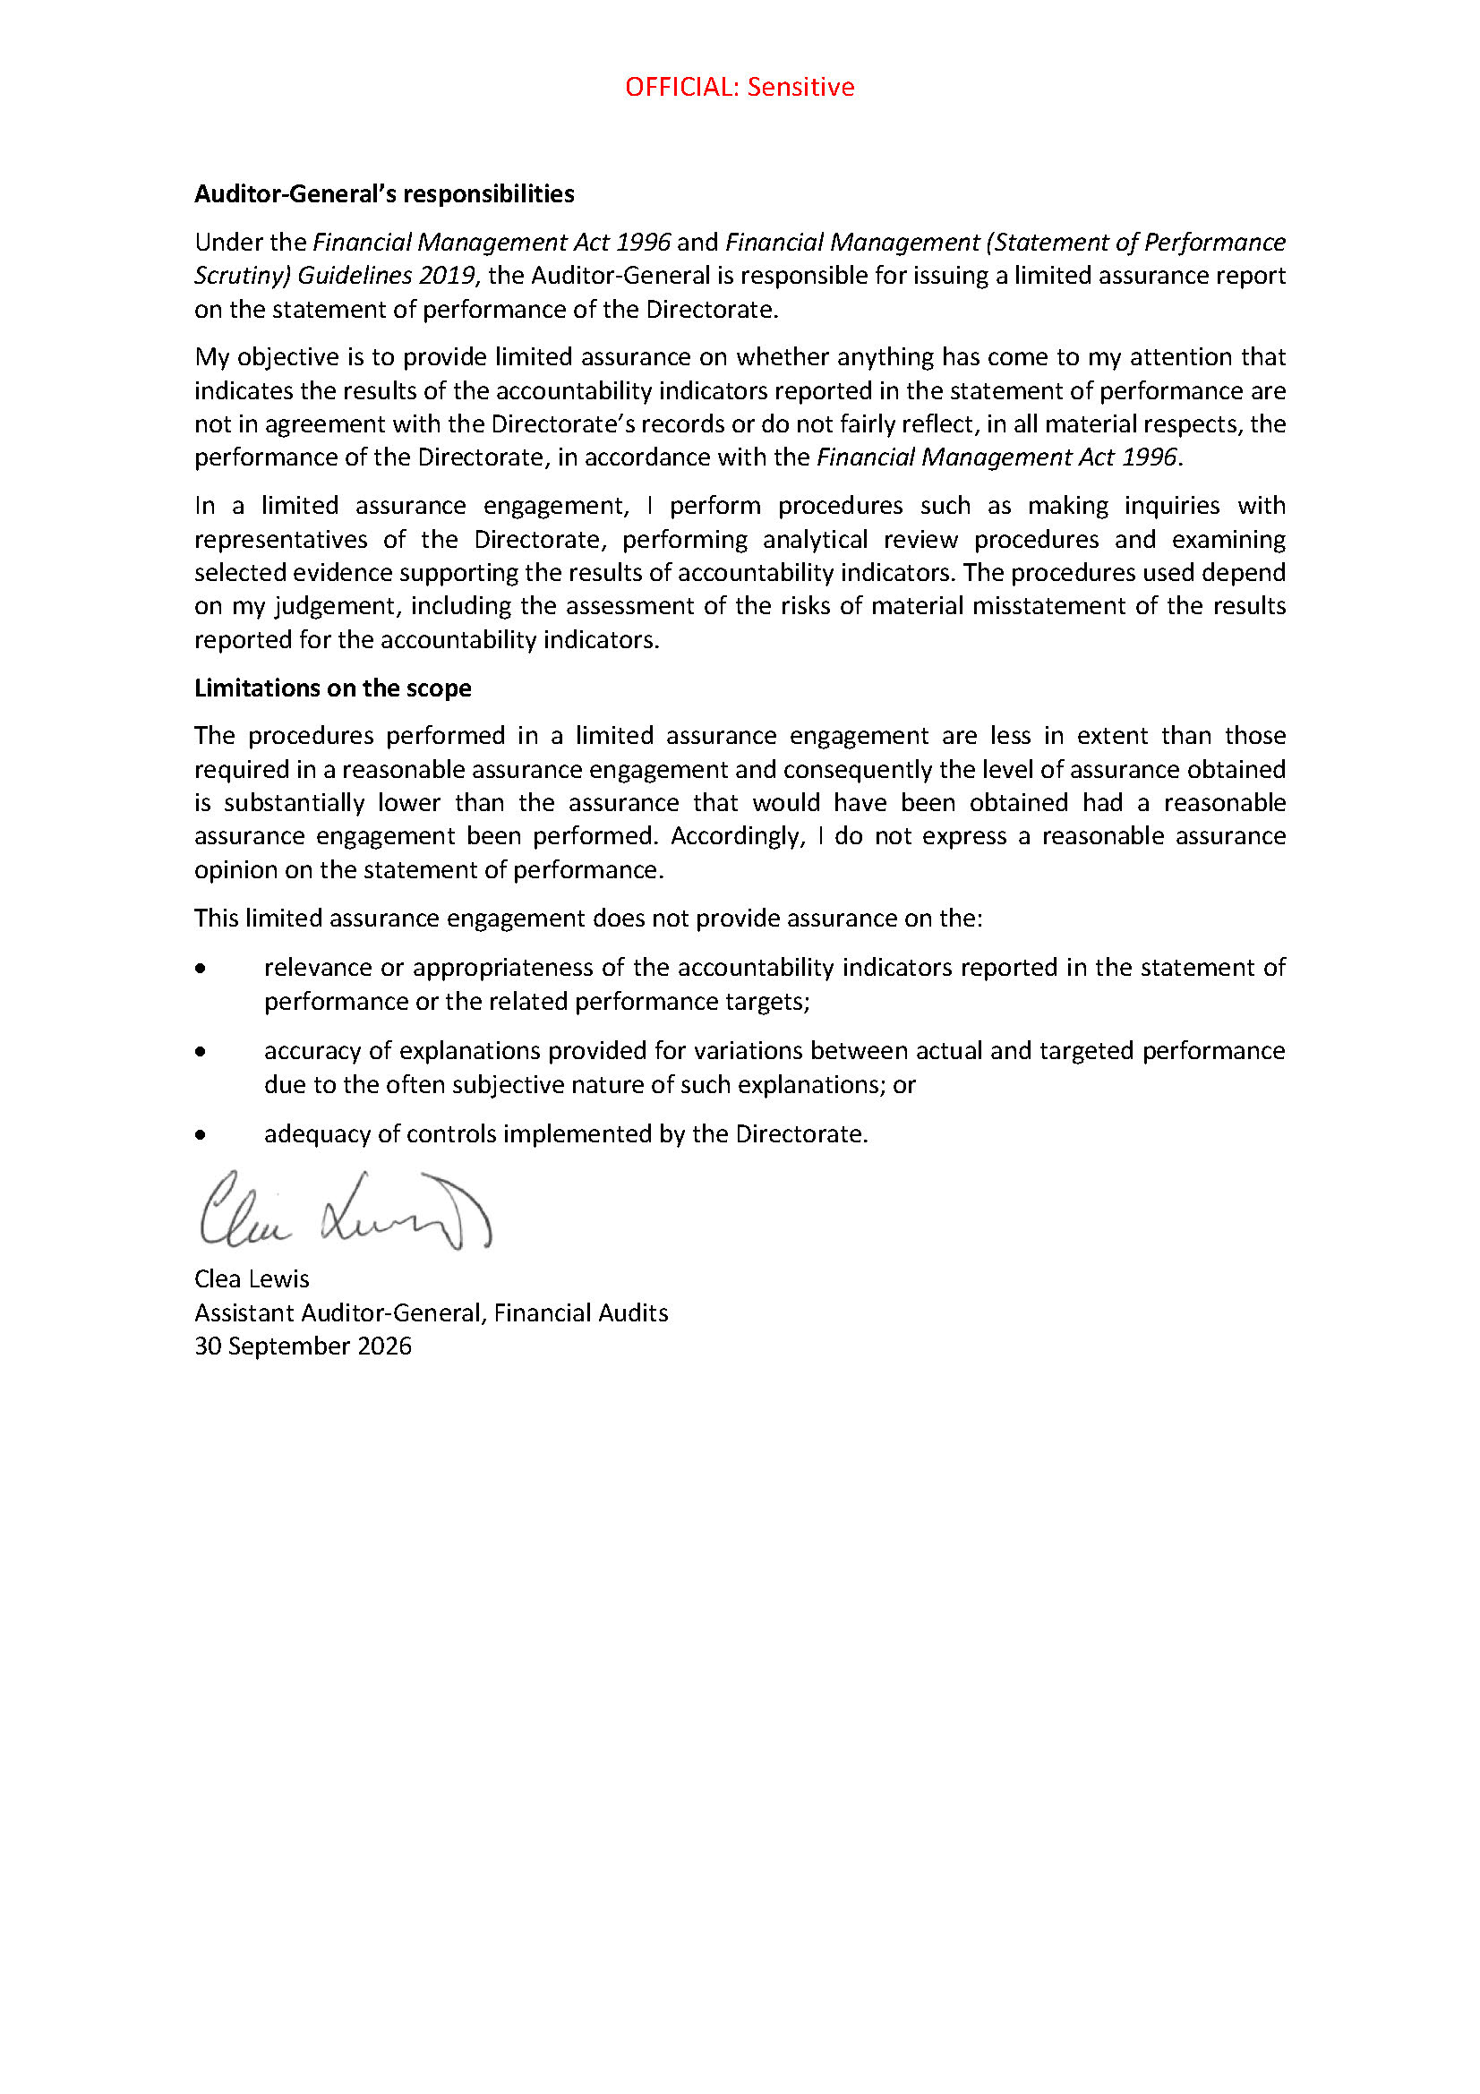


Statement of Performance

For the year ended

30 June 2026

Digital Canberra

Digital Canberra, 2025-26 Statement of Performance
The following Statement of Performance sets out the performance of Digital Canberra against the accountability indicator targets set during the 2025-26 Budget process.
When reading the following Statement of Performance, please note:
- All tables in this report should be read in conjunction with the accompanying notes and explanations.
- All variances are rounded up to the nearest whole number.
- Variances where the metric is a percentage are calculated by subtracting the target from the result and dividing the difference by the target (from Strengthening Performance and Accountability: A Framework for the ACT Government).
- All variances are calculated before rounding.
- Negative variances are indicated using brackets.
- The ACT Audit Office examined all accountability indicators in accordance with the Financial Management Act 1996 (FMA Act). In accordance with the Financial Management (Statement of Performance Scrutiny) Guidelines 2019, the ACT Audit Office did not examine results for total cost and controlled recurrent payments.
- The term ‘total costs’ in the accountability indicator output tables refers to the total expenditure against that output minus any intra-directorate transactions, which are eliminated. The total cost for all outputs equals total expenditure reported in the Digital Canberra Financial Statements.
- The term ‘controlled recurrent payments’ in the accountability indicator output tables refers to revenue received from the ACT Government to fund the net costs of delivering outputs. Controlled recurrent payments is recognised when Digital Canberra gains control over the funding, which is obtained upon the receipt of cash, given it does not contain enforceable and sufficiently specific performance obligations as defined by AASB 15 Revenue from Contracts with Customers.

Output Classes
Total Directorate: Digital Canberra

Table 34: Digital Canberra ($’000)
2025-26 2025-26
Budget Actuals
Total Cost ($’000) | 402 075 |  | 401 186
Controlled Recurrent Payments ($’000) | 272 335 |  | 289 216

Output Class 1: Digital Canberra

Output 1.1: Digital Strategy and Solution Delivery
Through the Digital Strategy and Solution Delivery output, Digital Canberra (DCBR):
- supports the digital and data transformation of government services and provides strategy, policies, advice, and support for many aspects of technology and data development and implementation
- delivers a range of technology and data services, including technology infrastructure, cyber security, artificial intelligence, software applications development, and other technology components of projects to directorates and agencies
- manages the day-to-day operation of the technology environment for ACT Government.
Digital Canberra will deliver this output by taking advantage of digital, data, and technology to achieve:
- better services for the community
- greater engagement and better outcomes for business and academia
- a more sustainable and efficient government
- a more productive, engaged, and learning workforce
- providing services to government agencies as outlined in the ICT catalogue of services and affirmed through various service level support agreements
- managing the whole-of-government data and communications policy, services, and network
- providing general service and help desk functions.

Table 35: Accountability Indicators Output 1.1
 |  | 2025-26  Target | 2025-26  Result | Variance (%)* | Note
- Maturing our data and AI ecosystem |  | 3 | 3 | 0
- The value delivered through technology investment improves |  | 3 | 2 | (33%) | 1
- Delivery of joined up services achieves benefits for the community and for government |  | ≥99.99% | 100% | 0
- ICT requests made via the OneGov Service Centre are completed within Service Level Agreement timeframes |  | 90% | 93% | 3%
- Average time taken for telephone ICT service requests to be answered by a Service Desk Officer |  | 80% | 78% | (3%)
- Number of successful attacks on internally hosted ACT Government systems |  | 0 | 0 | 0
Total Cost ($’000) |  | 270 277 | 259 592
Controlled Recurrent Payments ($’000) |  | 181 816 | 187 141
* Variances where the metric is a percentage are calculated by subtracting the target from the result and dividing the difference by the target. Variances are rounded up to the nearest whole number.

Accountability Indicator Descriptions:
- This accountability indicator covers the program of work for the Data, AI and Digital Records branch (DAIDR). This indicator is considered completed through the delivery of policy, strategy, and services to mature the ACT’s data and information management capability and support safe and responsible use of artificial intelligence solutions across the service. This indicator is considered complete when the following have been delivered:
  - Lead the ACT’s participation in national data integration partnerships, ensuring timely provisioning of data as per schedules agreed with the Commonwealth and other relevant partners. Lead the participation in and broader jurisdictional roll out of the Data and Digital Ministers’ Meeting data agenda.
  - The implementation of the ACT AI policy and assurance framework including the establishment of the AI Advisory Group, and a high level of utilisation of the AI assurance risk self-assessment across AI initiatives (falling under the remit of the policy).
  - Mature the ACT’s data and information management practices and capabilities to ensure legislative compliance and reliable data and digital information to support evidence informed decision-making, and the safe and reliable deployment of automation or AI technologies.
- DCBR leads the provision of whole-of-government advice to inform technology priorities, resource allocation, and investment decisions. DCBR will continue to support government to make informed technology investment decisions and will embed the principles outlined in the ACT Digital Strategy. This indicator will be considered complete when:
  - a greater percentage of business cases and initiative proposals with technology components are developed in accordance with the 2024 update to the Guiding Best Practice Design and Delivery (GBPDD) guidance. Measured by the proportion of business cases that are advised and proposals reviewed by the Technology Investment Review Committee (TIRC)* that align with the stages in the GBPDD guidance.
  - a greater percentage of business cases and initiative proposals with technology components are developed in accordance with the Technology Investment Framework and aligned to the Technology Directions. Measured by the proportion of business cases that are advised as ready to proceed for investment by TIRC*.
* Note: The 2025-26 Digital Canberra Budget Statement references the Budget Assessment Sub-Group (BASG). This committee was replaced by the Technology Investment Review Committee (TIRC) during this period.
  - the establishment of a whole-of-government Enterprise Architecture practice that provides advice to align with the Technology Investment Framework and Technology Directions. Measured by the publishing of three solution patterns for whole-of-government adoption, prioritised by technology capability.
- This accountability indicator covers uptime of the Salesforce platform administered by DCBR’s Digital Communities Branch.
- Service Level Agreement timeframes are standards for DCBR service delivery.
- This measure covers percentage of calls answered within 240 seconds.
- This measure covers security breaches of internally hosted ACT Government systems and web applications.
Explanation of material variances (+/-5%)
- While substantial progress was made towards delivery of a whole-of-government Enterprise Architecture practice, the target of publishing three whole-of-government patterns, which are reusable, standardised ICT solutions, was not fully achieved, with two patterns published during 2025-26 and a third endorsed for publication in July 2026, just outside the reporting period.
Several factors contributed to this outcome:
- The strategic pattern approach and supporting framework were finalised later than initially anticipated, with endorsement of the Pattern Framework occurring in November 2025. This reflected the additional time required to establish the foundations for a pattern-centric approach across government, including stakeholder engagement to build a shared understanding of how patterns should be developed, approved, and applied. As a result, the available timeframe to develop and publish patterns during the remainder of the reporting period was reduced.
- A third pattern was progressed for review and approval before the end of the financial year. However, additional work was required to ensure the pattern contained sufficient technical detail to support practical adoption by delivery teams. Combined with competing directorate project priorities, this resulted in delays in subsequent reviews and final approval being deferred to the beginning of the 2026/27 year.
- 2025-26 represented the foundational year for the establishment of a pattern-centric approach across ACT Government. Significant effort has been invested in establishing architecture governance, developing the pattern framework, educating stakeholders and building awareness of the role that enterprise architecture and patterns play in supporting whole-of-government technology decision-making and reuse. Currently, the DCBR Design and Strategy Branch Architecture team is the primary contributor developing whole-of-government patterns. As the adoption of a pattern approach matures across government, DCBR's role will increasingly focus on oversight, assurance, and approval of patterns, while enabling broader contributions from teams across government. This is expected to increase both the volume and diversity of patterns progressing through the governance process.

Output 1.2: Digital Health Enablement and System Support
The Digital Health Enablement and System Support output supports the ACT public health system by delivering and maintaining the digital foundations required for clinical and operational excellence. It includes:
- governance and delivery of the ACT Digital Health Strategy, including oversight of major digital health programs and platforms
- provision of secure, high availability digital infrastructure and services to the ACT Health and Community Services Directorate and Canberra Health Services
- development and maintenance of digital health platforms, including the Digital Health Record (DHR), health integration services, and analytics environments
- cyber security operations and risk management for health-related digital assets, ensuring compliance with national standards and protection against emerging threats
- support for innovation in digital health, including pilot programs, proof of concept initiatives, and the adoption of emerging technologies
- collaboration with national digital health bodies and alignment with Commonwealth digital health initiatives to ensure interoperability and strategic coherence.

Table 36: Accountability Indicators Output 1.2
 |  | 2025-26  Target | 2025-26  Result | Variance (%)* | Note
- ACT health system digital services are reliable and efficient:  - Percentage of calls answered measures all phone calls placed to the Digital Health Group’s** Service Desk answered within 240 seconds  - Percentage of JIRA requests for assistance resolved within the 24-hour Service Level Agreement timeframe |  | 80%  80% | 70%  86% | (13%)  8% | 1  2
Total Cost ($’000) |  | 131 798 | 141 594
Controlled Recurrent Payments ($’000) |  | 90 519 | 102 075
* Variances where the metric is a percentage are calculated by subtracting the target from the result and dividing the difference by the target. Variances are rounded up to the nearest whole number.
Accountability Indicator Descriptions
- This percentage is based on the callers’ wait time in the queue and includes abandoned calls in the overall percentage. They are calculated on a monthly average.
- JIRA is a task management tool for electronically submitted requests for assistance.
** Note: The 2025-26 Digital Canberra Budget Statement references Digital Solutions Division. This group was renamed Digital Health Group during this reporting period.
Explanation of material variances (+/-5%)
- Performance was affected by higher-than-anticipated staff vacancies and turnover during the reporting period, resulting in significant recruitment, onboarding, and training activity. In addition, the Service Desk increased its focus on resolving customer issues at the first point of contact to improve customer experience and overall service delivery. While this approach increased average call handling times and affected performance against the answer time KPI, it enabled more issues to be resolved during the initial interaction, reducing the need for follow-up contact or escalation to other support teams.
- Request resolution is tracking above average because of the greater focus on resolving customer issues at the first point of contact within 24 hours, demonstrating a consistent and reliable service.

