Risk Assessment and Management Plan

2026 Research to Improve VET Completions Grant Program

Applicant: _________________________________________________________

Project title: _______________________________________________________

Applicants must complete the Risk Assessment and Management Plan table to identify and mitigate risks that may impact the delivery, quality, feasibility or integrity of the research project.
Before completing the table, applicants should familiarise themselves with the Risk Assessment Matrix and Risk Control Ratings provided below.
Contact Skills Canberra’s Grants and Projects team at skills.projects@act.gov.au or (02) 6205 4006 if you have any questions or require further information about this template.

Risk Scope Guidance
As a minimum, applicants should consider risk relating to:
- data access, governance and ethics;
- staffing continuity, capability, or supervisory arrangements;
- research timeline and milestone delivery;
- budget or cost variation; and
- any other material risks relevant to the proposed research design.

This program funds research activities only and does not support implementation or service delivery. Risks should therefore focus on research feasibility and governance rather than operational or commercial delivery.

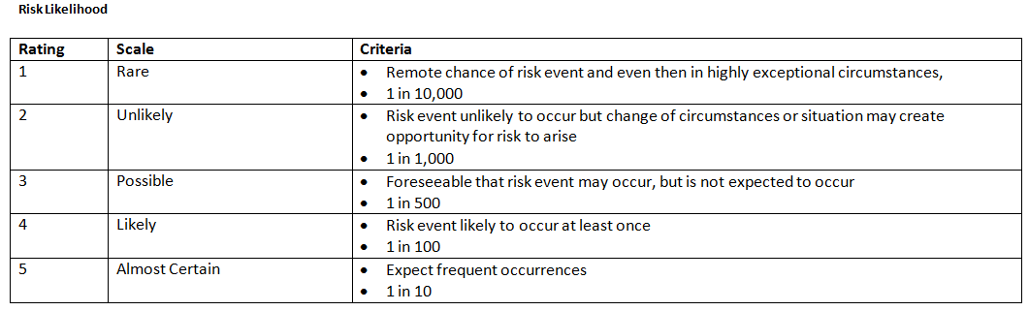
Risk Likelihood and Risk Assessment Matrix

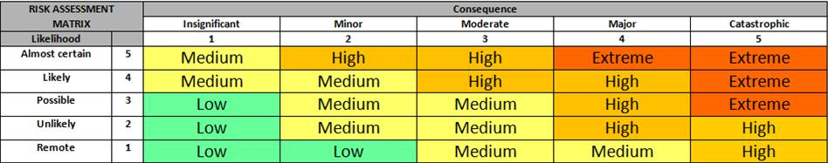

Risk Control Ratings

Good (G) – Documented policy and procedures
- Adequate (A) – Established and proven practice
- Marginal (M) – Untested practice or subject of unsubstantiated assessment

Risk Management Plan *
Complete the following plan for identifying and mitigating any risks that may impact the delivery of your project. Applicants must complete all rows marked “Required”. Additional rows may be added where necessary.
Please complete the following plan for identifying and mitigating any risks that may impact the delivery of your project.
Description of risk  (What could happen? How could it happen?) | Impact on project  (What is the consequence if it happens?) | Before Controls |  |  | Controls:  Risk Treatment/Prevention Measures  Describe controls: What actions will be taken to prevent or reduce the risk? Include risk control rating:  - Good (G)  - Adequate (A)  - Marginal (M) | After Controls
 | Impact on project  (What is the consequence if it happens?) | Likelihood | Consequence | Inherent Risk Rating (before controls) |  | Likelihood | Consequence | Residual Risk Rating (after controls)
Example: Delay in ethics or data access approvals | Research commencements delayed; milestones impacted | 3 (Possible) | 3 (Moderate) | Medium | Early engagement with data custodians; application prepared in advance; contingency timeline included; alternative data sources scoped. (A) | 1 (Remote) | 2 (Minor) | Low
Example: Key research staff turnover | Loss of expertise; milestones delayed | 2 (Unlikely) | 4 (Major) | High | Succession planning; clear documentation of research process and methodology; careful screening of research assistant/pos-doc fellow applications. (G) | 2 (Unlikely) | 3 (Moderate) | Medium
Required: Data access, governance or ethics risk |  | Choose an item. | Choose an item. | Choose an item. |  | Choose an item. | Choose an item. | Choose an item.
Required: Timeline or milestone delivery risk |  | Choose an item. | Choose an item. | Choose an item. |  | Choose an item. | Choose an item. | Choose an item.
Required: Staffing or capability risk |  | Choose an item. | Choose an item. | Choose an item. |  | Choose an item. | Choose an item. | Choose an item.
Required: Budget or cost variation risk |  | Choose an item. | Choose an item. | Choose an item. |  | Choose an item. | Choose an item. | Choose an item.
 |  | Choose an item. | Choose an item. | Choose an item. |  | Choose an item. | Choose an item. | Choose an item.
 |  | Choose an item. | Choose an item. | Choose an item. |  | Choose an item. | Choose an item. | Choose an item.
 |  | Choose an item. | Choose an item. | Choose an item. |  | Choose an item. | Choose an item. | Choose an item.
 |  | Choose an item. | Choose an item. | Choose an item. |  | Choose an item. | Choose an item. | Choose an item.
(Notes: Add more rows as needed)

Additional notes (if required)
(Use this space to explain assumptions, dependencies between risks, or mitigation sequencing as necessary)

