ACT Migration Application Portal
New Account Creation Guide

Step 1 – Create a New Account
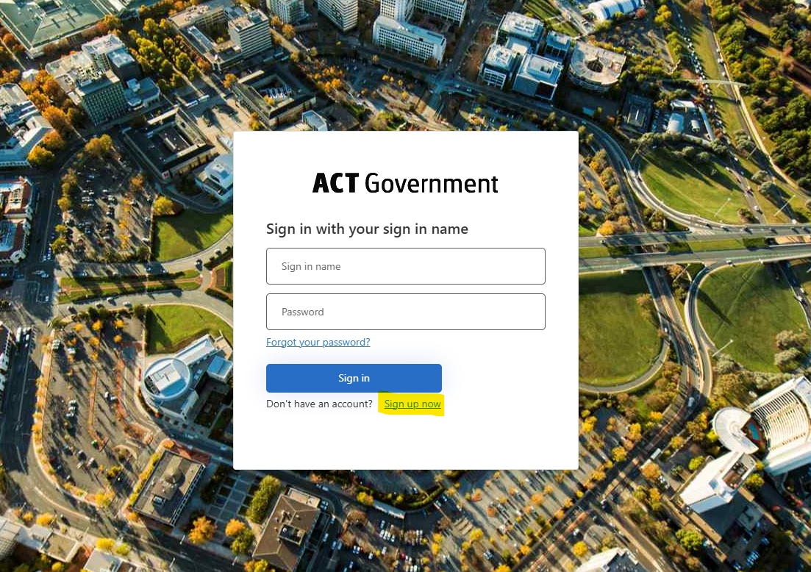
On the ACT Migration sign-in page, select “Sign up now”.

Step 2 – Request an Email Verification Code
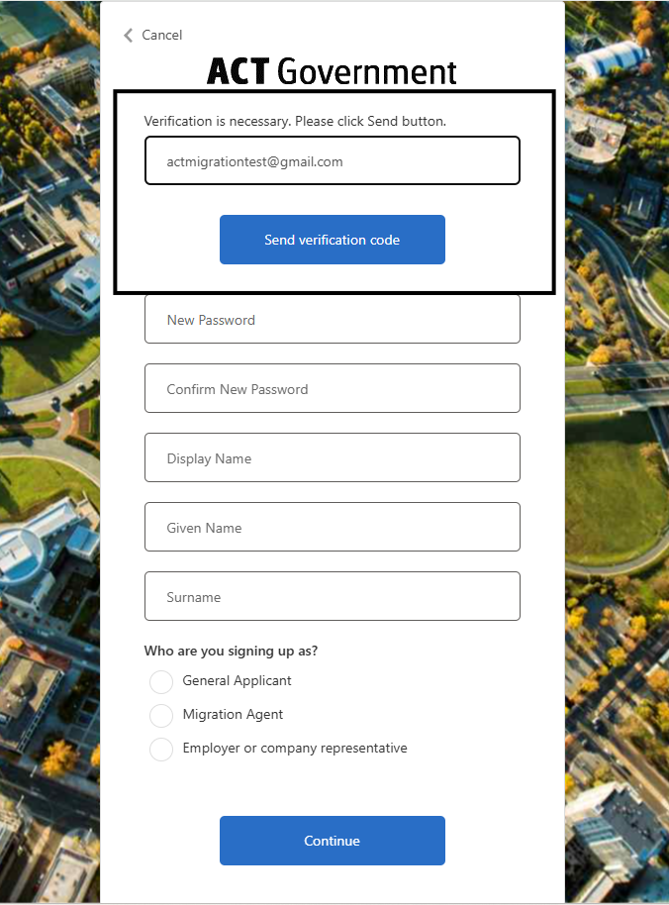
Enter your email address and select “Send verification code”.

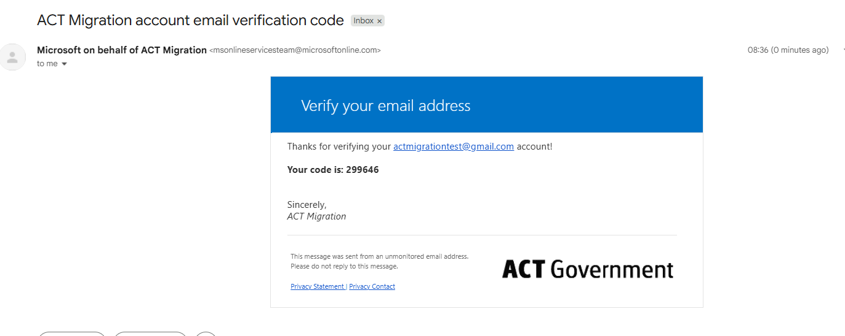
Step 3 – Retrieve the Verification Code
Open the ACT Migration email and note the six-digit verification code.

Step 4 – Verify Your Email Address
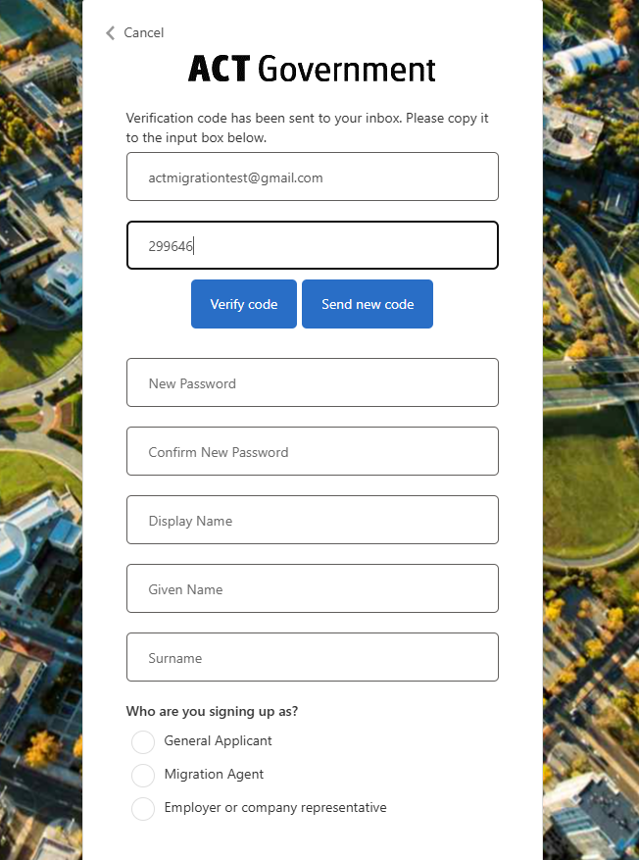
Enter the code and select Verify code. If required, select Send new code.

Step 5 – Complete Your Account Details
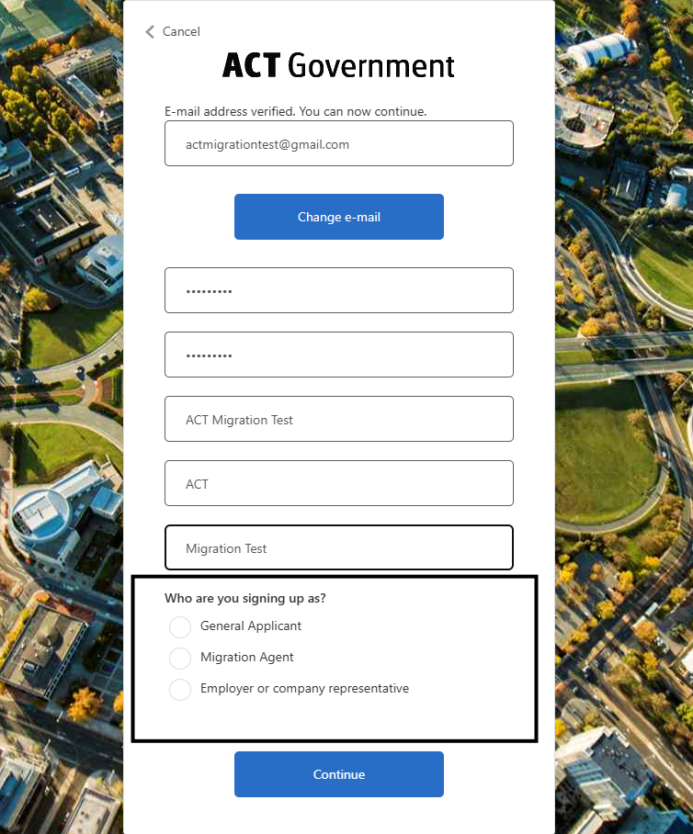
Create and confirm your password. Enter Display Name, Given Name and Surname and select the role (general applicant, agent, or employer) appropriate to your circumstances.

Step 6 – Set Up Multi-Factor Authentication (MFA)
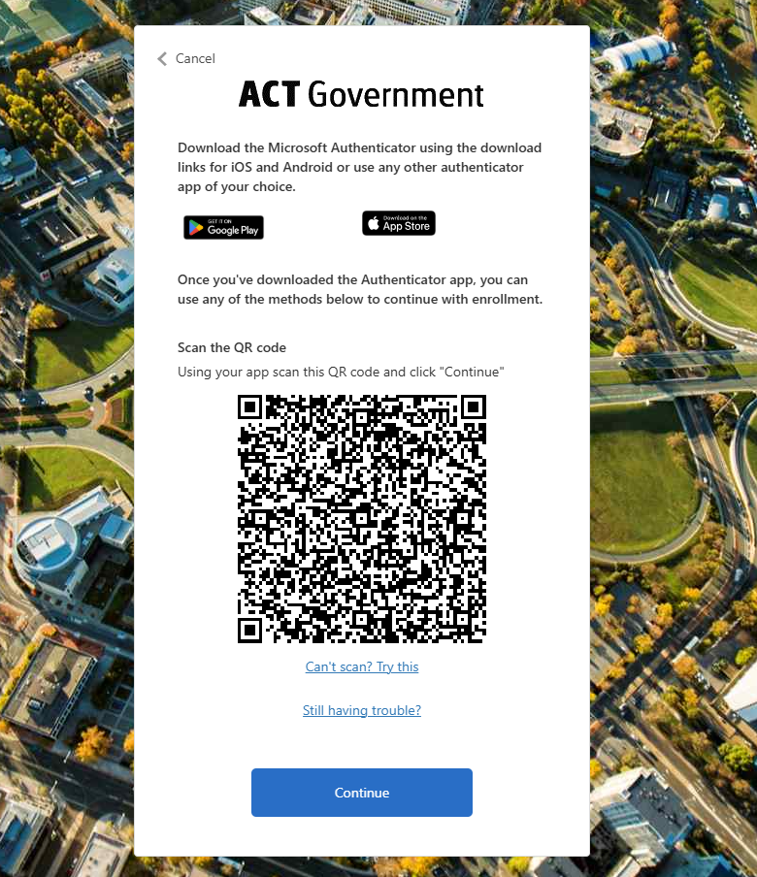
Download Microsoft Authenticator (or compatible app), scan the QR code and continue. Make sure you back up your accounts in the authenticator app to the cloud.

Step 7 – Verify Multi-Factor Authentication Code
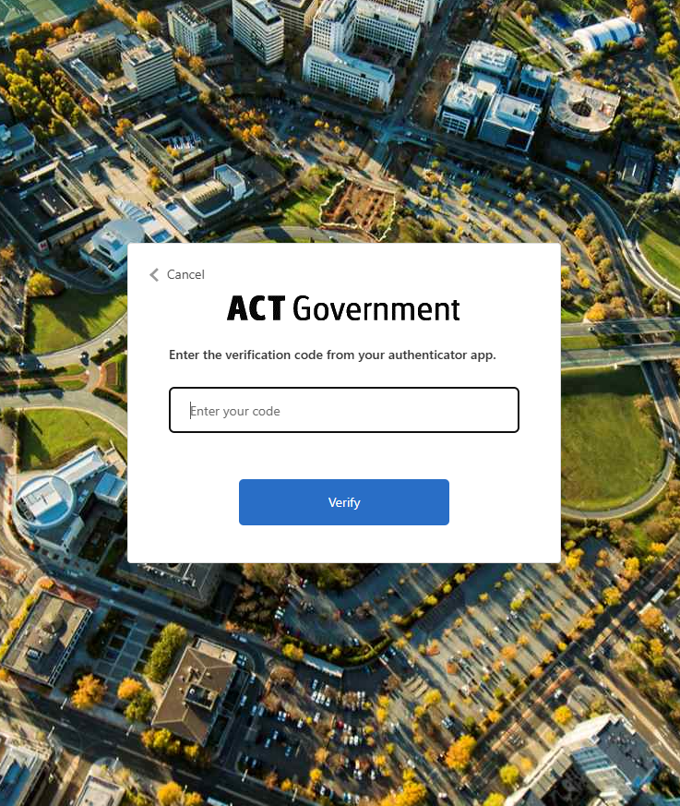
Enter the verification code from your authenticator app and select Verify.

Step 8 – Complete Your Profile
Complete all required profile fields and select Save. Please note, the exact profile page may differ based on the role you chose in step 5.
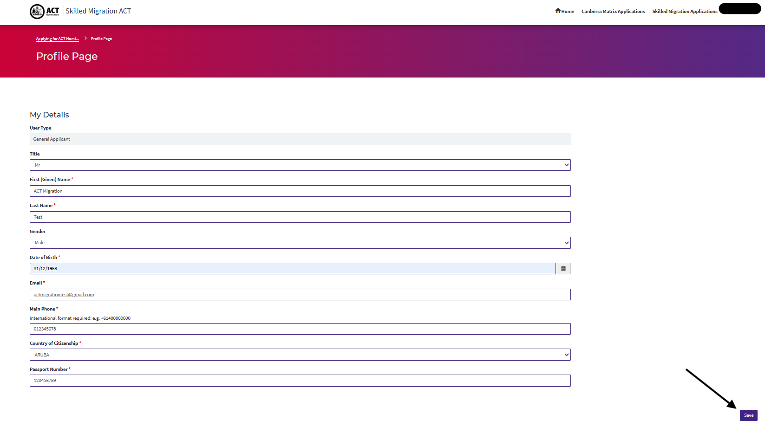

Step 9 – ACT Migration Application Portal Navigation
Use the portal to access Canberra Matrix Submissions and ACT Nomination Applications. 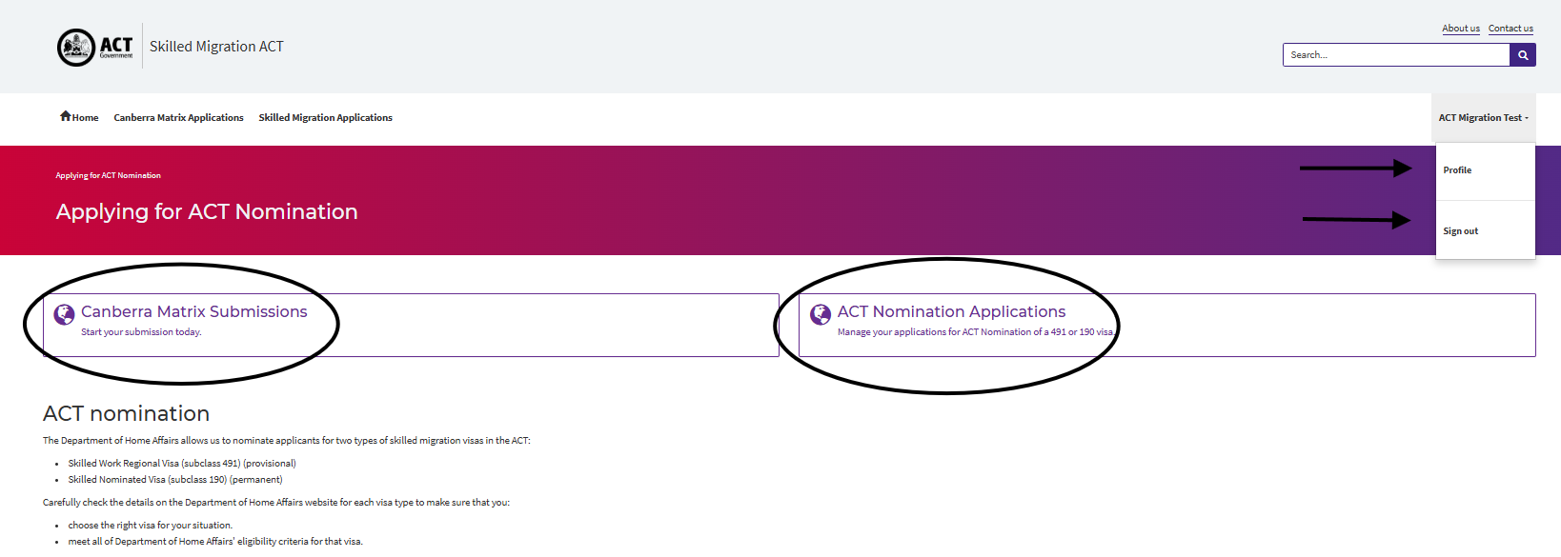
Canberra Matrix Submissions Management Canberra Matrix Submissions Management 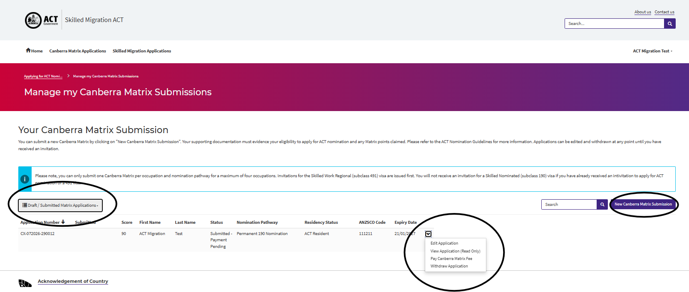
ACT Nomination Application Management
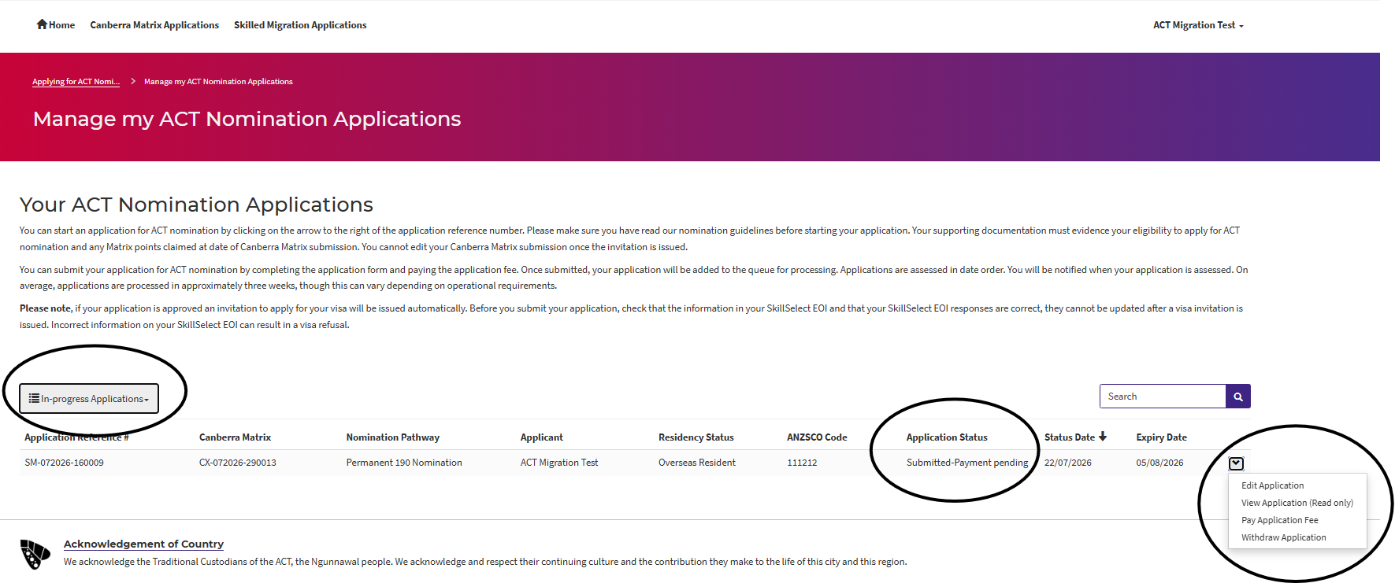
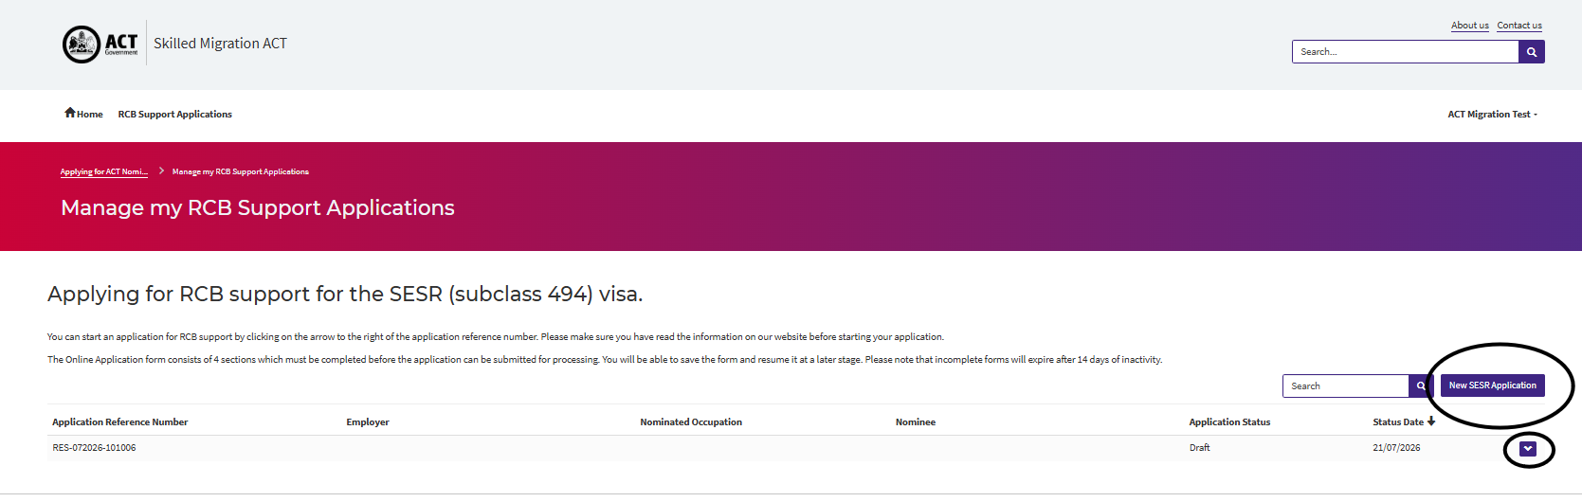
Regional Certifying Body Support Application Management

Support Information
Email: migration@act.gov.au
Phone: +61 2 6207 0517
Hours of Operation: 9 AM – 4 PM (AEST) in August 2026. Normal hours of operation are 10 AM to 12 PM (AEST)
Website: https://www.act.gov.au/migration

