

A MESSAGE FROM THE COMMISSIONER
EDITION 1, APRIL 2026
ACT CORRECTIVE
SERVICES NEWSLETTER
I am pleased to introduce the ACT Corrective Services Newsletter. This publication is designed to keep our stakeholders informed and connected to the work of ACT Corrective Services.
Issued quarterly, the newsletter will provide updates on key activities and developments across ACTCS, including general operational updates, significant milestones, progress on major projects and policy updates.
We welcome your feedback and encourage you to share your views through our usual channels, as this helps us continue to improve how we communicate and engage with our stakeholders.

ACTCS Launch Population Data Insights webpage
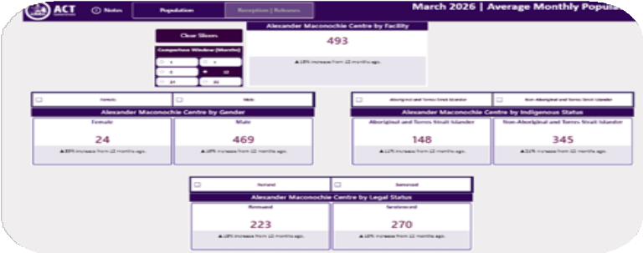
As part of ACT Corrective Services’ (ACTCS) commitment to strengthening evidence-based decision-making and service delivery, the ACTCS Population Data Insights webpage is now available via the ACT Government website.
This new resource proactively shares automated data products with the ACT community, providing clear insights into detainee demographic trends to support timely, informed service improvement.



Official Visitors
Two new cafés open at the AMC
The two detainee-run cafés at the AMC, launched late last year, have been hugely popular amongst staff and visitors. The Hume Café, located in the visits centre, and The Daily Grind Café, operating from the staff canteen, have quickly become well-loved spaces.
Beyond the positive feedback, the cafés provide a fantastic opportunity for detainees to gain experience and skills that support future employment after release.
For more information, visit the ACT Government website.

In April, we welcomed Leslie (Les) Purcell as an Official Visitor to the AMC and said farewell to Vickie Quinn. We thank Vickie for her dedication and contribution during her time with us.
Official Visitors provide independent oversight of correctional facilities and identify systemic issues, but does not handle individual complaints. For more information, visit the ACT Official Visitor website.


Report on Government Services 2026
In February, The Productivity Commission released Part C of their 2026 Report on Government Services (RoGs), which includes information on how states and territories have performed in the delivery of corrective services.
Key ACT results in the 2026 RoGs include:
We have the second highest completion rate of community corrections orders in Australia at 85.3%.
We perform well above the national average for detainee participation in employment and education opportunities, ranking second nationally with 90.1% of eligible detainees engaged in employment.
While the ACT had the third-lowest rate of Aboriginal and Torres Strait Islander adults returning to prison within two years, this rate increased slightly.
First Nations adults continue to be over-represented and are 1.3 times more likely to return to custody within two years compared to non-indigenous adults. The ACT Government continues to prioritise culturally responsive rehabilitation programs to reduce recidivism among Aboriginal and Torres strait Islander people.
If you’d like to explore the results in more detail or see how we compare nationally, you can view the full ROGS data here.



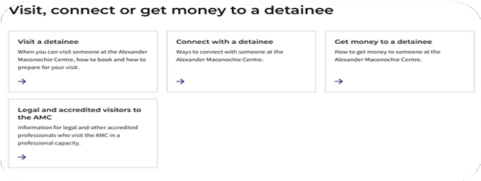
Staff Spotlight
The ACT Government website holds key information for family and f riends on how to:
Book visits
Get money to a detainee Connect with a detainee
For more, visit the
Detainees at the AMC webpage.
One of our Community Corrections Officers received a note f rom a client, thanking the Officer for their
support in securing a placement in a residential rehabilitation program.
“I wanted to thank you for the support you gave me through such difficult moments. You treated me with respect at a time when I felt like no one believed in me and that made a real difference. Thank you for working so hard to give me the opportunity to prove myself. I am doing well in rehab and working hard. I really appreciate the chance you helped give me and everything you did. Thank you, with great respect.”

Policy Update
This quarter, the following policies and procedures have been updated:
Closed-Circuit Television Policy and Operating Procedure
The policy has been updated to provide staff with clear direction on the use of CCTV within ACT Corrective Services.
All custodial policies are available on the ACT Legislation Register.

