



**ACT   
QUALITY**

**FRAMEWORK**

August 2022 | Version 2.1

**Skills Canberra**

Chief Minister, Treasury and Economic Development Directorate

220 London Circuit, Canberra ACT 2601

GPO Box 158 , Canberra ACT 2601

Phone: (02) 6205 8555

Email: [skills@act.gov.au](mailto:skills@act.gov.au)

Web: <https://www.act.gov.au/skills>

# Version control

| Version | Effective date | Status | Details |
| --- | --- | --- | --- |
| 2.0 | 1 October 2019 | New release | Commencement of Training Initiative Funding Agreement |
| 2.1 | 24 August 2022 | Modification | Skills Canberra address and website hyperlinks updated |

It is the responsibility of the user to ensure that this is the current and complete document. The latest version is located on the [Skills Canberra website](https://www.act.gov.au/skills/home).



# Contents

Version control 3

Contents 4

Introduction 5

1. PRINCIPLES AND OBLIGATIONS 6

ACT Statement of Expectations (CARE) 6

2. CONTRACTUAL ARRANGEMENTS 8

Training Initiative Funding Agreement 8

Application Process 8

Eligibility Criteria 9

3. ACT STANDARDS 10

4. ONGOING COMPLIANCE 11

Audit Guide for Training Providers in the ACT 11

Compliance Matrix 11

RTO Internal Review 12

5. FRAMEWORK OVERVIEW 13

# Introduction

The ACT Quality Framework (the Framework) underpins the delivery of training in the ACT. It aims to promote excellence and transparency and provides a foundation for the vocational education and training (VET) sector in the ACT. The Framework is comprised of contractual and compliance arrangements and incorporates a set of principles and obligations governing Registered Training Organisation (RTO) conduct. Combined, these components support the ACT Government’s objective for a flexible and responsive training sector that delivers high quality training.

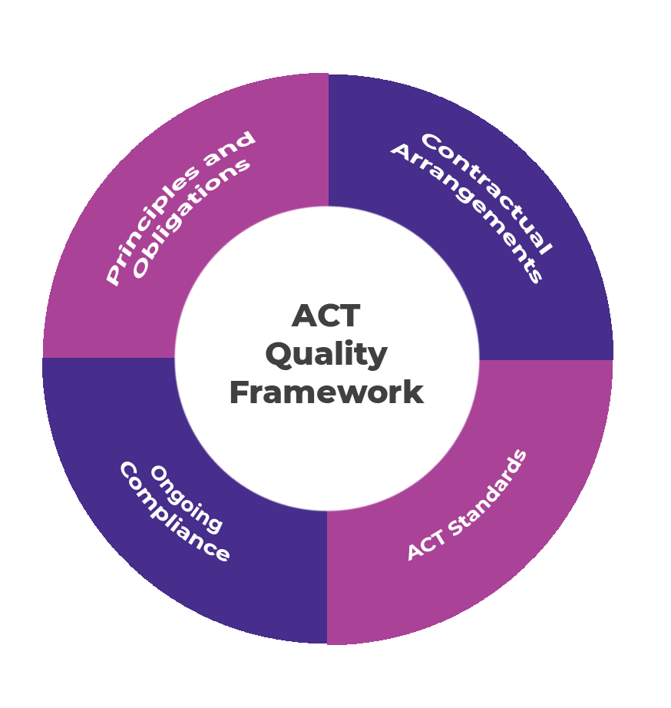

Training Initiative Funding Agreement (Agreement)

* Application Process
* Eligibility Criteria

ACT Statement of Expectations

* **C**o-operative
* **A**ccountable
* **R**esponsive
* **E**thical

Compliance Guides

* ACT Standards Compliance Guide for Australian Apprenticeships
* ACT Standards Compliance Guide for Skilled Capital

Audit Guide for Training Providers in the ACT

* Compliance Matrix
* RTO Internal Review

The Framework complements the work of the national VET regulator, the Australian Skills Quality Authority (ASQA), in providing information and guidance to promote quality training and to assist RTOs to demonstrate and maintain compliance. In addition to the Framework, the ACT Government may also share information with ASQA and other state and territory governments to support and enhance the quality of the national VET sector.

# PRINCIPLES AND OBLIGATIONS

Skills Canberra is invested in developing the knowledge, skills and capabilities that will shape the ACT’s future. To support this, the ACT needs an effective training market that ensures vocational education and training is responsive to workforce needs as well as to the ACT’s economic aspirations.

The ACT Government aims to:

* target and support economic growth by helping to ensure employers’ skills needs are met, and building new workforce capability for emerging sectors
* target government funding to support training in areas of highest demand to best provide the skills needed by industry, students and the ACT community
* ensure training delivered in the ACT is of the highest quality
* provide better access to training with additional support, particularly for those experiencing disadvantage.

The ACT Statement of Expectations (the Statement) supports the ACT to achieve these objectives.

## ACT Statement of Expectations (CARE)

The Statement outlines the expectations for RTO conduct in the provision of training in the ACT. The Statement recognises the contractual and compliance obligations for RTOs and identifies the specific responsibilities and ethical behaviours required. The Statement also applies to RTOs delivering funded training initiatives under a fee-for-service arrangement.

The Statement is structured around four key principles of professional conduct. These principles serve as a minimum benchmark for professional behaviour and ensure public confidence in the integrity of the VET sector in the ACT.







***The RTO must act in a co-operative manner in all dealings with the ACT Government, students,   
employers and other stakeholders.***

The RTO will:

* exchange information with the ACT Government and relevant stakeholders as required
* respond to ACT Government correspondence in a co-operative and timely manner
* communicate professionally with the ACT Government, students, employers and other stakeholders.

Principle 1:  
Co-operative

* have an appropriately established and maintained complaints and appeals process that is accessible to stakeholders.



***To ensure the ACT VET sector is high performing, the RTO must have accountable and effective governance arrangements.***

The RTO will:

* meet performance obligations under its registration, the *Training and Tertiary Education Act 2003*, and other governing legislation, standards, laws and regulations and funding arrangements
* implement compliance and timely reporting frameworks to meet the ACT Government’s requirements

Principle 2:  
Accountable

* identify and act to resolve instances of fraud, misconduct, maladministration, inappropriate use of public funds and any risks to health and safety or the overall welfare of students.



***The RTO must contribute to the flexibility of the ACT VET sector by remaining responsive to government and the needs of industry, current and prospective students and the broader ACT community.***

The RTO will:

* identify and respond to opportunities to support a relevant and responsive VET sector
* establish and maintain relationships with industry to build their confidence in utilising VET pathways to integrate new and emerging skills needs
* listen and respond to issues and concerns raised by students, employers and other stakeholders about training and RTO performance

Principle 3:  
Responsive

* work collaboratively to resolve issues and concerns raised by the ACT Government, students, employers and other stakeholders.



***The RTO must act ethically, fairly and honestly in the performance of its obligations.***

The RTO will:

* provide training, assessment and support services that enable students to gain the most from their training
* use fair and transparent decision-making processes
* keep true and accurate records relating to training and service delivery

Principle 4:  
Ethical

* accurately represent its products and services to prospective students and clients.

# 2. Contractual Arrangements

Only RTOs that can demonstrate high quality training provision in accordance with the ACT Government’s comprehensive quality and performance criteria are approved to deliver government subsidised training in the ACT.

RTOs must apply to the ACT Government through the Chief Minister, Treasury and Economic Development Directorate (the Directorate) for a Training Initiative Funding Agreement (Agreement). To be approved for an Agreement, RTOs are assessed against mandatory criteria and a series of quality and performance indicators determined by the ACT Government and validated by external expert consultants.

## Training Initiative Funding Agreement

The Agreement is the contractual arrangement between the ACT Government and approved RTOs for the delivery of subsidised vocational education and training (VET) in the ACT. The Agreement sets out the terms and conditions under which the ACT Government may make available funds to RTOs for the delivery of training and assessment for a range of training initiatives.

## Application Process

RTOs must hold an Agreement to be eligible to deliver government subsidised training. In addition, an RTO with an Agreement must meet the specific requirements for each ACT Government training initiative under which it delivers training.

The [Training Initiative Funding Agreement Application Guidelines](https://www.act.gov.au/skills/publications) outline how RTOs apply for an Agreement. The guidelines provide an overview of the Agreement, the application process and how applications are assessed.

RTOs must submit the application online via the Directorate’s website using the SmartForm application. The form collects information on the following areas:

* RTO details
* Legal information
* RTO leadership
* Enrolment history
* Meeting learner needs
* Financial health
* Industry engagement
* Past performance
* Program quality

## Eligibility Criteria

An initial assessment of eligibility is performed at the commencement stage of the application against mandatory criteria.

To be eligible, the RTO must:

* hold a current registration with ASQA
* hold all insurance cover necessary to carry out its business operations
* be able to report training delivery information using an AVETMISS compliant student management system.

Only RTOs that meet the mandatory criteria for an Agreement will progress to the next stage of the eligibility assessment process.

Each application is then assessed against a range of further eligibility criteria, using the following methodology:

* indicator criteria, based on information collected from Directorate data sources and information provided by the RTO through the application process
* RTO groupings, to ensure RTOs with similar characteristics are assessed fairly
* mean-variance benchmarking, which provides a determined minimum benchmark for each indicator
* weightings for each indicator, based on relevance to quality VET and ACT Government priorities for training
* overall scoring, which combines the weighted score from each indicator where the benchmark is achieved to form an aggregate score for the RTO.

RTOs must meet the minimum assessment threshold determined by the ACT Government to be offered an Agreement.



# 3. ACT STANDARDS

The ACT Standards for Delivery of Subsidised Training (the ACT Standards) outline the mandatory standards for RTOs in the management and delivery of training in the ACT.

Each ACT Government funded training initiative has a Compliance Guide. The ACT Standards Compliance Guides (Compliance Guides) provide direction to RTOs on:

* how to interpret, implement and comply with the ACT Standards and additional initiative specific requirements when delivering government subsidised training
* the administrative requirements
* examples of evidence to be retained for audit.

The ACT Standards apply equally to RTOs delivering ACT Government training initiatives and RTOs with an Agreement offering Australian Apprenticeships training on a fee-for-service basis.

The ACT Standards form a schedule to the Agreement.

## CONSISTENT

The ACT Standards and Compliance Guides apply a consistent interpretation of the requirements for RTOs across all ACT Government training initiatives and Australian Apprenticeship Fee-for-Service arrangements.

## TRANSPARENT

The ACT Standards and associated Compliance Guides are available to RTOs, employer groups and individuals. These documents are also publicly available on the Skills Canberra website.

## STREAMLINED

The format of the ACT Standards and Compliance Guides clearly outlines the compliance requirements for RTOs in the ACT. They contain the essential elements against which RTOs operating in the ACT are audited.

# 4. ONGOING COMPLIANCE

Ongoing RTO compliance is monitored using a structured risk management framework that is flexible and adaptive to changing environments, RTO performance issues and emerging risks. The risk level of each RTO is assessed against a set of measurable risk indicators each calendar year. The results of the assessment are used to inform the audit schedule. Information generated may be used to target strategic reviews, audits, and discussions with RTOs that will determine whether a genuine risk exists or, alternatively, whether there are mitigating circumstances. This process ensures that RTOs where higher risk practices may exist are audited more frequently.

The indicators are classified into two categories, potential and known concerns. The combined indicators are used to classify each RTO into a low, medium, high or extreme risk indicator band. A high score in either category increases the probability of the RTO being selected for an audit. RTOs are selected from each risk indicator band for the on-cycle audit program to ensure a broad selection of providers are audited.

## Audit Guide for Training Providers in the ACT

The ACT Government uses a range of audit methods to assess RTO compliance. The [Audit Guide for Training Providers in the ACT](https://www.act.gov.au/skills/publications) (the Guide) provides information about the audit strategy for ACT Government training initiatives. The Guide provides the context, key objectives and an overview of the end-to-end audit process. It also provides information on the type of audits conducted and provides the methodology for RTO and student file sample selection.

## Compliance Matrix

The Compliance Matrix, included in the guide, outlines the methodology for assessing RTO compliance with the ACT Standards and Compliance Guides. The matrix provides a clear framework that allows for audits to be carried out against the ACT Standards and Compliance Guides and is used to apply consistent and equitable actions for specified instances of non-compliance.

## RTO Internal Review

RTOs that hold an Agreement are required to complete an internal audit annually.

The RTO Internal Review Tool (the Tool) provides RTOs with a structured outline of the expectations of the internal audit required under the Agreement. The Tool provides a consistent format for an RTO to present the results of its internal review and provides a platform for self-assessing and evaluating compliance with a selection of clauses from the Agreement, as well as the ACT Standards for Delivery of Subsidised Training and applicable ACT Standards Compliance Guides. The Tool also allows an RTO to identify areas for continuous improvement.

The RTO Internal Review Tool Guidelines provide clear advice for completing the Tool. They also describe how the information provided in the Tool will be evaluated.

###### Objectives of the RTO Internal Review Tool

* Assist RTOs to meet their contractual requirements under the Agreement
* Assist RTOs to meet the minimum service requirements of ACT Government training initiatives
* Promote quality training and assessment systems
* Ensure accurate reporting and record keeping practices
* Provide a set of outcomes for RTOs to self-assess compliance and assist in establishing a framework to identify and develop improvement practices



# 5. FRAMEWORK OVERVIEW

The following diagram represents the components of the ACT Quality Framework and the relationship between the relevant documents. These documents can be accessed on the [Skills Canberra website](https://www.act.gov.au/skills/publications).

The ACT Government has a strong focus on the delivery of quality training. Each component of the Quality Framework is subject to review and updates are published as required.



Contractual Arrangements

Ongoing Compliance­­­

Principles and Obligations

ACT Standards



ACT Government logo

### Skills Canberra

Chief Minister, Treasury and  
Economic Development Directorate